**Libraries:**

For third party libraries, here is how you can install them,

1. pip install fmrest (for both extract and smart Image Form script)

2. pip install future

3. pip install pillow

4. pip install requests

5. install this "tkscrolledframe" using quick actions

**Extract:**

In the extract script, please change this path

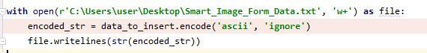

**Smart Image Form:**

In the Smart image form script, change this path to be file created when running extract script



Please add this image into your project, and add its path in the create_image function ****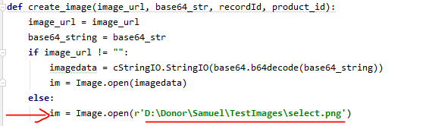Let me know, if you find any issue while testing.