1. What is cloud computing? Enumerate the benefits a business realizes using cloud services.

Cloud computing allows you to take advantage of physical and virtual computer resources in a non-local datacenter as services.

One of the major advantages of using cloud computing is low cost, another is flexibility as you can spin up or spin down resources as needed.

* Less Costs.
* 24 X 7 Availability.
* Flexibility in Capacity.
* All over Functioning. ...
* Automated Updates on Software.
* Security.

2. Why is it preferable to run Deep Learning models on a cloud server?

You can take advantage of the cloud servers GPUs (TPUs) , used them anytime you need them and power them down when you do not need them with minimal setup

* Specialized hardware, generally in the form of graphics processing units (GPUs)
* Storage for massive training datasets that only continue to grow
* High throughput I/O between this specialized hardware and high volume storage

3. Briefly compare the 3 major cloud service providers: Amazon Web Services (AWS), Microsoft’s Azure, Google Cloud Platform (GCP).

* Establishment: With a head start of 5 years, the winner here is AWS.
* Availability zones: With a greater number of regions and availability zones, the winner here is AWS.
* Market shares: With around one-third of market shares in its name, the winner here is AWS.
* Growth rate: Having a growth rate of almost 100 percent, the winner is GCP.
* Who uses them: With various high-end customers using all the three cloud platforms, it’s a tie!
* Services:
  + When it comes to the number of services, the winner is AWS.
  + Regarding the integration with open-source and on-premise systems, such as MS tools, that are mostly used in almost all organizations, the winner is Azure.
* Pricing Models: With more customer-friendly pricing models and discount models, the winner here is Google Cloud.

**AWS ML verdict**: the company has invested more than anyone into the diversification of its services and tools. This includes machine learning services as well. Amazon is dedicated to enhancing current AI and ML technologies and expanding the current limits of image, voice, and face recognition capabilities. Pricing of MLaaS is difficult to estimate, but if you need massive cloud storage for data on your project, then you should note that Amazon offers very cost-effective options. We recommend using the cost calculator tool on the official website due to the complex structure of calculations or maybe even consulting with a third-party organization to pick the most effective options within your budget.

**Azure ML verdict**: compatibility with Microsoft products certainly opens many possibilities for organizations that are already using MS products. Add open source availability to the mix, and you will get a flexible and adjustable platform, which is Azure. Scale your project up and down whenever you want without worrying about the legacy data as it will be saved by Microsoft. The company may have fewer ML tools than Google and Amazon at the moment, but it is not going to stop investing in machine learning. Right now, Azure is probably the most flexible platform in terms of price on machine learning services. However, it requires thorough analysis, planning, and precise calculations for each project to determine the best prices.

**GCP ML verdict**: Google Cloud is growing fast, so does its ML segment. The corporation is working on new services while enhancing the already existing ones. Even in beta, some APIs are already showing fantastic results allowing Google to compete on par with time-tested Amazon services. There is not much to see in the IoT department, but if it is not your main concern, and you would rather sacrifice it to have cost-effective ML services, then Google ML is might be what you need. Google’s pricing is more transparent and client-friendly. In addition to that, the company has started a trend of giving out major discounts and other bonuses to win the audience.

4. Create a Google Cloud Platform (GCP) account. Get a credit of $300 for a new GCP account.

Copy the screenshot of your GCP console on the answer document. Once you start using GCP

account, the credit of $300 will deplete. After the credit balance

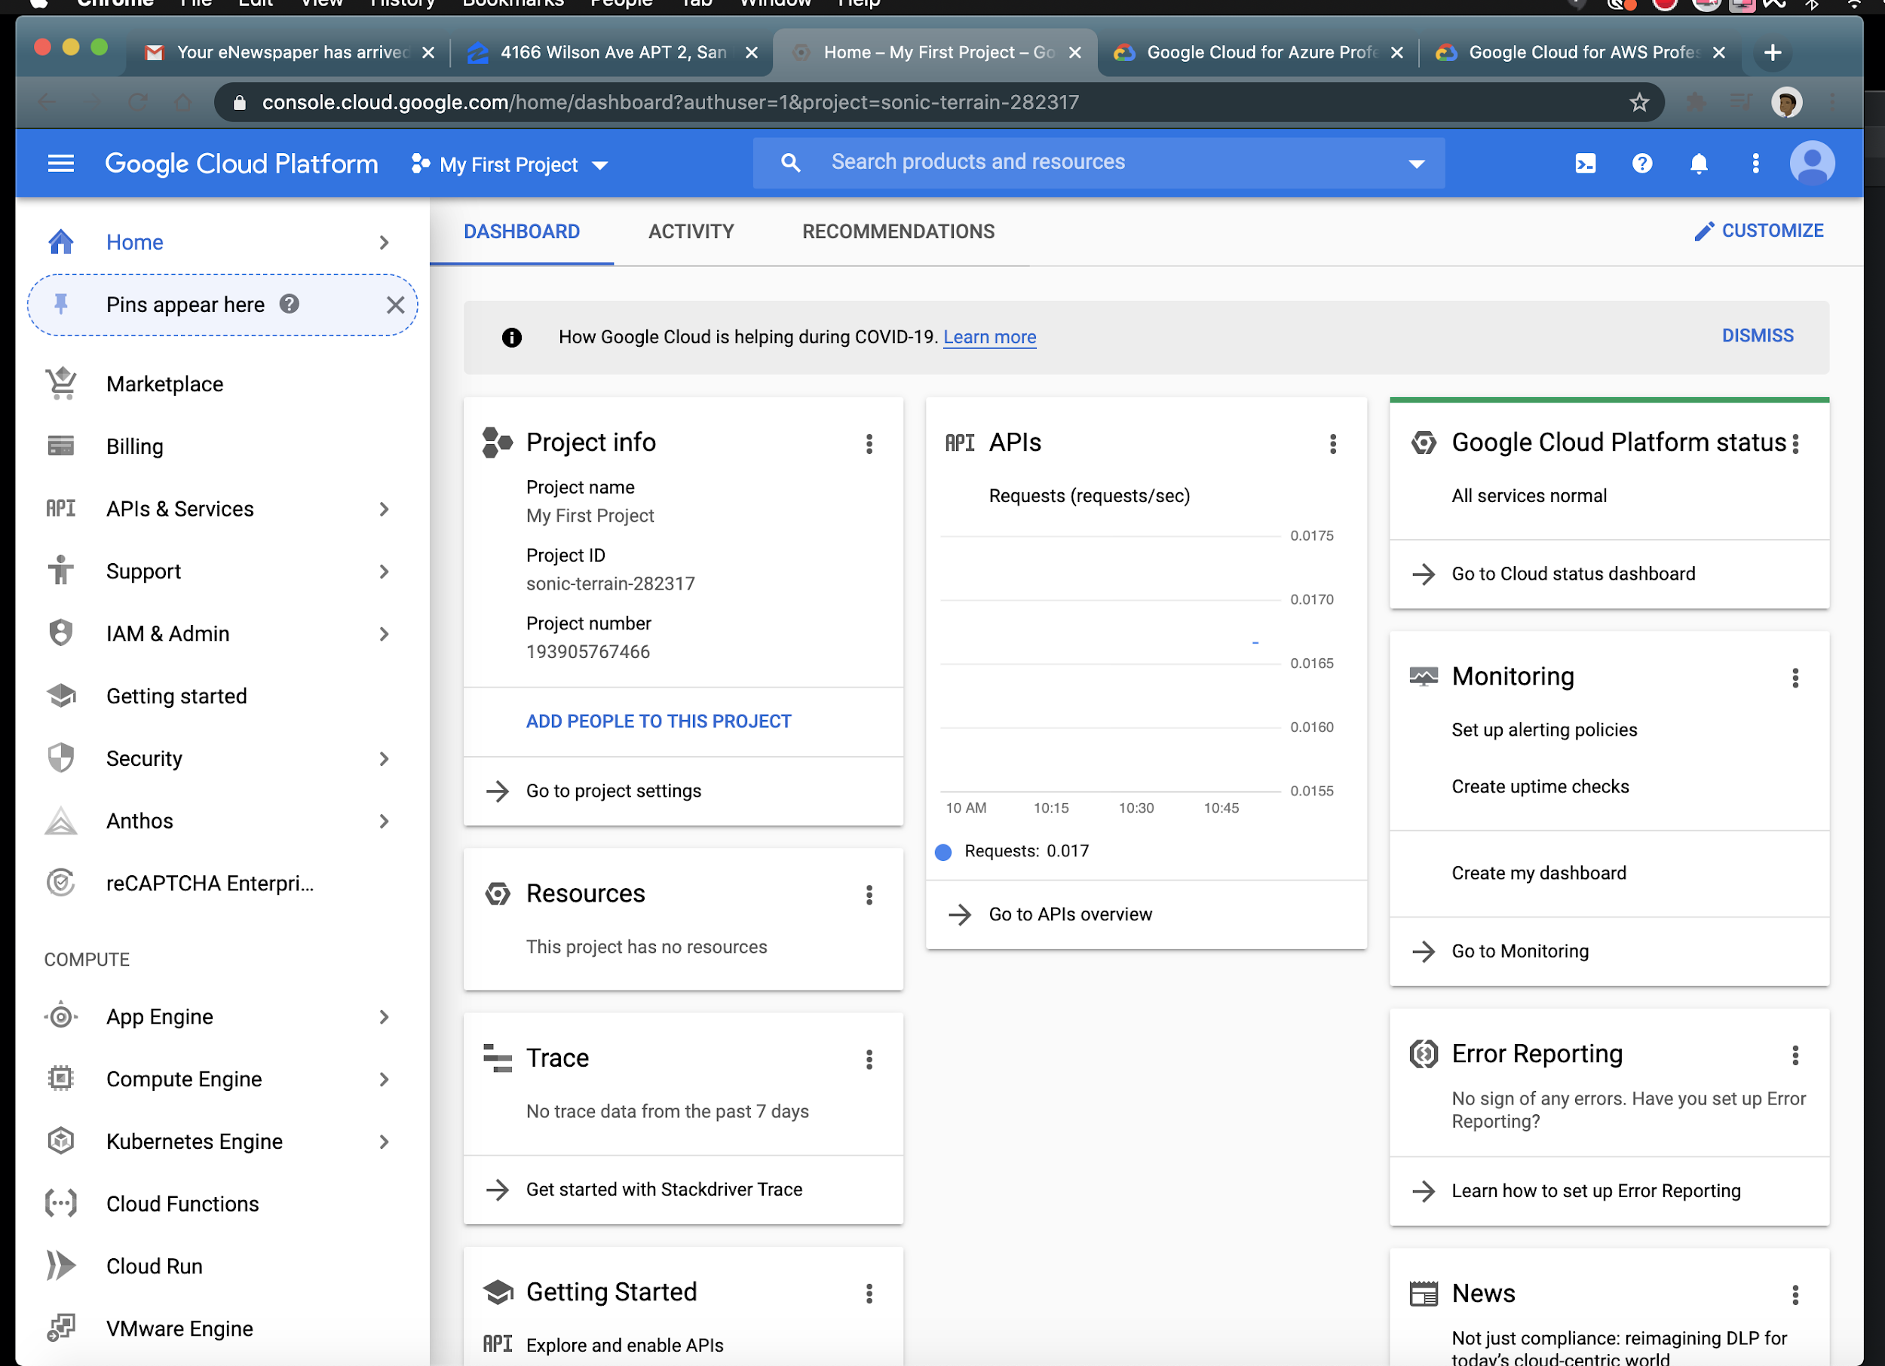

5. If variables a, b, c, d, and f are scalars, write Python program in Colab to compute and display

the following expressions. Test your statements for the following values.

a = 1.12, b = 2.34, c = 0.72, d = 0.81, f = 19.83

Make sure that the answers computed by your Python code matches with the given answers.

#Homework one #5

print('Problem 5')

Problem 5

import tensorflow as tf

ans = []

a = tf.constant(1.12)

b = tf.constant(2.34)

c = tf.constant(0.72)

d = tf.constant(0.81)

f = tf.constant(19.83)

x = 1 + tf.divide(a,b) + tf.divide(c,tf.square(f))

ans.append(x)

s = tf.divide((b - a),(d - c))

ans.append(s)

r = tf.math.reciprocal( tf.math.reciprocal(a)+ tf.math.reciprocal(b)+ tf.math.reciprocal(c)+ tf.math.reciprocal(d))

ans.append(r)

y = tf.divide(tf.multiply(tf.multiply(a,b),tf.square(f)),tf.multiply(2,c))

ans.append(y)

tf.print(ans)

[1.48046339, 13.5555582, 0.253571272, 715.676514]

6. Print the version number of TensorFlow and Keras software packages available on Colab.

import tensorflow as tf

import keras

keras.__version__

2.3.1

tf.__version__

2.2.0