# **MunafaAI – Implementation Progress Report**

## **Overview**

MunafaAI is being developed as an **AI-powered investment assistant** for the Pakistan Stock Exchange (PSX). The platform’s objective is to empower retail investors by offering portfolio creation, real-time market analysis, investment insights, and financial data–driven decision-making through an **AI + chatbot interface**.

The system combines:

* **Real-time data collection (web scraping & APIs)**
* **Historical financial reports (10 years of annual reports of KSE-100 companies)**
* **AI-driven investment analysis**
* **RAG (Retrieval-Augmented Generation) pipeline under development**

## **Features Implemented So Far**

### **1. Smart Investment Calculator**

* Built and functional.
* Allows users to input an amount and calculate **exact share quantities** for either:  
  + **KSE-100 Index weightage replication**
  + **Custom allocations** suggested by AI.
* Ensures leftover cash handling for accurate fund replication.

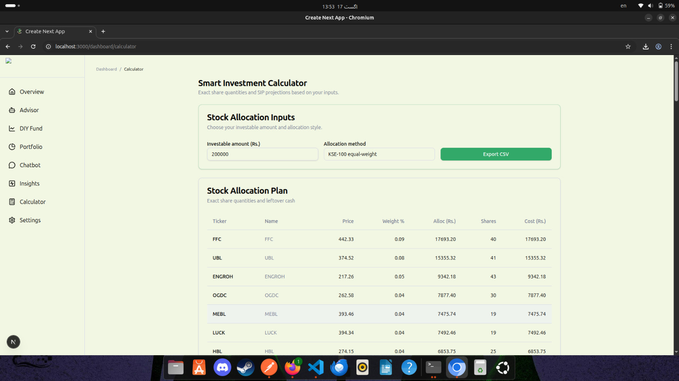

### **2. KSE-100 Index Weightage Implementation**

* The calculator integrates **KSE-100 sectoral and company weightages**.
* Users can replicate **index-based investment strategies** with transparency.
* Basis for creating **DIY mutual fund comparisons** in future.

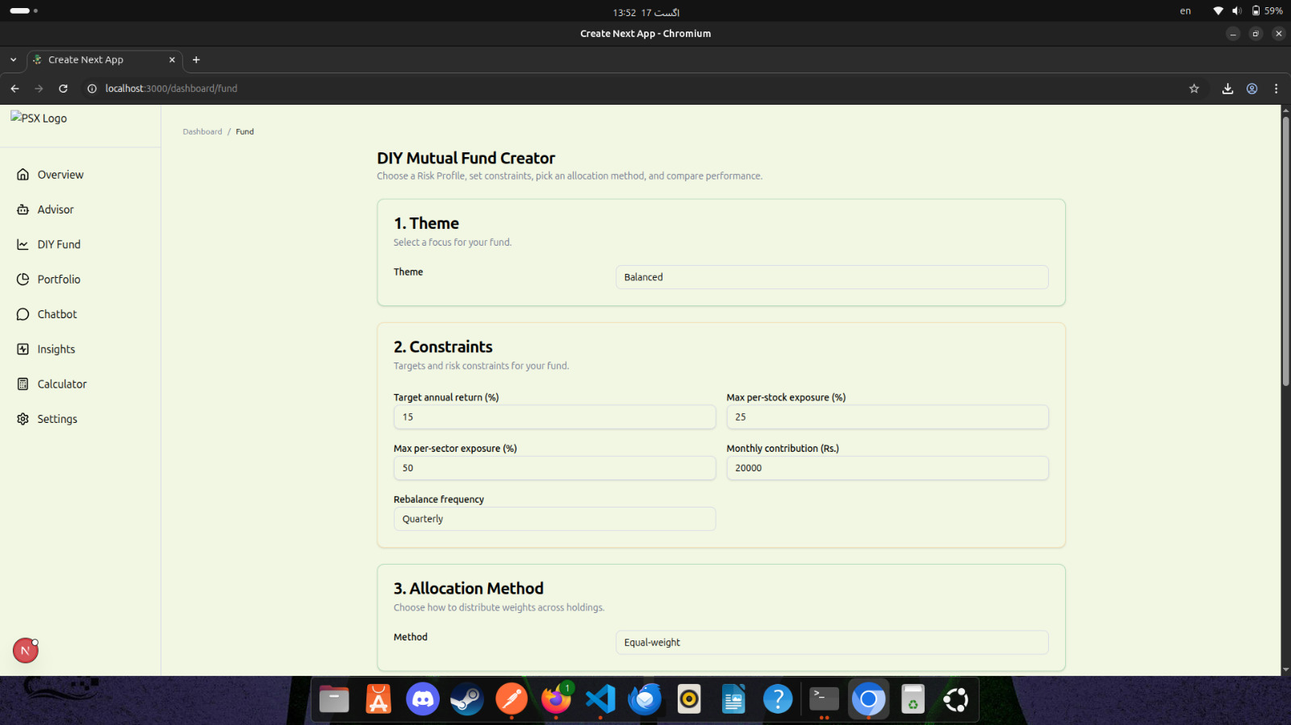

### **3. Market Insights & Daily Summaries**

* Implemented via **web scraping of the DPS PSX website**.
* Provides:  
  + Daily gainers, losers, and most active stocks.
  + Sector-wise performance summaries.
  + Symbol-specific news and insights.
* This forms the **real-time insights backbone** for the chatbot and dashboard.

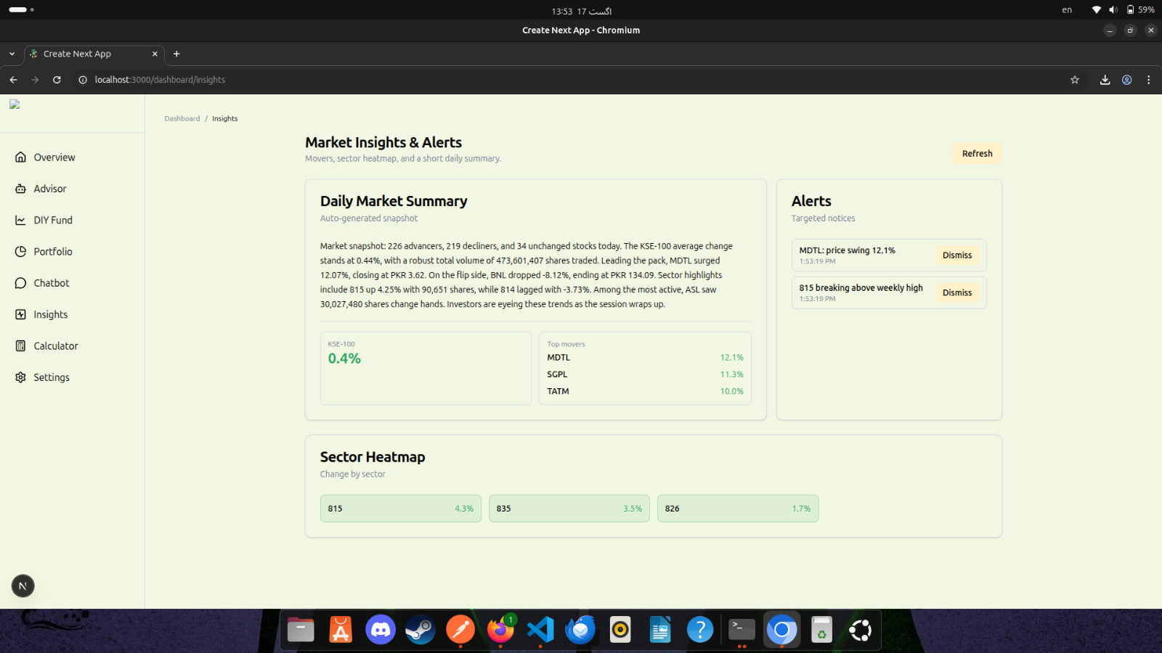

### **4. Data Collection Layer (Completed)**

* **Web scraping pipelines** capture live data for:  
  + Market summaries
  + Gainers/losers/most active lists
  + Sector-wise breakdowns
  + Company news
* **10 years of annual financial reports** collected for **KSE-100 companies**.
* Data warehouse structured for **fundamentals + historical trend analysis**.

## 

## **Work in Progress**

### **1. RAG-Based System Implementation**

* Currently in progress.
* Goal: integrate **retrieval-augmented generation (RAG)** so the chatbot can query across:  
  + Live market data
  + Historical financial reports
  + Sector performance trends
* Expected output:  
  + Context-aware answers like *“Explain the last 5-year profitability trend of ENGRO”*
  + AI-backed portfolio suggestions referencing both live data and past reports.

### **2. AI Chatbot Advisor**

* Prototype integrated with scraped and financial data sources.
* Will support queries such as:  
  + *“How many shares of UBL should I buy for Rs. 200,000?”*
  + *“Summarize cement sector performance today.”*
* Currently being upgraded with **RAG** to improve accuracy and depth.

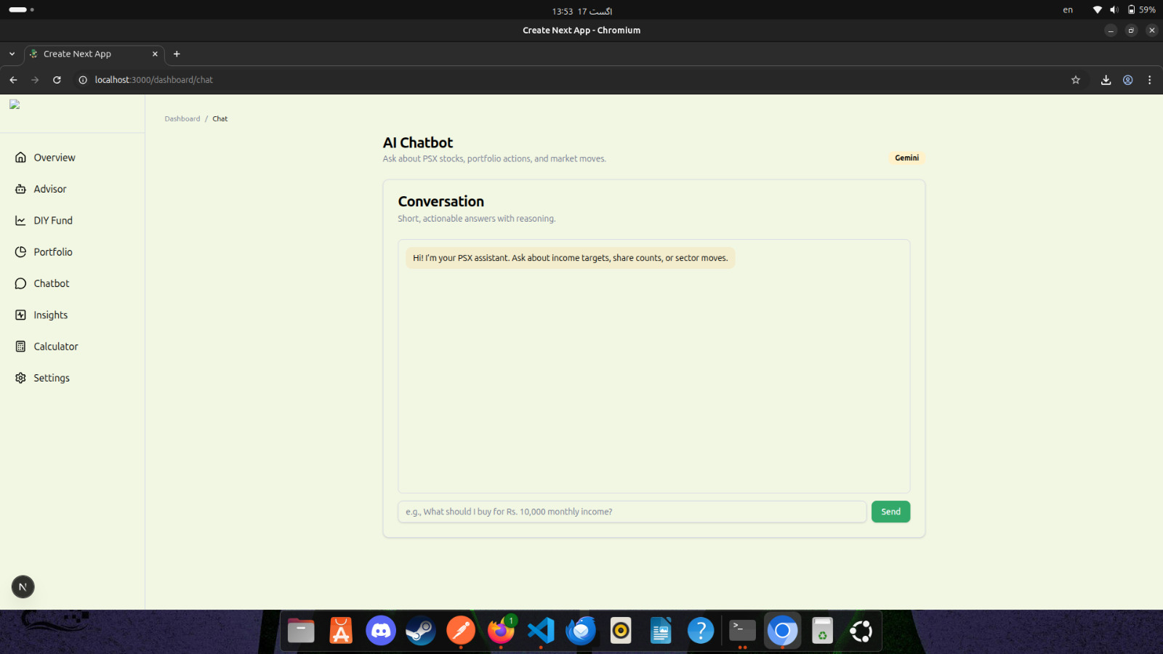

## **Planned Next Steps**

1. **RAG Integration Completion**
   * Enable hybrid responses (real-time + historical).
   * Index financial reports for semantic search.
2. **DIY Mutual Fund Creator**
   * Guided flow for building a custom mutual fund.
   * Compare with real mutual fund NAVs.
3. **Portfolio Tracker Dashboard**
   * Import holdings.
   * Show live profit/loss, sector allocation, IRR.
4. **Enhanced Daily Market Summaries & Alerts**
   * Natural-language, personalized summaries.
   * User-specific alerts (portfolio changes, target triggers).

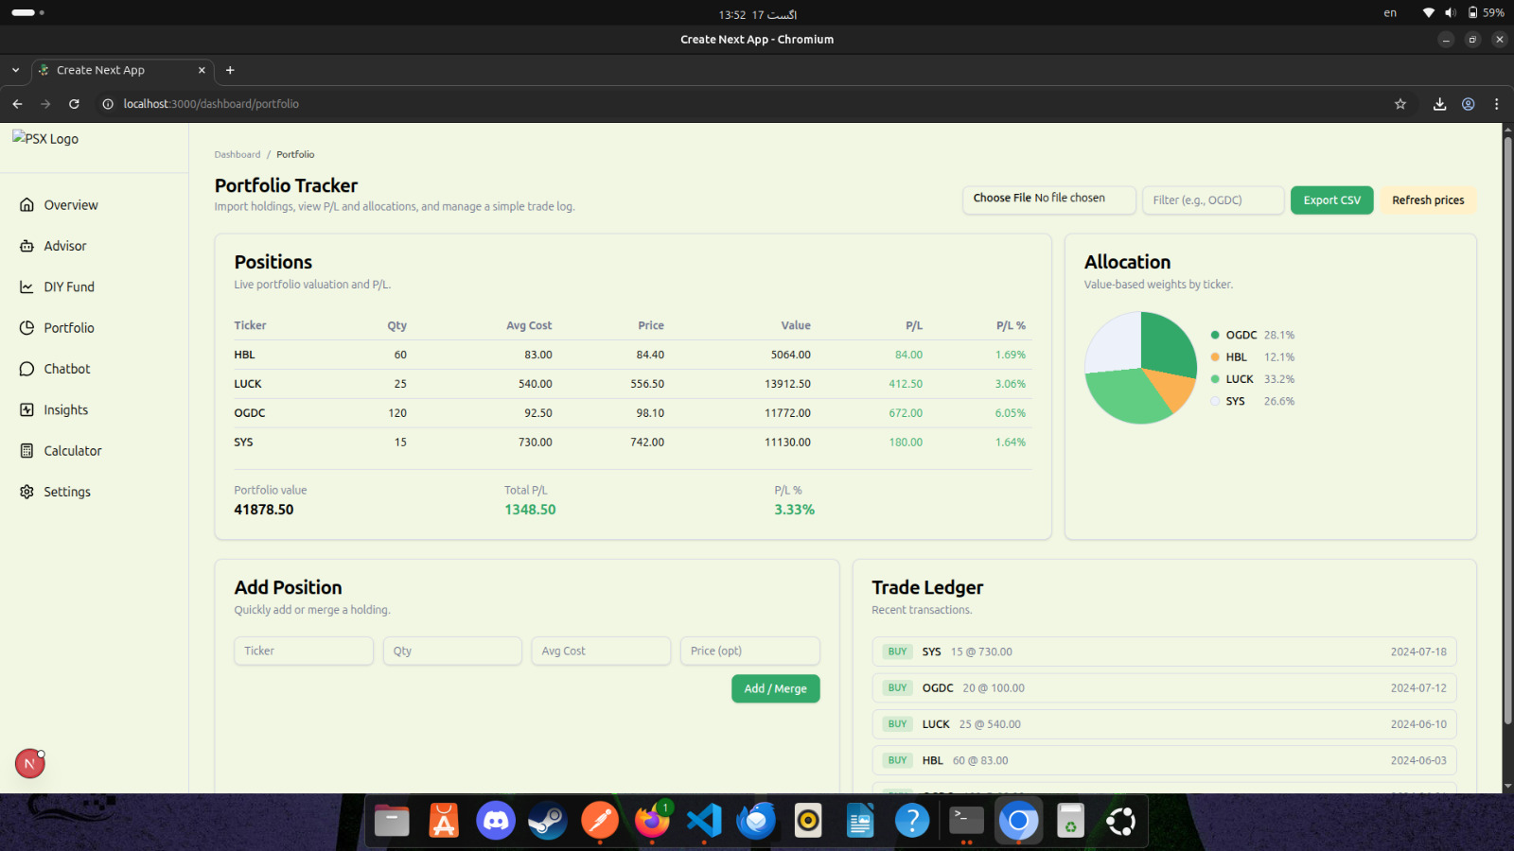

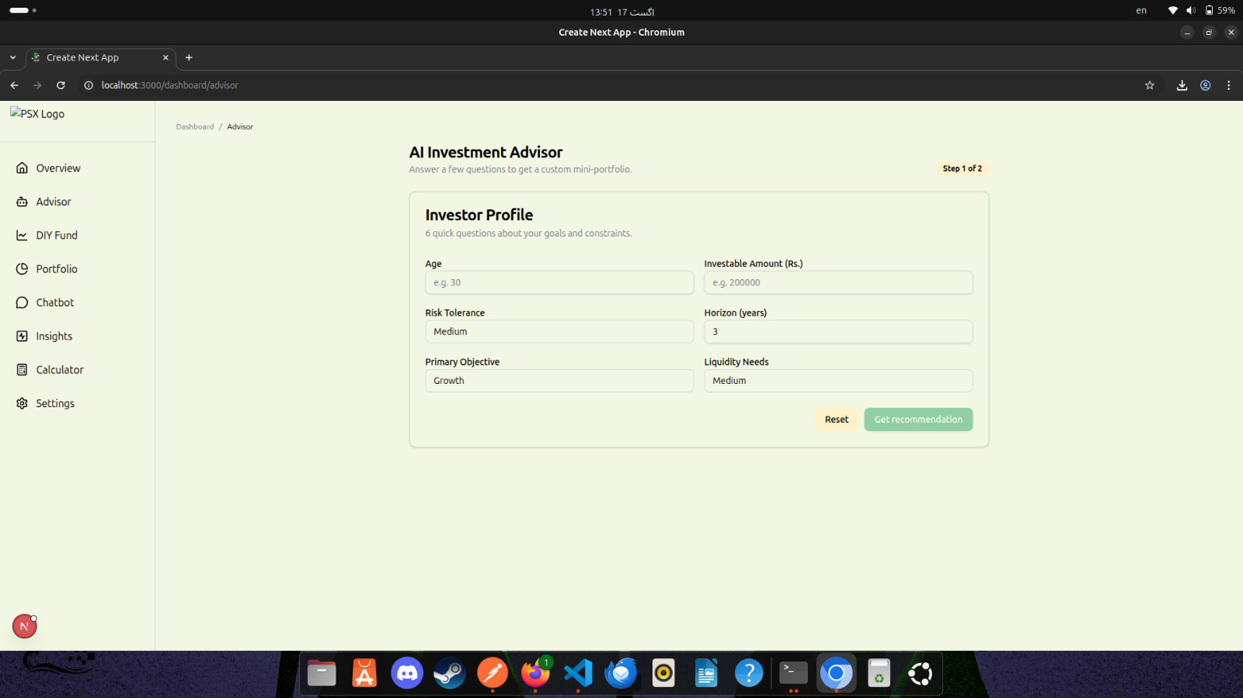  
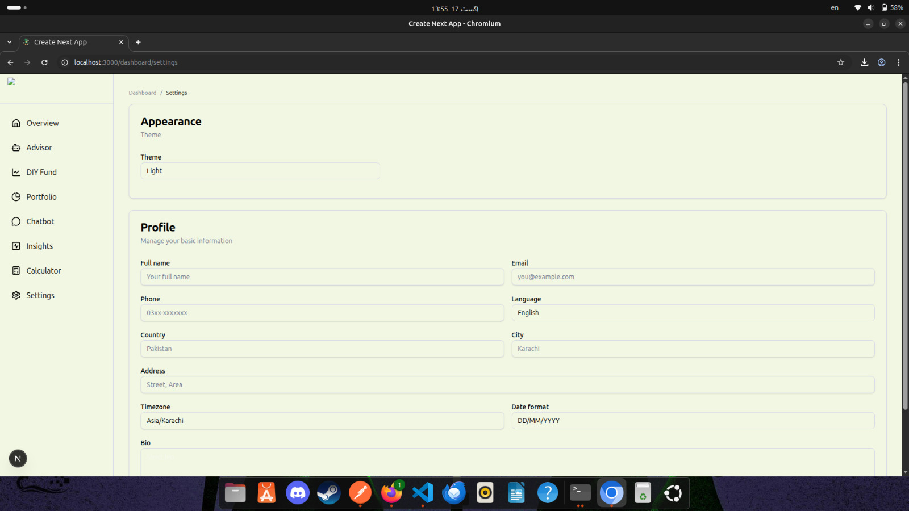

## 

## 

## **Summary of Progress**

✅ **Completed:**

* SIP Calculator
* KSE-100 Index Weightage Model
* Market Insights (gainers, losers, most active, sector summaries)
* Live Data Scraping from DPS PSX
* Collection of 10 years of financial reports (KSE-100 companies)

🟡 **In Progress:**

* RAG-powered chatbot (integrating live + historical data)

🔜 **Upcoming:**

* DIY Mutual Fund Creator
* Real-time portfolio tracker
* Personalized alerts and summaries