NEKTON
Narrowbeam Echosounder for Kinematic Tracking and Organism Numeration

Development Log
Robin Bhugun and Sam Field

What NEKTON is

Nekton – the Ancient Greek word for fish – is a small RC boat which uses an ultrasound transducer to map out the beds of ponds and lakes, and track fish in real-time to help in fishing or just biological research. We made it from scratch, including electronics, algorithms, and design.

See all our source code on GitHub.

Our Portfolios
https://samfield.co
[robin bhugun]

Project Log

25/08/2026 Researching and buying transducer
NEKTON needed to be able to:
- Measure depths of up to 75m
- Also support shallow depths of 1-2m
- Detect what type of bed was being measured
For this we needed a 200kHz transducer with a 50kHz mode, preferably for as cheap as possible. After research we found the Aimar P66 – an official brand, meaning there would be documentation – which was budget-friendly on eBay and had the features we needed. Plus shipping from Florida it cost us £100.

27/09/2026 Testing transducer and starting electronics design
A few weeks later, the transducer arrived, and we needed to make sure it actually worked in the way we expected it to. This involved testing the piezoelectric component in the transducer, and the thermistor. The thermistor was needed due to the fact that the speed of sound in water changes substantially across temperatures, so getting the surface temperature allows us to approximately model the average speed of sound in the water, taking into account the gradient of temperatures as the water gets deeper.
After some digging around we found the wiring diagram for the connector our P66 had:
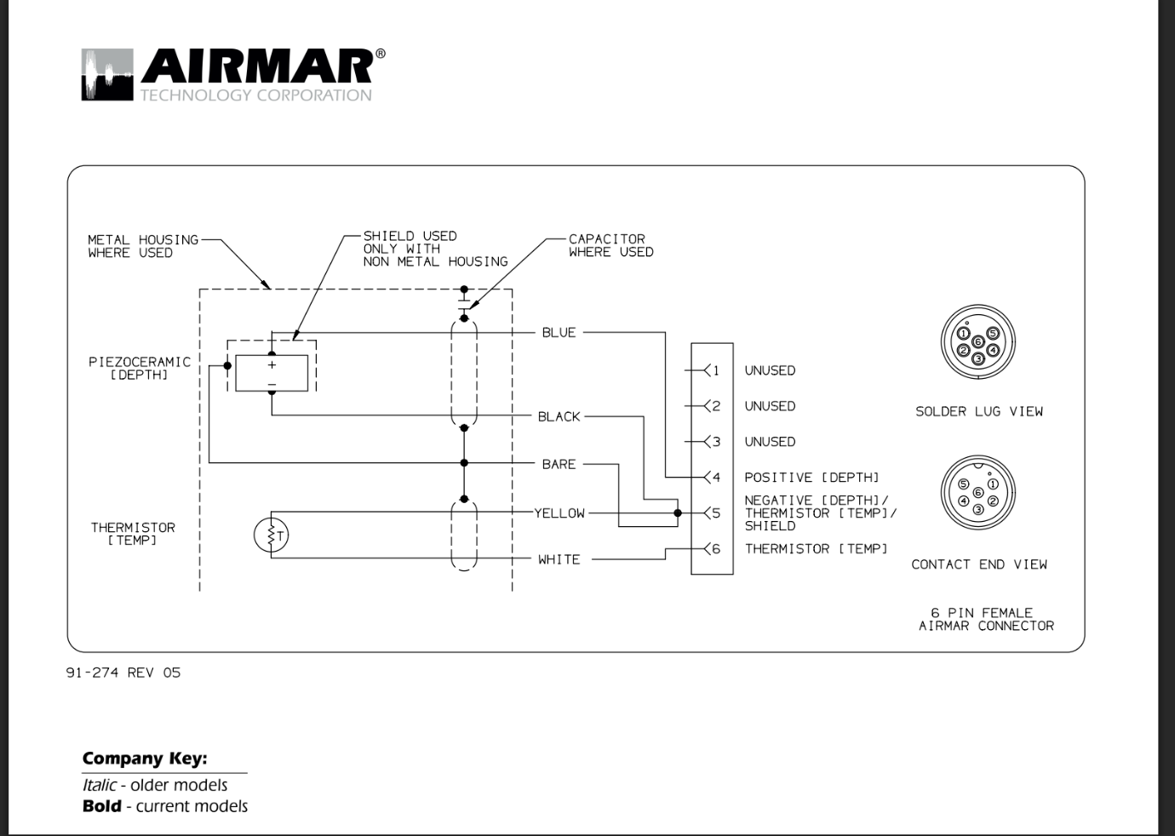
Initially we tried measuring capacitance across pins 4 and 5, as the piezoceramic effectively behaves like a capacitor. Unfortunately, being in the nF range, our multimeter could not read these values, so we tried measuring AC potential difference in mV. This fluctuated every time we tapped it, indicating the piezoceramic was working.
For the thermistor, we measured its resistance, reading about 11kΩ at room temperature. As we held the transducer with our hands to increase its temperature, the resistance began steadily falling, indicating the thermistor was working properly too.
So we’d now confirmed we had a working Airmar P66 – the most difficult of the components to sort out. We then made a plan for how the electronics of the system were going to be laid out (excluding the boat itself for the moment). This was what we eventually came up with:

- A raspberry pi 3B+ (any pi at least this modern would have worked; we just happened to have these ones lying around) sends a signal via USB to an RPi Pico to begin transmitting four 200kHz square waves out four digital pins. These waves are in complimentary pairs – as D1 and D3 read LO, D2 and D4 read HI. There is a small gap between switching from LO to HI, as for reasons explained in the next step, D1 and D2 or D3 and D4 both reading HI simultaneously would cause a short circuit.
- D1 and D2 are connected to a UCC27211 gate driver, and D3 and D4 to another gate driver. These gate drivers control two IRF540N MOSFETs each – so four in all – creating a high-voltage H-bridge switch linking to the 24V rail. In short, this layout lets the voltage be swung from +24V to -24V across the transducer, resulting in 48Vpp, on the command of the Pico.
- The supply is then fed through a 250 uH inductor to cancel out the ~2.5nF of capacitance in the transducer, so the power actually makes the transducer make a sound rather than just charging a capacitor. As inductors store energy in a magnetic field, the square voltage wave also almost completely smooths out to a sine wave, which is preferable for the P66.

