
Mini project report on

CrewGuard: Regulatory Compliance Validation and Violation Explanation for Airline Crew Rosters
Submitted in partial fulfilment of the requirements for the award of degree of

Bachelor of Technology
in
Computer Science & Engineering
UE24CS351A – DBMS Project
Submitted by:
Samyak Sanklecha  Shriram Chandrasekar | PES2UG24CS436  PES2UG24CS495
under the guidance of
Dr. Shilpa S
Assistant Professor
PES University
AUG - DEC 2026
DEPARTMENT OF COMPUTER SCIENCE AND ENGINEERING
FACULTY OF ENGINEERING
PES UNIVERSITY
(Established under Karnataka Act No. 16 of 2013)
Electronic City, Hosur Road, Bengaluru – 560 100, Karnataka, India

PES UNIVERSITY

(Established under Karnataka Act No. 16 of 2013)
Electronic City, Hosur Road, Bengaluru – 560 100, Karnataka, India

CERTIFICATE

This is to certify that the mini project entitled

CrewGuard: Regulatory Compliance Validation and Violation Explanation for Airline Crew Rosters

is a bonafide work carried out by

Samyak Sanklecha  Shriram Chandrasekar | PES2UG24CS436  PES2UG24CS495

In partial fulfilment for the completion of fifth semester DBMS Project (UE24CS351A) in the Program of Study -Bachelor of Technology in Computer Science and Engineering under rules and regulations of PES University, Bengaluru during the period AUG. 2026 – DEC. 2026. It is certified that all corrections / suggestions indicated for internal assessment have been incorporated in the report. The project has been approved as it satisfies the 5th semester academic requirements in respect of project work.
Signature
Dr. Shilpa S
Assistant Professor

DECLARATION

We hereby declare that the DBMS Project entitled CrewGuard: Regulatory Compliance Validation and Violation Explanation for Airline Crew Rosters has been carried out by us under the guidance of Dr. Shilpa S, Assistant Professor and submitted in partial fulfilment of the course requirements for the award of degree of Bachelor of Technology in Computer Science and Engineering of PES University, Bengaluru during the academic semester AUG – DEC 2026.

Samyak Sanklecha | PES2UG24CS436 | <Signature>
Shriram Chandrasekar | PES2UG24CS495 | <Signature>

ACKNOWLEDGEMENT

We would like to express our gratitude to Dr. Shilpa S, Department of Computer Science and Engineering, PES University, for her continuous guidance, assistance, and encouragement throughout the development of this UE24CS351A - DBMS Project.
We take this opportunity to thank Dr. Sandesh B J, C, Professor, ChairPerson, Department of Computer Science and Engineering, PES University, for all the knowledge and support we have received from the department.
We are deeply grateful to Prof. Jawahar Doreswamy, Chancellor – PES University, Dr. Suryaprasad J, Vice-Chancellor, PES University for providing us various opportunities and enlightenment every step of the way. Finally, this DBMS Project could not have been completed without the continual support and encouragement we have received from our families and friends.

ABSTRACT
An airline crew roster can be fully staffed and still be illegal. The Directorate General of Civil Aviation limits how long crew may work and how much rest they must get, and most of those limits depend on time windows that span many duties, so a breach cannot be seen by looking at any single flight.
CrewGuard is a database-centric web application that stores an airline roster in PostgreSQL, prevents impossible data with integrity constraints and a trigger, and detects regulatory breaches with a stored procedure. Four rules are checked: minimum rest between duties (RST), maximum length of one duty (FDP), maximum duty hours in any rolling seven days (WDH) and a valid aircraft type rating (CER). Every detected violation is linked to the exact duties that caused it through a many-to-many table, which is the explanation feature of the system.
The schema has eleven relational tables in third normal form, with primary, foreign, unique, check and exclusion constraints, four functions, three views, four triggers, a validation procedure and full-text search. MongoDB stores a per-violation evidence document and an activity log, linked to PostgreSQL by the document's ObjectId, and powers the analytics dashboard through aggregation pipelines. A Next.js application with two roles, Scheduler and Auditor, provides the user interface. On the sample two-week roster the validator finds exactly the sixteen violations that were planted, and 46 automated tests pass.

TABLE OF CONTENTS

Chapter No. | Title | Page No.
1 | INTRODUCTION | 1
2 | PROBLEM DEFINITION | 3
3 | ER MODEL | 5
4 | ER TO RELATIONAL MAPPING | 7
5 | DDL STATEMENTS | 12
6 | DML STATEMENTS | 25
7 | QUERIES | 37
8 | STORED PROCEDURES, FUNCTIONS AND TRIGGERS | 46
9 | FRONT END DEVELOPMENT | 55
10 | CONCLUSION AND FUTURE ENHANCEMENTS | 81
 | REFERENCES | 82
 | APPENDIX A DEFINITIONS, ACRONYMS AND ABBREVIATIONS | 83

LIST OF TABLES

Table No. | Title | Page No.
1.1 | Technology stack | 2
2.1 | Rules handled by CrewGuard | 3
2.2 | Roles and their permissions | 3
3.1 | Entities in the ER model | 6
3.2 | Relationships and cardinalities | 6
4.1 | Data dictionary (all tables and columns) | 11
8.1 | Triggers | 51
9.1 | Choice of database for each kind of data | 57
10.1 | Individual contributions | 81
A.1 | Definitions, acronyms and abbreviations | 83

LIST OF FIGURES

Figure No. | Title | Page No.
3.1 | ER diagram of CrewGuard | 5
4.1 | Relational schema with every foreign key | 8
5.1 | All eleven tables created (\dt) | 12
5.2 | Structure of airport (\d airport) | 13
5.3 | Structure of aircraft_type (\d aircraft_type) | 14
5.4 | Structure of app_user (\d app_user) | 15
5.5 | Structure of crew_member (\d crew_member) | 16
5.6 | Structure of certification (\d certification) | 17
5.7 | Structure of flight (\d flight) | 18
5.8 | Structure of duty_assignment (\d duty_assignment) | 19
5.9 | Structure of rule_definition (\d rule_definition) | 20
5.10 | Structure of validation_run (\d validation_run) | 21
5.11 | Structure of violation (\d violation) | 22
5.12 | Structure of violation_assignment (\d violation_assignment) | 23
5.13 | All indexes (\di) | 24
6.1 | Rows in airport | 26
6.2 | Rows in aircraft_type | 27
6.3 | Rows in app_user (password hashes shortened) | 28
6.4 | Rows in crew_member | 29
6.5 | Rows in certification | 30
6.6 | Rows in flight | 31
6.7 | Rows in duty_assignment (first 24 of 62) | 32
6.8 | Rows in rule_definition | 33
6.9 | Rows in validation_run after one run | 34
6.10 | Rows in violation: the 16 planted breaches | 34
6.11 | Rows in violation_assignment: the duties behind each violation | 35
6.12 | A valid INSERT inside a transaction (rolled back afterwards) | 36
6.13 | Invalid INSERTs rejected by UNIQUE and CHECK constraints | 36
7.1 | GROUP BY with aggregates, HAVING and FILTER | 38
7.2 | UPDATE statements, including one rejected by a CHECK constraint | 39
7.3 | DELETE with ON DELETE CASCADE, and a DELETE blocked by RESTRICT | 40
7.4 | Correlated sub-queries | 41
7.5 | Nested queries with NOT IN and NOT EXISTS | 42
7.6 | Querying the v_crew_summary and v_violation_report views | 43
7.7 | LAG and running SUM over one crew member's duties | 44
7.8 | Full-text search and EXPLAIN ANALYZE using the composite index | 45
8.1 | The four functions and their results | 47
8.2 | CALL sp_run_validation for the first week | 50
8.3 | The explanation: the duties behind a violation add up to the observed value | 50
8.4 | The triggers installed in the database | 52
8.5 | trg_validate_duty rejecting an inactive crew member, a wrong role and a duty that does not cover its flight | 52
8.6 | Compliance triggers maintaining the count and the review time, and the resolution-note CHECK | 54
9.1 | System architecture | 55
9.2 | MongoDB collections, document counts and indexes | 57
9.3 | A WDH evidence document (violation 11, Farhan Ali) | 58
9.4 | Evidence documents for an RST and a CER violation: different shapes per rule | 59
9.5 | Aggregation pipelines behind the dashboard | 59
9.6 | The activity log in audit_log | 60
9.7 | Sign-in page with the two demo accounts | 61
9.8 | Overview (scheduler): roster statistics, duties per day, busiest crew and ratings needing attention | 62
9.9 | Crew list with search and filters, read from v_crew_summary | 63
9.10 | Crew detail: weekly duty hours against the 60-hour limit, type ratings and roster | 64
9.11 | Flight detail with the assign-crew form and warnings computed with EXISTS and range overlap | 65
9.12 | Duty roster read from v_duty_roster | 66
9.13 | Database rejecting a flight with the same departure and arrival airport (CHECK) | 67
9.14 | Database rejecting a duplicate employee code (UNIQUE) | 67
9.15 | Assigning two crew in one transaction: the overlap is rejected by EXCLUDE and neither duty is saved | 68
9.16 | Validation runs (auditor) with the run form | 69
9.17 | Result of one run: violations per rule | 70
9.18 | Violations list from v_violation_report with filters | 71
9.19 | Explanation page for an RST violation: rule, observed value, causing duties, MongoDB evidence and review | 72
9.20 | Explanation page for an FDP violation (resolved with a note) | 73
9.21 | Explanation page for a WDH violation: six duties adding up to 66 hours | 74
9.22 | Explanation page for a CER violation: no rating for the aircraft type | 75
9.23 | Explanation page for a CER violation: rating expired | 76
9.24 | Rule catalogue with full-text search | 77
9.25 | Dashboard: PostgreSQL GROUP BY next to MongoDB aggregation pipelines | 78
9.26 | Activity log read from the MongoDB audit_log collection | 79
9.27 | Output of npm test: 46 tests, 46 passed | 80

1. INTRODUCTION
Airlines plan who works which flight in advance. This plan is the crew roster: every row says that one crew member works one flight, from a report time before departure to a release time after arrival. To keep fatigue in check, India's Directorate General of Civil Aviation (DGCA) limits duty and rest through its Civil Aviation Requirements (CAR), for example a minimum rest between duties, a maximum length for one duty and a maximum number of duty hours in any seven consecutive days. Pilots must also hold a valid type rating for the aircraft they fly.
These limits are hard to check by hand because most of them are about time windows across many duties. A captain who flies six 11-hour duties in six days has nothing wrong on any single flight, yet the week adds up to 66 hours, above the 60-hour limit. A roster can be fully staffed and still be illegal.
CrewGuard is a database-centric application that stores a roster, refuses impossible data, detects regulatory breaches and explains each breach by pointing at the duties that caused it. It is a detector and an explainer, not a roster generator: a scheduler builds the roster, and an auditor runs the validator over a date range and reviews what it finds.
1.1 Objectives
• Store airports, aircraft, crew, type ratings, flights and duties in PostgreSQL, with the integrity rules enforced by the database itself.
• Prevent impossible data, such as one person on two overlapping duties, with constraints and a trigger.
• Detect breaches of four DGCA-style rules with a stored procedure, reading every limit from a rule table rather than from code.
• Explain every breach by linking it to the duties that caused it through a many-to-many table.
• Give auditors a review workflow (OPEN, ACKNOWLEDGED, RESOLVED) with an accountable trail of who did what.
• Keep per-violation evidence and an activity log in MongoDB, and use aggregation pipelines for analytics.
• Provide a web interface with authentication and two roles, and an automated test suite.
1.2 Technology used
Layer | Technology | Purpose
Relational database | PostgreSQL 16 | Tables, constraints, views, functions, triggers, procedure, full-text search
NoSQL database | MongoDB 7 | Violation evidence documents, activity log, aggregation pipelines
Backend | Next.js 16 route handlers (Node.js), node-postgres (pg), MongoDB driver | API, parameterised SQL, transactions
Frontend | Next.js 16, React 19, TypeScript, Tailwind CSS 4 | Pages, forms, tables, dashboard
Security | bcrypt password hashes, signed JWT session cookie, role checks | Authentication and authorisation
Testing | Node.js test runner | 46 tests against the real databases
Table 1.1: Technology stack

2. PROBLEM DEFINITION
Given a crew roster for a period, the system must store it with full integrity, and on request find every crew member who breaks a duty-time or certification rule in a chosen date range, record each breach, and show exactly which duties caused it. The rules checked are listed below. The thresholds are stored in the rule_definition table, so a limit can change without changing any code.
Code | Rule | Limit | Severity | How it is enforced
RST | Minimum rest between two consecutive duties | at least 10 h | HIGH | Detected by the validator (LAG window function)
FDP | Maximum length of a single flight duty period | at most 13 h | CRITICAL | Detected by the validator
WDH | Maximum duty hours in any rolling 7 days | at most 60 h | MEDIUM | Detected by the validator (rolling SUM over a 7-day RANGE)
CER | Pilot holds a valid type rating for the aircraft flown (cabin crew exempt) | valid on the duty date | CRITICAL | Detected by the validator (NOT EXISTS)
– | One crew member cannot be on two overlapping duties | no overlap | – | Prevented by an EXCLUDE constraint
Table 2.1: Rules handled by CrewGuard
Two kinds of protection are used on purpose. Impossible data (overlapping duties, an inactive crew member on a flight, a duty that does not cover its flight) is prevented: the database rejects the row. Data that is possible but illegal (too little rest, too many hours, an expired rating) is accepted, because a scheduler may need to save a draft, and is then detected and reported by the validator.
2.1 Users and functional requirements
Role | Can do
Both roles | Sign in and out; view the overview, crew, flights, duty roster, airports and fleet, validation runs, violations, rules, dashboard and activity log; search and filter every list.
SCHEDULER (sched_sam) | Add, edit and delete crew members; add and remove type ratings; schedule and delete flights; assign several crew to a flight in one transaction; remove a duty.
AUDITOR (audit_shriram) | Run a validation over a date range; review a violation by moving it from OPEN to ACKNOWLEDGED to RESOLVED with a note.
Table 2.2: Roles and their permissions
Non-functional requirements: passwords are stored only as bcrypt hashes, database credentials live in an environment file that is never committed, every write is checked by the database, and every role check is repeated on the server so that hiding a button is never the only protection.
2.2 Sample data
The seed data is a two-week roster from 2 to 15 November 2026 (all times in UTC) with 8 airports, 4 aircraft types, 13 crew, 13 type ratings, 24 flights and 62 duties. Breaches were planted on purpose so the expected output is known: a run over the whole period must find 16 violations (RST 7, FDP 2, WDH 3, CER 4).

3. ER MODEL
The ER model has eleven entity types. The two central relationships are many-to-many: a crew member works many flights and a flight has many crew (resolved by DUTY_ASSIGNMENT, which also carries the duty times and role), and a violation is caused by many duties while one duty can contribute to several violations (resolved by VIOLATION_ASSIGNMENT, which carries the hours each duty contributed). This second relationship is what lets the system explain a violation.
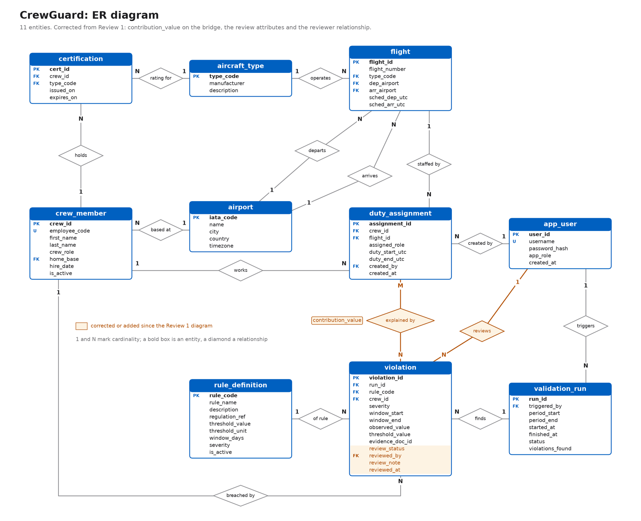
Figure 3.1: ER diagram of CrewGuard
Entity | Key | Description
AIRPORT | iata_code | An airport, identified by its three-letter IATA code
AIRCRAFT_TYPE | type_code | An aircraft model that crew can be rated on (A320, B788, ...)
APP_USER | user_id | A login account with role SCHEDULER or AUDITOR
CREW_MEMBER | crew_id | A captain, first officer or cabin crew member, with a home base
CERTIFICATION | cert_id | A type rating: crew member X may operate type Y between two dates
FLIGHT | flight_id | One scheduled flight between two airports on one aircraft type
DUTY_ASSIGNMENT | assignment_id | One crew member working one flight (the roster)
RULE_DEFINITION | rule_code | A regulation with its threshold, window and severity
VALIDATION_RUN | run_id | One execution of the validator over a date range
VIOLATION | violation_id | One breach of one rule by one crew member in one run
VIOLATION_ASSIGNMENT | (violation_id, assignment_id) | Which duties caused which violation
Table 3.1: Entities in the ER model
Relationship | Cardinality | Participation
AIRPORT is home base of CREW_MEMBER | 1 : N | every crew member has one base
AIRPORT is departure / arrival of FLIGHT | 1 : N (two relationships) | every flight has both
AIRCRAFT_TYPE operates FLIGHT | 1 : N | every flight has one type
CREW_MEMBER holds CERTIFICATION for AIRCRAFT_TYPE | 1 : N and N : 1 | a crew member may hold none
CREW_MEMBER works FLIGHT (via DUTY_ASSIGNMENT) | M : N | partial on both sides
APP_USER created DUTY_ASSIGNMENT | 1 : N | optional (SET NULL)
APP_USER triggered VALIDATION_RUN / reviewed VIOLATION | 1 : N | optional (SET NULL)
VALIDATION_RUN finds VIOLATION | 1 : N | every violation belongs to a run
RULE_DEFINITION is broken in VIOLATION | 1 : N | every violation has one rule
CREW_MEMBER commits VIOLATION | 1 : N | every violation has one crew member
VIOLATION caused by DUTY_ASSIGNMENT (via VIOLATION_ASSIGNMENT) | M : N | every violation has at least one duty
Table 3.2: Relationships and cardinalities

4. ER TO RELATIONAL MAPPING
4.1 STEPS OF ALGORITHM FOR CHOSEN PROBLEM
The standard seven-step ER-to-relational mapping algorithm was applied as follows.
• Step 1, strong entity types: every strong entity becomes a table with its simple attributes and its key as the primary key: airport (iata_code), aircraft_type (type_code), app_user (user_id), crew_member (crew_id), flight (flight_id), rule_definition (rule_code), validation_run (run_id). Surrogate keys use SERIAL; natural codes such as IATA codes and rule codes are used directly.
• Step 2, weak entity types: there are none. A type rating could be seen as weak (it has no meaning without its crew member), but renewals create new rows, so certification gets its own key cert_id and the natural key (crew_id, type_code, issued_on) is kept as a UNIQUE constraint.
• Step 3, binary 1:1 relationships: there are none in this model.
• Step 4, binary 1:N relationships: the key of the 1-side becomes a foreign key in the N-side table: crew_member.home_base → airport, flight.dep_airport and flight.arr_airport → airport, flight.type_code → aircraft_type, certification.crew_id → crew_member, certification.type_code → aircraft_type, violation.run_id → validation_run, violation.rule_code → rule_definition, violation.crew_id → crew_member, and the optional user links duty_assignment.created_by, validation_run.triggered_by and violation.reviewed_by → app_user.
• Step 5, binary M:N relationships: each becomes its own table holding both foreign keys. CREW_MEMBER–FLIGHT becomes duty_assignment, which also stores the relationship attributes assigned_role, duty_start_utc and duty_end_utc; (crew_id, flight_id) is UNIQUE and a surrogate assignment_id is the primary key because other tables reference a duty. VIOLATION–DUTY becomes violation_assignment with the composite primary key (violation_id, assignment_id) and the attribute contribution_value.
• Step 6, multivalued attributes: there are none; a crew member's several ratings are already modelled as the CERTIFICATION entity.
• Step 7, n-ary relationships: there are none; every relationship is binary.
• Referential actions: child rows that cannot exist alone use ON DELETE CASCADE (a crew member's ratings and duties), master data uses ON DELETE RESTRICT (an airport in use cannot be deleted), and optional author links use ON DELETE SET NULL.
4.2 COMPLETE DIAGRAM OF RELATIONAL MAPPING
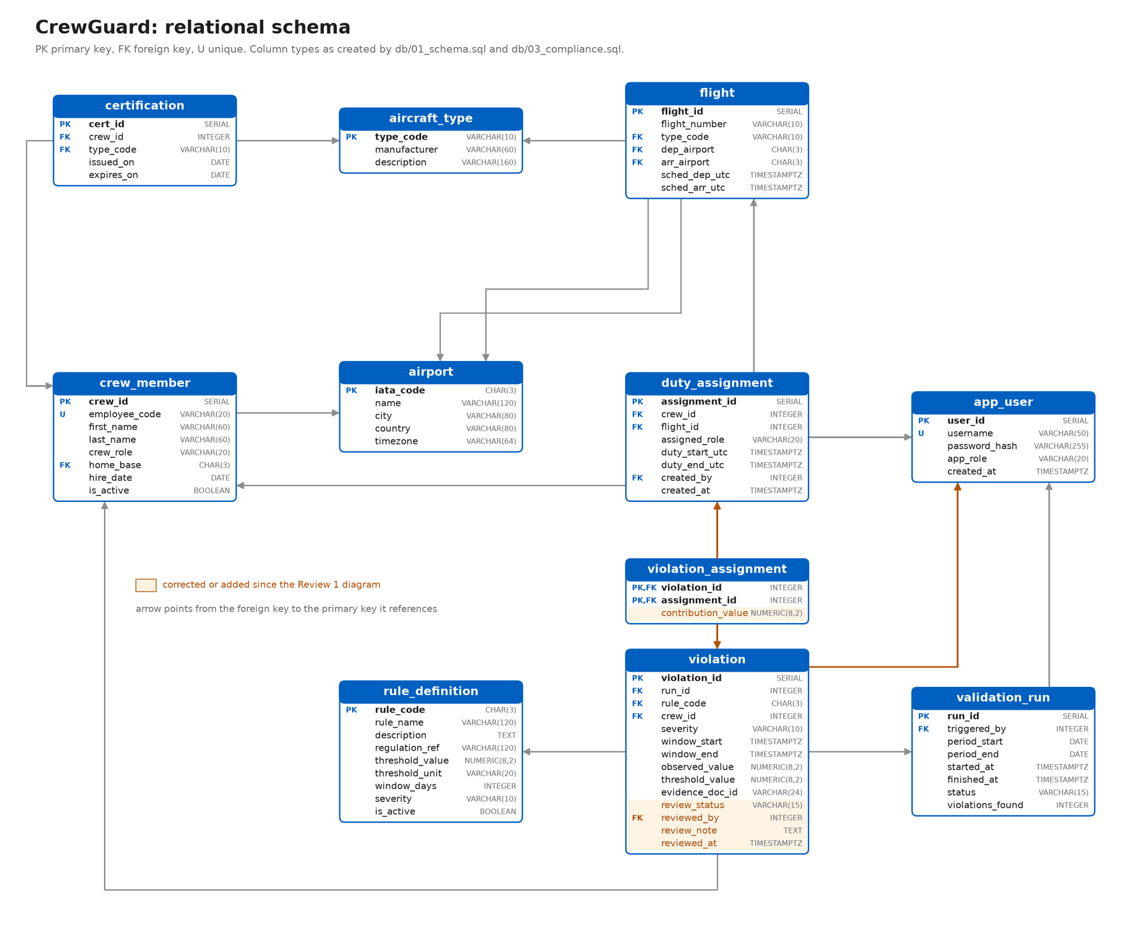
Figure 4.1: Relational schema with every foreign key
4.3 Normalisation
Each table is about one thing. Crew details are stored once in crew_member and duties hold only crew_id; airport and aircraft details live in their own tables; a renewed rating is a new certification row, so history is kept. Every non-key column depends on the key, the whole key and nothing but the key, so the schema is in third normal form and free of update, insert and delete anomalies. One copy is deliberate: violation stores severity and threshold_value from rule_definition as a snapshot, so an old violation keeps the limit it was judged against even if the rule changes later.
4.4 Data dictionary
The data dictionary below is generated from the live database catalogue (information_schema), so it matches the deployed schema exactly.
Table | Column | Type | Null | Key
airport | iata_code | char(3) | NOT NULL | PK
airport | name | varchar(120) | NOT NULL
airport | city | varchar(80) | NOT NULL
airport | country | varchar(80) | NOT NULL
airport | timezone | varchar(64) | NOT NULL
aircraft_type | type_code | varchar(10) | NOT NULL | PK
aircraft_type | manufacturer | varchar(60) | NOT NULL
aircraft_type | description | varchar(160)
app_user | user_id | integer | NOT NULL | PK
app_user | username | varchar(50) | NOT NULL | UNIQUE
app_user | password_hash | varchar(255) | NOT NULL
app_user | app_role | varchar(20) | NOT NULL
app_user | created_at | timestamptz | NOT NULL
crew_member | crew_id | integer | NOT NULL | PK
crew_member | employee_code | varchar(20) | NOT NULL | UNIQUE
crew_member | first_name | varchar(60) | NOT NULL
crew_member | last_name | varchar(60) | NOT NULL
crew_member | crew_role | varchar(20) | NOT NULL
crew_member | home_base | char(3) | NOT NULL | FK
crew_member | hire_date | date | NOT NULL
crew_member | is_active | boolean | NOT NULL
certification | cert_id | integer | NOT NULL | PK
certification | crew_id | integer | NOT NULL | FK, UNIQUE
certification | type_code | varchar(10) | NOT NULL | FK, UNIQUE
certification | issued_on | date | NOT NULL | UNIQUE
certification | expires_on | date | NOT NULL
flight | flight_id | integer | NOT NULL | PK
flight | flight_number | varchar(10) | NOT NULL | UNIQUE
flight | type_code | varchar(10) | NOT NULL | FK
flight | dep_airport | char(3) | NOT NULL | FK
flight | arr_airport | char(3) | NOT NULL | FK
flight | sched_dep_utc | timestamptz | NOT NULL | UNIQUE
flight | sched_arr_utc | timestamptz | NOT NULL
duty_assignment | assignment_id | integer | NOT NULL | PK
duty_assignment | crew_id | integer | NOT NULL | FK, UNIQUE
duty_assignment | flight_id | integer | NOT NULL | FK, UNIQUE
duty_assignment | assigned_role | varchar(20) | NOT NULL
duty_assignment | duty_start_utc | timestamptz | NOT NULL
duty_assignment | duty_end_utc | timestamptz | NOT NULL
duty_assignment | created_by | integer |  | FK
duty_assignment | created_at | timestamptz | NOT NULL
rule_definition | rule_code | char(3) | NOT NULL | PK
rule_definition | rule_name | varchar(120) | NOT NULL
rule_definition | description | text | NOT NULL
rule_definition | regulation_ref | varchar(120)
rule_definition | threshold_value | numeric(8,2)
rule_definition | threshold_unit | varchar(20)
rule_definition | window_days | integer
rule_definition | severity | varchar(10) | NOT NULL
rule_definition | is_active | boolean | NOT NULL
validation_run | run_id | integer | NOT NULL | PK
validation_run | triggered_by | integer |  | FK
validation_run | period_start | date | NOT NULL
validation_run | period_end | date | NOT NULL
validation_run | started_at | timestamptz | NOT NULL
validation_run | finished_at | timestamptz
validation_run | status | varchar(15) | NOT NULL
validation_run | violations_found | integer | NOT NULL
violation | violation_id | integer | NOT NULL | PK
violation | run_id | integer | NOT NULL | FK
violation | rule_code | char(3) | NOT NULL | FK
violation | crew_id | integer | NOT NULL | FK
violation | severity | varchar(10) | NOT NULL
violation | window_start | timestamptz
violation | window_end | timestamptz
violation | observed_value | numeric(8,2)
violation | threshold_value | numeric(8,2)
violation | evidence_doc_id | varchar(24)
violation | review_status | varchar(15) | NOT NULL
violation | reviewed_by | integer |  | FK
violation | review_note | text
violation | reviewed_at | timestamptz
violation_assignment | violation_id | integer | NOT NULL | FK, PK
violation_assignment | assignment_id | integer | NOT NULL | FK, PK
violation_assignment | contribution_value | numeric(8,2)
Table 4.1: Data dictionary (all tables and columns)

5. DDL STATEMENTS
The schema is created by db/01_schema.sql, and the compliance additions by db/03_compliance.sql. The script starts with DROP TABLE ... CASCADE so it can be re-run from zero, and creates parent tables before the tables whose foreign keys point at them. Each statement is followed by a screenshot of the created table (\d in psql), which lists its columns, indexes, constraints, references and triggers.
DROP TABLE IF EXISTS violation_assignment, violation, validation_run,
rule_definition, duty_assignment, flight, certification,
crew_member, app_user, aircraft_type, airport CASCADE;
-- btree_gist lets a GiST index compare plain values (crew_id WITH =)
-- alongside ranges; the no-overlap EXCLUDE constraint needs it.
CREATE EXTENSION IF NOT EXISTS btree_gist;
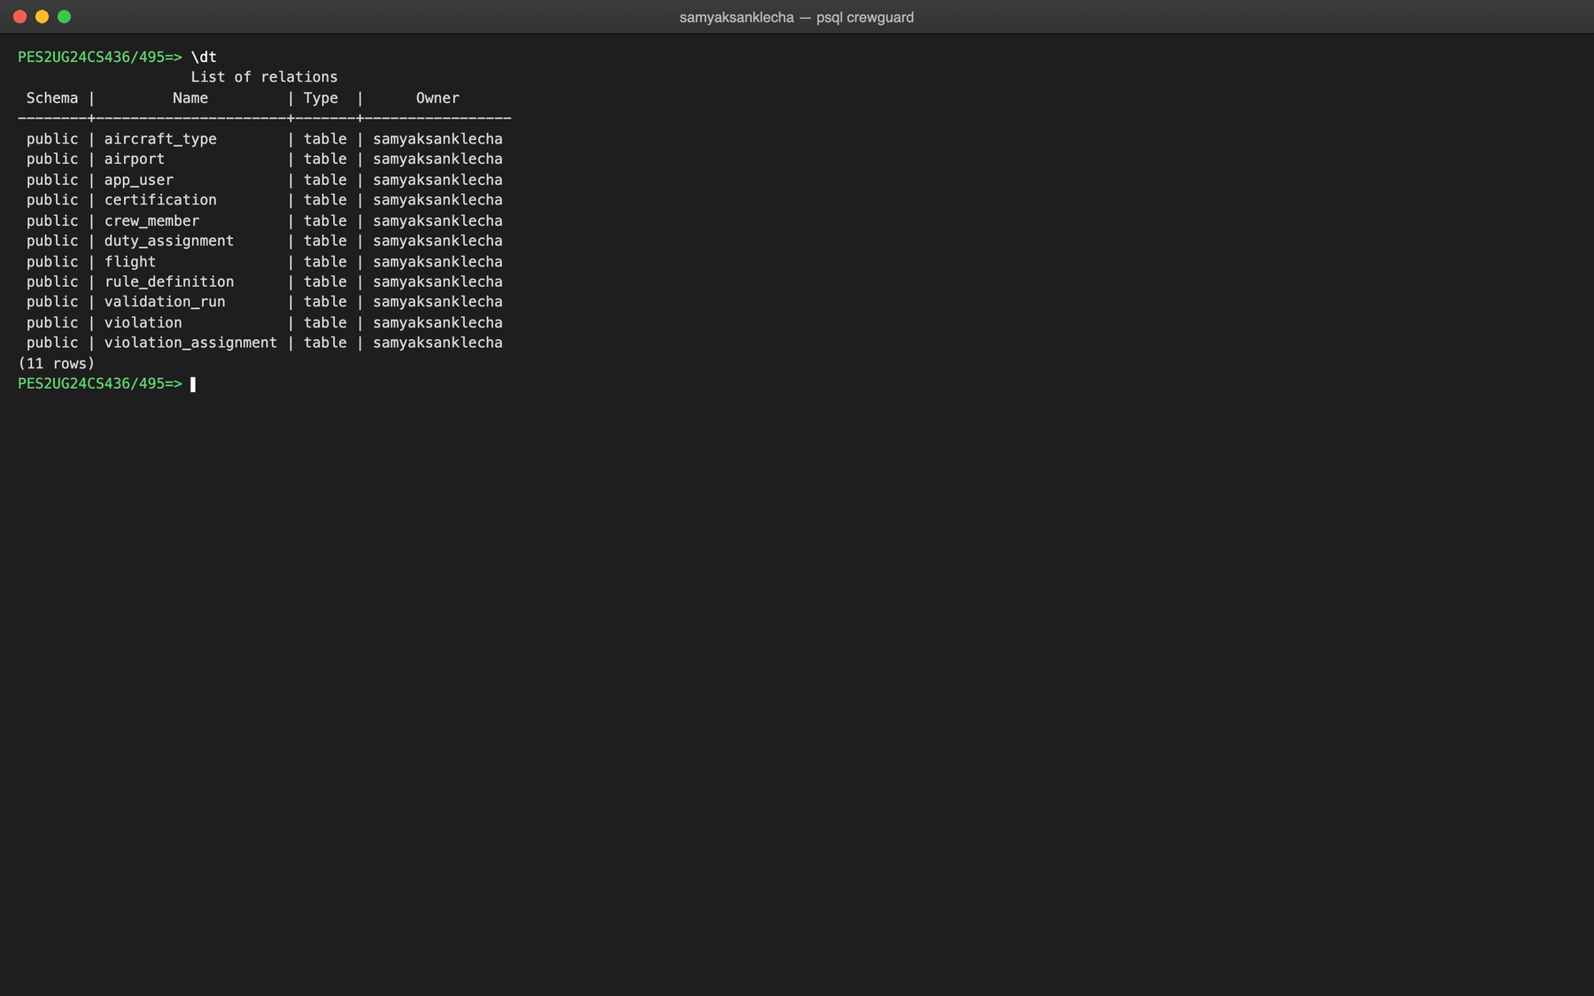
Figure 5.1: All eleven tables created (\dt)
Table airport
CREATE TABLE airport (
iata_code CHAR(3) PRIMARY KEY,
name VARCHAR(120) NOT NULL,
city VARCHAR(80) NOT NULL,
country VARCHAR(80) NOT NULL,
timezone VARCHAR(64) NOT NULL,
-- regex check: exactly three capital letters, e.g. BLR
CONSTRAINT chk_airport_iata_format CHECK (iata_code ~ '^[A-Z]{3}$')
);
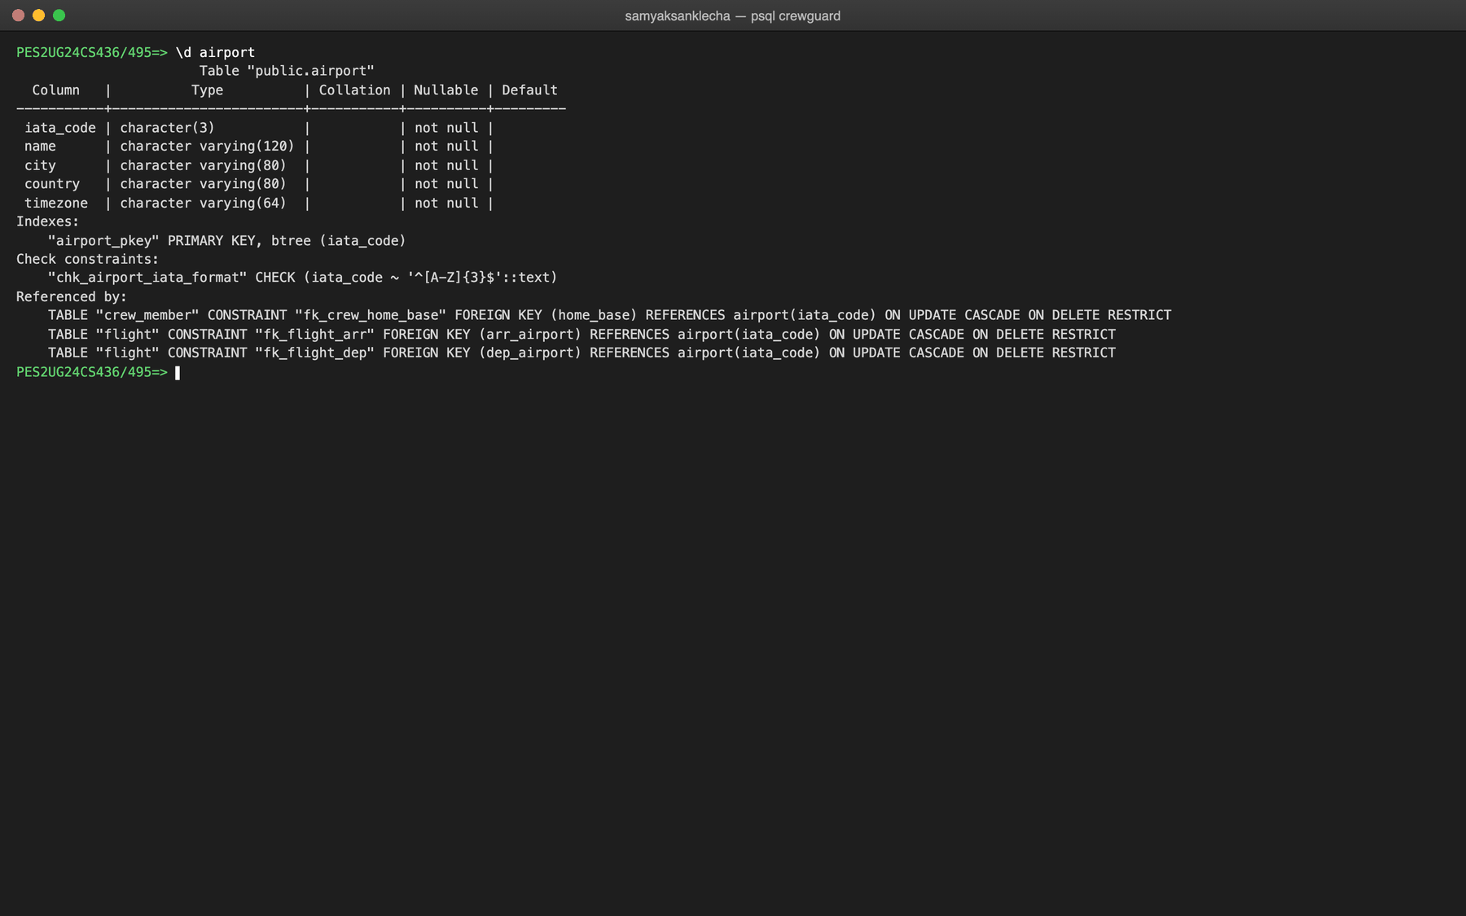
Figure 5.2: Structure of airport (\d airport)
Table aircraft_type
CREATE TABLE aircraft_type (
type_code VARCHAR(10) PRIMARY KEY,
manufacturer VARCHAR(60) NOT NULL,
description VARCHAR(160),
CONSTRAINT chk_aircraft_type_upper CHECK (type_code = UPPER(type_code))
);
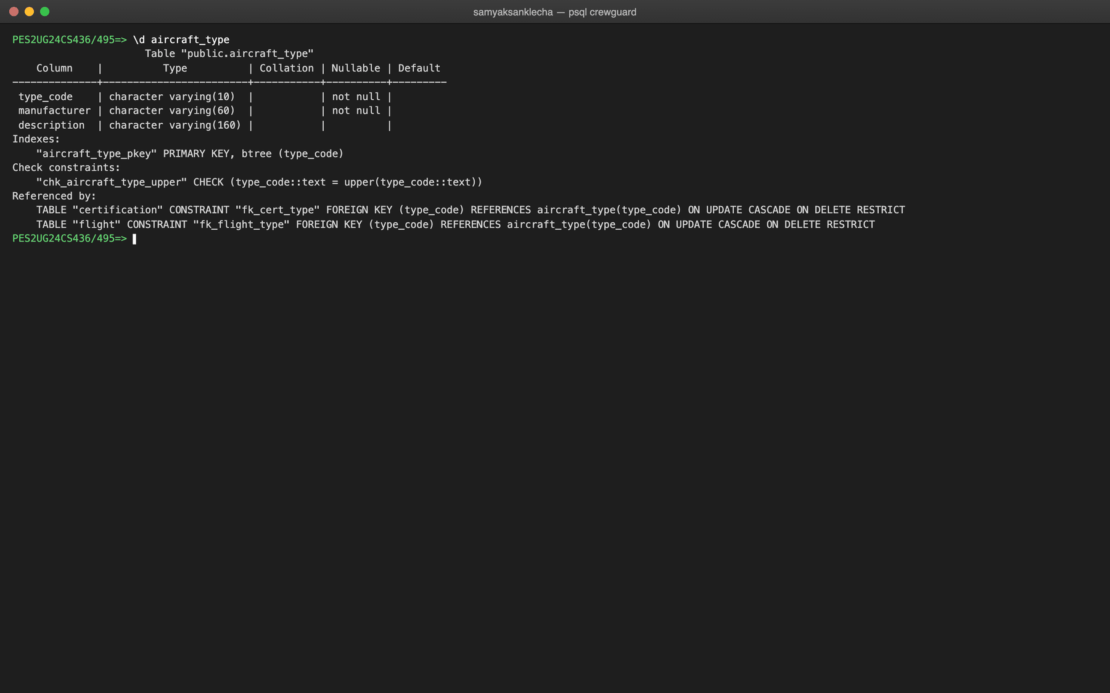
Figure 5.3: Structure of aircraft_type (\d aircraft_type)
Table app_user
CREATE TABLE app_user (
user_id SERIAL PRIMARY KEY,
username VARCHAR(50) NOT NULL UNIQUE,
password_hash VARCHAR(255) NOT NULL,
app_role VARCHAR(20) NOT NULL,
created_at TIMESTAMPTZ NOT NULL DEFAULT NOW(),
CONSTRAINT chk_app_role CHECK (app_role IN ('SCHEDULER', 'AUDITOR'))
);
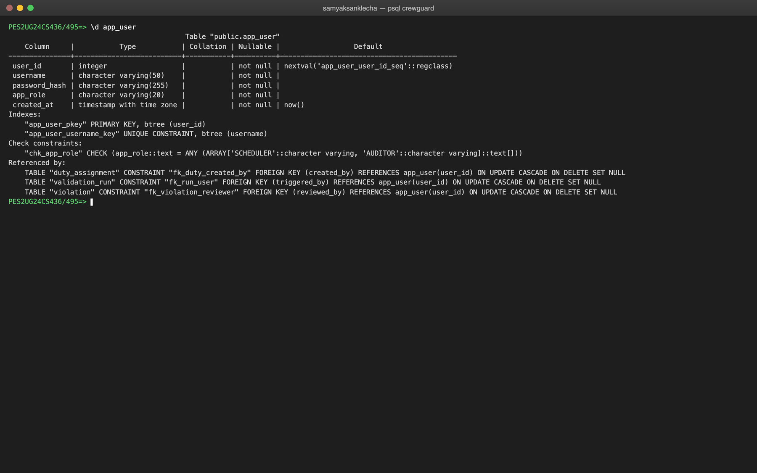
Figure 5.4: Structure of app_user (\d app_user)
Table crew_member
CREATE TABLE crew_member (
crew_id SERIAL PRIMARY KEY,
employee_code VARCHAR(20) NOT NULL UNIQUE,
first_name VARCHAR(60) NOT NULL,
last_name VARCHAR(60) NOT NULL,
crew_role VARCHAR(20) NOT NULL,
home_base CHAR(3) NOT NULL,
hire_date DATE NOT NULL,
is_active BOOLEAN NOT NULL DEFAULT TRUE,
-- an airport that is someone's home base cannot be deleted (RESTRICT)
CONSTRAINT fk_crew_home_base FOREIGN KEY (home_base) REFERENCES airport(iata_code)
ON UPDATE CASCADE ON DELETE RESTRICT,
CONSTRAINT chk_crew_role CHECK (crew_role IN ('CAPTAIN', 'FIRST_OFFICER', 'CABIN_CREW')),
CONSTRAINT chk_crew_hire_date CHECK (hire_date <= CURRENT_DATE)
);
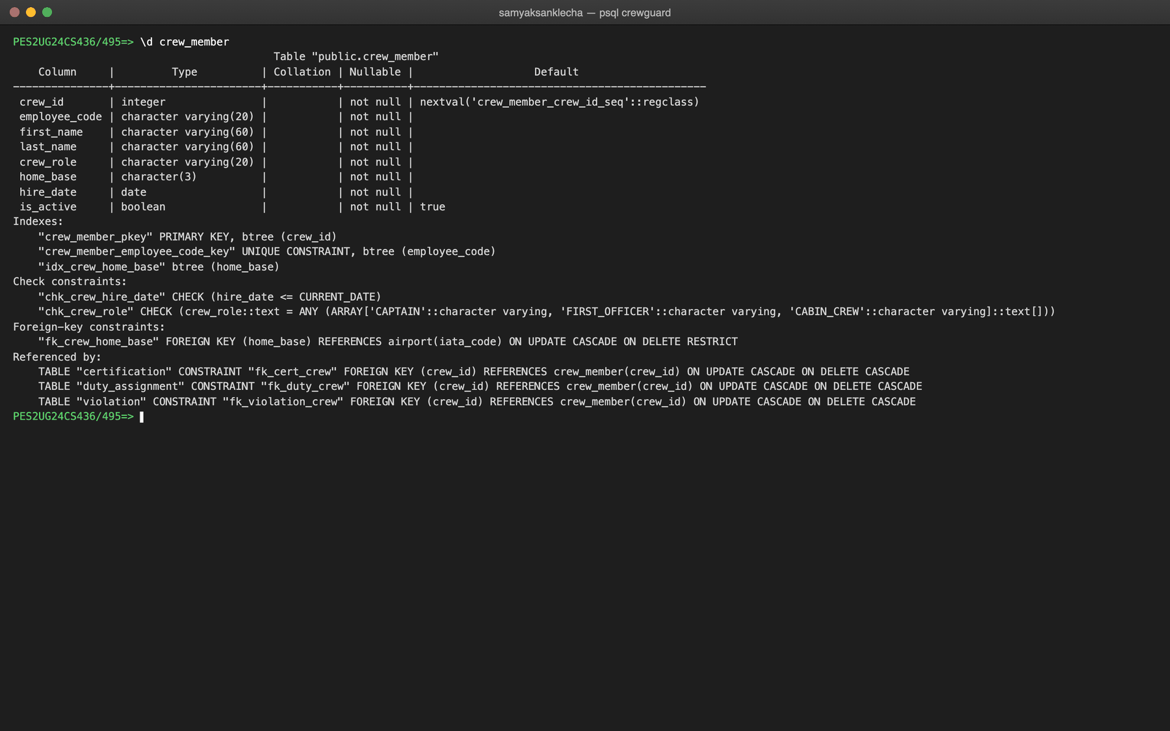
Figure 5.5: Structure of crew_member (\d crew_member)
Table certification
CREATE TABLE certification (
cert_id SERIAL PRIMARY KEY,
crew_id INTEGER NOT NULL,
type_code VARCHAR(10) NOT NULL,
issued_on DATE NOT NULL,
expires_on DATE NOT NULL,
-- deleting a crew member deletes their certificates (CASCADE)
CONSTRAINT fk_cert_crew FOREIGN KEY (crew_id) REFERENCES crew_member(crew_id)
ON UPDATE CASCADE ON DELETE CASCADE,
CONSTRAINT fk_cert_type FOREIGN KEY (type_code) REFERENCES aircraft_type(type_code)
ON UPDATE CASCADE ON DELETE RESTRICT,
-- renewals are new rows, so (crew, type, issue date) is the natural key
CONSTRAINT uk_cert_crew_type_issue UNIQUE (crew_id, type_code, issued_on),
CONSTRAINT chk_cert_validity_order CHECK (expires_on > issued_on)
);
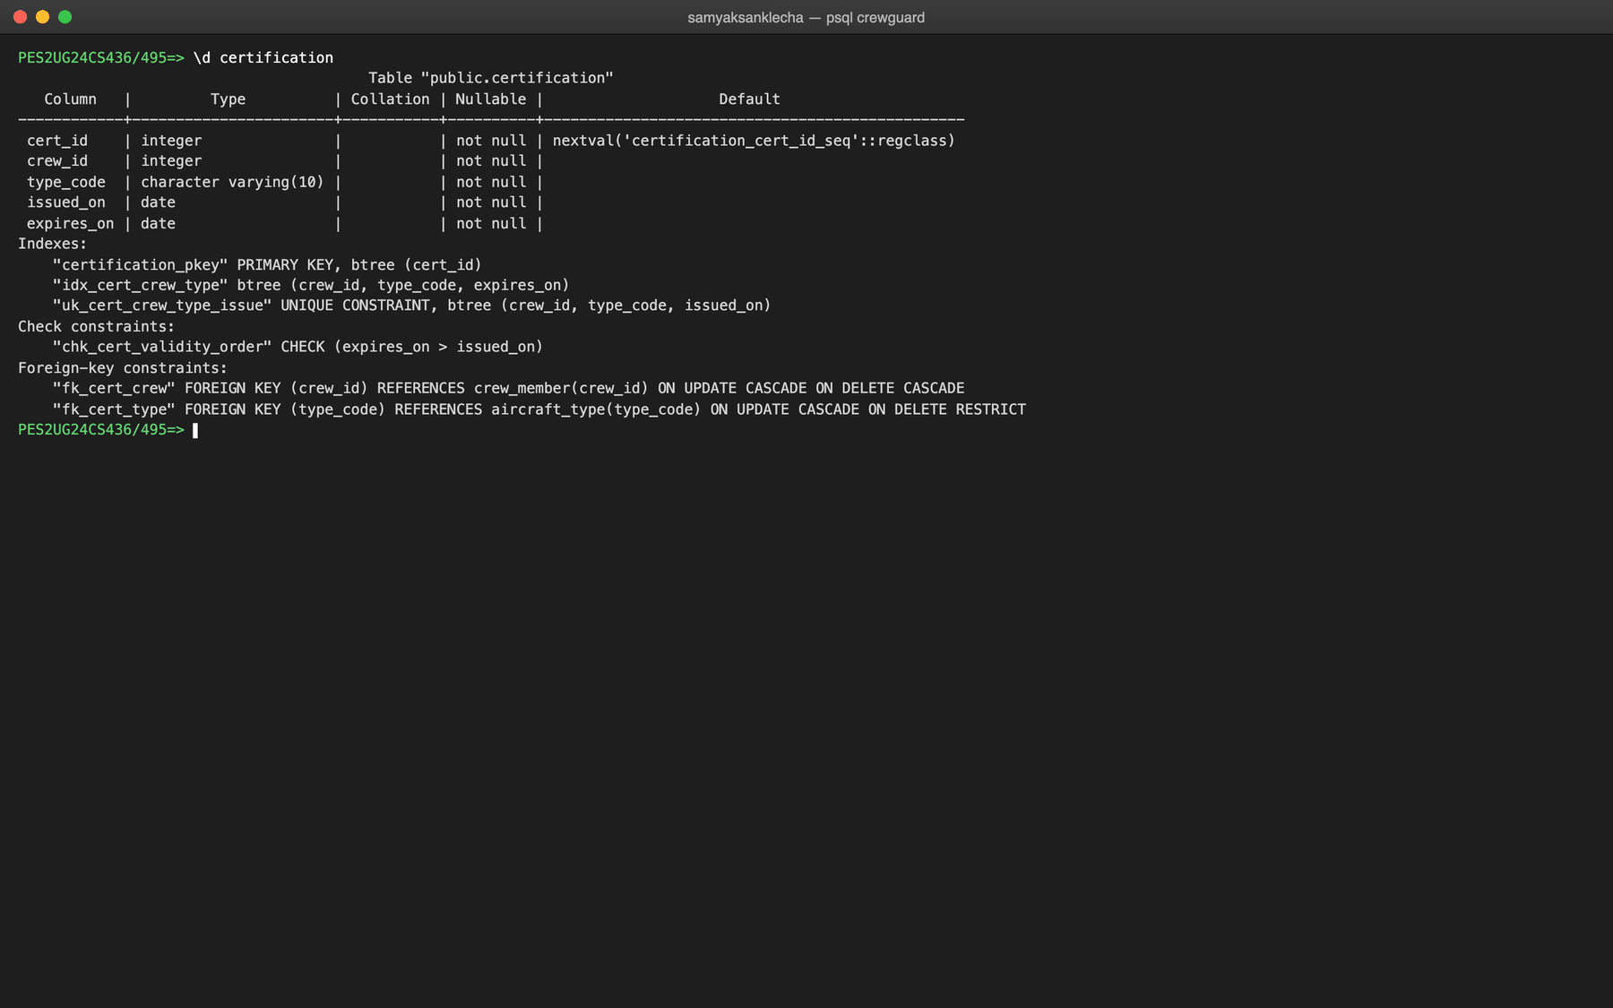
Figure 5.6: Structure of certification (\d certification)
Table flight
CREATE TABLE flight (
flight_id SERIAL PRIMARY KEY,
flight_number VARCHAR(10) NOT NULL,
type_code VARCHAR(10) NOT NULL,
dep_airport CHAR(3) NOT NULL,
arr_airport CHAR(3) NOT NULL,
sched_dep_utc TIMESTAMPTZ NOT NULL,
sched_arr_utc TIMESTAMPTZ NOT NULL,
CONSTRAINT fk_flight_type FOREIGN KEY (type_code) REFERENCES aircraft_type(type_code)
ON UPDATE CASCADE ON DELETE RESTRICT,
CONSTRAINT fk_flight_dep FOREIGN KEY (dep_airport) REFERENCES airport(iata_code)
ON UPDATE CASCADE ON DELETE RESTRICT,
CONSTRAINT fk_flight_arr FOREIGN KEY (arr_airport) REFERENCES airport(iata_code)
ON UPDATE CASCADE ON DELETE RESTRICT,
-- the same flight number flies every day, so it is unique per departure
CONSTRAINT uk_flight_number_dep UNIQUE (flight_number, sched_dep_utc),
CONSTRAINT chk_flight_time_order CHECK (sched_arr_utc > sched_dep_utc),
CONSTRAINT chk_flight_distinct_endpoints CHECK (dep_airport <> arr_airport)
);
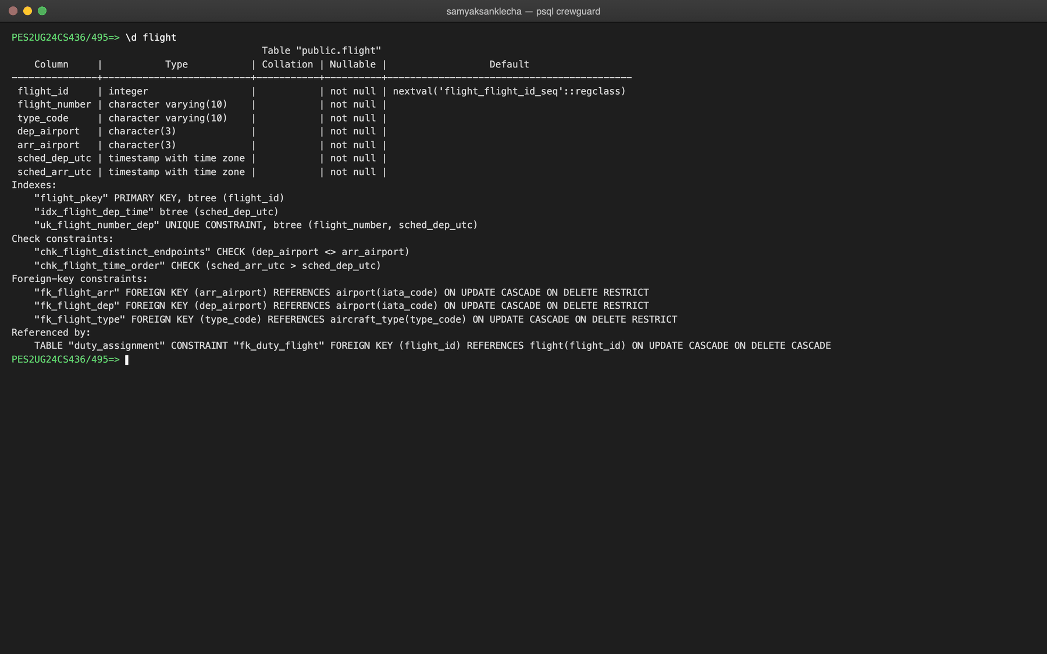
Figure 5.7: Structure of flight (\d flight)
Table duty_assignment
CREATE TABLE duty_assignment (
assignment_id SERIAL PRIMARY KEY,
crew_id INTEGER NOT NULL,
flight_id INTEGER NOT NULL,
assigned_role VARCHAR(20) NOT NULL,
duty_start_utc TIMESTAMPTZ NOT NULL,
duty_end_utc TIMESTAMPTZ NOT NULL,
created_by INTEGER,
created_at TIMESTAMPTZ NOT NULL DEFAULT NOW(),
CONSTRAINT fk_duty_crew FOREIGN KEY (crew_id) REFERENCES crew_member(crew_id)
ON UPDATE CASCADE ON DELETE CASCADE,
CONSTRAINT fk_duty_flight FOREIGN KEY (flight_id) REFERENCES flight(flight_id)
ON UPDATE CASCADE ON DELETE CASCADE,
-- if the scheduler's account is removed, keep the duty but forget the author
CONSTRAINT fk_duty_created_by FOREIGN KEY (created_by) REFERENCES app_user(user_id)
ON UPDATE CASCADE ON DELETE SET NULL,
CONSTRAINT uk_duty_crew_flight UNIQUE (crew_id, flight_id),
CONSTRAINT chk_duty_time_order CHECK (duty_end_utc > duty_start_utc),
CONSTRAINT chk_duty_assigned_role CHECK (assigned_role IN ('CAPTAIN', 'FIRST_OFFICER', 'CABIN_CREW'))
);
ALTER TABLE adds the exclusion constraint. A UNIQUE constraint can only reject equal values; EXCLUDE USING GIST rejects any two rows with the same crew_id whose time ranges overlap (&&), which is what "no overlapping duties" means. The btree_gist extension lets one GiST index compare the integer and the range together.
ALTER TABLE duty_assignment
ADD CONSTRAINT excl_duty_no_overlap
EXCLUDE USING GIST (
crew_id WITH =,
tstzrange(duty_start_utc, duty_end_utc) WITH &&
);
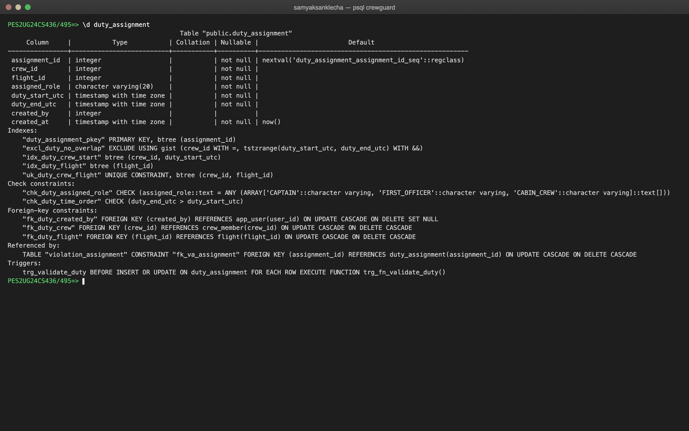
Figure 5.8: Structure of duty_assignment (\d duty_assignment)
Table rule_definition
CREATE TABLE rule_definition (
rule_code CHAR(3) PRIMARY KEY,
rule_name VARCHAR(120) NOT NULL,
description TEXT NOT NULL,
regulation_ref VARCHAR(120),
threshold_value NUMERIC(8,2),
threshold_unit VARCHAR(20),
window_days INTEGER,
severity VARCHAR(10) NOT NULL,
is_active BOOLEAN NOT NULL DEFAULT TRUE,
CONSTRAINT chk_rule_severity CHECK (severity IN ('LOW', 'MEDIUM', 'HIGH', 'CRITICAL')),
CONSTRAINT chk_rule_window_days CHECK (window_days IS NULL OR window_days > 0)
);
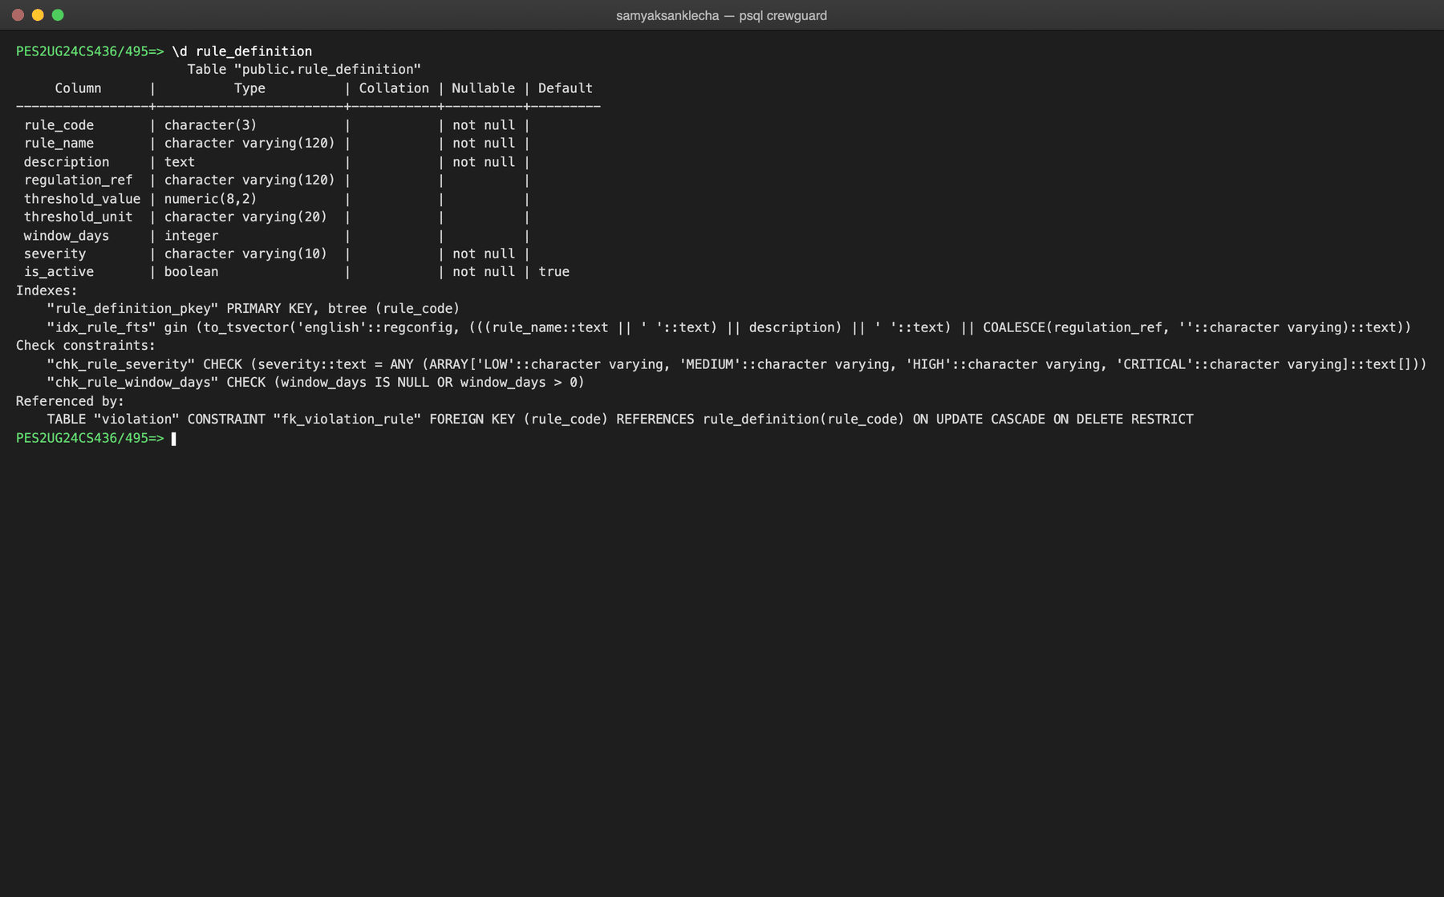
Figure 5.9: Structure of rule_definition (\d rule_definition)
Table validation_run
CREATE TABLE validation_run (
run_id SERIAL PRIMARY KEY,
triggered_by INTEGER,
period_start DATE NOT NULL,
period_end DATE NOT NULL,
started_at TIMESTAMPTZ NOT NULL DEFAULT NOW(),
finished_at TIMESTAMPTZ,
status VARCHAR(15) NOT NULL DEFAULT 'RUNNING',
violations_found INTEGER NOT NULL DEFAULT 0,
CONSTRAINT fk_run_user FOREIGN KEY (triggered_by) REFERENCES app_user(user_id)
ON UPDATE CASCADE ON DELETE SET NULL,
CONSTRAINT chk_run_status CHECK (status IN ('RUNNING', 'COMPLETED', 'FAILED', 'STALE')),
CONSTRAINT chk_run_period_order CHECK (period_end >= period_start),
CONSTRAINT chk_run_violation_count CHECK (violations_found >= 0)
);
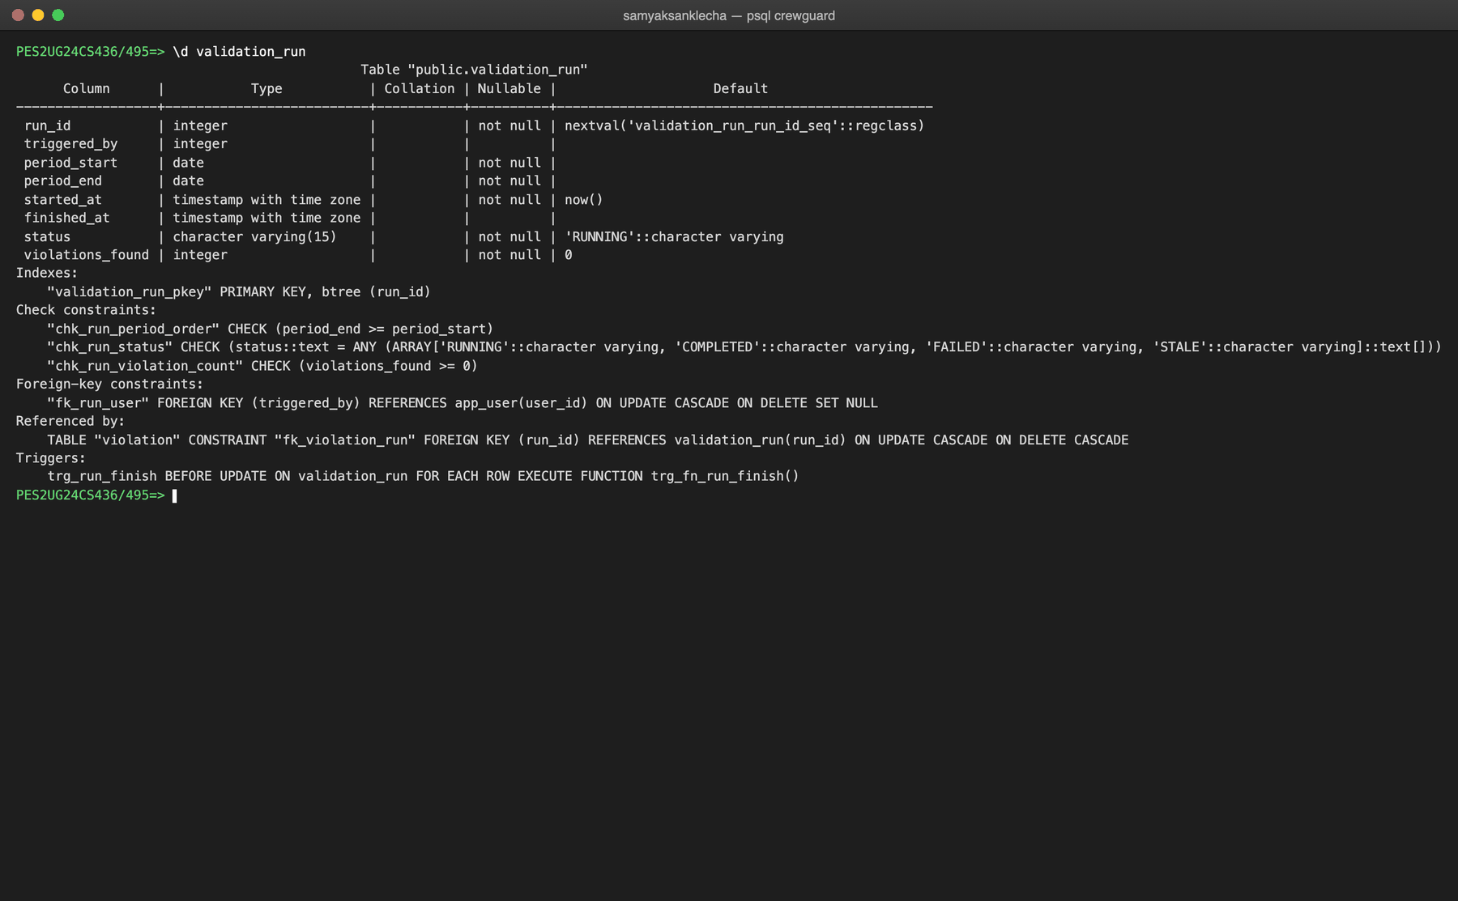
Figure 5.10: Structure of validation_run (\d validation_run)
Table violation
CREATE TABLE violation (
violation_id SERIAL PRIMARY KEY,
run_id INTEGER NOT NULL,
rule_code CHAR(3) NOT NULL,
crew_id INTEGER NOT NULL,
severity VARCHAR(10) NOT NULL,
window_start TIMESTAMPTZ,
window_end TIMESTAMPTZ,
observed_value NUMERIC(8,2),
threshold_value NUMERIC(8,2),
evidence_doc_id VARCHAR(24), -- MongoDB ObjectId of the evidence document
CONSTRAINT fk_violation_run FOREIGN KEY (run_id) REFERENCES validation_run(run_id)
ON UPDATE CASCADE ON DELETE CASCADE,
CONSTRAINT fk_violation_rule FOREIGN KEY (rule_code) REFERENCES rule_definition(rule_code)
ON UPDATE CASCADE ON DELETE RESTRICT,
CONSTRAINT fk_violation_crew FOREIGN KEY (crew_id) REFERENCES crew_member(crew_id)
ON UPDATE CASCADE ON DELETE CASCADE,
CONSTRAINT chk_violation_severity CHECK (severity IN ('LOW', 'MEDIUM', 'HIGH', 'CRITICAL')),
CONSTRAINT chk_violation_window_order
CHECK (window_end IS NULL OR window_start IS NULL OR window_end >= window_start)
);
The review workflow was added after Review 1 with ALTER TABLE in db/03_compliance.sql: four columns, a foreign key to the reviewer, and two CHECK constraints (a valid status, and a note required to resolve).
ALTER TABLE violation
ADD COLUMN review_status VARCHAR(15) NOT NULL DEFAULT 'OPEN',
ADD COLUMN reviewed_by INTEGER,
ADD COLUMN review_note TEXT,
ADD COLUMN reviewed_at TIMESTAMPTZ,
ADD CONSTRAINT chk_violation_review_status
CHECK (review_status IN ('OPEN', 'ACKNOWLEDGED', 'RESOLVED')),
-- if the auditor's account is removed, keep the review but forget who did it
ADD CONSTRAINT fk_violation_reviewer FOREIGN KEY (reviewed_by) REFERENCES app_user(user_id)
ON UPDATE CASCADE ON DELETE SET NULL,
-- a violation cannot be closed without saying how it was resolved
ADD CONSTRAINT chk_violation_resolution_note
CHECK (review_status <> 'RESOLVED' OR review_note IS NOT NULL);
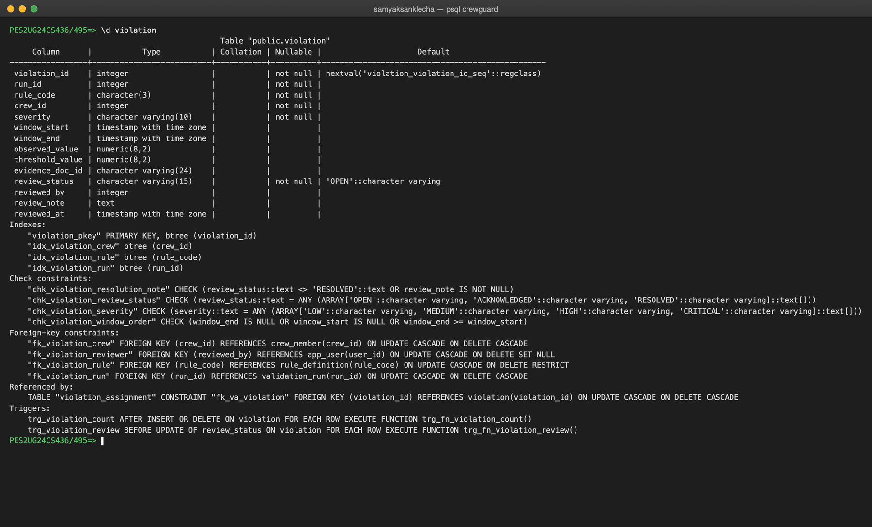
Figure 5.11: Structure of violation (\d violation)
Table violation_assignment
CREATE TABLE violation_assignment (
violation_id INTEGER NOT NULL,
assignment_id INTEGER NOT NULL,
contribution_value NUMERIC(8,2), -- hours this duty contributed
CONSTRAINT pk_violation_assignment PRIMARY KEY (violation_id, assignment_id),
CONSTRAINT fk_va_violation FOREIGN KEY (violation_id) REFERENCES violation(violation_id)
ON UPDATE CASCADE ON DELETE CASCADE,
CONSTRAINT fk_va_assignment FOREIGN KEY (assignment_id) REFERENCES duty_assignment(assignment_id)
ON UPDATE CASCADE ON DELETE CASCADE
);
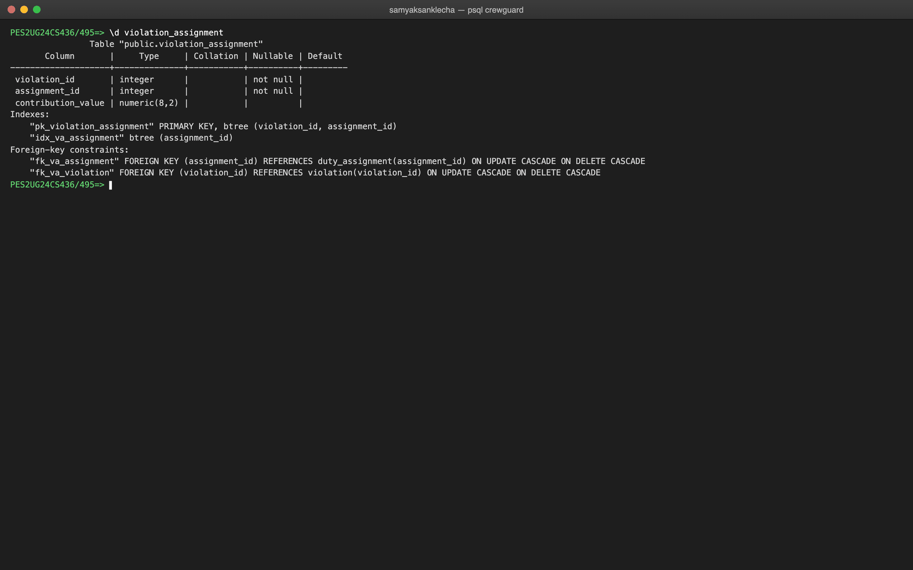
Figure 5.12: Structure of violation_assignment (\d violation_assignment)
Indexes
PostgreSQL indexes primary keys and UNIQUE columns automatically, but not foreign keys. The join and filter columns used by the application are therefore indexed explicitly. The composite index on (crew_id, duty_start_utc) serves "all duties of one crew member in time order", which the roster pages and the RST and WDH checks use. A GIN index supports full-text search on the rule catalogue.
CREATE INDEX idx_duty_crew_start ON duty_assignment (crew_id, duty_start_utc);
CREATE INDEX idx_duty_flight ON duty_assignment (flight_id);
CREATE INDEX idx_flight_dep_time ON flight (sched_dep_utc);
CREATE INDEX idx_cert_crew_type ON certification (crew_id, type_code, expires_on);
CREATE INDEX idx_crew_home_base ON crew_member (home_base);
CREATE INDEX idx_violation_run ON violation (run_id);
CREATE INDEX idx_violation_crew ON violation (crew_id);
CREATE INDEX idx_va_assignment ON violation_assignment (assignment_id);
CREATE INDEX idx_violation_rule ON violation (rule_code);
CREATE INDEX idx_rule_fts ON rule_definition
USING GIN (to_tsvector('english', rule_name || ' ' || description || ' ' || COALESCE(regulation_ref, '')));
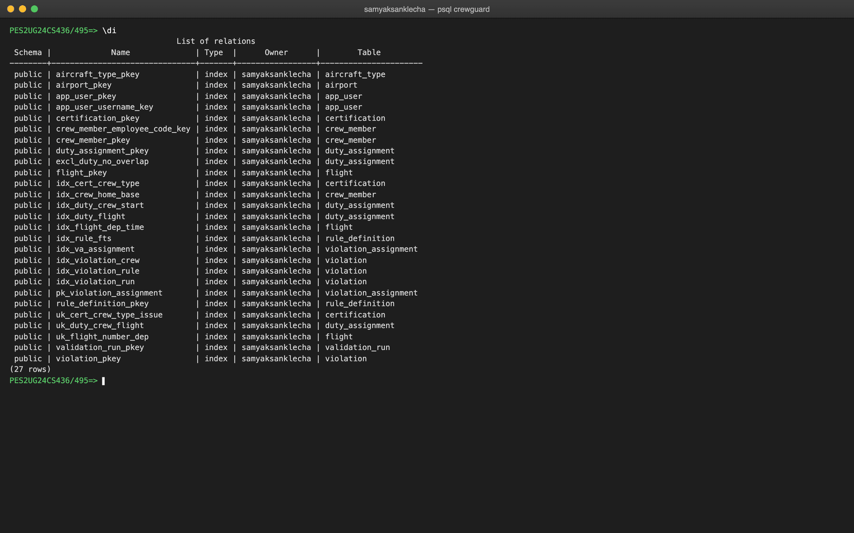
Figure 5.13: All indexes (\di)

6. DML STATEMENTS
The sample data is loaded by db/04_seed.sql. Most tables use multi-row INSERT ... VALUES. Duties use INSERT ... SELECT from a VALUES list joined to flight and crew_member, so each duty's times are computed from its flight (report one hour before departure, release 30 minutes after arrival, plus any delay) instead of being typed by hand. Explicit ids are used for readability, and the sequences are re-synchronised with setval at the end. Each statement is followed by a screenshot of the table with its inserted values.
Table airport
INSERT INTO airport (iata_code, name, city, country, timezone) VALUES
('BLR', 'Kempegowda International Airport', 'Bengaluru', 'India', 'Asia/Kolkata'),
('DEL', 'Indira Gandhi International Airport', 'Delhi', 'India', 'Asia/Kolkata'),
('BOM', 'Chhatrapati Shivaji Maharaj Intl', 'Mumbai', 'India', 'Asia/Kolkata'),
('MAA', 'Chennai International Airport', 'Chennai', 'India', 'Asia/Kolkata'),
('HYD', 'Rajiv Gandhi International Airport', 'Hyderabad', 'India', 'Asia/Kolkata'),
('CCU', 'Netaji Subhas Chandra Bose Intl', 'Kolkata', 'India', 'Asia/Kolkata'),
('DXB', 'Dubai International Airport', 'Dubai', 'United Arab Emirates', 'Asia/Dubai'),
('LHR', 'London Heathrow Airport', 'London', 'United Kingdom', 'Europe/London');
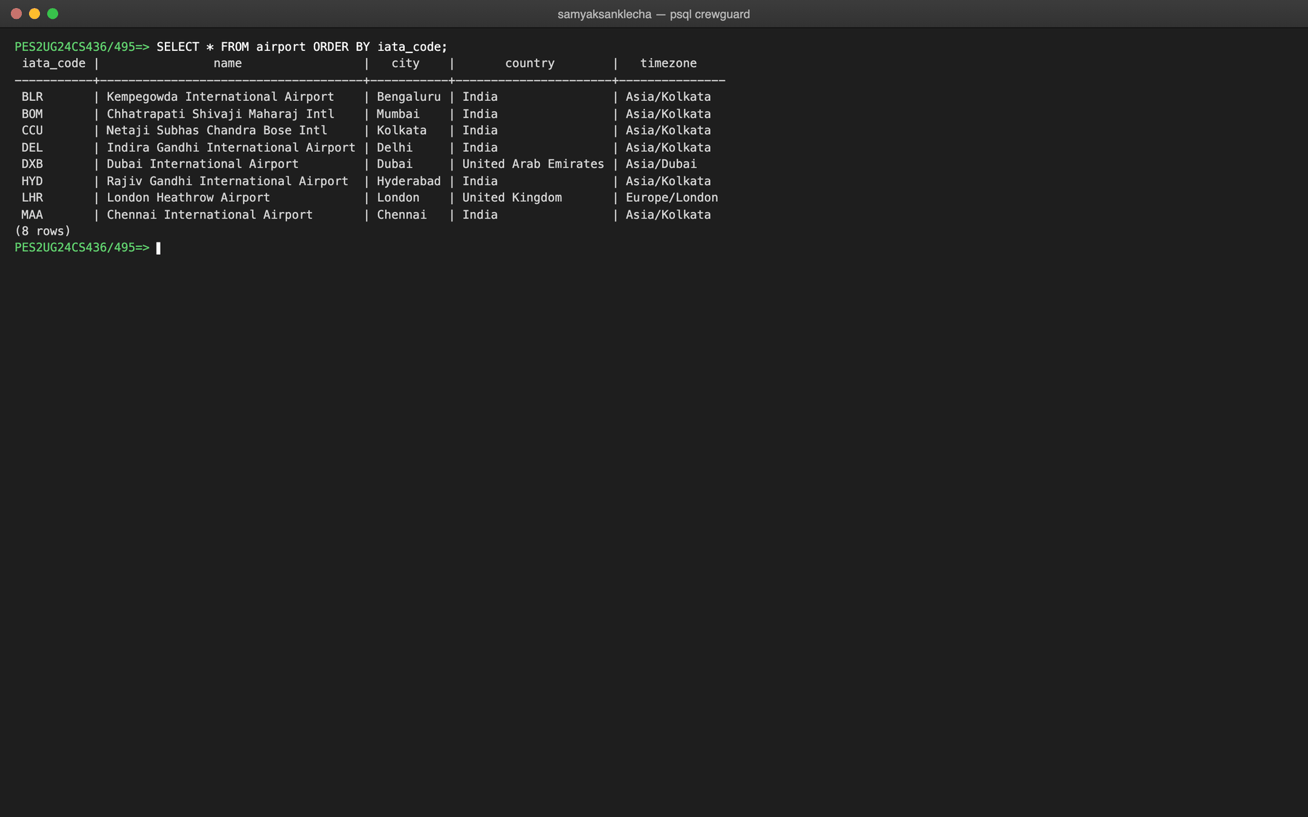
Figure 6.1: Rows in airport
Table aircraft_type
INSERT INTO aircraft_type (type_code, manufacturer, description) VALUES
('A320', 'Airbus', 'Airbus A320neo narrow-body'),
('A321', 'Airbus', 'Airbus A321neo narrow-body'),
('B738', 'Boeing', 'Boeing 737-800 narrow-body'),
('B788', 'Boeing', 'Boeing 787-8 Dreamliner wide-body');
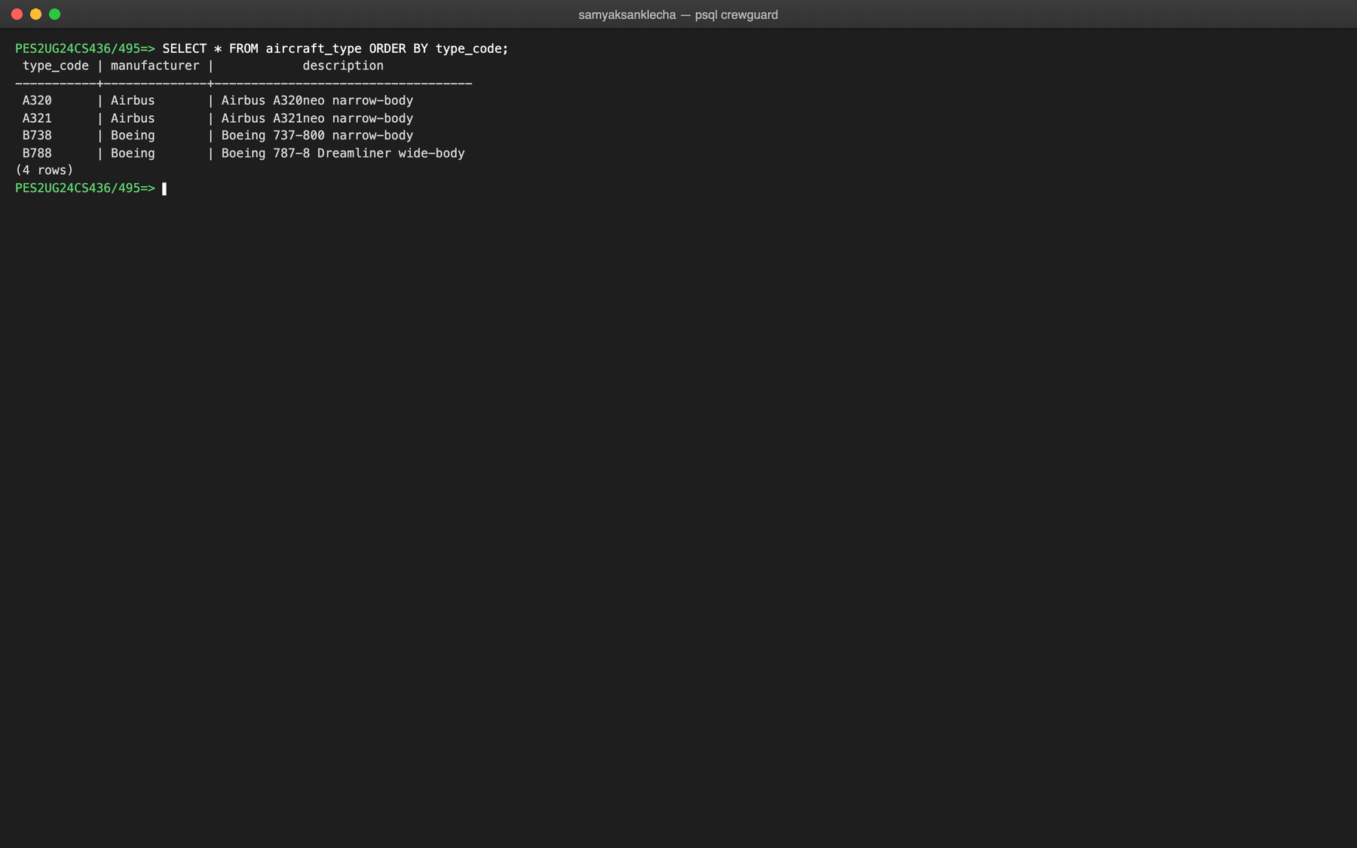
Figure 6.2: Rows in aircraft_type
Table app_user
INSERT INTO app_user (user_id, username, password_hash, app_role) VALUES
(1, 'sched_sam', '$2b$10$cwu/pvgdqv2C95XdPtGVUuxjRJHuLDi5K0gYnnFfQnQki6lkuBAlC', 'SCHEDULER'),
(2, 'audit_shriram', '$2b$10$5bokBBUTwKn8PqLJFAEPN.vewwqJNS.MgS2S3b1pQ4p0QtPX2mZzm', 'AUDITOR');
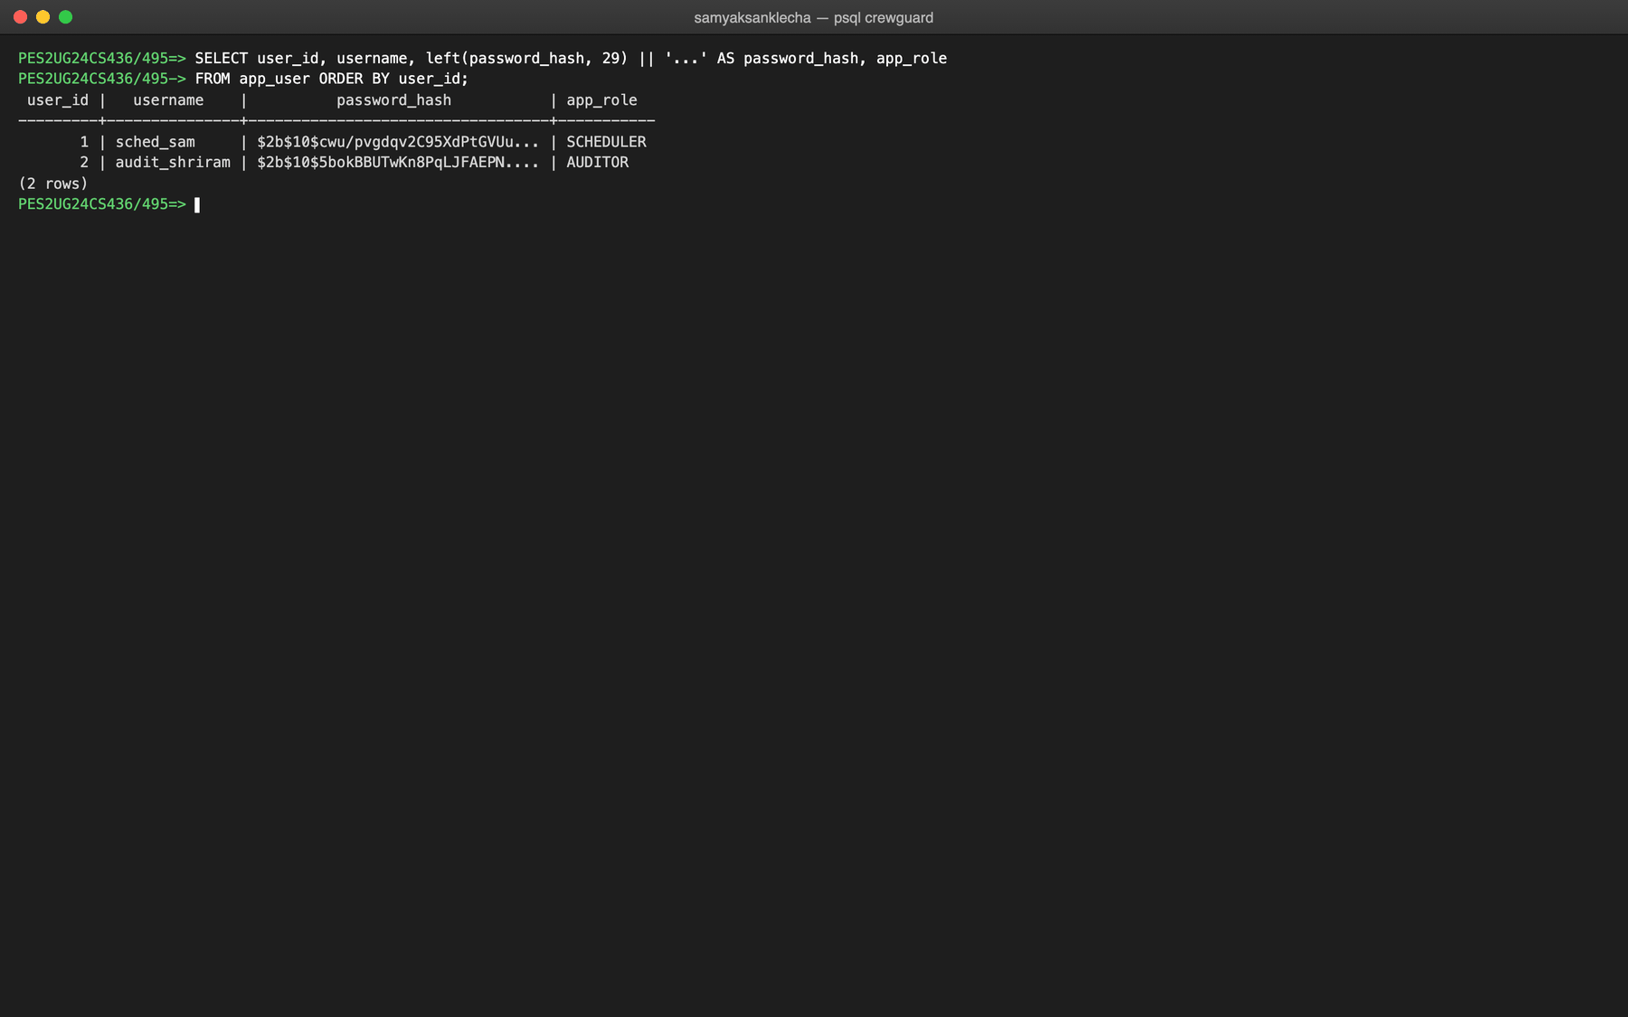
Figure 6.3: Rows in app_user (password hashes shortened)
Table crew_member
INSERT INTO crew_member (crew_id, employee_code, first_name, last_name, crew_role, home_base, hire_date, is_active) VALUES
(1, 'EMP1001', 'Arjun', 'Menon', 'CAPTAIN', 'BLR', '2015-06-01', TRUE),
(2, 'EMP1002', 'Kavya', 'Sharma', 'CAPTAIN', 'BLR', '2017-03-15', TRUE),
(3, 'EMP1003', 'Rohan', 'Kumar', 'FIRST_OFFICER', 'BLR', '2019-07-10', TRUE),
(4, 'EMP1004', 'Sneha', 'Patil', 'FIRST_OFFICER', 'DEL', '2020-01-20', TRUE),
(5, 'EMP1005', 'Vikram', 'Joshi', 'CABIN_CREW', 'BLR', '2021-09-05', TRUE),
(6, 'EMP1006', 'Nisha', 'Shah', 'CABIN_CREW', 'DEL', '2022-02-11', TRUE),
... -- remaining rows omitted, see db/04_seed.sql
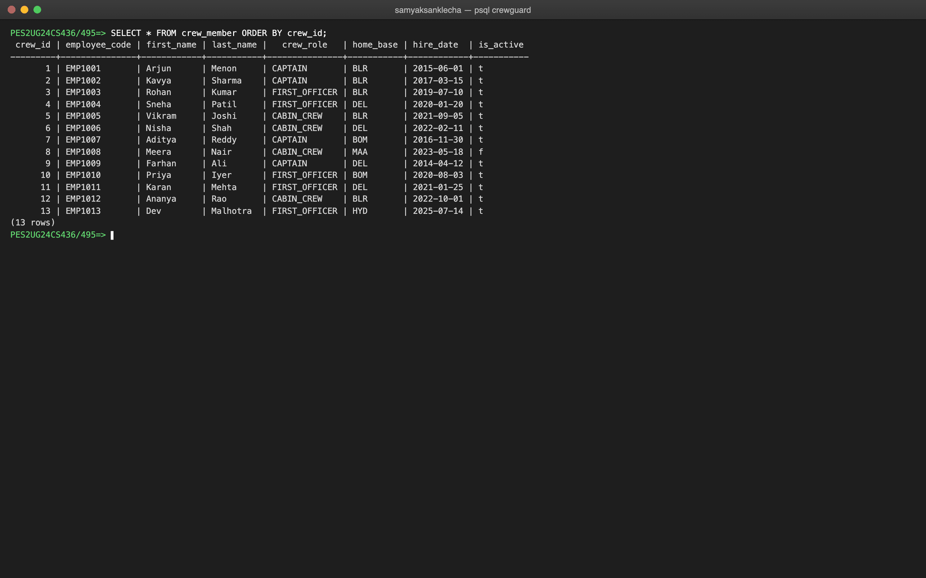
Figure 6.4: Rows in crew_member
Table certification
INSERT INTO certification (cert_id, crew_id, type_code, issued_on, expires_on) VALUES
(1, 1, 'A320', '2024-01-10', '2027-01-09'),
(2, 1, 'A321', '2024-02-15', '2026-12-20'), -- expiring soon
(3, 2, 'A320', '2023-11-01', '2026-10-31'), -- expired, but ...
(4, 2, 'A320', '2026-10-20', '2029-10-19'), -- ... renewed before it lapsed
(5, 2, 'B738', '2025-01-05', '2028-01-04'),
(6, 3, 'A320', '2024-05-20', '2027-05-19'),
... -- remaining rows omitted, see db/04_seed.sql
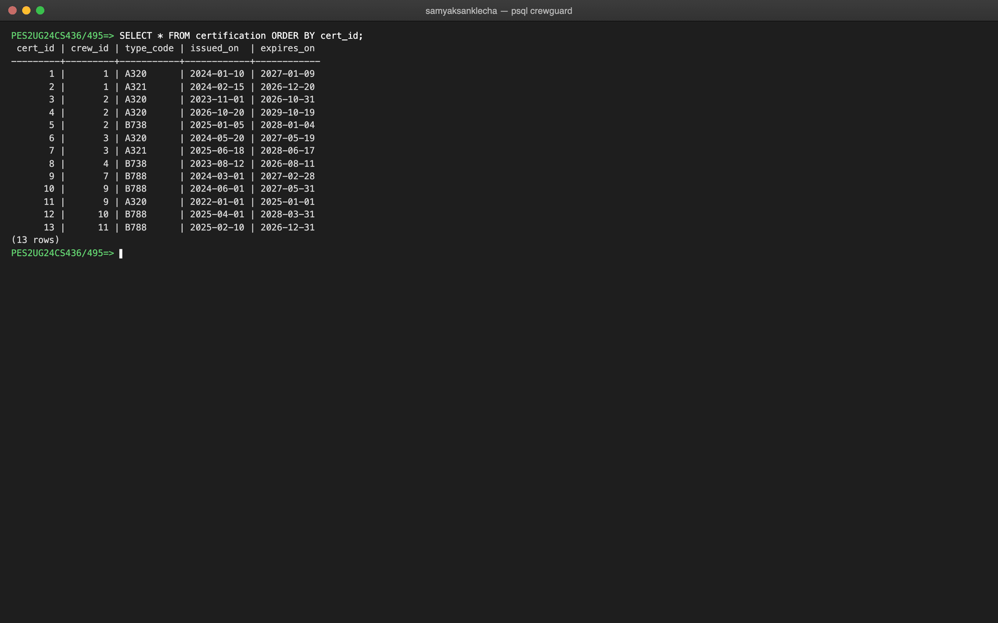
Figure 6.5: Rows in certification
Table flight
INSERT INTO flight (flight_id, flight_number, type_code, dep_airport, arr_airport, sched_dep_utc, sched_arr_utc) VALUES
-- week 1, domestic and regional
(1, 'CG101', 'A320', 'BLR', 'DEL', '2026-11-02 01:00+00', '2026-11-02 03:45+00'),
(2, 'CG102', 'A320', 'DEL', 'BLR', '2026-11-02 05:30+00', '2026-11-02 08:15+00'),
(3, 'CG201', 'B738', 'BLR', 'BOM', '2026-11-03 02:00+00', '2026-11-03 03:45+00'),
(4, 'CG202', 'B738', 'BOM', 'BLR', '2026-11-03 16:00+00', '2026-11-03 17:45+00'),
(5, 'CG301', 'A321', 'BLR', 'MAA', '2026-11-04 01:30+00', '2026-11-04 02:40+00'),
... -- remaining rows omitted, see db/04_seed.sql
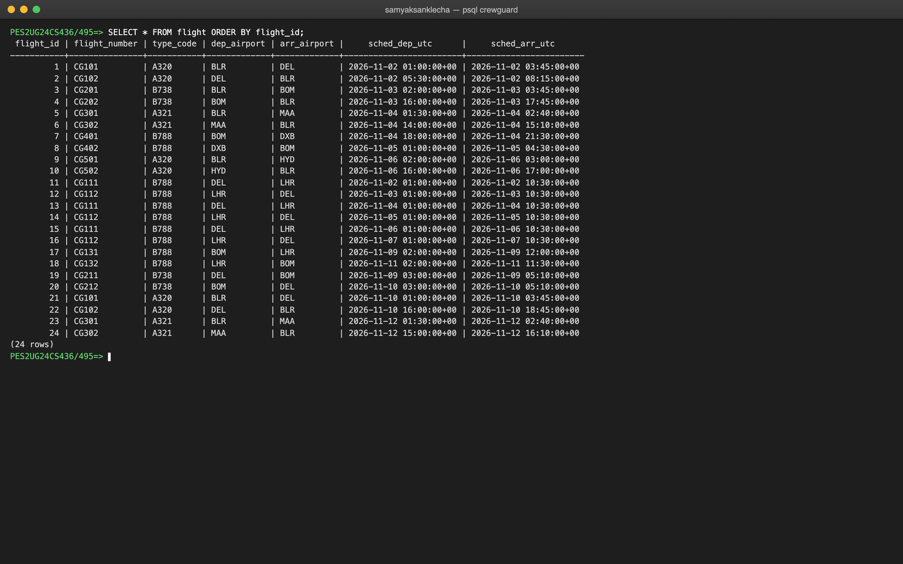
Figure 6.6: Rows in flight
Table duty_assignment
INSERT INTO duty_assignment (crew_id, flight_id, assigned_role, duty_start_utc, duty_end_utc, created_by)
SELECT r.crew_id,
f.flight_id,
cm.crew_role,
f.sched_dep_utc - INTERVAL '1 hour',
f.sched_arr_utc + INTERVAL '30 minutes' + r.delay,
1 -- rostered by sched_sam
FROM (VALUES
-- (flight_id, crew_id, extra delay)
(1, 1, INTERVAL '0'), (1, 3, INTERVAL '0'), (1, 5, INTERVAL '0'),
(2, 1, INTERVAL '0'), (2, 3, INTERVAL '0'), (2, 5, INTERVAL '0'),
(3, 2, INTERVAL '0'), (3, 3, INTERVAL '0'), (3, 12, INTERVAL '0'),
(4, 2, INTERVAL '0'), (4, 3, INTERVAL '0'), (4, 12, INTERVAL '0'),
(5, 1, INTERVAL '0'), (5, 5, INTERVAL '0'),
... -- remaining rows omitted, see db/04_seed.sql
SELECT setval('app_user_user_id_seq', (SELECT MAX(user_id) FROM app_user));
SELECT setval('crew_member_crew_id_seq', (SELECT MAX(crew_id) FROM crew_member));
SELECT setval('certification_cert_id_seq', (SELECT MAX(cert_id) FROM certification));
SELECT setval('flight_flight_id_seq', (SELECT MAX(flight_id) FROM flight));
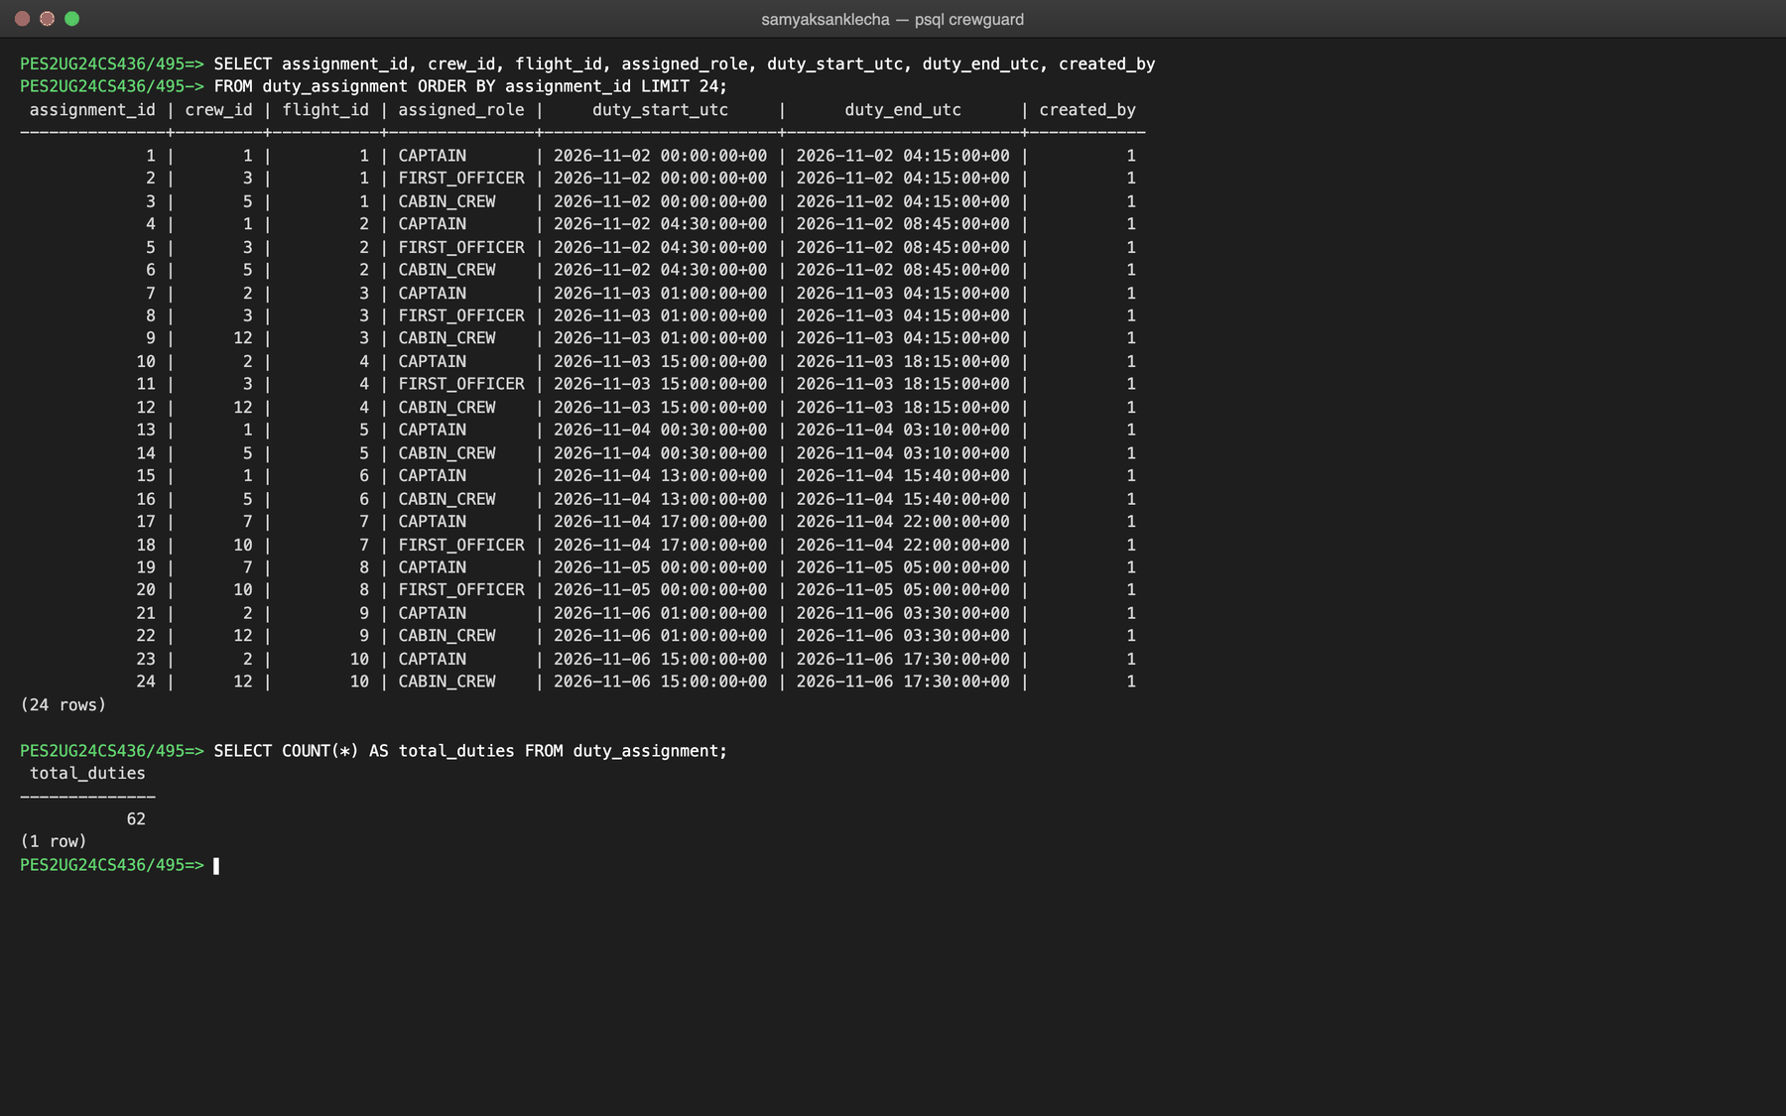
Figure 6.7: Rows in duty_assignment (first 24 of 62)
Table rule_definition
INSERT INTO rule_definition (rule_code, rule_name, description, regulation_ref, threshold_value, threshold_unit, window_days, severity, is_active) VALUES
('RST', 'Minimum Rest Between Duties',
'A crew member must receive a minimum continuous rest period between the end of one duty and the start of the next duty, so that fatigue from one duty does not carry into the next.',
'DGCA CAR Section 7 Series J Part III', 10.00, 'HOURS', NULL, 'HIGH', TRUE),
... -- remaining rows omitted, see db/04_seed.sql
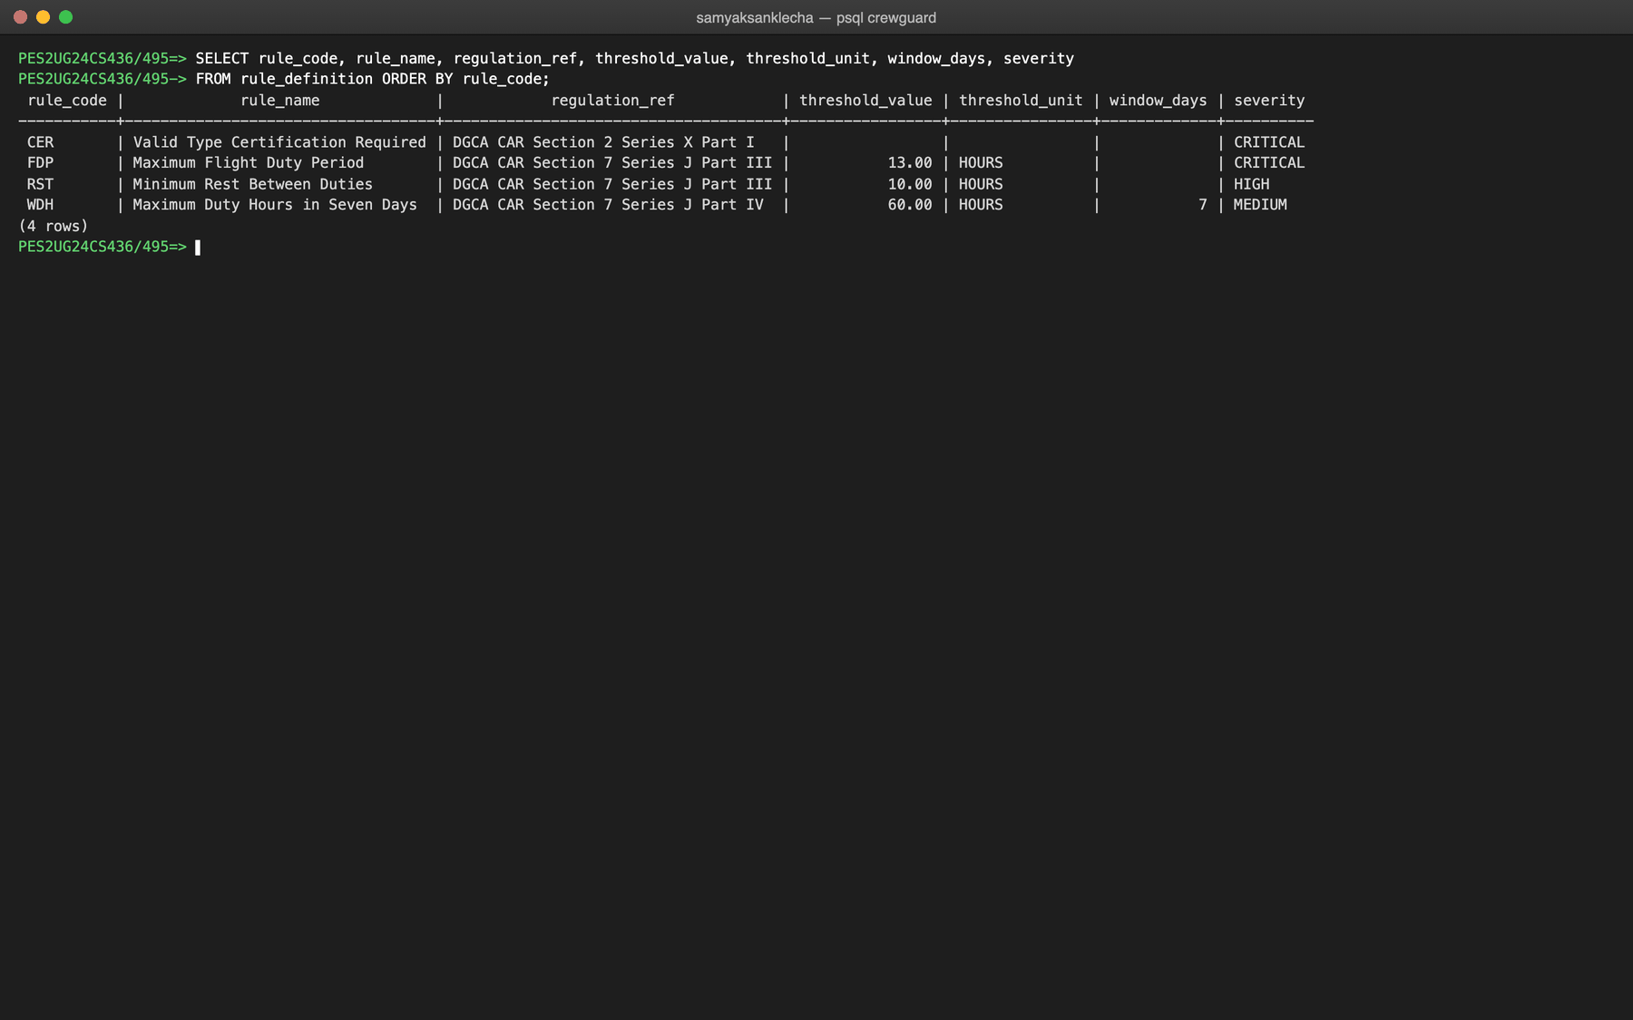
Figure 6.8: Rows in rule_definition
Compliance tables
validation_run, violation and violation_assignment are filled by the validator, not by the seed script. The screenshots below show them after the auditor ran a validation from 2 to 15 November in the application and reviewed two violations. evidence_doc_id holds the ObjectId of each violation's MongoDB document.
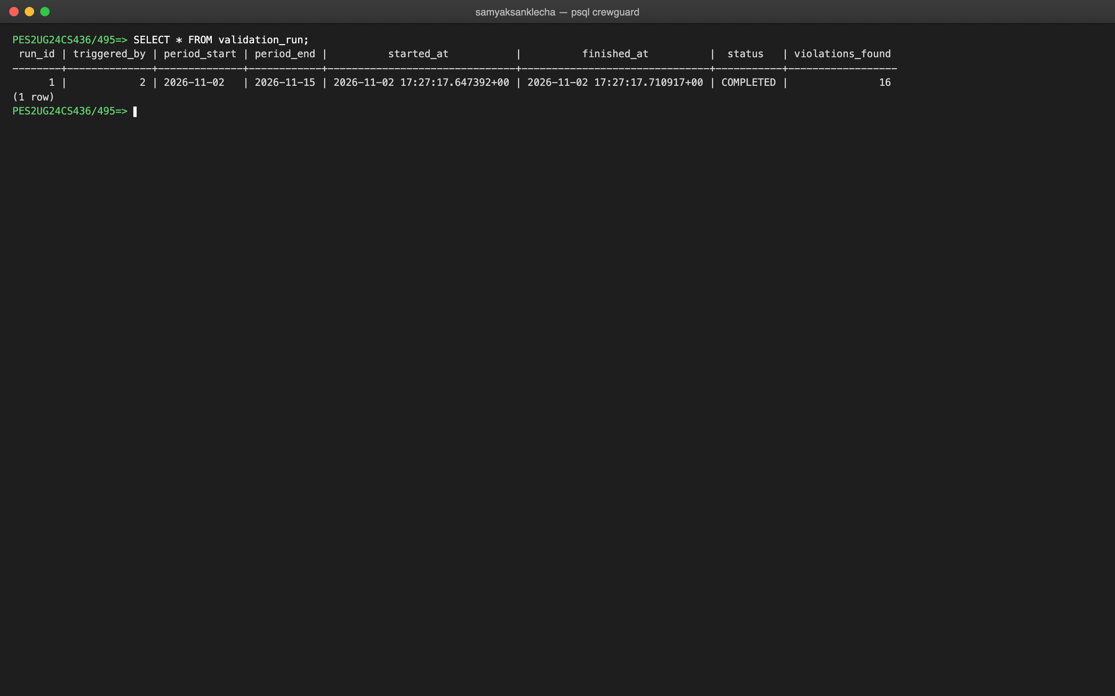
Figure 6.9: Rows in validation_run after one run
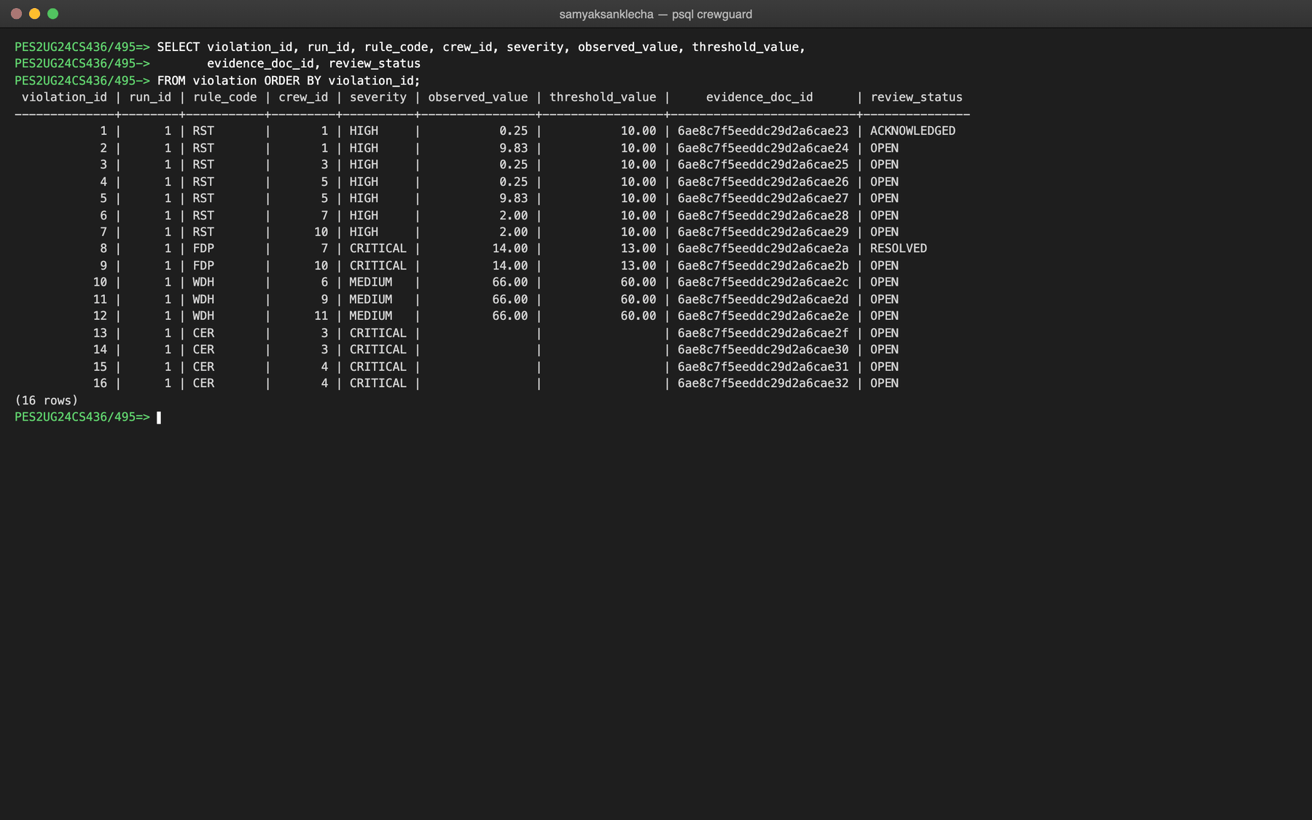
Figure 6.10: Rows in violation: the 16 planted breaches
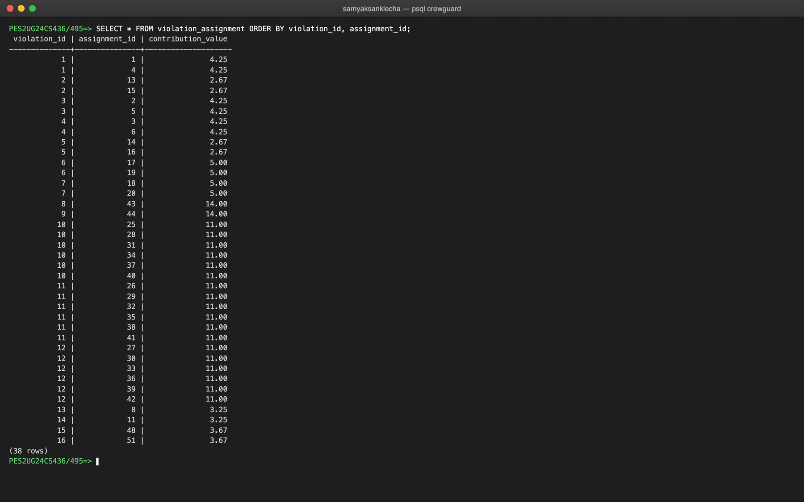
Figure 6.11: Rows in violation_assignment: the duties behind each violation
Inserting through the constraints
A valid insert succeeds and returns the generated key. Invalid inserts are rejected by the database, and the error names the constraint that fired: UNIQUE on employee_code, CHECK on the role, CHECK on distinct airports, and CHECK on the rating dates.
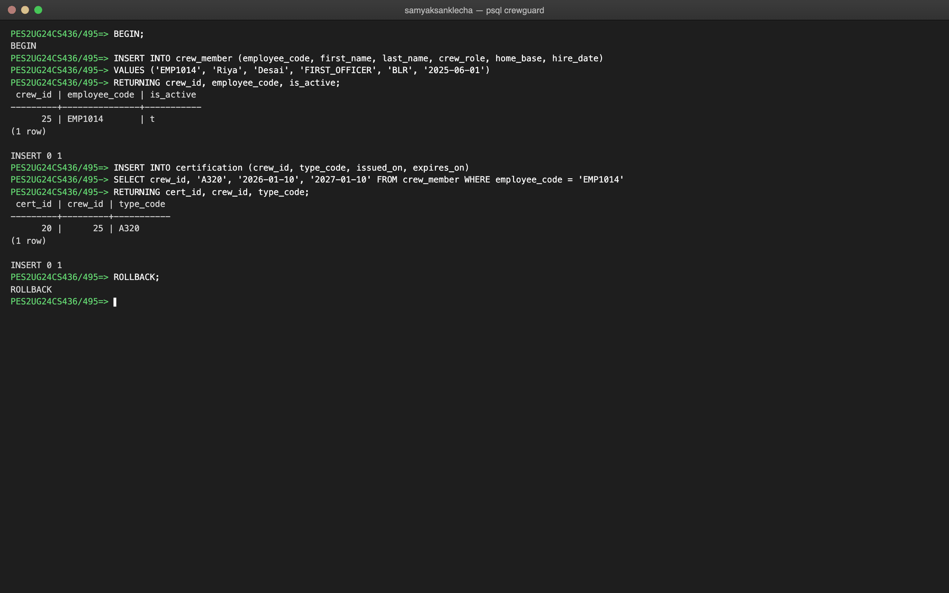
Figure 6.12: A valid INSERT inside a transaction (rolled back afterwards)
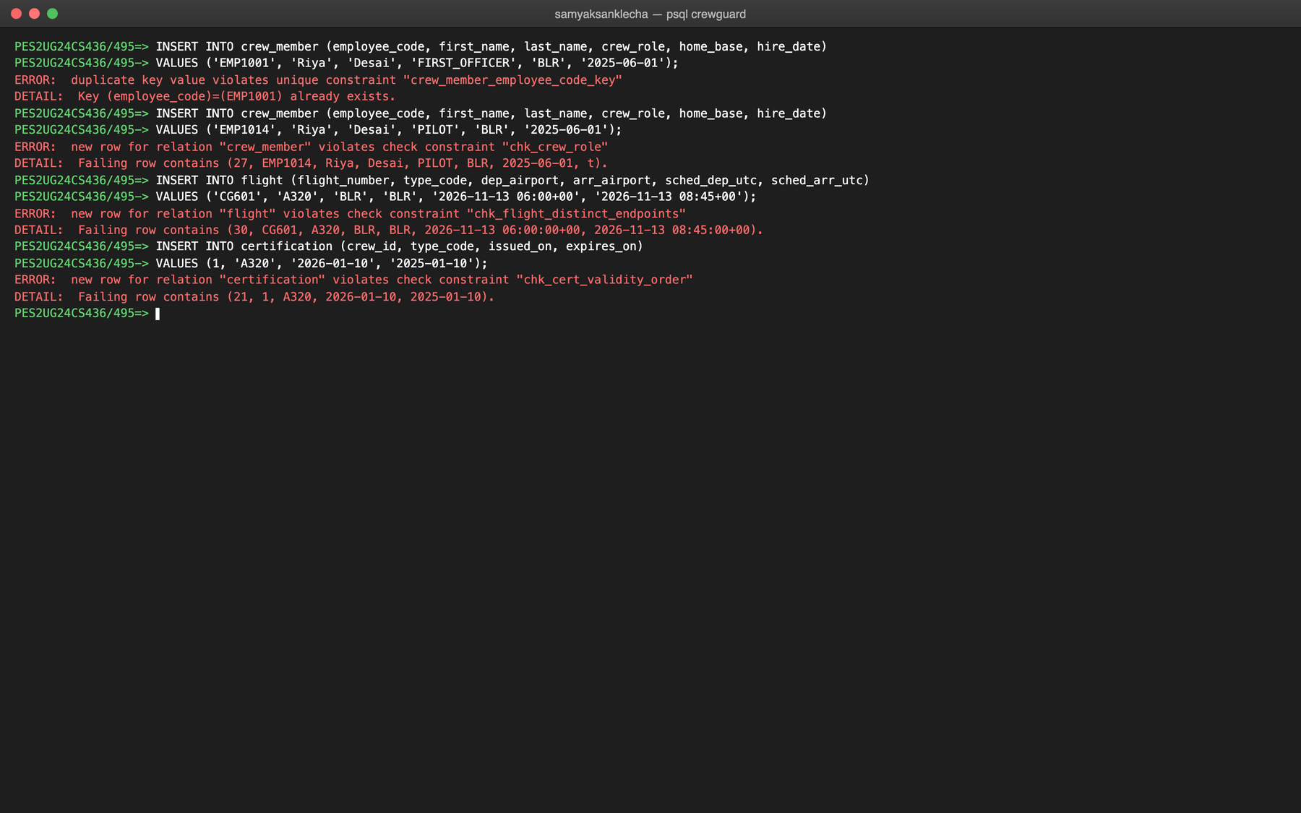
Figure 6.13: Invalid INSERTs rejected by UNIQUE and CHECK constraints

7. QUERIES
All queries below were run in psql on the sample data after one validation run. Statements that change data were run inside BEGIN ... ROLLBACK so the sample data stays intact. db/queries.sql in the repository contains these and further queries.
7.1 SIMPLE QUERY WITH GROUP BY, AGGREGATE
The first query aggregates the roster by role using COUNT, COUNT(DISTINCT), SUM, AVG and MAX over the v_duty_roster view. The second uses HAVING to keep only crew with more than 30 rostered hours. The third counts violations per rule and uses an aggregate FILTER clause to count the ones still open.
SELECT assigned_role,
COUNT(*) AS duties,
COUNT(DISTINCT crew_id) AS crew,
ROUND(SUM(duty_hours), 2) AS total_hours,
ROUND(AVG(duty_hours), 2) AS avg_hours,
MAX(duty_hours) AS longest_duty
FROM v_duty_roster
GROUP BY assigned_role
ORDER BY total_hours DESC;
SELECT crew_name, COUNT(*) AS duties, SUM(duty_hours) AS hours
FROM v_duty_roster
GROUP BY crew_id, crew_name
HAVING SUM(duty_hours) > 30
ORDER BY hours DESC;
SELECT rule_code,
COUNT(*) AS violations,
COUNT(*) FILTER (WHERE review_status = 'OPEN') AS still_open
FROM violation
GROUP BY rule_code
ORDER BY violations DESC;
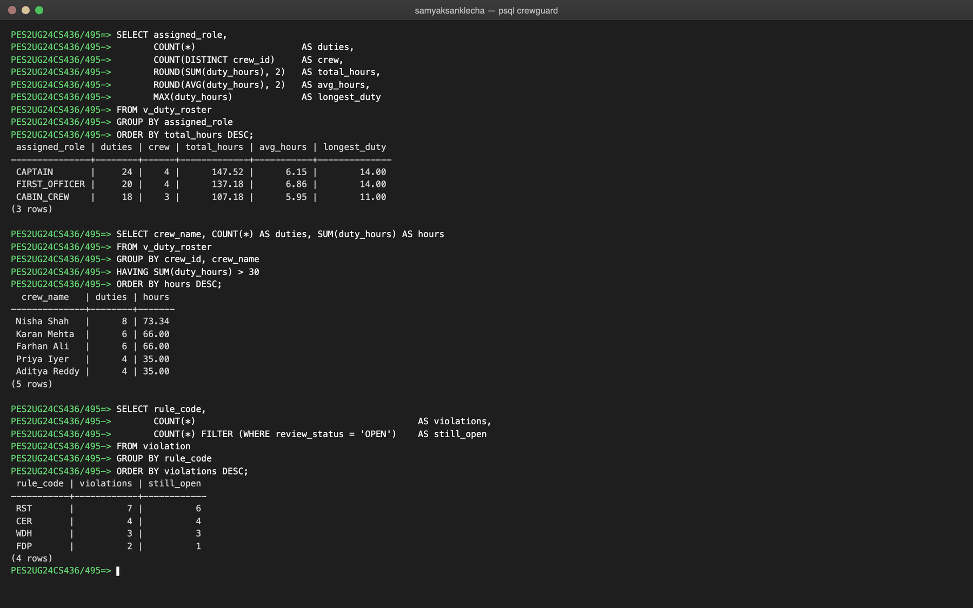
Figure 7.1: GROUP BY with aggregates, HAVING and FILTER
7.2 UPDATE OPERATION
The first UPDATE moves a crew member to another base. The second records an auditor's review; the trg_violation_review trigger stamps reviewed_at automatically, as RETURNING shows. The third tries to make a flight arrive before it departs and is rejected by the CHECK constraint chk_flight_time_order, which aborts the transaction.
BEGIN;
UPDATE crew_member SET home_base = 'HYD'
WHERE employee_code = 'EMP1006'
RETURNING crew_id, first_name, last_name, home_base;
UPDATE violation
SET review_status = 'ACKNOWLEDGED', review_note = 'Weekly limit breach confirmed.', reviewed_by = 2
WHERE violation_id = 11
RETURNING violation_id, rule_code, review_status, reviewed_by, reviewed_at;
UPDATE flight SET sched_arr_utc = sched_dep_utc - INTERVAL '1 hour'
WHERE flight_number = 'CG101';
ROLLBACK;
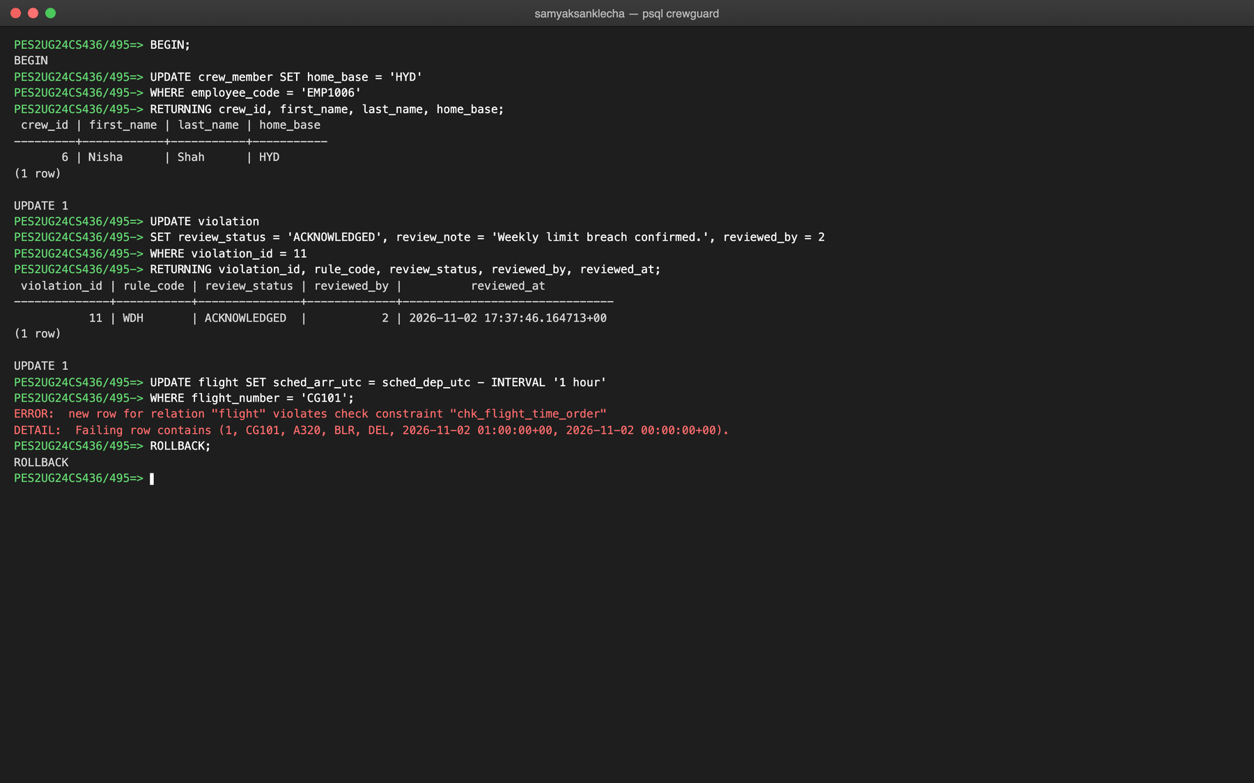
Figure 7.2: UPDATE statements, including one rejected by a CHECK constraint
7.3 DELETE OPERATION
Deleting a crew member cascades: ON DELETE CASCADE removes the member's certificates, duties and violations in the same statement, as the before and after counts show. Deleting an airport that is still in use is rejected by ON DELETE RESTRICT on the foreign keys that reference it.
BEGIN;
SELECT (SELECT COUNT(*) FROM certification WHERE crew_id = 3) AS certificates,
(SELECT COUNT(*) FROM duty_assignment WHERE crew_id = 3) AS duties,
(SELECT COUNT(*) FROM violation WHERE crew_id = 3) AS violations;
DELETE FROM crew_member WHERE crew_id = 3
RETURNING crew_id, employee_code, first_name, last_name;
SELECT (SELECT COUNT(*) FROM certification WHERE crew_id = 3) AS certificates,
(SELECT COUNT(*) FROM duty_assignment WHERE crew_id = 3) AS duties,
(SELECT COUNT(*) FROM violation WHERE crew_id = 3) AS violations;
ROLLBACK;
DELETE FROM airport WHERE iata_code = 'BLR';
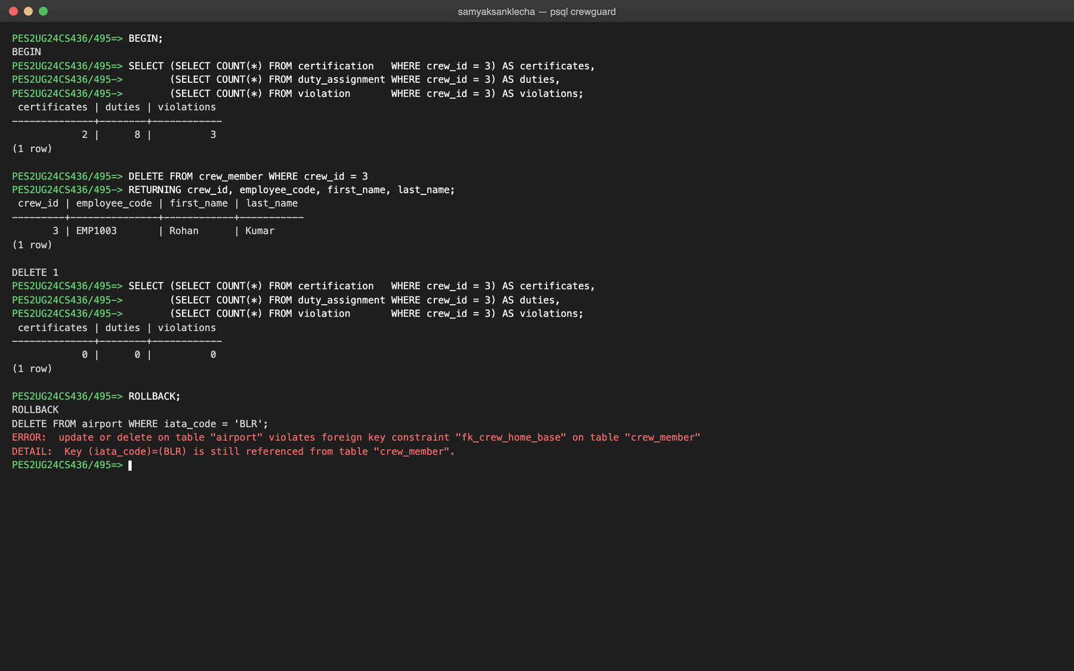
Figure 7.3: DELETE with ON DELETE CASCADE, and a DELETE blocked by RESTRICT
7.4 CORRELATED QUERY
A correlated sub-query refers to the outer row, so it is evaluated once per outer row. The first query counts, for each airport, the crew based there and the flights departing and arriving. The second lists crew whose total duty hours exceed the average of their own role; the inner query reads the outer row's crew_role.
SELECT a.iata_code, a.city,
(SELECT COUNT(*) FROM crew_member c WHERE c.home_base = a.iata_code) AS crew_based,
(SELECT COUNT(*) FROM flight f WHERE f.dep_airport = a.iata_code) AS departures,
(SELECT COUNT(*) FROM flight f WHERE f.arr_airport = a.iata_code) AS arrivals
FROM airport a
ORDER BY departures DESC, a.iata_code;
SELECT s.crew_name, s.crew_role, s.total_duty_hours
FROM v_crew_summary s
WHERE s.total_duty_hours > (SELECT AVG(t.total_duty_hours)
FROM v_crew_summary t
WHERE t.crew_role = s.crew_role)
ORDER BY s.crew_role, s.total_duty_hours DESC;
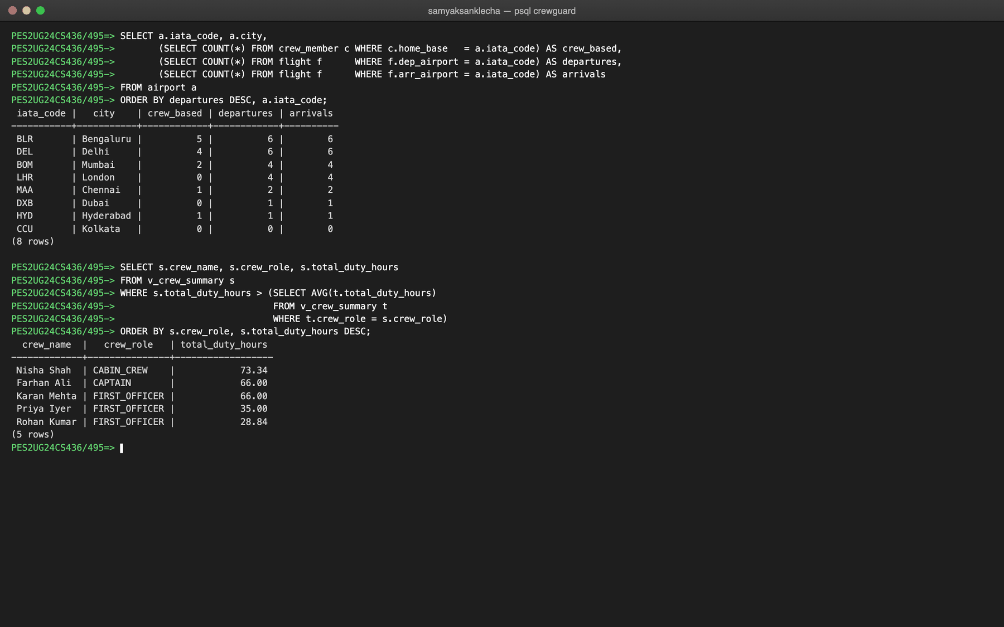
Figure 7.4: Correlated sub-queries
7.5 NESTED QUERY
The first query uses NOT IN with an independent sub-query to find crew who have never been rostered (an inactive cabin crew member and a newly hired first officer). The second uses a nested NOT EXISTS anti-join to find pilots who flew an aircraft type without a rating valid on the day of the flight, the same logic the validator uses for the CER rule.
SELECT employee_code, first_name || ' ' || last_name AS name, crew_role, is_active
FROM crew_member
WHERE crew_id NOT IN (SELECT crew_id FROM duty_assignment);
SELECT DISTINCT cm.employee_code, cm.first_name, f.flight_number, f.type_code
FROM duty_assignment da
JOIN crew_member cm USING (crew_id)
JOIN flight f USING (flight_id)
WHERE da.assigned_role <> 'CABIN_CREW'
AND NOT EXISTS (SELECT 1 FROM certification c
WHERE c.crew_id = da.crew_id
AND c.type_code = f.type_code
AND f.sched_dep_utc::date BETWEEN c.issued_on AND c.expires_on)
ORDER BY cm.employee_code, f.flight_number;
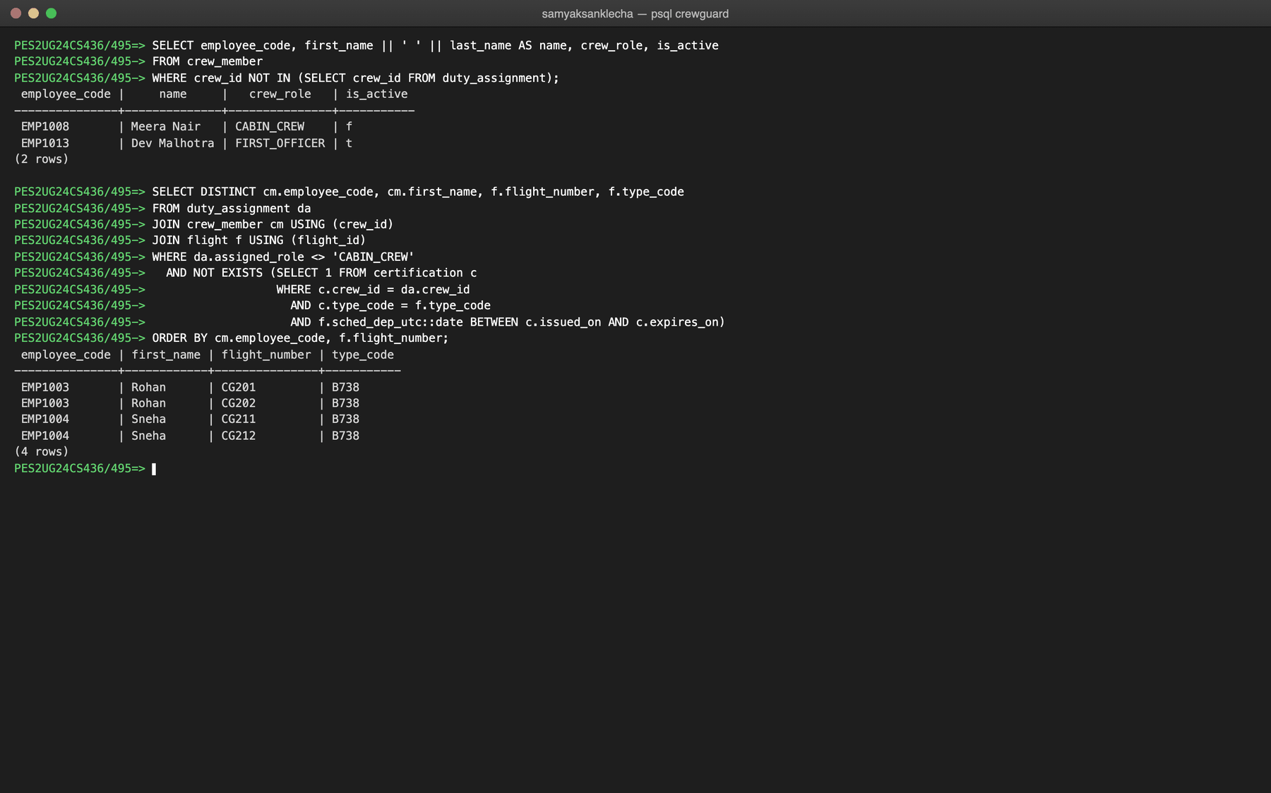
Figure 7.5: Nested queries with NOT IN and NOT EXISTS
7.6 VIEWS
Three views keep join logic inside the database. v_duty_roster joins duty_assignment, crew_member and flight. v_crew_summary gives one row per crew member; it LEFT JOINs two GROUP BY sub-queries so crew with no duties still appear and the duty and certificate counts do not multiply each other. v_violation_report gives one readable row per violation with its rule, crew member, reviewer and number of linked duties.
CREATE OR REPLACE VIEW v_crew_summary AS
SELECT cm.crew_id,
cm.employee_code,
cm.first_name,
cm.last_name,
cm.first_name || ' ' || cm.last_name AS crew_name,
cm.crew_role,
cm.home_base,
cm.hire_date,
cm.is_active,
COALESCE(d.duty_count, 0) AS duty_count,
COALESCE(d.duty_hours, 0) AS total_duty_hours,
d.last_duty_end,
COALESCE(c.valid_certs, 0) AS valid_certs
FROM crew_member cm
LEFT JOIN (
SELECT crew_id,
COUNT(*)::int AS duty_count,
SUM(fn_duty_hours(duty_start_utc, duty_end_utc)) AS duty_hours,
MAX(duty_end_utc) AS last_duty_end
FROM duty_assignment
GROUP BY crew_id
) d ON d.crew_id = cm.crew_id
LEFT JOIN (
SELECT crew_id, COUNT(*)::int AS valid_certs
FROM certification
WHERE expires_on >= CURRENT_DATE
GROUP BY crew_id
) c ON c.crew_id = cm.crew_id;
SELECT crew_name, crew_role, home_base, duty_count, total_duty_hours, valid_certs
FROM v_crew_summary
ORDER BY total_duty_hours DESC;
SELECT violation_id, rule_code, crew_name, observed_value, threshold_value,
review_status, reviewer, duty_count
FROM v_violation_report
ORDER BY violation_id;
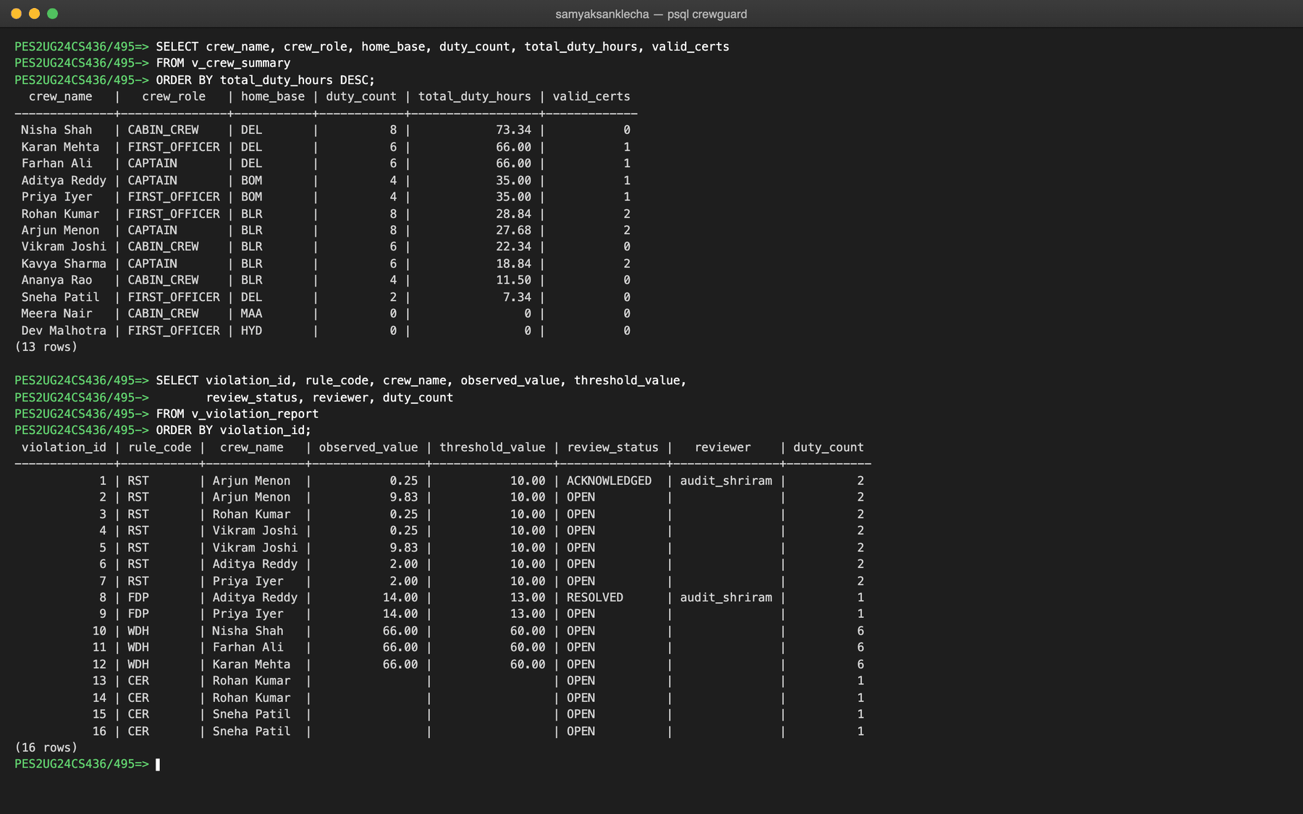
Figure 7.6: Querying the v_crew_summary and v_violation_report views
7.7 WINDOW FUNCTIONS
LAG reads the previous row of the same partition, so the rest before each duty is the gap since the same crew member's previous duty ended; a running SUM gives cumulative hours. Arjun Menon's 0.25-hour rest between CG101 and CG102 is visible directly.
SELECT crew_name, flight_number, duty_start_utc, duty_end_utc,
ROUND(EXTRACT(EPOCH FROM duty_start_utc - LAG(duty_end_utc) OVER w) / 3600, 2) AS rest_hours,
SUM(duty_hours) OVER w AS running_hours
FROM v_duty_roster
WHERE crew_id = 1
WINDOW w AS (PARTITION BY crew_id ORDER BY duty_start_utc);
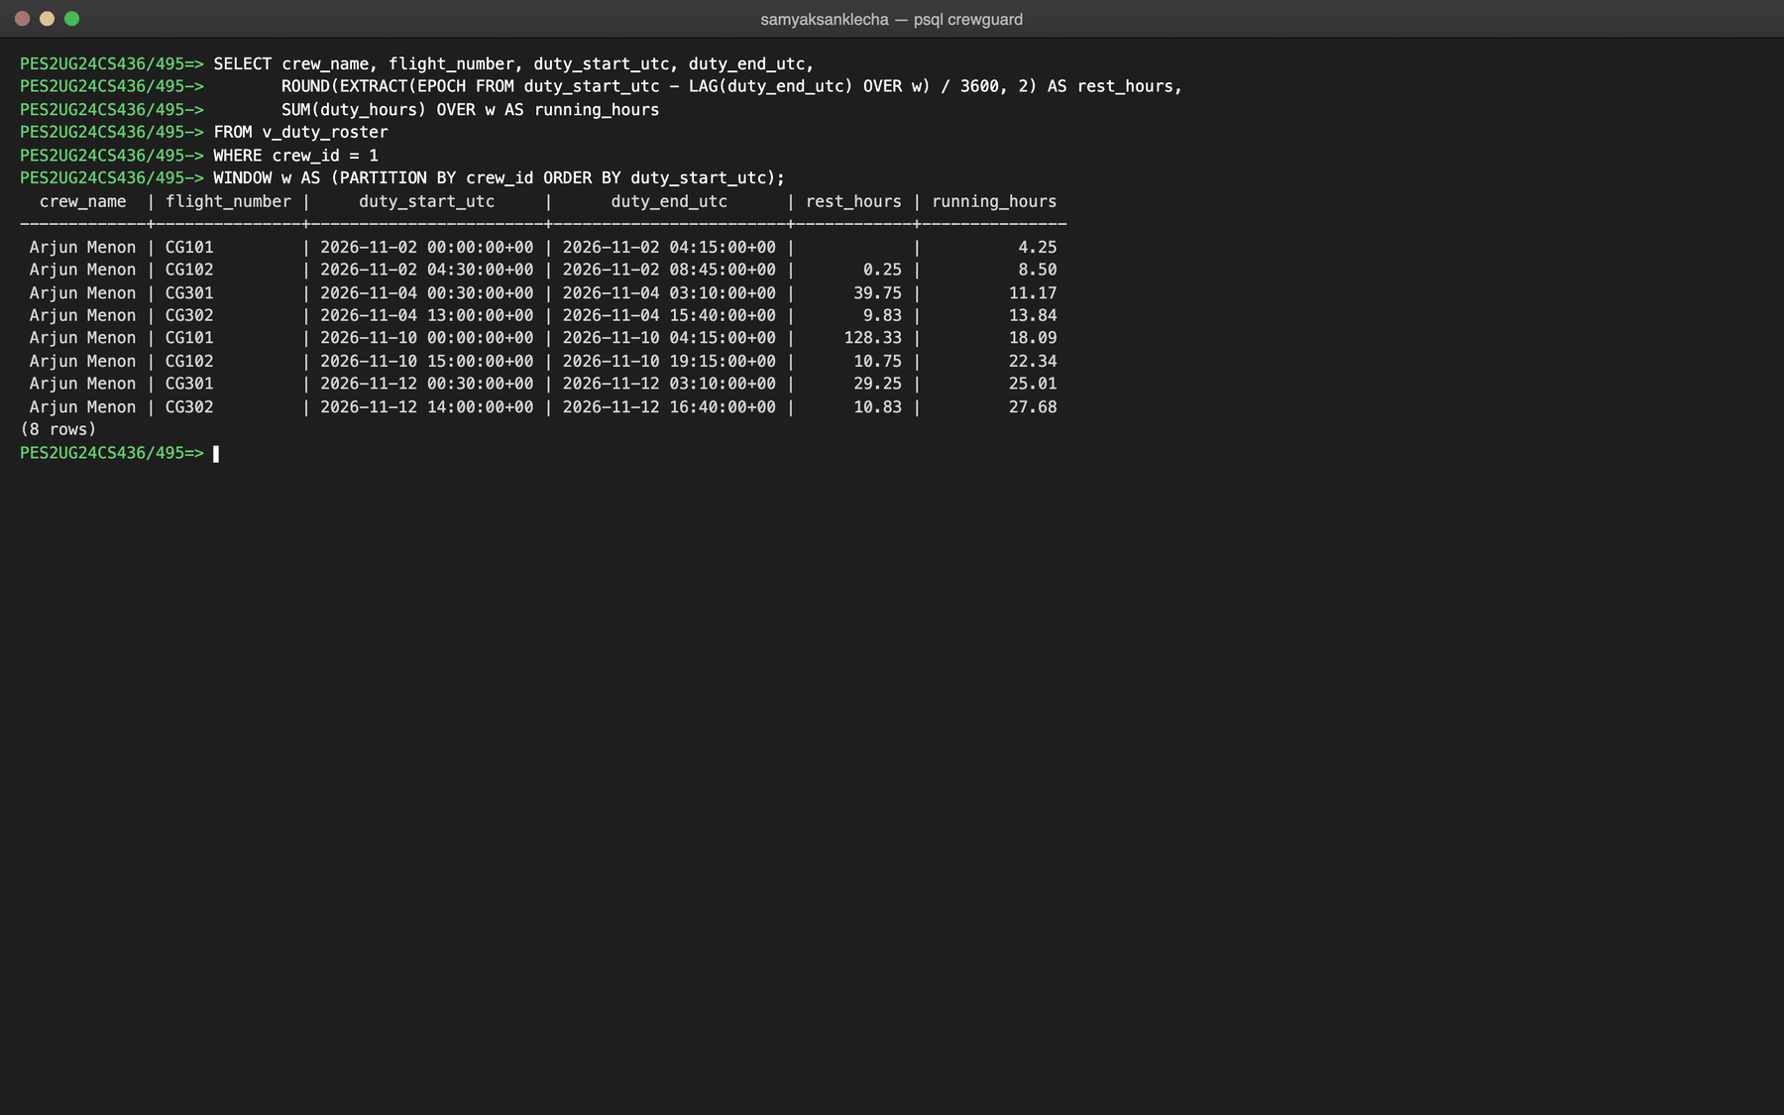
Figure 7.7: LAG and running SUM over one crew member's duties
7.8 FULL-TEXT SEARCH AND INDEX USE
The rule catalogue is searched with to_tsvector and websearch_to_tsquery and ranked with ts_rank; the expression matches the GIN index exactly so the index can be used. EXPLAIN ANALYZE shows the composite index idx_duty_crew_start serving a crew member's duties in time order (sequential scans are switched off for the demonstration because the sample table is small).
SELECT rule_code, rule_name,
ts_rank(to_tsvector('english', rule_name || ' ' || description || ' ' || COALESCE(regulation_ref, '')),
websearch_to_tsquery('english', 'rest')) AS rank
FROM rule_definition
WHERE to_tsvector('english', rule_name || ' ' || description || ' ' || COALESCE(regulation_ref, ''))
@@ websearch_to_tsquery('english', 'rest');
SET enable_seqscan = off;
EXPLAIN ANALYZE
SELECT * FROM duty_assignment WHERE crew_id = 1 ORDER BY duty_start_utc;
RESET enable_seqscan;
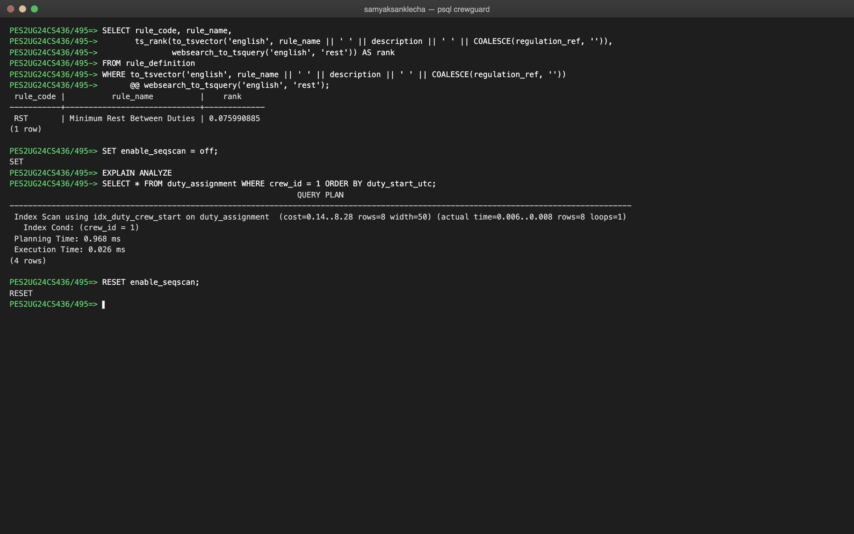
Figure 7.8: Full-text search and EXPLAIN ANALYZE using the composite index

8. STORED PROCEDURES, FUNCTIONS AND TRIGGERS
8.1 STORED PROCEDURES OR FUNCTIONS
Four SQL functions are defined in db/02_roster.sql. fn_duty_hours is IMMUTABLE (same input, same output) and the others are STABLE because they read tables. fn_crew_roster is table-valued: it returns rows and is used like a table in FROM.
CREATE OR REPLACE FUNCTION fn_duty_hours(p_start TIMESTAMPTZ, p_end TIMESTAMPTZ)
RETURNS NUMERIC
LANGUAGE sql
IMMUTABLE
AS $$
SELECT ROUND((EXTRACT(EPOCH FROM (p_end - p_start)) / 3600)::numeric, 2);
$$;
CREATE OR REPLACE FUNCTION fn_crew_duty_hours(p_crew_id INTEGER,
p_from TIMESTAMPTZ,
p_to TIMESTAMPTZ)
RETURNS NUMERIC
LANGUAGE sql
STABLE
AS $$
SELECT COALESCE(SUM(fn_duty_hours(duty_start_utc, duty_end_utc)), 0)
FROM duty_assignment
WHERE crew_id = p_crew_id
AND duty_start_utc >= p_from
AND duty_start_utc < p_to;
$$;
CREATE OR REPLACE FUNCTION fn_cert_status(p_expires_on DATE, p_on DATE DEFAULT CURRENT_DATE)
RETURNS TEXT
LANGUAGE sql
STABLE
AS $$
SELECT CASE
WHEN p_expires_on < p_on THEN 'EXPIRED'
WHEN p_expires_on < p_on + 60 THEN 'EXPIRING'
ELSE 'VALID'
END;
$$;
CREATE OR REPLACE FUNCTION fn_crew_roster(p_crew_id INTEGER)
RETURNS TABLE (assignment_id INTEGER,
flight_id INTEGER,
flight_number VARCHAR(10),
type_code VARCHAR(10),
sector TEXT,
assigned_role VARCHAR(20),
duty_start_utc TIMESTAMPTZ,
duty_end_utc TIMESTAMPTZ,
duty_hours NUMERIC)
LANGUAGE sql
STABLE
AS $$
SELECT da.assignment_id, f.flight_id, f.flight_number, f.type_code,
f.dep_airport || ' → ' || f.arr_airport,
da.assigned_role, da.duty_start_utc, da.duty_end_utc,
fn_duty_hours(da.duty_start_utc, da.duty_end_utc)
FROM duty_assignment da
JOIN flight f ON f.flight_id = da.flight_id
WHERE da.crew_id = p_crew_id
ORDER BY da.duty_start_utc;
$$;
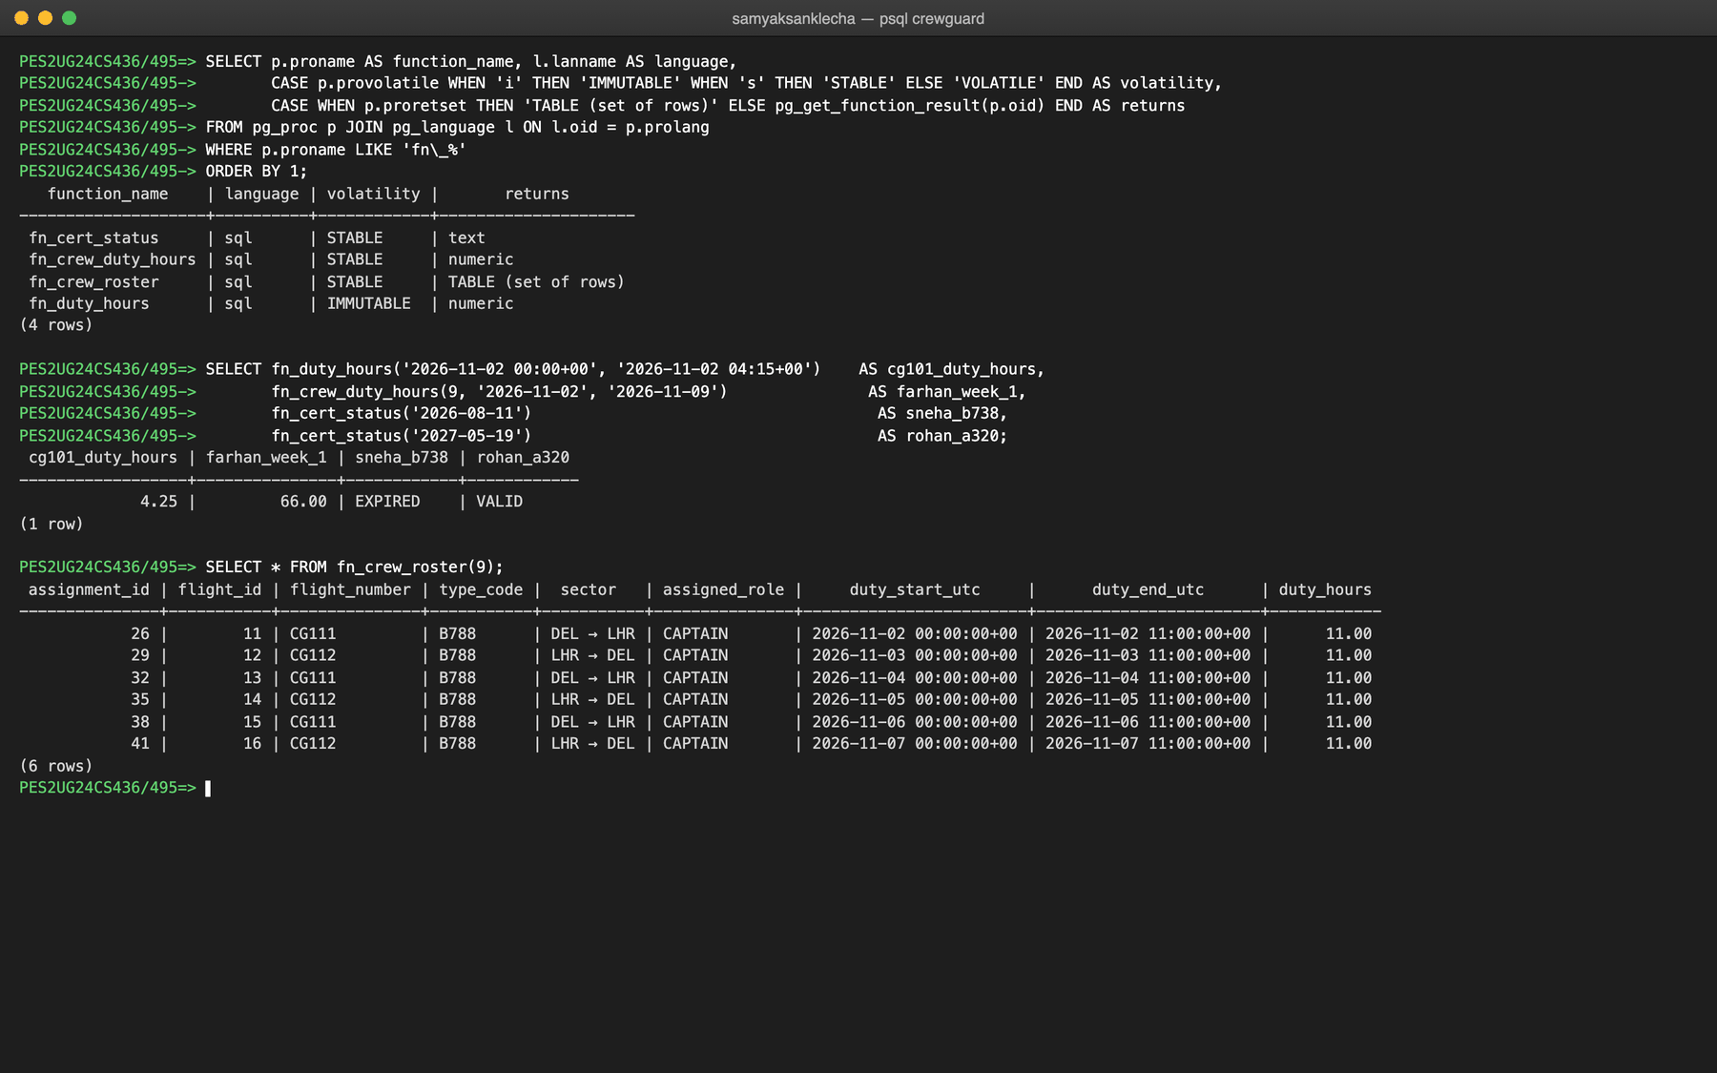
Figure 8.1: The four functions and their results
The validator is the stored procedure sp_run_validation in db/03_compliance.sql. It opens a validation_run, reads each rule's threshold and severity from rule_definition (no limit is hard-coded), checks the four rules over the period with set-based SQL, inserts one violation per breach and links the causing duties in violation_assignment. It does not COMMIT itself: the caller runs it inside a transaction, so a run is saved completely or not at all. RST uses LAG over each crew member's duties, FDP compares one duty's length with the limit, WDH uses a rolling SUM over a seven-day RANGE window and keeps each crew member's worst window with DISTINCT ON, and CER uses a NOT EXISTS anti-join on certification.
CREATE OR REPLACE PROCEDURE sp_run_validation(p_user_id INTEGER,
p_start DATE,
p_end DATE,
INOUT p_run_id INTEGER DEFAULT NULL)
LANGUAGE plpgsql
AS $$
DECLARE
-- AT TIME ZONE 'UTC': the result must not depend on the session time zone
v_from TIMESTAMPTZ := p_start::timestamp AT TIME ZONE 'UTC';
v_to TIMESTAMPTZ := (p_end + 1)::timestamp AT TIME ZONE 'UTC';
v_rule rule_definition%ROWTYPE;
v_id INTEGER;
r RECORD;
BEGIN
INSERT INTO validation_run (triggered_by, period_start, period_end)
VALUES (p_user_id, p_start, p_end)
RETURNING run_id INTO p_run_id;
-- ---------- RST: minimum rest between two consecutive duties ----------
SELECT * INTO v_rule FROM rule_definition WHERE rule_code = 'RST';
IF v_rule.is_active THEN
FOR r IN
-- LAG reads the same crew member's previous duty, in time order
SELECT d.*, fn_duty_hours(d.prev_end, d.duty_start_utc) AS rest_hours
FROM (
SELECT da.assignment_id, da.crew_id, da.duty_start_utc, da.duty_end_utc,
LAG(da.assignment_id) OVER w AS prev_id,
LAG(da.duty_start_utc) OVER w AS prev_start,
LAG(da.duty_end_utc) OVER w AS prev_end
FROM duty_assignment da
WINDOW w AS (PARTITION BY da.crew_id ORDER BY da.duty_start_utc)
) d
WHERE d.prev_id IS NOT NULL
AND d.duty_start_utc >= v_from AND d.duty_start_utc < v_to
AND fn_duty_hours(d.prev_end, d.duty_start_utc) < v_rule.threshold_value
ORDER BY d.crew_id, d.duty_start_utc
LOOP
INSERT INTO violation (run_id, rule_code, crew_id, severity, window_start, window_end,
observed_value, threshold_value)
VALUES (p_run_id, v_rule.rule_code, r.crew_id, v_rule.severity, r.prev_end, r.duty_start_utc,
r.rest_hours, v_rule.threshold_value)
RETURNING violation_id INTO v_id;
-- explanation: the two duties the short rest sits between
INSERT INTO violation_assignment (violation_id, assignment_id, contribution_value)
VALUES (v_id, r.prev_id, fn_duty_hours(r.prev_start, r.prev_end)),
(v_id, r.assignment_id, fn_duty_hours(r.duty_start_utc, r.duty_end_utc));
END LOOP;
END IF;
-- ---------- FDP: maximum length of a single duty ----------
SELECT * INTO v_rule FROM rule_definition WHERE rule_code = 'FDP';
IF v_rule.is_active THEN
FOR r IN
SELECT da.assignment_id, da.crew_id, da.duty_start_utc, da.duty_end_utc,
fn_duty_hours(da.duty_start_utc, da.duty_end_utc) AS hours
FROM duty_assignment da
WHERE da.duty_start_utc >= v_from AND da.duty_start_utc < v_to
AND fn_duty_hours(da.duty_start_utc, da.duty_end_utc) > v_rule.threshold_value
ORDER BY da.crew_id, da.duty_start_utc
LOOP
INSERT INTO violation (run_id, rule_code, crew_id, severity, window_start, window_end,
observed_value, threshold_value)
VALUES (p_run_id, v_rule.rule_code, r.crew_id, v_rule.severity, r.duty_start_utc, r.duty_end_utc,
r.hours, v_rule.threshold_value)
RETURNING violation_id INTO v_id;
INSERT INTO violation_assignment (violation_id, assignment_id, contribution_value)
VALUES (v_id, r.assignment_id, r.hours);
END LOOP;
END IF;
-- ---------- WDH: maximum duty hours in any rolling window ----------
-- The window function gives every duty the total of that crew member's duties
-- in the window ending at it. DISTINCT ON then keeps each crew member's single
-- worst window (the earliest if tied), so one overworked week is ONE violation
-- per crew per run, not one for every duty inside that week.
SELECT * INTO v_rule FROM rule_definition WHERE rule_code = 'WDH';
IF v_rule.is_active THEN
FOR r IN
SELECT DISTINCT ON (d.crew_id) d.crew_id, d.duty_start_utc, d.duty_end_utc, d.rolling_hours
FROM (
SELECT da.crew_id, da.duty_start_utc, da.duty_end_utc,
SUM(fn_duty_hours(da.duty_start_utc, da.duty_end_utc)) OVER (
PARTITION BY da.crew_id
ORDER BY da.duty_start_utc
RANGE BETWEEN make_interval(days => v_rule.window_days) PRECEDING AND CURRENT ROW
) AS rolling_hours
FROM duty_assignment da
) d
WHERE d.duty_start_utc >= v_from AND d.duty_start_utc < v_to
AND d.rolling_hours > v_rule.threshold_value
ORDER BY d.crew_id, d.rolling_hours DESC, d.duty_start_utc
LOOP
INSERT INTO violation (run_id, rule_code, crew_id, severity, window_start, window_end,
observed_value, threshold_value)
VALUES (p_run_id, v_rule.rule_code, r.crew_id, v_rule.severity,
r.duty_start_utc - make_interval(days => v_rule.window_days), r.duty_end_utc,
r.rolling_hours, v_rule.threshold_value)
RETURNING violation_id INTO v_id;
-- explanation: every duty inside the window, each with its hours
INSERT INTO violation_assignment (violation_id, assignment_id, contribution_value)
SELECT v_id, da.assignment_id, fn_duty_hours(da.duty_start_utc, da.duty_end_utc)
FROM duty_assignment da
WHERE da.crew_id = r.crew_id
AND da.duty_start_utc >= r.duty_start_utc - make_interval(days => v_rule.window_days)
AND da.duty_start_utc <= r.duty_start_utc;
END LOOP;
END IF;
-- ---------- CER: pilot must hold a valid type rating ----------
-- Anti-join: no certificate covers this aircraft type on the duty date.
-- A renewal is a separate row, so an expired certificate does not trigger this
-- as long as a newer one covers the date. Cabin crew are exempt.
SELECT * INTO v_rule FROM rule_definition WHERE rule_code = 'CER';
IF v_rule.is_active THEN
FOR r IN
SELECT da.assignment_id, da.crew_id, da.duty_start_utc, da.duty_end_utc,
fn_duty_hours(da.duty_start_utc, da.duty_end_utc) AS hours
FROM duty_assignment da
JOIN flight f ON f.flight_id = da.flight_id
WHERE da.duty_start_utc >= v_from AND da.duty_start_utc < v_to
AND da.assigned_role <> 'CABIN_CREW'
AND NOT EXISTS (
SELECT 1 FROM certification c
WHERE c.crew_id = da.crew_id
AND c.type_code = f.type_code
AND (da.duty_start_utc AT TIME ZONE 'UTC')::date BETWEEN c.issued_on AND c.expires_on)
ORDER BY da.crew_id, da.duty_start_utc
LOOP
-- there is no number to compare here, so observed and threshold stay NULL
INSERT INTO violation (run_id, rule_code, crew_id, severity, window_start, window_end)
VALUES (p_run_id, v_rule.rule_code, r.crew_id, v_rule.severity, r.duty_start_utc, r.duty_end_utc)
RETURNING violation_id INTO v_id;
INSERT INTO violation_assignment (violation_id, assignment_id, contribution_value)
VALUES (v_id, r.assignment_id, r.hours);
END LOOP;
END IF;
-- trg_run_finish stamps finished_at; trg_violation_count already kept the count
UPDATE validation_run SET status = 'COMPLETED' WHERE run_id = p_run_id;
END;
$$;
Calling the procedure for the first week inside a transaction creates run 2 with 12 violations (RST 7, WDH 3, CER 2); the triggers keep violations_found and finished_at correct. The explanation query then joins violation_assignment to v_duty_roster: Farhan Ali's WDH violation is caused by six 11-hour duties whose contributions add up to the observed 66 hours.
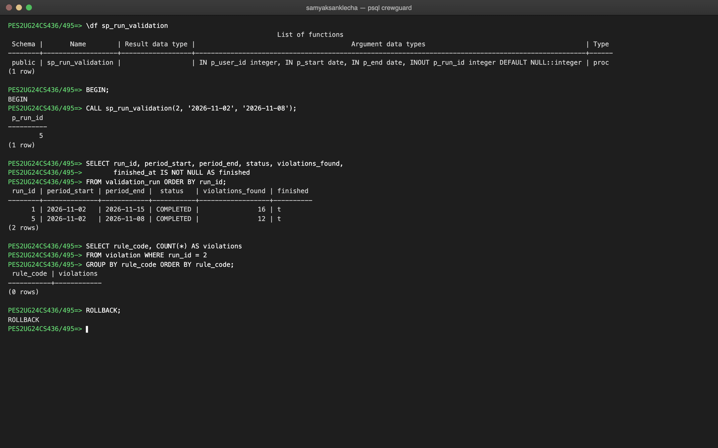
Figure 8.2: CALL sp_run_validation for the first week
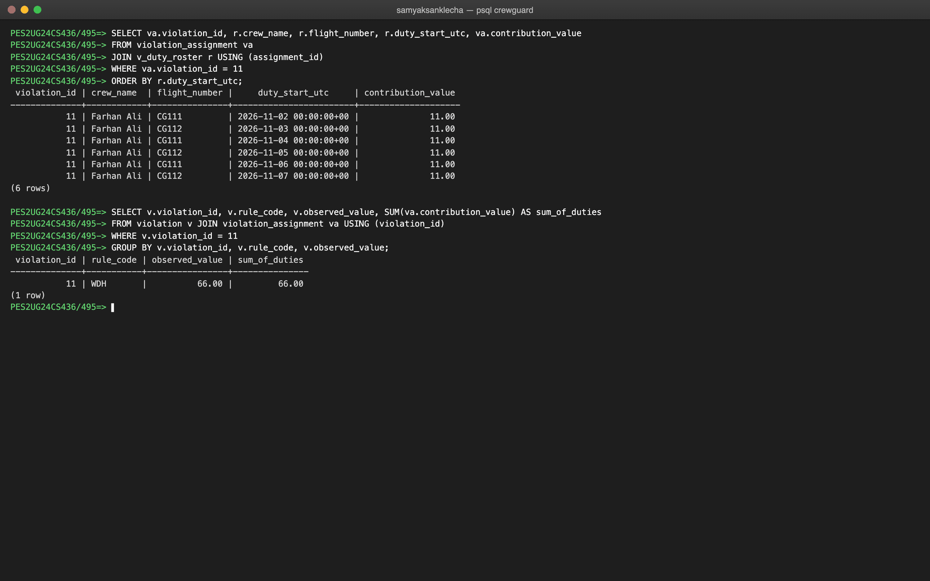
Figure 8.3: The explanation: the duties behind a violation add up to the observed value
8.2 TRIGGERS
Four triggers are used. trg_validate_duty prevents bad duties; the other three maintain derived values that the application must never have to keep in step itself.
Trigger | Table and timing | What it does
trg_validate_duty | duty_assignment, BEFORE INSERT OR UPDATE, per row | Rejects a duty if the crew member is inactive, if the assigned role differs from the crew member's role, or if the duty does not cover the whole flight. A CHECK constraint cannot do this because it needs data from other tables.
trg_violation_count | violation, AFTER INSERT OR DELETE, per row | Keeps validation_run.violations_found equal to the real number of violations.
trg_run_finish | validation_run, BEFORE UPDATE, per row | Stamps finished_at when a run becomes COMPLETED or FAILED.
trg_violation_review | violation, BEFORE UPDATE OF review_status, per row | Stamps reviewed_at when the review status changes.
Table 8.1: Triggers
CREATE OR REPLACE FUNCTION trg_fn_validate_duty()
RETURNS TRIGGER
LANGUAGE plpgsql
AS $$
DECLARE
v_crew crew_member%ROWTYPE;
v_flight flight%ROWTYPE;
BEGIN
SELECT * INTO v_crew FROM crew_member WHERE crew_id = NEW.crew_id;
SELECT * INTO v_flight FROM flight WHERE flight_id = NEW.flight_id;
IF NOT v_crew.is_active THEN
RAISE EXCEPTION 'Crew member % is inactive and cannot be rostered', v_crew.employee_code
USING ERRCODE = 'check_violation', CONSTRAINT = 'trg_duty_crew_active';
END IF;
IF NEW.assigned_role <> v_crew.crew_role THEN
RAISE EXCEPTION 'Crew member % is a %, not a %',
v_crew.employee_code, v_crew.crew_role, NEW.assigned_role
USING ERRCODE = 'check_violation', CONSTRAINT = 'trg_duty_role_match';
END IF;
IF NEW.duty_start_utc > v_flight.sched_dep_utc OR NEW.duty_end_utc < v_flight.sched_arr_utc THEN
RAISE EXCEPTION 'Duty must start before departure and end after arrival of flight %',
v_flight.flight_number
USING ERRCODE = 'check_violation', CONSTRAINT = 'trg_duty_covers_flight';
END IF;
RETURN NEW;
END;
$$;
DROP TRIGGER IF EXISTS trg_validate_duty ON duty_assignment;
CREATE TRIGGER trg_validate_duty
BEFORE INSERT OR UPDATE ON duty_assignment
FOR EACH ROW
EXECUTE FUNCTION trg_fn_validate_duty();
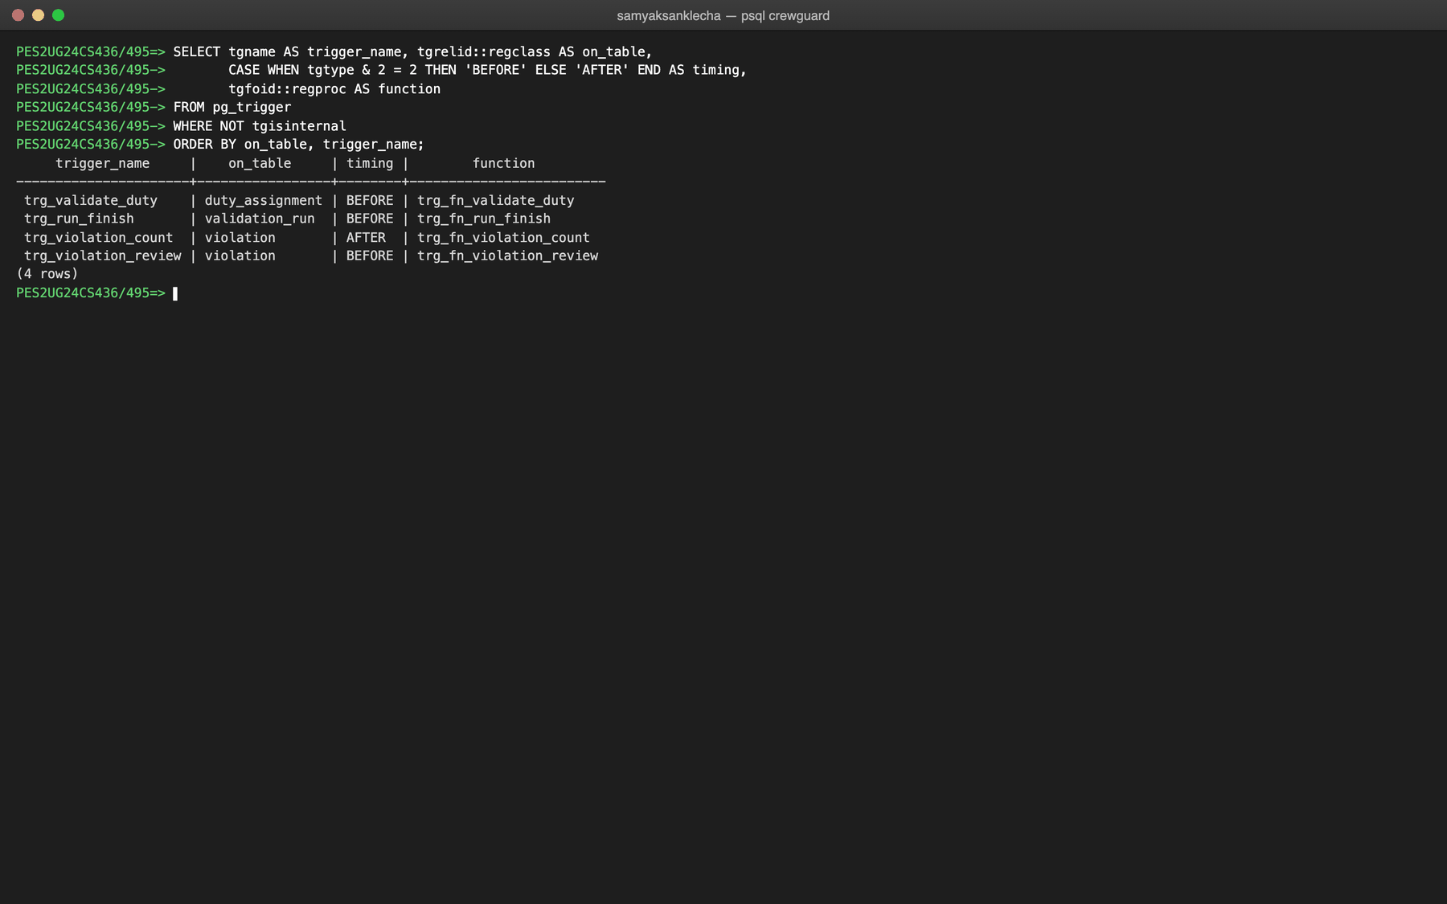
Figure 8.4: The triggers installed in the database
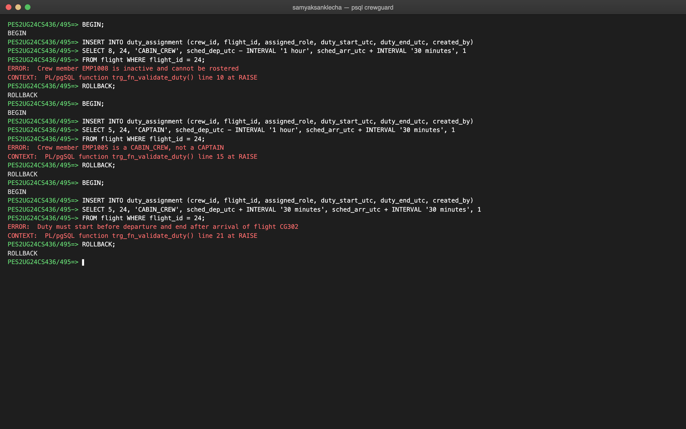
Figure 8.5: trg_validate_duty rejecting an inactive crew member, a wrong role and a duty that does not cover its flight
CREATE OR REPLACE FUNCTION trg_fn_violation_count()
RETURNS TRIGGER
LANGUAGE plpgsql
AS $$
BEGIN
IF TG_OP = 'INSERT' THEN
UPDATE validation_run
SET violations_found = violations_found + 1
WHERE run_id = NEW.run_id;
RETURN NEW;
END IF;
-- GREATEST: never goes below 0, which chk_run_violation_count would reject
UPDATE validation_run
SET violations_found = GREATEST(violations_found - 1, 0)
WHERE run_id = OLD.run_id;
RETURN OLD;
END;
$$;
DROP TRIGGER IF EXISTS trg_violation_count ON violation;
CREATE TRIGGER trg_violation_count
AFTER INSERT OR DELETE ON violation
FOR EACH ROW
EXECUTE FUNCTION trg_fn_violation_count();
-- Stamps finished_at when a run is closed.
-- clock_timestamp(), not NOW(): NOW() is frozen at the start of the transaction,
-- so a run closed in the same transaction that opened it would show 0 ms.
CREATE OR REPLACE FUNCTION trg_fn_run_finish()
RETURNS TRIGGER
LANGUAGE plpgsql
AS $$
BEGIN
IF NEW.status IN ('COMPLETED', 'FAILED') AND NEW.finished_at IS NULL THEN
NEW.finished_at := clock_timestamp();
END IF;
RETURN NEW;
END;
$$;
DROP TRIGGER IF EXISTS trg_run_finish ON validation_run;
CREATE TRIGGER trg_run_finish
BEFORE UPDATE ON validation_run
FOR EACH ROW
EXECUTE FUNCTION trg_fn_run_finish();
-- Stamps reviewed_at when the review status actually changes.
-- UPDATE OF fires only if review_status is in the SET list, and the IF ignores
-- an update that writes the same status again (e.g. editing only the note).
CREATE OR REPLACE FUNCTION trg_fn_violation_review()
RETURNS TRIGGER
LANGUAGE plpgsql
AS $$
BEGIN
IF NEW.review_status IS DISTINCT FROM OLD.review_status THEN
NEW.reviewed_at := NOW();
END IF;
RETURN NEW;
END;
$$;
DROP TRIGGER IF EXISTS trg_violation_review ON violation;
CREATE TRIGGER trg_violation_review
BEFORE UPDATE OF review_status ON violation
FOR EACH ROW
EXECUTE FUNCTION trg_fn_violation_review();
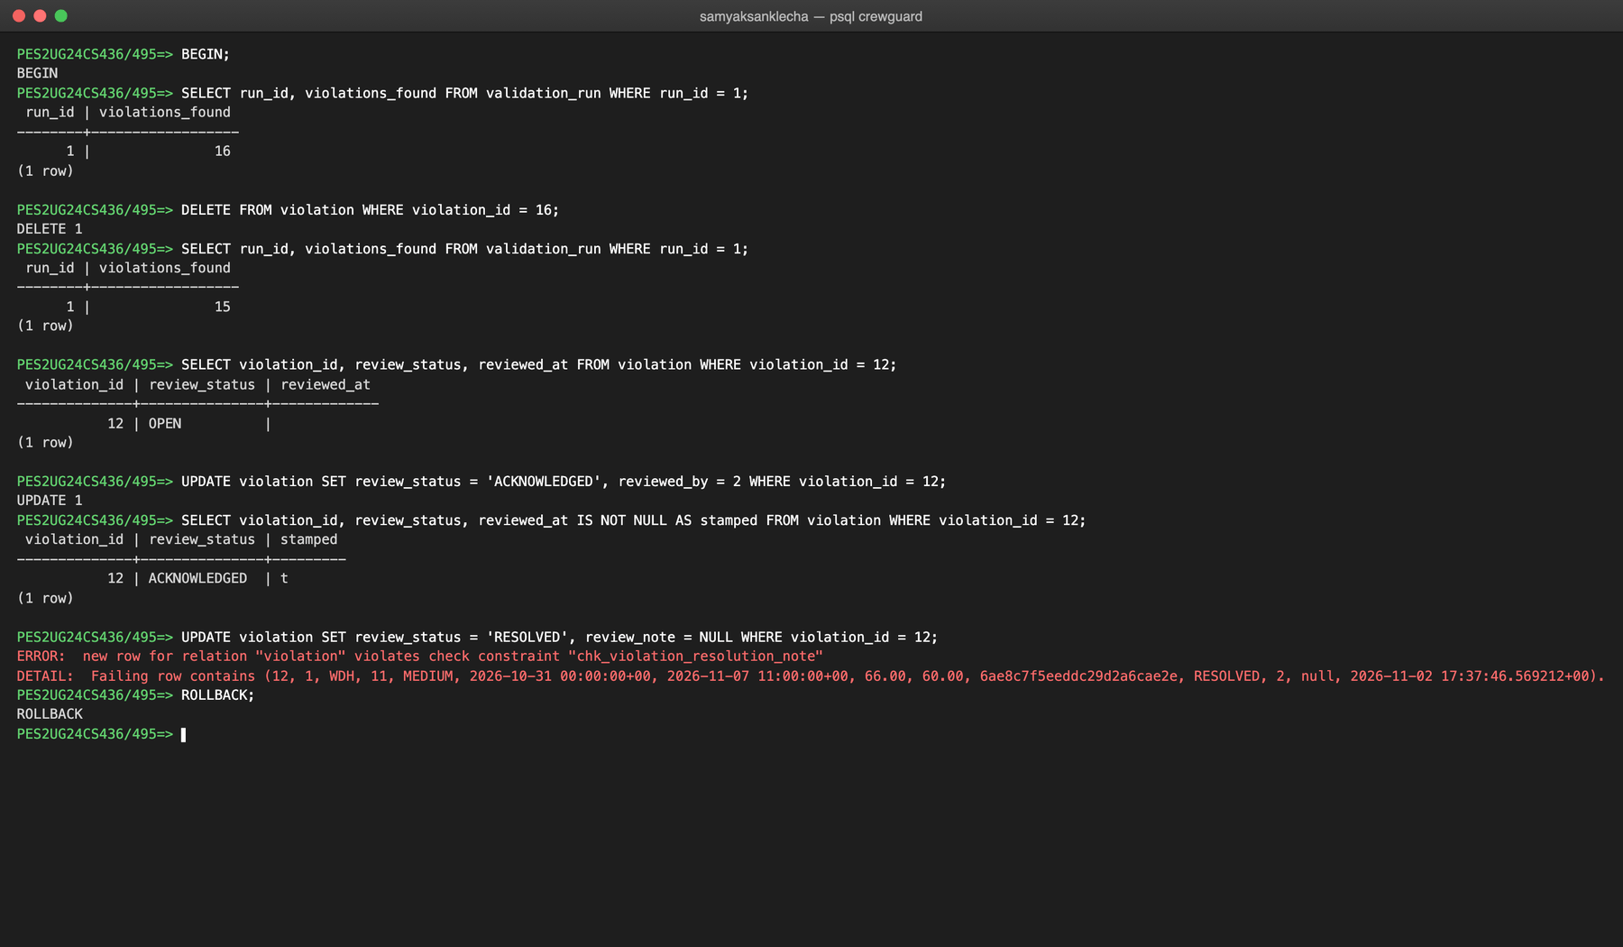
Figure 8.6: Compliance triggers maintaining the count and the review time, and the resolution-note CHECK

9. FRONT END DEVELOPMENT
The front end is a Next.js 16 application written in TypeScript with React 19 and Tailwind CSS. Pages are server components that query the database directly on the server; forms send JSON to API route handlers that check the user's role and run parameterised SQL. The browser never connects to a database.
9.1 System architecture
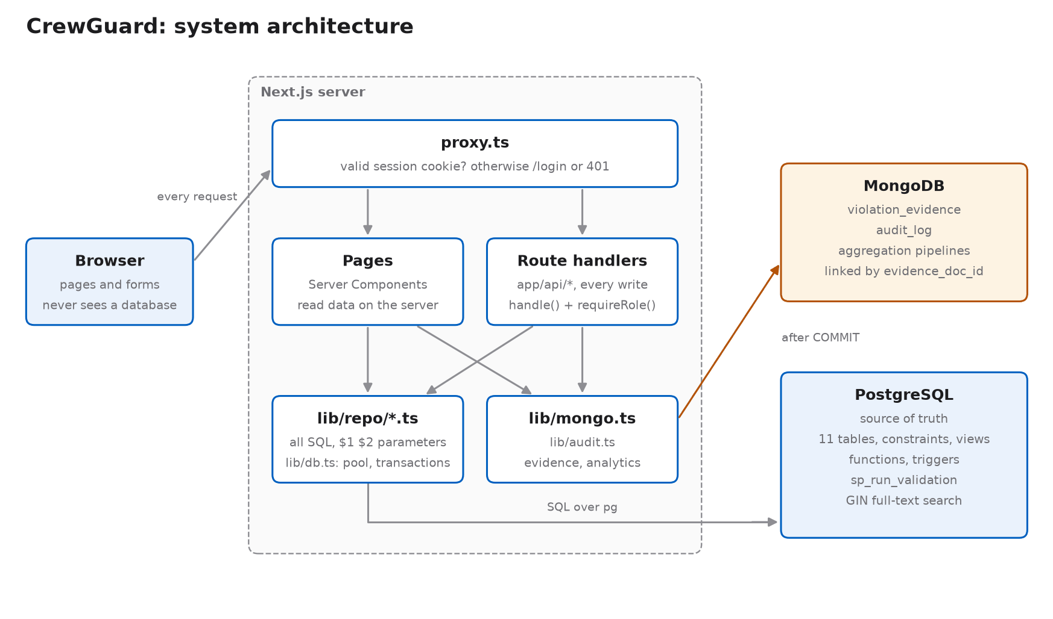
Figure 9.1: System architecture
A request travels through the following layers. As an example, when the scheduler assigns crew to a flight:
• Form: components/assign-crew-form.tsx posts the selected crew and duty times as JSON to /api/flights/[id]/duties.
• Session check: proxy.ts runs before every request and rejects anyone without a valid signed session cookie.
• Route handler: app/api/flights/[id]/duties/route.ts calls requireRole("SCHEDULER"), so an auditor receives HTTP 403.
• SQL: lib/repo/flights.ts runs one INSERT per crew member inside withTransaction from lib/db.ts (BEGIN, the INSERTs, COMMIT or ROLLBACK), so the assignment is all or nothing.
• Database: PostgreSQL fires trg_validate_duty and checks the CHECK, UNIQUE, EXCLUDE and FOREIGN KEY constraints.
• Error mapping: if a constraint fails, lib/api.ts maps its name to a readable message, and the page shows the message together with the name of the constraint that rejected the row.
9.2 Connecting the backend to the databases
lib/db.ts creates one PostgreSQL connection pool for the server process with the node-postgres driver. The connection string comes from the environment, never from code. Every query passes its values separately as $1, $2, ... so user input can never be executed as SQL, which prevents SQL injection. withTransaction runs several statements on a single pooled connection between BEGIN and COMMIT, and rolls back if any of them fails.
export const pool =
globalForPg.pgPool ??
new Pool({
connectionString: process.env.DATABASE_URL, // from .env.local, never hard-coded
options: "-c timezone=UTC", // the roster is in UTC, so date casts are too
max: 10,
});
if (process.env.NODE_ENV
...
export async function query<T extends QueryResultRow>(text: string, params: unknown[] = []): Promise<T[]> {
const { rows } = await pool.query<T>(text, params);
return rows;
}
export async function withTransaction<T>(fn: (client: PoolClient) => Promise<T>): Promise<T> {
const client = await pool.connect();
try {
await client.query("BEGIN");
const result = await fn(client);
await client.query("COMMIT");
return result;
} catch (err) {
await client.query("ROLLBACK");
throw err;
} finally {
client.release(); // give the connection back to the pool
}
}
lib/mongo.ts does the same for MongoDB: one shared client, the URI from the environment, a two-second server-selection timeout and idempotent index creation on start-up. PostgreSQL is the source of truth: the evidence is written to MongoDB only after the validation transaction commits, and if MongoDB is unavailable the violations still exist and the page reports that the evidence is unavailable.
9.3 MongoDB: evidence, activity log and aggregation
The violation_evidence collection holds one document per violation, whose evidence part has a different shape for each rule (a rest gap, a seven-day breakdown, certificate details), which a flexible document stores more cleanly than many nullable columns. Its ObjectId is saved in violation.evidence_doc_id, the link between the two databases. The audit_log collection is append-only and records every login, roster change, validation run and review. The dashboard's charts are aggregation pipelines ($match, $group, $sort, $limit, $avg).
Data | Store | Reason
Airports, aircraft, users, crew, ratings, flights, duties, rules, runs, violations | PostgreSQL | Related data that needs keys, constraints, transactions and temporal SQL
violation_evidence | MongoDB | Shape differs per rule; a frozen snapshot taken at run time
audit_log | MongoDB | Append-only, write-heavy, different payload per action, never joined
Table 9.1: Choice of database for each kind of data
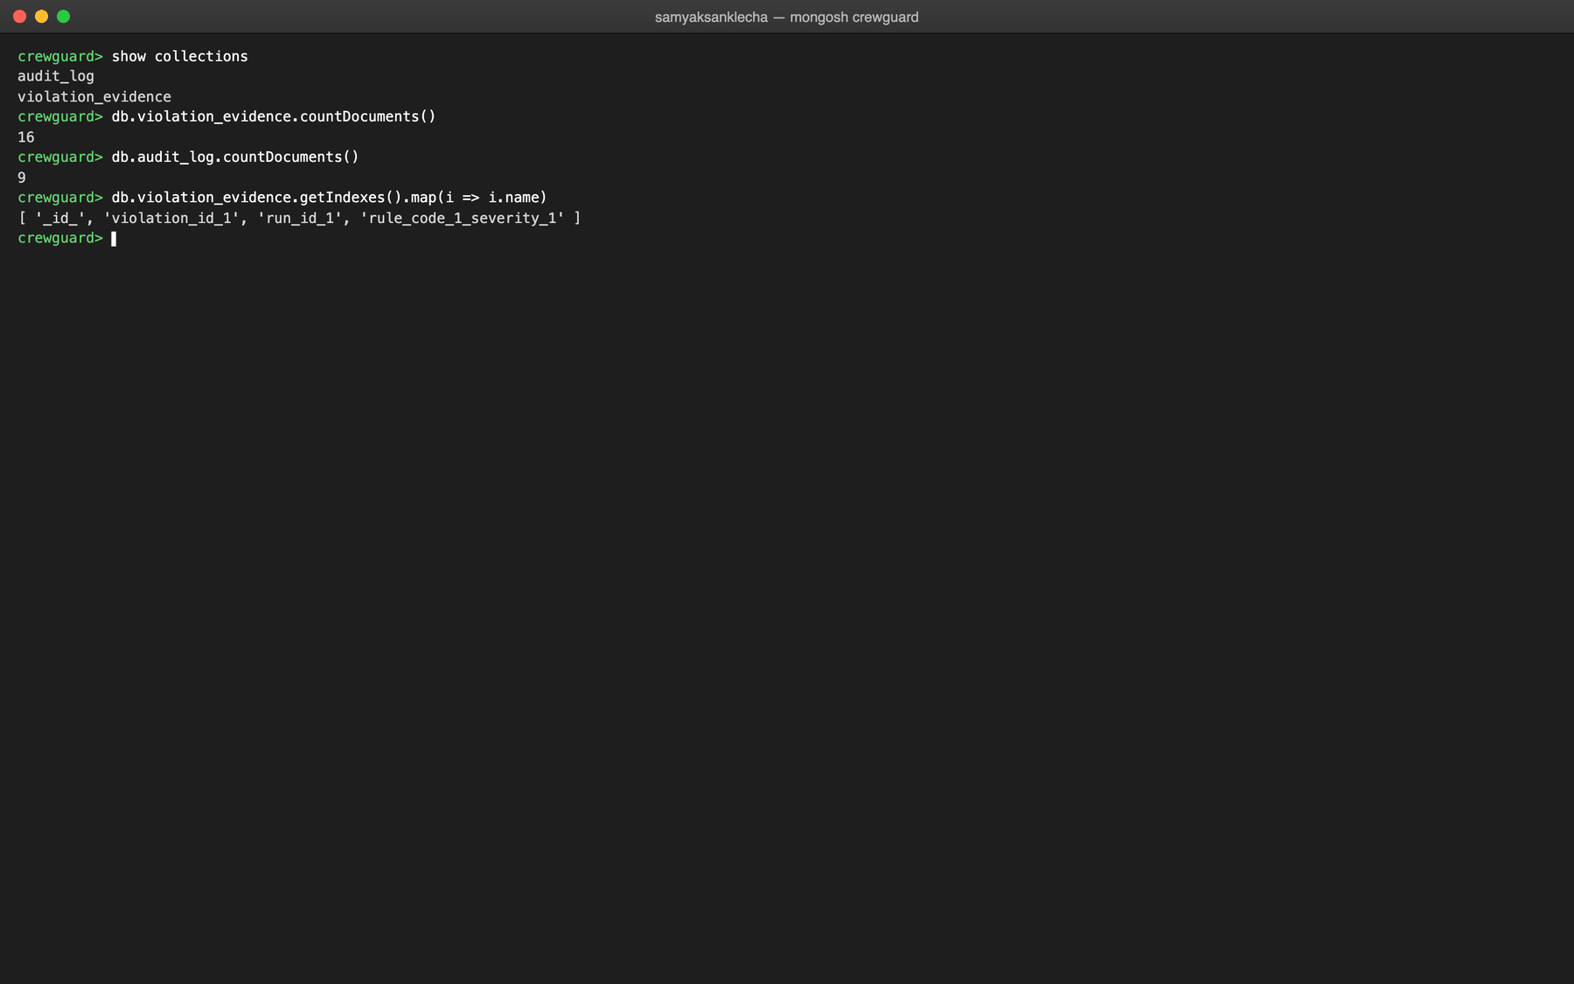
Figure 9.2: MongoDB collections, document counts and indexes
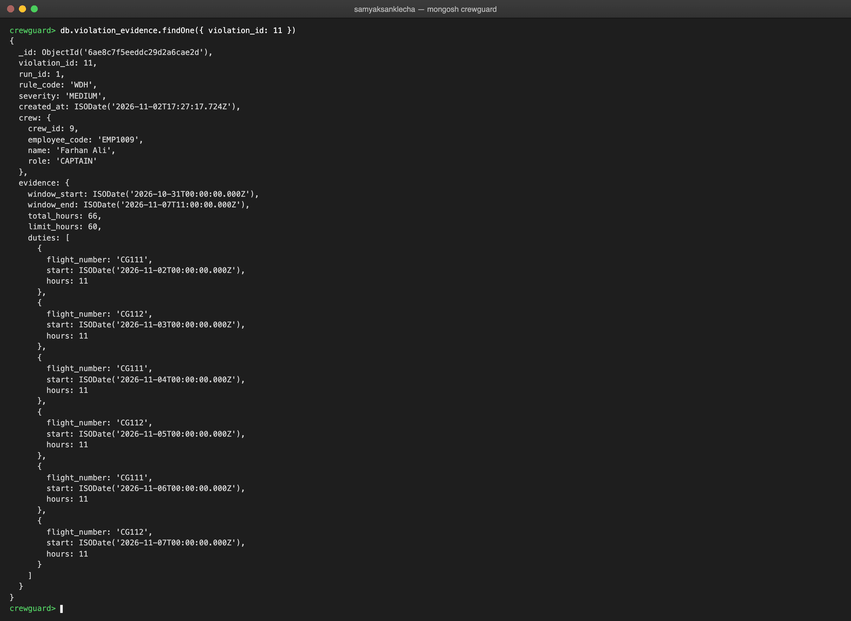
Figure 9.3: A WDH evidence document (violation 11, Farhan Ali)
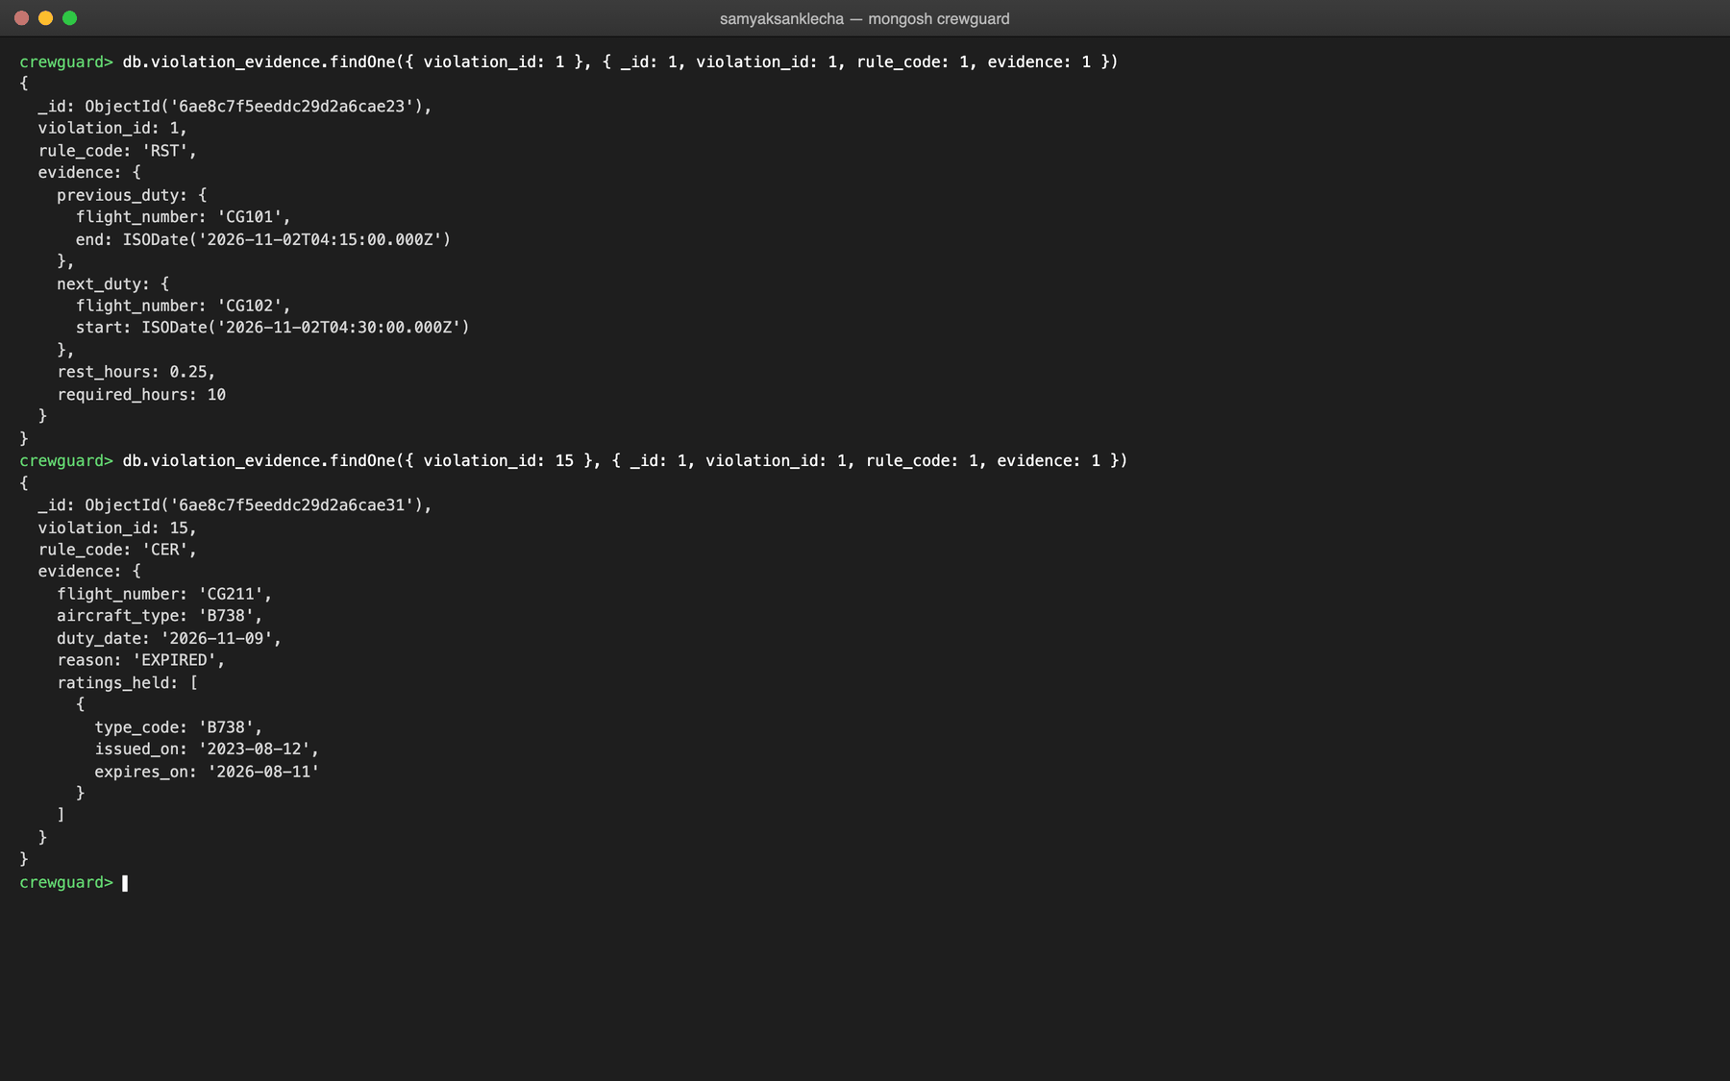
Figure 9.4: Evidence documents for an RST and a CER violation: different shapes per rule
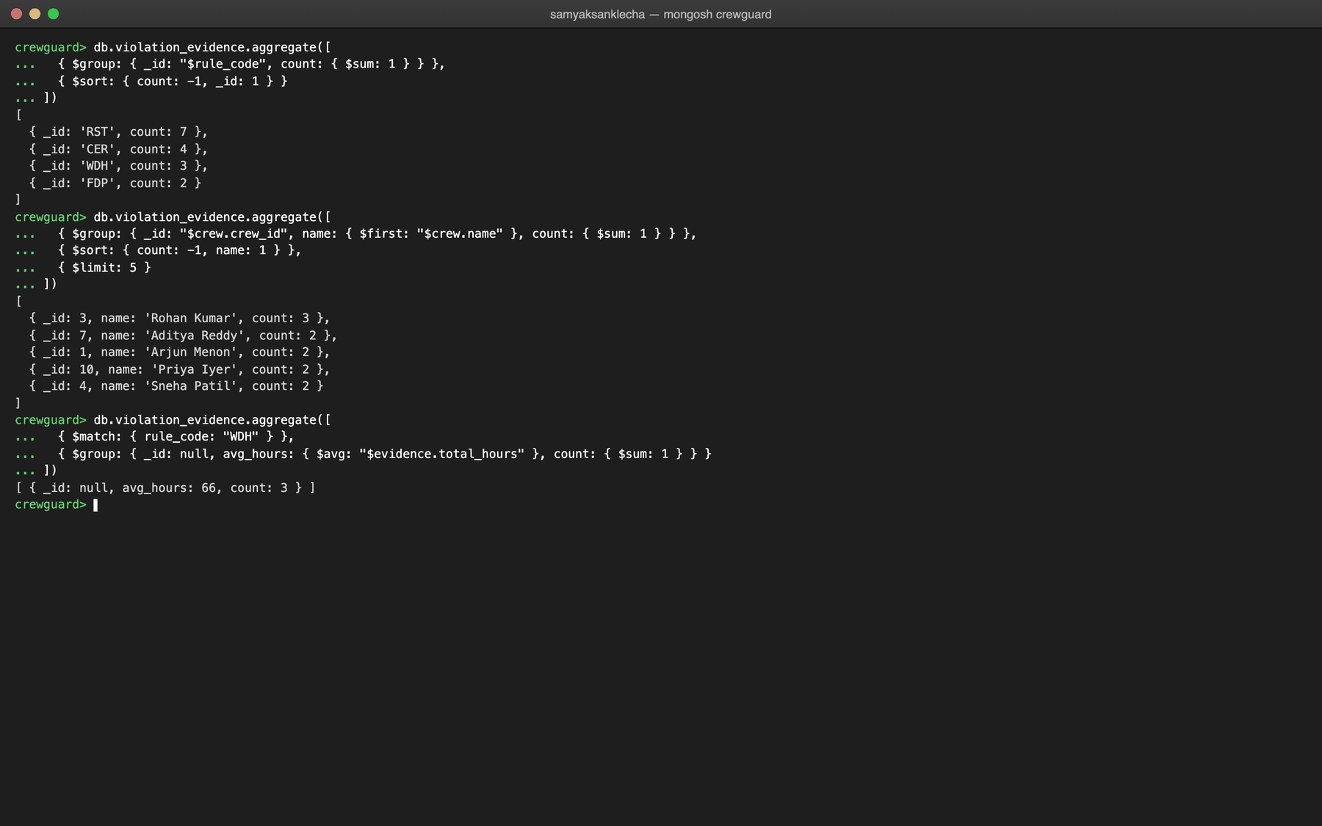
Figure 9.5: Aggregation pipelines behind the dashboard
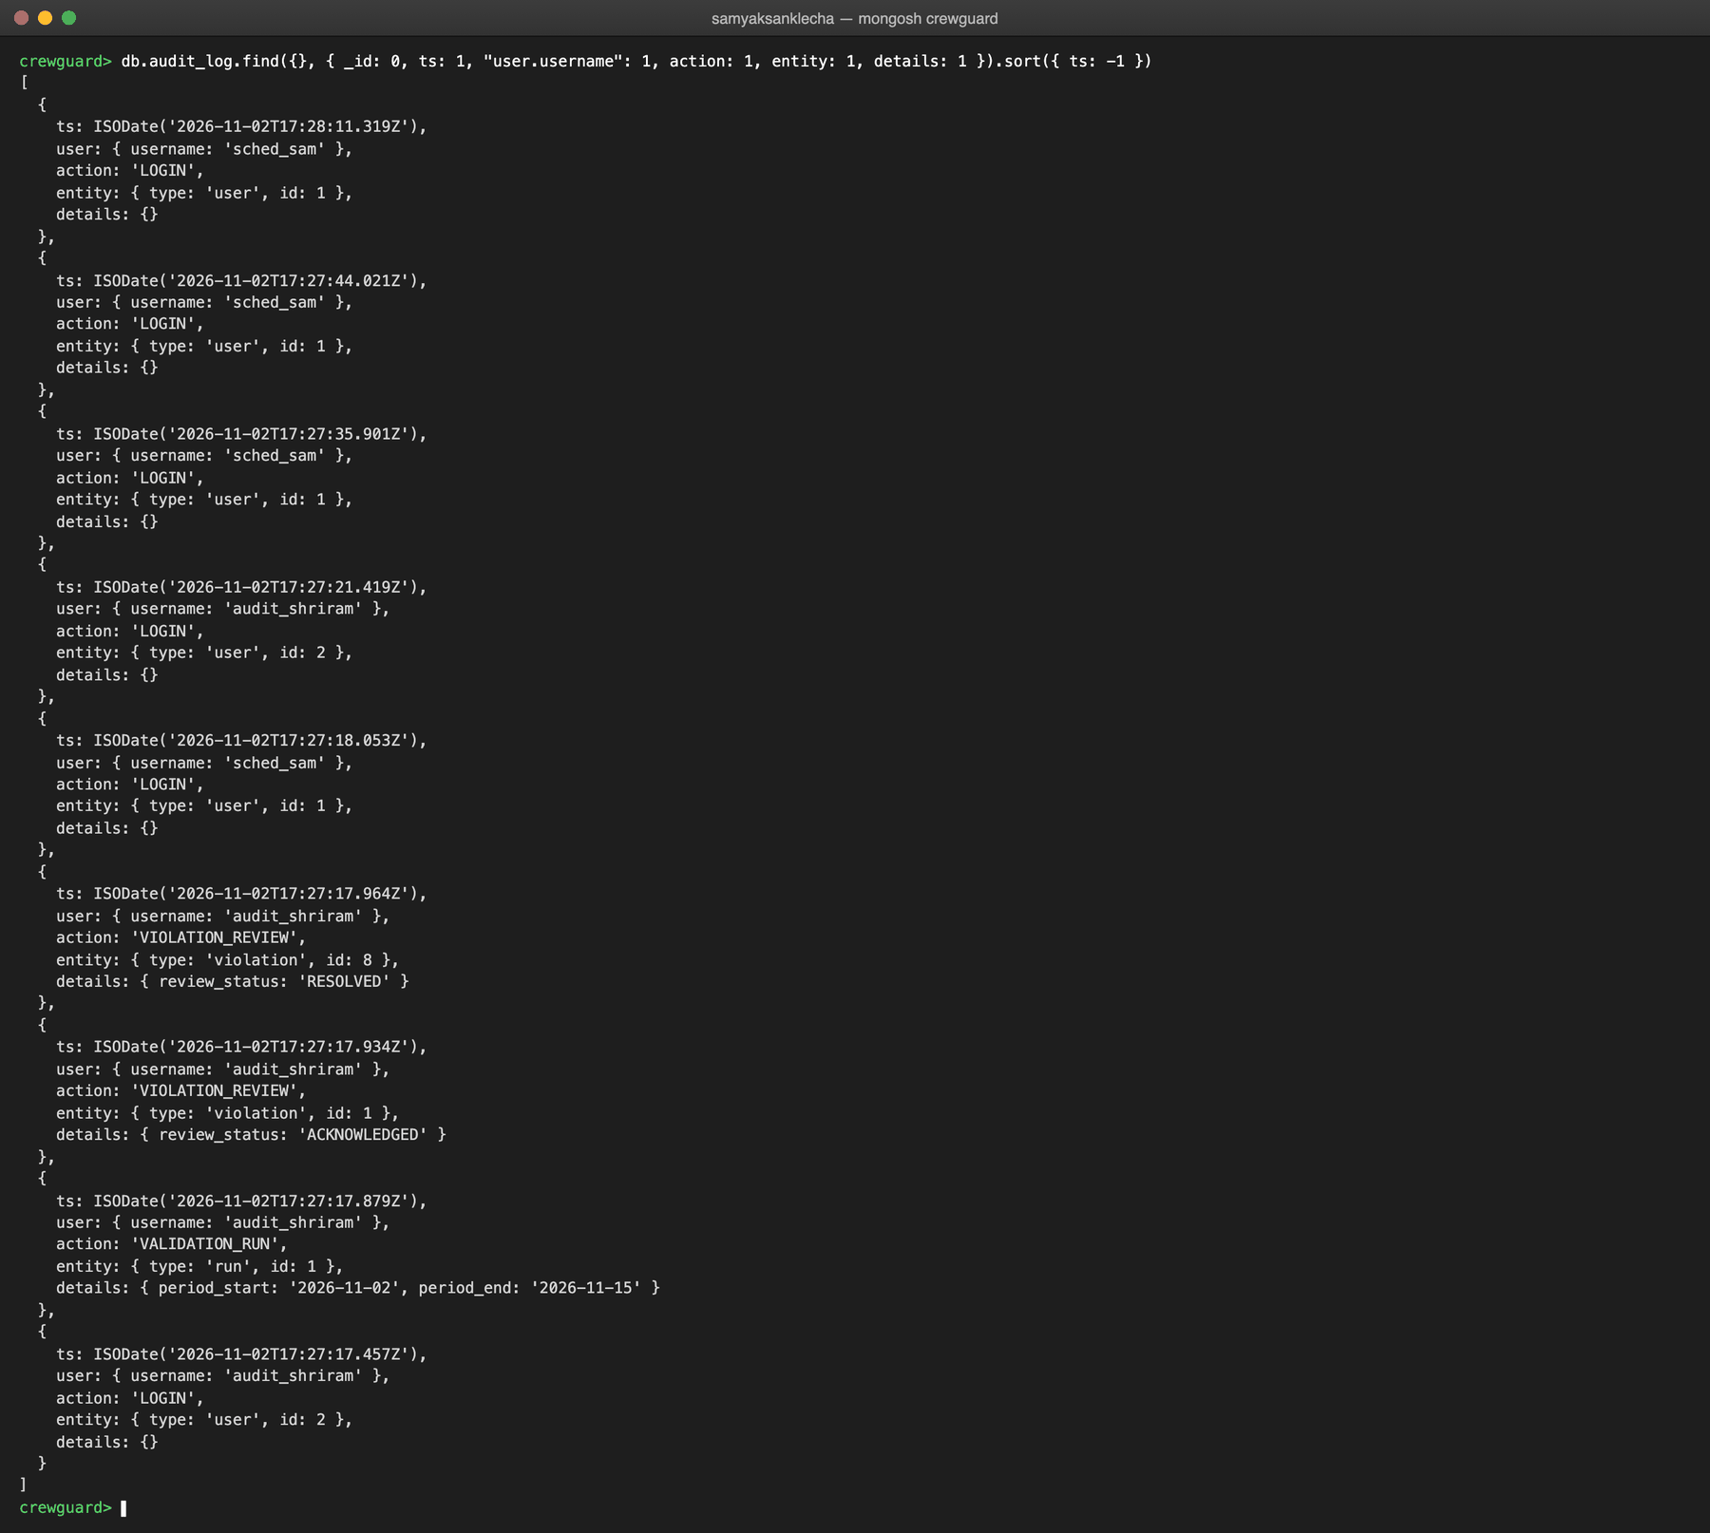
Figure 9.6: The activity log in audit_log
9.4 Application screens
Screens are shown for both roles. The scheduler (sched_sam) manages the roster; the auditor (audit_shriram) runs validations and reviews violations. Flight and duty times are in UTC, as airlines use; times of events such as logins, runs and reviews are shown in IST.
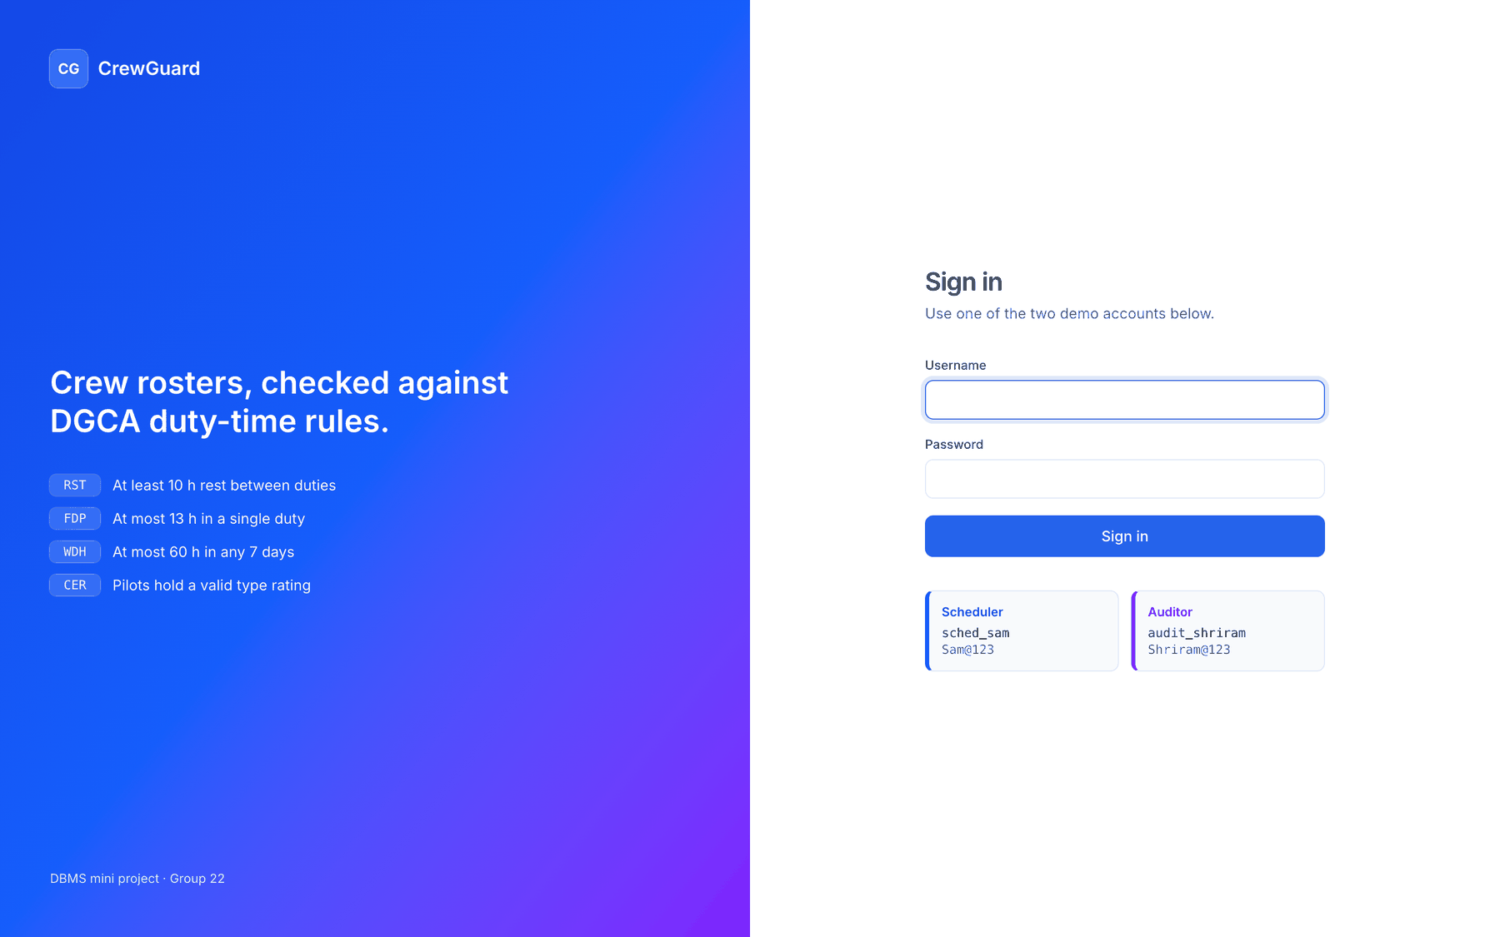
Figure 9.7: Sign-in page with the two demo accounts
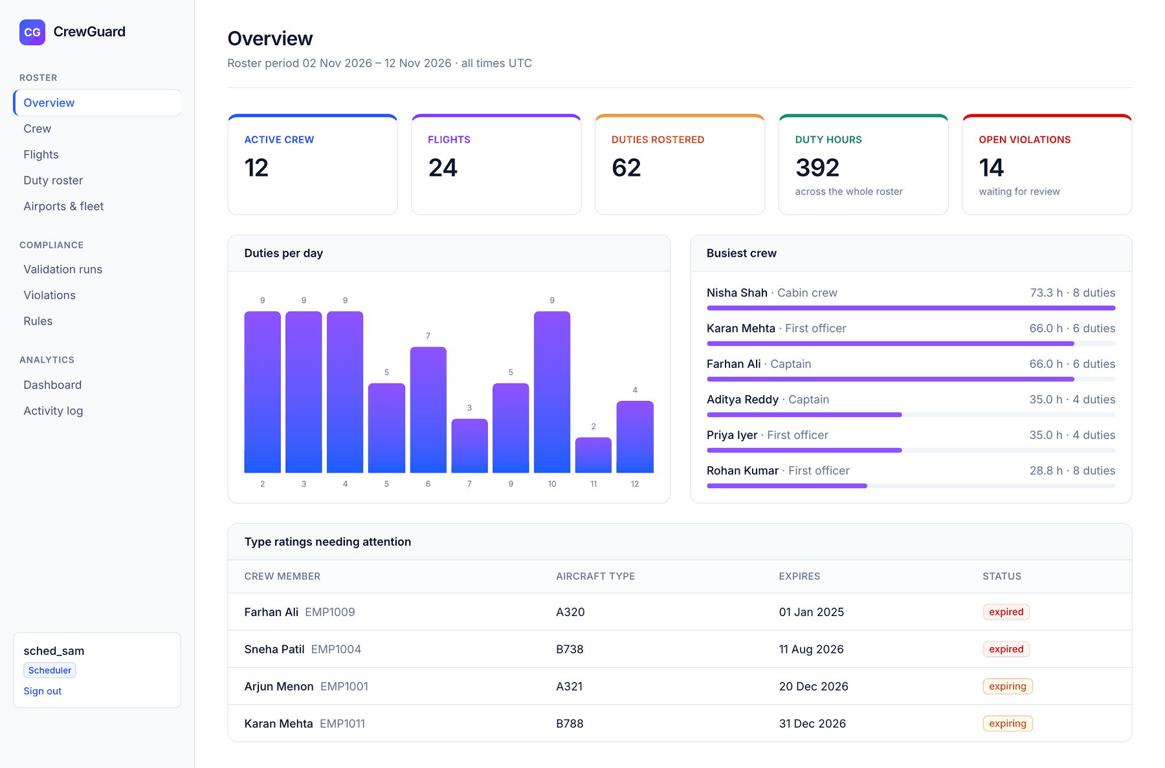
Figure 9.8: Overview (scheduler): roster statistics, duties per day, busiest crew and ratings needing attention
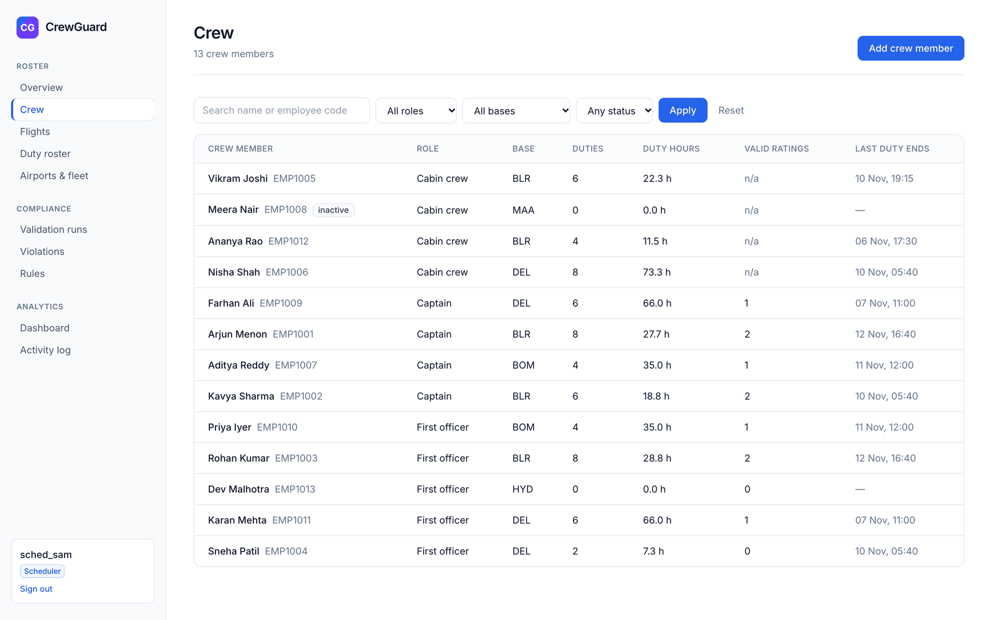
Figure 9.9: Crew list with search and filters, read from v_crew_summary
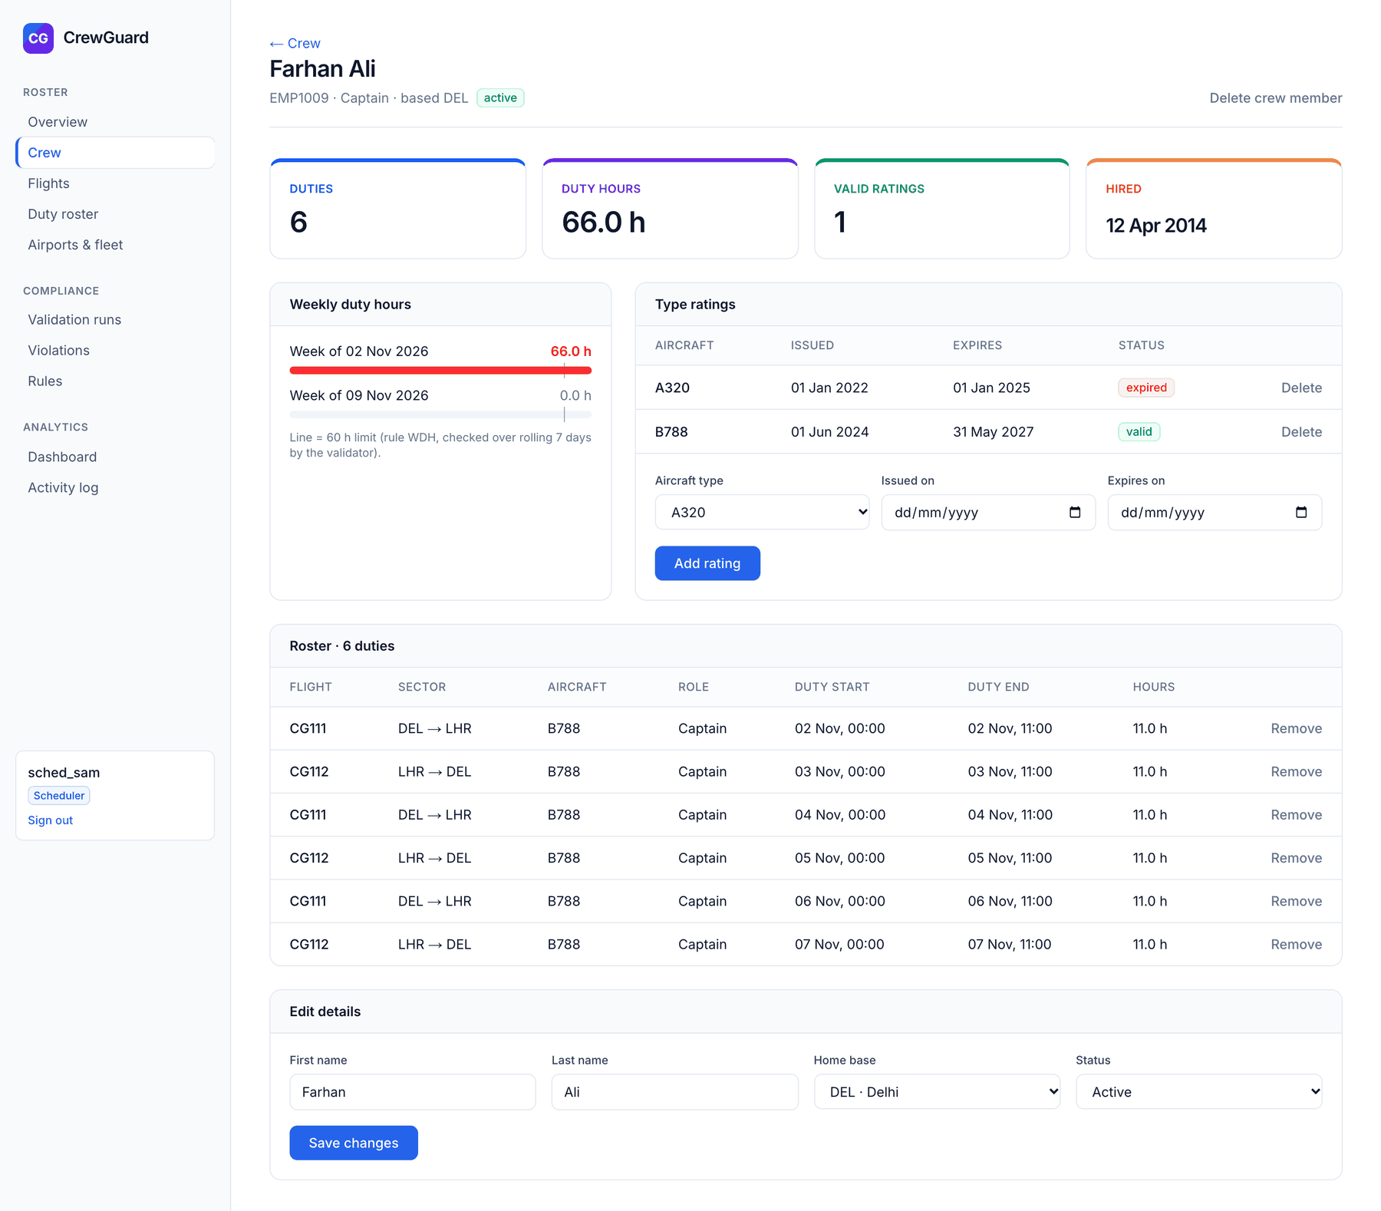
Figure 9.10: Crew detail: weekly duty hours against the 60-hour limit, type ratings and roster
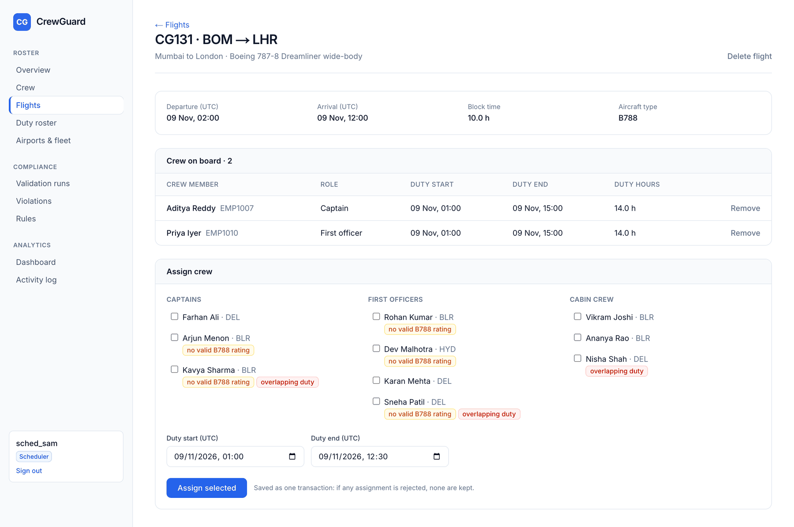
Figure 9.11: Flight detail with the assign-crew form and warnings computed with EXISTS and range overlap
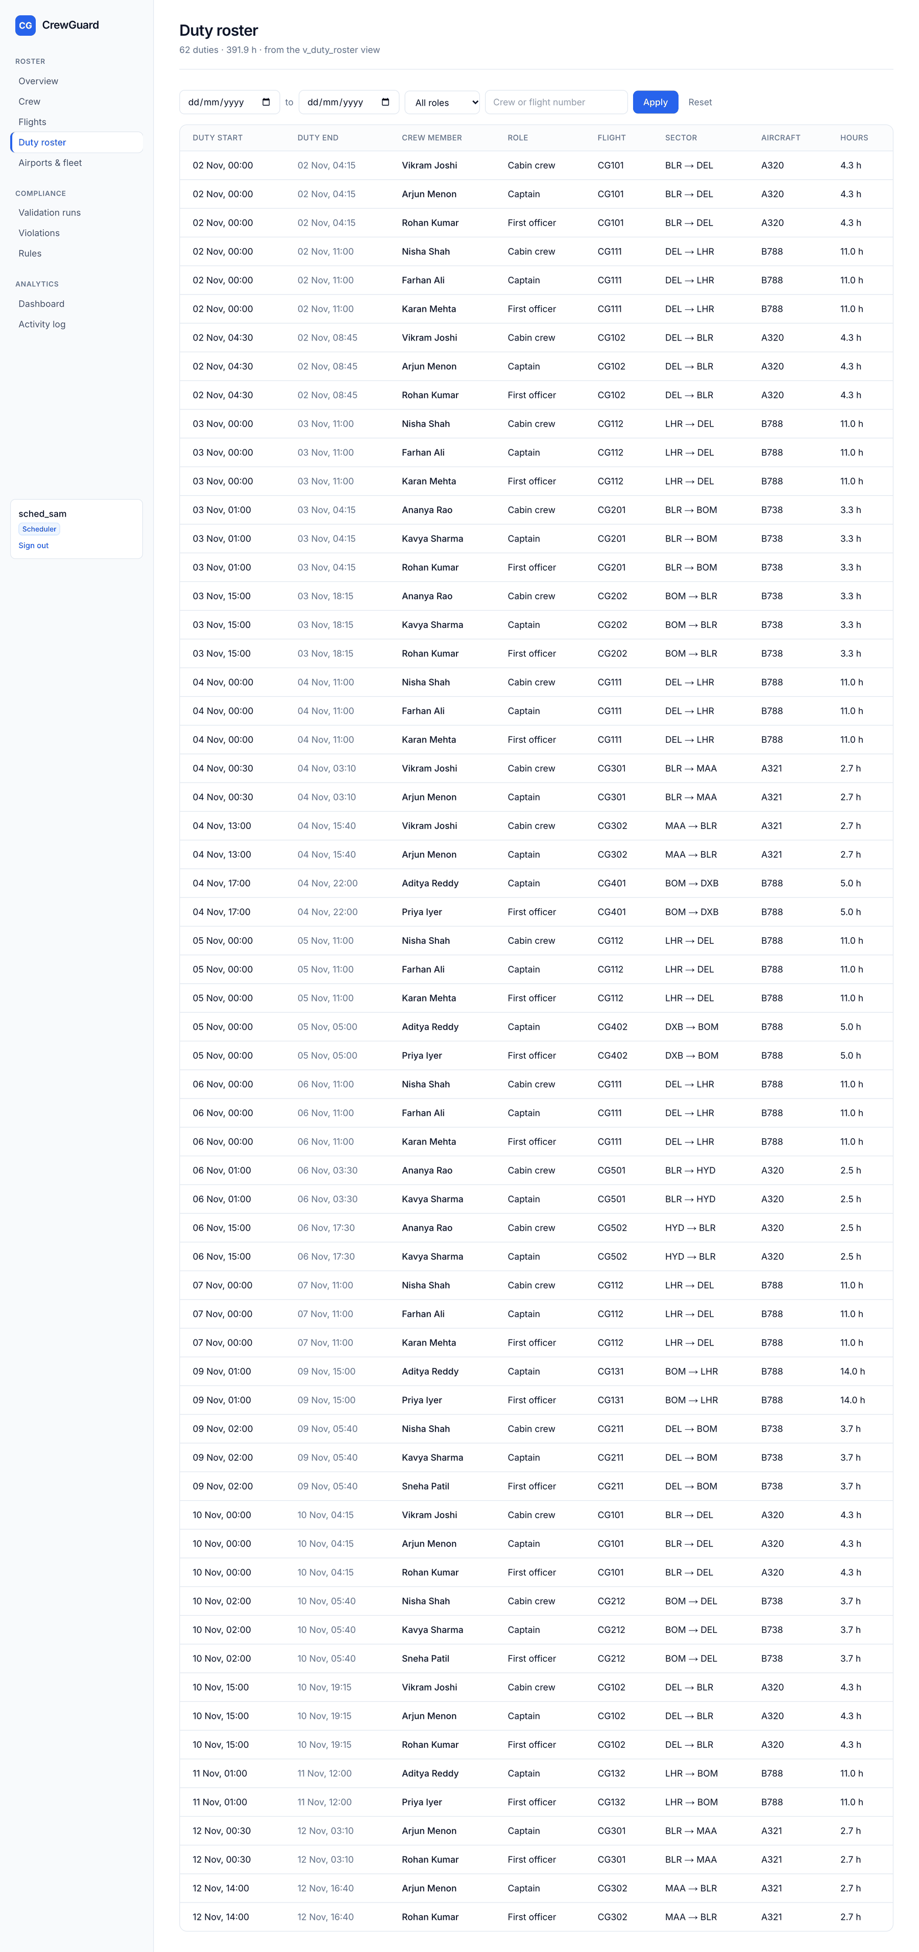
Figure 9.12: Duty roster read from v_duty_roster
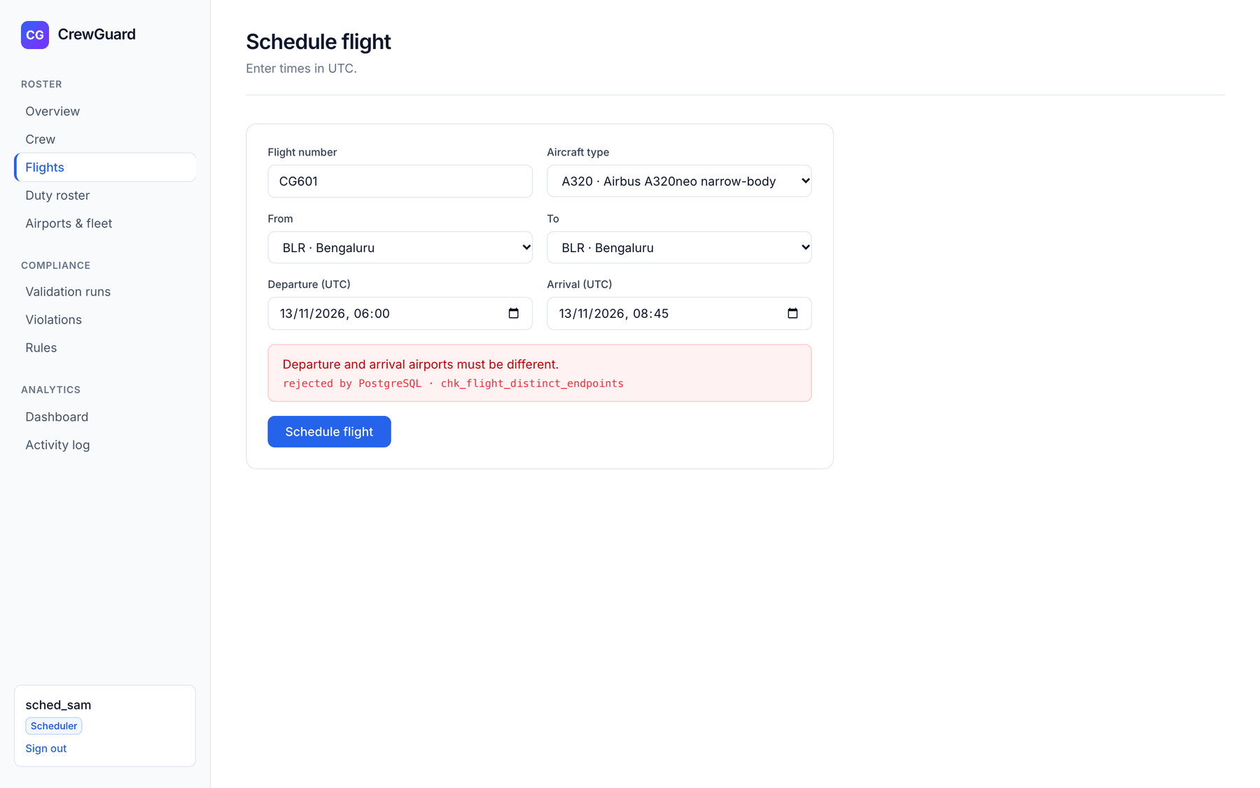
Figure 9.13: Database rejecting a flight with the same departure and arrival airport (CHECK)
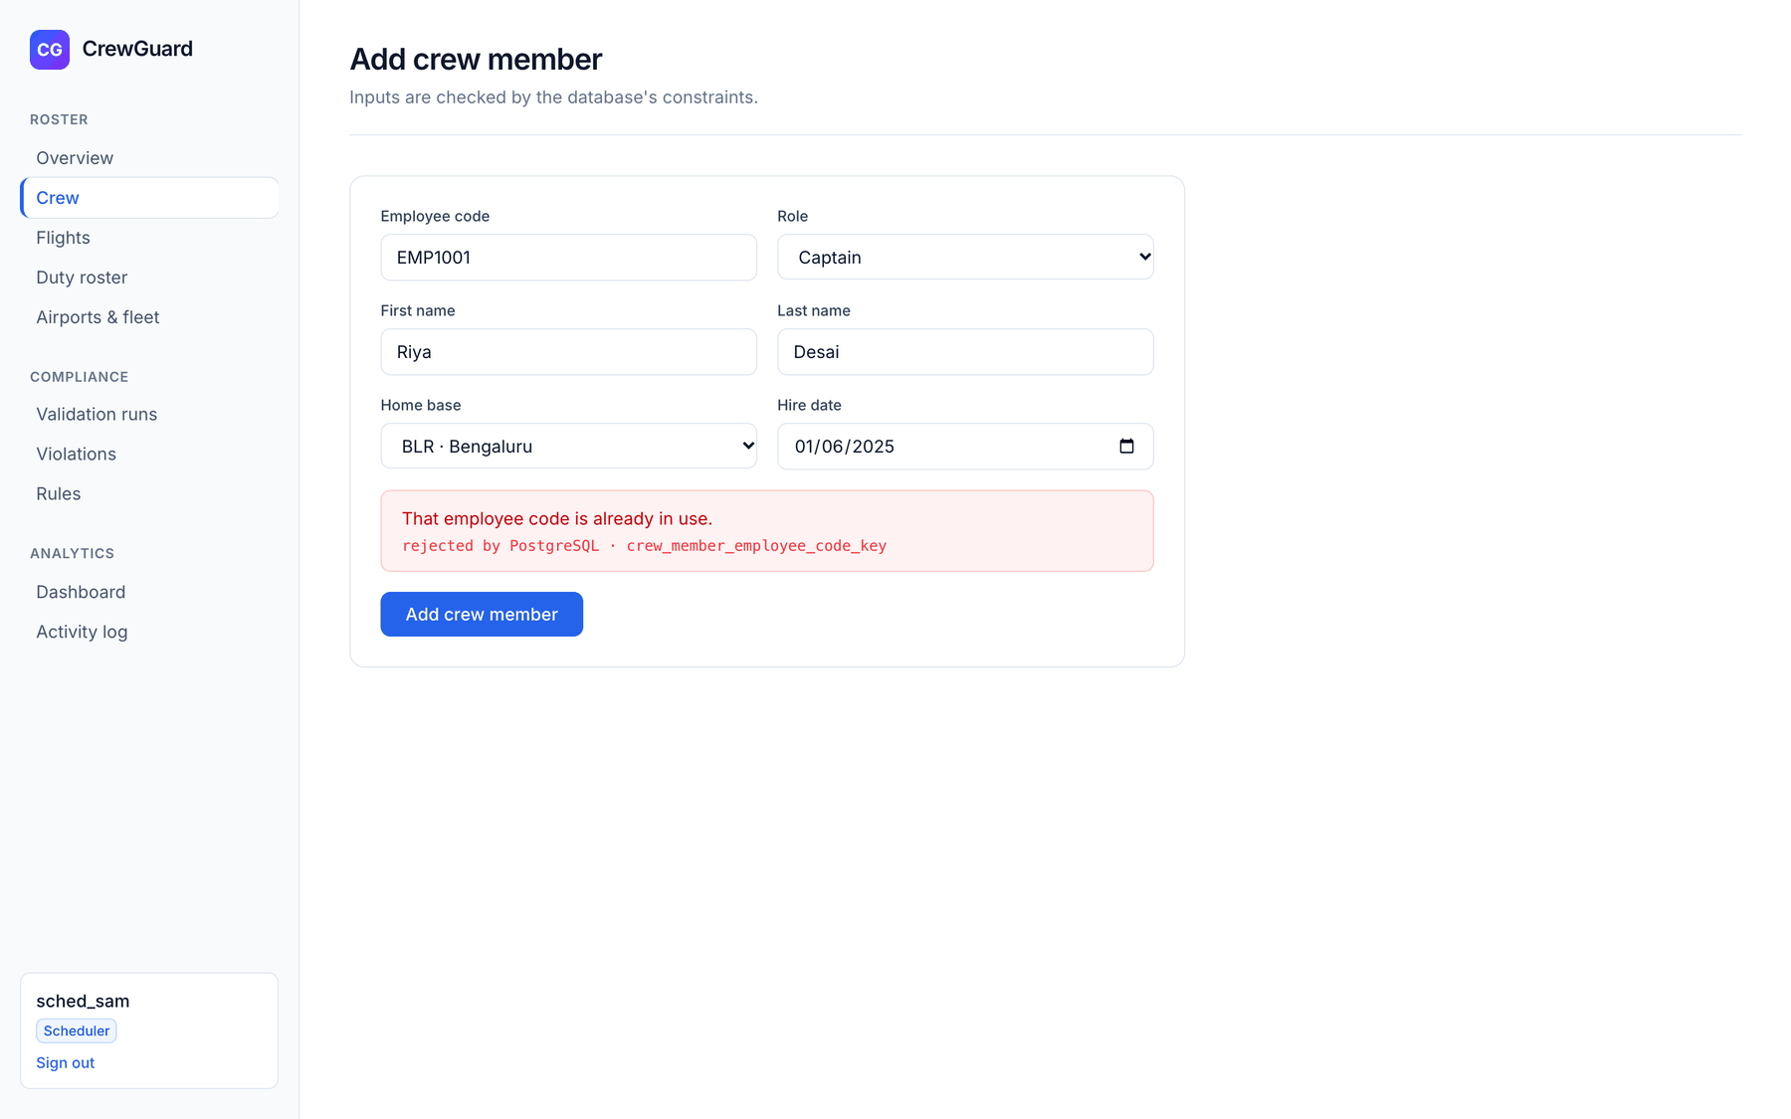
Figure 9.14: Database rejecting a duplicate employee code (UNIQUE)
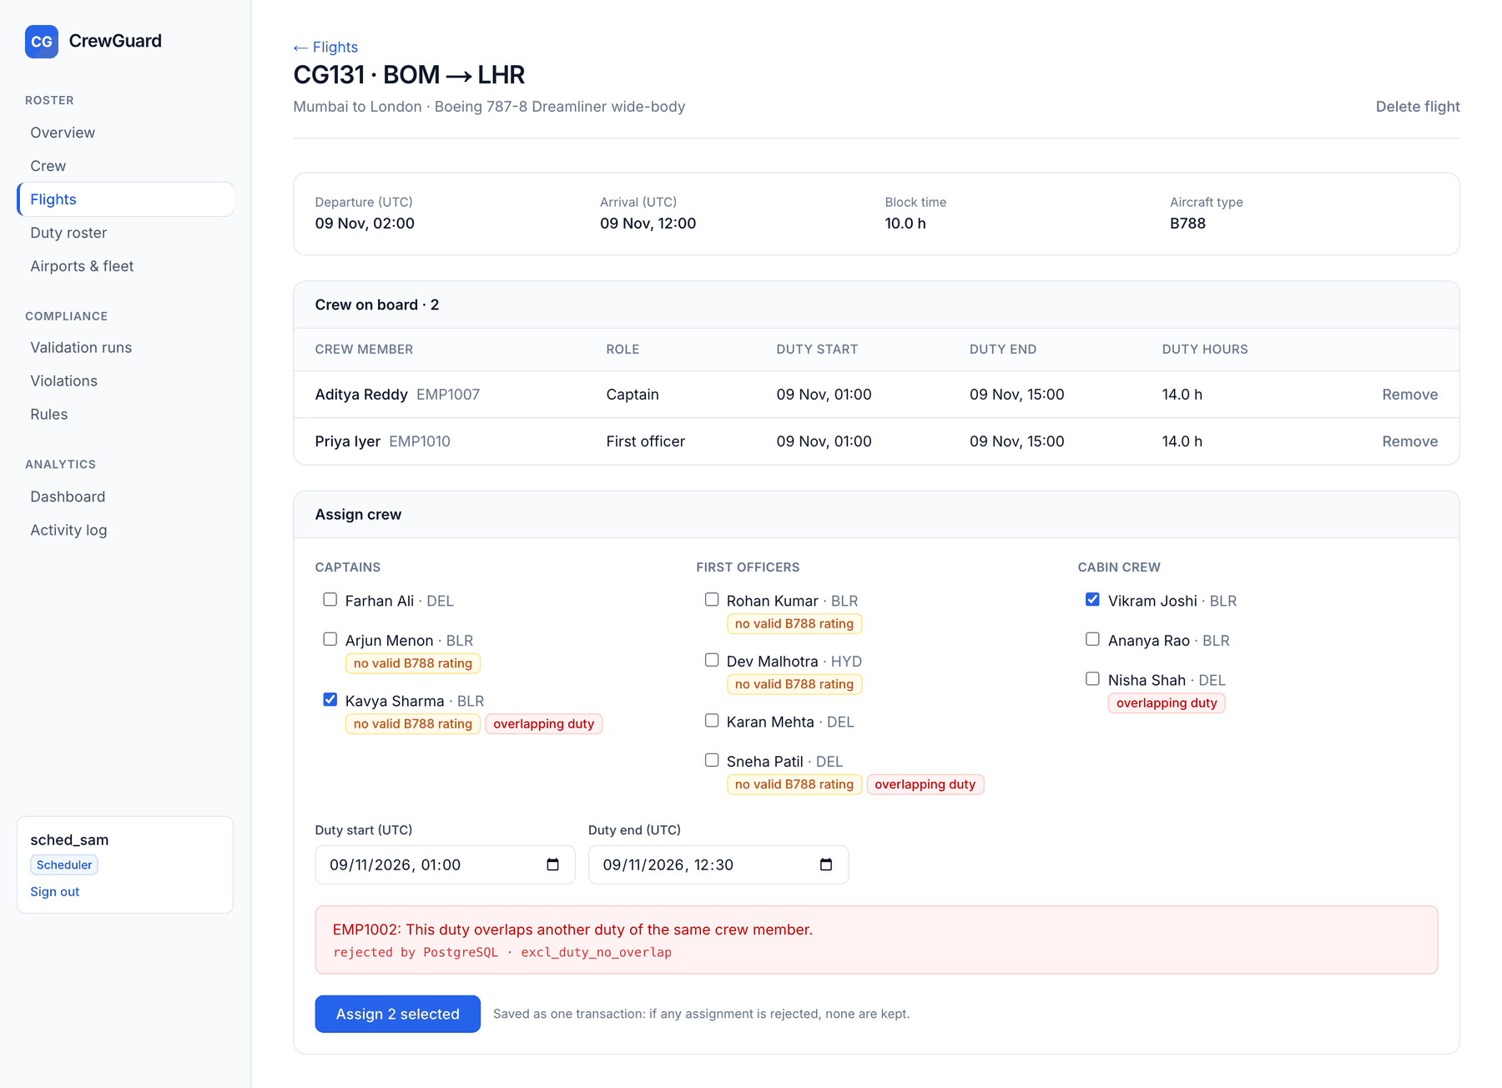
Figure 9.15: Assigning two crew in one transaction: the overlap is rejected by EXCLUDE and neither duty is saved
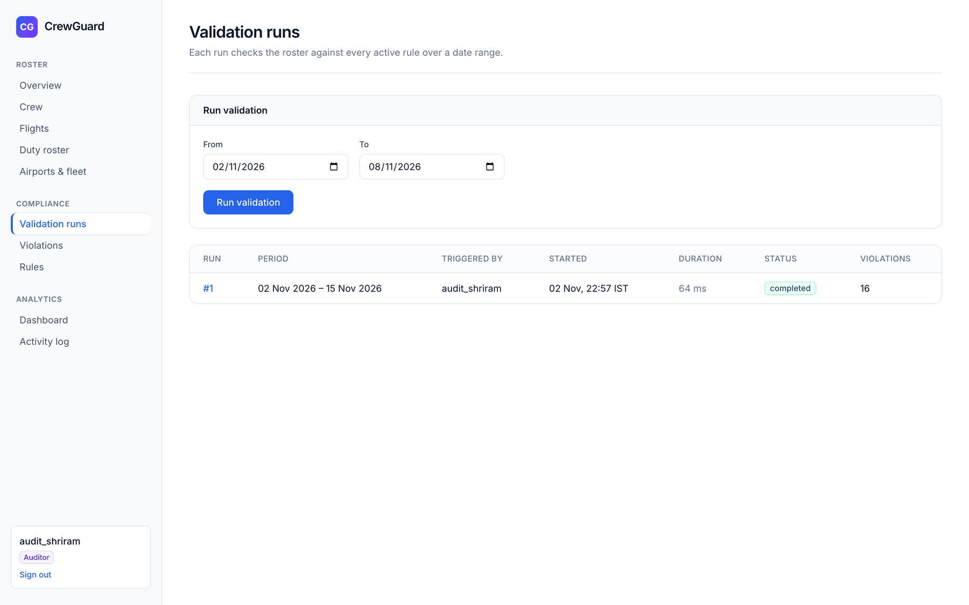
Figure 9.16: Validation runs (auditor) with the run form
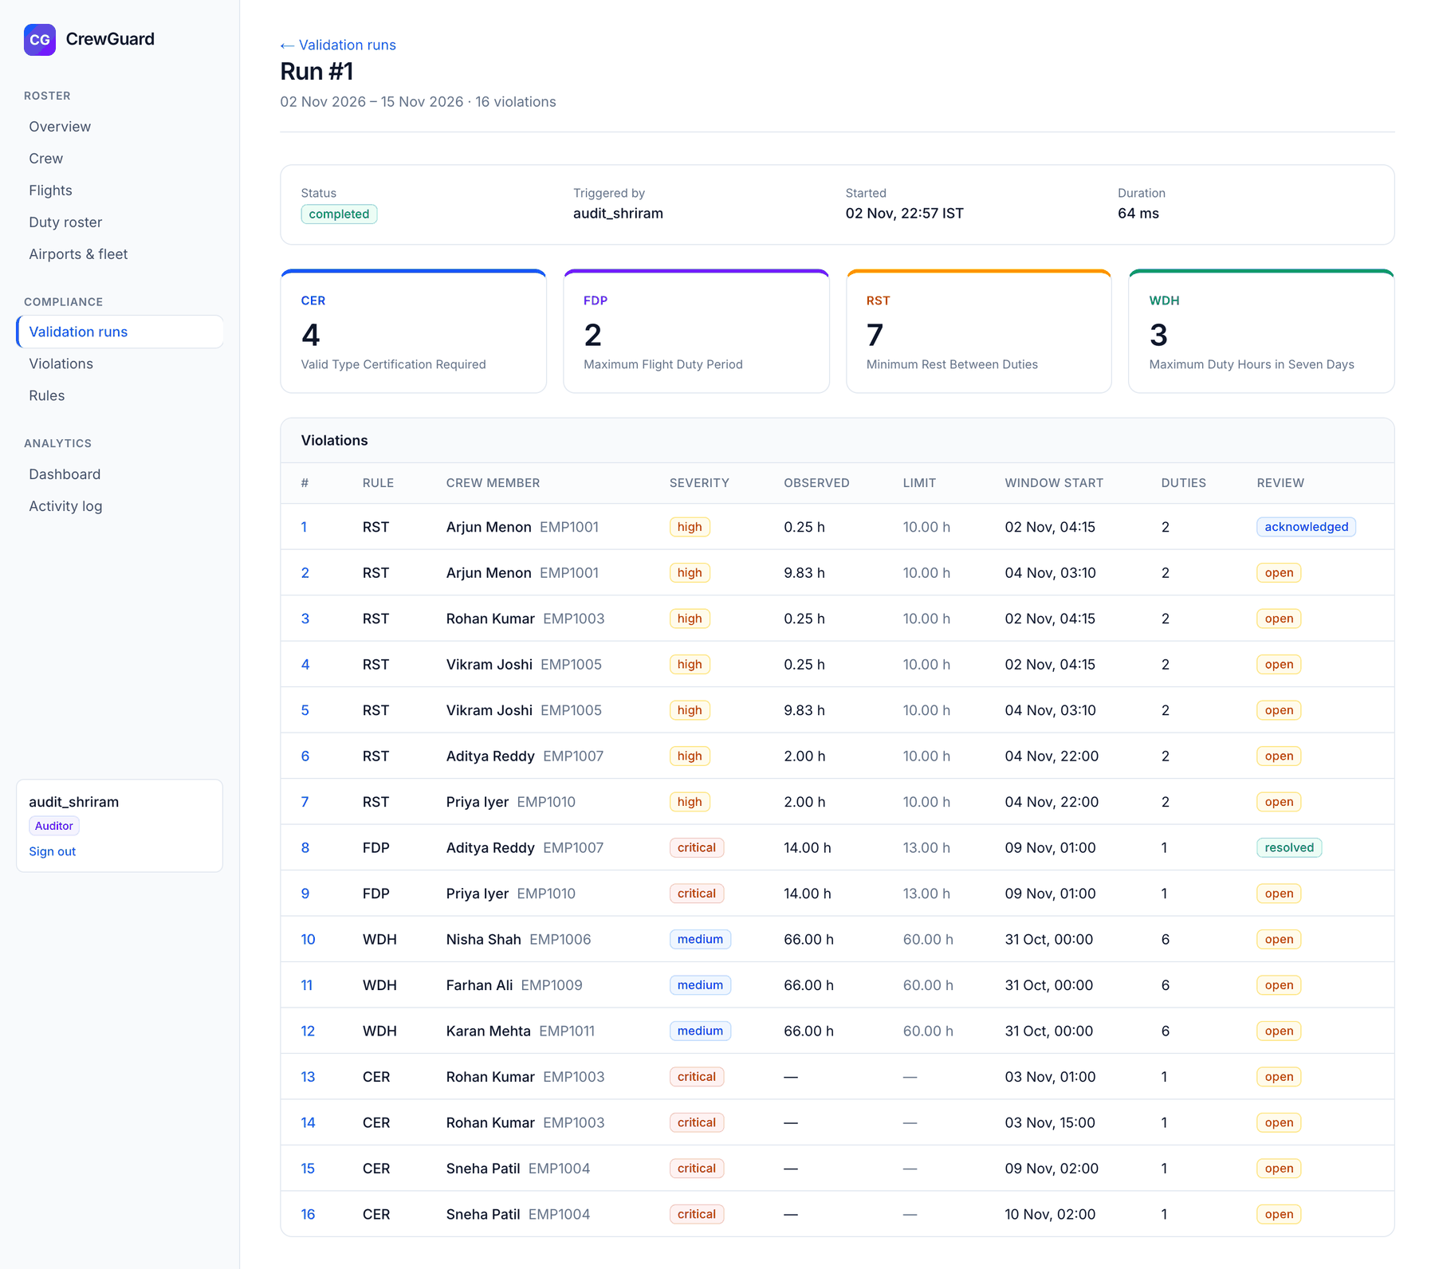
Figure 9.17: Result of one run: violations per rule
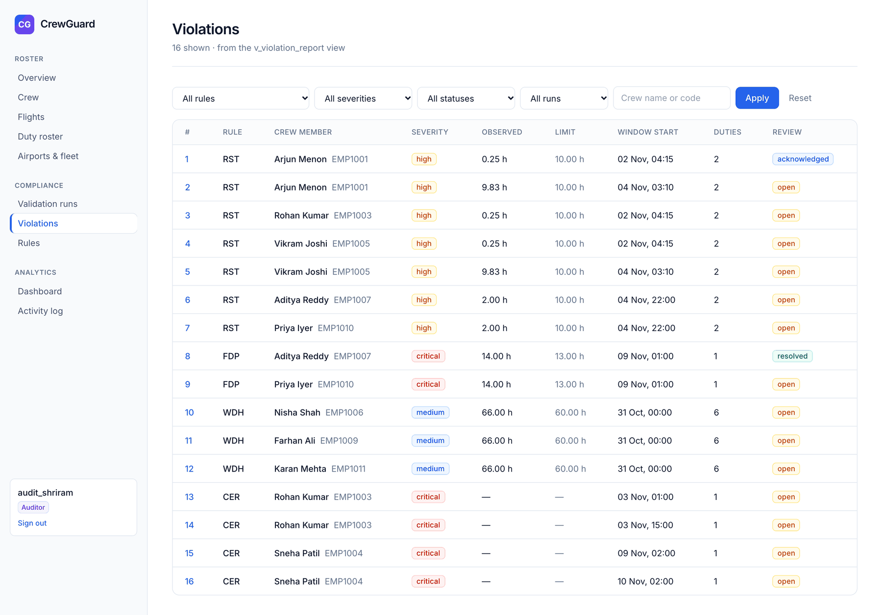
Figure 9.18: Violations list from v_violation_report with filters
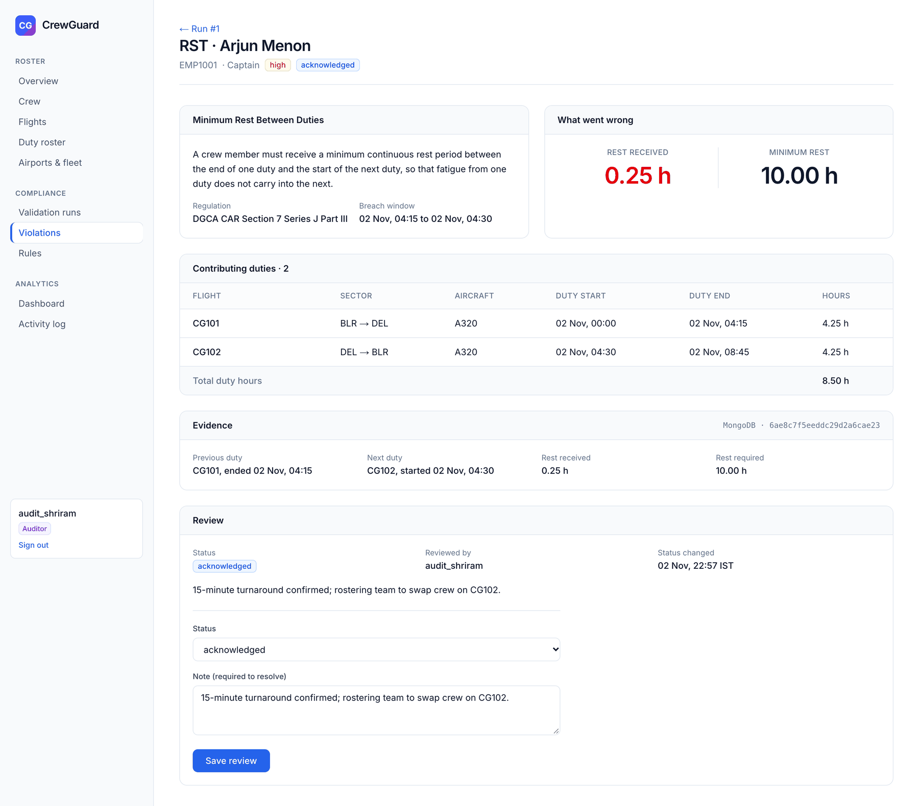
Figure 9.19: Explanation page for an RST violation: rule, observed value, causing duties, MongoDB evidence and review
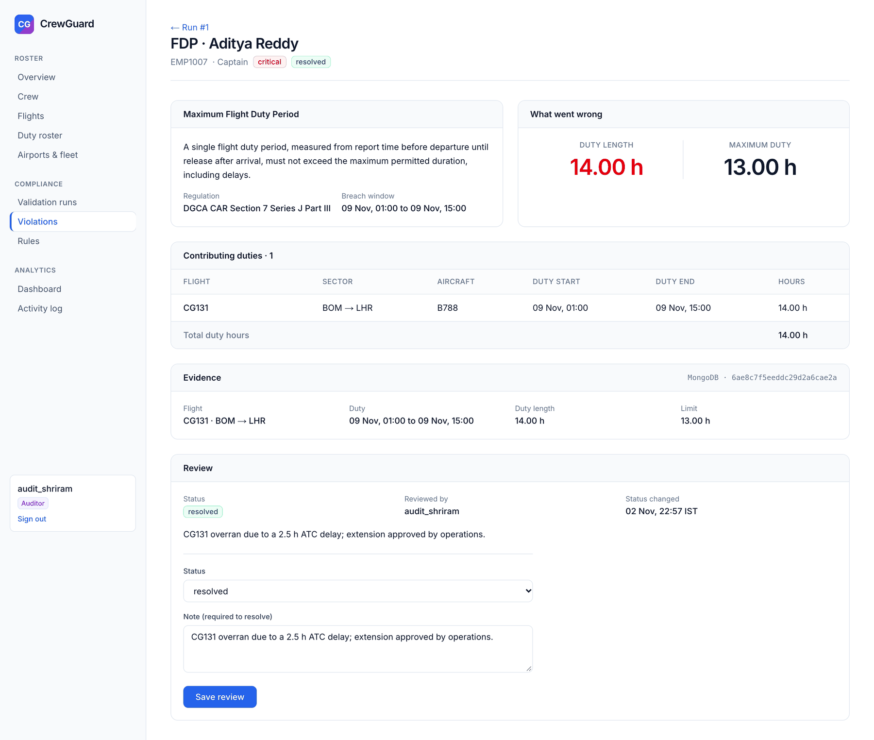
Figure 9.20: Explanation page for an FDP violation (resolved with a note)
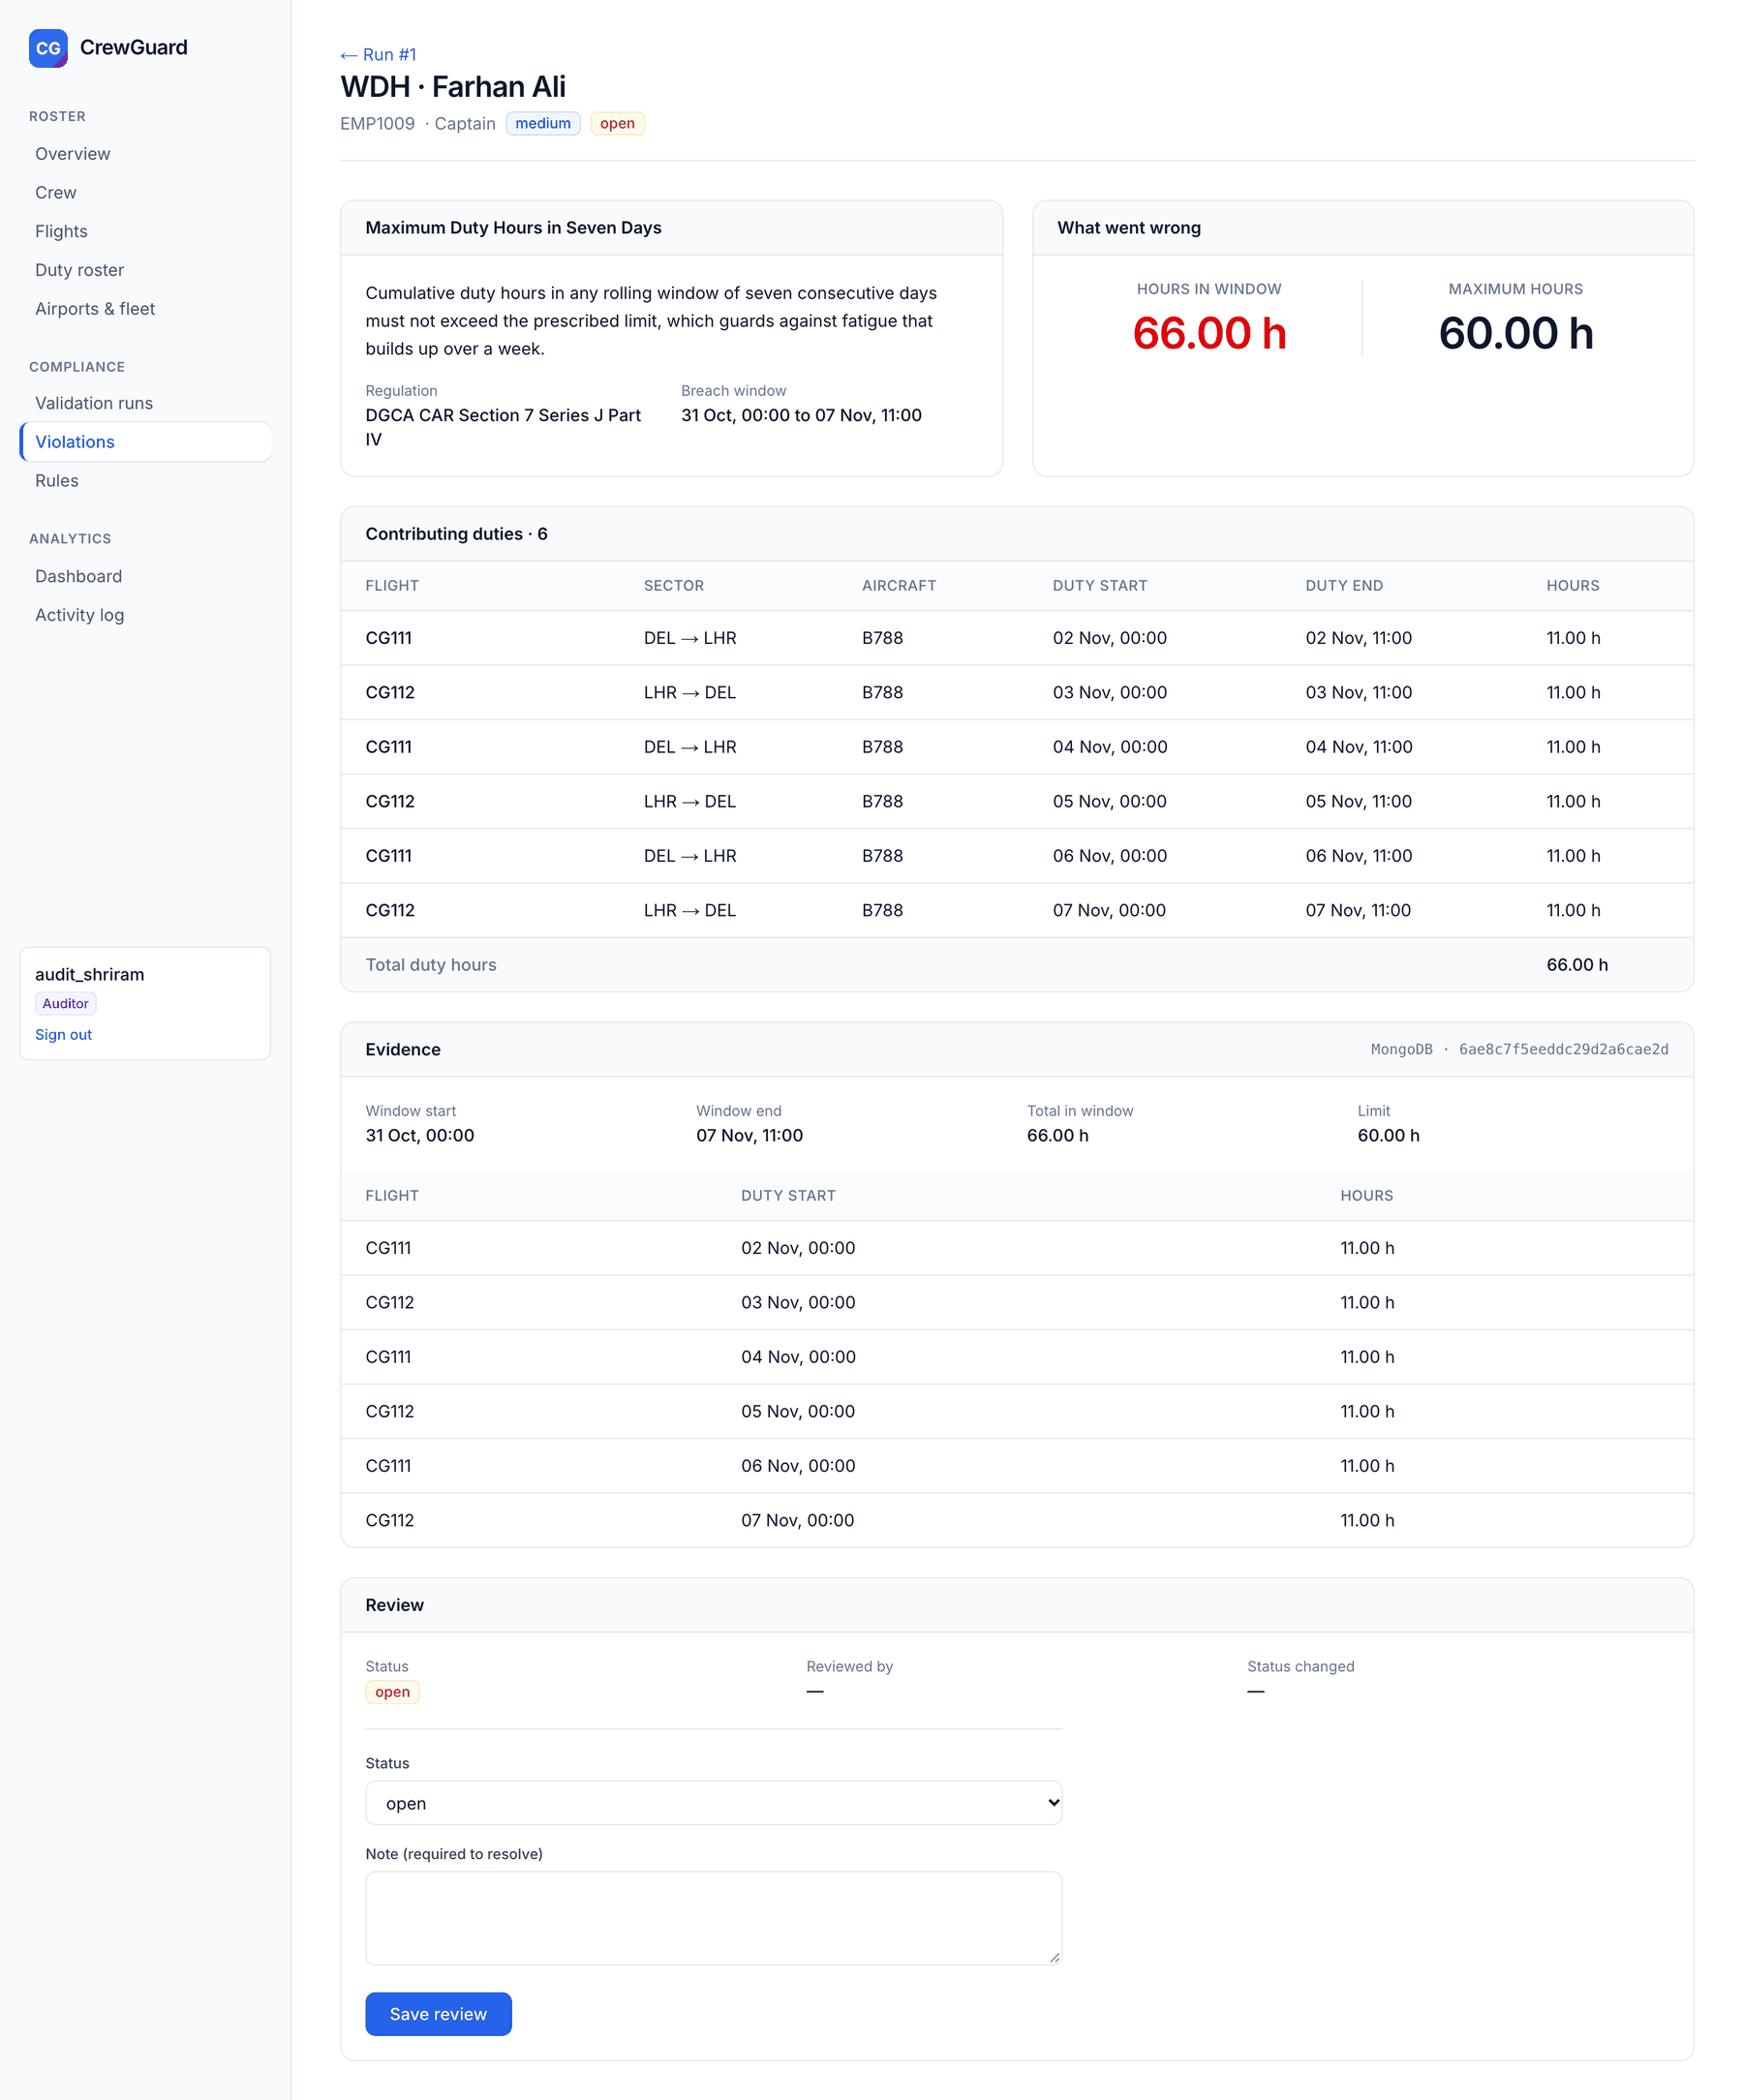
Figure 9.21: Explanation page for a WDH violation: six duties adding up to 66 hours
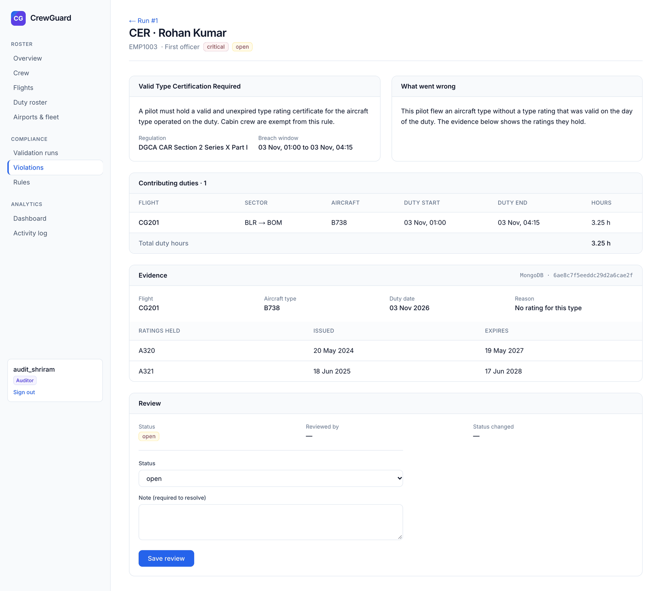
Figure 9.22: Explanation page for a CER violation: no rating for the aircraft type
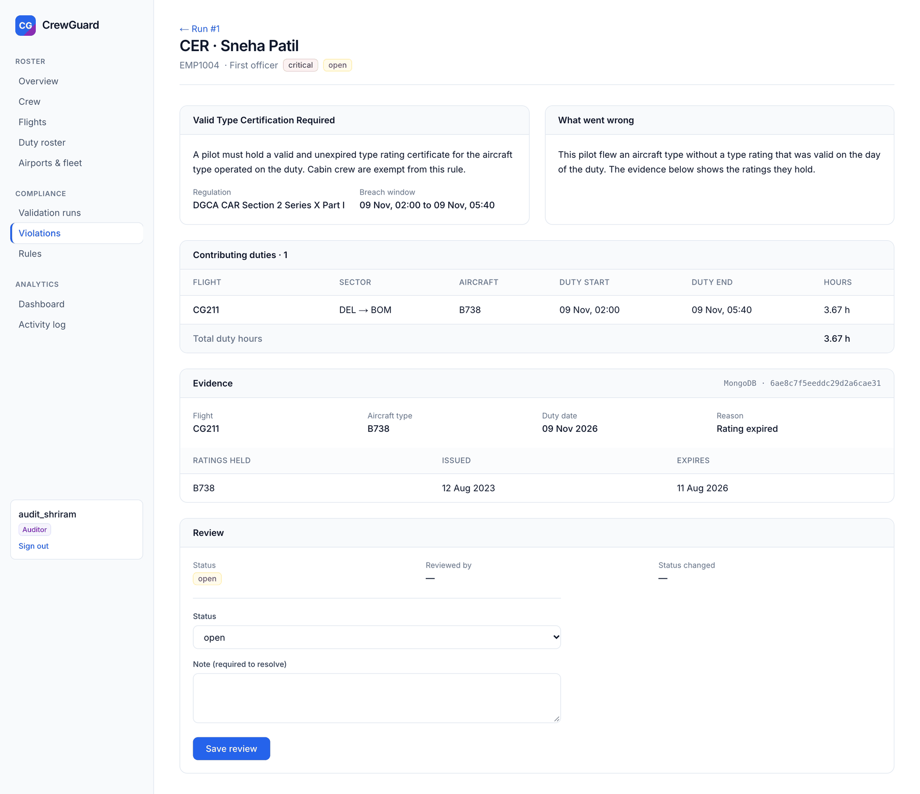
Figure 9.23: Explanation page for a CER violation: rating expired
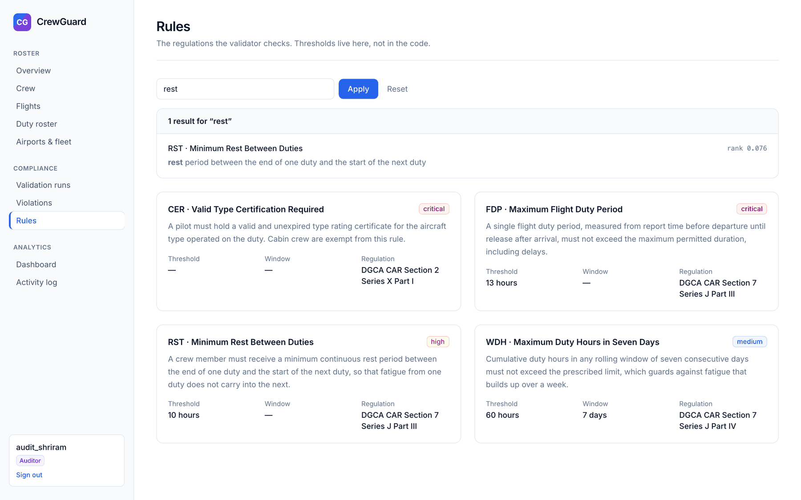
Figure 9.24: Rule catalogue with full-text search
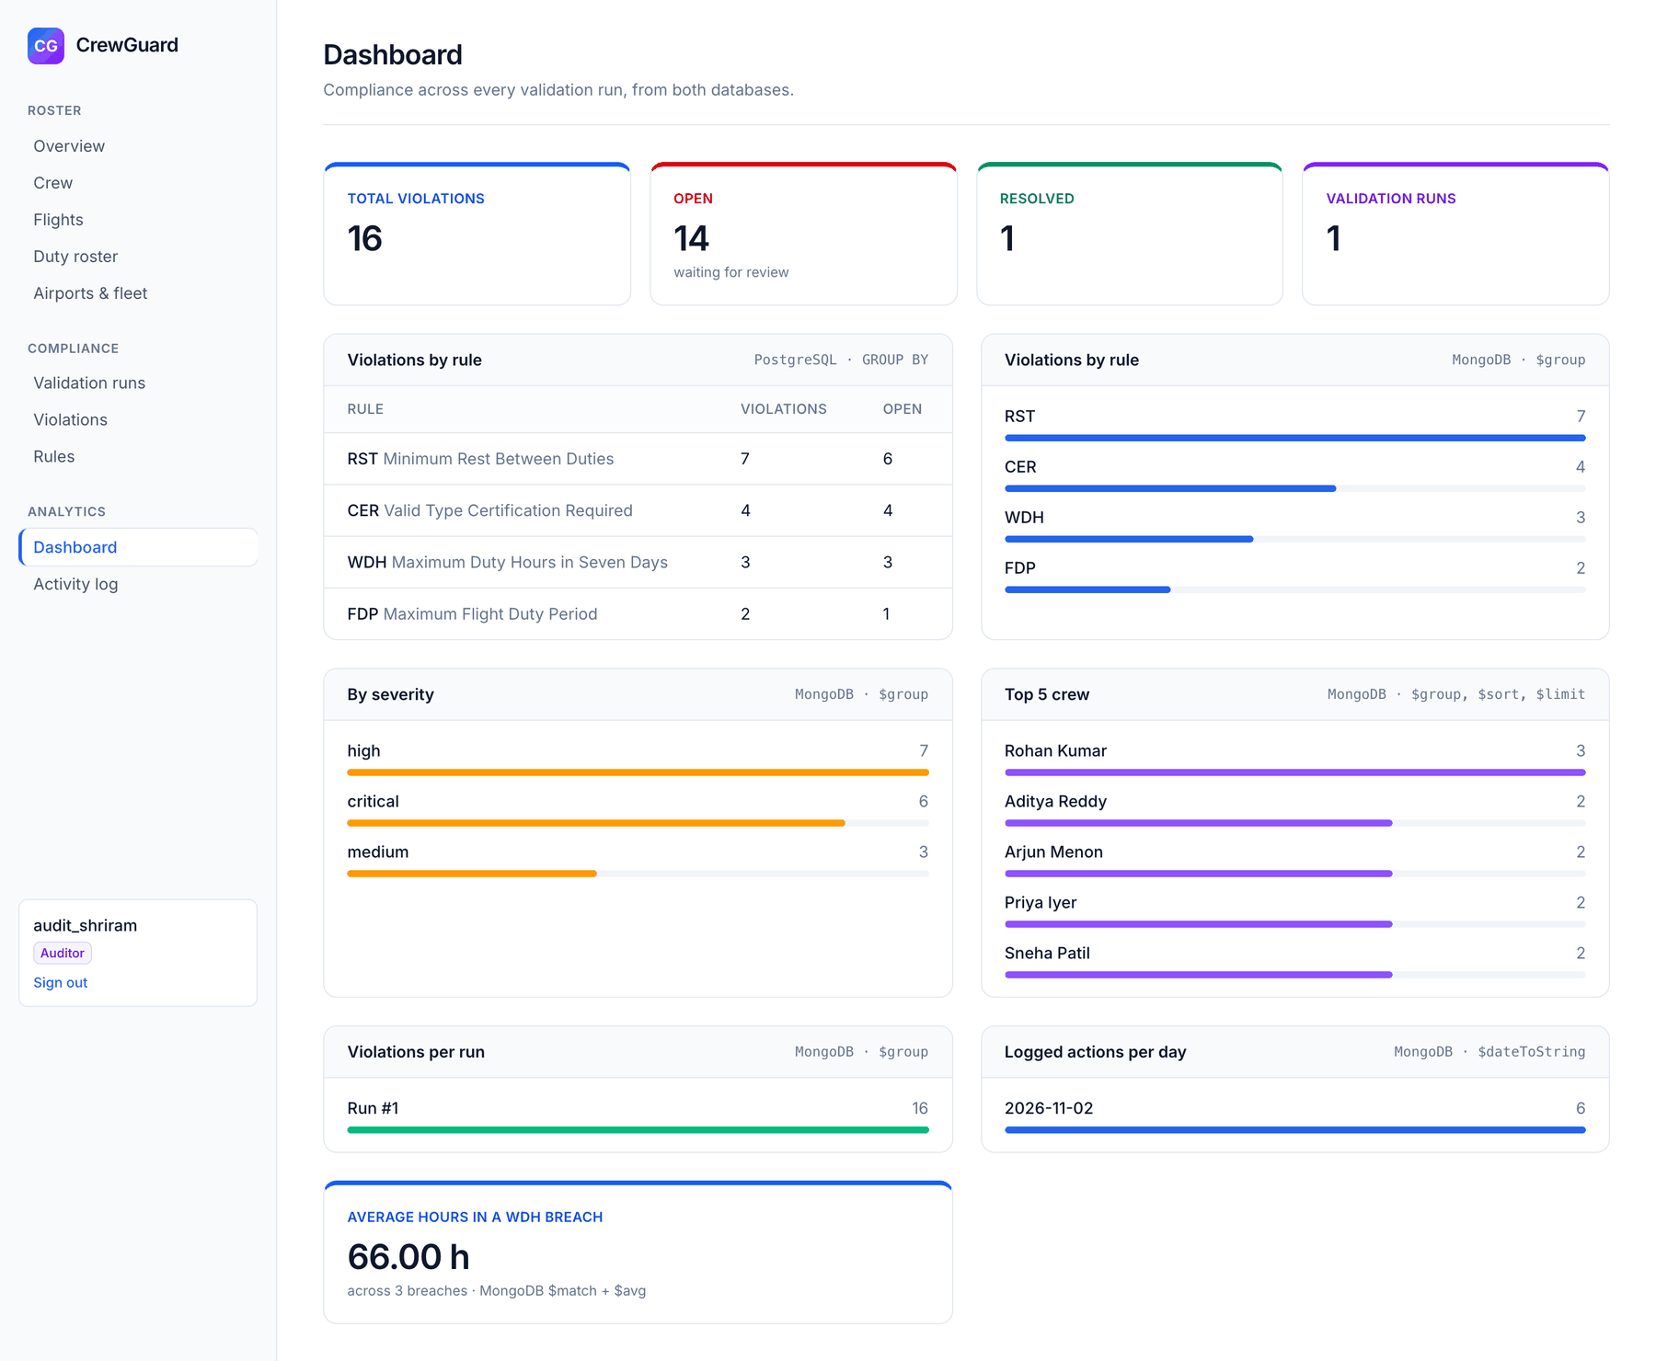
Figure 9.25: Dashboard: PostgreSQL GROUP BY next to MongoDB aggregation pipelines
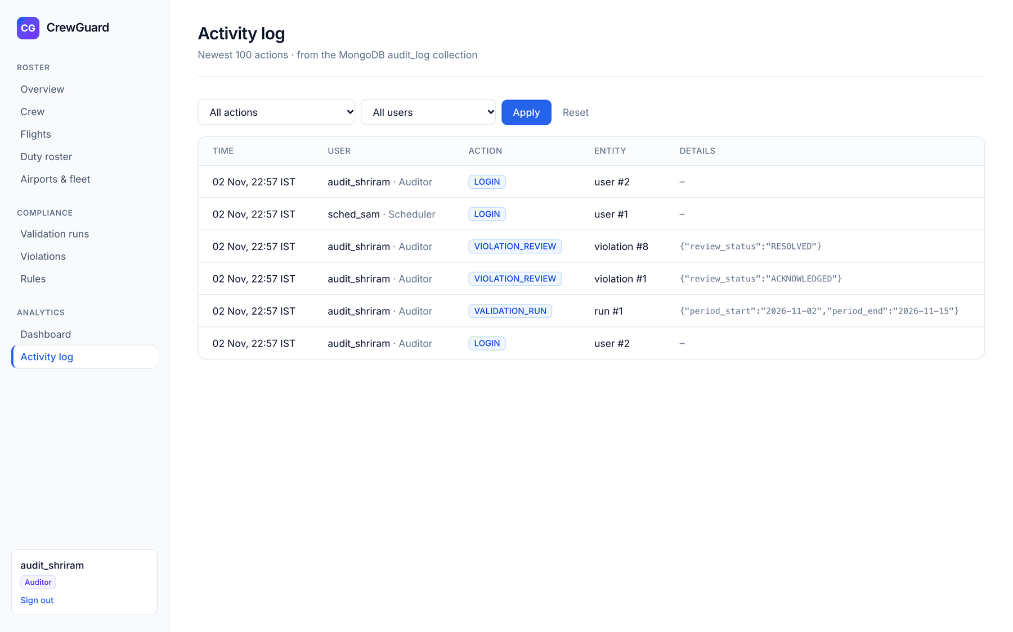
Figure 9.26: Activity log read from the MongoDB audit_log collection
9.5 Testing
The test suite (npm test) runs 46 tests with the Node.js test runner against the real PostgreSQL and MongoDB databases. Each database test runs inside a transaction that is rolled back, so the sample data is never changed. The tests cover every constraint, cascade and restrict rule, the duty trigger, transaction rollback, the functions and views, the validator's expected results (16 violations for the full period, 12 for week 1 and 4 for week 2), the explanation links, the compliance triggers, the review CHECK constraints, full-text search and the MongoDB collections and pipelines. All 46 pass.
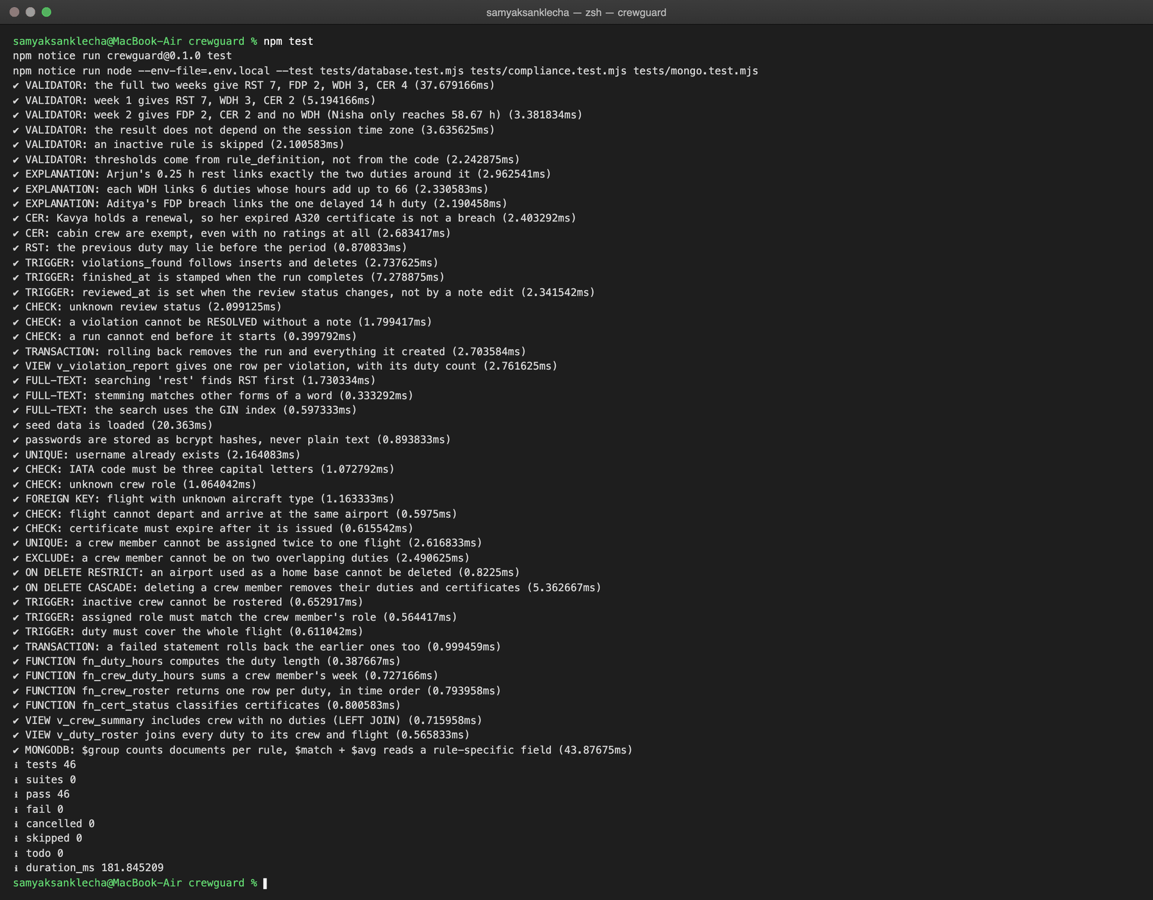
Figure 9.27: Output of npm test: 46 tests, 46 passed

10. CONCLUSION AND FUTURE ENHANCEMENTS
CrewGuard shows how much of an application's correctness can live inside the database. Impossible rosters are rejected by constraints, an exclusion constraint and a trigger; regulatory breaches in otherwise valid data are found by a single stored procedure using window functions and anti-joins; and every breach is explained through a many-to-many link to the duties that caused it. Transactions keep multi-row writes atomic, views keep join logic in one place, and MongoDB complements PostgreSQL where the data is document-shaped. On the sample roster the validator finds exactly the sixteen planted violations, and the full test suite passes.
Possible enhancements:
• More DGCA rules, such as cumulative duty limits over 28 days and a weekly day off, added as new rows in rule_definition plus a section in the procedure.
• Time-zone-aware rules such as night duty and acclimatisation, using each airport's stored time zone.
• Suggesting a legal replacement crew member when a violation is found, using the same EXISTS and range-overlap queries as the assign form.
• Semantic search over the full regulation text using vector embeddings.
• Scheduled automatic validation runs and notifications to the auditor.
Individual contributions
Area | Samyak Sanklecha (PES2UG24CS436) | Shriram Chandrasekar (PES2UG24CS495)
PostgreSQL | Schema with 11 tables and all constraints including EXCLUDE; indexes; functions, views and trg_validate_duty (02_roster.sql); seed data; queries | 03_compliance.sql: review columns, three compliance triggers, v_violation_report, sp_run_validation, full-text search
MongoDB | – | violation_evidence and audit_log collections, aggregation pipelines
Application | Backend–database layer (pool, parameterised queries, transactions), authentication and roles, roster pages, UI theme | Compliance and analytics pages: runs, violations and explanation, rules, dashboard, activity log
Quality and documentation | Database constraint tests | Compliance and MongoDB tests, diagrams, demo script
Table 10.1: Individual contributions

REFERENCES
[1] PostgreSQL Global Development Group, PostgreSQL 16 Documentation. https://www.postgresql.org/docs/16/
[2] PostgreSQL 16 Documentation, Exclusion Constraints and the btree_gist module. https://www.postgresql.org/docs/16/btree-gist.html
[3] PostgreSQL 16 Documentation, Window Functions. https://www.postgresql.org/docs/16/tutorial-window.html
[4] PostgreSQL 16 Documentation, Full Text Search. https://www.postgresql.org/docs/16/textsearch.html
[5] MongoDB, Inc., MongoDB Manual: Aggregation Pipeline. https://www.mongodb.com/docs/manual/core/aggregation-pipeline/
[6] node-postgres documentation. https://node-postgres.com/
[7] Vercel, Next.js Documentation. https://nextjs.org/docs
[8] Directorate General of Civil Aviation, Civil Aviation Requirements Section 7 Series J Part III: Flight Duty Time Limitations and Rest Requirements. https://www.dgca.gov.in/
[9] R. Elmasri and S. B. Navathe, Fundamentals of Database Systems, 7th ed., Pearson, 2016.
GitHub Link: https://github.com/samyak-1021/crewguard

APPENDIX A DEFINITIONS, ACRONYMS AND ABBREVIATIONS
The following terms, acronyms and abbreviations are used in this report.
Term | Meaning
CAR | Civil Aviation Requirements, the regulations issued by the DGCA
CER | Rule code: valid type certification required
DDL / DML | Data Definition Language / Data Manipulation Language
DGCA | Directorate General of Civil Aviation, India's aviation regulator
Duty | The working period for one flight, from report time before departure to release after arrival
ER | Entity-Relationship
FDP | Flight Duty Period; rule code for the maximum length of one duty
FK / PK | Foreign key / primary key
FTS | Full-text search
GiST / GIN | Generalised Search Tree / Generalised Inverted Index, PostgreSQL index types
IATA | International Air Transport Association; its three-letter airport codes are used as keys
JWT | JSON Web Token, used for the signed session cookie
ObjectId | MongoDB's 12-byte document identifier, stored as 24 hexadecimal characters
Roster | The set of duties: which crew member works which flight, and when
RST | Rule code: minimum rest between duties
Type rating | A licence to operate a specific aircraft type, valid between two dates
UTC / IST | Coordinated Universal Time / Indian Standard Time (UTC + 5:30)
WDH | Rule code: maximum duty hours in any rolling seven days
3NF | Third normal form
Table A.1: Definitions, acronyms and abbreviations
GitHub Link: https://github.com/samyak-1021/crewguard

