Half Adder

Equation –

Sum S = AB’ + A’B

Carry C = AB

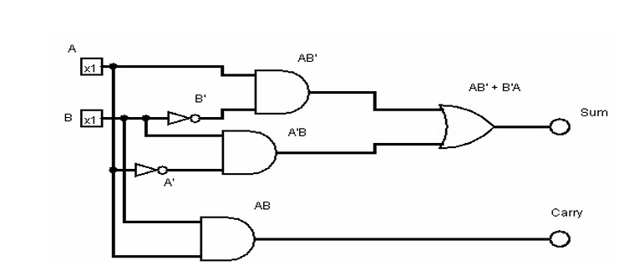

Truth Table  
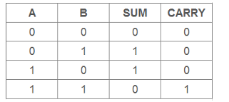

Full Adder

Equation:-

Sum S = AB’C’ + A’BC’ + A’B’C + ABC

Carry C = AB + BC + CA

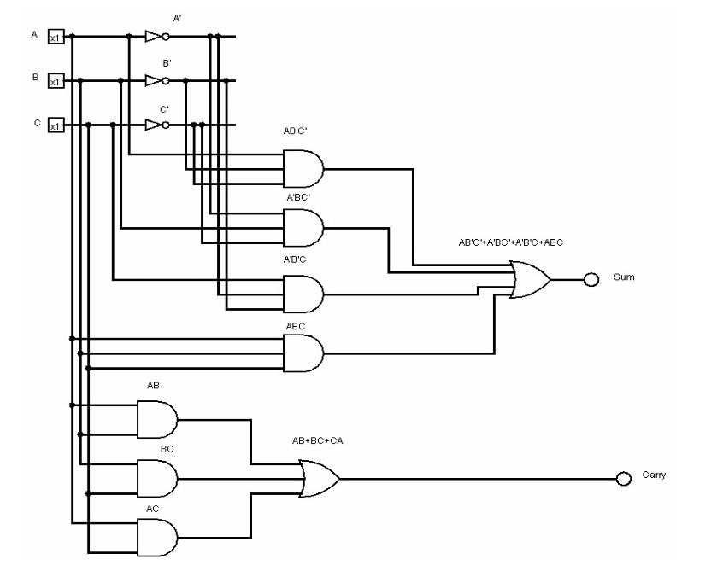

Truth Table  
