MULTIPLEXER

• Inputs: 4 (I0,I1,I2,I3)

• Selection Lines: 2 (S0,S1)

• Output Equation: Y = (I0.S1 bar.S0 bar) + (I1.S1 bar.S0) + (I2.S1.S0 bar) + (I3.S1.S0)

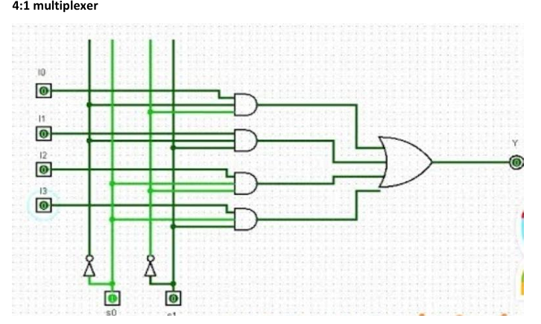

Truth Table

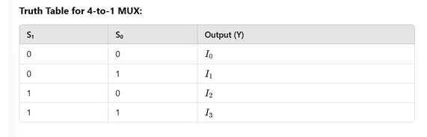

DEMULTIPLEXER

* Y0 = I0 · S1' · S0'
* Y1 = I0 · S1' · S0
* Y2 = I0 · S1 · S0'
* Y3 = I0 · S1 · S0

Here I0 is the Data-input

S0 and S1 are Select input

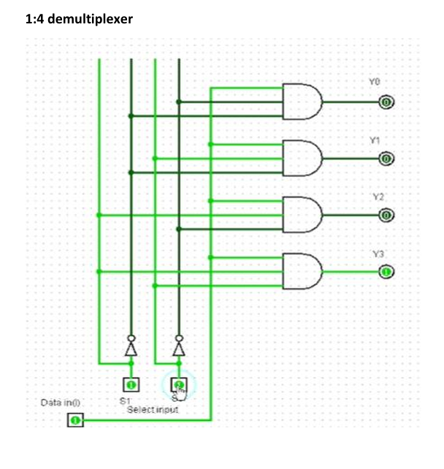

Truth Table

