

## Walchand College Of Engineering, Sangli.

#### (An Autonomous Institute)

**Department Of**

#### Computer Science and Engineering

##### Inhouse/ Summer Internship Report

On

**WCE Spot Round Automation**

Submitted by

**Mr.Shivprasad Bele 2018BTECS00092**

**Mr.Samyak Kabure 2016BTECS00100**

###### Mr.Shivaduth Jakore 2018BTECS00096

Under the Guidance of

**Prof. N.L.Mudegol**

Computer Science Department

WCE, Sangli

**2021-2022**



##### Walchand College of Engineering, Sangli

(An Autonomous Institute)

**Department Of**

**Computer Science and Engineering**

### CERTIFICATE

This is to certify that the Project Report entitled, **”WCE spot round automation ”**submitted by Mr. Shivprasad Bele, Mr. Samyak Kabure and Mr.Shivaduth Jakore to Walchand College of Engineering ,Sangli, India, is a record of bonafide Project work of course *”In-house Intership”* carried out by him under my supervision and guidance and is worthy of consideration for the award of the degree of Bachelor of Technology in Computer Science & Engineering of the Institute.

|  |  |  |
| --- | --- | --- |
| **Prof. N.:** |  | **Dr. M. A. Shah** |
| Guide |  | Head Of Department |
| Computer Sci. & Engg. Dept, |  | Computer Sci. & Engg.Dept, |
| WCE, Sangli. | .. | WCE, Sangli |

# Acknowledgement

We feel immense pleasure in submitting this Project report entitled” WCE spot round automation”.

We are thankful to our guide Mrs. N.L. Mudegol for their valuable guidance and kind help during completion of Project and feel great to express our sincere gratitude to other all staff members of CSE Department.

We are also thankful to the Head of the ’Department of Computer Science’ Dr. M.A. Shah for their valuable guidance during the completion of Project.

We would like to thank all faculty members and staff of Department of Computer Science for their generous help in various ways for the completion of this thesis.

We would like to thank all our friends and especially our classmates for all the thoughtful and mind stimulating discussions we had, which prompted us to think beyond the obvious. we have enjoyed their companionship so much during our stay at WCE, Sangli

# Declaration

I hereby declare that work presented in this project report titled **”WCE spot round automation ”** submitted by me in the partial fulfillment of the requirement

of the award of the degree of **Bachelor of Technology (B.Tech)** Submitted in the **Department of Computer Science & Engineering, Walchand College of Engineering, Sangli**, is an au- thentic record of my project work carried out under the guidance of Prof.N.L.Mudegol

**Mr.Shivprasad Bele 2018BTECS00092**

**Mr.Samyak Kabure 2016BTECS00100**

###### Mr.Shivaduth Jakore 2018BTECS00096

Date :

Place : Sangli

## Table Of Contents

1. Abstract 7
2. Introduction and SRS 8
3. Problem statement 8
4. Objectives 9
5. Methodology 10
6. Project Diagrams (UML diagrams, Flow chart etc.) 11
7. Testing (Unit, System, Integration etc.) 13
8. Results and Conclusion 15
9. References 16
10. Annexure A 17
    1. **Minutes of meeting with Industry guide (For industry internship)**
    2. **Final acceptance received from industry mentor on implemented product (Email screenshot, for industry internship)**
    3. **Certificate Image/PDF of industry internship**
    4. **Documentation of Project(Modulewise Documentation)**
    5. **Github Hosting Link**

#### Abstract

WCE spot round automation is a system where the process of spot round which is conducted manually is automated using this system. In this system we conduct the procedure of spot round online where students wouldn’t be required present at the institution and the manual error which happens all the time because of ample student data would also decrease.

Generally, when the Directorate of Technical Education (DTE) completes its procedure of rounds there are still vacant seats available which the institution are asked to conduct a spot round at the institute. Here students directly come to the institute and fill the admission form and the admits.

In our system we provide registration form where student data is gathered . After successful registration student can check the status of their registration form . Once registration is completed student can pay registration fee online through our system.

#### Introduction

The title of the project is “WCE Spot Round Automation” . The word automation in our case is defined to automate the current manual system

carried out in various colleges and Universities.

Spot round is generally asked by DTE(Directorate of Technical Education) to conduct at institution level once CAP rounds are completed. The current spot round procedure asks students to be present at the institution with their documents and the whole process is manually handled by the college authorities which leads to lot of possible human error.

Our system automates the whole process which saves man hours to perform this task. This would result in fast processing of the spot round and would also save students time.

#### Problem statement

To automate the current spot round admission process.

#### Objectives

1. To study the traditional system and gather the requirements about the automation system

2.To create a REST api.

for establishing the communication between endpoints

to record the requests for analysis

to handle user requests

3. To fetch registered student data and allot seat accordingly

4. To create payment gateway.

#### Methodology

#### 

1. **Project diagrams**

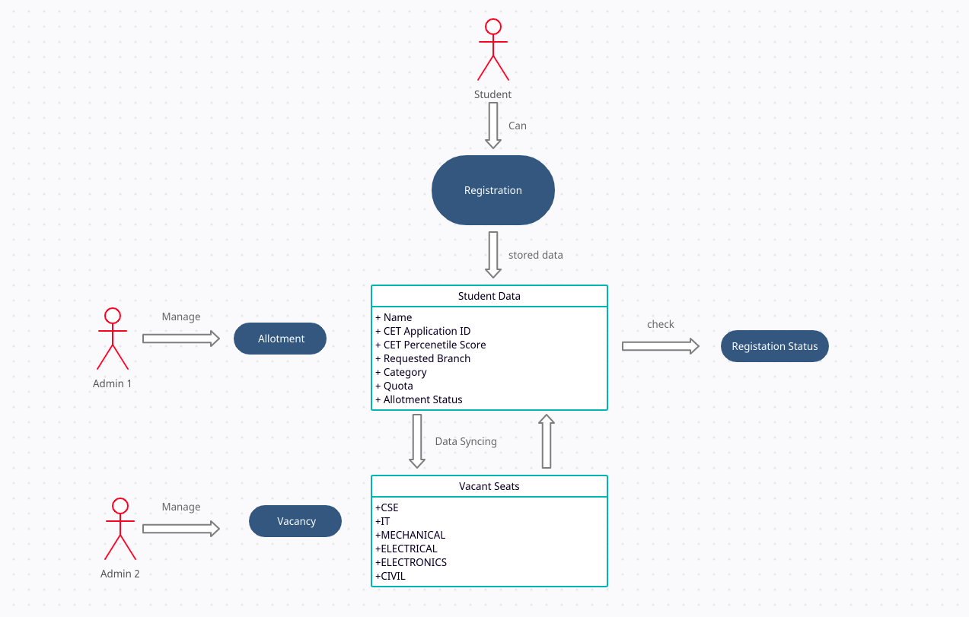

#### Results and Conclusion

1. Successfully developed registration form.

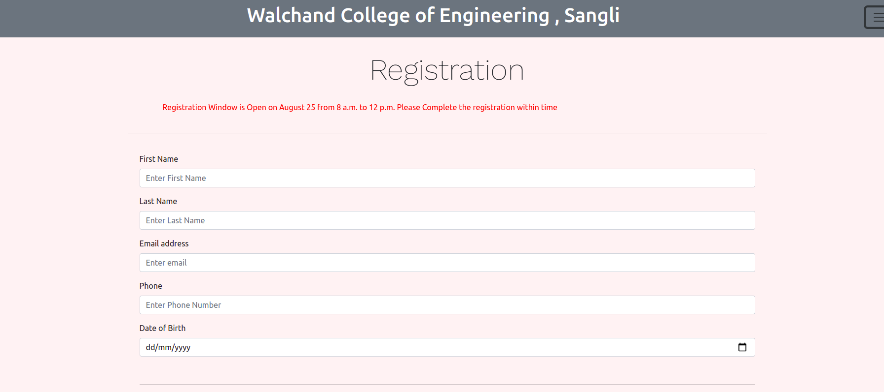

2. Displayed Merit List using students data

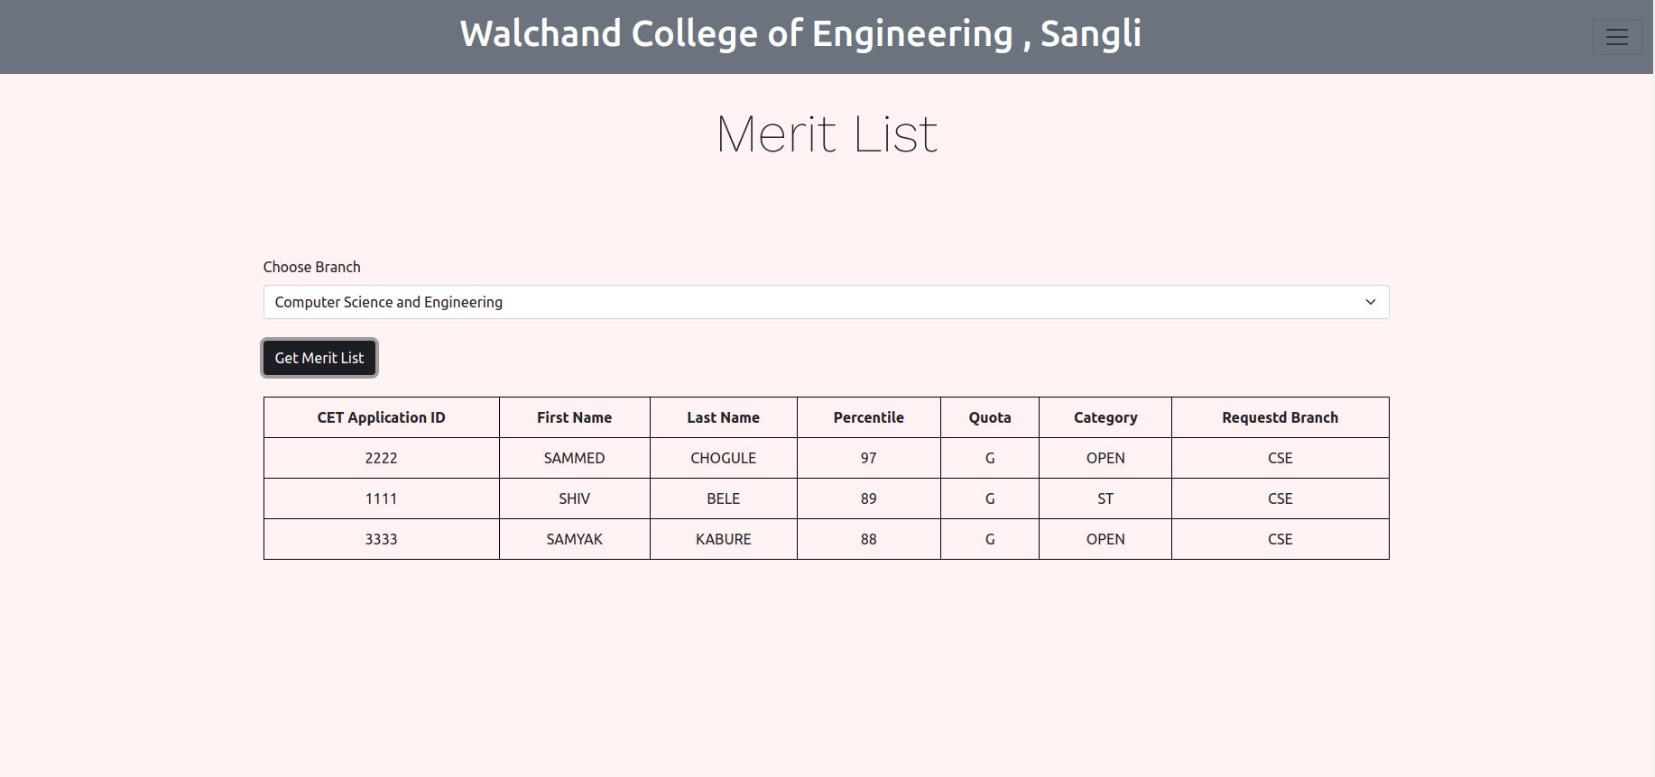

3. Displayed Vacancy

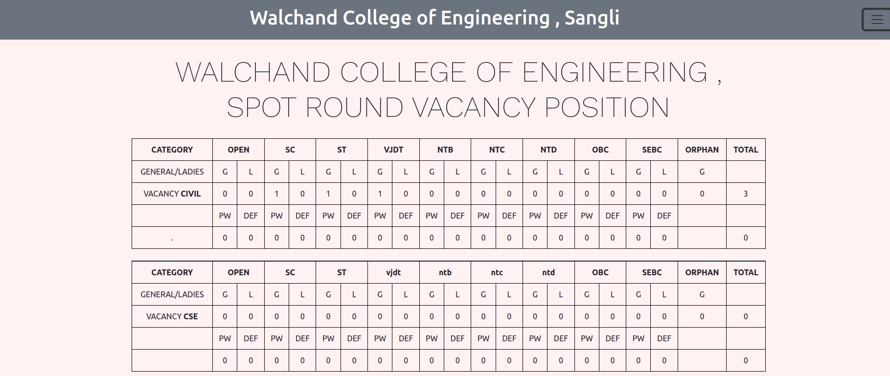

4. Allotted seats according to merit list.

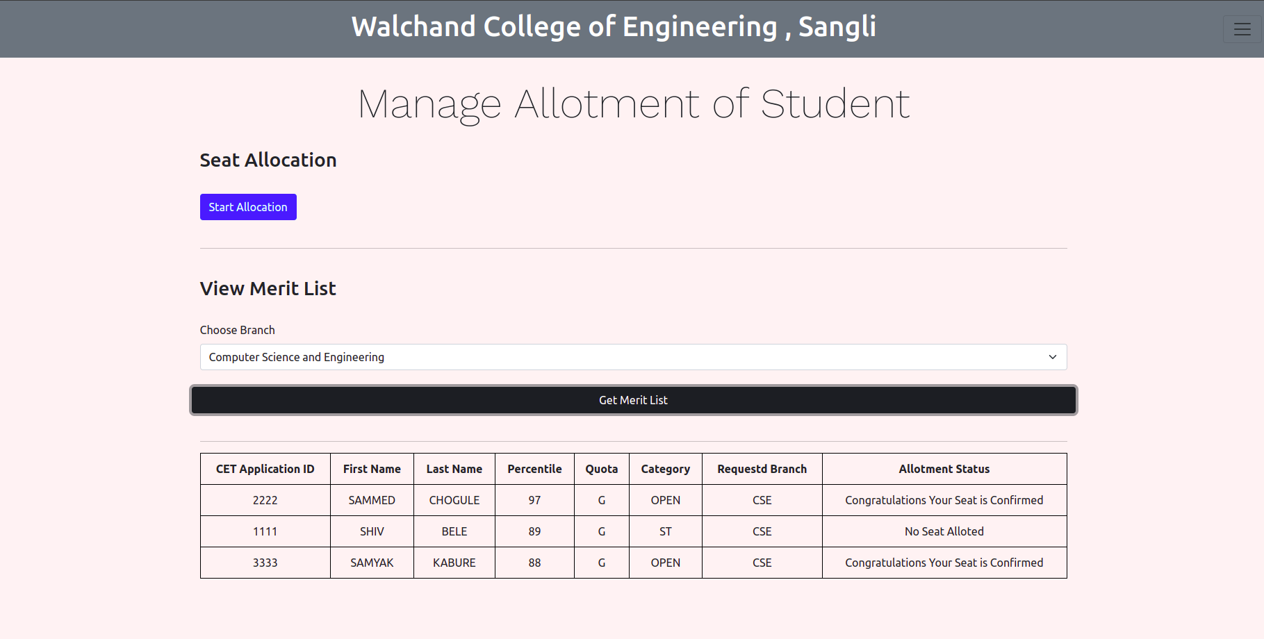

#### References References

1. Michel Goossens, Frank Mittelbach, and Alexander Samarin. *The LATEX Companion*. Addison- Wesley, Reading, Massachusetts, 1993.
2. Albert Einstein. *Zur Elektrodynamik bewegter K¨orper*. (German) [*On the electrodynamics of mov- ing bodies*]. Annalen der Physik, 322(10):891921, 1905.
3. Knuth: Computers and Typesetting,

<http://www-cs-faculty.stanford.edu/~uno/abcde.html>

# Annexure A

## Minutes of meeting with Industry guide (For industry internship)

|  |  |  |  |
| --- | --- | --- | --- |
| **Sr.No** | **Day, Date and time of meeting** | **Discussion regarding (SRS, implementation, testing, problems during**  **implementation, progress review etc.)** | **Meeting Summary** |
| **1** |  |  |  |
| **2** |  |  |  |
| **3** |  |  |  |
| **4** |  |  |  |
| **5** |  |  |  |

**Final acceptance received from industry mentor on implemented product (Email screenshot, for industry internship)**

## Certificate Image/PDF of industry internship

**Documentation of Project(Modulewise Documentation) Github Hosting**