

**INTERNET OF THINGS (CS-3007)**

**REPORT**

**on**

Traffic Management System



**Submitted by  
Afrah Mirza - 21051622  
Abhrajit Ray - 2105349**

**Akash Agrawal - 2105219**

**Kanhaiya Kunj - 2105277**

**Samyak Nath - 21051333  
  
  
  
B.Tech Programme in CSE**

**SPRING SEMESTER 2024**

**CONTENTS**

**TOPIC**

Abstract

1. INTRODUCTION
   * Brief Introduction about the topic
   * IoT level description
   * Objective of the work
2. LITERATURE REVIEW
3. SYSTEM MODEL
   * Ciruit Diagram
   * Components used
   * Working Principle
4. RESULT ANALYSIS
5. CONCLUSION

**Traffic Management System**

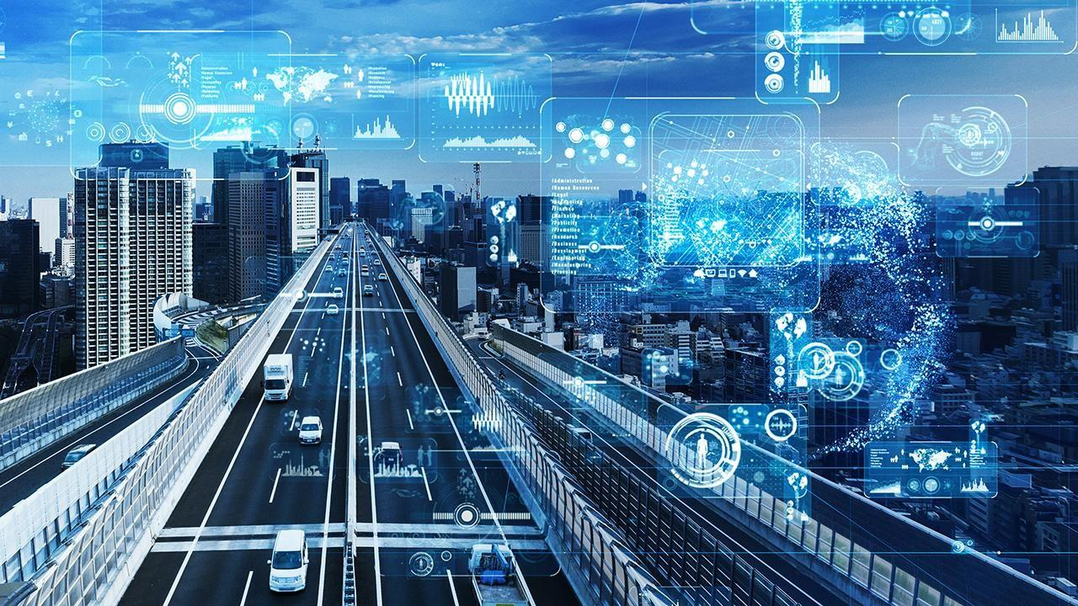

# Introduction

**Stuck in Gridlock? Navigate Your Way to a Smoother Commute with Our IoT-Powered Traffic Management System!**

Imagine navigating bustling city streets without the frustration of endless traffic jams, unexpected detours, and the constant worry of accidents. Our state-of-the-art Traffic Management System, powered by the trans formative capabilities of the Internet of Things (IoT), makes this vision a reality.

Gone are the days of relying solely on outdated information and static infrastructure. Our system leverages a network of smart devices and sensors strategically placed throughout urban areas, collecting real-time data on:

* **Traffic flow:** Identify congested areas and predict upcoming bottlenecks before they even form.
* **Accidents and incidents:** Respond promptly to emergencies, minimizing their impact on overall traffic flow.
* **Road conditions:** Stay informed about potholes, construction zones, and other hazards, ensuring a safer journey.
* **Weather patterns**: Anticipate rain, snow, or fog and adjust traffic management strategies accordingly.

This wealth of real-time data is then fed into advanced analytic engines, churning out actionable insights.

# Survey

**Our Traffic Survey:** Unveiling the Challenges, Paving the Way for Solutions

We conducted a traffic survey to understand the pain points of city residents. Key findings?

* **Peak hour gridlock:** Frustrating congestion slows commutes.
* **Speeding concerns**: Safety worries due to reckless driving.
* **Emergency response lag:** Delays in accident response need addressing.

These insights are crucial for developing impactful solutions! Join the conversation and share your experiences to help us build a better traffic flow for everyone.

# Novelty of Our Work

Our Traffic Management System leverages the latest tech (imagine sensors, cloud power, and smart data analysis) to deliver real-time solutions for:

* **Faster commutes:** No more peak hour paralysis!
* **Enhanced safety:** Say goodbye to speeding concerns.
* **Swift emergency response**: Accidents handled quickly.

Join the movement for a smoother, safer city for all!

# Components and Functionalities

1. **TrafficLights:** Keeping roads orderly and managing vehicle flow efficiently.
2. **Camera/Speed Camera:** Recording historical data to gain insights into traffic patterns, speed violations, and accident occurrences.
3. **Services like Google Maps:** Utilizing real-time map data for quick information on congestion and accidents.
4. **Communication Devices:** Integrating traffic police radio receivers for efficient emergency response.

# **Wireless Sensor Network (WSN) Integration**

In the realm of traffic management, the role of Wireless Sensor Networks (WSN) is paramount. WSN involves the interconnection of various sensors, forming a network that facilitates seamless communication and efficient transfer of collected data. This technology is a game-changer, providing real-time insights into traffic conditions and enabling adaptive control measures.

## Energy-Efficient Protocols

A key focus of our WSN implementation is the utilization of energy-efficient protocols. This strategy ensures an extended battery life for the deployed sensors, minimizing the need for frequent maintenance and optimizing the overall cost-effectiveness of the system. By carefully selecting and implementing protocols that balance data accuracy with energy conservation, we aim to create a sustainable and reliable network.

## Sensor Types and Their Roles

Our WSN incorporates different types of sensors, each serving a specific purpose to enhance the functionality of the Traffic Management System:

1. **RFID Tags:** These passive or active devices play a crucial role in automatic toll collection, smart parking, and vehicle tracking. Attached to vehicles or drivers' licenses, RFID tags transmit information such as identity, location, and status. RFID readers strategically placed at toll booths, traffic signals, and parking lots interact with these tags, contributing to a seamless traffic management experience.
2. **BLE Beacons:** Low-energy devices utilizing Bluetooth technology to broadcast signals. Deployed at traffic signals or roadside signs, BLE beacons interact with smartphones or navigation systems of drivers and passengers. They provide real-time traffic information, navigation guidance, and personalized services, enhancing the overall user experience on the road.
3. **Cameras:** Optical devices capturing images or videos of the traffic scene. Mounted on traffic poles, bridges, buildings, or even drones, these cameras employ computer vision techniques to analyze traffic data. They contribute to vehicle classification, license plate recognition, incident detection, and traffic enforcement, offering a comprehensive understanding of the traffic environment.

## Data Collection and Utilization

The sensors in our WSN primarily collect the following data:

* Presence of vehicles • Speed of vehicles
* Direction of vehicles
* Humidity
* Temperature
* Noise

•

This data is invaluable for making informed decisions regarding traffic flow optimization, emergency response, and environmental impact mitigation.

## Environmental Factors and Traffic Management

Beyond traditional traffic data, our WSN considers environmental factors, such as temperature, humidity, and noise, which can significantly influence traffic conditions and road safety. By measuring and analyzing these factors, the WSN contributes to the creation of a holistic traffic management system.

# **Cloud Computing Integration**

Our Traffic Management System leverages Cloud Computing to store, process, and analyze vast amounts of data generated by the WSN and other components. Cloud Computing offers scalability, flexibility, and accessibility, allowing for real-time data processing and seamless integration of new functionalities.

## Data Storage and Accessibility

Cloud-based storage solutions provide a centralized repository for the massive amounts of data collected by the system. This not only ensures data integrity and security but also facilitates easy access for authorized personnel, allowing for efficient decision-making.

## Scalability and Resource Optimization

Cloud Computing allows our system to scale dynamically based on the fluctuating demands of data processing. This scalability ensures that the system remains efficient and responsive even during peak traffic hours or emergencies.

# **Big Data Analytic**

The integration of Big Data Analytic is pivotal for extracting meaningful insights from the vast datasets generated by our Traffic Management System. By employing sophisticated algorithms and analytic tools, we can identify traffic patterns, predict congestion, and optimize traffic flow.

## Traffic Pattern Analysis

Big Data Analytics enables us to analyze historical and real-time data to identify patterns in traffic behavior. This information is invaluable for optimizing traffic light timings, predicting high-traffic periods, and implementing adaptive control measures.

## Predictive Analytics for Congestion

Predictive analytics models, fueled by Big Data, allow us to forecast potential congestion points based on historical data and current trends. This proactive approach enables us to implement measures to alleviate congestion before it becomes a major issue.

# **Communication Protocols**

Efficient communication among system components is essential for the seamless operation of our Traffic Management System. Adopting robust communication protocols ensures reliable data transfer, quick response times, and effective coordination between various elements.

## Real-time Communication

Utilizing communication protocols designed for low-latency and real-time data transfer, our system ensures timely updates on traffic conditions, emergencies, and system status. This facilitates swift decision-making and enhances overall system responsiveness.

## Interoperability

Our system employs communication protocols that support interoperability, allowing different components, including sensors, cameras, and communication devices, to communicate seamlessly. This interoperability ensures a cohesive and integrated traffic management ecosystem.

# **Embedded Systems**

Embedded systems play a crucial role in the functionality of individual components within our Traffic Management System. These specialized systems are designed to perform specific tasks, contributing to the overall efficiency and reliability of the system.

## Sensor Integration and Control

Embedded systems within sensors control data acquisition, processing, and transmission. These systems ensure that sensors operate optimally, collecting accurate data and communicating seamlessly with other components in the network.

## Traffic Light Control Units

Embedded systems are embedded within traffic light control units to regulate and optimize traffic flow. These systems process real-time data from sensors and implement adaptive control measures, adjusting traffic light timings based on current conditions.

# **Workplan**

**From blueprint to reality: Building a smoother commute**

We know a great idea needs a solid plan. That's why we've created a detailed work plan for our Traffic Management System, covering:

* **Hardware roll-out:** Deploying the sensors, cameras, and other tech that keeps things flowing.
* **Software symphony:** Bringing all the pieces together with seamless software integration.
* **Constant care:** Ensuring the system runs smoothly with ongoing maintenance strategies.

This methodical approach guarantees a robust, reliable system ready to transform your commute. Stay tuned for more updates as we turn vision into reality!

## Application of our Project

**From highways to hometowns, our traffic system keeps you moving:**

**Imagine:**

* **Busy intersections**: No more gridlock, just smooth sailing with adaptive lights.
* **Highways on autopilot:** Dynamic speed limits and congestion alerts for a safer, faster ride.
* **Peaceful neighborhoods:** Calmer streets thanks to smart parking and traffic calming measures.

Our system adapts to any urban environment, reducing delays, boosting safety, and making every journey more enjoyable.

## Model Detail

**Smart, not complex: Our system thrives on simplicity**

We avoid unnecessary complexity, sticking to the **Level 3 IoT model.**

This means:

* **Sensory superpowers:** Sensors gather real-time data on traffic flow, speeds, and even weather.
* **Brainy decisions**: Advanced analytics crunch the data, making smart choices on the fly.

No need for tangled tech , just a simple, effective solution for a smoother, safer commute.

## Uses

**Beyond Green Lights: Your Commute, Transformed Imagine:**

* **Smarter traffic lights**: Adapting in real-time to keep you moving, not waiting.
* **Emergency hezoes, faster**: Help arrives quicker thanks to our system's insights.
* **Never lost again**: Real-time updates guide you around congestion like a pro.

This isn't just traffic management, it's your commute reimagined. Experience the difference:

* **Urban flow:** No more rush hour rage, just a smooth journey through the city.
* **Seconds count:** Emergencies get the fastest response, ensuring safety for all. ● **Stress-free navigation:** Relax, knowing your route is perfectly optimized.

Join the movement for a smarter, safer city. Experience the difference today

References:

<https://www.sciencedirect.com/science/article/pii/S2589791820300207><https://relevant.software/blog/iot-in-transportation-smart-traffic-control-system/><https://www.pantechsolutions.net/iot-based-intelligent-traffic-management-system><https://iopscience.iop.org/article/10.1088/1742-6596/2027/1/012017/pdf><https://www.hologram.io/blog/7-ways-iot-can-improve-traffic-management/>[https://www.infosysbpm.com/blogs/retail-cpg-logistics/iot-in-transportation-all-you-need-to-know](https://www.infosysbpm.com/blogs/retail-cpg-logistics/iot-in-transportation-all-you-need-to-know-about-smart-traffic-control-systems-using-iot.html)about-smart-traffic-control-systems-using-iot.html

<https://www.rishabhsoft.com/blog/smart-traffic-control-using-iot>

**Group Members:**

**Abhrajit Ray-2105349**

**Akash Agrawal-2105219**

**Afrah Mirza - 21051622**

### **(IOT_CSE_4)**