**SOME IMPORTANT NOTES - MINESWEEPER**

**1) Warning on First Launch:**

*Windows protected your PC*

*Microsoft Defender SmartScreen prevented an unrecognized app from starting. Running this app might put your PC at risk.*

**SUMMARY**

If your *SmartScreen* is on, you will see this warning when launching the application for the first time.

**CAUSE**

This warning is because I am not a known(recognized) publisher to *Microsoft Windows*, and doesn’t mean that the file has virus or something, at all!

You can scan the folder with your antivirus.

**RESOLUTION**

If you have downloaded the game from my [github](https://github.com/samyak1409/Minesweeper-for-PC) or took it from someone who directly downloaded it from the same, you can completely trust it and simply proceed by clicking ->

*More Info* -> *Run Anyway*.

**SOURCES ->**

[MSDN Blog](http://blogs.msdn.com/b/vsnetsetup/archive/2013/01/09/windows-smartscreen-prevented-an-unrecognized-app-from-running-running-this-app-might-put-your-pc-at-risk.aspx)

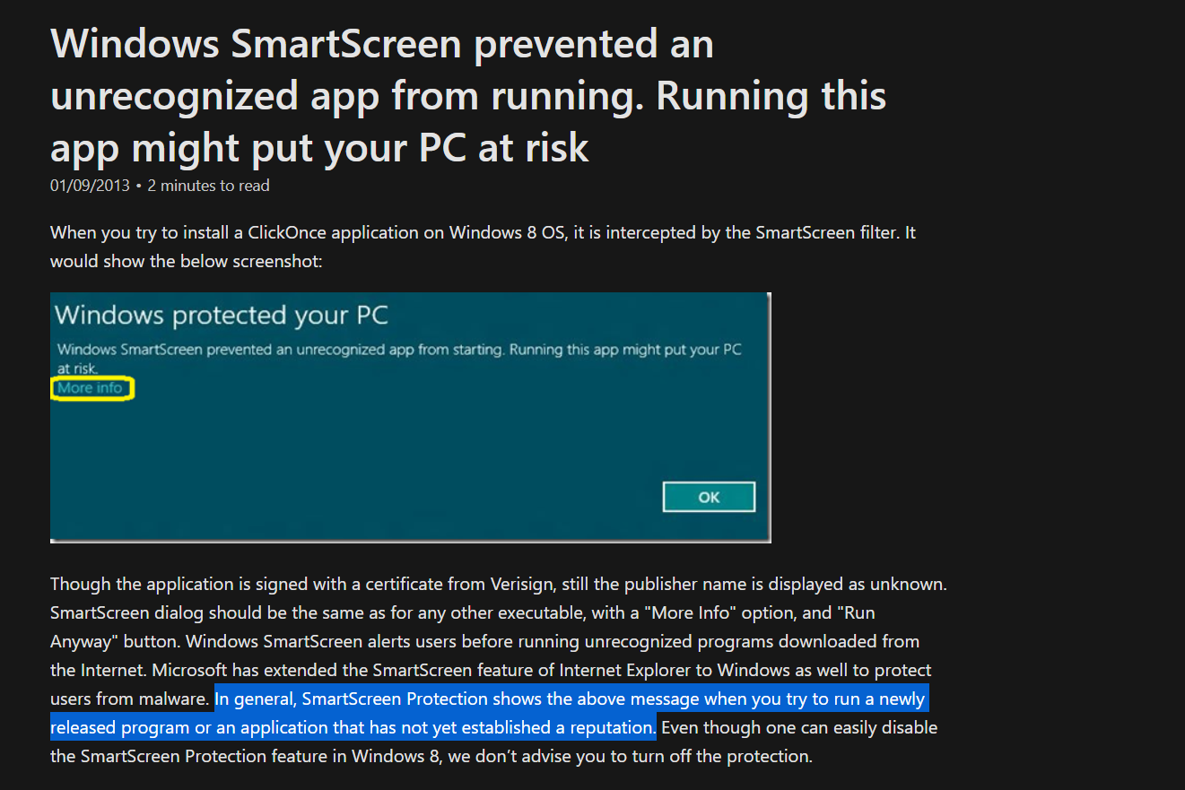

<https://youtu.be/KSDM6d9B2K8>

If after doing this, game still doesn’t launch and show a dialog box saying: *Operation did not complete successfully because a file contains a virus or potentially unwanted software.,*

this is because a substandard windows feature named **Real-time protection** just speaks out the same dialog for any unrecognized application.

You can disable it by going to -> **Settings** -> **Update & Security** -> **Windows Security** -> **Virus & threat protection** -> under **Virus and threat protection settings** -> **Manage settings** -> and turn the **Real-time protection** off!

**Sources-**

<https://www.youtube.com/watch?v=fRA1JZF-grc>

<https://www.youtube.com/watch?v=_0_A9D0JeVo>

**2) WARNING-** Don’t try to alter the values in the *Data* table of *DB.sqlite*, if you do, all your best time records will be erased in result of *attempt to cheat*.

**3) Customization-** Game’s background music ‘*BGM.mp3’* {an EDM called *Warping* by *Hoverboots*} can be changed.

Just put your favorite music (mp3 only) in the current directory and rename it to “*BGM”*, and relaunch the game, that’s it, game’s background music changed!

**4) Note**- This program is tested on *Windows 10 x64*, so if you're on any other OS, and encounter some compatibility issue, please report me via [mail](mailto:samyak65400@gmail.com) or [linkedIn](http://www.linkedin.com/in/samyak1409/).

***THANK YOU FOR READING, NOW LAUNCH THE GAME!***