Advanced Task Report
Submitted by: Samyak Jain
Task3 = Present your findings on the final project,where you are tasked with creating a Jupyter notebook from scratch and conducting a data analysis on a dataset of your choice. This comprehensive process involves selecting a dataset that piques your interest, exploring its contents within a Jupyter notebook, and identifying research questions that the data might help answer.
TABLE OF CONTENTS
SR.NO | SECTION | PAGE.NO
1 | Executive Summary | 2-4
2 | Introduction | 5-6
3 | Data Overview | 7-11
4 | Data Cleaning & Preparation | 12
5 | Exploratory Data Analysis | 12
6 | Key Findings
7 | Conclusion

- EXECUTIVE SUMMARY
This report presents a comprehensive analysis of sales data from a retail company operating across 10 major Indian cities. The dataset(1000 rows and 7 columns) contains 1,000 orders spanning January to June 2026, covering 14 unique products across 5 categories: Electronics, Fashion, Home Appliances, Accessories and Books.
Key Highlight:
- Total Revenue = Rupees 27620651.09
- Total Orders = 1000
- Total Units Sold = 3035
- Top Performing Category = Electronics
- Top Performing City = Mumbai
- Peak Month = January
- Introduction
2.1 Project Background
This project aims to analyze sales data to identify patterns, trends, and opportunities for business optimization. The analysis focuses on answering the following research question: Which product categories and cities drive the highest revenue, and what patterns can we identify to optimize business strategy?
  - Dataset Information
Feature | Description | Data Type
Order_ID | Unique order identifier | String
Product | Product name | String
Category | Product Category | String
Quantity | Numbers of units purchased | Integer
Price | Price per unit | Float
City | City where order was placed | String
Date | Order Date | Date

  - Tool Used
- Python for Programming Language.
- Pandas for Data Manipulation.
- Matplotlib for Data Visualization.
- Seaborn for Statistical Visualization.
- Jupyter Notebook it provide development Enivorement.

- Data Overview
  - Loading the Dataset
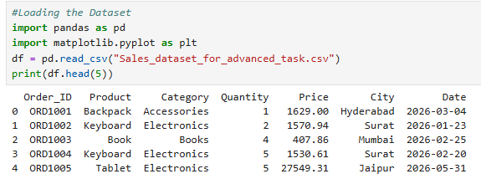3.2 Basic Details of the Data set

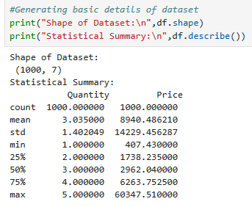
- Data Cleaning and Preparation
4.1 Data Cleaning

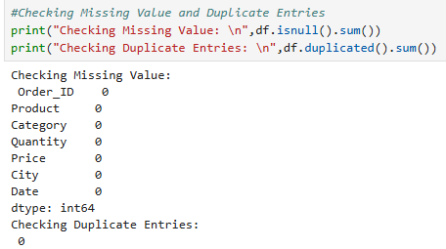
4.2 Adding new features
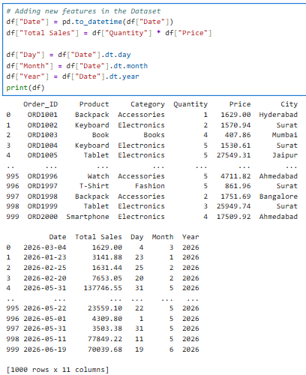

- Converting the date in the correct format.
- Adding the total Revenue Column.
- Extracting the day, month and year from the date column.
- EXPLORATORY DATA ANALYSIS (EDA)
5.1 Category Analysis
5.1.1 Revenue by Category
Code:
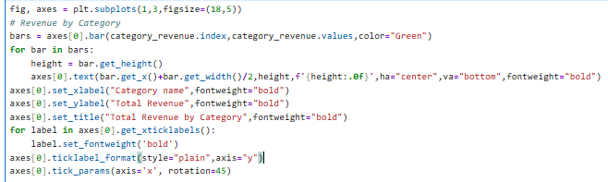
Output:
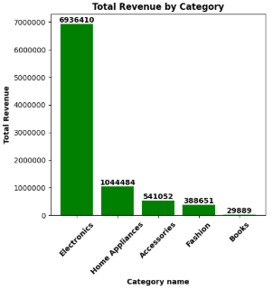
Key Observation:
1. Electronics Product generate highest revenue.
2. Books product generate lowest revenue.
5.1.2 Quantity Sold by Category

Input:
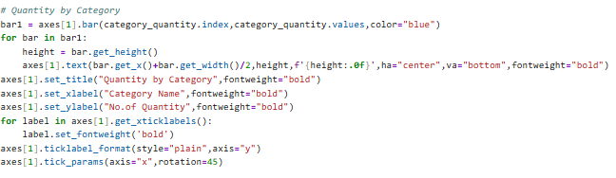
Output:
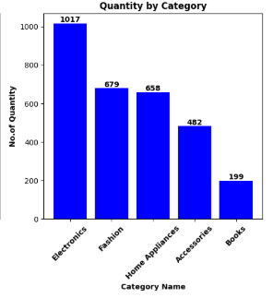
Key Observation:
- Electronics has the highest quantity sold indicating high demand.
- Books has the lowest quantity sold indicating less students buyer.
5.1.3 Numbers of orders by Category
Input:
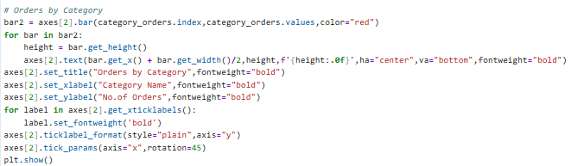
Output:
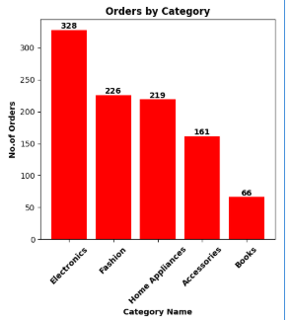
Key Observation:
- Electronics has the most orders high requirement of electronics product.
- Books has the less orders.
5.1.3 Revenue Distribution by Category
Input:
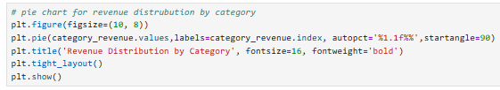

Output:
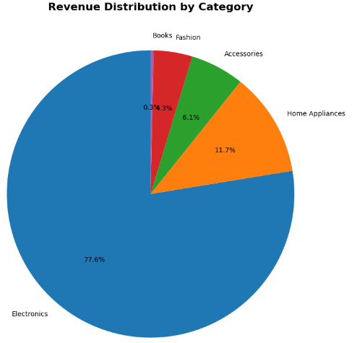
Key Observation:
- Electronics dominates with 77.6% of total revenue.
- Books contribute only 0.3% of total revenue.
- Fashion contribute only 4.3% of total revenue.
- Accessories contribute only 6.1% of total revenue
- Home Appliances contribute only 11.7% of total revenue.

5.2 City Analysis
5.2.1 Revenue by City
Input:
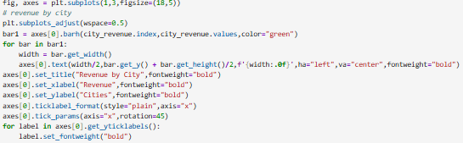
Output:
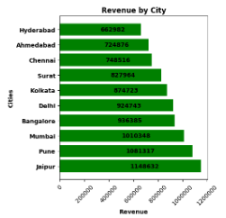
Key Observation:
- Jaipur has the highest revenue, we can say it contribute more in total revenue.
- Hyderabad has the lowest revenue, we can say it contribute less in total revenue.
5.2.2 total orders by City
Input:
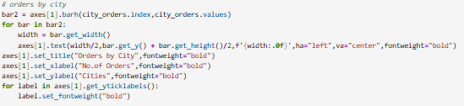
Output:
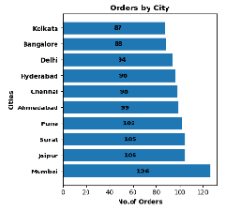
Key Observation:
- Mumbai has the highest Orders but the total revenue is not highest means people not buying more expensive product.
- Kolkata has the lowest orders but the total revenue is not lowest means few people are buying expensive product.
5.2.3 Average orders value by City
Input:
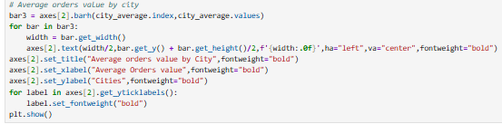
Output:
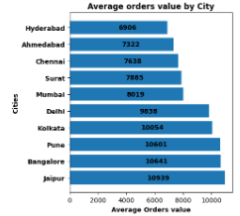
Key Observation:
- Jaipur has the highest average orders value as it has the highest total revenue.
- Hyderabad has the lowest average orders value as it has the lowest total revenue.
- From above two point we can say that total revenue is directly proportional to average orders value.
5.3 Monthly Trend
5.3.1 Monthly Revenue Trend
Input:
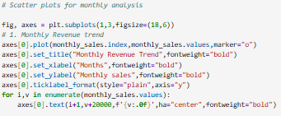
Output:
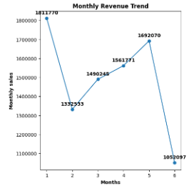
Key Observation:
- January shows the highest revenue.
- February shows a significant dip.
- May shows the strong recovery.

5.3.2 Monthly Orders Trend
Input:
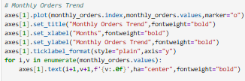
Output:
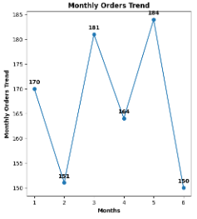
Key Observation:
- May has the highest orders as it recovery the loss in this month.
- June has the lowest orders.
5.3.3 Monthly Quantity Trend
Input:
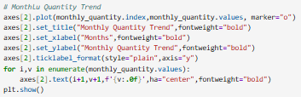

Output:
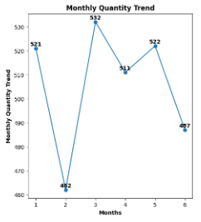
Key Observation:
- March has the highest quantity sold.
- Feburary has the lowest quantity sold.
5.4 Product Analysis
5.4.1 Top 10 product by revenue
Input:
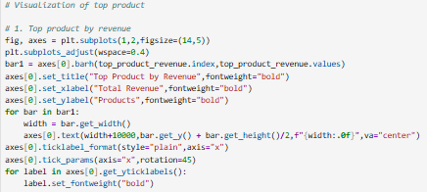
Output:
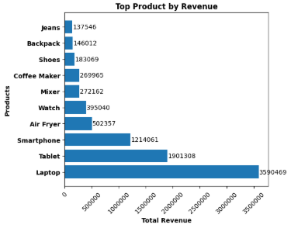
Key Observation:
- Laptops and Tablets are the top revenue generators
- High-value electronics dominate the top 5 positions.
- Only one fashion product(jeans) appears in top 10.
5.4.2 Top 10 product by Quantity sold
Input:
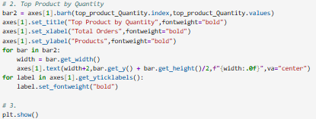
Output:
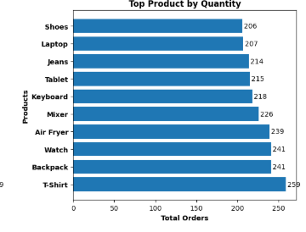
Key Observation:
- T-Shirts sell the highest quantity but have low individual prices.
- T-Shirts sell the highest quantity but have low individual prices.
- T-Shirts sell the highest quantity but have low individual prices.

5.5 Price Distribution Analysis
5.5.1 Price Distribution by Category
Input:
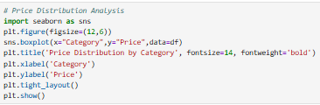
Output:
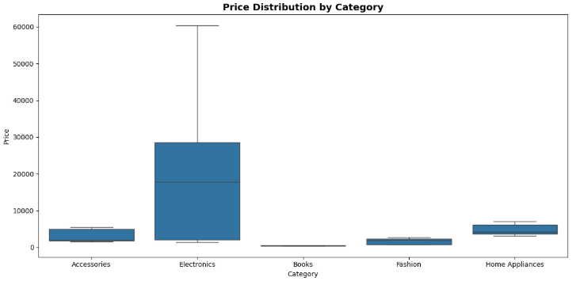
- Key Findings
6.1 Category Insights
- Electronics Dominates – It contribute 77.6% of total Revenue.
- Fashion drives volume – 2^nd Highest quantity sold but lower revenue per unit.
- Books underperform - Lowest revenue and quantity across all metrics.
- Home Appliances steady - Consistent performance with good average order value.
6.2 City Insights
- Jaipur leads - Highest revenue among all cities.
- Pune Strong second - Closely follows Jaipur in revenue.
- Jaipur premium market - Highest average order value.
- Hyderabad potential - Lowest revenue growth opportunity
6.3 Time-Based Insights
- January peak - Highest revenue month.
- February dip - Significant decrease from January.
- Consistent growth - Upward trend from March to May.
- Seasonal pattern - Clear monthly fluctuations
6.4 Product Insights
- Laptops and Smartphones are the top revenue generators.
- T-shirts lead in quantity sold.
- Air Fryers are the most popular home applicances.
- Conclusion
7.1 Summary
- Electronics is the dominant category, driven by high-value products like Laptops and Smartphones
- Jaipur and Pune are the strongest markets.
- January is the peak sales month, while February shows a significant dip
- Fashion products drive volume, while Electronics drives revenue
- Jaipur has the highest average order value, indicating premium customers
- Books is the underperforming category with significant growth potential
7.2 Answer to Research Question
Question - Which product categories and cities drive the highest revenue, and what patterns can we identify to optimize business strategy?
Answer - Electronics is the dominant category contributing 77.6% of revenue, with Jaipur and Pune as the top-performing cities. Sales show a seasonal pattern with January peaking and February dipping. To optimize strategy, the business should focus on Electronics in top cities, promote Fashion products more effectively, and leverage January's peak for major campaigns while addressing the February slowdown.

