### **Phase-5**

* Project Title: *Student Enrollment & Engagement CRM*
* Phase-5: Reports & Dashboards

## **1. Introduction**

In Phase-5, we created reports and dashboards to analyze student inquiries, applications, and enrollments. This phase helps admissions teams monitor progress, identify trends, and make better decisions.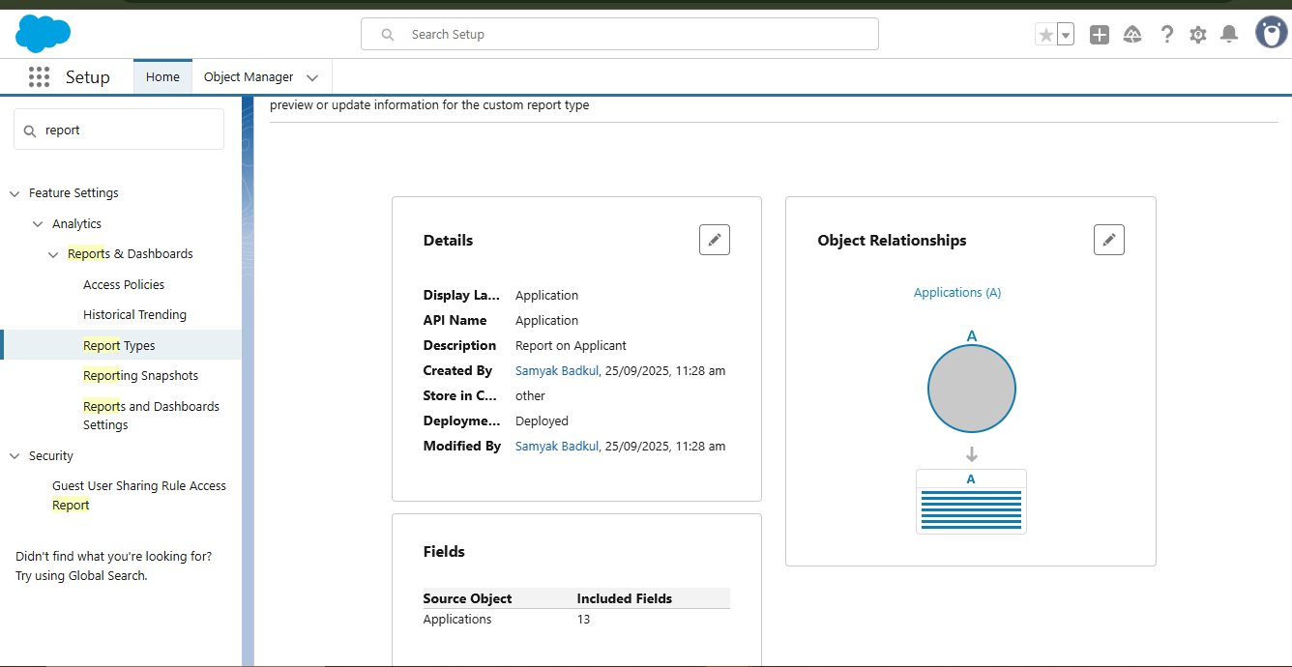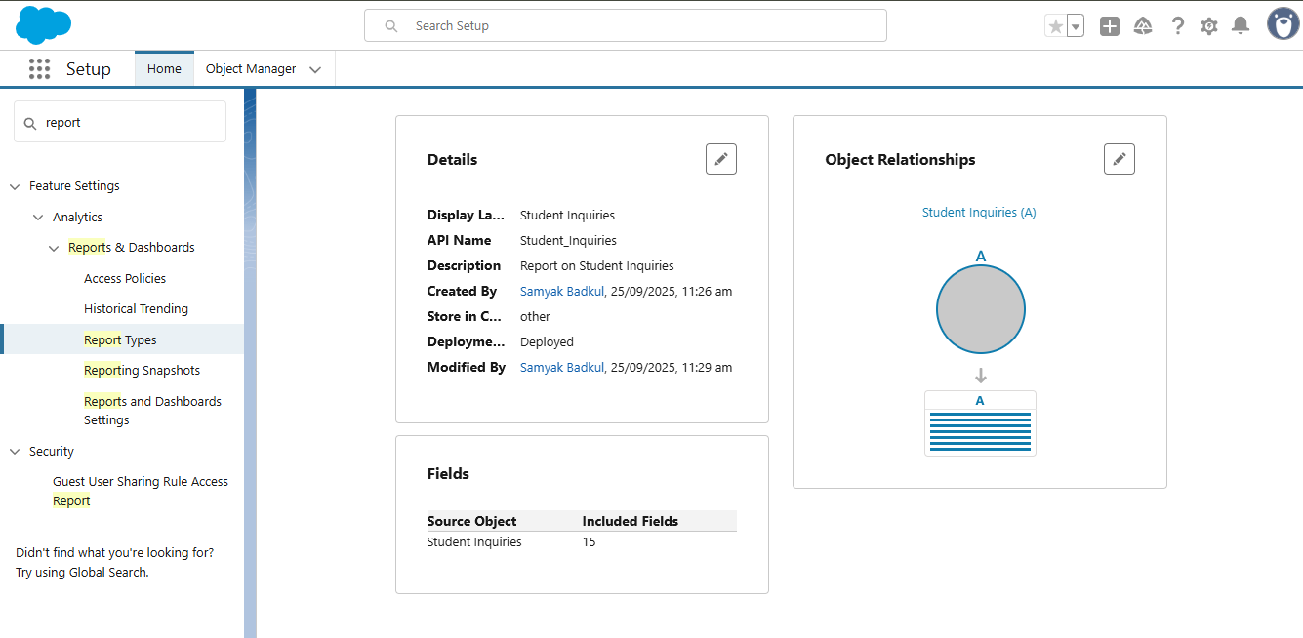

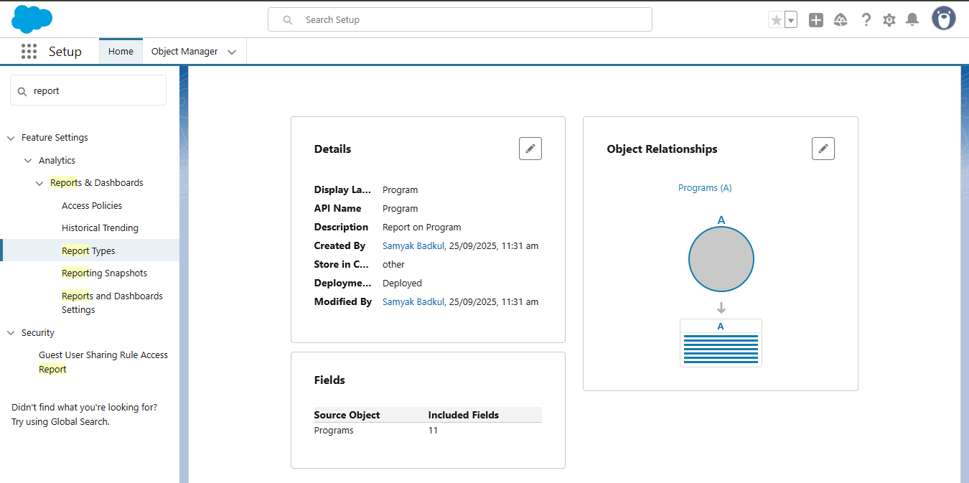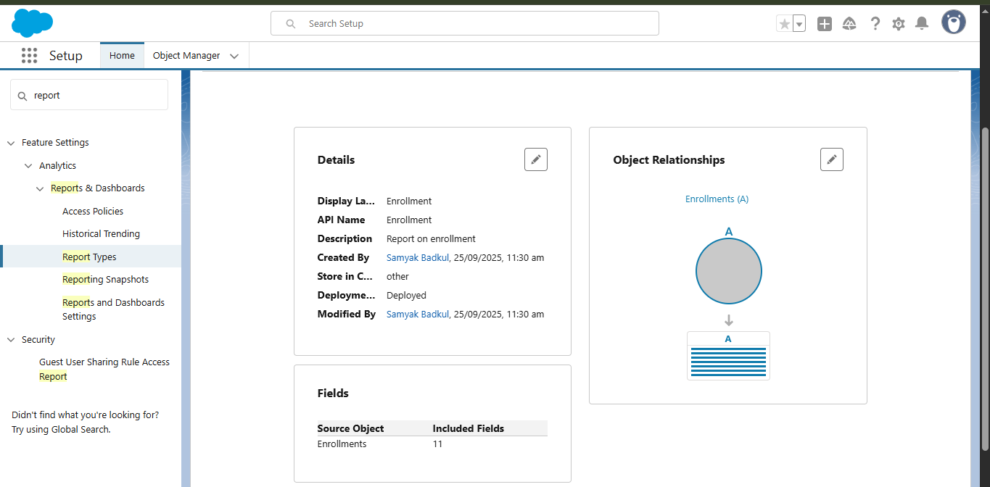

## **2. Report 1 – Student Inquiries by Status**

* **Purpose**: Track how many inquiries are New, Assigned, Qualified, or Rejected.
* **Steps to Create**:  
  + Created a custom report type for Student Inquiry.
  + Grouped rows by **Status**.
  + Added a **Bar Chart** for visualization.
* **Observation**: This shows where inquiries are stuck and helps balance counselor workloads.  
  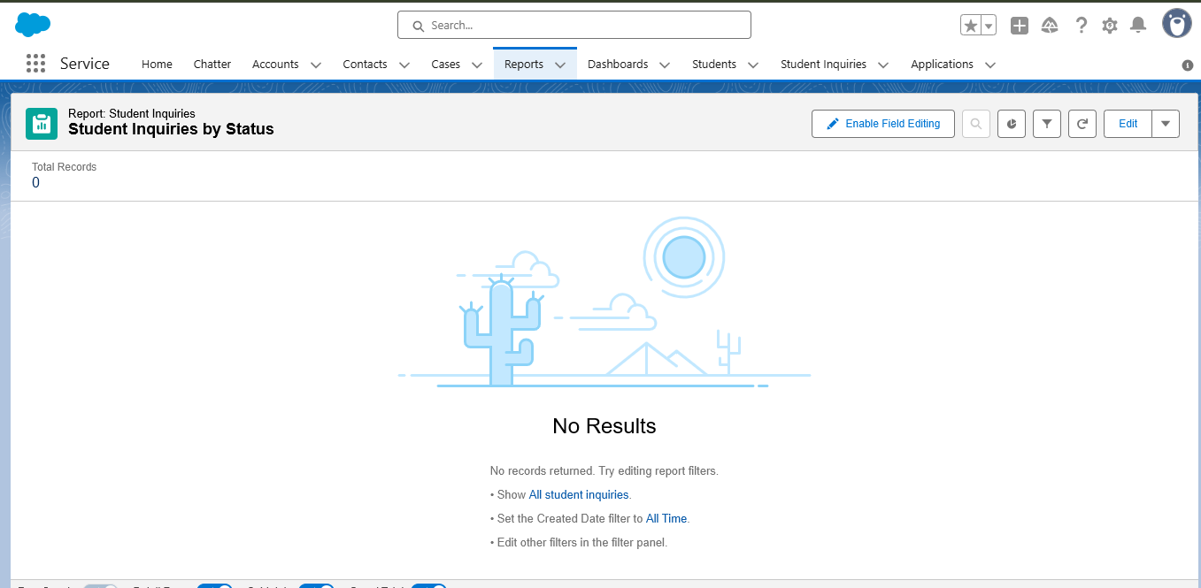

📸 *Insert screenshot of Report 1 here*

## **3. Report 2 – Applications by Program**

* **Purpose**: Understand how many applications are submitted for each program.
* **Steps to Create**:  
  + Created a custom report type for Application.
  + Grouped rows by **Program**.
  + Added a **Donut Chart** for visualization.
* **Observation**: This highlights the most popular programs among applicants.  
  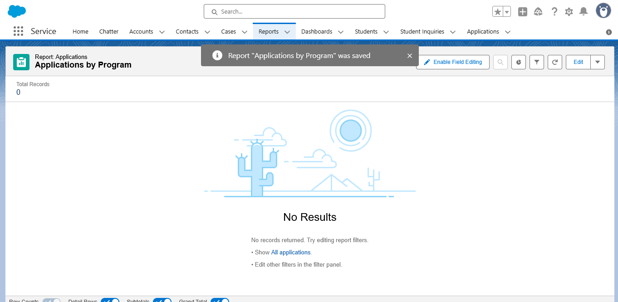

📸 *Insert screenshot of Report 2 here*

## **4. Report 3 – Enrollments by Status**

* **Purpose**: Monitor the current status of enrollments (Active, Completed, Dropped, etc.).
* **Steps to Create**:  
  + Created a custom report type for Enrollment.
  + Grouped rows by **Status**.
  + Added a **Bar Chart** for visualization.
* **Observation**: This helps track how many students successfully enrolled and how many dropped.  
  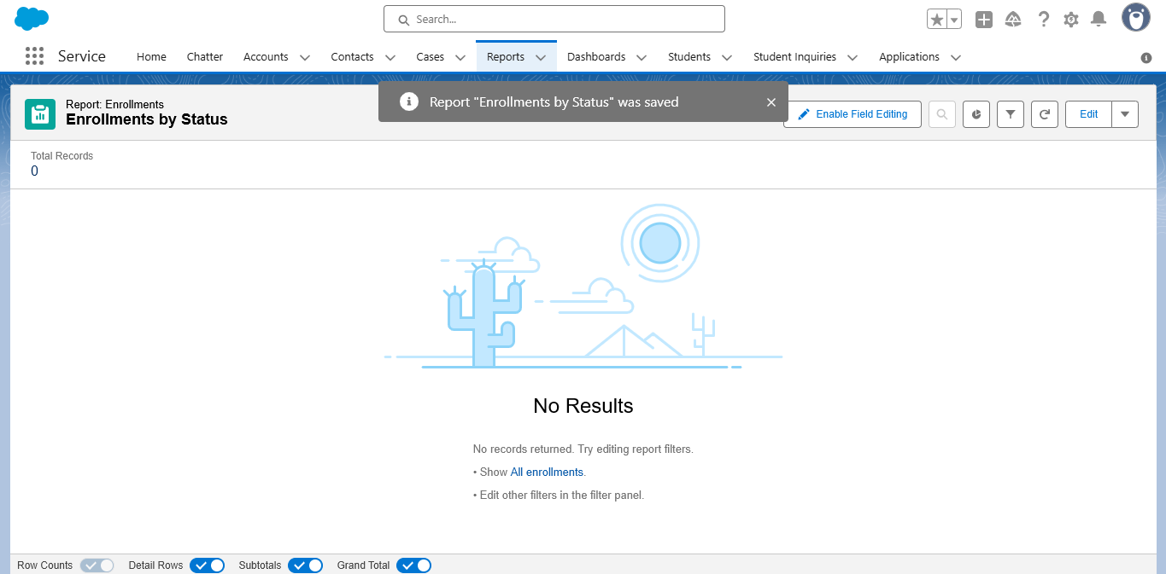

📸 *Insert screenshot of Report 3 here*

## **5. Admissions Dashboard**

* **Purpose**: Combine all key reports into one visual dashboard for decision-making.
* **Steps to Create**:  
  + Created **Admissions Dashboard** in the Dashboard tab.
  + Added three components:  
    1. Student Inquiries by Status (Bar Chart)
    2. Applications by Program (Donut Chart)
    3. Enrollments by Status (Bar Chart)
* **Observation**: The dashboard provides a one-page view of the entire admissions process.

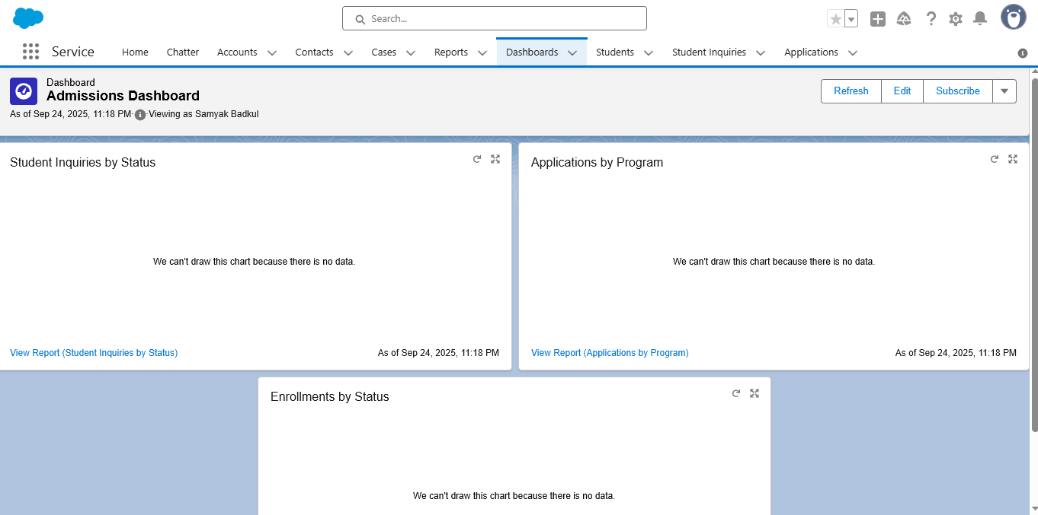

## **6. Conclusion**

Phase-5 provided insights into the admissions lifecycle. Reports and dashboards enable the college to identify trends, track counselor performance, and improve student conversion rates. This phase transforms raw CRM data into actionable insights.