About Project

In this project we have given an insight to the development of a computer based database titled “Parcel Management”. This is a Courier service Parcel Management System Project. This is a web-based project and its main purpose is to offer an automated platform for courier services to manage and track parcels information. This project has a simple user interface and user-friendly functionalities of the given project.

Frontend (UI) : Python (3.10.2)

Backend (Programming Language): Python (3.10.2)

Database : MySQL (8.0.28)

Python download link : https://www.python.org/downloads/

MySQL download link : https://dev.mysql.com/downloads/mysql/

Objective of the Project:
- Even a non-technical user can use the system effectively and without any difficulty.

- It is upgradeable. Hence further enhancement to the system is possible.

- The system maintains speed and accuracy with eye-catching GUI.

References/Bibliography

- www.scribd.com/document/348228893/The-Transport-Management-System

- https://www.w3schools.com/sql

- Sumita Arora Text Book for Class XII

Database Designs

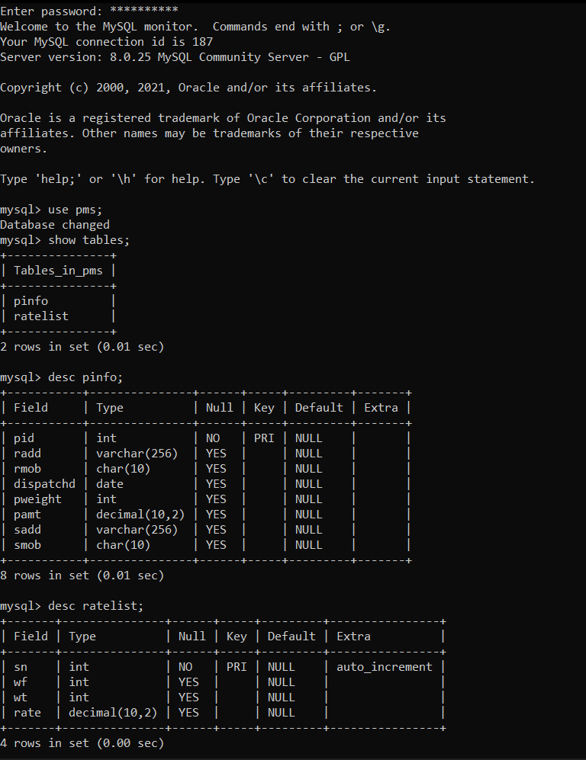

Setting the connection between Python and RDBMS(MySQL)

import mysql.connector
from tabulate import tabulate

con=mysql.connector.connect(host="localhost",user="root",password="Admin@1234",database="pms")

cur=con.cursor()

Python Program Code
#pMgtSys.py

import orderMgt
import mysql.connector
con=mysql.connector.connect(host="localhost",user="root",password="Admin@1234")
cur=con.cursor()
cur.execute("create database if not exists pms;")
cur.execute('use pms')
cur.execute('''create table if not exists pinfo(pid int primary key,radd varchar(256),rmob char(10),dispatchd date,
pweight int,pamt decimal(10,2),sadd varchar(256),smob char(10));''')
while True:
print('------------WELCOME TO INSTANT PARCEL SERVICES---------------')
print('here is the list of operations:')
print("1. ORDER MGT 2. RATE LIST 3. EXIT")
op=input('enter your choice: ')
if op=='1':
print("1.Placing order\n 2.Search order\n 3.Edit order details\n 4.Display all details\n 5.Delete order")
cho=input("enter your choice: ")
if cho=='1':
orderMgt.add()
elif cho=='2':
orderMgt.search()
elif cho=='3':
orderMgt.edit()
elif cho=='4':
orderMgt.dispall()
elif cho=='5':
orderMgt.delete()
else:
print("Wrong choice entered")
if op=='2':
orderMgt.ratelist()

#orderMgt.py

import mysql.connector
from tabulate import tabulate
con=mysql.connector.connect(host="localhost",user="root",password="Admin@1234",database="pms")
cur=con.cursor()

def add():
while True:
cur.execute("select max(pid) from pinfo;")
pid=cur.fetchone()[0]
if pid:
pid=pid+1;
else:
pid=301
pamt=0
radd=input("Enter Receiver's Address(with name):")
rmob=input("Enter Receiver's Mobile No:")
pweight=int(input("Enter the weight of the parcel(in kg):"))
if (pweight>0 and pweight<=5):
pamt=pamt+(pweight*50)
elif (pweight>5 and pweight<=10):
pamt=pamt+(pweight*70)
elif pweight>10:
pamt=pamt+(pweight*100)
else:
print("Invalid Input")
break
print("Total payable amount is",pamt)
ch=input("You want to proceed(Y/N)")
if ch in['Y', 'y']:
sadd=input("Enter Sender's address(with name):")
smob=input("Enter sender's Mobile No:")
cur.execute("insert into pinfo values({},'{}','{}',curdate(),{},{},'{}','{}');".format(pid,radd,rmob,pweight,pamt,sadd,smob))
con.commit()
print("Parcel Information added successfully!")
status=input("Do you want to proceed another records(Y/N):\t")
if status in ['n','N']:
break

def search():
pid=int(input("Enter Packet Id whose information is to be searched:"))
print()
cur.execute("select * from pinfo where pid={};".format(pid))
rec=cur.fetchall()
if rec:
print(tabulate(rec,headers=["pid","radd","rmob","dispatchd date","pweight","pamt","sadd","smob"],tablefmt="psql"))
print()
else:
print("Record not found for the entered Packet Id!")
print()

def edit():
pid=int(input("Enter Packet Id whose information is to be edited:"))
print()
cur.execute("select * from pinfo where pid={};".format(pid))
rec=cur.fetchall()
if rec:
print(tabulate(rec,headers=["pid","radd","rmob","dispatchd date","pweight","pamt","sadd","smob"],tablefmt="psql"))
print()
smob=input("Enter updated Mobile No of Sender:")
rmob=input("Enter updated Mobile No of receiver:")
cur.execute("update pinfo set smob='{}',rmob='{}' where pid={};".format(smob,rmob,pid))
con.commit()
print()
print("Information for entered Packet Id is edited successfully!")
print()
else:
print("Record not found for the entered Packet Id!")
print()

def dispall():
cur.execute("select * from pinfo;")
rec=cur.fetchall()
if rec:
print(tabulate(rec,headers=["pid","radd","rmob","dispatchd date","pweight","pamt","sadd","smob"],tablefmt="psql"))
print()
else:
print("Table is empty:No record found!")
print()

def delete():
pid=int(input("Enter Packet Id whose information is to be deleted:"))
print()
cur.execute("select * from pinfo where pid={};".format(pid))
rec=cur.fetchall()
if rec:
print(tabulate(rec,headers=["pid","radd","rmob","dispatchd date","pweight","pamt","sadd","smob"],tablefmt="psql"))
print()
cur.execute("delete from pinfo where pid={};".format(pid))
con.commit()
print("Information for the entered Packet Id is deleted successfully!")
print()
else:
print("Record not found for the entered Packet Id!")
print()

def ratelist():
cur.execute("select * from ratelist;")
rec=cur.fetchall()
if rec:
print(tabulate(rec,headers=["S.No.","Weight From(in Kg)","Weight To(in Kg)","Price(Per Kg)"],tablefmt="psql"))
print()

Output Screens :

- RATE LIST:

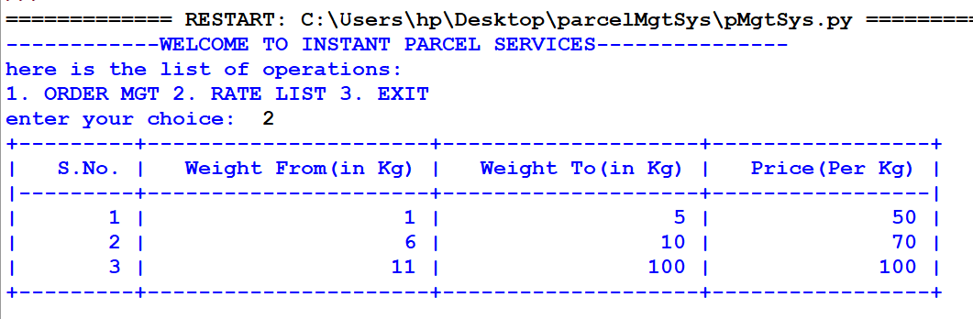

- PLACING ORDER:
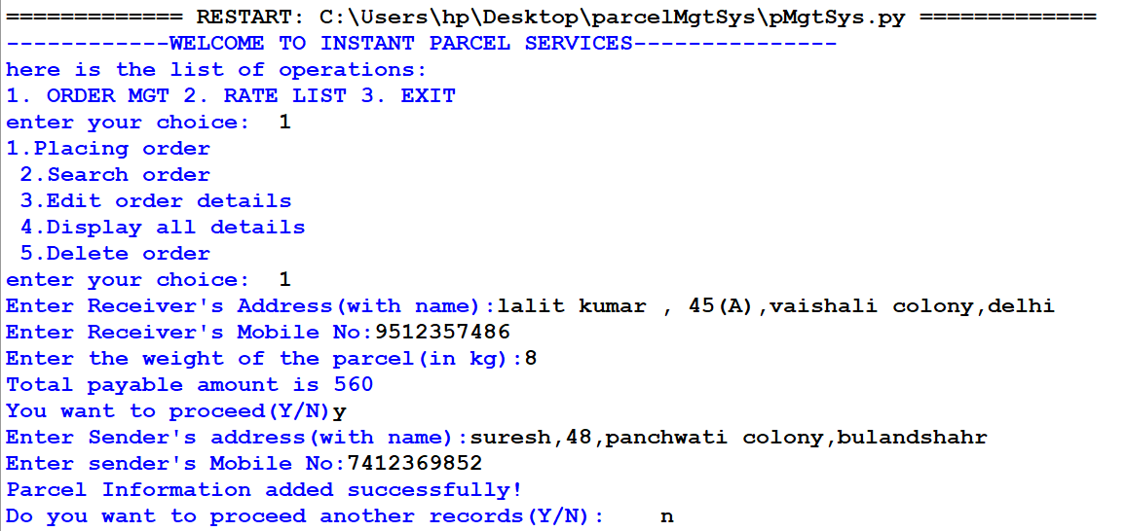
- DISPLAY FUNCTION:

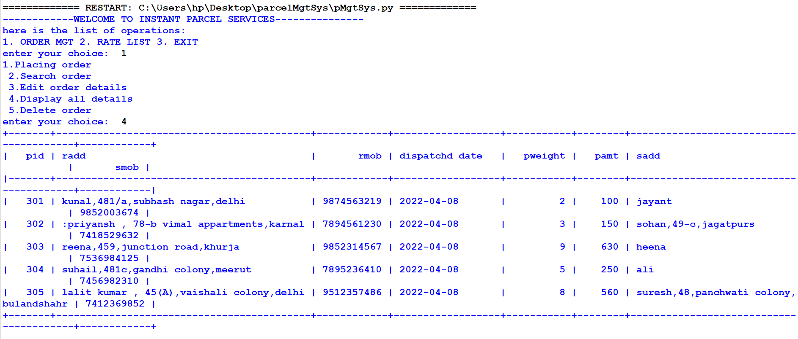

- EDIT FUNTION:

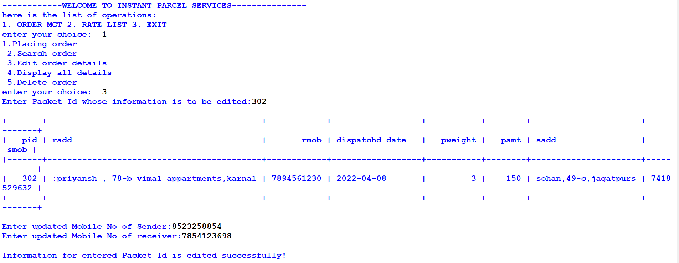

- DELETE FUNTION:

