# INTRODUCTION TO PROJECT

The web based “Agricultural Portal” project is an attempt to stimulate the basic concepts of web based e-commerce application. The system enables the customer to do the things such as search for agricultural products for farming activities, choose a product based on the details and uses of the product.

The system provides you Quick Search facility that provides you details about products without login. But if user want to buy something then it must require login into account.

The system allows buyers to search for products based upon category, namely the “Pesticides” and “Fruits” etc. The portal system displays all the products’ details such as Quantity of ingredients, product name, price, discount available on particular product and place order etc.

Here we provided quick search facility which displays list of available products and allows customer to choose a particular product. Then the system checks for the availability of product on the inventory. If the inventories are available then the system allows the passenger to put order.

To book a product the portal system asks the customer to enter his details such as username, first name, last name, email, address, city, state, bank account number and contact number. Then it checks the validity of user details and placed the order and update the agri-portal base and user database.

**2.REQUIREMENTS**

**2.1 FUNCTIONAL REQUIREMENTS**

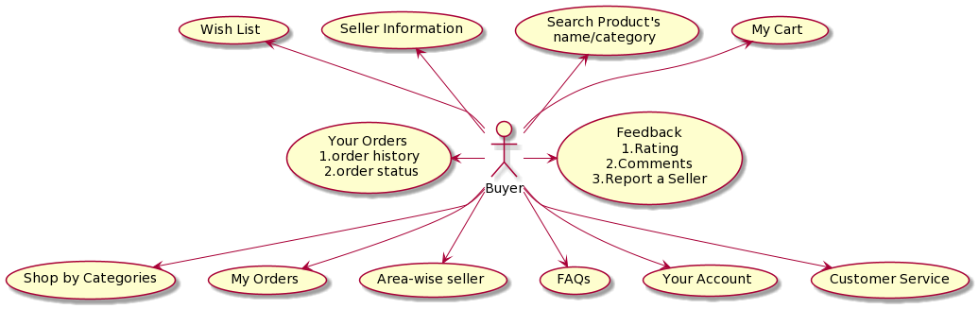

**2.1 Buyer Account**

The buyer, who will henceforth be called the ‘customer user’, will be presented with multiple choices by the portal system, as the first step in the interaction between them. A user can choose one of these and his choice would be governed by whether he is a guest or a registered user and whether he wants to check the availability of products or also buy/report them. The terms ‘customer user’ and ‘guest’ are described below.

A customer user who has shopped earlier would have been given a user name and a password. This ‘personal information’ would be henceforth referred to as ‘profile login details’. Such a user with a profile login details in DB-user shall be called a ‘registered user’. A registered user will be able to check the different products as well as buy products by logging into the system.

A new user, on the other hand, would either have to

1. register him/herself with the system by providing personal information or
2. log into the system as a guest.

In case of ‘a’, the new user becomes a registered user.

In case of ‘b’, the new user would remain a guest.

A guest can only check the availability of products and cannot buy or add it to personal cart. But a registered user can also act as a guest if he only wants to check the available products.

‘Availability of products’ always refers to viewing the products in category wise manner, the price of product and any discount offers. The system shall present the user with an option to exit from the system at any time during the following processes.

**2.2 Registration and creation of user profile**

The system shall require a user to register, in order to carry out any transactions with it except for checking the availability of products. It will ask the user for the following information at the least – a user name, a password, first name, last name, email, phone number. The system will automatically create a ‘address and bank details’ field and initialize it to null in the user’s profile.

* 1. **Quick Search**

Here we provided Quick Search facility for any user to search product with its name. This will provide user an option for searching products and comparing their prices of all companies.

After logging in a user (either a registered user or a guest), the system shall request him to enter the following details – address and bank account details. As name suggest for placing an order address should have to be mentioned to deliver product and also bank details are required in case of refund of paid amount.

.

After the address and bank details are ascertained, the system shall now access the user details database. After adding this details in profile, user can go through different products and add them into cart or wish list and then place the order for a product sold by seller.

The system shall allow a user to view all information about his previous orders. After logging him on, he can hit the button to see all his previous orders. It accesses Order’s table and retrieves the details of the orders and presents them to the user in a tabular format.

‘Seller’ refers to another important module of this site. Seller is an also user who can sell their products to other customer users.

* 1. **Seller Profile**

**‘Seller’,** who can sold different range products to the registered customer have to login in as the role of seller. Once he or she will register themselves into the site they will have PENDING account status which can be approved by Admin only. On a successful approval, seller can login into website and add different products to sell in the databases with nice description. Once customer placed the order seller can see all the order details and take actions like ‘Confirm Order’, ‘Cancel Order’, ‘Dispatch Order’ and ‘Deliver Order’. Once order will be confirmed by the seller, his inventory details will updated automatically and along with other customer, he can see available stock. Seller can generate sales report of previous month and analyze profit of last month. Following functionality will be available to seller to perform:

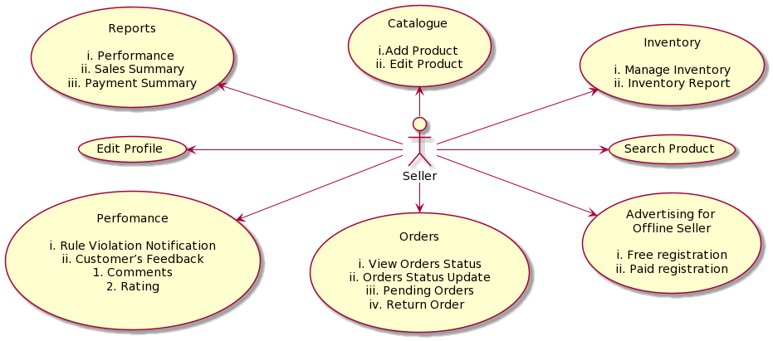

Seller will have option to search particular product with different searching option. Seller can see customer’s feedback in terms of words and number as ratting in scale of 1-5. On the violation of terms and policies, seller’s account can be lock or suspended for a particular time period. Seller can restock the inventory according to the availability of the product. He has to enter the newly added stock and it will updated the number of units available.

* 1. **Admin Profile**

**Admin** is the maintainer of whole website and can take actions to maintain the decorum of this e-commerce website. Admin will have many functionality like he can get the list of all the customers and sellers. He can search particular product with seller name and category wise filter option is also available. Admin will add different categories. Categories will be use to maintain data in database. Products will be added to categories for filtering the products according the uses of it.

Following are the different function available for Admin:

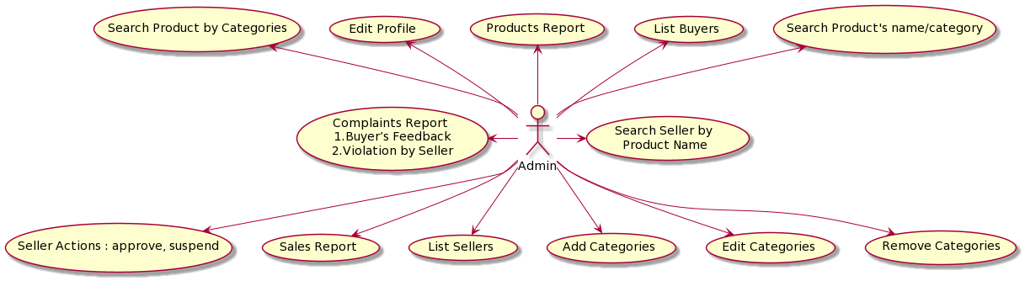

Admin can assign another admin and give him all admin privileges to perform all this activities. Admin will have feature to see the revenue report of previous month. Admin can take actions on customer feedback and complaints. He can remove any seller for violating the website’s term and policies.

**3. DESIGN**

**3.1 Database Design**

The following table structures depict the database design.

# Table1: User Info

|  |  |  |  |  |
| --- | --- | --- | --- | --- |
| **Key Type/ Constraint** | **Column Name** | **Data Type** | **Length** | **Allow Null (1=Yes;0=No)** |
| PRI | User ID | Int | - | 0 |
| UNI | User name | Varchar | 20 | 0 |
| 0 | First name | Varchar | 30 | 0 |
| 0 | Last name | Varchar | 30 | 0 |
| UNI | Email | Varchar | 50 | 0 |
| 0 | Contact number | Varchar | 15 | 0 |
| 0 | Password | Varchar | 200 | 0 |
| 0 | Role | Varchar | 12 | 0 |
| 0 | Address | embedded | - | 1 |
| 0 | Bank Details | embedded | - | 1 |

# Table2: Seller Info

|  |  |  |  |  |
| --- | --- | --- | --- | --- |
| **Key Type/ Constraint** | **Column Name** | **Data Type** | **Length** | **Allow Null (1=Yes;0=No)** |
| PRI | User ID | Number | - | 0 |
| UNI | User name | Varchar | 20 | 0 |
| 0 | First name | Varchar | 30 | 0 |
| 0 | Last name | Varchar | 30 | 0 |
| UNI | Email | Varchar | 50 | 0 |
| 0 | Contact number | Varchar | 15 | 0 |
| 0 | Password | Varchar | 200 | 0 |
| 0 | gstin | Varchar | 30 | 0 |
| 0 | PAN | Varchar | 20 | 1 |
| 0 | Status | Varchar | 12 | 0 |
| 0 | Address | embedded | - | 1 |
| 0 | Bank Details | embedded | - | 1 |

# Table3: Address

|  |  |  |  |  |
| --- | --- | --- | --- | --- |
| 0 | Pin Code | Number | 5 | 1 |
| 0 | Line1 | Varchar | 100 | 1 |
| 0 | Line2 | Varchar | 100 | 1 |
| 0 | Land mark | Varchar | 100 | 1 |
| 0 | City | Varchar | 25 | 1 |
| 0 | State | Varchar | 25 | 1 |
| 0 | Country | Varchar | 25 | 1 |
| 0 | Land mark | Varchar | 100 | 1 |

**Table4: Bank Details**

|  |  |  |  |  |
| --- | --- | --- | --- | --- |
| 0 | IFSC code | Varchar | 30 | 1 |
| 0 | Account Number | Varchar | 30 | 1 |

**Table5: Category**

|  |  |  |  |  |
| --- | --- | --- | --- | --- |
| PRI | Category Id | Int | - | 0 |
| 0 | Category name | Varchar | 20 | 1 |
| 0 | Description | Varchar | 150 | 1 |
| 0 | Picture | longblob | - | 1 |

**Table6: Cart**

|  |  |  |  |  |
| --- | --- | --- | --- | --- |
| PRI | Id | Int | - | 0 |
| 0 | Created date | Date | - | 1 |
| MUL | Pid | Int | - | 0 |
| 0 | Quantity | Int | - | 0 |
| 0 | Seller id | Int | - | 0 |
| MUL | User id | Int | - | 0 |

**Table7: Wish list**

|  |  |  |  |  |
| --- | --- | --- | --- | --- |
| PRI | Id | Int | - | 0 |
| 0 | Created date | Datetime | 6 | 1 |
| MUL | Pid | Int | - | 0 |
| MUL | User id | Int | - | 1 |

**Table8: Feedback**

|  |  |  |  |  |
| --- | --- | --- | --- | --- |
| PRI | Id | Int | - | 0 |
| 0 | Feedback | Varchar | 100 | 1 |
| MUL | Pid | Int | - | 0 |
| 0 | Rating | Double | - | 0 |
| MUL | User id | Int | - | 0 |

**Table9: wishlist**

|  |  |  |  |  |
| --- | --- | --- | --- | --- |
| PRI | Id | Int | - | 0 |
| 0 | Estimate Delivery Date | Datetime | 6 | 1 |
| 0 | Order Date | Datetime | 6 | 0 |
| 0 | Order Status | Varchar | 15 | 0 |
| 0 | Paid amount | Double | - | 1 |
| 0 | Payment type | Varchar | 20 | 1 |
| 0 | Ship date | Datetime | 6 | 1 |
| 0 | Total amount | Double | - | 0 |
| 0 | Transaction status | Varchar | 20 | 1 |
| MUL | Buyer id | Int | - | 0 |

**Table10: Order Details**

|  |  |  |  |  |
| --- | --- | --- | --- | --- |
| PRI | Id | Int | - | 0 |
| 0 | Discount | Double | - | 1 |
| 0 | Quantity | Int | - | 0 |
| 0 | Total | Double | - | 0 |
| MUL | Pid | Int | - | 0 |
| MUL | order id | Int | - | 0 |

**Table11: Complaint**

|  |  |  |  |  |
| --- | --- | --- | --- | --- |
| PRI | Id | Int | - | 0 |
| 0 | Complaint | Varchar | 100 | 1 |
| MUL | Pid | Int | - | 0 |
| MUL | User id | Int | - | 0 |
| 0 | Status | Varchar | 10 | 0 |

**E-R Diagram,Dataflow diagram and Class Diagram:**

Go to Appendix A

**4. CODING STANDARDS IMPLEMENTED**

### Naming and Capitalization

Below summarizes the naming recommendations for identifiers in Pascal casing is used mainly (i.e. capitalize first letter of each word) with camel casing (capitalize each word except for the first one) being used in certain circumstances.

|  |  |  |  |
| --- | --- | --- | --- |
| **Identifier** | **Case** | **Examples** | **Additional Notes** |
| Class | Pascal | Users, Seller, Product, Order | Class names should be based on "objects" or "real things" and should generally be **nouns**. No ‘_’ signs allowed. Do not use type prefixes like ‘C’ for class. |
| Method | Camel | getAllUsers, getAlSeller, | Methods should use **verbs** or verb phrases. |
| Parameter | Camel | userName, password | Use descriptive parameter names. Parameter names should be descriptive enough that the name of the parameter and its type can be used to determine its meaning in most scenarios. |
| Interface | Pascal with "I" prefix | IUserService | Do not use the ‘_’ sign |
| Property | Pascal | ForeColor, BackColor | Use a noun or noun phrase to name properties. |
| Associated private member variable | camelCase | _foreColor, _backColor | Use underscore camel casing for the private member variables |
| Exception Class | Pascal with "Exception" suffix | GlobalHandlingException, |  |

### Comments

* Comment each type, each non-public type member, and each region declaration.
* Use end-line comments only on variable declaration lines. End-line comments are comments that follow code on a single line.
* Separate comments from comment delimiters (apostrophe) or // with one space.
* Begin the comment text with an uppercase letter.
* End the comment with a period.
* Explain the code; do not repeat it.

**5. TEST REPORT**

**Another group called Linux did the testing and the report of the testing is given here under.**

**GENERAL TESTING:**

|  |  |  |  |  |
| --- | --- | --- | --- | --- |
| **SR-NO** | **TEST CASE** | **EXPECTED RESULT** | **ACTUAL RESULT** | **ERROR MESSAGE** |
| 1 | Register Page | Redirected to Next page | OK | Nothing |
| 2 | Login Page | Pop-up will come | Ok | Please enter username and password again . |
| 3 | Reset login | Only users password will be reseted | Ok | Nothing |
| 4 | Quick search product | Gives all products details | Ok | Nothing |
| 5 | Place order | Order should be placed | Ok | Nothing |
| 6 | Checking login or not | User is logged in or not | Ok | Nothing |
| 7 | Add person details for ordering | Add information according to requirement | Ok | Nothing |
| 8 | Goto My cart | Load all cart items | Ok | Nothing |
| 9 | Personal account | See profile info | Ok | Nothing |
| 10 | Feedback page | Add feedback in word and number form | Ok | Nothing |
| 11 | View transaction done | It shows you all transactions done previously | Ok | Nothing |
| 12 | Logout | It will logout from user profile. | Ok | Nothing |
|  | **STATIC TESTING** |  |  |  |
| **SR-NO** | **Deviation** | **Program** |  |  |
| 1 | Commenting not followed | All Web Application |  |  |

**6. PROJECT MANAGEMENT RELATED STATISTICS**

|  |  |  |  |
| --- | --- | --- | --- |
| **DATE** | **WORK PERFORMED** | ****SLC Phase**** | **Additional Notes** |
| MAR 08,2021 | Project Allotment and User Requirements Gathering | Feasibility Study | Know about the requirements of farming. |
| MAR 09,2021 | Initial SRS Document Validation  And Team Structure Decided | Requirement Analysis  (Elicitation) | The initial SRS was presented to the client to understand his requirements better |
| MAR 10,2021 | Designing the use-cases, Class Diagram, Collaboration Diagram, E-R Diagram and User Interfaces | Requirement Analysis &  Design Phase | Database Design completed |
| MAR 11,2021 | Business Logic Component design Started | Design Phase | ---------------------- |
| MAR 12,2021 | Coding Phase Started | Coding Phase | 70% of Class Library implemented. |
| MAR 13,2021 | Implementation of Web Application and Window Application Started | Coding Phase | Class Library Development going on. |
| MAR 14,2021 | Off | Off | Off |
| MAR 15,2021 | Implementation of Web Application and Window Application Continued | Coding Phase and Unit Testing | Class Library Modified as per the need. |
| MAR 16,2021 | Implementation of Web Application and Window Application Continued | Coding Phase and Unit Testing | -- |
| MAR 17,2021 | After Ensuring Proper Functioning the Required Validations were Implemented | Coding Phase and Unit Testing | Module Integration was done by the Project Manager |
| MAR 18,2021 | The Project was Tested by the respective Team Leaders and the Project Manager | Testing Phase (Module Testing) | -- |
| MAR 19,2021 | The Project was Submitted to Other Project Leader of Other Project Group For Testing | Testing Phase (Acceptance Testing) | The Project of Other Team was Taken up by the Team for Testing |
| MAR 20,2021 | The Errors Found were Removed | Debugging | The Project was complete for submission |
| MAR 21,2021 | The Errors Found were Removed | Debugging | The Project was complete for submission |
| MAR 22,2021 | Final Submission of Project |  |  |

Appendix A

Entity Relationship Diagram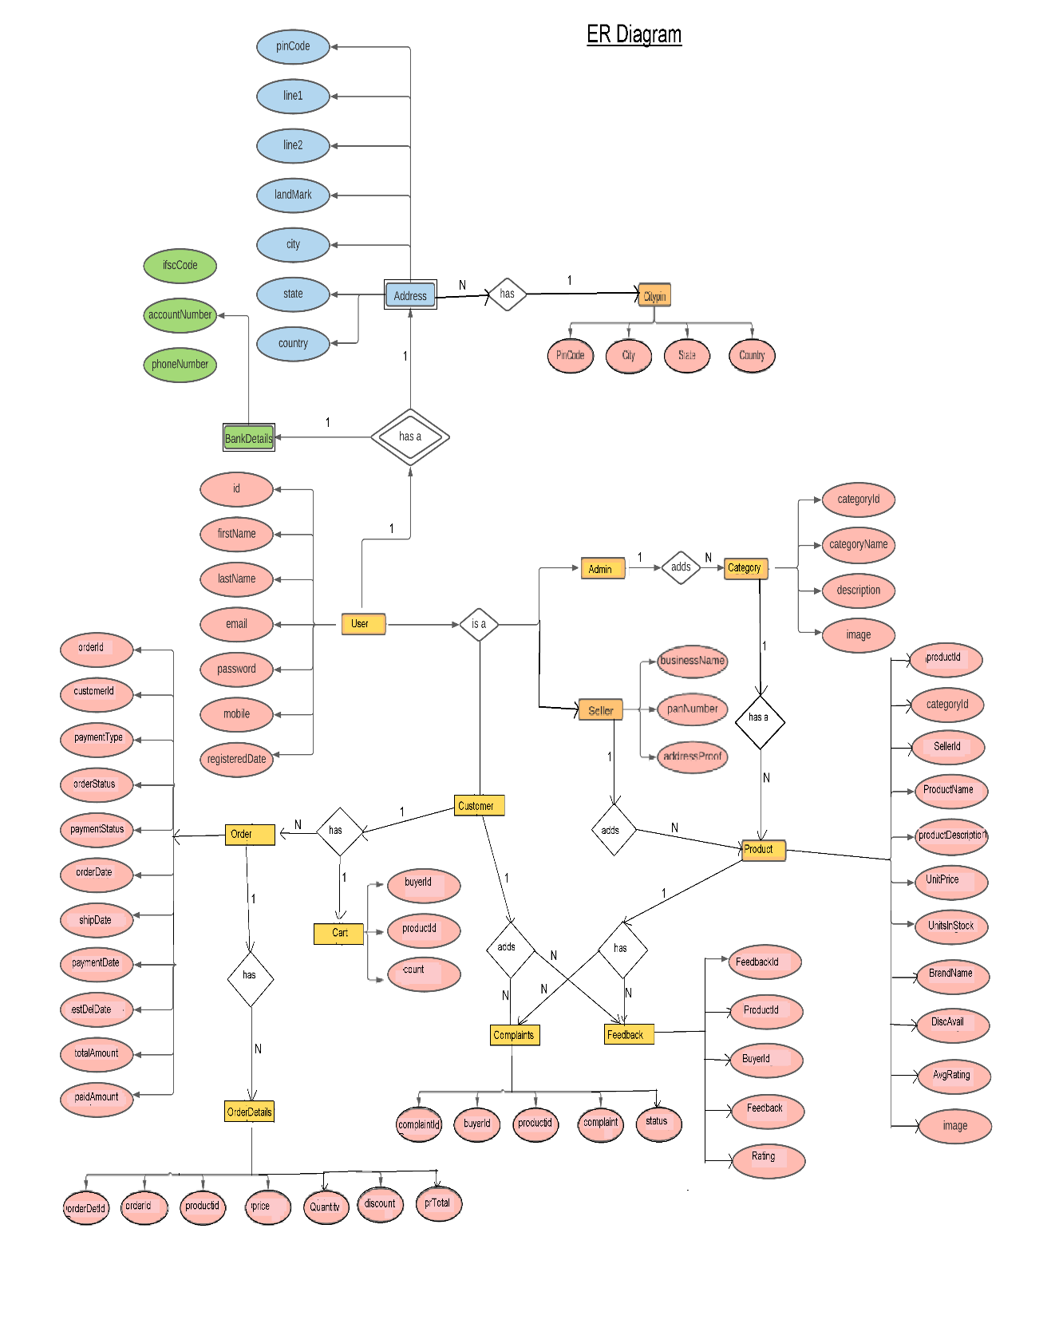

Appendix B

Homepage: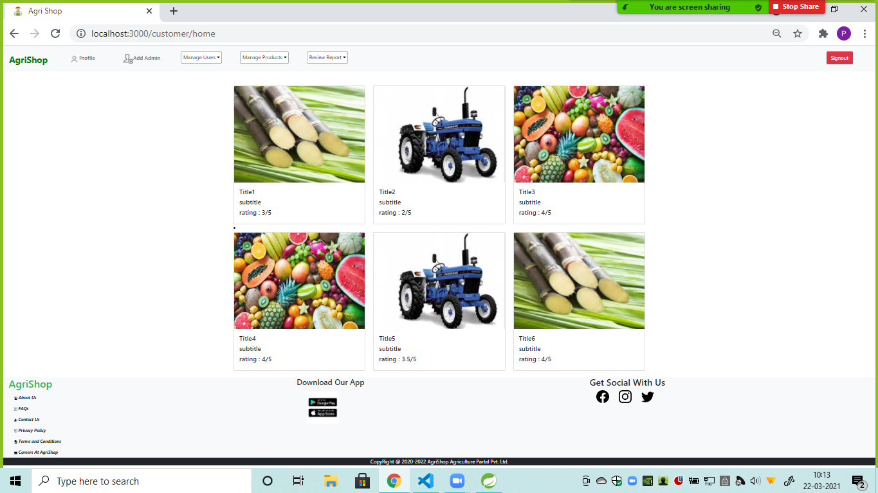

Signin: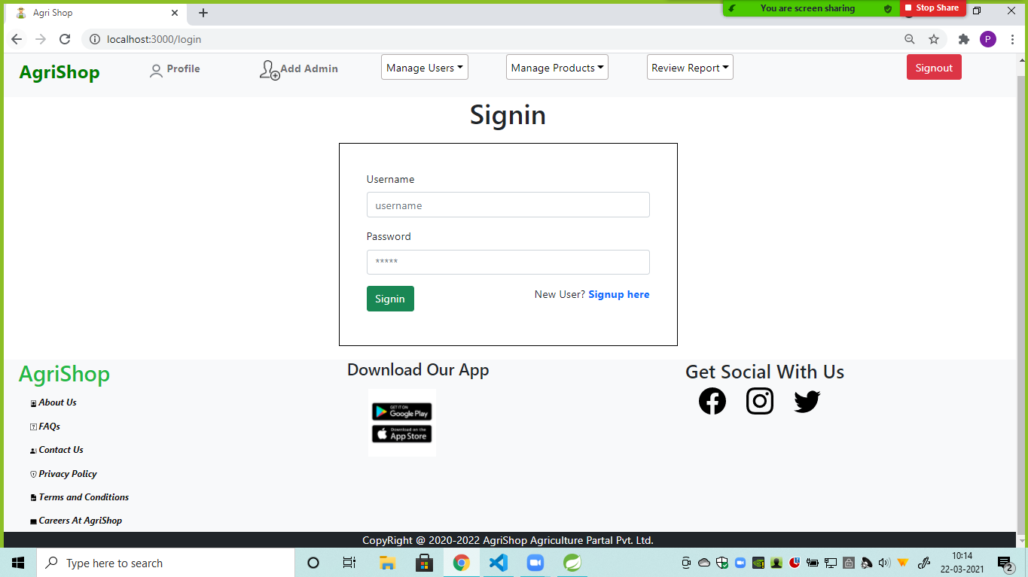

User Signup:

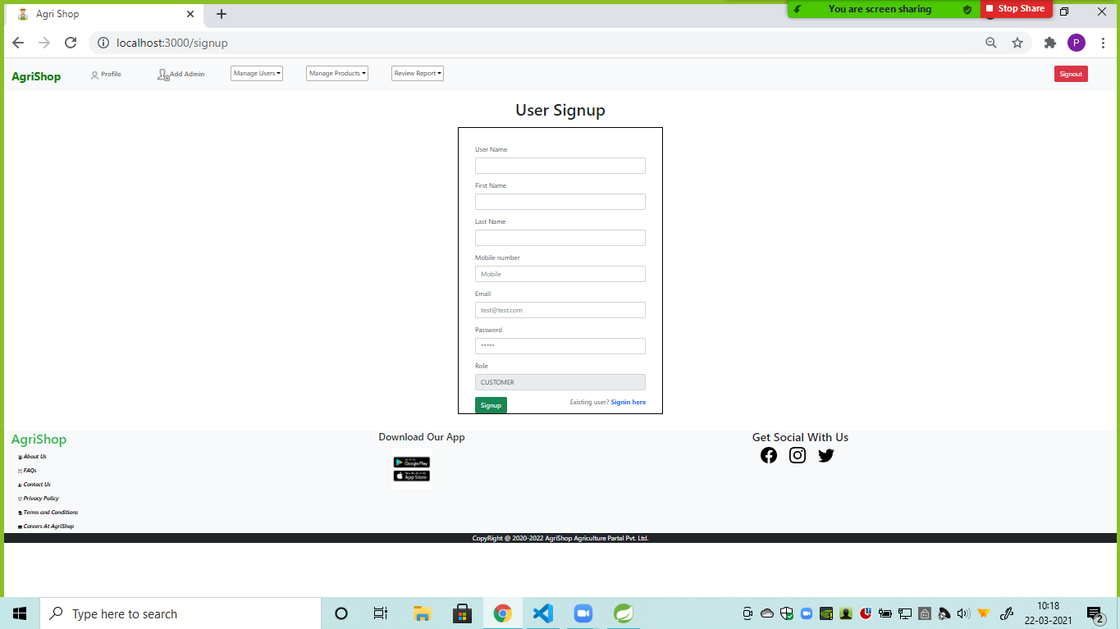

Your Orders:

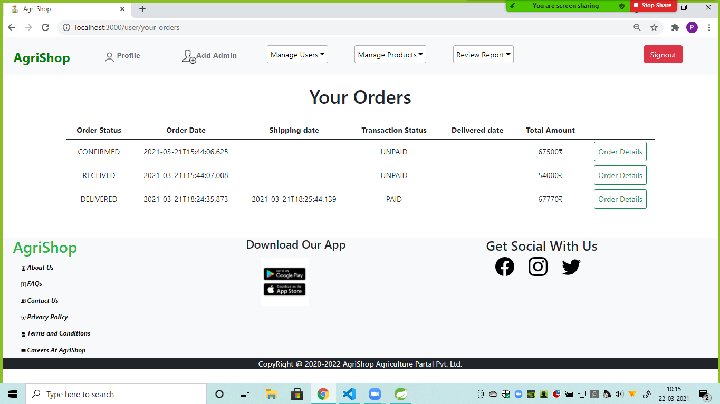

**Add Admin**

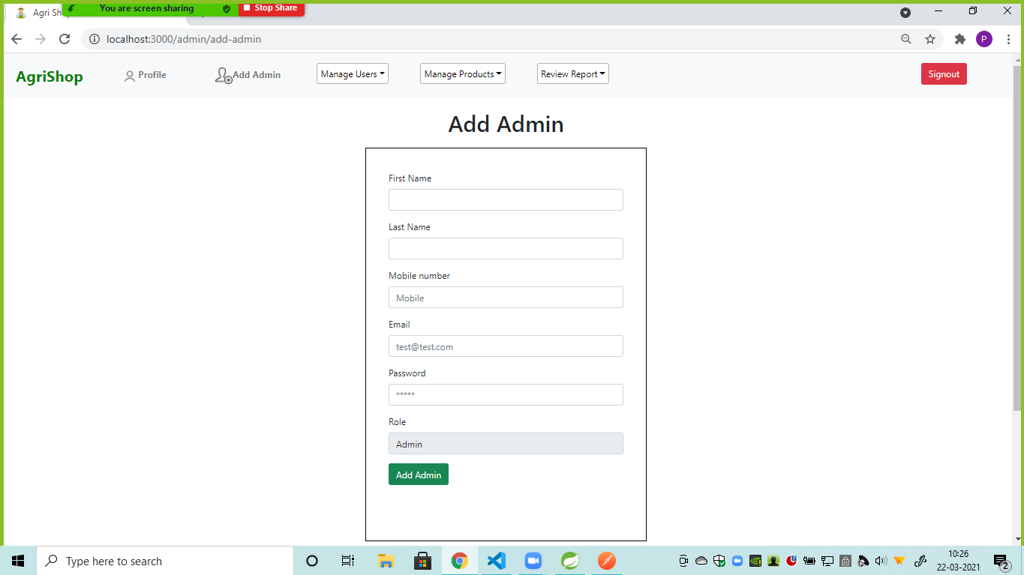

**MonthlySales**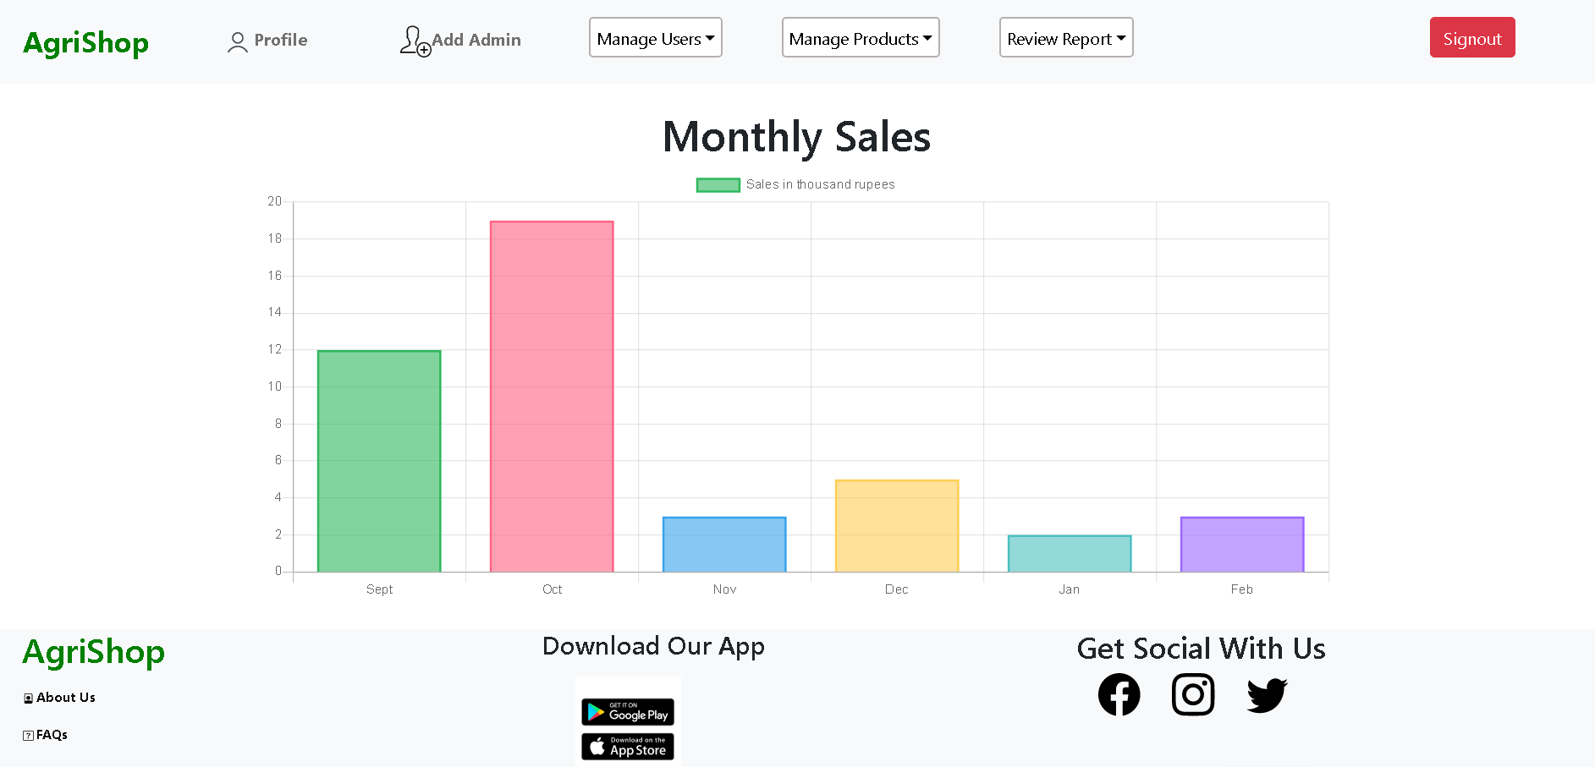

**Product Report**

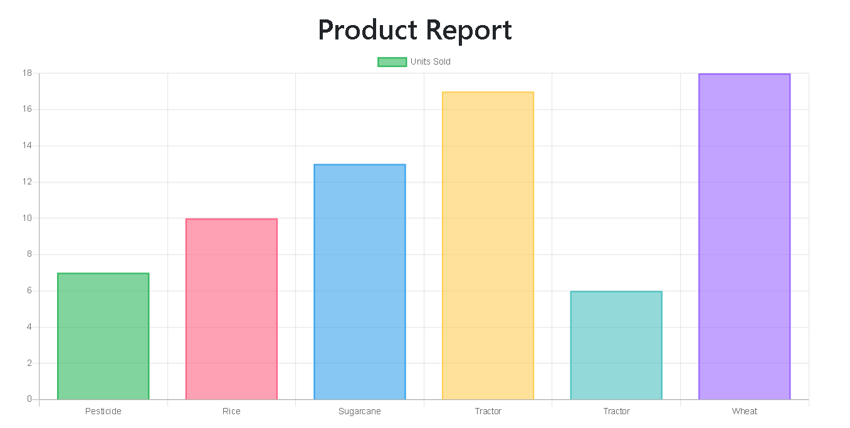

UserProfileDetails: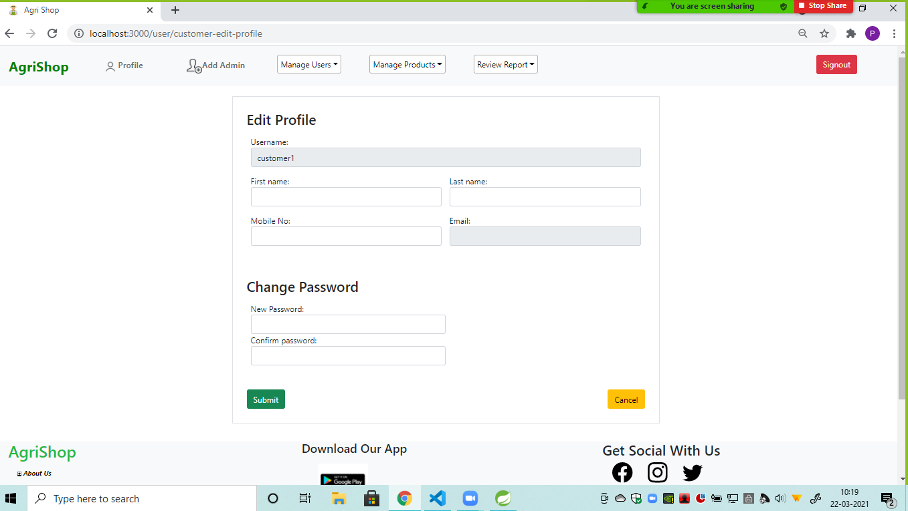

**7.REFERENCES:**

<http://www.google.com>

[http://](http://www.xml101.com:8081/xml/)www.airIndia.com

http://www.webdevelopersjournal.com/

http://www.lufthansa.com

http://www.w3.org

http://www.wikipedia.org

http://www.delta.com

http://www.priceline.com