**Agricultural Portal**

Agricultural Portal is a project developed to build a website which will help farmers from different villages to sell their products to different cities and also to buy pesticides, seeds and machineries.

This portal will also help industries, consumers to buy crops and other agricultural products directly from farmers without any broker/mediators. Pesticides dealer can also sell their products through this portal. This portal will also provide contact details of dealers who are selling agricultural machineries.

**Admin** will be monitoring all the activities performed by all the users and he will be having all the grants and permissions and can access whole website. Admin can monitor all the details of buyers and sellers registered on portal.

**Buyer** - Registered users can login as buyer. There will be two types of buyers such as Farmers and Industry/Hotels/mall/Individual. Buyer can view products list and details of dealers.

**Seller -** Registered users can login as seller. There will be two types of sellers such as Farmers and dealers for agriculture products (Seeds, Fertilizers, Pesticides, Machinery). Seller can perform activities like add item, edit item

**MODULES:**

1. Admin
   1. List all buyers
   2. List all Sellers
   3. Search Seller by Business Name
   4. Search Product by Categories
   5. All Products Report
   6. Edit Profile
   7. Complaints Report
      1. Buyer’s Feedback
      2. Violation by Seller
   8. Sales Report
   9. Add Categories
   10. Edit Categories
   11. Remove Categories
   12. Approve Seller
   13. Add Admin

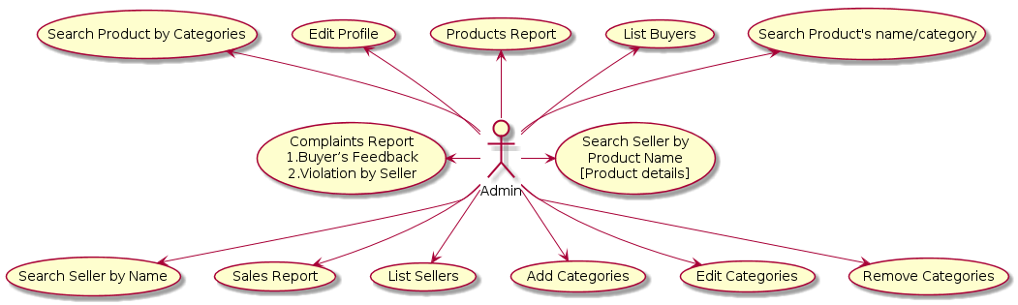NOTE: Admin can approve, reject and cancel any user as well as can manage products. Complaints Report can be generated on monthly basis.

1. Buyer
   1. Shop by Categories
   2. My Orders
   3. Wish List
   4. My Cart
   5. Your Account
2. Your Orders
   * 1. Order History
     2. Order Status
3. Your Address
4. Login & Security
5. Payment Options
   1. Offline Seller Information
6. Area-wise Seller
   1. Search Products’ Name/Category
   2. Customer Service
   3. FAQs
   4. Feedback
      1. Rating
      2. Comments
      3. Report a seller

NOTE: Buyer can view the list of all products and seller information only.

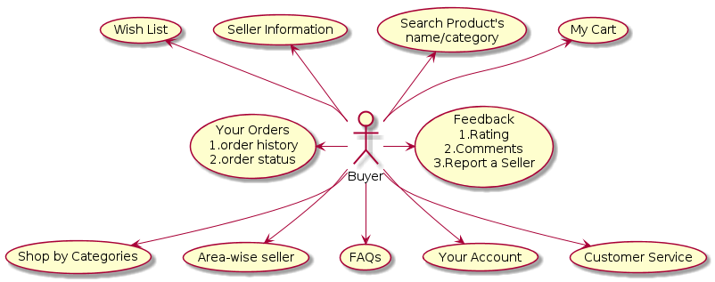

1. Seller
   1. Catalogue
      1. Add Products
      2. Edit Products
      3. Delete Products
      4. List Products
   2. Inventory
      1. Manage Inventory
      2. Inventory Report
   3. Pricing
   4. Register for Offline Business.
   5. Orders
      1. View Orders Status
      2. Orders Status Update

Confirmed /Cancelled

Dispatched

Delivered /Return

* + 1. Pending Orders
    2. Return Order
  1. Performance
     1. Rule Violation Notification
     2. Customer’s Feedback
        1. Rating
        2. Comments
  2. Edit Profile
  3. Reports
     1. Performance (based on customer feedback)
     2. Sales Summary
     3. Payment Summary (Within Given Time Limit)

