B.Tech. BCSE497J - Project-I

CODE-MIXED NLP SYSTEMS FOR MULTILINGUAL COMMUNICATION

Submitted in partial fulfillment of the requirements for the degree of

Bachelor of Technology

in

Computer Science and Engineering with Specialization in Data Science

by

23BCE0504 | PRANAV KALRA
23BDS0204 | SAMYA MEHTA
23BDS0209 | PALAK GOYAL

Under the Supervision of
Dr. Sanjiban Sekhar Roy
Professor Grade 2
School of Computer Science and Engineering (SCOPE)



October 2026

DECLARATION

I hereby declare that the project entitled Code-Mixed NLP Systems for Multilingual Communication submitted by me, for the award of the degree of Bachelor of Technology in Computer Science and Engineering with Specialization in Data Science to VIT is a record of bonafide work carried out by me under the supervision of Dr. Sanjiban Sekhar Roy. I further declare that the work reported in this project has not been submitted and will not be submitted, either in part or in full, for the award of any other degree or diploma in this institute or any other institute or university.

Place : Vellore Date : 20 October 2026
Signature of the Candidate

CERTIFICATE

This is to certify that the project entitled Code-Mixed NLP Systems for Multilingual Communication submitted by PRANAV KALRA (23BCE0504), SAMYA MEHTA (23BDS0204), PALAK GOYAL (23BDS0209), School of Computer Science and Engineering (SCOPE), VIT, for the award of the degree of Bachelor of Technology in Computer Science and Engineering with Specialization in Data Science, is a record of bonafide work carried out by them under my supervision.

The contents of this report have not been submitted and will not be submitted either in part or in full, for the award of any other degree or diploma in this institute or any other institute or university. The project fulfills the requirements and regulations of the University and in my opinion meets the necessary standards for submission.

Place : Vellore
Date : 20 October 2026

Signature of the Guide

Examiner(s)

Dr. Sendhil Kumar K. S.
Professor Grade 1
School of Computer Science and Engineering (SCOPE)
Computer Science and Engineering with Specialization in Data Science
ACKNOWLEDGEMENTS

I am deeply grateful to the management of Vellore Institute of Technology (VIT) for providing me with the opportunity and resources to undertake this project. Their commitment to fostering a conducive learning environment has been instrumental in my academic journey. The support and infrastructure provided by VIT have enabled me to explore and develop my ideas to their fullest potential.

My sincere thanks to Dr. Jaisankar N, the Dean of the School of Computer Science and Engineering (SCOPE), for his unwavering support and encouragement. His leadership and vision have greatly inspired me to strive for excellence. The Dean’s dedication to academic excellence and innovation has been a constant source of motivation for me. I appreciate his efforts in creating an environment that nurtures creativity and critical thinking.

I express my profound appreciation to Dr. Sendhil Kumar K. S., Professor Grade 1 and Head of the School of Computer Science and Engineering (SCOPE), for insightful guidance and continuous support. Their expertise and advice have been crucial in shaping the direction of this work.

I am immensely thankful to my project guide, Dr. Sanjiban Sekhar Roy, for dedicated mentorship and invaluable feedback. Their patience, knowledge, and encouragement have been pivotal in the successful completion of this project.

Thank you all for your contributions and support.

Pranav Kalra
Samya Mehta
Palak Goyal

TABLE OF CONTENTS
<Contents, Times New Roman 12, Line spacing 1.5>

Sl.No | Contents | Page No.
 | Abstract | i
1. | INTRODUCTION | 1
 | 1.1 Background | 1
 | 1.2 Motivations | 2
 | 1.3 Scope of the Project | 2
2. | PROJECT DESCRIPTION AND GOALS | 3
 | 2.1 Literature Review | 3
 | 2.2 Research Gap | 4
 | 2.3 Objectives | 4
 | 2.4 Problem Statement | 5
 | 2.5 Project Plan | 5
3. | TECHNICAL SPECIFICATION | 6
 | 3.1 Requirements | 6
 | 3.1.1 Functional | 6
 | 3.1.2 Non-Functional | 6
 | 3.2 Feasibility Study | 7
 | 3.2.1 Technical Feasibility | 7
 | 3.2.2 Economic Feasibility | 7
 | 3.2.3 Social Feasibility | 7
 | 3.3 System Specification | 8
 | 3.3.1 Hardware Specification | 8
 | 3.3.2 Software Specification | 8
4. | DESIGN APPROACH AND DETAILS | 9
 | 4.1 System Architecture | 9
 | 4.2 Design | 10
 | 4.2.1 Data Flow Diagram | 10
 | 4.2.2 Use Case Diagram | 10
 | 4.2.3 Class Diagram | 11
 | 4.2.4 Sequence Diagram | 11
5. | METHODOLOGY AND TESTING | 12
 | 5.1 Module Description | 12
 | 5.2 Testing | 14
6. | PROJECT DEMONSTRATION | 15
7. | RESULT AND DISCUSSION | 18
8. | CONCLUSION | 21
9. | REFERENCES | 22
 | APPENDIX A – SAMPLE CODE | 23

List of Figures

Figure No. | Title | Page No.
4.1 | TruthGuard dual-pipeline architecture (Approach A + Approach B) | 9
6.1 | Streamlit demo — FAKE verdict (RBI ₹5000 rumour) | 15
6.2 | Streamlit demo — REAL verdict (Chandrayaan-3) | 16
6.3 | Streamlit demo — MISLEADING verdict (school holiday claim) | 16
6.4 | Streamlit demo — UNVERIFIED verdict (free iPhone claim) | 17

(In the chapters, figure caption should come below the figure and table caption should come above the table. Figure and table captions should be of font size 10.)

List of Tables

Table No. Title Page No.
7.1 Hard-split classifier results (seed 42) 18
7.2 Random-split diagnostic results 19
3.1 Hardware / software specification 8
5.1 Approach A models compared 13

List of Abbreviations

API Application Programming Interface
BERT Bidirectional Encoder Representations from Transformers
BM25 Best Matching 25 (ranking function)
FAKE / REAL Binary veracity labels used in Approach A
LLM Large Language Model
mBERT Multilingual BERT
MuRIL Multilingual Representations for Indian Languages
OOD Out-of-Distribution
RAG Retrieval-Augmented Generation
RBI Reserve Bank of India
TF-IDF Term Frequency–Inverse Document Frequency
Tanglish Tamil–English code-mixed text
XLM-R XLM-RoBERTa

Note: All the abbreviations should follow Alphabetical order

Symbols and Notations
x Input text (headline or Tanglish claim)
c Normalized claim extracted from x
E Retrieved evidence set {e1..ek}
v Final verdict label
δf CFO
ε NCFO

ABSTRACT
Misinformation on Tamil social media is difficult to detect automatically for two practical reasons. First, users frequently write in Tanglish — Tamil and English mixed inside the same sentence, often with Romanized Tamil spellings such as “pannitanga” or “solli irukanga.” Many off-the-shelf detectors assume either clean English or formal native-script Tamil, so they fragment or misread such input. Second, a supervised classifier trained only on yesterday’s headlines cannot verify a rumour that started today unless it can retrieve fresh evidence from the web. Style-based scoring alone is not enough when the truth depends on current announcements from institutions such as the RBI, ISRO or a district collector.
This B.Tech. Project-I (BCSE497J) work presents TruthGuard, a dual-track system. Approach A is the supervised classification track. We collected and cleaned a balanced Tamil veracity corpus of 1400 headlines (exactly 700 FAKE and 700 REAL) from Tamil fact-checking publishers and mainstream news sites. We fine-tuned IndicBERTv2, MuRIL, mBERT and XLM-RoBERTa under a common protocol, and compared them with classical TF-IDF baselines (Naive Bayes, Logistic Regression, LinearSVC) plus a style-only logistic baseline. Because FAKE rows come almost only from fact-checkers and REAL rows from news outlets, a random train/test split can drive accuracy near 100% by learning source or style shortcuts rather than genuine veracity. Therefore our primary evaluation uses a source-disjoint hard split: training publishers are held out from test publishers. On that hard test (382 headlines), IndicBERTv2 reached about 86.65% accuracy with macro-F1 about 0.623. MuRIL and mBERT stayed near 61%. XLM-RoBERTa collapsed to about 32% accuracy and predicted FAKE for a large share of REAL headlines. TF-IDF models remained competitive on accuracy, which is an important honesty check for a student project.
Approach B is the evidence-grounded track for Tanglish claims. It runs six stages: claim extraction, query generation, Serper web search, webpage text extraction (Trafilatura / BeautifulSoup, with search-snippet fallback), multi-factor ranking (relevance, source authority, freshness), and Gemini adjudication that must cite evidence IDs. Modules that search or extract never decide truth. When evidence is missing, the system prefers UNVERIFIED rather than FAKE. A Streamlit demo shows live runs on prepared claims (FAKE currency rumour, REAL Chandrayaan landing, MISLEADING holiday wording, UNVERIFIED free-iPhone forward). Approach A is fast for offline screening of formal Tamil headlines; Approach B is slower and API-dependent but can check new rumours with citations. Remaining limits include source–label alignment in the 1400 set, class imbalance on the hard test FAKE subset, and the absence of a large labelled Tanglish veracity benchmark for quantitative Approach B metrics.
Keywords: Fake news detection; Tanglish; code-mixed NLP; MuRIL; IndicBERTv2; mBERT; XLM-RoBERTa; LLM; evidence-grounded verification; Serper; Streamlit; source-disjoint evaluation.
CHAPTER 1
INTRODUCTION
1.1 Background
Mobile internet and messaging apps have made it easy to share news-like posts in Tamil Nadu. Alongside genuine updates, false or half-true claims also travel quickly — for example rumours about new currency notes, free gadgets from “government schemes,” or statewide school holidays after rain. When such claims are wrong, they can create panic, waste public attention, or damage trust in institutions.
A second difficulty is linguistic. Everyday Tamil social text is often code-mixed. Users mix Tamil script, Romanized Tamil, and English inside one utterance. An example used throughout this project is: “RBI 5000 rupees note release pannitanga nu news la varudhu, real ah fake ah verify pannunga.” Tools built only for monolingual English fake-news corpora, or only for edited newspaper Tamil, do not see this pattern during training. Tokenizers may split Romanized Tamil oddly, and lexical cues differ from formal headlines.
There is also a knowledge problem. Even a strong classifier freezes its notion of the world at training time. It cannot “look up” whether RBI announced a note today. Evidence-based fact-checking systems therefore retrieve documents first and decide later. TruthGuard uses both ideas: a trainable classifier for formal Tamil headlines, and a retrieve-then-verify pipeline for Tanglish claims.
1.2 Motivations
Most published high scores in fake-news detection come from English datasets. Those numbers are useful as references, but they are not directly transferable to Tanglish WhatsApp forwards. We also noticed that if FAKE and REAL examples come from different website families, a model can quietly learn “this looks like a fact-check page” versus “this looks like a news page,” which inflates accuracy on a random split.
Our motivation was therefore threefold: (1) build a self-collected Tamil veracity set we fully control and can document; (2) evaluate with a source-disjoint protocol so Review panels see honest numbers; (3) implement a working Tanglish demo that shows citations, not only a label. The project sits under BCSE497J Project-I and is meant to be reproducible with free-tier APIs and CPU-friendly model sizes.
1.3 Scope of the Project
In scope for this Project-I phase:
• Approach A: binary REAL/FAKE classification on Tamil headlines from the 1400 balanced set.
• Random split (diagnostic) and hard source-disjoint split (primary) evaluation.
• Comparison across IndicBERTv2, MuRIL, mBERT, XLM-RoBERTa and TF-IDF baselines.
• Approach B: six-stage evidence pipeline for Tanglish claims with Streamlit UI.
• Qualitative demo cases covering FAKE, REAL, MISLEADING and UNVERIFIED outcomes.
Out of scope / deferred:
• Production deployment, mobile app packaging, or large-scale moderation APIs.
• Full Acc/F1 for Approach B on a large gold Tanglish veracity benchmark (not yet available).
• Training very large LLMs from scratch or heavy multi-GPU hyperparameter sweeps.
• Legal takedown workflows; the system is a research/demo aid, not a censor.
CHAPTER 2
PROJECT DESCRIPTION AND GOALS
2.1 Literature Review
Classical fake-news detection used handcrafted features: n-grams, punctuation, sentiment scores, readability measures and sometimes user or network metadata. These methods are interpretable but brittle across domains. Deep learning then moved the field toward end-to-end text encoders. BERT-based systems such as FakeBERT combine transformer embeddings with CNN blocks and report very high accuracy on English Kaggle-style corpora. Those results show that transformers can model news text well in English, but the evaluation setting is monolingual and closed-world: the model never retrieves external evidence for a new claim.
For Indian languages, general multilingual models (mBERT, XLM-RoBERTa) help, yet capacity for Indic scripts and transliteration varies. MuRIL was pretrained on 17 Indian languages plus English with translation/transliteration signal, which is relevant for Romanized Tamil. IndicBERT and IndicBERTv2 from AI4Bharat target Indic corpora more directly; we use IndicBERTv2 because the older ALBERT-based IndicBERT v1 checkpoint is gated on Hugging Face. Shared tasks under DravidianLangTech / related workshops created Tanglish resources mainly for sentiment and offensive language, not for evidence-grounded fake-news verification.
Evidence-based fact checking is a separate line of work. FEVER asks systems to retrieve Wikipedia sentences and label claims as supported, refuted or not enough info. Retrieval-augmented generation (RAG) couples a retriever with a generator so answers are conditioned on documents. Our Approach B follows the same separation: search and extraction never assign REAL/FAKE; only the final verifier does, and only from the evidence text it was given. We specialize queries and authority lists toward Indian sources (RBI, PIB, major fact-checkers, reputable news).
2.2 Research Gap
After reviewing the above, three gaps remain for a Tamil/Tanglish student project. First, many Tamil experiments reuse external dumps without documenting source–label alignment, so near-perfect accuracy may be leakage. Second, Tanglish code-mixing is studied more for sentiment/offense than for veracity with citations. Third, few Project-I systems show both a measurable Indic classifier track and a live retrieve-then-verify demo in one codebase. TruthGuard addresses these by (a) releasing evaluation on a self-collected 1400 set with an explicit hard split, and (b) shipping Approach B with Streamlit screenshots and module-level separation.
2.3 Objectives
• Collect, clean and document a balanced 1400-row Tamil FAKE/REAL headline dataset with source metadata.
• Implement random and source-disjoint splits; treat hard split as the primary metric table.
• Fine-tune and compare IndicBERTv2, MuRIL, mBERT and XLM-RoBERTa under one training protocol.
• Add TF-IDF and style-only baselines to contextualize transformer scores.
• Build a six-stage Approach B pipeline with caching, failure notes and citation constraints.
• Demonstrate Approach B in Streamlit on FAKE/REAL/MISLEADING/UNVERIFIED Tanglish presets.
• State limitations clearly for Review panels (confounds, API limits, future work).
2.4 Problem Statement
Approach A (closed-world classification). Given a formal Tamil headline x_formal, learn a function f_A such that f_A(x_formal) ∈ {REAL, FAKE}. Training uses labelled headlines from the 1400 corpus. Evaluation must disclose whether train and test share publishers.
Approach B (open-world verification). Given informal Tanglish text x_cm, (i) detect whether a checkable claim exists, (ii) normalize it to a clear English proposition c, (iii) retrieve an evidence set E = {e1, …, ek} from the live web, and (iv) produce v = f_B(c, E) ∈ {REAL, FAKE, MISLEADING, UNVERIFIED} together with cited evidence IDs and a short explanation grounded in those sources. If E is empty or insufficient, return UNVERIFIED.
2.5 Project Plan
Table 2.1 High-level project phases
Phase | Work items | Outcome
1. Data & scaffolding | Collect 1400 set; clean; earlier LID silver labels on YouTube comments | Documented corpus + tooling
2. Approach A | Preprocess splits; train transformers + TF-IDF; save metrics | Hard/random result tables
3. Approach B | Implement 6 modules + cache + Serper/Gemini wiring | Working pipeline CLI
4. Demo & eval polish | Streamlit UI; error analysis; romanisation OOD checks | Screenshots + eval folder
5. Documentation | BCSE497J report, Review PPT, manuscript notes | This report

CHAPTER 3
TECHNICAL SPECIFICATION
3.1 Requirements
3.1.1 Functional
• Ingest the 1400 CSV; map label_name to REAL/FAKE; produce train/dev/test CSVs for both splits.
• Fine-tune a chosen encoder and write test metrics JSON plus prediction CSV.
• Run classical TF-IDF baselines on the same splits for fair comparison.
• Accept Tanglish/English claim text; return verdict, confidence, relation, explanation, citations.
• Expose intermediate artefacts: normalized claim, queries, ranked evidence list.
• Provide a Streamlit interface with prepared demo presets and free-text input.
3.1.2 Non-Functional
• Reliability: on missing API keys, timeouts or empty evidence, fail loudly with notes — never invent sources.
• Performance: Approach A inference is near-instant after training; Approach B may take tens of seconds per claim.
• Cost control: disk cache for Serper/LLM prompts during repeated demos.
• Security/privacy: API keys only in local .env; do not commit secrets; YouTube handles stripped in earlier LID data.
• Usability: demo labels (FAKE/REAL/…) are for the presenter; the model still computes its own verdict.
• Maintainability: SearchProvider interface allows swapping Serper later without rewriting the verifier.
3.2 Feasibility Study
3.2.1 Technical Feasibility
Base-sized transformers (≈110M parameters class) and 1400 training rows are feasible on CPU or Apple MPS. Hugging Face Trainer scripts already exist in the repository. Serper offers a free query tier adequate for demos; Gemini free-tier keys (including newer AQ. auth keys via google-genai) are sufficient for Project-I demonstrations. Webpage extraction is imperfect on YouTube/Facebook shells, so we added snippet fallback. Overall the stack is technically realistic for a student laptop.
3.2.2 Economic Feasibility
No paid cloud GPU was required for the reported seed-42 runs. Main monetary costs are optional API top-ups if free quotas are exhausted. Software dependencies are open source. Time cost is the larger investment (data cleaning, training hours, debugging extraction).
3.2.3 Social Feasibility
The intended use is defensive fact-checking and education. Preferring UNVERIFIED when evidence is weak reduces the risk of wrongly branding a claim as FAKE. Sources used for the 1400 set are publicly published fact-check and news pages. The demo should not be presented as an infallible authority.
3.3 System Specification
3.3.1 Hardware Specification
Table 3.1 Hardware used / recommended
Item | Specification
Development machine | Laptop/desktop with multi-core CPU (GPU optional)
RAM | Recommended ≥16 GB for comfortable transformer fine-tuning
Storage | Several GB for model checkpoints and caches
Network | Required for Serper, Gemini, and page downloads in Approach B

3.3.2 Software Specification
Table 3.2 Software stack
Layer | Tools
Language / env | Python 3, venv, python-dotenv
Approach A | PyTorch, Hugging Face transformers/datasets, scikit-learn
Approach B | google-genai, requests, trafilatura, BeautifulSoup, rank-bm25
Search | Serper.dev REST API
UI | Streamlit
Data formats | CSV, JSON/JSONL, CoNLL (LID side track)

CHAPTER 4
DESIGN APPROACH AND DETAILS
4.1 System Architecture
TruthGuard is intentionally dual, not a forced cascade. Approach A and Approach B can run independently. Approach A is appropriate when the input is a formal Tamil headline and a quick REAL/FAKE score is enough. Approach B is appropriate when the user pastes a Tanglish social claim and needs an explanation with links.
Approach A: Tamil headline → clean → encoder → softmax → REAL/FAKE
Approach B: Tanglish claim → clean → (1) claim extract → (2) queries → (3) Serper
→ (4) page extract → (5) rank E1..Ek → (6) Gemini verdict + cites
Figure 4.1 Dual-pipeline architecture of TruthGuard
Design principle for Approach B: information retrieval must never adjudicate truth. That keeps ranking experiments separate from verifier prompts and makes UNVERIFIED a first-class outcome when retrieval fails.
4.2 Design
4.2.1 Data Flow Diagram
Context level (Approach B). External entities: End User, Serper API, Remote Websites, Gemini API. The system receives claim text and returns a structured verdict package (label, confidence, relation, explanation, evidence IDs).
Level-1 processes. P1 Clean & extract claim; P2 Generate search queries; P3 Web search; P4 Fetch & extract page text; P5 Rank evidence; P6 Verify claim against top evidence. Data store D1: on-disk JSON cache keyed by prompt/query. Failed extraction may still pass a Serper snippet into P5/P6 so the demo does not die on JS-heavy pages.
4.2.2 Use Case Diagram
Primary actor: Student/reviewer using the Streamlit app. Use cases include: select a prepared demo claim; edit free-text claim; verify claim; view verdict banner; read explanation; open cited source titles; expand pipeline details (normalized claim, queries, notes). Secondary actors: Serper, Gemini, and destination websites. A separate offline use case exists for the engineer: train/evaluate Approach A models from CLI.
4.2.3 Class Diagram
Shared dataclasses (schemas.py): ExtractedClaim, SearchResult, Evidence, RankedEvidence, Verdict, PipelineResult. LLMClient wraps Gemini generate_content with retries and JSON parsing. SearchProvider is abstract; SerperSearchProvider is the concrete class. Functions extract_from_url, rank_evidence and verify_claim operate on those dataclasses. run_pipeline orchestrates stages and records stage_reached / notes for early exits (LLM unavailable, no claim, search unavailable, no results).
4.2.4 Sequence Diagram
Happy path: User clicks Verify → UI calls run_pipeline → LLMClient.extract claim → LLMClient.generate queries → for each query Serper.search → for each URL extract_from_url → rank_evidence → LLMClient.verify → UI renders verdict, explanation and citations. Alternate paths: missing GEMINI_API_KEY stops at llm_unavailable; Serper failure stops at search_unavailable; zero usable evidence still calls verifier which should return UNVERIFIED with an explicit explanation.
CHAPTER 5
METHODOLOGY AND TESTING
5.1 Module Description
5.1.1 Dataset construction (Approach A)
Primary file: data/raw/tamil_news_dataset_1400_balanced.csv. Each row includes id, headline, text (article body), label/label_name, source, url and length fields. For training we mainly use the headline to reduce body-style cues. Class balance is exact: 700 FAKE and 700 REAL. FAKE sources are dominated by FactCrescendoTamil, with smaller counts from BOOMTamil and NewscheckerTamil. REAL sources include Dinamalar variants, Puthiya Thalaimurai and Vikatan. All 1400 rows were retained after cleaning (UTF-8-SIG load, label mapping, clean_comment on headlines, dedupe checks).
Table 5.1 Source × label summary (conceptual)
Source family | Typical label | Role in hard split
FactCrescendoTamil | FAKE | Train FAKE pool
BOOM / Newschecker | FAKE | Test FAKE (held out)
Dinamalar* | REAL | Train REAL pool
Puthiya Thalaimurai / Vikatan | REAL | Test REAL (held out)

Hard split sizes: train 630, dev 70, test 382 (test has only 32 FAKE vs 350 REAL because held-out fact-checkers are small). Therefore we report macro-F1 and per-class behaviour, not accuracy alone. Random split (seed 42): 1120 / 140 / 140 stratified — used only as a learnability / leakage diagnostic.
5.1.2 Approach A training
Each transformer is fine-tuned as a 2-label sequence classifier. Typical shared settings: max length 64 (headlines are short), a few epochs, batch size 16, learning rate on the order of 2e-5, AdamW, checkpoint selection by development macro-F1. Models compared: IndicBERTv2 (ai4bharat/IndicBERTv2-MLM-only), MuRIL (google/muril-base-cased), bert-base-multilingual-cased, and xlm-roberta-base. Classical baselines vectorize headlines with TF-IDF and train MultinomialNB, LogisticRegression or LinearSVC. A style-only logistic model uses a tiny handcrafted feature set (for example punctuation/question markers) to show how far shallow style cues go without semantics.
5.1.3 Approach B stages
• Claim extraction: Gemini detects a checkable fact and rewrites one clear English sentence.
• Query generation: three diverse short queries (not the raw Tanglish string).
• Web search: Serper organic results; URLs de-duplicated across queries.
• Extraction: download HTML; Trafilatura then BeautifulSoup; snippet fallback on failure.
• Ranking: weighted mix of TF-IDF/BM25 relevance, curated domain authority, freshness.
• Verification: Gemini compares claim vs top evidence; must cite E1..Ek style IDs.
5.2 Testing
Testing mixes automated metrics and manual demo checks. For Approach A, the held-out hard test CSV is the main gate: we store Accuracy, Precision/Recall/F1 on FAKE, macro-F1, and confusion counts under eval_results_1400/. We also compared MuRIL vs mBERT predictions (they disagree on a substantial fraction of hard-test rows, so they are not identical artefacts). XLM-RoBERTa was audited because of suspiciously low Acc; it predicted FAKE for roughly two-thirds of REAL hard-test headlines. Romanisation OOD tests apply a transliteration to test text without retraining to estimate script-shift fragility.
For Approach B, acceptance tests are scenario-based: the RBI ₹5000 preset should tend to FAKE when fact-checks are retrieved; Chandrayaan soft-landing wording should tend to REAL; over-broad holiday claims often become MISLEADING; thin WhatsApp forwards often become UNVERIFIED. We also verified that missing packages (trafilatura/bs4) previously caused total extraction failure — installing them restored page text and sensible verdicts.
CHAPTER 6
PROJECT DEMONSTRATION
Approach B is demonstrated through a Streamlit application (apps/approach_b_demo.py). From the project root, after configuring GEMINI_API_KEY and SERPER_API_KEY in .env, run:
.venv/bin/streamlit run apps/approach_b_demo.py
The sidebar/presets load Tanglish claims chosen for viva clarity. The main pane shows the claim box, Verify button, verdict banner (colour-coded), explanation paragraph, cited sources with ranking scores, and an expander for normalized claim, queries and pipeline notes. Figures 6.1–6.4 are screenshots from live runs on our machine.
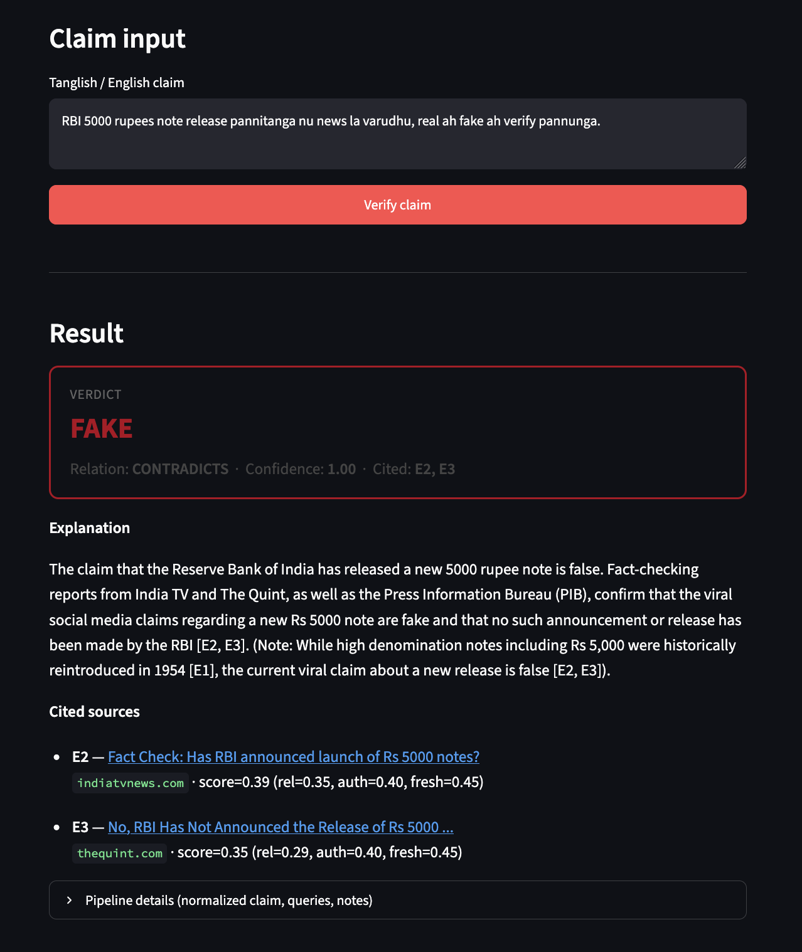
Figure 6.1 FAKE verdict for the viral RBI ₹5000 note rumour (Tanglish input). Relation CONTRADICTS with citations to fact-check pages.
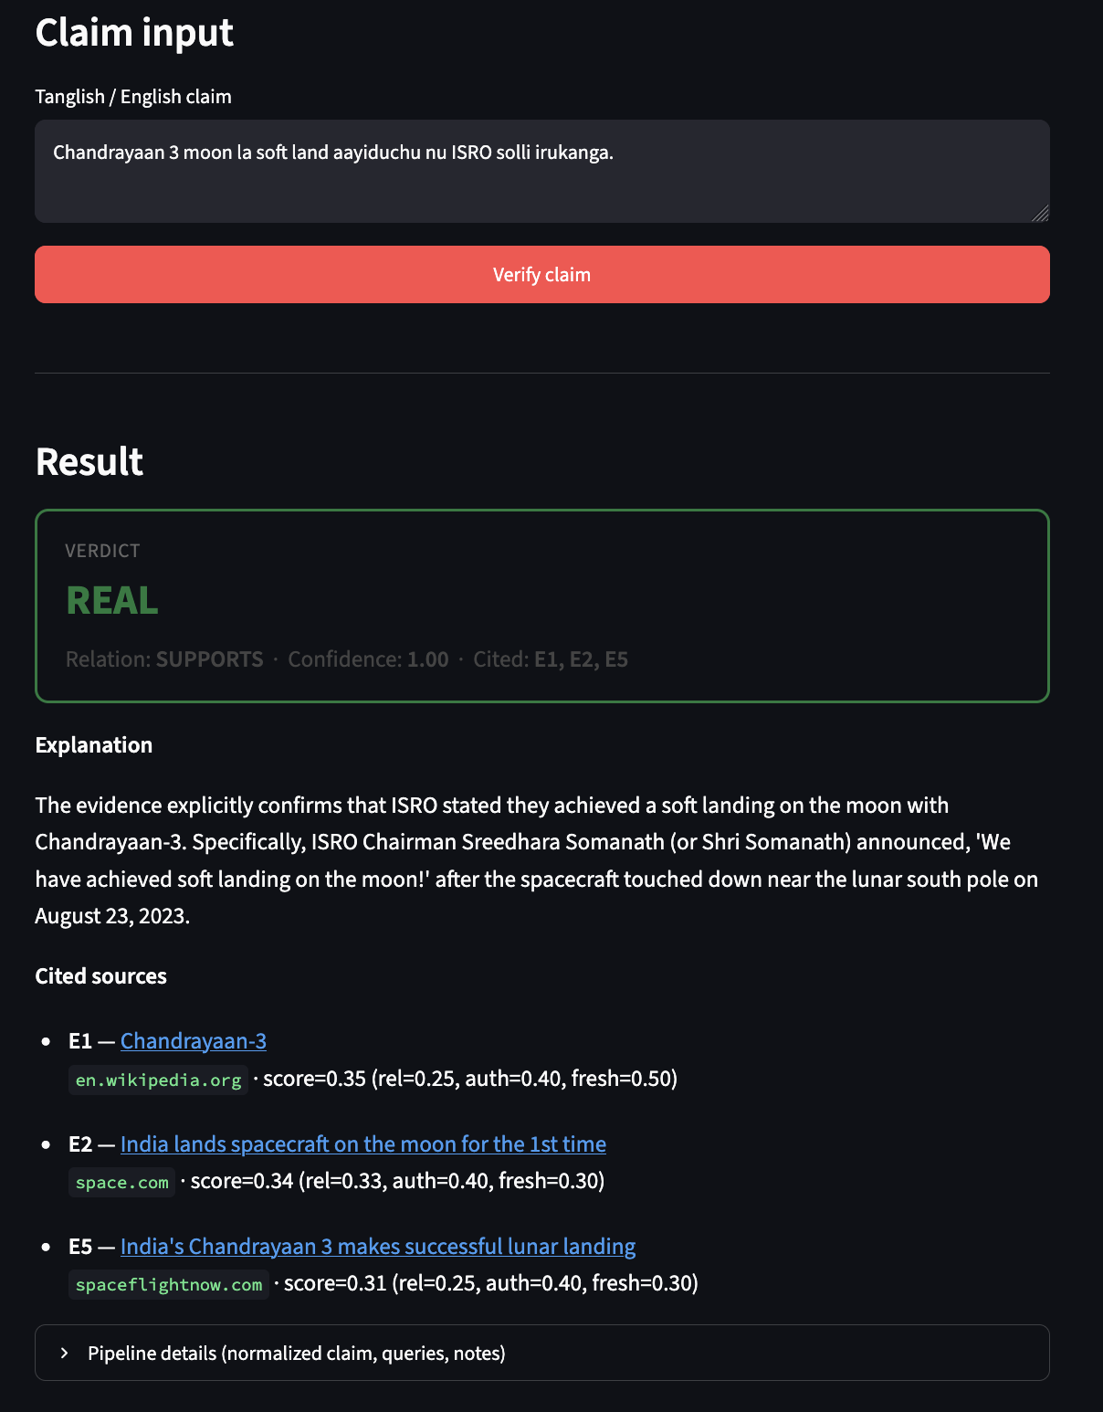
Figure 6.2 REAL verdict for Chandrayaan-3 soft landing claim. Evidence supports ISRO’s announced soft landing.
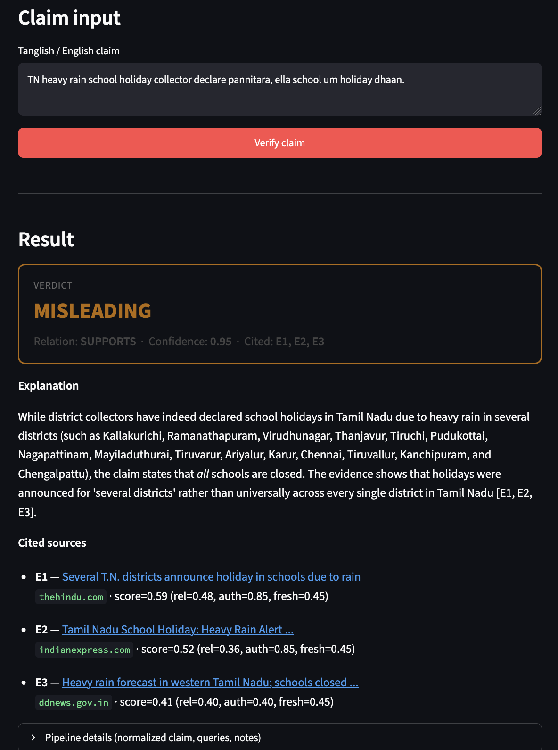
Figure 6.3 MISLEADING verdict for a statewide school-holiday claim. Evidence shows district-wise holidays, not necessarily all schools statewide.
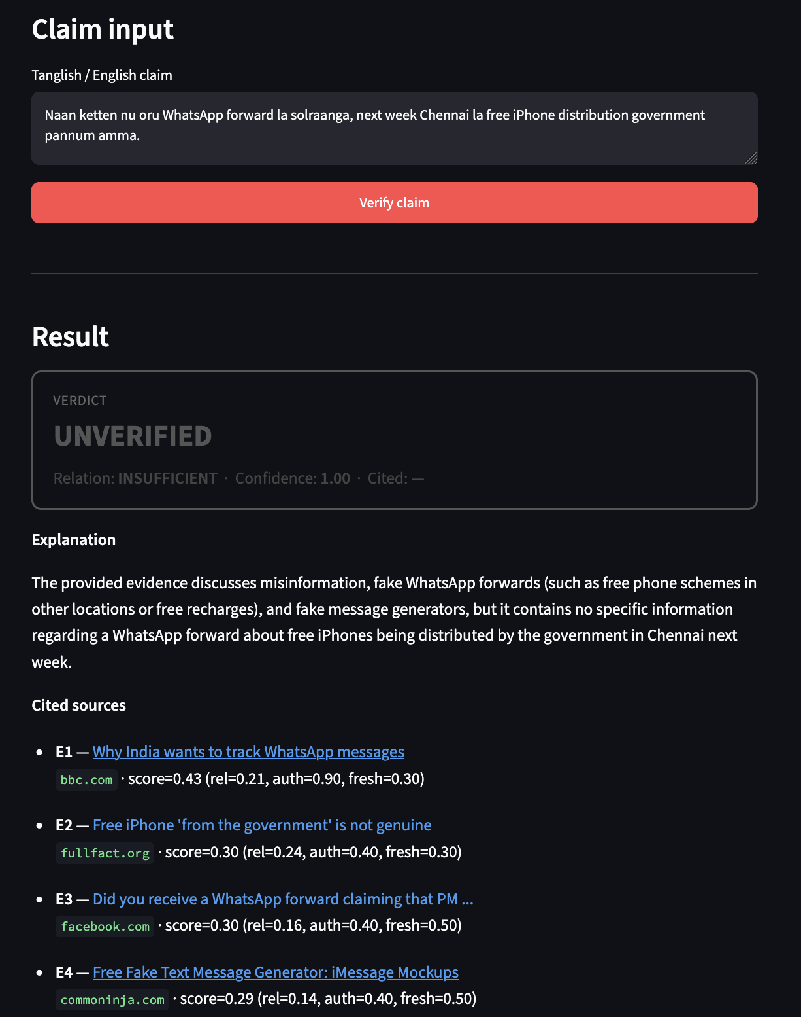
Figure 6.4 UNVERIFIED verdict for a free-iPhone WhatsApp rumour. Retrieved pages discuss similar scams but not a confirmed Chennai government distribution.
During demos, latency is dominated by search + page downloads + three LLM calls (claim, queries, verdict). Caching makes re-runs of the same claim much faster. If extraction fails on social platforms, snippet fallback still feeds the verifier so the UI remains usable for Review.
CHAPTER 7
RESULT AND DISCUSSION
7.1 Approach A — hard split (primary)
Table 7.1 summarises seed-42 results on the source-disjoint hard test. This is the table we ask evaluators to treat as the main Approach A outcome. Accuracy alone is optimistic when REAL dominates the test set; macro-F1 and qualitative error checks matter more.
Table 7.1 Hard-split (source-disjoint) results — seed 42
Model | Acc | Macro-F1 | Observation
IndicBERTv2 | 0.8665 | 0.623 | Best transformer on this protocol
TF-IDF + LogReg | 0.8743 | 0.641 | Competitive Acc vs transformers
TF-IDF + NB | 0.8455 | 0.679 | Stronger FAKE recall in error analysis
TF-IDF + LinearSVC | 0.8063 | 0.588 | Solid classical baseline
mBERT | 0.6126 | 0.420 | Large drop vs random split
MuRIL | 0.6099 | 0.419 | Similar band to mBERT here
XLM-RoBERTa | 0.3246 | 0.266 | Collapsed; many REAL→FAKE
Style-only LR | 0.5759 | 0.402 | Style cues fail when sources change

7.2 Approach A — random split (diagnostic only)
On the random split, IndicBERTv2, mBERT and XLM-RoBERTa reached 1.0 Acc on the 140-row test set; MuRIL reached 0.9929. These numbers show the task is learnable when the same source families appear in train and test. They do not prove real-world fake-news detection ability. We therefore refuse to lead the report with “≈100% accuracy.”
Table 7.2 Random-split diagnostic summary
Model group | Acc range | How to read it
Transformers | 0.9929–1.000 | Leakage / shortcut upper bound
TF-IDF baselines | ≈0.84–0.88 | Lower than transformers when sources overlap
Style-only LR | ≈0.89 | Confirms shallow cues help on random split

7.3 Error analysis and extra checks
Error analysis on IndicBERTv2 hard predictions showed weaker recall on some held-out FAKE sources (for example BOOM headlines) compared with TF-IDF+NB in our sample. False negatives often lacked obvious fact-check cue words. Near-duplicate scanning found only two near-duplicate pairs under a high similarity threshold, so clone leakage is not the main issue — source alignment is. Romanisation without retraining hurt several models, reminding us that Approach A headlines are mostly native-script Tamil, not Roman Tanglish.
7.4 Approach B — qualitative results
We do not invent a numeric Accuracy% for Approach B in this report. Instead, Chapter 6 screenshots document behaviour on controlled presets. In successful runs, the RBI ₹5000 rumour is labelled FAKE with fact-check citations; confirmed public science events lean REAL; partially true but overclaimed statements lean MISLEADING; underspecified forwards lean UNVERIFIED. This four-way label set is more honest for social claims than forcing every input into REAL/FAKE.
7.5 Discussion and cost notes
What worked. The hard-split story is teachable and defensible in a viva: students can explain why random Acc looked “too good.” IndicBERTv2 beat other transformers under our primary protocol. Approach B’s module separation made debugging possible (for example missing extraction libraries looked like “no evidence” until dependencies were installed).
What was harder than expected. XLM-RoBERTa’s hard-split failure shows that a famous multilingual model is not automatically best for this small Tamil set. Hard-test FAKE count is small, so FAKE F1 stays noisy. Approach B depends on third-party APIs and site HTML quality; live demos need keys and network. Ranking weights (relevance/authority/freshness) are reasoned defaults, not exhaustively tuned.
Cost analysis (as applicable). Approach A: one-time training cost (CPU hours) then nearly free inference. Approach B: per-claim cost ≈ several LLM calls + search queries + HTTP fetches; mitigated by caching during rehearsal. No separate cloud bill was required for the numbers reported here beyond optional free-tier APIs.
CHAPTER 8
CONCLUSION
TruthGuard meets the Project-I goal of a concrete, explainable system for Tamil/Tanglish misinformation work. Approach A contributes a self-collected 1400-headline corpus, multiple model comparisons, and an evaluation protocol that refuses to hide behind random-split ceilings. Approach B contributes a working evidence pipeline and Streamlit demonstration with citeable verdicts. The dual design clarifies a practical trade-off: classifiers are cheap and fast on formal headlines; retrieval-augmented checking is slower but better matched to fresh Tanglish rumours.
Future work. (1) Finish and report multi-seed mean±std if additional seeds complete. (2) Label a small Tanglish claim set so Approach B can quote Acc/F1 honestly. (3) Increase FAKE source diversity for a healthier hard-test balance. (4) Add romanisation / code-mix augmentation for Approach A. (5) Optional batch runner for Approach B with rate limits. (6) Draw formal UML diagrams in a diagramming tool for the final hardbound copy if required.
Individual Contributions
All members reviewed results and the demo together. The ownership split below reflects primary responsibility areas for Project-I / Review documentation.
Table 8.1 Team contribution split
Name | Reg. No. | Main contributions
Pranav Kalra | 23BCE0504 | TF-IDF and style baselines; error analysis; romanisation OOD checks; eval packaging; PPT support
Samya Mehta | 23BDS0204 | Approach B modules and caching; Streamlit demo; Gemini client updates; report drafting
Palak Goyal | 23BDS0209 | 1400 dataset curation/cleaning; Approach A splits; transformer training runs; metrics tables

CHAPTER 9
REFERENCES
[1] R. K. Kaliyar, A. Goswami, and P. Narang, “FakeBERT: Fake news detection in social media with a BERT-based deep learning approach,” Multimedia Tools and Applications, 2021.
[2] S. Khanuja et al., “MuRIL: Multilingual Representations for Indian Languages,” arXiv:2103.10730, 2021.
[3] D. Kakwani et al., “IndicNLPSuite: Monolingual Corpora, Evaluation Benchmarks and Pre-trained Multilingual Language Models for Indian Languages,” Findings of EMNLP, 2020.
[4] S. Doddapaneni et al., “Towards Leaving No Indic Language Behind: Building Monolingual Corpora, Benchmark and Models for Indic Languages,” ACL, 2023 (IndicBERTv2).
[5] J. Thorne, A. Vlachos, C. Christodoulopoulos, and A. Mittal, “FEVER: a Large-scale Dataset for Fact Extraction and VERification,” NAACL, 2018.
[6] P. Lewis et al., “Retrieval-Augmented Generation for Knowledge-Intensive NLP Tasks,” NeurIPS, 2020.
[7] B. R. Chakravarthi et al., DravidianLangTech shared tasks on code-mixed Dravidian language processing.
[8] Google AI, Gemini API documentation. [Online]. Available: https://ai.google.dev/
[9] Serper.dev, Google Search API documentation. [Online]. Available: https://serper.dev/
[10] Project evaluation notes, eval_results_1400/RESULTS.md (internal technical summary).
APPENDIX A – SAMPLE CODE
This appendix lists only entry points. Full source lives in the project repository under src/fake_news_classifier/, src/verification/ and apps/.
A.1 Approach B demo
# from project root, with .env configured
.venv/bin/streamlit run apps/approach_b_demo.py
# CLI single-claim run
.venv/bin/python src/verification/run_demo.py --text "RBI 5000 rupees note release pannitanga nu news la varudhu"
A.2 Approach A training (example)
.venv/bin/python src/fake_news_classifier/preprocess_1400.py --split hard
.venv/bin/python src/fake_news_classifier/train_classifier.py --model indicbert-v2
# metrics written under models_fake_news_1400_hard/ or eval_results_1400/
A.3 Orchestrator. The function run_pipeline(raw_text) in src/verification/pipeline.py wires claim extraction → queries → search → extraction → ranking → verification and returns a PipelineResult with every intermediate field for debugging and viva explanation.

