
Vellore Institute of Technology
School of Computer Science and Engineering (SCOPE)
Vellore, Tamil Nadu, India
REVIEW 3 — PROJECT REPORT
TruthGuard: Detecting Fake News in Tamil–English (Tanglish)
Social Media using Transformers and an Evidence-Based LLM Pipeline
Submitted in partial fulfilment of the requirements for the
B.Tech. Capstone / Project Review – III
Team Members
Name | Register Number
Samya Mehta | 23BDS0204
Palak Goyal | 23BDS0209
Pranav Kalra | 23BCE0504

Project Guide
Dr. Sanjiban Sekhar Roy
Professor Grade 1, SCOPE, VIT Vellore
Academic Year 2025–26

1. Abstract
People on Tamil social media often write in a mix of Tamil and English in the same sentence (Tanglish). Fake news spreads fast in this style, but most detectors are built for English or clean Tamil only. In this project we built TruthGuard, which works in two parts.
Part A is a supervised classifier. We collected a balanced set of 1400 Tamil news headlines (700 fake, 700 real) and fine-tuned IndicBERTv2, MuRIL, mBERT and XLM-RoBERTa. When train and test share the same websites, accuracy looks almost perfect. That can be misleading. So we also test with a source-disjoint (hard) split. On that harder test, IndicBERTv2 got about 86.7% accuracy; MuRIL and mBERT were around 61%; XLM-RoBERTa did poorly (~32%). We also ran TF-IDF baselines for comparison.
Part B does not only look at wording. It extracts the claim, searches the web (Serper), pulls page text, ranks sources, and asks Gemini to judge the claim only from that evidence. Output can be REAL, FAKE, MISLEADING or UNVERIFIED, with citations. We demoed this in Streamlit on Tanglish examples.
Overall, Part A is fast for offline screening; Part B is slower but can check new rumours and show sources. This Review 3 report covers what we built, how we tested it, and what still needs work.
2. Introduction
Fake or misleading posts about money, exams, holidays or health can cause panic. In Tamil Nadu, many posts look like:
“RBI 5000 rupees note release pannitanga nu news la varudhu”
Here Tamil words and English words sit together. A normal English fake-news model often fails on such text. A classifier trained last month also cannot know a rumour that started yesterday unless we give it fresh facts. So we decided not to rely on one method alone.
- Approach A — train models on labelled Tamil headlines (REAL / FAKE).
- Approach B — live check: search + evidence + LLM verdict for Tanglish claims.
3. Problem Statement
Approach A: Given a Tamil headline, predict REAL or FAKE.
Approach B: Given a Tanglish comment or claim, (i) find if there is a checkable fact, (ii) search for evidence, (iii) return REAL / FAKE / MISLEADING / UNVERIFIED with an explanation and source IDs.
If FAKE rows always come from fact-check sites and REAL rows always come from news sites, a model can cheat by learning website style instead of falsity. That is why we report a hard split as the main result.
4. Objectives (Review 3)
- Build and clean a self-collected Tamil fake/real headline dataset (1400 rows, balanced).
- Fine-tune Indic-friendly and multilingual transformers; compare with TF-IDF baselines.
- Evaluate with both random and source-disjoint splits; treat hard split as main result.
- Implement a six-stage evidence pipeline for Tanglish claims.
- Show a working Streamlit demo for Approach B.
- Document limits clearly (source bias, Tanglish OOD drop, API dependency).
5. Literature Survey (Brief)
Older fake-news systems used hand-made features. Later work used BERT-style models on English datasets. Those scores look high, but the setting is not Tamil or Tanglish.
For Indian languages, MuRIL (Google) and IndicBERT / IndicBERTv2 (AI4Bharat) are useful because they saw Indic text during pretraining. Code-mixed Tamil–English work exists more for sentiment or offensive language than for fact-checking with web evidence. Evidence-based fact-checking (retrieve-then-verify) is common in English; we reuse that idea for Tanglish and do not let the search stage itself say true/false.
Gap we target: few project systems that (a) train on self-collected Tamil news veracity data with a leakage-aware split, and (b) also offer a live Tanglish evidence pipeline in one project.
6. Proposed System Overview
Approach A maps Tamil headlines to REAL/FAKE using fine-tuned transformers. Approach B maps a Tanglish claim through clean → claim extract → queries → Serper search → page extract → rank evidence → Gemini verdict.
Design rule for Approach B: modules that search or extract never decide truth. Only the final verifier does, and only from the evidence text it received. If evidence is missing, we prefer UNVERIFIED, not FAKE.
7. Dataset
7.1 Main dataset for Approach A
File: data/raw/tamil_news_dataset_1400_balanced.csv
Item | Detail
Size | 1400 rows
Labels | 700 FAKE, 700 REAL
Training field | mainly headline
FAKE sources | FactCrescendoTamil, BOOMTamil, NewscheckerTamil
REAL sources | Dinamalar family, Puthiya Thalaimurai, Vikatan, etc.

Source and label are aligned (fact-check sites → FAKE; news sites → REAL). A random split can give near-100% accuracy without true understanding. We still report it as a learnability check, not as the main claim.
7.2 Splits
Split | Idea | Approx. sizes
Random | Stratified 80/10/10, seed 42 | 1120 / 140 / 140
Hard (source-disjoint) | Held-out publishers in test | 630 / 70 / 382

8. Methodology
8.1 Approach A
Models compared: IndicBERTv2, MuRIL, mBERT, XLM-RoBERTa, and classical TF-IDF + MultinomialNB / Logistic Regression / LinearSVC. Same protocol for fair comparison: sequence classification, 2 labels, short max length, few epochs, pick checkpoint using dev macro-F1. A style-only logistic baseline (~4 features) did well on random split (~0.89 Acc) but collapsed on hard split (~0.58 Acc).
8.2 Approach B — six stages
- Claim extraction — is there a checkable fact? Rewrite as one clear English sentence.
- Query generation — make 3 short search queries.
- Web search — Serper API → Google organic results.
- Page extraction — Trafilatura / BeautifulSoup; snippet fallback if blocked.
- Ranking — relevance + trusted domains + freshness.
- LLM verdict — Gemini compares claim vs top evidence; must cite evidence IDs.
Demo UI: apps/approach_b_demo.py (Streamlit).
9. Implementation Stack
Area | Tools
Language | Python 3
Transformers | Hugging Face transformers, PyTorch
Classical ML | scikit-learn
Gemini | google-genai
Search | Serper.dev
Extraction | trafilatura, BeautifulSoup
Demo | Streamlit
Config | .env for API keys (not committed)

10. Experimental Results (Approach A)
Seed-42 runs on the 1400 dataset. Hard split is the main table for Review 3.
10.1 Hard split (main)
Model | Accuracy | Macro-F1 | Comment
IndicBERTv2 | 0.8665 | 0.623 | Best transformer
TF-IDF + LR | 0.8743 | 0.641 | Competitive Acc
TF-IDF + NB | 0.8455 | 0.679 | Stronger FAKE recall in error check
MuRIL | 0.6099 | 0.419 | Much lower than random split
mBERT | 0.6126 | 0.420 | Similar to MuRIL
XLM-RoBERTa | 0.3246 | 0.266 | Collapsed toward FAKE
Style-only LR | 0.5759 | 0.402 | Style alone is weak OOD

10.2 Random split (diagnostic only)
All four transformers reached ≥ 0.9929 Acc. We do not present this as real-world performance. It mainly shows the labels are learnable when the same source families appear in train and test.
10.3 Extra checks
- MuRIL vs mBERT: predictions differ on many hard-test rows (agreement ~71%).
- XLM-R predicted FAKE for roughly 67% of REAL headlines on hard test.
- Romanised OOD without retrain: accuracy/F1 drop — not robust to script change.
- Near-duplicates: only 2 pairs under our threshold; source alignment is the main confound.

11. Approach B Demo Results (Streamlit Screenshots)
Approach B is shown qualitatively for Review 3 (no large labelled Tanglish veracity test set yet). Below are live Streamlit screenshots from our demo.
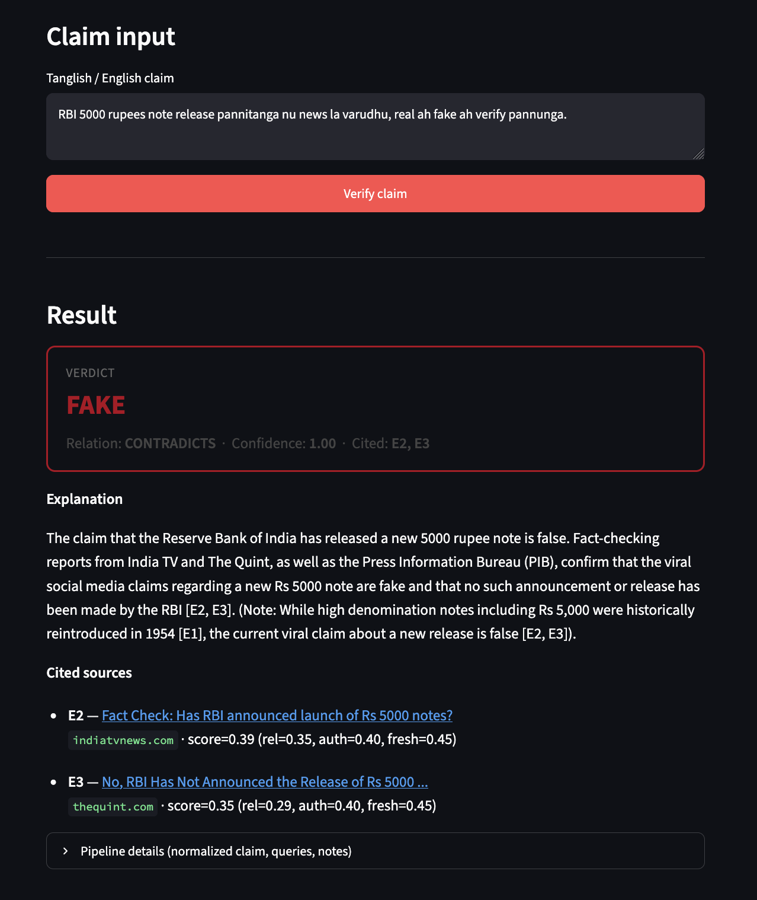
Figure 1. Approach B — FAKE verdict for viral RBI ₹5000 note rumour (Tanglish input).
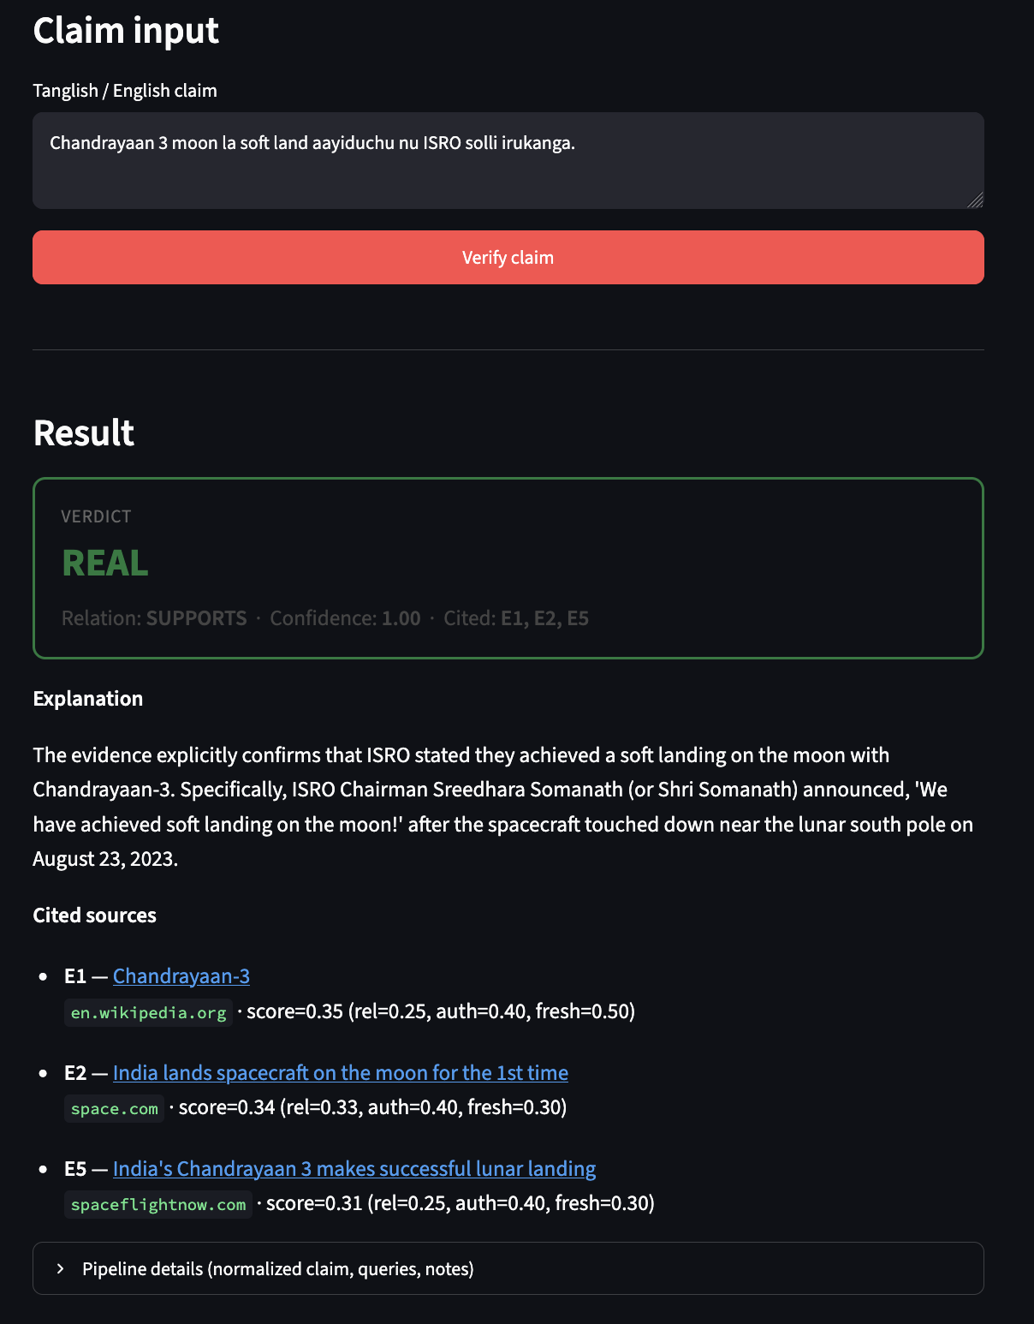
Figure 2. Approach B — REAL verdict for Chandrayaan-3 soft landing claim (cites Wikipedia / space news).
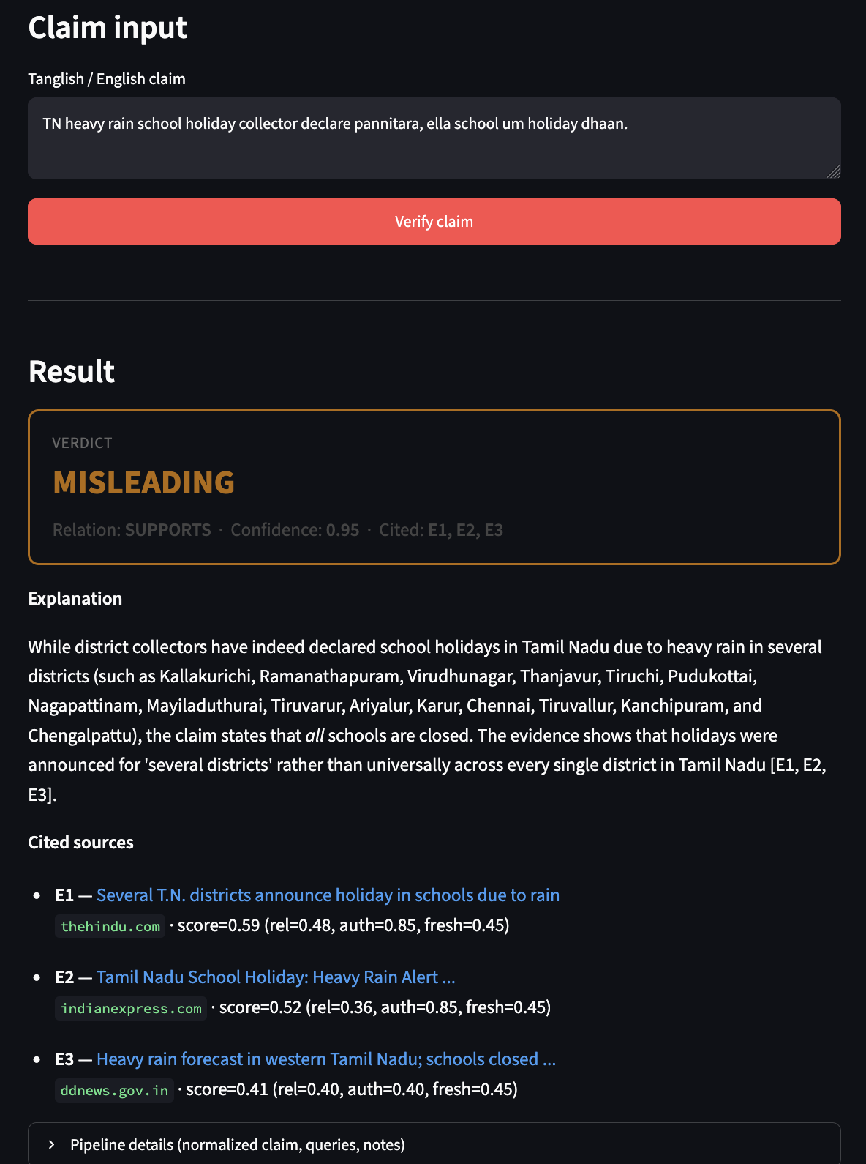
Figure 3. Approach B — MISLEADING verdict for statewide school-holiday overclaim (district-level evidence).
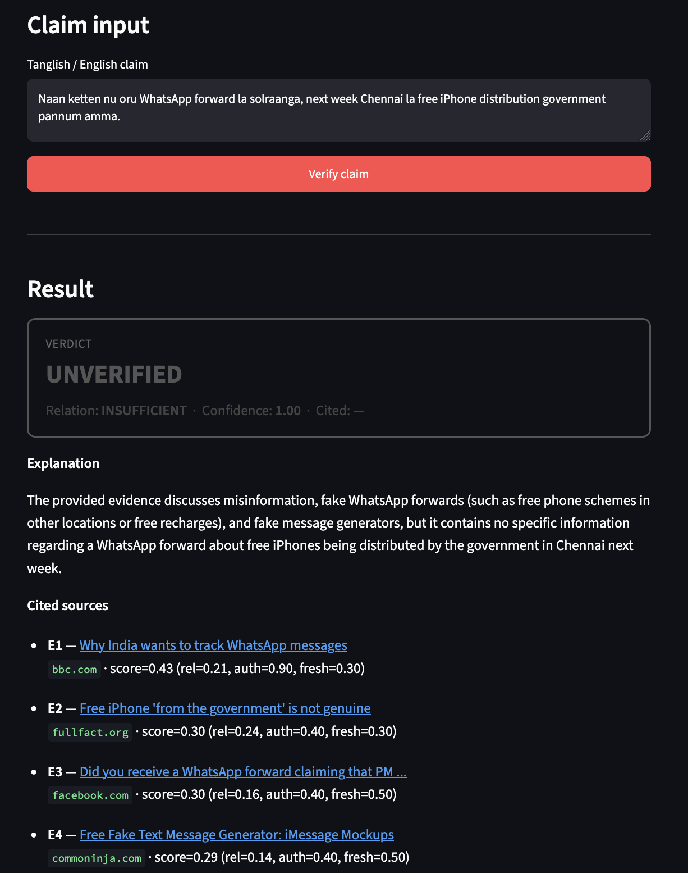
Figure 4. Approach B — UNVERIFIED verdict for free-iPhone WhatsApp rumour (insufficient specific evidence).
12. Discussion
- High random Acc is a warning, not a trophy. Hard split changes the ranking of models.
- TF-IDF is still useful on this small hard set — transformers are not automatic winners.
- Approach A and B solve different jobs: cheap batch screening vs interactive citeable checking.
- Approach A training text is mostly native-script headlines, not Roman Tanglish comments.
13. Limitations
- Source–label alignment in the 1400 dataset.
- Hard test has class imbalance (few FAKE); Acc alone can look okay while FAKE F1 stays low.
- Approach B depends on Gemini + Serper keys, rate limits, and site blocking.
- No large public Tanglish fake-news benchmark yet for Approach B metrics.
- Ranking weights are sensible defaults, not fully grid-searched.
14. Conclusion
For Review 3 we have a working dual system. Approach A gives measurable results on a self-collected Tamil dataset, with an honest hard-split story instead of only ~100% random Acc. Approach B gives a citeable Tanglish verification demo with Streamlit. Together they show both the strength and the limits of classifier-only fake-news detection for regional Indian languages.
15. Future Work
- Finish multi-seed aggregation and put mean±std in the final PPT if pending runs complete.
- Build a small labelled Tanglish claim set so Approach B can report Acc/F1 properly.
- Batch-run Approach B on held-out claims with cost control.
- Add more FAKE sources so hard-test FAKE count is healthier.
- Try romanisation augmentation for Approach A.
16. Individual Contributions
Work was shared across the team. The split below reflects the main ownership for Review 3 (everyone reviewed results and the demo together).
Name | Register No. | Main contributions
Samya Mehta | 23BDS0204 | Approach B pipeline (search/extract/rank/verify), Streamlit demo, Gemini client migration, Review 3 report drafting
Palak Goyal | 23BDS0209 | 1400 dataset curation & cleaning, Approach A preprocess/splits (random + hard), transformer training runs, metrics tables
Pranav Kalra | 23BCE0504 | TF-IDF / style baselines, error analysis & romanisation OOD checks, eval_results packaging, literature notes & PPT support

17. References
[1] R. K. Kaliyar, A. Goswami, and P. Narang, “FakeBERT: Fake news detection in social media with a BERT-based deep learning approach,” Multimedia Tools and Applications, 2021.
[2] S. Khanuja et al., “MuRIL: Multilingual Representations for Indian Languages,” arXiv:2103.10730, 2021.
[3] D. Kakwani et al., “IndicNLPSuite: Monolingual Corpora, Evaluation Benchmarks and Pre-trained Multilingual Language Models for Indian Languages,” Findings of EMNLP, 2020.
[4] S. Doddapaneni et al., “Towards Leaving No Indic Language Behind: Building Monolingual Corpora, Benchmark and Models for Indic Languages,” ACL, 2023 (IndicBERTv2).
[5] J. Thorne, A. Vlachos, C. Christodoulopoulos, and A. Mittal, “FEVER: a Large-scale Dataset for Fact Extraction and VERification,” NAACL, 2018.
[6] P. Lewis et al., “Retrieval-Augmented Generation for Knowledge-Intensive NLP Tasks,” NeurIPS, 2020.
[7] B. R. Chakravarthi et al., DravidianLangTech shared tasks on code-mixed Dravidian language processing (sentiment / offensive language).
[8] Google AI, Gemini API documentation — https://ai.google.dev/
[9] Serper.dev, Google Search API documentation — https://serper.dev/
[10] Project evaluation notes: eval_results_1400/RESULTS.md (internal).
Appendix — How to Run (for viva)
.venv/bin/streamlit run apps/approach_b_demo.py
Needs GEMINI_API_KEY + SERPER_API_KEY in .env. Approach A metrics: eval_results_1400/metrics/ and RESULTS.md.
— End of Review 3 Report —

