FINAL YEAR PROJECT REPORT

HOLISTIC MIND
A Privacy-Conscious Mobile Wellness Application
with Hybrid Practice Recommendations
Design, Implementation, and Critical Evaluation
Student name: ______________________________
Student number: ____________________________
Supervisor: _________________________________
Degree / course: _____________________________
Institution: __________________________________
Submission date: ____________________________
Report prepared: 3 October 2026
Chapters 1–8: approximately 5,509 words
11 figures · Academic references · Project-grounded evaluation

Abstract
Holistic Mind is a mobile wellness application that combines daily check-ins, personalised practice recommendations, reflective journaling, and structured learning content. The project investigates how a small, explainable recommendation system can support a daily self-care routine while respecting explicitly declared comfort preferences and keeping journal content private. The artefact consists of an Expo React Native application, a Node.js and Express API, PostgreSQL, an administration dashboard, object storage, and a Python recommendation service. Its hybrid engine combines suitability rules, MiniLM semantic similarity, and, when sufficient interactions exist, collaborative evidence. Journal entries are encrypted on the device and are excluded from server-side recommendation inputs. A saved journal-free development benchmark covers 30 authored scenarios and a fixed 14-exercise catalogue. The hybrid approach achieved Precision@4 of 77.50% and NDCG@4 of 0.7387, compared with 73.33% and 0.7244 for rules with eligibility filtering. However, hybrid recommendations also included 3.33% negative-labelled selections, showing that ranking improvements do not establish universal suitability. A separate eight-scenario comfort suite recorded no explicit exclusion violations. Documented simulator and backend checks support functional feasibility, while independent label review, physical-device testing, user acceptance research, and clinical effectiveness remain unverified. The contribution is an integrated, privacy-conscious software artefact with transparent evaluation and identifiable limitations.

Contents
Select a chapter title to navigate within this document.
Abstract
1. Introduction
2. Review of Existing Knowledge
3. Aims, Objectives, and Scope
4. Project Design and Methodology
5. Artefact Design
6. Implementation
7. Validation and Testing
8. Critical Evaluation, Conclusion, and Future Work
References
Appendix A. Evidence and submission details

Word count basis
Approximately 5,509 words in Chapters 1–8, including headings. Excludes cover, abstract, contents, captions, table, references, and appendix.

Submission fields
Complete the cover metadata and add any institution-required declaration or acknowledgement before submission.

List of Figures
Figure 1. Existing iOS simulator welcome screen, captured 3 October 2026
Figure 2. Development phases summarised from the project's 15-week journal
Figure 3. Current logical architecture reconstructed from source
Figure 4. Daily user journey
Figure 5. Simplified conceptual data relationships
Figure 6. Recommendation stages and implemented base-score weights
Figure 7. Existing iOS simulator Library screen, captured 3 October 2026
Figure 8. Journal encryption and recovery boundary
Figure 9. Content publication workflow reconstructed from the implemented admin, API, and storage modules
Figure 10. Existing project benchmark chart for journal-free ONNX evaluation
Figure 11. Existing comfort-suite ONNX chart, eight selected scenarios

List of Tables
Table 1. Saved journal-free ONNX benchmark

1. Introduction

1.1 Background and motivation
A daily self-care routine involves several different activities: noticing a present feeling, choosing something manageable, completing that activity, and reflecting afterwards. When these activities are disconnected, the user must repeatedly decide where to begin. Holistic Mind brings them into one mobile environment. Its intended experience is a short, voluntary sequence of check-in, practice, feedback, and reflection, supported by an exercise catalogue and a separate learning library. This project treats that sequence as a software design problem. It does not assume that using an application produces a measurable improvement in mental health.
The project is motivated by the difficulty of selecting relevant content from a general library. Someone seeking focus may need a different suggestion from someone reporting low energy or feeling overwhelmed. A category label alone cannot capture every distinction, while a ranking model cannot reliably interpret every personal concern. The application therefore combines structured answers with declared comfort preferences. Personalisation is designed to organise available practices and reduce selection effort, while keeping users free to browse, decline a suggestion, or report discomfort.

1.2 Problem statement
The central problem is to deliver a coherent daily wellness experience without making unexplained or overly confident recommendations. Three challenges shape the implementation. First, a new account has little behavioural history, creating a cold-start problem. Second, semantic relevance does not guarantee suitability: a description can match a user's state while involving a practice they wish to avoid. Third, reflective journals contain private information that should not automatically become recommendation data. Addressing these challenges requires coordinated interface, API, ranking, storage, and evaluation decisions rather than an isolated algorithm.

1.3 Research questions
RQ1 asks whether a hybrid of structured suitability rules and semantic matching improves top-four recommendation relevance over random, semantic-only, and rules-based alternatives on the project's authored scenarios. RQ2 asks whether explicitly declared comfort restrictions remain enforced throughout filtering, ranking, and fallback behaviour. RQ3 asks whether persistent reflective journaling can coexist with personalisation when journal decryption remains on the user's device. These questions are deliberately bounded: the first concerns offline ranking quality, the second concerns software policy enforcement, and the third concerns an implemented privacy boundary.

1.4 Contribution and report structure
The contribution is an integrated mobile artefact supported by reproducible evaluation files and documented development checks. It connects account management, onboarding, daily check-ins, recommendations, practice media, feedback, encrypted journals, and managed learning content. The report follows the academic structure demonstrated by Rai (2026) and Fullel (2026), while presenting original project-specific analysis. Chapter 2 reviews relevant technical ideas; Chapter 3 defines objectives and scope; Chapters 4 to 6 explain methodology, design, and implementation; Chapter 7 examines testing evidence; and Chapter 8 evaluates the contribution and future work.

Figure 1. Existing iOS simulator welcome screen, captured 3 October 2026. The image illustrates the application's visual identity; it is not a usability-test result.

2. Review of Existing Knowledge

2.1 Content-based and collaborative recommendation
Content-based recommendation matches descriptions of items to a representation of a user's interests or current context. For Holistic Mind, exercise descriptions, categories, intended states, and support goals provide this content. The approach can produce suggestions before an account has accumulated interaction history. Its weakness is dependence on the quality of metadata and the chosen similarity representation. Missing restrictions or ambiguous wording remain problematic even when a numerical similarity score is high.
Collaborative recommendation uses patterns in interaction data to estimate which items may suit a user. Holistic Mind includes a neighbour-based component, but enables it only when sufficient overlapping interactions and neighbours exist. This is appropriate because sparse histories cannot support a dependable comparison. Completion, repetition, saving, and explicit helpfulness feedback also represent different behaviours. Treating every event as equally positive would hide those distinctions. The implementation consequently assigns different values to events and prioritises uncomfortable feedback as a negative signal.

2.2 Hybrid approaches
Burke (2002) surveys ways to combine recommendation techniques and explains why hybrid systems can address weaknesses of individual methods. Holistic Mind applies that principle through eligibility filtering followed by weighted rules, semantic relevance, and conditional collaborative scoring. The rationale is complementary evidence: structured rules support predictable alignment, embeddings capture descriptive similarity, and interactions may support later adaptation. This rationale does not prove that any particular weighting is optimal; weight selection remains a separate empirical problem.
A key distinction is between eligibility and ranking. Eligibility decides whether an exercise may appear at all under the application's known restrictions. Ranking orders the remaining candidates. If restrictions were only soft penalties, sufficiently strong similarity could override them. The implemented hard exclusions avoid that failure for declared concerns. Nevertheless, they cannot address a restriction that was never collected or encoded in metadata. The system therefore needs both transparent data collection and conservative interpretation of its output.

2.3 Semantic representations
Reimers and Gurevych (2019) describe Sentence-BERT representations that support efficient comparison of sentences using cosine similarity. Holistic Mind uses the pretrained all-MiniLM-L6-v2 model through ONNX inference. Its model card describes a 384-dimensional representation suited to sentence and short-paragraph tasks (Sentence Transformers, n.d.). This supports a practical comparison between check-in descriptions and exercise documents without requiring a generative model to compose advice. The project does not fine-tune MiniLM or claim a newly trained language model.
Semantic similarity remains narrower than understanding a person's needs. A vector representation may associate related words without distinguishing whether an activity is welcome, uncomfortable, or medically inappropriate. The current engine consequently limits semantic scoring to eligible candidates and combines it with rules. Model failure is also observable: the service can identify a lexical fallback backend, while strict ONNX evaluation aborts rather than silently producing results labelled as semantic inference. This distinction makes benchmark interpretation more defensible.

2.4 Privacy and evaluation gaps
Morris et al. (2023) demonstrate that text can be recovered from embeddings under studied attack conditions. Their work challenges the assumption that converting a journal to a vector makes its meaning private. Holistic Mind therefore uploads neither journal text nor device-generated journal embeddings for personalisation. This is a specific application design decision, not a claim that every embedding system has identical leakage. It also creates an explicit trade-off: the recommender has less reflective context available.
The reference dissertations provide useful examples of connecting architecture, implementation evidence, metrics, and critical evaluation. Rai's travel recommender and Fullel's Nepali voice assistant address different domains, datasets, and users. Their performance figures cannot validate Holistic Mind. The gap addressed here is the combination of a daily wellness workflow, declared comfort controls, and a journal privacy boundary within a small recommendation application. Clinical effectiveness, longitudinal engagement, and representative usability remain future research questions rather than established contributions.

2.5 Implications for this project
The reviewed ideas suggest three practical design principles. Context should be represented in a form the system can inspect, restrictions should be applied before relevance scoring, and evaluation should measure several competing outcomes. Holistic Mind uses short structured questions to make the first principle concrete, shared comfort mapping for the second, and separate quality, fill, and violation measures for the third. Together, these choices make failures easier to locate than a single opaque model output would permit.
There is also a clear gap between recommendation research and this application's eventual use. General-purpose semantic models are trained for broad language similarity rather than this exercise catalogue. Authored relevance judgments may reward descriptions that match familiar language without establishing personal usefulness. The project therefore needs domain-specific review and user-centred evidence before moving from technical feasibility to stronger effectiveness claims. This gap motivates the critical evaluation rather than undermining the value of building and testing a bounded prototype.

3. Aims, Objectives, and Scope

3.1 Project aim
The aim is to design, implement, and critically evaluate a mobile application that supports voluntary self-reflection and selection of short wellness practices through an explainable recommendation workflow. The intended outcome is a functioning software artefact with persistent account-specific data, managed content, explicit restriction enforcement, and evidence that supports carefully bounded conclusions. Success therefore includes identifying unresolved failures, rather than presenting a favourable ranking score as sufficient proof of overall quality.

3.2 Objectives and acceptance criteria
Objective O1 is to implement authenticated accounts, onboarding, check-ins, history, and account-specific persistence. Acceptance requires server-owned identity and separation of private records between accounts. O2 is to implement recommendations combining structured rules and semantic matching, with a documented cold-start strategy and reasons for returned exercises. O3 is to enforce declared exclusions across recommendation stages and preserve short or empty results when suitable candidates are unavailable. O4 is to support encrypted journal storage, device-side decryption, and recovery-key verification without server access to journal content.
Objective O5 is to provide administrator-managed exercises, audio, courses, modules, and related media so content changes can be made independently of a mobile release. O6 is to evaluate recommendation relevance, restriction behaviour, and documented native/backend functionality. Acceptance for O6 requires clearly identifying the dataset, baseline differences, measurement boundaries, and remaining checks. These criteria permit an honest distinction between implemented features, previously recorded passes, and capabilities that still need deployment or independent validation.

3.3 Functional and non-functional requirements
The main functional requirements follow the user journey. A user should create or access an account, complete short onboarding, record a daily state, receive suggestions, open a practice, provide feedback, and browse content independently. Journaling must allow private writing and later retrieval after unlocking the vault. The learning library should organise courses and modules separately from short exercises. Administrators should manage publication status and media references through protected operations. Profile features support account security, reminders, and access to configured policy or support links.
Non-functional requirements concern understandable interaction, persistent data, privacy boundaries, maintainability, and recoverable failures. The interface should clearly show selected answers, loading states, and save errors. Backend validation should reject invalid input and prevent client-selected ownership. Content and ranking services should remain separable. Secure journal design must acknowledge key-loss consequences, and recommendation behaviour must remain inspectable when dependencies fail. No unmeasured response-time target or accessibility conformance level is asserted as achieved.

3.4 Scope boundaries
The implemented scope includes a cross-platform codebase, with documented native validation concentrated on an iOS simulator. Local services use PostgreSQL and S3-compatible object storage; deployment documentation describes cloud arrangements. The report does not establish that every described deployment path is currently operating. The recommendation benchmark uses a fixed 14-exercise catalogue and authored scenarios rather than the entire live content system. Its results therefore describe a controlled development setting.
Diagnosis, crisis intervention, clinical prescribing, therapist messaging, and clinical outcome measurement are outside the evidenced scope. The system does not infer undeclared comfort restrictions from encrypted journals. Physical Android and iPhone release testing, independent security assessment, representative user acceptance research, and journal key rotation are incomplete. These boundaries limit the claims made in later chapters and provide concrete priorities for the next development phase.

4. Project Design and Methodology

4.1 Development approach
The project documentation records an iterative development process organised around a 15-week journal. Early stages addressed problem definition, requirements, interface planning, and navigation. Subsequent work connected onboarding, check-ins, journals, authentication, persistent storage, content administration, and recommendations. Later changes introduced stronger privacy and comfort controls. The journal is a development record rather than independently verified time-sheet evidence. It supports an account of sequencing, but does not establish the exact effort spent on each activity.
Iterative delivery suits this artefact because changes in one component expose requirements in another. For example, device-only journal encryption changes both the journal API contract and the recommender's available inputs. Comfort preferences require corresponding metadata, backend mapping, fallback handling, and tests. Small vertical increments help expose these dependencies before the system is treated as complete. However, iteration can also leave older documentation inconsistent with newer source, so the report prioritises current routes and the journal-free evaluation over historical descriptions.
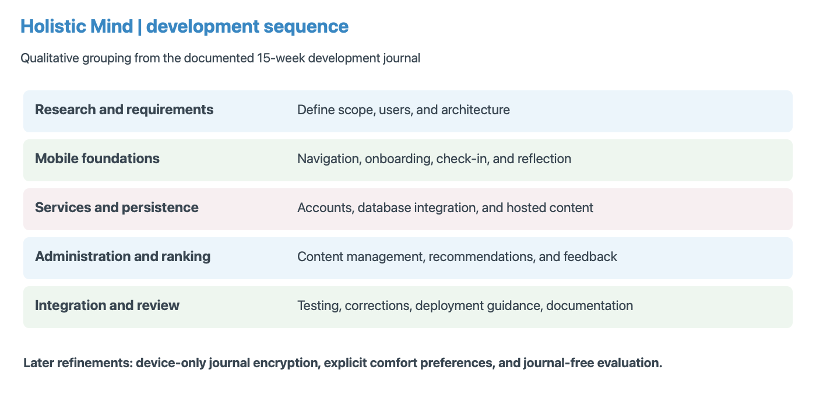
Figure 2. Development phases summarised from the project's 15-week journal. Later privacy and evaluation refinements are shown separately; the graphic is a qualitative sequence, not measured effort.

4.2 Technology selection
Expo React Native and TypeScript provide a shared mobile implementation and typed integration between screens and services. Node.js with Express manages authenticated application operations, while PostgreSQL stores relational wellness and content records. A Python FastAPI service isolates numerical recommendation work from account and content APIs. ONNX inference keeps the pretrained embedding model within the recommendation service. The architecture adds operational complexity compared with a single process, but gives each component a clear responsibility.
Object storage holds larger media assets, avoiding their inclusion in ordinary database rows or every application bundle. A separate React administration interface allows structured content updates. These decisions are appropriate to the existing codebase and content requirements; they are not the result of a formal comparison of every available framework. Maintaining several runtimes, schema migrations, native builds, and storage policies remains a cost that must be considered alongside flexibility.

4.3 Evidence and evaluation strategy
The evaluation uses several evidence types because no single test answers all objectives. Offline ranking files compare recommendation approaches. Restriction tests exercise explicit exclusions and insufficient candidate pools. Journal cryptography and API tests address envelope validation, ownership, and migration. The device-and-backend record describes previous checks against a simulator and running development services. Source inspection establishes what is implemented, but it cannot demonstrate that a production deployment behaves identically.
The main ranking dataset contains 30 authored personas, each with relevance labels for all 14 benchmark exercises. Labels range from negative suitability to strongest relevance. The production suite removes synthetic journal inputs while retaining the original scenario labels. Ten repetitions per persona support timing measurement and random-baseline variation. They do not create 300 independent people. A separate eight-scenario suite examines declared comfort restrictions. The suites are reported separately because their purposes and input distributions differ.

4.4 Ethical and methodological controls
The report uses supplied dissertations as structural references without adopting their instructions, declarations, participant claims, or results. Existing project screenshots illustrate interfaces, while architectural figures explain source-observed behaviour. Reported benchmark values come from saved project artefacts. No new participant study is invented, and documented development passes are attributed to their original test record. This separation makes it possible to assess implementation without implying evidence that does not exist.
Privacy is considered throughout the architecture rather than added only to the discussion. Journal encryption reduces server access to reflective content, while structured check-ins and interaction data remain server-readable. The distinction should be explained to users. Synthetic scenarios reduce the need to expose real journals during development, but cannot replace independent expertise or diverse real-world experience. Any later user study should define consent, withdrawal, data minimisation, and a suitable research protocol before recruitment.

5. Artefact Design

5.1 System architecture
The mobile application communicates with the Node API, which authenticates requests and coordinates persistence, content access, and recommendation generation. The API queries PostgreSQL for account-specific context and published recommendable exercises, maps comfort choices to constraints, pseudonymises interaction identifiers, and calls the Python service. Returned items are recorded and exposed through the application. The administrator uses protected content endpoints and signed media-upload operations. Figure 3 separates these responsibilities and shows the journal boundary alongside the ordinary application data flow.
Keeping the recommender behind the API prevents the mobile client from directly deciding another account's context. PostgreSQL provides relationships and transaction support; object storage handles media delivery separately. A signed URL grants a bounded storage operation without distributing permanent storage credentials to the client. These are design mechanisms rather than evidence of a completed security audit. Service configuration, deployment policies, and operational logging must preserve the same boundaries in a release environment.
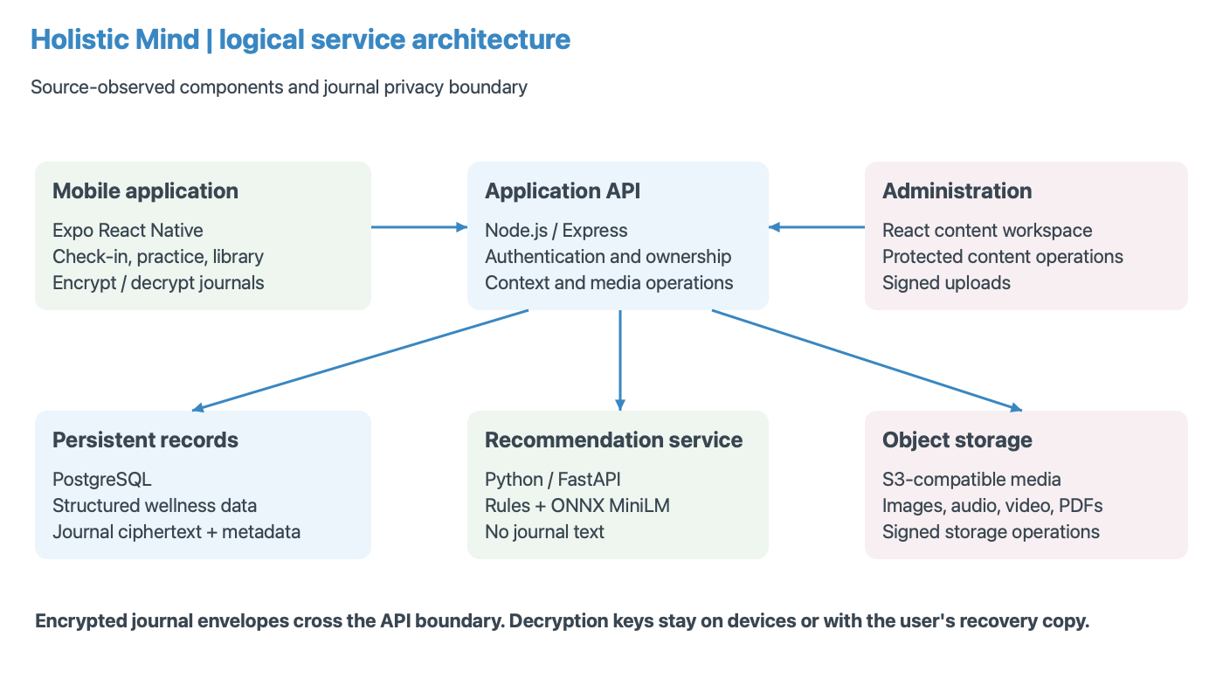
Figure 3. Current logical architecture reconstructed from source. Journal content is encrypted before upload; structured wellness context reaches the separate recommendation service.

5.2 User journey and interface design
The user journey begins with welcome, account access, and brief onboarding. The Home screen prioritises daily check-in and relevant next actions. Explore offers user-led browsing, Journal provides reflective writing, Library organises learning content, and Profile manages account-related settings. History presents previous activity and check-in information. This arrangement gives personalisation a clear place without requiring every activity to start from a recommendation.
The visual design uses warm neutral backgrounds, rounded components, body-based illustrations, and restrained accent colours. Selected states, readable spacing, and short prompts aim to reduce interaction complexity. Figure 4 shows the daily loop, while Figure 7 later illustrates the implemented library screen. These observations describe design intent. Without measured task completion, accessibility testing, or participant feedback, the report cannot conclude that the interface is easy for every target user.
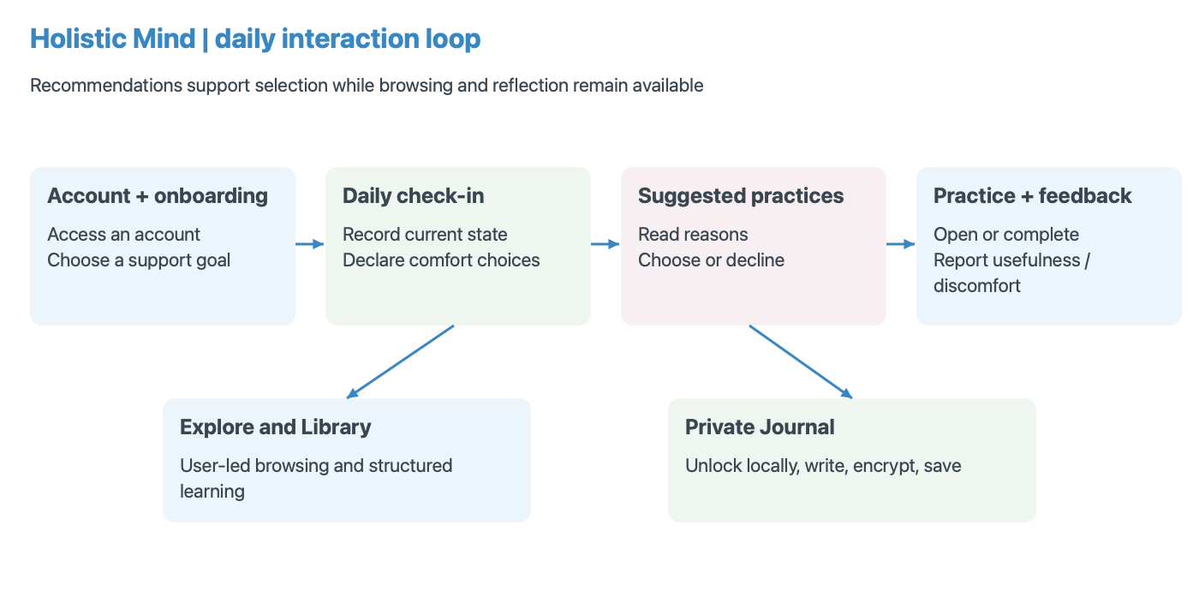
Figure 4. Daily user journey. Browsing and encrypted reflection remain voluntary parallel paths; practice feedback contributes to later recommendations.
A practical example clarifies the interaction. A user reports feeling scattered and selects focus as the immediate support need. If the same user also avoids breath holds, the recommendation pathway must remove exercises requiring that action before deciding which remaining practice best matches focus. The interface should present the resulting options as suggestions with reasons, and the user may still choose another activity through Explore. Reporting discomfort provides additional evidence for future exclusions. This example illustrates the intended sequence, not a new measured test case or a claim about the user's eventual response to a practice.

5.3 Data model and ownership
Private records are associated with a server-established user identity. The principal groups include accounts and profiles, authentication sessions, onboarding responses, daily check-ins, encrypted journal entries and vault records, recommendation requests and items, and interaction feedback. Content groups include exercises, media, courses, modules, and related learning resources. Figure 5 presents a simplified relationship map; it deliberately omits operational columns and is not a substitute for the actual migration definitions.
Ownership matters especially when reading journals, retrieving history, or submitting recommendation feedback. Knowing an object identifier should not grant access to another account's record. Recommendation feedback is tied to an exercise returned in an owned request. The journal API validates versioned envelopes while deriving the account from authentication. These checks complement database relationships: a schema can express associations, but application queries must still apply account boundaries consistently.
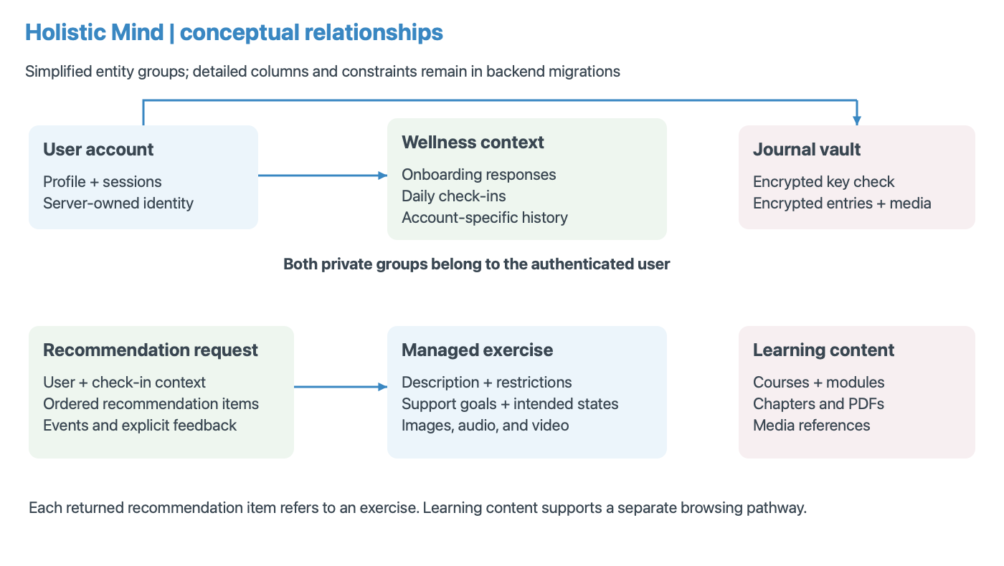
Figure 5. Simplified conceptual data relationships. Private wellness records belong to users; recommendation items refer to managed exercise content.

5.4 Recommendation pipeline
The pipeline first constructs eligible candidates using known contraindications and explicit exclusions. It then builds text documents from current check-in answers, the onboarding goal, and exercise metadata. The current application sends an empty journal list. After tokenisation and ONNX inference, normalised embeddings support cosine-based comparison. Structured rules assess alignment with declared needs. Collaborative evidence is considered only when interaction overlap and neighbour thresholds are met. This sequencing prevents a filtered exercise from re-entering through a later scoring component.
In cold start, the base score is S = 0.72R + 0.23C + 0.05H, where R represents rules, C current-context similarity, and H goal/history similarity. When collaboration is active, S = 0.65R + 0.20C + 0.05H + 0.10B, with B the collaborative component. The engine subtracts recency penalties and uses category diversity during selection. Primary-support alignment and a limited fresh-item substitution may also shape the final list. Consequently, a returned position is not simply a sorted semantic score.
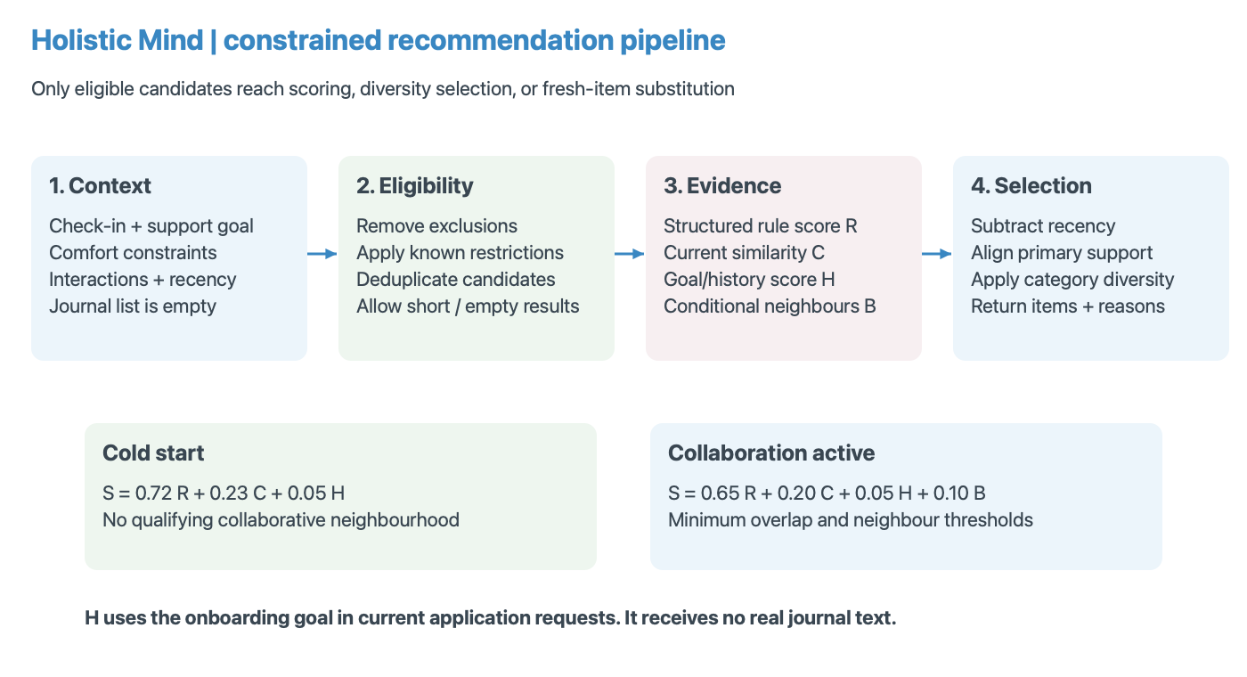
Figure 6. Recommendation stages and implemented base-score weights. Hard exclusions precede all scoring; journals do not supply H in current application requests.

5.5 Privacy design
Journal content uses a separate trust boundary from recommendations. A device generates a random 256-bit key, encrypts entry content using XChaCha20-Poly1305 with a fresh 24-byte nonce, and uploads an authenticated envelope. Associated data binds encryption to identifiers and purpose. Native key storage uses account-scoped SecureStore; web unlocks keep the key in memory. Recovery imports the user's recovery key and verifies an encrypted known value. Figure 8 shows how persistent storage can coexist with device-side decryption.
The server can still observe ownership, timestamps, counts, identifiers, and ciphertext lengths. Check-ins, comfort choices, and feedback also remain readable to application services. Losing every device key and recovery copy makes encrypted entries unrecoverable. Ordinary account-password reset does not restore journal access. Existing plaintext entries require an explicit migration path, and clearing current database fields does not erase earlier backups. These limits are essential to describing what the privacy design actually protects.

6. Implementation

6.1 Mobile application and state management
The mobile source separates screens, services, shared types, navigation, context, and theme definitions. Authentication context manages account state, journal context coordinates unlock and entry operations, and audio-player context supports playback across screens. Service modules centralise API access rather than embedding every network request in presentation components. This structure helps changes such as a new journal envelope format propagate through a defined layer while preserving the screen's writing interaction.
The application includes dedicated authentication and account-security screens, multi-step check-in components, exercise detail and playback, free writing, prompted journaling, course navigation, and PDF viewing. Recent source also includes journal attachment composition and media handling. Their existence is implementation evidence, but the earlier documented simulator checks should not be stretched to cover every later attachment path. The report therefore treats the wider media feature set as source-observed capability requiring release-level verification.

Figure 7. Existing iOS simulator Library screen, captured 3 October 2026. Course progress and the persistent compact audio player demonstrate implemented presentation features.

6.2 Authentication and persistence
The backend owns account identity and stores private records under that identity. Passwords are hashed, session storage uses native secure storage, and authenticated routes apply account-specific queries. Email verification, password recovery, password change, and account deletion have dedicated flows. Google and Apple identity-token verification are present in source, with platform configuration requirements. Their implementation does not establish that every provider has been tested in a production-signed build.
PostgreSQL separates structured data from hosted media. Onboarding supplies a support goal, check-ins supply present context, and recommendation requests record returned items and associated context. Feedback and event records retain evidence for later adaptation. Persistence is especially important across app restarts, but it also introduces retention and deletion responsibilities. Account deletion can remove server-linked records and attempt local-key cleanup; it cannot erase a recovery key copied elsewhere or material retained outside the application's control.

6.3 Recommendation service integration
The Node recommendation route loads onboarding, the latest check-in, eligible published exercise records, interaction aggregates, discomfort exclusions, and recent recommendation IDs. It rejects generation when required context is unavailable. User identifiers are transformed with an HMAC before being sent to the Python service. This reduces direct identifier exposure across that boundary, but the transformed identifier still links interactions within the service. Pseudonymisation is therefore not equivalent to anonymous data.
The Python engine loads its tokenizer and ONNX model, truncates input at the configured limit, pools token outputs when needed, and normalises embeddings. Scoring records component values and returns an explanatory reason. Collaborative activation requires at least two qualifying neighbours and at least two common interactions under current defaults. Without those conditions, the engine labels its strategy as content-based cold start. The saved benchmark exercises this cold-start pathway and cannot support conclusions about collaborative quality.
The application also has a local fallback recommendation algorithm for service failure. It shares comfort mapping with backend policy, but it is a different ranker from the Python benchmark. A successful empty response is preserved rather than refilled with unfiltered local suggestions. This distinction is important: degraded operation may justify alternate ranking, while an empty eligible set should continue to communicate that no suitable items were available under current constraints.
The interaction aggregation also deserves scrutiny. Current backend code combines explicit feedback and event values over a bounded recent period, groups them by user and exercise, and limits the returned interaction dataset. Averaging is simple to inspect, but may suppress disagreement between a completed activity and an uncomfortable experience. Sparse observations, repeated clicks, and differences in how users provide ratings can distort neighbour similarity. Future analysis should examine these behaviours before adjusting weights or increasing the influence of collaboration. A pseudonymous identifier helps separate the service from direct account identifiers, but does not remove the sensitivity of the behavioural record.

6.4 Encrypted journaling
Journal creation begins with vault setup and recovery-backup confirmation. Entry titles, prompts, packs, and text are serialised and encrypted locally. The backend accepts versioned ciphertext envelopes and rejects new plaintext writes. On retrieval, the device decrypts content only after unlocking. Wrong-account, wrong-key, altered-ciphertext, and identifier mismatches should fail authentication rather than display plausible corrupted text. Current source also defines authenticated encryption for journal media, with its own associated identifiers and media purpose.
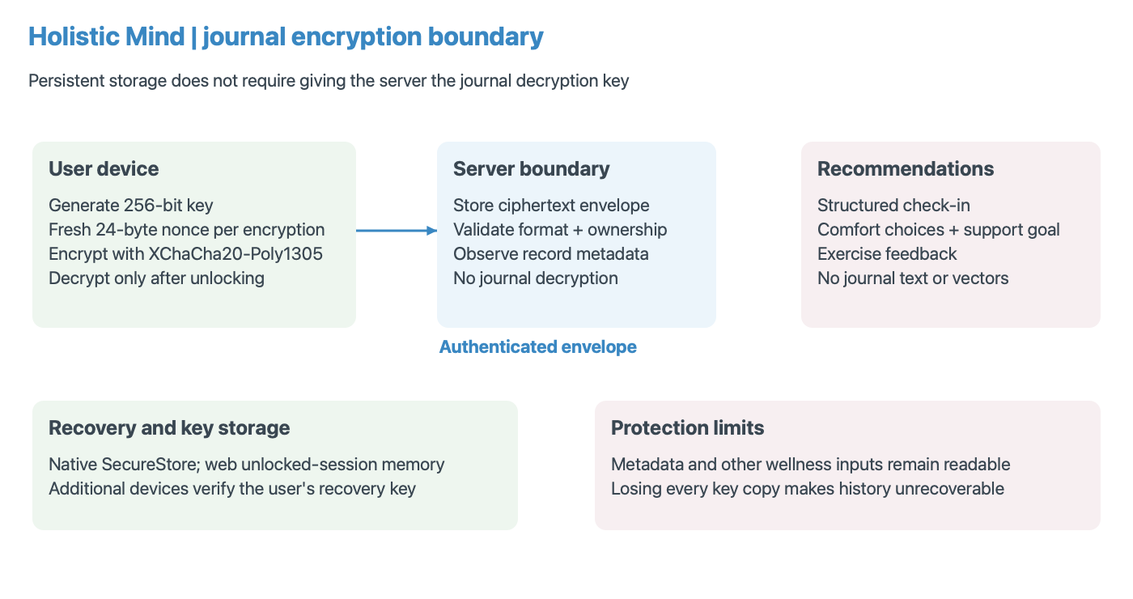
Figure 8. Journal encryption and recovery boundary. The server stores envelopes and metadata; journal text and decryption keys are excluded from recommendation requests.
Legacy migration is explicit rather than a silent server-side conversion. An unlocked client retrieves older entries, encrypts and verifies them, and submits conditional replacements. The previous plaintext fields become null while the original record identity and timestamp remain. Retrying a migration should return the already encrypted result without overwriting it. The documented tests used synthetic entries and did not migrate real journals. A production transition must also address retained backups and compatibility with older clients.

6.5 Content administration and deployment
The administration application manages exercises, audio records, curriculum structure, and related media through protected backend operations. Published status controls ordinary content availability, while recommendation metadata adds intended states, support goals, activation levels, and restrictions. This allows presentation content and ranking semantics to evolve together. However, inaccurate metadata can undermine eligibility even when upload, authentication, and publication mechanisms operate correctly. Content review is consequently part of maintaining recommendation quality.
Local development uses containerised PostgreSQL, object storage, and the recommendation service alongside the API and mobile tooling. Deployment documentation describes managed database, private service networking, S3-compatible hosting, and configured email delivery. These are reproducible operational arrangements, not evidence of full production acceptance. Export/import scripts support moving managed content between environments. Private wellness records should not be treated as content-promotion data, and no live deployment change was performed for this report.
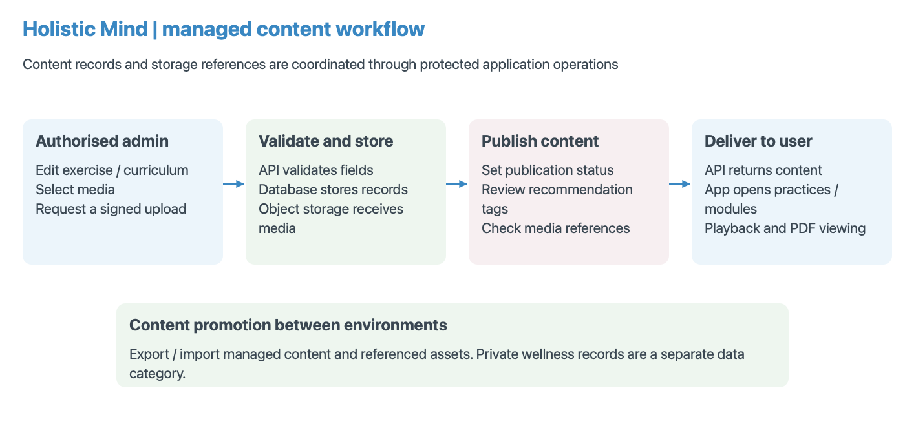
Figure 9. Content publication workflow reconstructed from the implemented admin, API, and storage modules. A published record and usable media reference are distinct prerequisites for delivery.

7. Validation and Testing

7.1 Test strategy and evidence boundaries
Validation combines saved evaluation outputs, regression-test source, and an existing device-and-backend test record. The report does not claim that these suites were newly rerun during preparation. The functional record is dated 15 September 2026 and describes an iPhone simulator with local Node, PostgreSQL, and Docker recommendation services. That provides useful integration evidence, while leaving physical-device behaviour, production configuration, and full automated native screen coverage unresolved.
Different checks address different failure classes. Ranking metrics quantify agreement with authored relevance labels. Explicit-exclusion tests check whether declared policy is preserved. Cryptographic tests examine round trips and tampering failures. API checks examine ownership and accepted formats. Native checks address module availability, secure key storage, restart persistence, and connectivity. A good score in one layer cannot substitute for a missing check in another, so the conclusions preserve these evidence boundaries.

7.2 Journal-free ranking benchmark
The journal-free ONNX run was generated on 18 September 2026 using hybrid-v4, the MiniLM ONNX backend, 30 scenarios, ten repeats per approach, and seed 42. Four approaches were compared: random ranking, semantic text similarity, rules with eligibility, and the hybrid. All deduplicate and honour explicit exercise exclusions, but random and text-only do not apply the same suitability rules as rules and hybrid. This is a comparison of complete approaches, not a controlled ablation isolating one component.
Relevance is defined as an authored label of at least two. Precision@4 divides relevant returned items by four, penalising unfilled slots. NDCG@4 uses graded gains and rank discounts to compare the returned ordering with an ideal ordering. Negative labels contribute zero gain but are also reported through a separate violation measure. Fill rate helps reveal systems that avoid violations simply by returning nothing. Bootstrap intervals resample the 30 scenario means; they estimate variation within this dataset rather than clinical or population uncertainty.
Table 1. Saved journal-free ONNX benchmark, 30 authored scenarios. Violation percentages represent negative benchmark labels, not measured adverse outcomes.
Approach | Precision@4 | NDCG@4 | Negative-label items
Random | 48.50% | 0.4315 | 5.17%
MiniLM text similarity | 71.67% | 0.6602 | 1.67%
Rules + eligibility | 73.33% | 0.7244 | 2.50%
Hybrid | 77.50% | 0.7387 | 3.33%
Source: Holistic Mind project (2026b), saved production-suite ONNX evaluation.
The hybrid returned an average of 3.1 relevant items per four. Its precision exceeded rules by 4.17 percentage points and NDCG by 0.0143. Those improvements are modest and should be read alongside the higher negative-label rate. Text-only recorded fewer negative-labelled selections in this suite. Figure 10 includes quality and warm timing, making the trade-offs visible rather than selecting only the strongest hybrid metric. No statistical significance or clinical superiority is inferred from the point estimates.
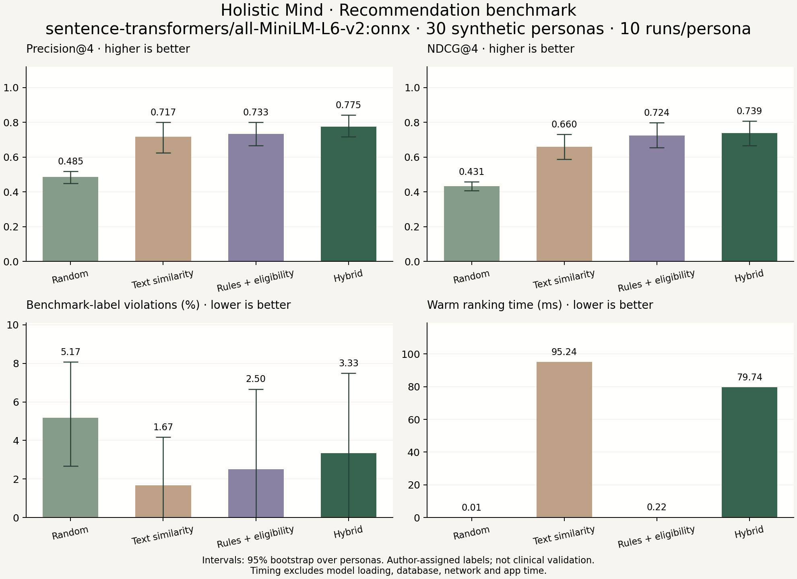
Figure 10. Existing project benchmark chart for journal-free ONNX evaluation. Error bars are bootstrap intervals over authored scenarios; timing excludes startup, database, HTTP, and mobile rendering.

7.3 Comfort restrictions and unresolved cases
The separate comfort suite contains eight selected variants with declared choices, including individual restrictions and combinations. All approaches recorded zero explicit exclusion violations with full top-four fill in these selected cases. Hybrid precision was 90.62% and NDCG was 0.7441, while text-only NDCG was higher at 0.7885. These figures should not be compared directly with the 30-scenario benchmark because the comfort cases are a selected stress suite, sometimes derived from the same source persona.
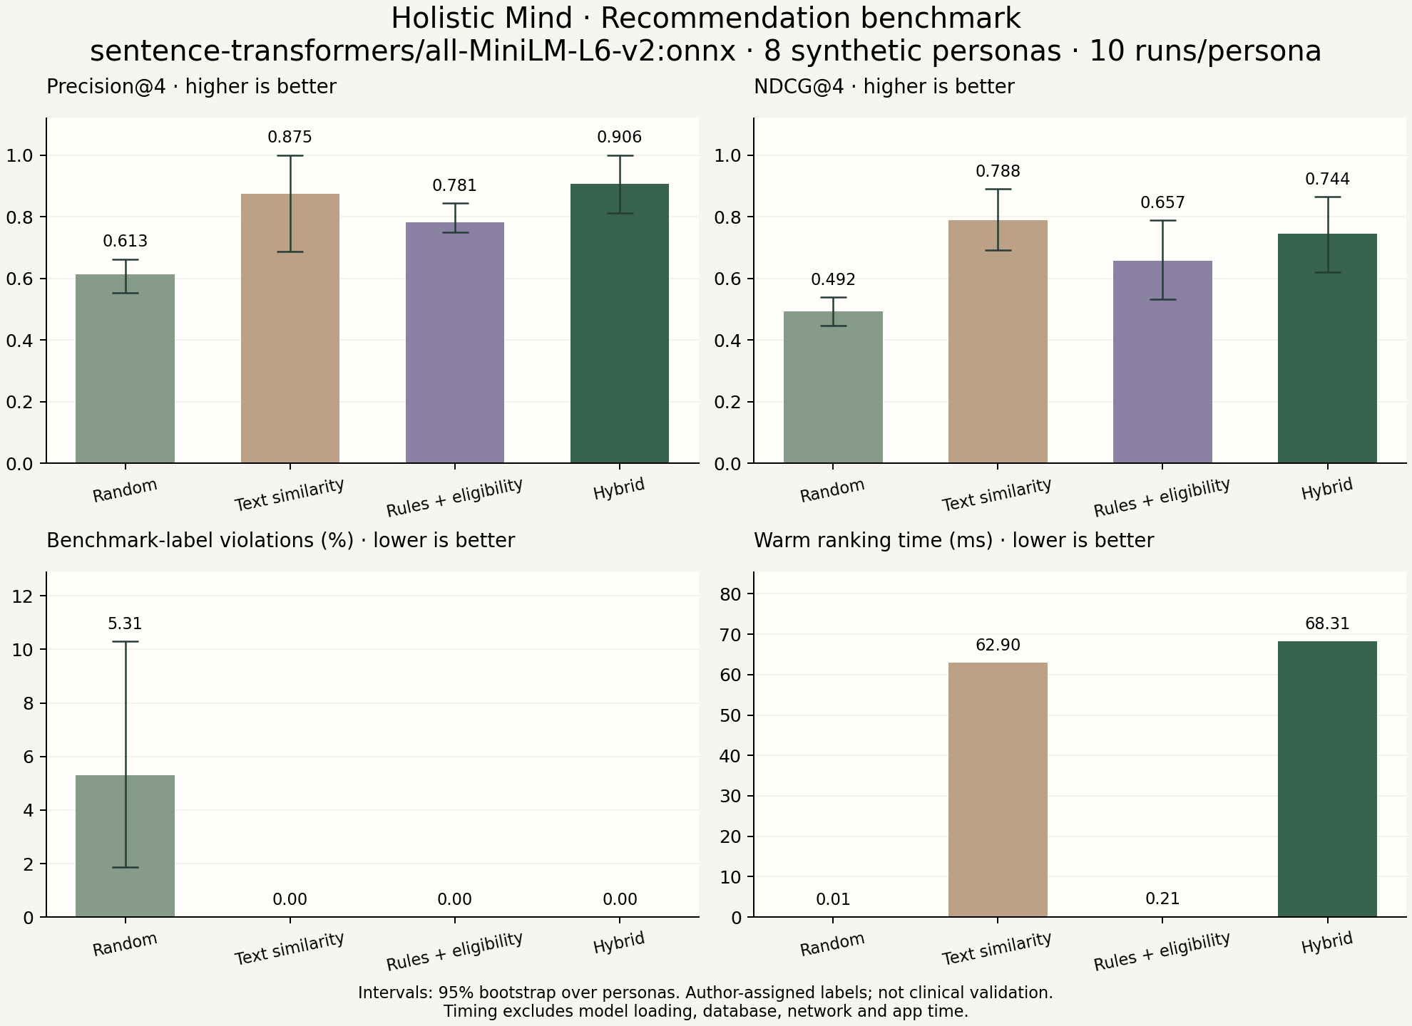
Figure 11. Existing comfort-suite ONNX chart, eight selected scenarios. The suite tests declared restrictions; it does not establish detection of unspoken concerns or representative user performance.
Three original cases remain informative. One describes touch aversion only in synthetic journal text, another describes head or eye scanning discomfort without a corresponding declared choice, and another negatively labels body scanning without a matching metadata restriction. Current production cannot read the journals, and none of these failures should be hidden by inventing preferences after the fact. Separate variants demonstrate that explicit choices trigger exclusions, while the original labels remain unchanged. Independent review is needed for disputed suitability judgments.

7.4 Documented functional checks
The September test record reports successful native encryption/decryption, Nepali and emoji round trips, recovery-key verification, rejection of different-account decryption, SecureStore readback, and key persistence after terminating and relaunching the application. Live backend checks used temporary synthetic accounts to verify vault setup, encrypted save/read, duplicate retry behaviour, account separation, legacy migration, plaintext rejection, comfort-choice persistence, and a live hybrid-v4 ONNX response. Temporary fixtures were cleaned up after those checks.
The same record documents problems with a missing native cryptography module, a simulator build lacking keychain entitlements, and an outdated running recommender container. Rebuilding the native app with the required module and signing, then rebuilding the recommender, resolved those recorded issues. This illustrates why source correctness alone is insufficient for native integration. A library can exist in JavaScript while being absent from the installed binary. Release validation must therefore include the actual installed application and service versions.

8. Critical Evaluation, Conclusion, and Future Work

8.1 Evaluation against objectives
The source and recorded checks support O1 through implemented account, onboarding, check-in, and persistence pathways, although complete release testing remains open. O2 is supported by a working rules-and-semantic pipeline, recorded score components, and baseline evaluation. O3 has specific evidence for declared exclusions, including short or empty candidate handling. O4 is supported by implemented device encryption and documented native/backend round trips. O5 is supported by the administration and content modules. O6 is partially achieved because technical evaluation exists, while representative usability and independent suitability assessment do not.
The strongest engineering result is consistency across boundaries. Declared comfort concerns become explicit constraints, filtered candidates remain excluded during selection, and encrypted journals do not quietly re-enter server recommendation context. The artefact also supports content administration without requiring every content change to become a mobile code change. These outcomes demonstrate useful integration. They do not prove that all content is appropriate or that every deployment path is equally reliable.

8.2 Threats to validity
The benchmark is small and authored within the project, so selection and label bias are plausible. A fixed catalogue limits coverage, and preserved labels may reflect expectations inconsistent with newly declared exclusions. Cold-start scenarios cannot assess long-term collaborative behaviour or rotation quality. Repeating deterministic rankers primarily supports timing; it does not enlarge the independent sample. Rules and text baselines differ in eligibility behaviour, so measured improvements cannot be assigned solely to semantic weighting.
Other evidence boundaries concern environment and time. Simulator validation does not establish physical-device signing, interruption handling, reinstall recovery, or Android behaviour. Historical documentation may lag current source. Warm ranking latency excludes network and interface delay. Cryptographic implementation evidence does not replace an independent security review, and current row migration does not erase earlier backups. These limitations should constrain both academic conclusions and public product claims.

8.3 Usability, maintenance, and practical impact
The application's practical value lies in reducing the steps between noticing a state and finding an available activity. That value remains plausible rather than measured. A user study should examine whether check-in questions are understandable, whether comfort choices accurately describe what people wish to avoid, and whether recommendation reasons help users make decisions. It should also observe skipped questions and declined practices, because these behaviours may reveal friction that a favourable satisfaction score alone would miss.
Maintenance is equally relevant to future impact. A published exercise can change wording, media, or metadata without changing the ranking code. Such updates may alter semantic similarity or eligibility, making catalogue versioning and regression checks valuable. Journal envelope versions and native cryptography dependencies also require coordinated compatibility. The project should retain reproducible evaluation snapshots while documenting when their catalogue or engine no longer matches a release. This would improve the usefulness of both favourable and unfavourable historical results.

8.4 Answers to research questions
RQ1 is answered provisionally: on the journal-free authored benchmark, hybrid ranking improved precision and NDCG over the included alternatives, but also returned more negative-labelled items than rules or semantic-only ranking. RQ2 is supported for declared restrictions by the comfort suite and targeted regression cases; undeclared restrictions remain unresolved. RQ3 is supported at implementation level: encrypted journals persist through the API while the current recommendation route sends no journal text. The resulting loss of reflective context is an intentional design trade-off rather than a missing server decryption feature.

8.5 Future work and conclusion
The next priority is independent review of exercise metadata and relevance labels, followed by weight selection on development scenarios and evaluation on unseen cases. A longitudinal dataset should assess feedback adaptation, collaborative activation, and repeated recommendation quality. Physical iOS and Android tests should cover interruptions, secure-storage behaviour, recovery on another device, media, and account deletion. A consented usability study should measure task completion and perceived control, while separate accessibility checks examine contrast, assistive technology, and text scaling.
Further privacy work should examine key rotation, compromised recovery material, background locking, and retention of legacy backups. Any journal-aware personalisation should begin with a distinct local-processing design and its own performance and privacy evaluation. Holistic Mind demonstrates that an integrated wellness application can combine a practical daily workflow, constrained recommendation logic, and device-side journal privacy. Its saved results justify continued development, while the reported violations and evidence gaps identify exactly where stronger validation is still required.

References
Burke, R. (2002) 'Hybrid Recommender Systems: Survey and Experiments', User Modeling and User-Adapted Interaction, 12, pp. 331–370. https://doi.org/10.1023/A:1021240730564.
Fullel, S. (2026) Saathi: Nepali Voice Assistant for Elderly Users. Undergraduate project report, Birmingham City University / Sunway College Kathmandu. User-supplied PDF; used as a structural reference.
Morris, J. X., Kuleshov, V., Shmatikov, V. and Rush, A. M. (2023) 'Text Embeddings Reveal (Almost) As Much As Text', Proceedings of EMNLP, pp. 12448–12460. https://aclanthology.org/2023.emnlp-main.765/.
Rai, A. (2026) A Semantic Approach to Tourist Recommendation in Nepal. Undergraduate dissertation, Birmingham City University. User-supplied PDF; used as a structural reference.
Reimers, N. and Gurevych, I. (2019) 'Sentence-BERT: Sentence Embeddings using Siamese BERT-Networks', Proceedings of EMNLP-IJCNLP, pp. 3982–3992. https://aclanthology.org/D19-1410/.
Sentence Transformers (n.d.) all-MiniLM-L6-v2 model card. https://huggingface.co/sentence-transformers/all-MiniLM-L6-v2. Accessed 3 October 2026.
Holistic Mind project (2026a) Current implementation: src/, backend/src/, admin/src/, and recommender/app/. Local repository inspected 3 October 2026; implementation evidence, not an independently published source.
Holistic Mind project (2026b) Journal-free evaluation and restriction investigation. recommender/evaluation/PRODUCTION-EVALUATION.md; evaluation_results_production_onnx.json; evaluation_results_comfort_onnx.json. Saved ONNX runs dated 18 September 2026.
Holistic Mind project (2026c) Device and backend test results. samyam docs/DEVICE-AND-BACKEND-TEST-RESULTS.md. Recorded verification dated 15 September 2026.
Holistic Mind project (2026d) Project development and privacy documentation. samyam docs/15-Week-Development-Journal.md; samyam docs/journal-privacy.md; samyam docs/RECOMMENDATION-BENCHMARK.md. Read alongside current source because some historical sections describe earlier behaviour.

Appendix A. Evidence and submission details
The report was prepared from the local Holistic Mind repository and the two supplied example dissertations. Reference-report declarations, institutional metadata, participant data, and project results were not transferred to this artefact. Student name, student number, supervisor, degree, institution, and submission date should be completed on the cover before submission. Any required originality declaration or acknowledgement should be written and confirmed by the student rather than inferred from the example reports.
Figures 1 and 7 use existing simulator screenshots. Figures 2–6, 8, and 9 are explanatory diagrams prepared for this report from source and development documentation. Figures 10 and 11 are existing project charts corresponding to the saved evaluation suites. No image is evidence of a new participant study. The body word count covers Chapters 1–8 and excludes the abstract, cover, navigation, captions, tables, references, and appendix.

