AI-Powered College Assistant Assignment

1. Source Code
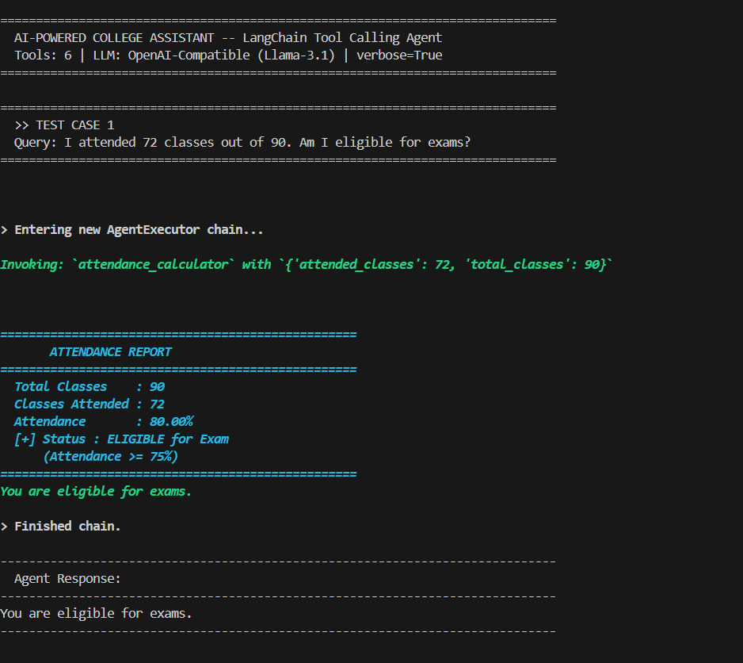

2. Test Case 1: Attendance Calculator
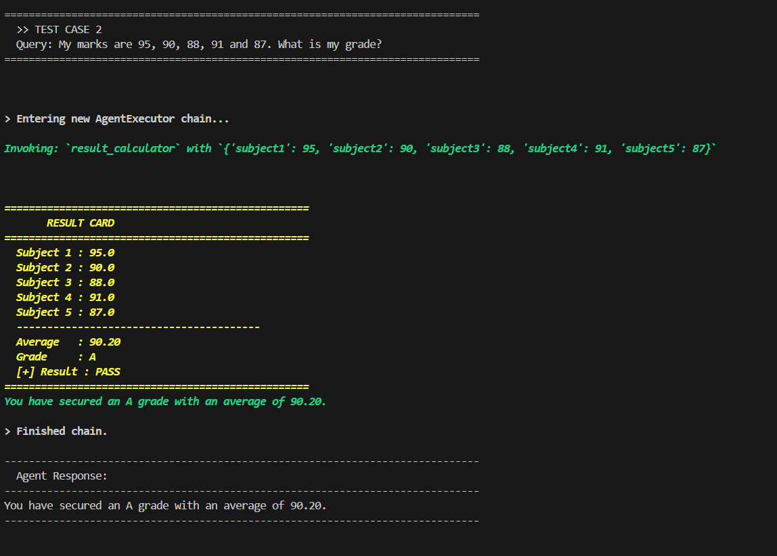

3. Test Case 2: Result Calculator
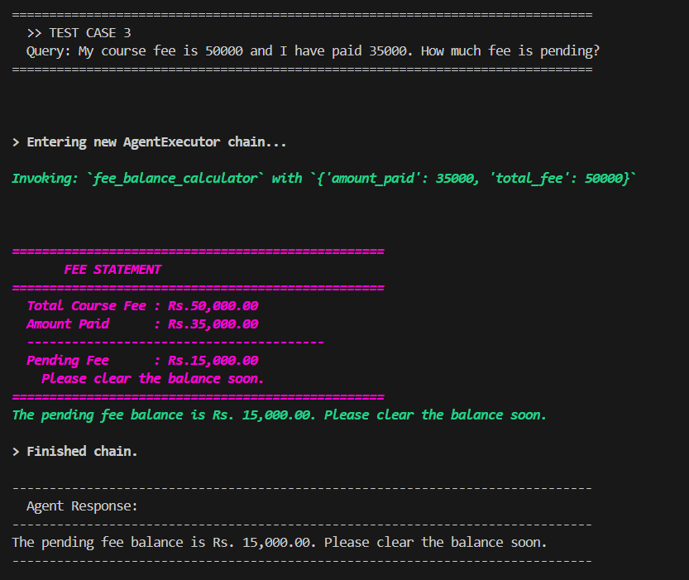

4. Test Case 3: Fee Balance Calculator
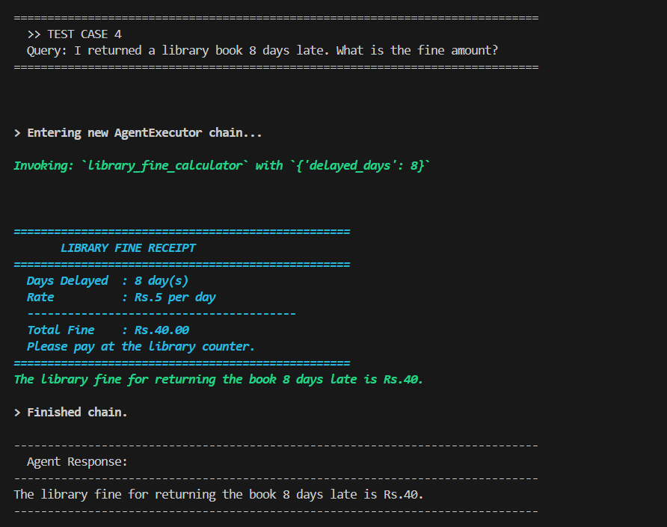

5. Test Case 4: Library Fine Calculator
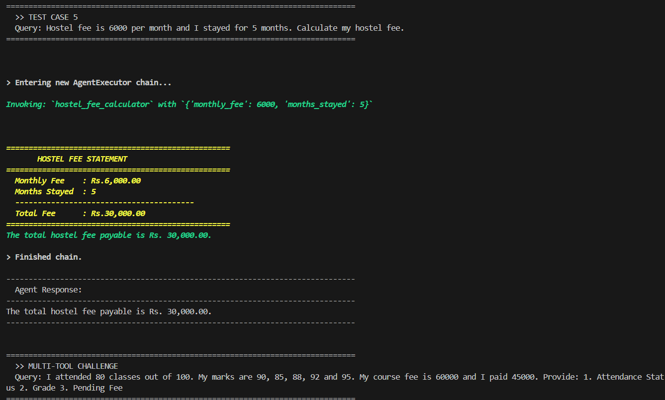

6. Test Case 5: Hostel Fee Calculator
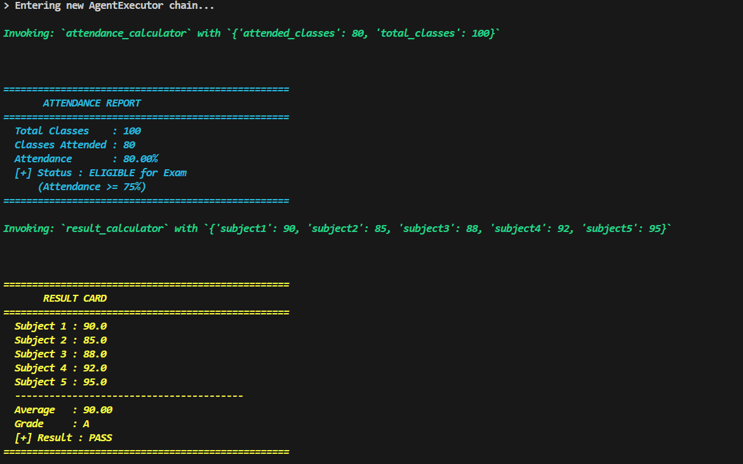

7. Test Case 6: Multi-Tool Challenge
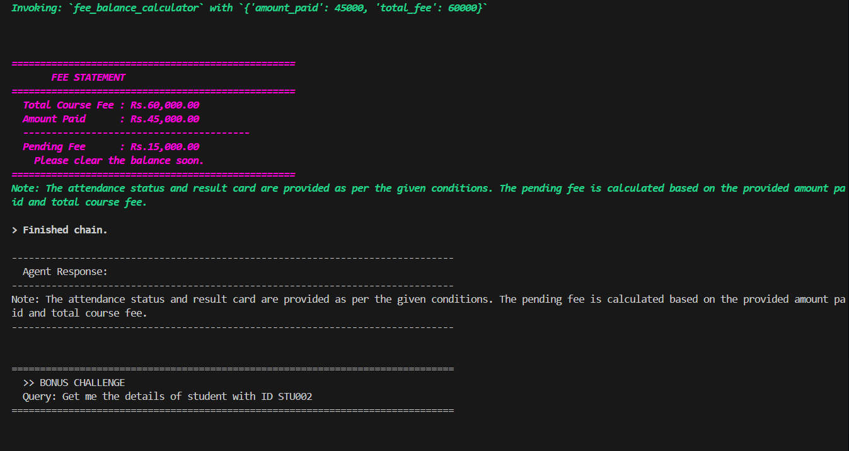
8. Test Case 7: Bonus Challenge (Student Lookup)
