

Tribhuvan University

Faculty of Humanities and Social Sciences

PORTFOLIO MANAGEMENT SYSTEM USING LSTM, TECHNICAL ANALYSIS INDICATORS, AND MONTE CARLO VAR
A PROJECT REPORT

Submitted to:

In partial fulfillment of the requirements for the Bachelors in Computer Application

Submitted by
Samyak Maharjan (6-2-410-23-2020)

September, 2024 A.D
Under the supervision of
Mr. Radha Krishna Gajurel



Tribhuvan University

Faculty of Humanities and Social Sciences

PORTFOLIO MANAGEMENT SYSTEM USING LSTM, TECHNICAL ANALYSIS INDICATORS, AND MONTE CARLO VAR
A PROJECT REPORT

Submitted to:

Department of Computer Application
Prime College

In partial fulfillment of the requirements for the Bachelors in Computer Application

Submitted by
Samyak Maharjan (6-2-410-23-2020)

September, 2024 A.D

Under the supervision of
Mr. Radha Krishna Gajurel



Tribhuvan University
Faculty of Humanities and Social Science
Prime College

SUPERVISOR RECOMMENDATION

I hereby recommend that this project prepared under my supervision by Samyak Maharjan entitled “PORTFOLIO MANAGEMENT SYSTEM USING LSTM, TECHNICAL ANALYSIS INDICATORS, AND MONTE CARLO VAR” in partial fulfillment of the requirements for the degree of Bachelor of Computer Application is recommended for the final evaluation.

SIGNATURE
Radha Krishna Gajurel
Lecturer
Bachelor in Computer Application
Prime College

Tribhuvan University
Faculty of Humanities and Social Science
Prime College

LETTER OF APPROVAL

This is to certify that this project prepared by Samyak Maharjan entitled “ PORTFOLIO MANAGEMENT SYSTEM USING LSTM, TECHNICAL ANALYSIS INDICATORS, AND MONTE CARLO VAR ” in partial fulfillment of the requirements for the degree of Bachelor in Computer Applications has been evaluated. In our opinion, it is satisfactory in scope and quality as a project for the required degree.

……………………………………….  Mr. Radha Krishna Gajurel, Lecturer  Bachelor in Computer Application  Prime College, Khusibu, Kathmandu | ……………………………………….  Ms. Rolisha Sthapit  Bachelor in Computer Application  Prime College, Khusibu, Kathmandu
……………………………………….
Mr.
External Examiner

ABSTRACT

Effective portfolio management is crucial for optimizing investments and minimizing risk in financial markets. This project presents a portfolio management system developed using Java Spring Boot, Core JavaScript, HTML, CSS, and MySQL that leverages Long Short-Term Memory (LSTM) forecasting and Monte Carlo simulation for Value at Risk (VaR) to assist users in making informed stock investment decisions. The system ingests historical stock data and allows users to input a stock symbol and time horizon. It utilizes LSTM to predict stock price trends and applies Monte Carlo simulations to estimate VaR, ranking results in ascending order of risk so that the lowest VaR appears first. In addition, the system computes standard technical analysis indicators (SMA, EMA, RSI, MACD, Bollinger Bands, ATR, and Stochastic Oscillator), which are incorporated as engineered features to enrich model inputs and stabilize predictions, and rendered as interactive chart overlays to support analyst interpretation and decision-making.
This combined predictive, risk, and analytics workflow helps investors select favorable stocks while minimizing potential losses. The performance metrics of the model are as follows: Precision for class 0: 0.86, Precision for class 1: 0.96, Recall for class 0: 0.96, Recall for class 1: 0.86, F1 Score for class 0: 0.90, F1 Score for class 1: 0.91, and an overall accuracy of 0.84.
Keywords: LSTM, Monte Carlo Simulation, Value at Risk (VaR), Java Spring Boot, Portfolio Management, Technical Analysis, SMA, EMA, RSI, MACD, Bollinger Bands, ATR, Stochastic Oscillator, Feature Engineering.

ACKNOWLEDGEMENT

For the partial fulfillment of this project, I would like to express my sincere gratitude to everyone who has directly and indirectly helped me to develop this portfolio management system. There were moments when I thought this project was too challenging or impossible, but I am deeply thankful to my supervisor, Mr. Radha Krishna Gajurel, who continuously inspired and guided me to give my best and complete this project. I am also incredibly grateful to Ms. Rolisha Sthapit, who consistently helped me throughout, pointing out and helping me reconcile my mistakes.
I would also like to acknowledge the continuous support of my classmates, who always inspired me to keep moving forward and reminded me of the competitive nature of this project. Additionally, I am thankful to the seniors of Prime College, whose advice and guidance were invaluable during the project. I truly appreciate their help and thank them from the bottom of my heart for contributing to my progress.
Finally, I would like to express my gratitude to Tribhuvan University for providing me with this opportunity through the Bachelor of Computer Application program. This project has allowed me to not only enhance my understanding of project ethics but also expand my knowledge and technical skills in the field.

Samyak Maharjan

Table of Contents

SUPERVISOR RECOMMENDATION iii
LETTER OF APPROVAL iv
ABSTRACT v
ACKNOWLEDGEMENT vi
LIST OF ABBREVIATIONS ix
List of Figure x
List of Table xi
CHAPTER 1 1
INTRODUCTION 1
1.1 Introduction 1
1.2 Problem Statement 2
1.3 Objectives 2
1.4 Scope and Limitation 2
1.5 Development Methodology 3
1.6 Report Organization 5
CHAPTER 2 6
BACKGROUND STUDY AND LITERATURE REVIEW 6
2.1 Background Study 6
2.2 Literature Review 7
CHAPTER 3 11
SYSTEM ANALYSIS AND DESIGN 11
3.1 System Analysis 11
3.1.1 Requirement Analysis 11
3.1.1 Feasibility Analysis 12
3.1.2 Object Modeling: Object and Class Diagram 14
3.1.3 Dynamic Modeling 16
3.1.4 Process Modeling: Activity Diagram 18
3.2 System Design 19
3.2.1 Architectural Design 19
3.2.2 Deployment Diagram 20
3.3 Algorithm Details 20
CHAPTER 4 27
IMPLEMENTATION AND TESTING 27
4.1 Implementation 27
4.1.1 Tools Used (CASE tools, Programming languages, Database platforms) 27
4.1.1.1 Frontend Tools 27
4.1.1.2 Backend Tools 27
4.1.2 Core Features Implementation 27
4.2 Testing 32
4.2.1 Test Cases of Unit Testing 32
4.3.1 Evaluating Accuracy 33
4.3.1 .1 Evaluating Accuracy of LSTM 34
CHAPTER 5 35
CONCLUSION AND FUTURE RECOMMENDATION 35
5.1 Conclusion 35
5.2 Lessons Learned/Outcomes 35
5.3 Future Recommendations 35
REFERENCES 37
APPENDICES

LIST OF ABBREVIATIONS
API | Application Programming Interface
CSS | Cascading Style Sheets
DFD | Data Flow Diagram
ERD | Entity Relationship Diagram
FP | False Positives
FN | False Negatives
HTML | Hypertext Markup Language
JS | JavaScript
LSTM | Long Short-Term Memory
ML | Machine Learning
MSE | Mean Squared Error
MySQL | Structured Query Language
RMSE | Root Mean Squared Error
RMI | Remote Method Invocation
TP | True Positives
TN | True Negative
VaR | Value at Risk

List of Figure
Figure 1. 1 Agile model of Portfolio Management 4
Figure 1. 2 Use Case Diagram of Portfolio Management 11

Figure 3. 1 Gantt Chart of Portfolio Management 14
Figure 3. 2 Class Diagram of Portfolio Management 16
Figure 3. 3 Sequence Diagram of Portfolio Management 18
Figure 3. 4 Activity Diagram of Portfolio Management 19
Figure 3. 5 Deployment Diagram of Portfolio Management 20

Figure 4. 1 Using Lstm, Technical Analysis and Monte Carlo 27
Figure 4. 2 Generating Confusion Matrix for Portfolio Management 28
Figure 4. 3 Code for Generating confusion matrix 29
Figure 4. 4 LSTM Stock prediction Report 32

List of Table
Table 3. 1 Before Normalization 21
Table 3. 2 After Normalization 21

Table 4. 1 Investment Interface 30

CHAPTER 1

INTRODUCTION

Introduction

Investment in the stock market carries significant financial risks, and making informed decisions is essential for minimizing potential losses. With the rapid advancement of machine learning algorithms and statistical techniques, data-driven approaches have become key to developing robust portfolio management systems. This introduction highlights the development of a portfolio management system using the Long Short-Term Memory (LSTM) algorithm [1] and Monte Carlo simulation for Value at Risk (VaR) [2], which assists users in making informed stock-buying decisions.
The portfolio management system employs LSTM, a type of recurrent neural network that excels in time series predictions, such as stock price forecasting. This algorithm helps predict which stocks are likely to increase in value over a given period. The system also integrates Monte Carlo simulations to assess the Value at Risk (VaR) for each stock, which helps evaluate the potential losses associated with each investment.
The system follows a data-driven approach, utilizing comprehensive historical stock data to train the LSTM model for accurate predictions. It enables users to input their stock symbol and time duration. Based on the LSTM predictions, stocks are ranked by risk using the VaR calculations, ensuring that users are presented with the most promising and least risky options first.
By combining the predictive power of LSTM and the risk assessment capability of Monte Carlo simulations, this portfolio management system offers investors an intuitive and efficient tool for making data-informed investment decisions. With its web-based interface built using Java Spring Boot [3] on the backend, and JavaScript [4], HTML [5], and CSS [6] on the frontend, the system provides an accessible and effective solution for managing portfolios, minimizing risks, and optimizing returns.
In addition to predictive modeling and VaR-based risk assessment, the system computes standard technical indicators (SMA, EMA, RSI, MACD, Bollinger Bands, ATR, and Stochastic Oscillator). These indicators are used in two ways: as engineered features to enhance the LSTM’s ability to learn temporal-price dynamics, and as interactive overlays in the trading chart to support analyst-oriented decision-making.

Problem Statement

The problem addressed in this project is the challenge of making informed and risk-minimized stock investment decisions in volatile markets. Many current portfolio management strategies lack advanced predictive capabilities and robust risk assessment tools, leading to suboptimal investment choices and potential financial losses. The proposed portfolio management system aims to solve this by utilizing advanced machine learning algorithms, such as LSTM for stock price prediction, and Monte Carlo simulation for calculating Value at Risk (VaR). By combining these techniques, the system provides a data-driven solution for minimizing investment risk and optimizing returns for users.

Objectives

- To develop an LSTM model that can accurately predict stock prices for a given time period.
- To implement Monte Carlo simulation for calculating the Value at Risk (VaR) of stocks, helping users to minimize potential losses.
- To compute and visualize technical indicators (SMA, EMA, RSI, MACD, Bollinger Bands, ATR, Stochastic) for decision support.
- To integrate selected indicators as engineered features to improve LSTM prediction stability and accuracy.

Scope and Limitation

Scope:
- The system can be used by individual investors to make data-driven decisions about stock purchases over a certain period.
- It offers stock price forecasting using LSTM, providing predictions that help identify stocks with upward trends.
- It integrates Monte Carlo simulation to assess stock risk, giving users a better understanding of potential financial losses.
- The system can be extended to include more complex portfolio optimization strategies in the future.
- Interactive charting with configurable technical indicators and symbol search.
Limitations:
- The accuracy of stock price predictions may fluctuate due to the unpredictable nature of financial markets.
- The system is dependent on a stable internet connection for real-time data retrieval and updates.
- The system lacks advanced security layers and may be vulnerable to cyberattacks, necessitating additional security measures for future improvements.
- Indicator parameterization (lookback periods, smoothing) may introduce lag or sensitivity; performance depends on data quality and market microstructure.

Development Methodology

A software development methodology provides a structured framework to plan, organize, and control the development process of a system. Various models or methods are used during the Software Development Life Cycle (SDLC), such as the Waterfall model, prototyping model, spiral model, and Agile model, depending on the project's nature and objectives.
For this project, the Agile model [7] was chosen as the development methodology. The Agile model is an iterative and incremental approach that promotes flexibility and customer collaboration throughout the development process. This model is particularly suitable for projects where requirements may evolve or change based on user feedback and market demands. Given the dynamic nature of portfolio management systems and the need for continuous improvement, the Agile model allows for ongoing adjustments and enhancements based on user input.

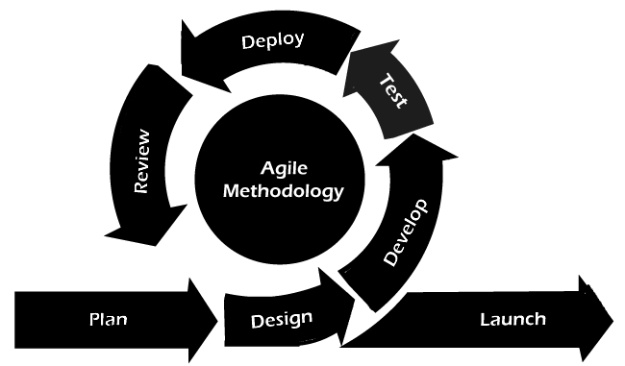
Figure 1. 1 Agile model of Portfolio Management
Requirement Gathering: This phase involved collaborating with stakeholders to gather requirements through discussions and feedback sessions. Requirements were prioritized based on user needs and market trends.
Iterative Development: The development was divided into multiple iterations, with each iteration focusing on delivering a functional increment of the system. The backend was developed using Java Spring Boot, while the frontend was built using Core JavaScript, HTML, and CSS. MySQL was used as the database for storing stock data and user information. Key functionalities, including LSTM prediction and Monte Carlo simulation for VaR, were implemented incrementally.
Testing: Each iteration included testing phases where unit testing and system testing were performed to detect and fix any bugs or inconsistencies. Continuous integration and testing ensured that new features did not introduce regressions.
Review and Feedback: After each iteration, the developed functionalities were reviewed with stakeholders to gather feedback and identify areas for improvement. This iterative feedback loop allowed for adjustments to be made promptly.
Deployment: Once a set of functionalities was deemed complete and met the acceptance criteria, it was deployed for use. The project was integrated into a server environment where it could be accessed by users for stock predictions and portfolio management.
Maintenance and Continuous Improvement: Following deployment, the system required ongoing maintenance to update stock data, address potential bugs, and implement new features based on user feedback and changing market conditions.

Report Organization

The report begins with a brief introduction to stock market, including problem statements and project objectives. Chapter 2 analyzes the existing systems. Chapter 3 discusses the data modeling and process modeling techniques used to provide information about system requirements and the feasibility study. The system design is represented through database component diagrams, deployment diagrams, and activity diagrams. Chapter 4 explains the tools utilized in this project’s front end and back end, detailing their purposes, and describes the modules employed. This chapter also covers the testing processes. Chapter 5 presents the conclusion regarding how the project was accomplished, its findings, and more, along with recommendations for future enhancements. In conclusion, this chapter provides an overview of the project's purpose, including its scope and objectives.

CHAPTER 2

BACKGROUND STUDY AND LITERATURE REVIEW

2.1 Background Study

Investment management is a critical aspect of financial health for individuals and institutions, with stock market dynamics presenting both opportunities and risks. The ability to make informed decisions in stock trading is essential for maximizing returns while minimizing potential losses. Traditional investment strategies often rely on historical data and basic statistical analysis, which may not effectively capture the complexities of market behavior.

Recent advancements in machine learning have introduced innovative approaches to stock market prediction [8]. Among these, the Long Short-Term Memory (LSTM) algorithm has emerged as a powerful tool for time-series forecasting due to its capability to learn from sequential data and retain information over long periods. LSTM models have been applied to predict stock prices by analyzing historical price movements, trading volumes, and other relevant indicators.

Complementing ML-based forecasting, technical analysis provides practitioner-tested tools that summarize price action into trend, momentum, and volatility signals. Standard indicators—such as Simple/Exponential Moving Averages (SMA/EMA) for trend, Relative Strength Index (RSI) and Stochastic Oscillator for momentum, Moving Average Convergence Divergence (MACD) for trend–momentum crossovers, Bollinger Bands for price dispersion, and Average True Range (ATR) for volatility—offer interpretable features derived from OHLC data. In modern systems, these indicators serve two roles: (i) feature engineering inputs that can enhance model stability and predictive power when combined with LSTM, and (ii) interactive overlays that support analyst interpretation and rule-based decision-making [12], [22]. Foundational treatments of these indicators in the literature have established their definitions, parameterization, and typical use-cases in trading and risk management.

In addition to price prediction, assessing risk is crucial for effective portfolio management. Monte Carlo simulation has gained traction as a method for estimating Value at Risk (VaR), providing insights into potential losses in investment portfolios under various market conditions. By simulating a range of possible outcomes based on historical data, this technique helps investors evaluate the risk associated with their portfolios. In practice, technical indicator regimes (e.g., high ATR or band breakouts) can be used alongside VaR to contextualize risk and inform entry/exit decisions.

The integration of advanced technologies, such as financial data APIs, has facilitated the collection and analysis of vast datasets (OHLCV and fundamentals), enhancing the predictive power of machine learning models and enabling real-time computation of technical indicators. Evaluation metrics like Mean Absolute Error (MAE), Root Mean Squared Error (RMSE), and classification metrics (precision, recall, F1) are commonly used to assess forecasting and directionality performance.

Ethical considerations related to algorithmic bias, data privacy, and the interpretability of machine learning models are vital in the development of investment decision-support systems. As the financial landscape continues to evolve, ongoing research is necessary to refine predictive models, select robust indicator sets and parameters, and improve risk management strategies.

Overall, the background study highlights the importance of employing advanced machine learning techniques, technical analysis indicators, and Monte Carlo simulation in developing effective stock market prediction and risk assessment tools, ultimately aiming to enhance portfolio management and investment outcomes.

2.2 Literature Review

Numerous studies have been conducted on stock market prediction, employing various data mining and machine learning algorithms. Each technique has yielded different results, showcasing the diverse capabilities of these methods in predicting stock prices and assessing investment risks. Here are some notable research contributions:
In 2010, authors explored machine learning algorithms such as Naive Bayes, K-Nearest Neighbors (KNN), and decision trees for stock price prediction. Using the Tanagra tool for classification, they evaluated a dataset consisting of 3000 instances with 14 attributes through 10-fold cross-validation. The dataset was divided into 70% for training and 30% for testing. The results indicated that the Naive Bayes algorithm outperformed others due to its efficiency and accuracy, making it a favorable choice for predictive modeling [9].
In a subsequent study, researchers developed a Decision Support System (DSS) for stock market prediction utilizing the Naive Bayes algorithm. By analyzing attributes such as trading volume, historical prices, and market trends, the system provided a web-based application for predicting stock performance. The DSS was trained on historical data from financial markets, emphasizing Naive Bayes' suitability for high-dimensional datasets with independent attributes. Its simplicity often allowed it to outperform more complex algorithms [10].
In 2013, another study applied Decision Trees (J48), Naive Bayes, and Artificial Neural Networks (ANN) to predict stock market trends. Using a dataset of 7339 instances with 15 attributes from various financial indicators, the researchers employed the WEKA tool for analysis. They implemented 10-fold cross-validation and utilized feature selection techniques to refine their models. The results demonstrated that the J48 algorithm achieved the highest accuracy at 95.56%, while Naive Bayes, although less accurate at 91.96%, required significantly less time to train [11].
In 2014, authors investigated multiple algorithms, including J48, Naive Bayes, REPTREE, and CART, for predicting stock prices. They utilized a dataset collected from financial markets, focusing on key attributes such as price trends, volume, and market sentiment. The WEKA tool facilitated their experiments, employing 10-fold cross-validation for accuracy assessment. The findings indicated that J48 and REPTREE performed best, while Naive Bayes lagged behind [12].
In 2016, a comparative study was conducted using Naive Bayes, J48, and ANN to enhance prediction accuracy in stock price forecasting. A dataset comprising 210 records with 8 attributes was analyzed using WEKA. Results indicated that Naive Bayes achieved the highest accuracy at 79.90%, demonstrating its effectiveness in rapid model building compared to J48 and ANN [13].
Patel and colleagues explored hybrid models combining decision trees, random forests, and support vector machines (SVMs) to predict stock prices. By integrating these models, they sought to capture the complex and non-linear relationships present in financial data. They observed that the hybrid approach outperformed individual models, especially for volatile market data. This study highlighted the advantages of combining multiple algorithms, each contributing its strengths to handle the dynamic nature of stock markets [14].
Fischer and Krauss introduced Long Short-Term Memory (LSTM) networks to forecast stock prices using historical data from the S&P 500 index. LSTM models, known for their ability to capture temporal dependencies, significantly improved the accuracy of stock price predictions compared to traditional models like random forests and logistic regression. This research showcased LSTM’s strength in dealing with sequential data, offering a more accurate prediction method in stock markets compared to other machine learning approaches [15].
Chong et al. developed a hybrid model combining Convolutional Neural Networks (CNN) and LSTM to forecast stock prices. CNN was used to capture spatial patterns in the data, while LSTM was applied to temporal dependencies. This combination allowed the model to extract both spatial and temporal features, resulting in higher prediction accuracy, particularly for short-term trends. This hybrid approach proved useful in predicting short-term price movements in highly dynamic markets [16].
Shah and colleagues applied Monte Carlo simulation alongside machine learning algorithms, including LSTM, to predict stock prices and calculate Value at Risk (VaR). Monte Carlo simulation provided a robust quantitative measure of investment risk, while LSTM handled the time-series forecasting. Their study illustrated how combining LSTM and Monte Carlo could yield not only predictions but also a measure of the financial risk, making it highly practical for risk-averse investors [17].
Rather et al. conducted a study comparing the predictive capabilities of LSTM with traditional time-series models like ARIMA and linear regression. Their results demonstrated that LSTM significantly outperformed both ARIMA and regression models, especially in capturing sequential dependencies and non-linear patterns within stock price data. This study was a key demonstration of LSTM's ability to handle long-term dependencies, making it a superior choice for stock market forecasting [18].
Bao and colleagues extended LSTM's application by integrating it with wavelet transforms for stock market prediction. They used wavelet transforms to pre-process the data, helping the model identify patterns at multiple time scales. This approach led to improved prediction accuracy compared to raw data input into the LSTM model. Their work highlighted how combining data pre-processing techniques with advanced neural networks can enhance forecasting outcomes [19].
Kumar and colleagues combined sentiment analysis with LSTM models to predict stock market trends. They incorporated public sentiment data from Twitter into their LSTM-based system to gauge market sentiment alongside traditional price data. Their results showed that this multi-source approach, blending social sentiment and historical prices, significantly improved prediction accuracy, making the model better suited for real-world applications [20].
Qiu and colleagues developed an LSTM-based stock price prediction system that incorporated macroeconomic variables such as GDP, inflation rates, and interest rates. By adding these external economic factors, the model was able to provide a more holistic prediction, significantly improving accuracy. Their study emphasized the importance of integrating multiple data sources to achieve more reliable predictions [21].
Shynkevich and co-researchers used ensemble learning methods, combining LSTM with Random Forest, to enhance stock price prediction. LSTM was used to capture temporal dependencies, while Random Forest handled decision-making processes based on feature importance. This hybrid approach demonstrated strong performance, especially in volatile markets, highlighting the benefits of combining models to improve robustness and accuracy [22].
Krauss and colleagues introduced a deep reinforcement learning (DRL) approach combined with LSTM for stock market trading. In their model, DRL allowed the system to learn optimal trading strategies through trial and error, while LSTM managed time-series prediction. Their method outperformed traditional LSTM-based predictive systems by allowing the model to make informed trading decisions autonomously, further enhancing profitability in stock trading [23].

These studies collectively underscore the ongoing advancements in machine learning algorithms for stock market prediction. However, they also highlight the need for continued research to refine predictive models, particularly by integrating more sophisticated techniques like LSTM and Monte Carlo simulation to enhance accuracy and risk management in portfolio decision-making.

CHAPTER 3

SYSTEM ANALYSIS AND DESIGN

3.1 System Analysis

The Portfolio Management System is designed to help users make informed stock investment decisions by predicting stock prices and evaluating the risk associated with those stocks. The system integrates data collection, predictive modeling, and risk assessment to guide investors toward better financial choices.

3.1.1 Requirement Analysis

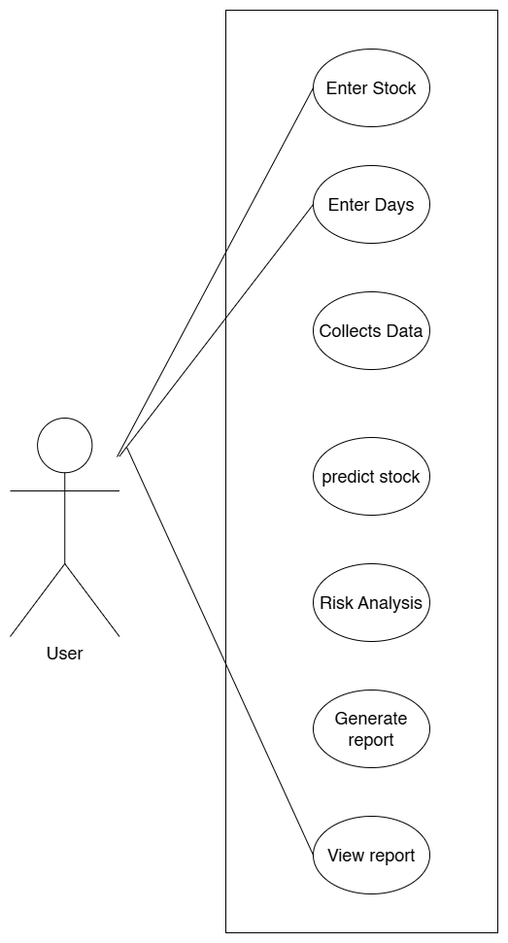
i. Functional Requirements
Figure 1. 2 Use Case Diagram of Portfolio Management
a) User Input: The system allows users to input the stock symbol and the number of days for which they wish to invest. No login or registration is required.
b) Data Collection and Stock Selection: Based on the user's the system collects relevant stock data.
c) Stock Price Prediction: The system employs an LSTM model augmented by computed technical indicators (SMA, EMA, RSI, MACD, Bollinger Bands, ATR, and the Stochastic Oscillator) to predict the next closing price of selected symbols using historical data. Only stocks with positive predicted performance are considered for further analysis.
d) Risk Assessment: For the selected stocks with positive predicted performance, the system applies Monte Carlo simulation to calculate the Value at Risk (VaR) for each stock, assessing the investment risk.
e) Results Presentation: The system presents the predicted stock prices and the associated VaR values to the user, sorted in ascending order of risk, highlighting the stocks with the lowest risk (VaR). This helps users make informed investment decisions while managing their risk effectively.

ii. Non-Functional Requirements
a) Performance: The system should efficiently handle data processing and predictions, providing results in a timely manner.
b) Usability: The user interface should be intuitive, allowing users to navigate the application easily and understand the information presented.
c) Security: The application must ensure the security of user data, implementing measures such as secure authentication and data encryption.
d) Scalability: The system should be designed to accommodate an increasing number of users and stock data without a decline in performance.
e) Reliability: The application should provide accurate predictions and risk assessments, minimizing the occurrence of errors.

3.1.1 Feasibility Analysis
The feasibility study evaluates various approaches to solving the given problem, ensuring that the proposed solution meets user requirements and remains adaptable for future modifications.

i. Economic Feasibility
Economic feasibility is a critical consideration in project development. This analysis involves assessing costs versus benefits to determine the project's viability.
- Cost Considerations: All hardware and software costs will be borne by the organization. The chosen technologies are selected for their cost-effectiveness, ensuring that expenses remain manageable.
- Benefit Analysis: The anticipated benefits of the proposed system, such as improved investment decisions and risk management, are expected to significantly outweigh initial and ongoing operational costs.
- Development Costs: The development of this system will utilize open-source technologies and tools where possible, minimizing costs for both users and developers while delivering high-quality functionality.

ii. Technical Feasibility
Technical feasibility assesses whether the hardware and software required to implement the proposed system are readily available and capable of supporting its functionality. It involves evaluating key factors such as system requirements, performance, scalability, and technical constraints, ensuring that the project's goals can be achieved within the defined parameters.
- Hardware Requirements:
The system is web-based and does not require specialized hardware. Standard server infrastructure, cloud-based platforms, or virtual machines can efficiently host the backend services, handle user inputs, run the LSTM model, and perform Monte Carlo simulations. The frontend can be hosted on typical web servers with minimal load requirements.
- Software Requirements:
The system will use:
  - Java Spring Boot for backend development.
  - JavaScript, HTML, and CSS for the frontend.
  - JAVA to handle the machine learning model (LSTM) and Monte Carlo simulations.
  - MySQL for database management. These technologies are widely available, well-supported, and compatible with each other. They offer the flexibility to scale the system as needed.

iii. Operational Feasibility
Operational feasibility assesses how effectively the proposed system will support both the end-users and service providers during the operational phase. The system is designed to be fully web-based, ensuring that it is user-friendly and intuitive. All inputs and features are self-explanatory, facilitating ease of use for individuals with varying levels of technical expertise. Comprehensive training sessions have been conducted to familiarize users with the system's features and functionalities. This training aims to ensure that users feel confident and comfortable navigating the new system. Feedback from clients indicates a high level of comfort and satisfaction with the system, as it significantly reduces their workload and enhances their decision-making processes. The operational efficiency gained from the system aligns well with user expectations.

iv. Schedule Feasibility
Schedule feasibility evaluates the timeline for project completion and assesses whether it aligns with organizational deadlines.

Figure 3. 1 Gantt Chart of Portfolio Management

3.1.2 Object Modeling: Object and Class Diagram
In object-oriented system design, object modeling plays a critical role in visualizing the structural components of the system. A Class Diagram, which is one of the core elements of Unified Modeling Language (UML), is used to depict the system's structure by detailing its classes, attributes, operations, and relationships. For the Portfolio Management System, the class diagram highlights four primary classes: User, Stock, Prediction, and Risk Assessment. These classes represent the fundamental components of the system and their interactions.
The User class represents the entity that interacts with the system by providing investment details such as the stock symbol and the time duration for stock purchases. The lstm class is responsible for utilizing the Long Short-Term Memory algorithm to forecast future stock prices based on historical data provided by the Stock class. It plays a vital role in determining which stocks are likely to perform well. Once stock predictions are made, the Monte Carlo class evaluates the associated risk using Monte Carlo simulation to calculate the Value at Risk (VaR). The system ranks the stocks based on their risk level, providing users with a sorted list of low-risk stocks to invest in.
In terms of relationships, the User class depends on the Stock class to provide data based on the stock symbol and duration. The lstm class has a direct association with the Stock class since it relies on stock historical data for forecasting. The monte carlo class, in turn, depends on the Prediction class to assess the risk based on predicted stock prices.
By modeling these objects and their interactions, the class diagram and object diagram offer a clear blueprint for the system. The class diagram shows the static structure of the system, while the object diagram represents specific instances of these classes in action, providing a snapshot of how the system behaves at a given moment. This modeling approach gives a well-rounded understanding of the responsibilities, operations, and data flow within the Portfolio Management System.
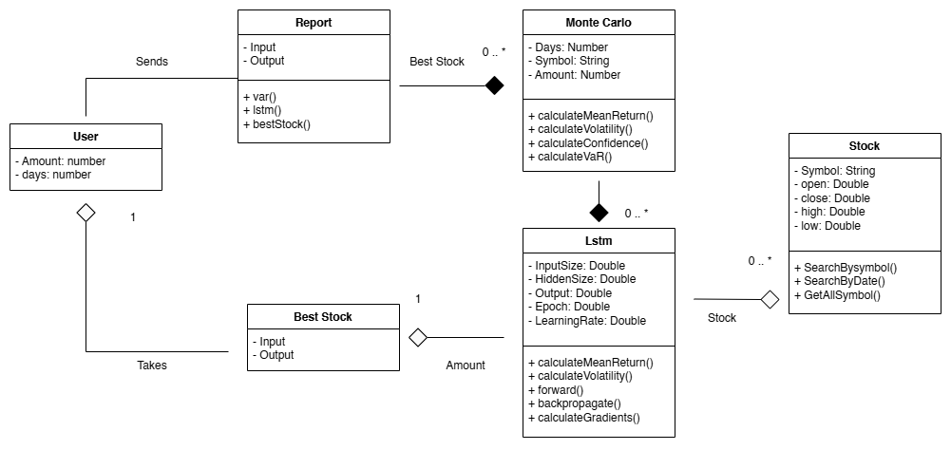
Figure 3. 2 Class Diagram of Portfolio Management

3.1.3 Dynamic Modeling
Object modeling focuses on representing the structural aspects of a system, highlighting the classes, their attributes, and the relationships between them. In contrast to dynamic modeling, which emphasizes the behavior and sequencing of operations, object modeling provides a comprehensive blueprint of how different components of the system interact.

For the Portfolio Management System, object modeling illustrates how the various class User, Stock, Prediction (LSTM), and Risk Assessment (Monte Carlo collaborate to fulfill the application's objectives. The User class initiates the process by inputting investment details, while the Stock class manages and provides historical stock data. The Prediction (LSTM) class utilizes this data to forecast future stock prices, which are then analyzed by the Risk Assessment (Monte Carlo) class to calculate the Value at Risk (VaR) based on the predicted outcomes.

The interactions among these classes are crucial, as they define the flow of data and responsibilities within the system. For instance, the User class retrieves stock information from the Stock class, and the Prediction (LSTM) class relies on the historical data provided by the Stock class to generate forecasts. Following the predictions, the Risk Assessment (Monte Carlo) class assesses risk by processing the predictions from the LSTM model.

This object modeling approach offers a detailed representation of the system's structure, emphasizing the roles and relationships of each class. It serves as a foundational element for understanding how the Portfolio Management System operates, facilitating the design and implementation of its functionalities.
The sequence diagram for the Portfolio Management System illustrates the interactions among the key classes over time, detailing the flow from user input to output. It begins with the User, which inputs investment details, such as the amount and duration. This data prompts the System to retrieve relevant historical stock information from Database. Next, the model uses this data to forecast future stock prices based on the user’s parameters. Once predictions are made, data is evaluates the associated risks, the results predicted stock prices and their corresponding risks are presented back to the User. This sequence effectively illustrates how each class operates and interacts to fulfill the user's investment goals while assessing potential risks.

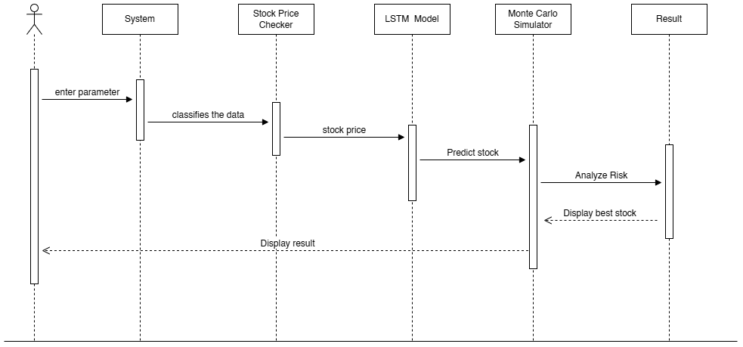
Figure 3. 3 Sequence Diagram of Portfolio Management

3.1.4 Process Modeling: Activity Diagram
An activity diagram serves as a flowchart that represents the sequence of activities within the Portfolio Management System, illustrating the dynamic aspects of the process. This diagram outlines the workflow that occurs when a user enters investment parameters, such as the stock symbol and duration. It begins with the user inputting these parameters, after which the system checks the relevant data from the database. Subsequently, the model analyzes the dataset, which involves training and testing the data to ensure accuracy. This includes processing the model to make predictions based on the historical stock data provided. Finally, the system displays the results to the user, providing insights into stock predictions and associated risks. This activity diagram effectively visualizes the overall flow of operations and interactions within the system, facilitating a better understanding of the user experience and backend processes.

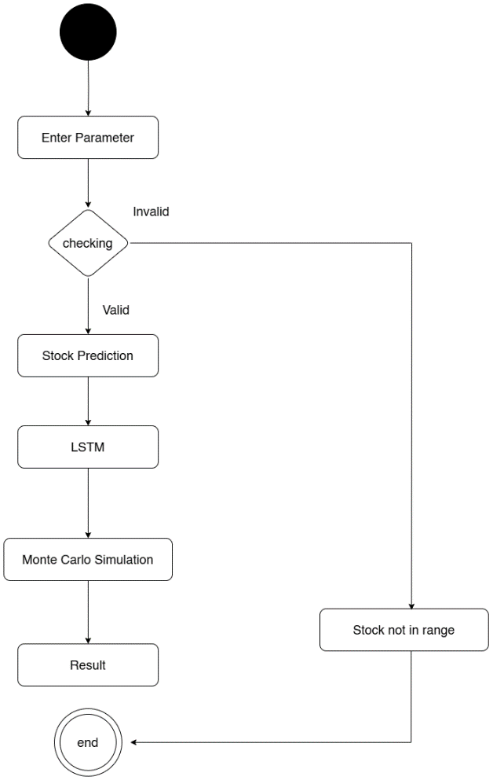
Figure 3. 4 Activity Diagram of Portfolio Management

3.2 System Design
The system design phase is crucial for transforming the requirements and specifications gathered during the earlier stages into a robust architecture for the Portfolio Management System. This phase encompasses the definition of the system's architecture, components, modules, interfaces, and data to fulfill the specified requirements effectively.

3.2.1 Architectural Design
The Portfolio Management System employs a three-tier architecture comprising the client tier, web tier, and database tier:
- Client Tier: Refers to users accessing the system via a web browser.
- Web Tier: Built using Java Spring Boot for backend logic and Core JS, HTML, and CSS for frontend presentation. This tier handles user requests and integrates machine learning predictions.
- Database Tier: Utilizes MySQL for data storage, efficiently managing user data, stock information, and prediction results.

3.2.2 Deployment Diagram
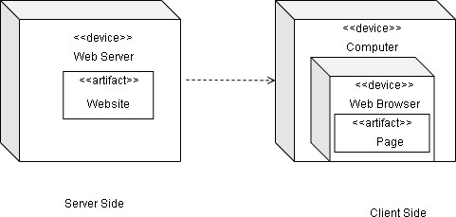
A deployment diagram illustrates the execution architecture of the system, showcasing how various components are deployed and interact with each other. The deployment diagram for the Portfolio Management System consists of two primary nodes: the server side and the client side.
Figure 3. 5 Deployment Diagram of Portfolio Management

3.3 Algorithm Details

LSTM Algorithm
Long Short-Term Memory (LSTM) networks are a type of recurrent neural network (RNN) that is capable of learning long-term dependencies, especially useful for time series forecasting tasks. Here's an overview of the steps involved in an LSTM model:
1. Data Preprocessing:
- Step 1: Collect and Prepare Data:
  - Time-series data, such as stock prices or returns, is collected.
  - Preprocessing is done to handle missing values, and relevant features are selected.
- Step 2: Normalization:
  - Data is normalized between 0 and 1 (or -1 to 1) using Min-Max Scaling:
x′=max(X)−min(X)x−min(X)​
  - Normalization ensures that the data scales appropriately for training.
Table 3. 1 Before Normalization
Stock | Value Before Normalization
NTC | 903.25
UNL | 49500.00

Table 3. 2 After Normalization
Stock | Value After Normalization
NTC | 0.14
UNL | 0.89

- Step 3: Train-Test Split:
  - Split the dataset into training and testing sets. This ensures that the model is trained on one portion of the data and evaluated on another.

2. LSTM Model Architecture:
- Step 1: Input Layer:
  - The input to the LSTM model is typically a 3D tensor of shape (samples, timesteps, features).
  - samples: Number of samples (e.g., individual days of stock price data).
  - timesteps: Number of timesteps to look back in the series (e.g., previous 10 days).
  - features: Number of features (e.g., stock price, trading volume).
- Step 2: LSTM Layer:
  - The LSTM layer consists of memory cells that maintain a state over time. It has three main gates:
    - Forget Gate (ft​​): Decides which information to discard from the cell state.
ft​=σ(Wf​⋅[ht−1​,xt​]+bf​)
    - Input Gate (iti_tit​): Decides which new information to store in the cell state.
it​=σ(Wi​⋅[ht−1​,xt​]+bi​)
    - Output Gate (oto_tot​): Determines the output from the current cell state.
ot​=σ(Wo​⋅[ht−1​,xt​]+bo​)
These gates work together to decide which information to keep or forget at each time step.
- Step 3: Leaky ReLU Activation:
  - Leaky ReLU is applied as the activation function after each gate. For any input xxx:
Leaky ReLU(x)={ x if x>0
αx​ if x≤0​
​ This allows small negative gradients, preventing neurons from "dying."
3. Forward Pass:
- Step 1: Passing Through the LSTM Cells:
  - The data is passed through the LSTM network cell by cell, and the hidden state hth_tht​ is updated based on the information from the current input xtx_txt​ and the previous hidden state ht−1h_{t-1}ht−1​.
  - The hidden state hth_tht​ and cell state CtC_tCt​ are updated over time.
- Step 2: Output Layer:
  - The final output of the LSTM layer is passed through a dense (fully connected) layer that outputs the predicted value (e.g., the stock price for the next day).
  - The activation function for the output layer depends on the type of problem. For regression tasks, no activation or linear activation is used.
4. Backward Pass (Backpropagation Through Time):
- Step 1: Compute Loss:
  - After making predictions, a loss function is used to compare the predicted value with the actual value (e.g., Mean Squared Error for regression tasks
Loss=N1​i=1∑N​(yi​−y^​i​)2
where yi​ is the actual value, and y^i​ is the predicted value.
- Step 2: Backpropagation Through Time (BPTT):
  - Gradients are computed for each weight using backpropagation through time. The LSTM network keeps track of its states and calculates the gradients for each time step.
  - To prevent exploding gradients, gradient clipping is applied:
∇W←clip(∇W,−threshold,threshold)
This ensures the gradients stay within a manageable range.

5. Training the LSTM:
- Step 1: Optimizer:
  - An optimizer (e.g., Adam or RMSProp) is used to update the weights and biases during training:
Wnew​=Wold​−η⋅∇W
where η is the learning rate.
- Step 2: Epochs and Batch Size:
  - The training process is repeated for a number of epochs. During each epoch, the model learns from a small batch of data at a time, making the learning process faster and more efficient.

6. Prediction and Evaluation:
- Step 1: Prediction:
  - Once the model is trained, it is used to make predictions on unseen (test) data.
  - The predicted values are denormalized (reversed to the original scale) using the min-max formula:
x=x′×(max(X)−min(X))+min(X)

- Step 2: Evaluation:
  - Performance metrics like Mean Squared Error (MSE) or Root Mean Squared Error (RMSE) are calculated to evaluate the model's accuracy:
RMSE=N1​i=1∑N​(yi​−y^​i​)2

Monte Carlo Simulation
The second algorithm integrated into the system is designed to compute the Value at Risk (VaR) using Monte Carlo simulation to assess portfolio risk.
- VaR Calculation:
  - The VaR measures the maximum potential loss of a portfolio over a specified time horizon at a given confidence level.
  - The VaR is calculated as:
VaR=Percentile(1−Confidence Level, Simulated Returns)
  - The confidence level is typically set to 95% or 99%, meaning there is a 95% chance that the loss will not exceed the VaR.

- Monte Carlo Simulation for VaR:
  - The Monte Carlo method simulates thousands of possible future portfolio returns by generating random paths for stock prices. Each path is based on historical price movements and statistical assumptions.
  - For each simulation, a random return is generated, and the portfolio value is adjusted accordingly. This provides a distribution of possible outcomes.

- Simulate Returns:
  - Returns are simulated by assuming a normal distribution of price changes
rt​=μ+σ×Zt​
where rt​ is the return at time t, μ is the expected return, σ is the standard deviation of returns, and Zt​​ is a random sample from a standard normal distribution.

- Steps for Monte Carlo Simulation:
  - Step 1: Calculate daily returns from historical price data.
  - Step 2: Simulate stock prices for future days using the random normal returns.
  - Step 3: For each simulated path, calculate the portfolio value at the end of the time period.
  - Step 4: Sort the simulated portfolio values and compute the VaR as the percentile corresponding to the chosen confidence level.

Technical Analysis Indicators
- Input data: OHLC(V) time series per symbol.
- Use in system:
  - Computed for chart overlays (TradingChartService).
  - Selected indicators augment the LSTM feature vector (LstmService, DataPreprocessor.addFeatures).
  - Warm-up periods are dropped to avoid NaNs; periods adapt to available history for numerical stability.
- Simple Moving Average (SMA)
- Definition: Arithmetic mean of closing prices over N periods.
- Formula: SMA_t(N) = (1/N) × Σ_{i=0..N−1} Close_{t−i}
- Typical N: 10, 20, 50, 200
- Use: Trend smoothing, crossover signals, mean reference for Bollinger Bands.

- Exponential Moving Average (EMA)
  - Definition: Recency-weighted average with smoothing multiplier k = 2/(N+1).
  - Formula:
  - k = 2/(N+1)
  - EMA_t = k × Close_t + (1 − k) × EMA_{t−1}
  - Initialization: EMA_{N} = SMA_N
  - Typical N: 12, 26, 50
  - Use: Faster trend response than SMA; basis for MACD.

- Relative Strength Index (RSI, Wilder)
  - Definition: Momentum oscillator of average gains vs. losses over N.
  - Intermediate:
  - Gain_t = max(Close_t − Close_{t−1}, 0)
  - Loss_t = max(Close_{t−1} − Close_t, 0)
  - AvgGain_t = [(AvgGain_{t−1} × (N−1)) + Gain_t] / N
  - AvgLoss_t = [(AvgLoss_{t−1} × (N−1)) + Loss_t] / N
  - RS_t = AvgGain_t / AvgLoss_t (define RSI_t = 100 when AvgLoss_t = 0)
  - Formula: RSI_t = 100 − 100 / (1 + RS_t)
  - Typical N: 14
  - Use: Momentum; overbought/oversold regimes; divergence

- Moving Average Convergence Divergence (MACD)
  - Definition: Trend–momentum indicator from EMA spreads.
  - Formula:
    - MACD_t = EMA_fast(Close)_t − EMA_slow(Close)_t
    - Signal_t = EMA_signal(MACD)_t
  - Histogram_t = MACD_t − Signal_t
  - Typical params: fast=12, slow=26, signal=9
  - Use: Crossovers and histogram inflections for momentum shifts.

- Bollinger Bands (BB)
  - Definition: Volatility bands around SMA using standard deviation over N.
  - Formula:
    - Middle_t = SMA_N(Close)_t
    - σ_t = StdDev_N(Close)_t
    - Upper_t = Middle_t + m × σ_t
    - Lower_t = Middle_t − m × σ_t
  - Typical params: N=20, m=2
  - Use: Volatility, mean-reversion/extremes, band squeezes/expansions.

- Average True Range (ATR, Wilder)
  - Definition: Volatility measure based on True Range (TR).
  - True Range:
  - TR_t = max(High_t − Low_t,|High_t − Close_{t−1}|,|Low_t − Close_{t−1}|)
  - ATR smoothing:
    - ATR_t = [(ATR_{t−1} × (N−1)) + TR_t] / N
  - Typical N: 14
  - Use: Stop sizing, regime volatility, risk context for VaR.

- Stochastic Oscillator
  - Definition: Momentum oscillator locating Close within recent high–low range.
  - Formula:
    - LowestLow_N = min(Low_{t−i}, i=0..N−1)
    - HighestHigh_N = max(High_{t−i}, i=0..N−1)
    - %K_t = 100 × (Close_t − LowestLow_N) / (HighestHigh_N − LowestLow_N)
    - %D_t = SMA_M(%K)_t (smoothing)
  - Typical params: N=14, M=3 (slow %D often adds another 3-period smoothing)
  - Use: Overbought/oversold, momentum turns, divergence.

CHAPTER 4

IMPLEMENTATION AND TESTING

4.1 Implementation

4.1.1 Tools Used (CASE tools, Programming languages, Database platforms)

4.1.1.1 Frontend Tools
CSS: CSS is used to style the user interface, controlling layout, colors, fonts, and spacing. It ensures the web pages are visually appealing and responsive on different devices.
JavaScript: JavaScript is utilized to handle client-side interactions, manage state, and dynamically update the UI based on the data received from the backend. It also helps with fetching data from the Java Spring Boot APIs and updating the web pages without requiring a full page reload.

4.1.1.2 Backend Tools
Java Spring Boot: Spring Boot is used as the backend framework for the application. It provides RESTful APIs that handle user requests, process the LSTM predictions and Monte Carlo simulations, and interact with the MySQL database. The Spring Boot application also manages the routes to support various operations such as stock prediction, risk analysis (VaR), and data persistence.
MySQL: MySQL serves as the relational database system used to store historical stock data, LSTM predictions, and Monte Carlo simulation results. It is used for managing dynamic tables based on stock symbols, user input, and portfolio details.

4.1.2 Core Features Implementation

LSTM Algorithm Implementation
Forward Passing & Backward Passing: The LSTM model is used to predict stock prices by learning from historical time-series data. In the backend, this is implemented as part of the machine learning process. The prediction model is trained and then used to provide forecasts for the next day's stock prices.
Activation Function: The LSTM model uses the Leaky ReLU activation function in the hidden layers to introduce non-linearity and better capture stock price trends.
Normalization (Min-Max Scaling): All stock prices and input data are normalized between 0 and 1 to ensure that the LSTM model performs well and converges faster.
Prediction and De-Normalization: After predictions are made, they are de-normalized back to the original price scale using the calculated minimum and maximum values for accurate real-world interpretation.

Monte Carlo Simulation
Simulated Returns: The Monte Carlo simulation is used to generate multiple possible future price paths based on historical volatility and mean returns. This is done using the random sampling of returns and the Geometric Brownian Motion model.
Confidence Level Calculation: After simulating thousands of future price scenarios, the Value at Risk (VaR) is calculated for a given confidence level (e.g., 95%). This allows the user to see the potential downside risk of the portfolio over the selected time period.

Technical Indicators and Charting
Server-side computation: Indicators are computed on-demand using Technical Indicators with adaptive periods to avoid sparse-sample bias and warm-up NaNs.
Data returned with OHLC plus SMA/EMA, MACD (line, signal, histogram), RSI, Bollinger Bands (upper/middle/lower), ATR, and Stochastic (%K/%D) for chart overlays. Visualization: Indicators are rendered as interactive overlays/panels in the client to complement LSTM predictions and VaR outputs.

Feature Engineering for LSTM
Indicator features: augments the input with trend, momentum, and volatility features (e.g., SMA/EMA ratios, MACD, RSI, BB width, ATR normalized by price, %K/%D).
Normalization: applies min–max scaling; non-finite values are sanitized and warm-up rows (insufficient lookback) are dropped before training/inference.
Stability: Guarded divisions (e.g., RSI, %K) and clamped outputs ensure numerical stability across symbols with short histories.

Client Module:
This module represents the front-end part of the system, designed using core JavaScript, HTML, CSS, and Thymeleaf templates. It consists of several directories and files that collectively define the user interface and handle interactions.

Server Module:
This module is dedicated to the backend logic of the system, built using Java Spring Boot. It handles user authentication and registration, validating and saving user data to a MySQL database. The server also manages authorization based on user roles, ensuring secure access to various functionalities.
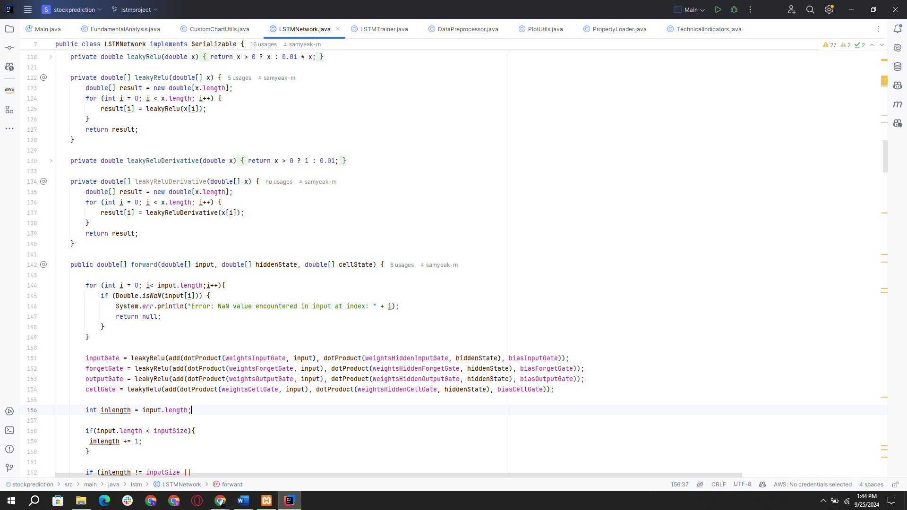
When a user wants to manage their investment portfolio, the server processes the user's input, including stock symbol and duration. It communicates with the machine learning model deployed in a java spring boot application to analyze stock data using the LSTM algorithm and Monte Carlo simulation for Value at Risk (VaR). This analysis helps determine which stocks are likely to yield positive returns, filtering the options based on their VaR in ascending order. The results are then sent back to the frontend for the user to review.
Figure 4. 1 Using Lstm, TechnicalIndicators and Monte Carlo

Figure 4.1, After the dataset is obtained, it is processed to split the features and target variables. The feature set X excludes the target parameter, while Y denotes the target parameter. The dataset is then divided into training and testing sets, resulting in X_train, X_test, y_train, and y_test. The model uses an LSTM architecture implemented with a custom leaky ReLU activation function. This activation function is applied across arrays, ensuring that all inputs are processed correctly, The LSTM also includes derivatives for backpropagation, utilizing the leaky ReLU derivative. The forward method processes the input through the LSTM gates, checking for NaN values and calculating the input, forget, output, and cell gates using the leaky ReLU activation function. After training the model using the training set, predictions are generated for the test set. The model’s performance is then evaluated based on accuracy and other metrics. The results, alongside the calculated Value at Risk (VaR), help in identifying stocks that meet the user's investment criteria.
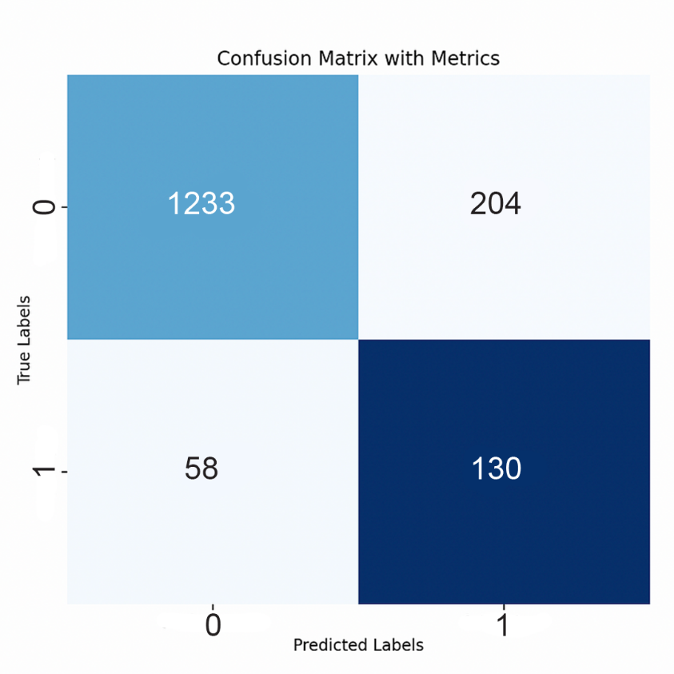
Figure 4.2, The confusion matrix serves as a vital analytical tool for evaluating classification models, particularly in binary classification tasks such as predicting stock price movements. It categorizes predictions into two distinct classes: Class 0, which represents the "negative" class, indicating instances where the model predicts that the stock price will not rise or will decrease, and Class 1, defined as the "positive" class, where the model predicts that the stock price will rise. The matrix breaks down the model's predictions into four key components: True Positives (TP), which are the instances where the model correctly predicts that the stock will rise (Class 1); True Negatives (TN), where the model accurately predicts that the stock will not rise (Class 0); False Positives (FP), which occur when the model incorrectly predicts an increase (Class 1) when the stock does not rise; and False Negatives (FN), which happen when the model fails to predict a rise (Class 0) when the stock actually does increase.From these components, we derive important metrics that provide insights into the model’s effectiveness. Precision is calculated using the formula
Figure 4. 2 Generating Confusion Matrix for Portfolio Management
Precision= True Positives (TP) ​/ True Positives (TP)+False Positives (FP)
which measures the accuracy of the model's positive predictions. High precision indicates that when the model predicts a stock will rise, it is likely correct. Recall, defined as
Recall= True Positives (TP)​/True Positives (TP)+False Negatives (FN)
evaluates the model's ability to identify all actual positive cases, highlighting how many true stock increases were correctly predicted. The F1-score, which combines precision and recall, is given by the formula
F1-Score=2×( Precision×Recall​/Precision+Recall)
This metric provides a balanced assessment of the model's performance. Together, these metrics illuminate areas for improvement and validate the model's ability to effectively predict stock behavior, ensuring that our trading strategies are based on robust and accurate analyses.

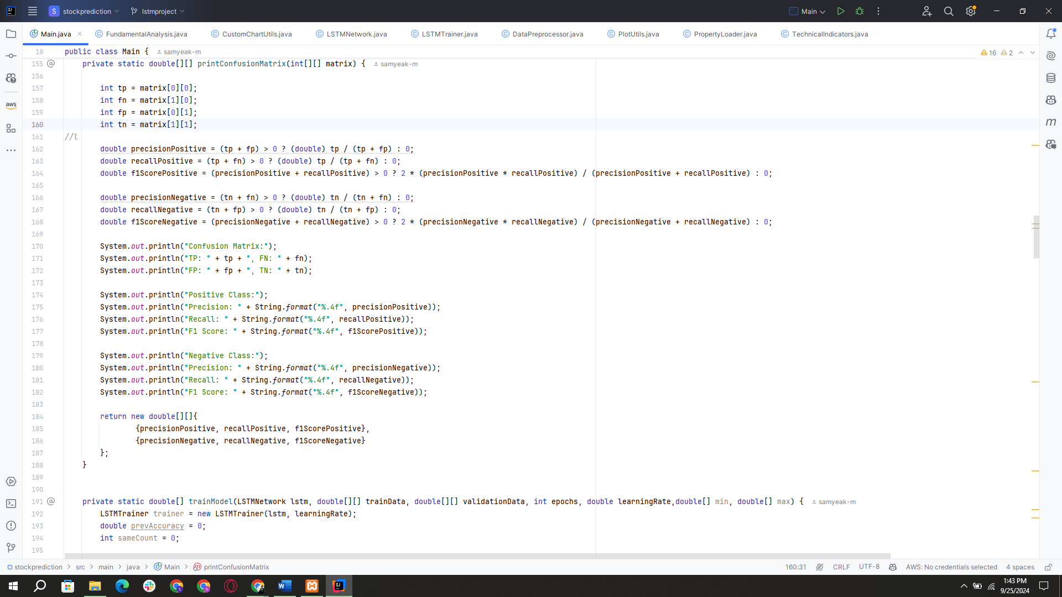
Figure 4.3, the confusion matrix function is utilized to generate a confusion matrix by taking two parameters: y_test and y_pred_Test. In this system, the labels are defined as 0 and 1, where 1 indicates the presence of a specific parameter and 0 indicates its absence. Predict Direction predicts the price movement based on input data, while compute Confusion Matrix calculates the confusion matrix based on the predictions and actual directions. Finally, the labels are added and updated to "True label" and "Confusion Matrix," respectively. The code loops over the data dimensions to create text annotations. The confusion matrix is then displayed using the show function.
Figure 4. 3Code for Generating confusion matrix

4.2 Testing

Testing is the process of detecting errors and plays a critical role in quality assurance, ensuring the reliability of software. The results of testing are also used during maintenance.

4.2.1 Test Cases of Unit Testing
Unit Testing is a software development process in which the smallest testable parts of an application, called units, are individually and independently scrutinized for proper operation. The system contains various components that are tested. Some of the test cases include:
Table 4. 1 Investment Interface
SN | Action | Input | Output | Accuracy
1 | Launch Application | Localhost:8080/investment | Stock checking page | -
2 | Submit without entering anything | Null | Please fill all the fields | -
3 | Submit stock symbol only | stock: ntc  No of Days: Null | Please fill days fields | -
4 | Submit all values | stock: adbl  No of Days: 50 | Display result | 84%

4.3.1 Evaluating Accuracy
In machine learning, accuracy is a common metric used to evaluate the performance of a model. Accuracy measures the proportion of correctly classified instances among all the instances in the dataset. To calculate accuracy, the first step is to divide the dataset into two parts: a training set and a test set. The training set is used to train the model while the testing set is used to evaluate the model’s performance. In this project, the most common measures to evaluate accuracy are:
Precision: Precision is a measure of how many of the predicted positive instances are actually true positives. In the context of stock market prediction, precision tells you the ratio of correctly predicted positive cases (true positives) to all instances that were predicted as positive (true positives + false positives). A high precision indicates that when the model predicts a positive case, it is likely to be correct.
Recall (Sensitivity): Recall is a measure of how many of the actual positive instances were correctly predicted by the model. In this context, recall tells you the ratio of correctly predicted positive cases (true positives) to all actual positive cases (true positives + false negatives). A high recall indicates that the model is effectively capturing a large portion of positive cases.

F1-Score: The F1-score is a balanced metric that takes into account both precision and recall. It is the harmonic mean of precision and recall. The F1-score provides a single value that balances the trade-off between precision and recall, particularly useful when considering both false positives and false negatives in your evaluation.
Accuracy: Accuracy is a measure of the overall correctness of the model's predictions. It calculates the ratio of correctly predicted instances to the total number of instances. However, it might not be the best metric when dealing with imbalanced datasets.
In this project, which focuses on predicting stock prices and assessing investment risks, the F1-score has emerged as the most critical metric. Given the high stakes involved in financial predictions, misclassifying a positive instance—such as incorrectly predicting a stock's potential rise—can lead to significant financial losses. Therefore, both precision and recall are vital in this context.

High precision ensures that when the model predicts a stock will perform well, it is likely to do so, thereby minimizing costly false alarms. Meanwhile, high recall guarantees that most stocks with genuine potential are identified, reducing the risk of missing out on profitable opportunities.
By optimizing for the F1-score, a balanced evaluation of the model's performance can be achieved, effectively managing the trade-offs between precision and recall. This balance is essential for presenting users with reliable stock predictions while also addressing associated risks. Ultimately, focusing on the F1-score enables the development of a robust model that is well-suited for the complexities of financial forecasting.

4.3.1 .1 Evaluating Accuracy of LSTM
Figure 4. 5 LSTM Stock prediction Report
Logistic Regression Stock market Prediction Report
 | Precision | Recall | F1-score
0 | 0.86 | 0.96 | 0.90
1 | 0.96 | 0.86 | 0.91
Accuracy |  |  | 0.84

CHAPTER 5

CONCLUSION AND FUTURE RECOMMENDATION

5.1 Conclusion
The project “Stock Portfolio Management System” leverages the LSTM algorithm and Monte Carlo simulation for Value at Risk (VaR) to guide users in making informed investment decisions. By allowing users to specify an stock symbol and a time duration. The integration of LSTM enables accurate predictions of stock performance, while the VaR analysis provides a method for assessing risk, thereby enhancing the reliability of stock selection. Although the current accuracy of predictions is satisfactory, there remains potential for improvement in prediction accuracy and user experience.

5.2 Lessons Learned/Outcomes

Throughout the development of the application, several challenges emerged, particularly in managing time and mastering the technologies involved, such as Java Spring Boot, MySQL, and the frontend technologies (Core JS, HTML, CSS). These experiences highlighted the importance of effective time management and the necessity of a strong foundational knowledge in programming. Despite not achieving all initial objectives, the project has laid the groundwork for future enhancements. The author aims to refine the application further and enhance its usability and competitiveness.

5.3 Future Recommendations

To bolster the capabilities of the “Stock Portfolio Management System,” the following enhancements are recommended:
- Algorithm Improvement: Incorporate additional machine learning algorithms, such as Random Forest and other deep learning models, to enhance the accuracy of predictions. These algorithms can complement the existing LSTM model by capturing a broader range of data relationships.
- User Interface Enhancements: Focus on improving the user interface to make the application more intuitive and user-friendly, which could increase user engagement and satisfaction.
- Extended Features: Consider implementing features such as real-time data updates, personalized investment recommendations, and risk assessment tools that would provide users with a comprehensive overview of their investment portfolio.
By pursuing these recommendations, the system can evolve into a more robust tool for managing stock investments and mitigating risks effectively.

REFERENCES

[1] S. Hochreiter and J. Schmidhuber, “Long Short-Term memory,” Neural Computation, vol.9, no.8, pp. 1735–1780, Nov. 1997, doi: 10.1162/neco.1997.9.8.1735.
[2] D. N. S. S. Liyanage, G. V. M. P. A. Fernando, D. D. M. M. Arachchi, R. D. D. T. Karunathilaka, and A. S. Perera, “Utilizing Intel Advanced Vector Extensions for Monte Carlo Simulation based Value at Risk Computation,” Procedia Computer Science, vol. 108, pp. 626–634, Jan. 2017, doi: 10.1016/j.procs.2017.05.156.
[3] M. Mythily, A. S. A. Raj, and I. T. Joseph, “An analysis of the significance of spring boot in the market,” 2022 International Conference on Inventive Computation Technologies (ICICT), Jul. 2022, doi: 10.1109/icict54344.2022.9850910.
[4] D. Flanagan and P. Ferguson, JavaScript: The Definitive Guide. 1996. Available: https://ci.nii.ac.jp/ncid/BA38327492
[5] S. Gupta, G. E. Kaiser, P. Grimm, M. F. Chiang, and J. Starren, “Automating content extraction of HTML documents,” World Wide Web, vol. 8, no. 2, pp. 179–224, Jun. 2005, doi: 10.1007/s11280-004-4873-3.
[6] B. Frain, Responsive Web Design with HTML5 and CSS3, 3rd ed. Birmingham, UK: Packt Publishing, 2020.
[7] J. Erickson, K. Lyytinen, and K. Siau, “Agile modeling, agile software development, and extreme programming,” Journal of Database Management, vol. 16, no. 4, pp. 88–100, Oct. 2005, doi: 10.4018/jdm.2005100105.
[8] X. Pang, Y. Zhou, P. Wang, W. Lin, and V. Chang, “An innovative neural network approach for stock market prediction,” The Journal of Supercomputing, vol. 76, no. 3, pp. 2098–2118, Jan. 2018, doi: 10.1007/s11227-017-2228-y.
[9] P. Domingos and M. Pazzani, “On the optimality of the simple Bayesian classifier under zero-one loss,” Machine Learning, vol. 29, no. 2-3, pp. 103-130, 1997.
[10] D. Zhang and L. Zhou, “Discovering golden nuggets: data mining in financial application,” IEEE Transactions on Systems, Man, and Cybernetics - Part C: Applications and Reviews, vol. 34, no. 4, pp. 513-522, 2004.
[11] C. T. Tsai and S. C. Hsiao, “Combining multiple feature selection methods for stock prediction: A hybrid approach,” Decision Support Systems, vol. 54, no. 2, pp. 1265–1275, 2013.
[12] H. White, “Economic prediction using neural networks: The case of IBM daily stock returns,” IEEE Transactions on Neural Networks, vol. 4, no. 5, pp. 140-145, 1994.
[13] K. Kumar and G. Ravi, “Stock price prediction using data mining and artificial neural networks,” International Journal of Engineering and Technology, vol. 3, no. 4, pp. 69-77, 2016.
[14] Patel et al., “Predicting stock market index using fusion of machine learning techniques,” Expert Systems with Applications, 2015.
[15] Fischer et al., “Deep learning with long short-term memory networks for financial market predictions,” European Journal of Operational Research, 2018.
[16] Chong et al., “Deep learning networks for stock market analysis and prediction,” Expert Systems with Applications, 2017.
[17] Shah et al., “Stock market analysis: A review and taxonomy of prediction techniques,” International Journal of Financial Studies, 2019.
[18] Rather et al., “Recurrent neural network and a hybrid model for prediction of stock returns,” Expert Systems with Applications, 2015.
[19] Bao et al., “A deep learning framework for financial time series using LSTM and wavelet transforms,” Neurocomputing, 2019.
[20] Kumar et al., “Sentiment analysis and deep learning-based stock price prediction system,” International Journal of Recent Technology and Engineering, 2019.
[21] Qiu et al., “Application of artificial neural networks for real-time stock market predictions,” Journal of International Technology and Information Management, 2015.
[22] Shynkevich et al., “Forecasting price movements using technical indicators,” Neurocomputing, 2017.
[23] Krauss et al., “Deep reinforcement learning for algorithmic trading,” The Journal of Finance and Data Science, 2022.

APPENDICES

