**Step1.**

lsusb

Find PL2303 check it’s working

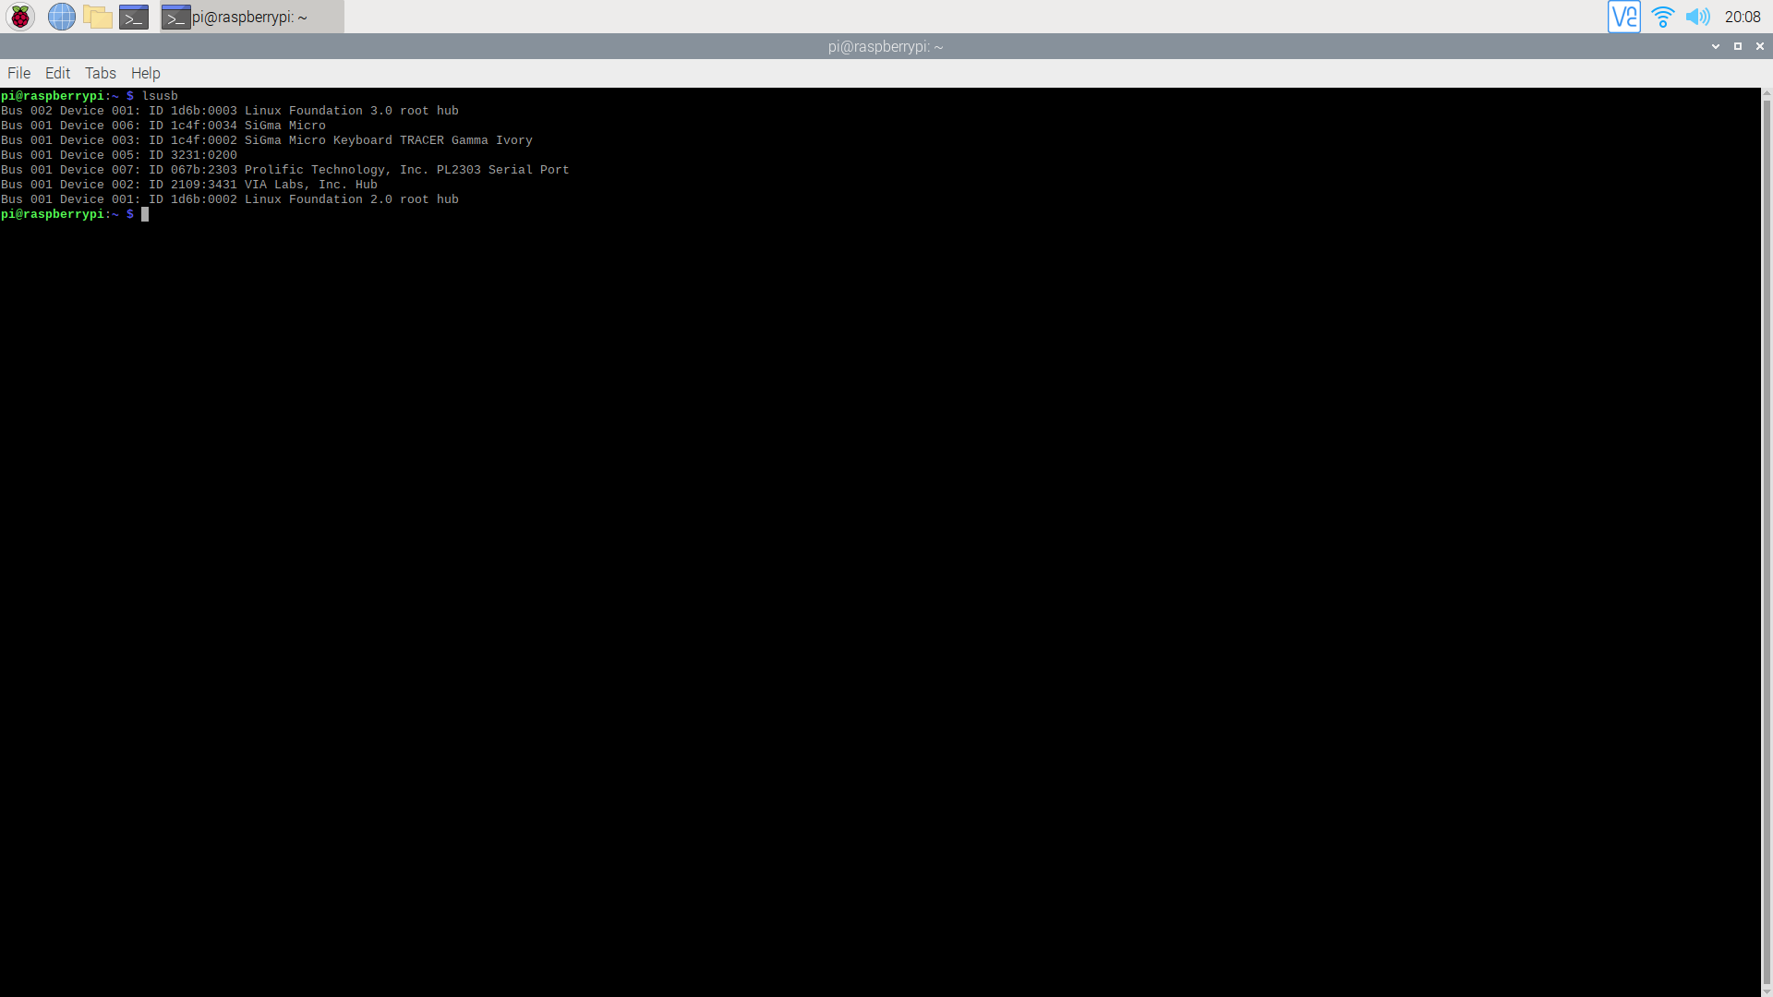

**Step2.**

Dmesg | grep tty

Check pl2303 attached port now is ttyUSB0

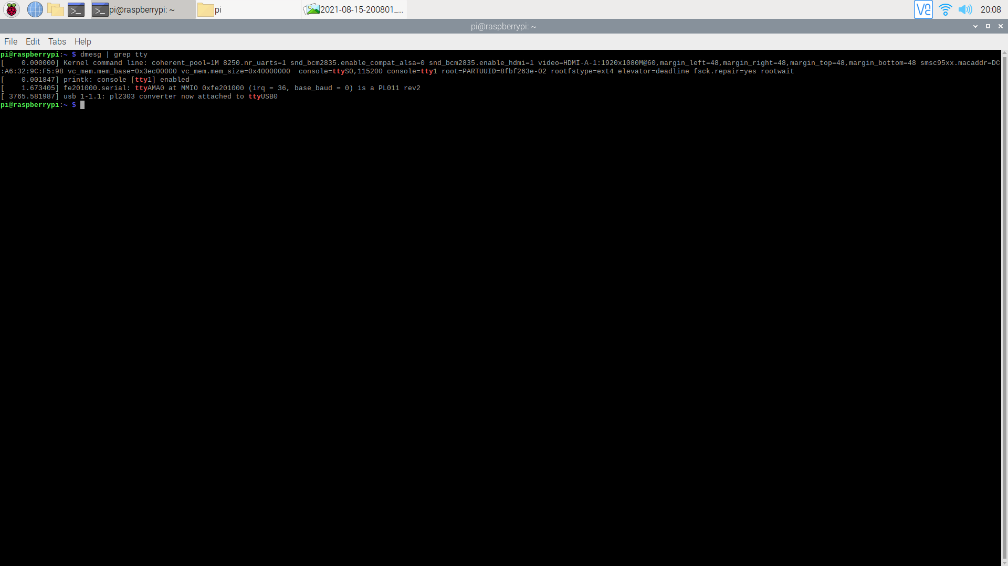

**Step3.**

If get the “ttyUSB1” should correct the erro

ser = serial.Serial('/dev/ttyUSB0',9600)

ser = serial.Serial('/dev/ttyUSB1',9600)

Note. If you want print slow ….

1. Timer
2. Sleep

葉新群HC Yeh 0928040719

Phone: 03-5797969 #8396

e-mail: [hc.yeh@u-media.com.tw](mailto:hc.yeh@u-media.com.tw)

[](http://www.u-media.com.tw/)

**宇智網通股份有限公司**

**300 新竹市金山八街一號3樓**

**U-Media Communications, INC.**

[www.u-media.com.tw](http://www.u-media.com.tw/)