Azure Front Door – DEMO

Step-by-Step Configuration

* Log in to the Azure portal at  [https://portal.azure.com](https://portal.azure.com/).
* Create an RG “azurefrontdoor-demo” on any one of the regions say “East US” wherein App Service is available for your (free?) subscription.
* Create a .Net core App Service “afd-demo-eastasia” based out “East Asia” Region.
* Create a Java App Service “afd-demo-centralusa” based out “Central US” Region.
* Note 🡪 Creating 2 app service web apps in different region to validate the local balancing and routing feature of Azure Front Door. That is, based on the location from where you access front door end, you will be routed to.
* Create Azure Front Door profile as shown below

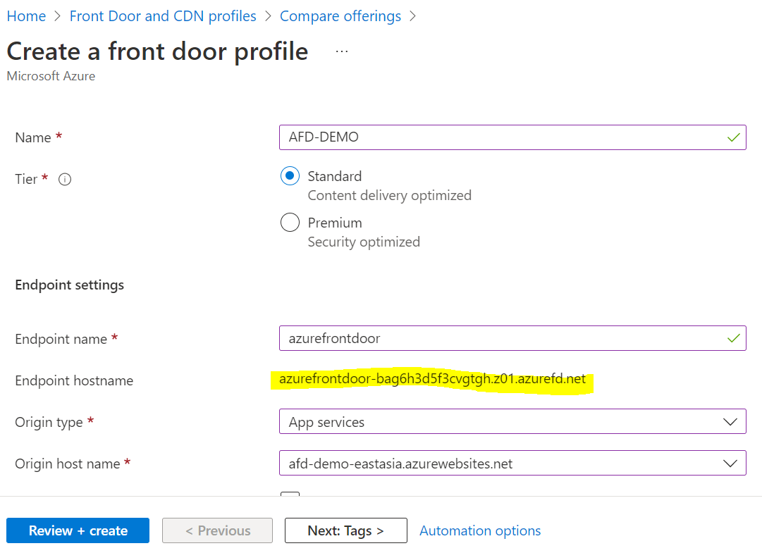

* Once its created successfully, configure it’s origin which is nothing but kind of backend pool to load balance global user traffic based on it its location.

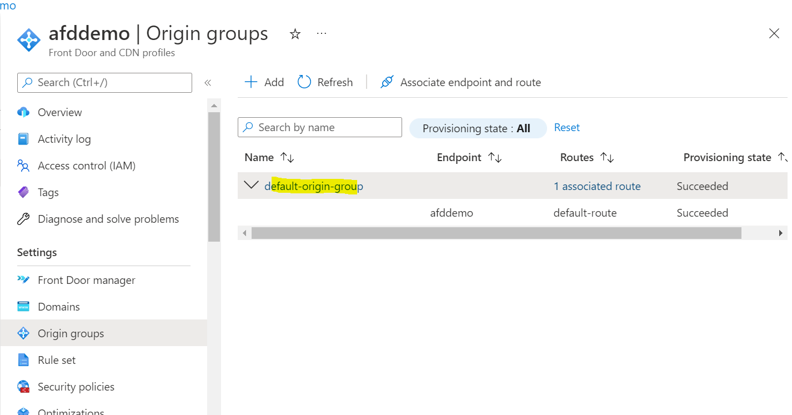

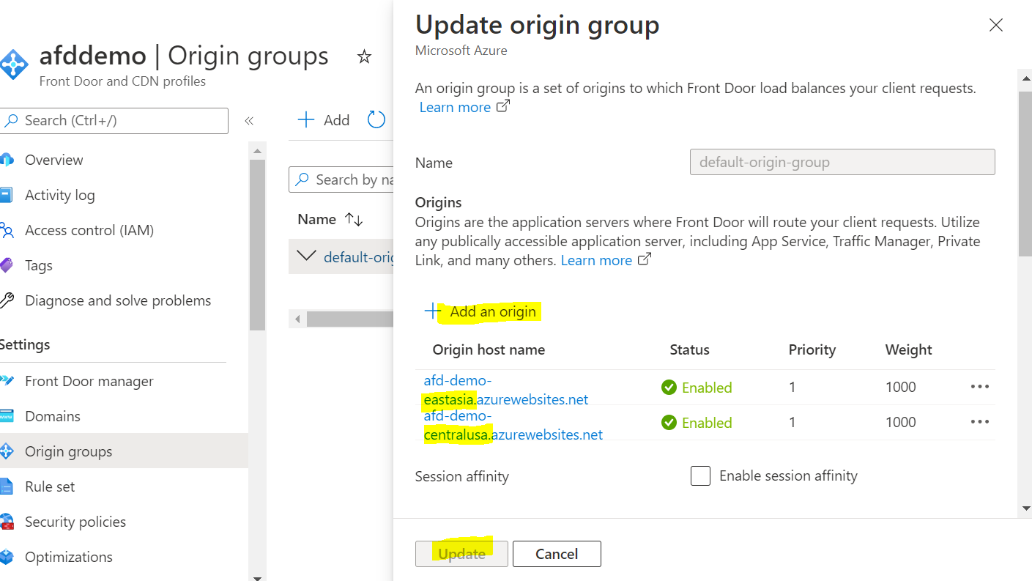

* Review the routing rules setting from “Front Door Manager”
* Now access the endpoint url of front door such as <https://afddemo-ddd7c9ewfscdacha.z01.azurefd.net/>
* You should be able to access the app service which is hosted nearby you. In this case East Asia, .net based app.

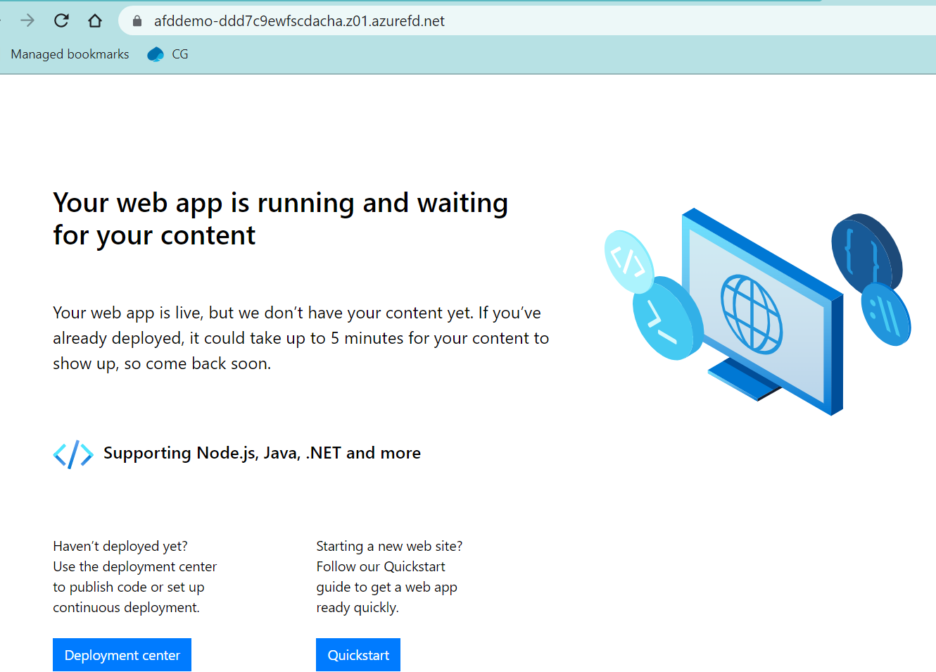

* If someone from US access it, it should show java app

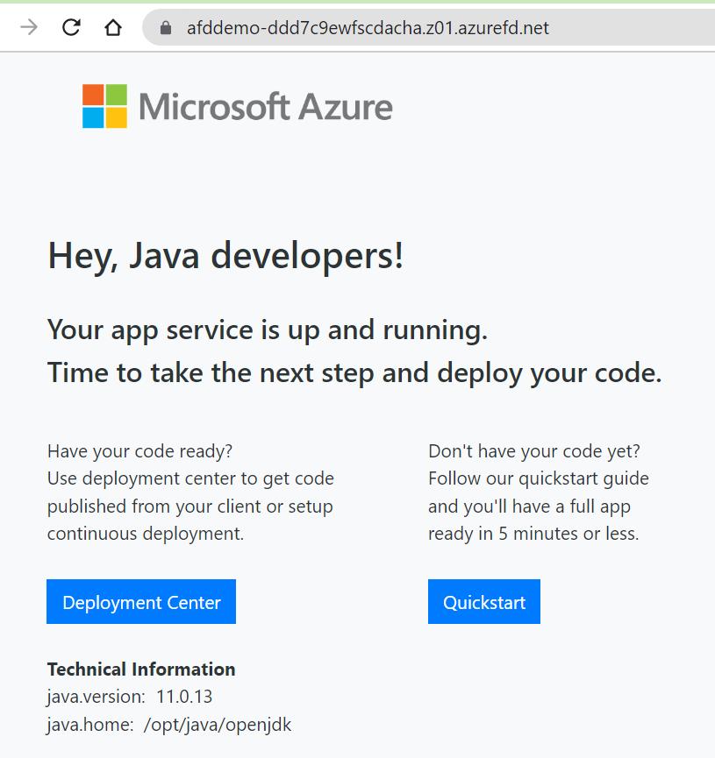

* NOTE – Load balancer working not only based on location but also availability of other app service. If you access from India and India website is busy in servicing content to other, then you may see USA website.