Networking Security Group (NSG), Host IIS WebSite – DEMO

Step-by-Step Configuration

* Log in to the Azure portal at  [https://portal.azure.com](https://portal.azure.com/).
* Create an RG “vnet_demo” on any one of the regions say “(Europe) UK South” wherein free VM is available for your (free?) subscription.
* Create a windows images based VM. Lets say “vm-nsg-demo”
* Create new inbound security rule as shown below to allow port 80 on VM “vm-nsg-demo”. So that, website hosted on this VM will be accessible.

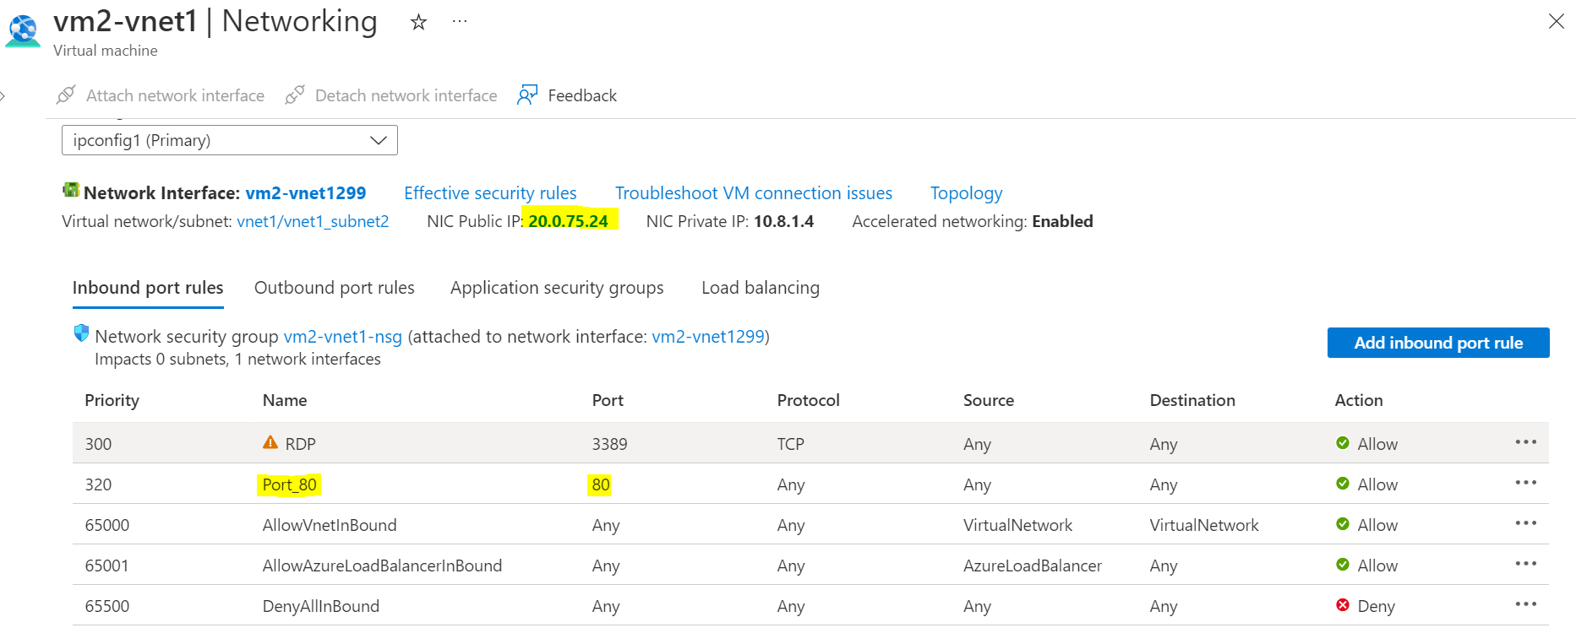

* RDP to VM “vm-nsg-demo”
  + Install IIS Server
  + Open IIS Server and Create New WebSite “demowebsite”
  + Create a sample webpage index.html and move it to “demowebsite”

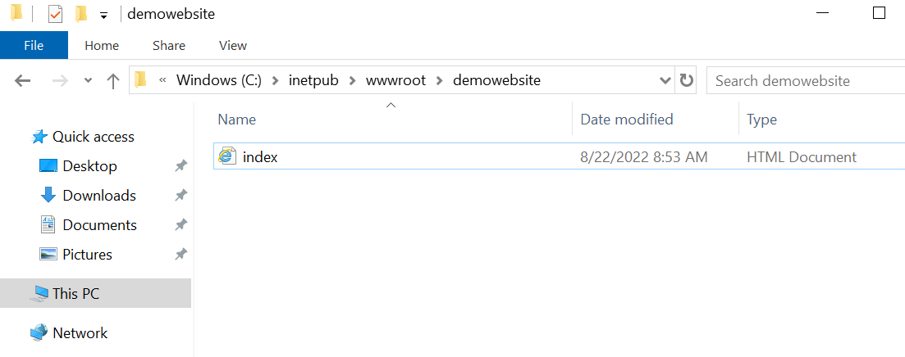

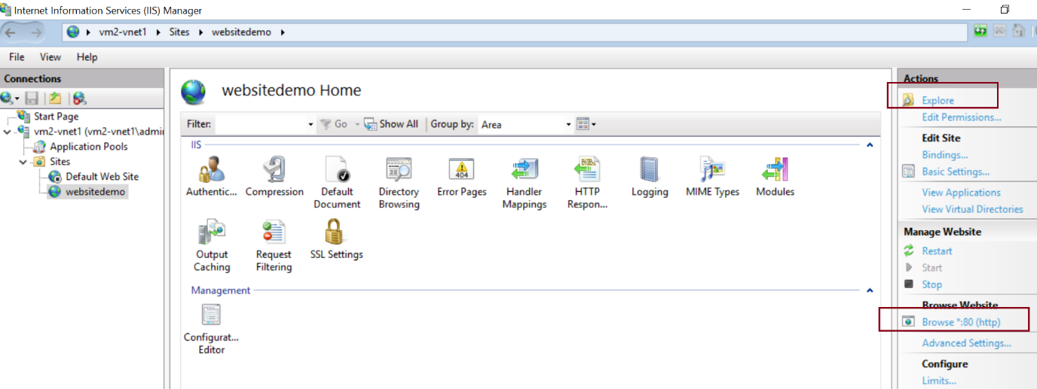

* Access the demowebsite from your PC with its public IP

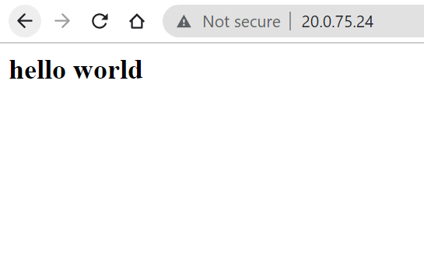

* + Remove the inbound rule and the access it. You won’t be able to.

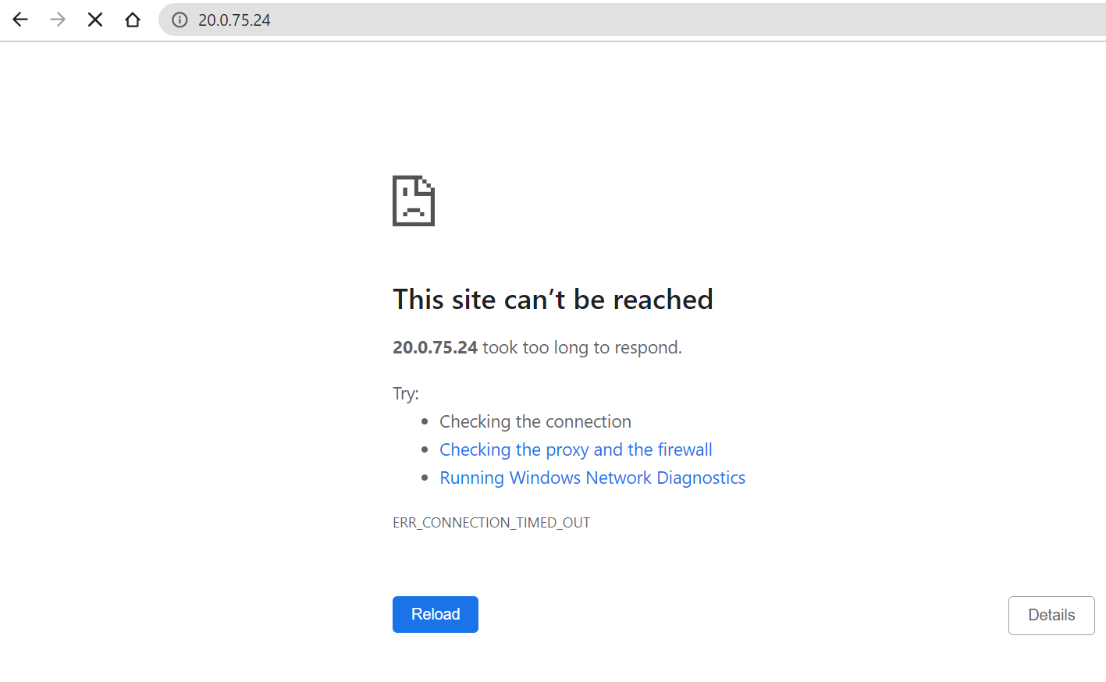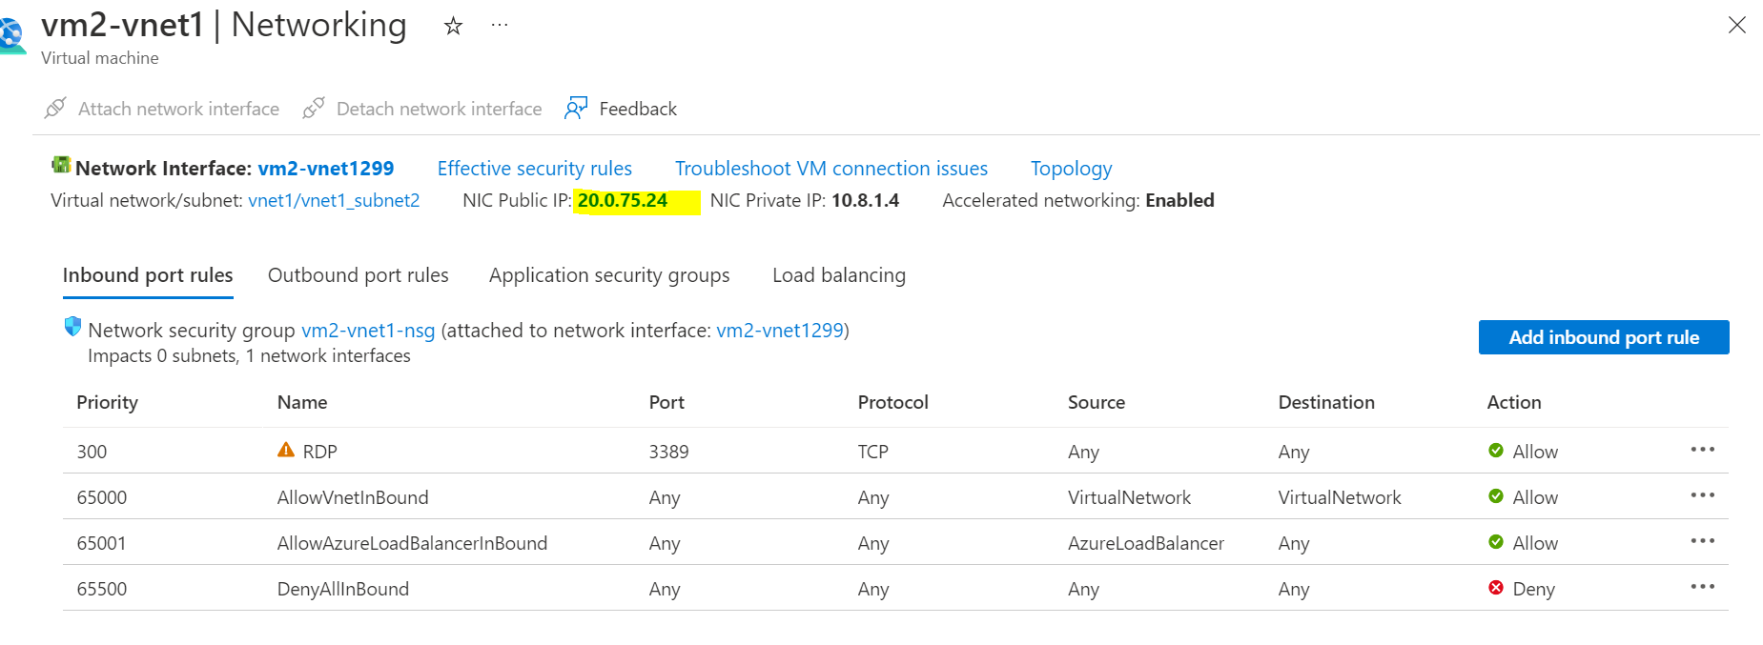

Note – Region should be same on VNET and NSG and VM