VM - VM PING
Find the IP address of Ubuntu using the ip a command
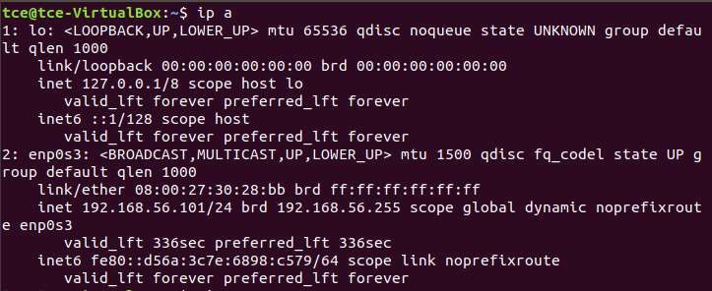

Find the IP address of Kali using the ip a command
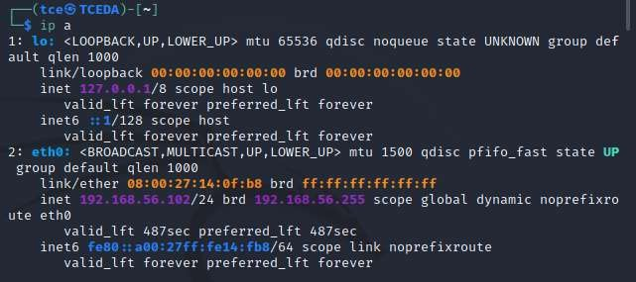
Ping Kali from Ubuntu
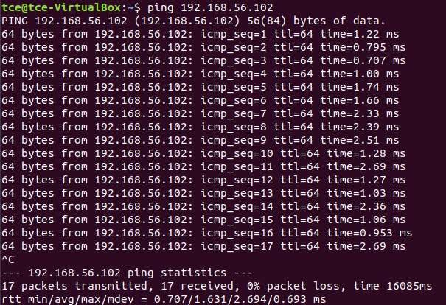

Ping Ubuntu from Kali
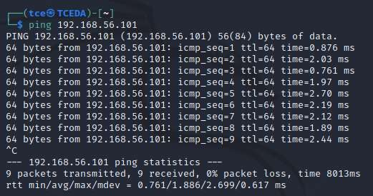

VM-NATIVE PING :
Find the IP address of Ubuntu using the ip a command
Find the IP address of Windows using the ipconfig command
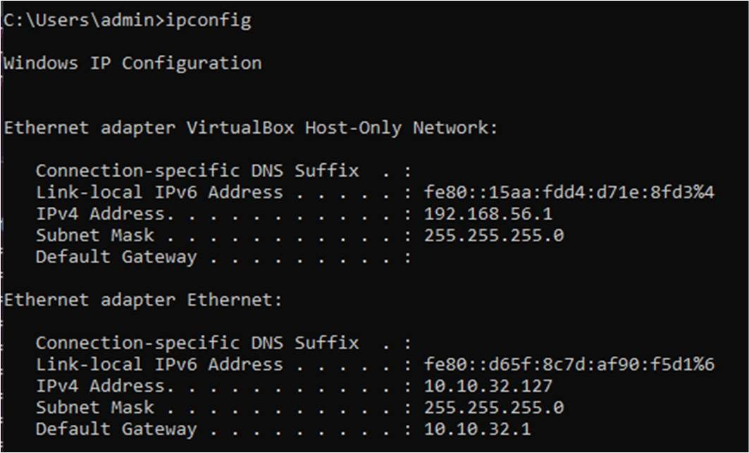

Ping Ubuntu from Windows
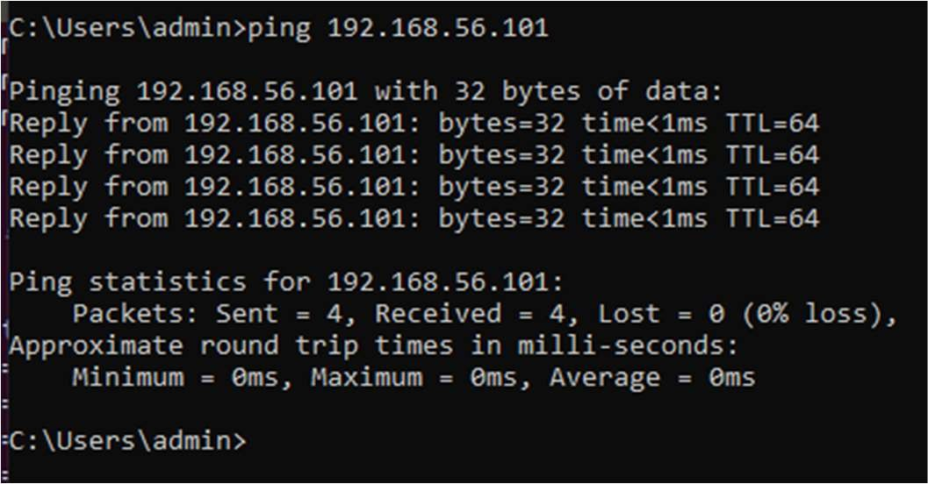

Ping Windows from Ubuntu
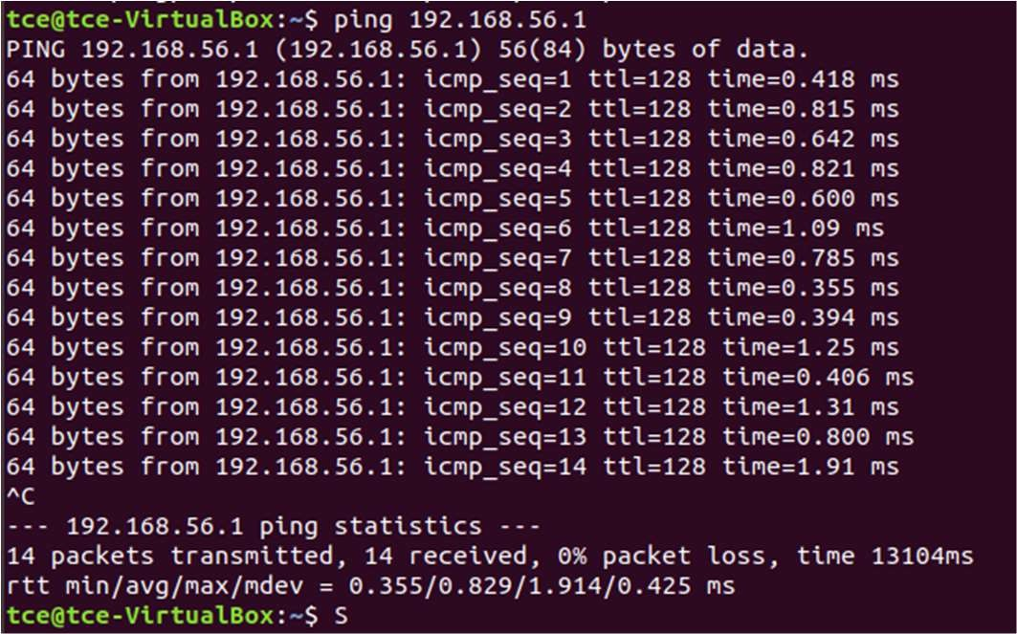

- Cold migration
- Created a java file to check whether the same file exist in vm after imported(cold migrated ) in another system.
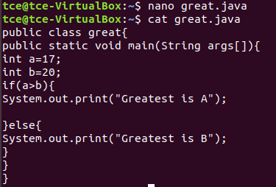
- Shut down the VM completely. Open VirtualBox and select the VM → Click File &gt; Export Appliance (or File &gt; Export OVF).
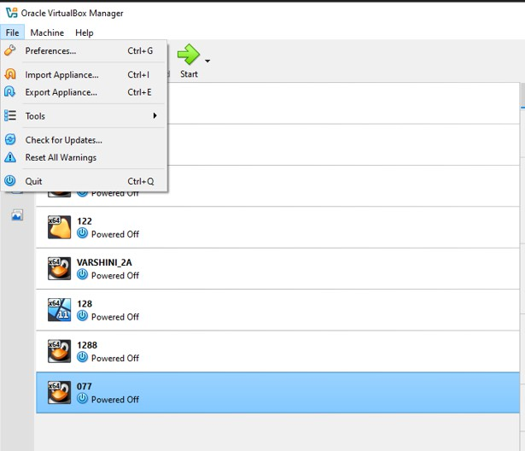
- Select the vm which you want to export.
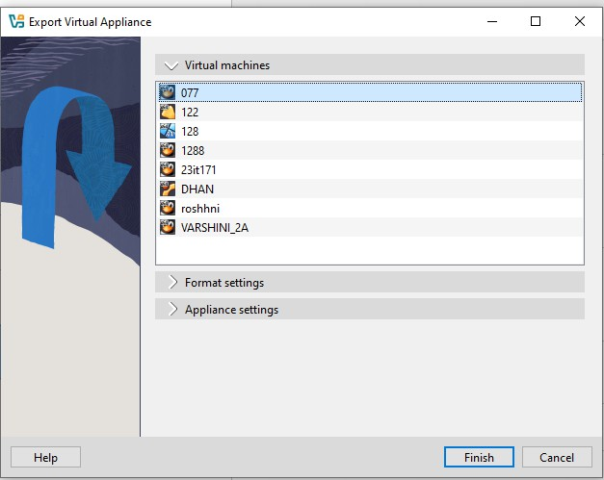

- Select the format which you want to export ova or ovf file format and select the path where you want to export in the file system
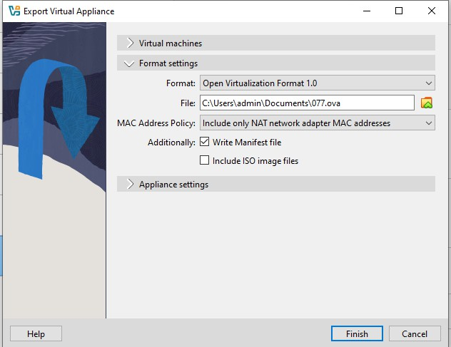
- Click export to (export appliance to the file system where you selected the location)

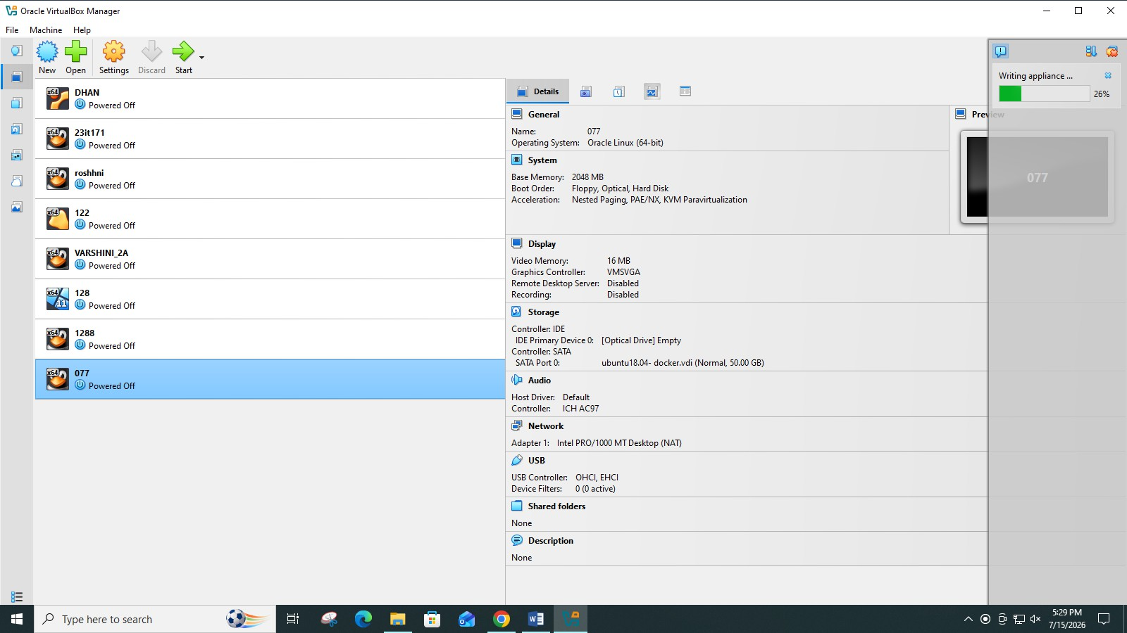
- Check the folder whether the ova image has been present in the folder.
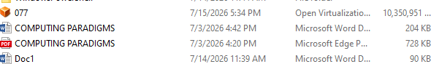

- Copy the image to the external device via internet , USB etc… I am using the usb and stored in my smartphone and Copy the image from your external device to the destination machine via usb.
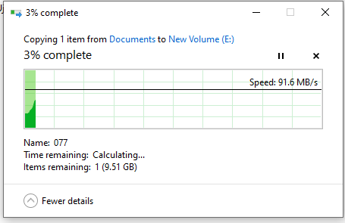
- On the Destination Host: Import the OVA Open Virtual Box Go to File &gt; Import Appliance (or File &gt; Open). Browse and select the .ova file you transferred.
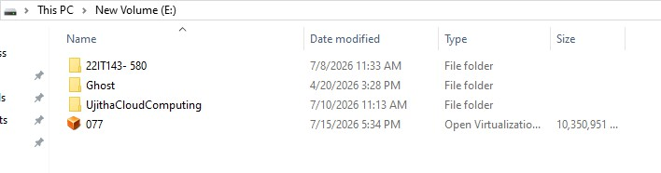
- Import the image by import appliance in the file -&gt;import appliance.
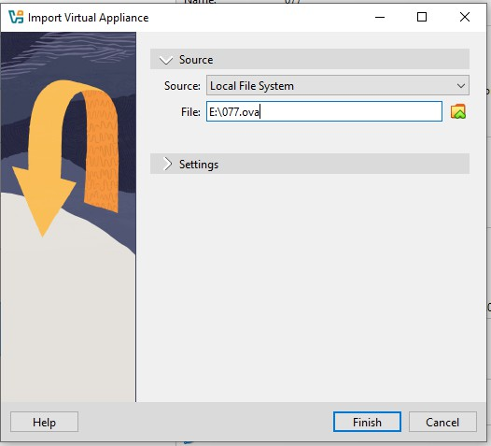

- Now the image has been importing.
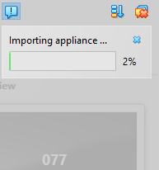
- Check whether the vm is shown in the oracle virtual box and open it.
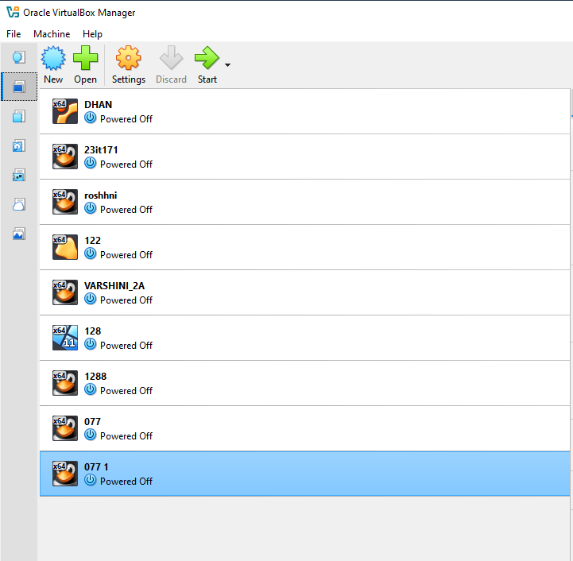
- Open the java file which you saved first using the linux commands cat kesho.java And its verified that the file are located and cold migration has done.
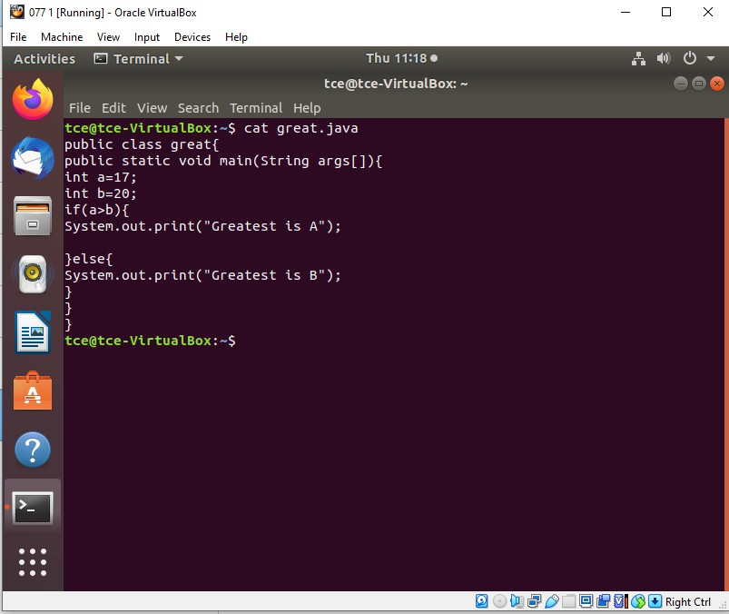

3. KVM install and img resize
Procedure:
- Check Hardware Virtualization Support.
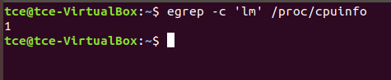
- Run uname -a , which shows kernel name, hostname, kernel version, build date, architecture, and OS type in one line.
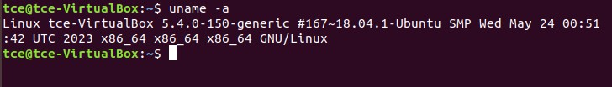
- To list the KVM kernel module files present in your kernel, run:
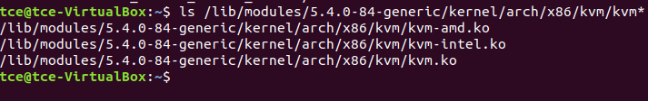

KVM Installation
- Install required packages : qemu-kvm, libvirt-bin, bridge-utils, virtmanager and qemu-system.
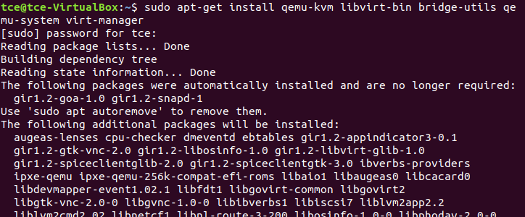
- Configure the libvirt daemon configuration file for remote access &amp; socket permissions in KVM/libvirt
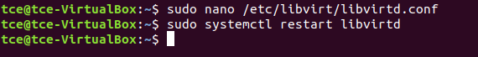
- Run virsh list - Displays no of Virtual machine running.
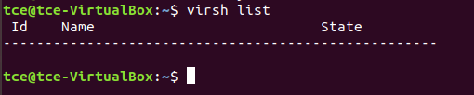
- Connecting to Virtualization interactive terminal.
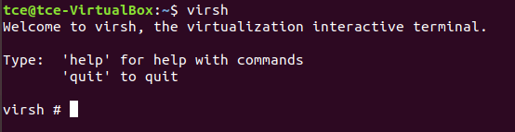
- Getting Version of libvirt &amp; QEMU.
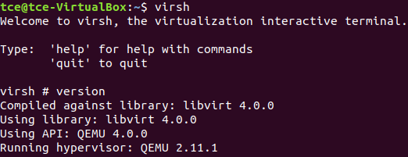
- Getting Node information
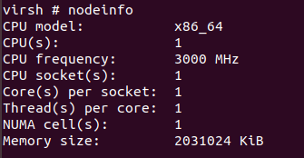
Importing existing VM
- Go to virtual machine manager (virt-manager) in your linux system. Then, right click QEMU/KVM and select New to create new VM.
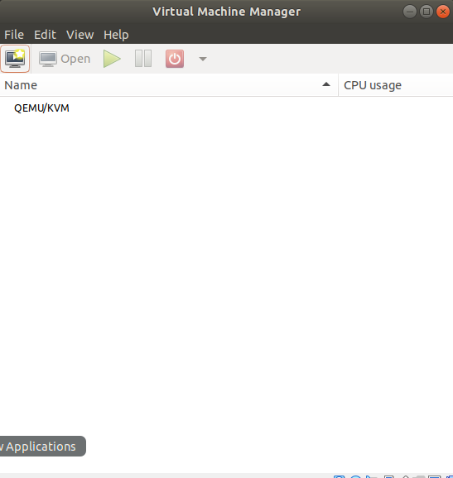
- Select import existing disk image and click forward.
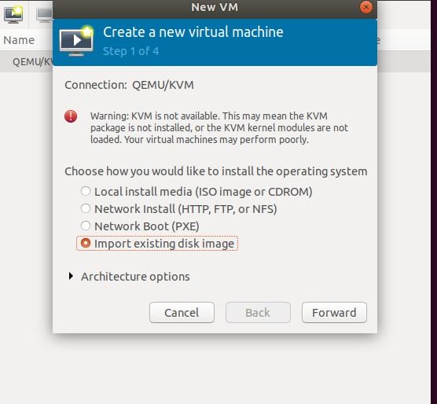

- Download cirros disk image from the link:https://download.cirroscloud.net/0.5.1/ and Give the path of downloaded cirros disk image and click forward
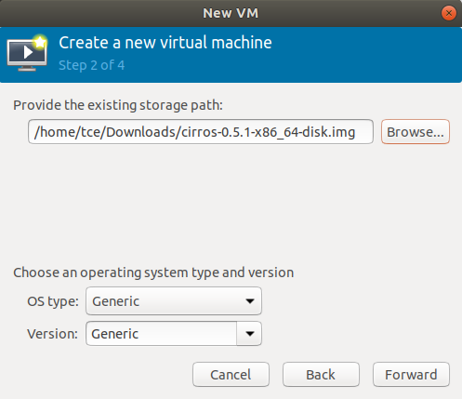

- Choose memory and CPU settings and click forward.
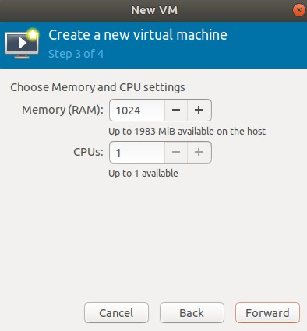

- Name your VM and click Finish.
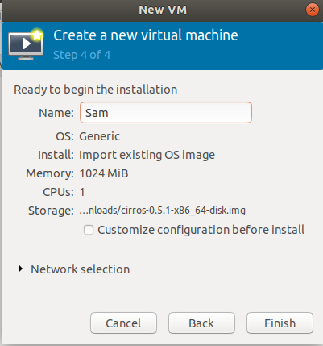
- The VM is booted successfully and the login was also successful.
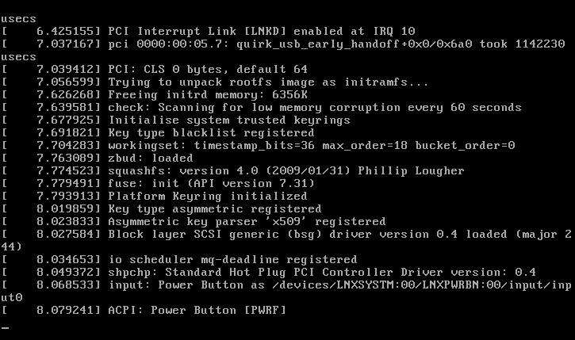

TRANSFER FOR FILES VM
Step 1: Create a Shared Folder on Your Host

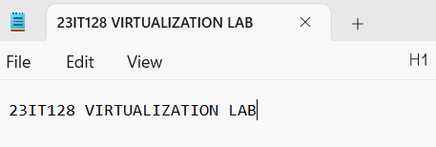

Step 2: Enable Shared Folder in VirtualBox (for Both VMs) Repeat this for both Ubuntu VMs.
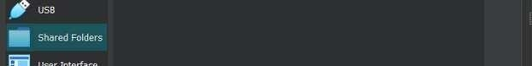
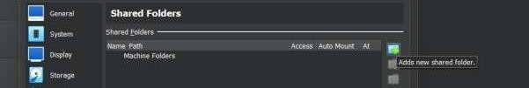

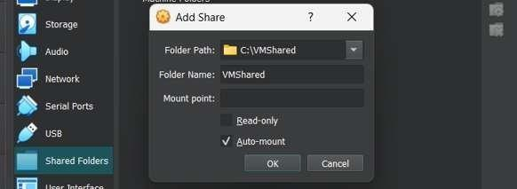

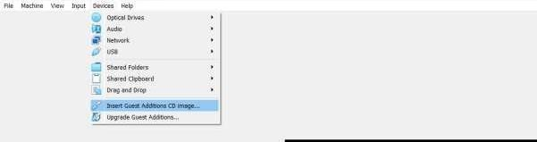

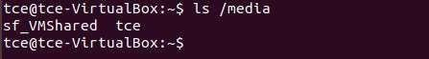

Therefore, in VM1 sf_VMShared folder is there in /media directory. VM2: SAME PROCEDURE FOR virtualbox 2
Run the command: ls /media

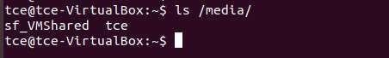

VM2 :

Run the command : ls /media/sf_VMShared VM1 :

VM2 :

You should see the 23IT128.txt file from your host.
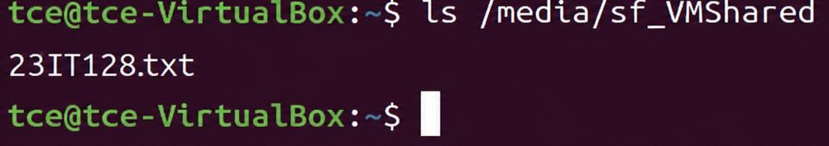

- Now in VM1, copy a file to /media/sf_VMShared folder,

- Switch to VM2, and check the shared folder: ls /media/sf_VMShared

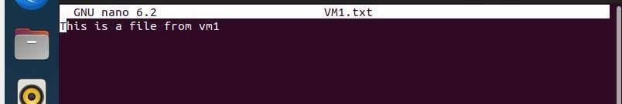

Also 23IT128.txt file is accessible in VM2,

METHOD 3(SSH Secure Shell)

Step 1: Install SSH

On both VMs (VM1 & VM2):

sudo apt update

sudo apt install openssh-server -y

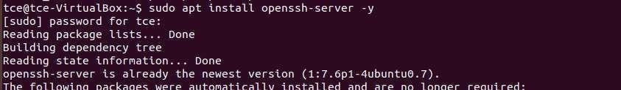
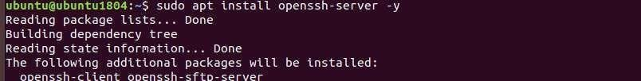

Check SSH status:

sudo systemctl status ssh
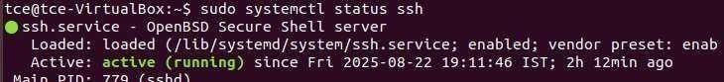

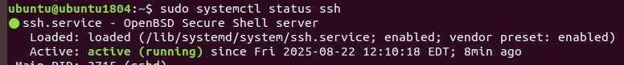

Step 2: Get Server’s IP

On VM1 (Server, username = tce):ip a

sudo ufw reload
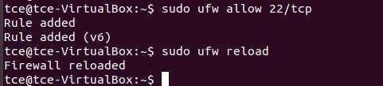

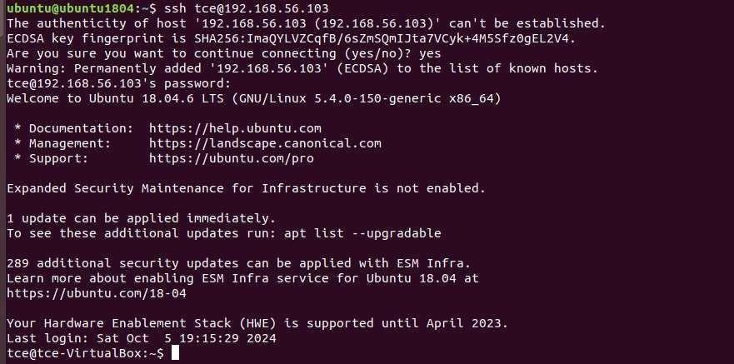
Step 3: Connect from VM2 to VM1 On VM2 (Client, username = ubuntu): ssh tce@192.168.56.103

Enter tce’s password → now you are logged into VM1. Step 4: Transfer Files with SCP (From VM2)

- Copy file from VM2 → VM1

scp 𝑓ile.txt tce@192.168.56.103:/home/tce/

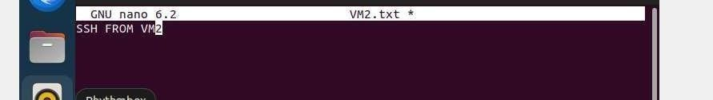

- Copy file from VM1 → VM2

scp tce@192.168.56.103:/home/tce/serverfile.txt /home/ubuntu/

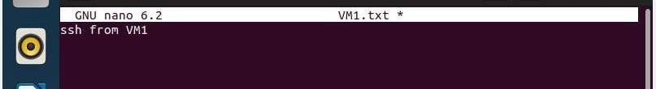

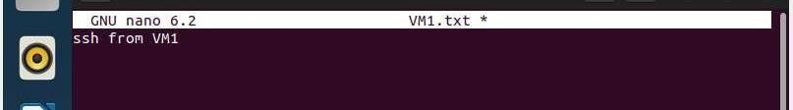

METHOD 4(FTP (File Transfer Protocol)

Step 1: Install FTP Server on VM1 (VM1 = server, VM2 = client)
On VM1:
sudo apt update

sudo apt install vsftpd -y
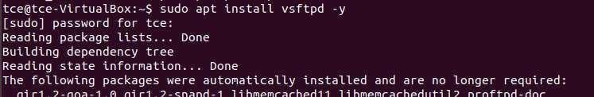

Enable and start the service: sudo systemctl enable vsftpd sudo systemctl start vsftpd
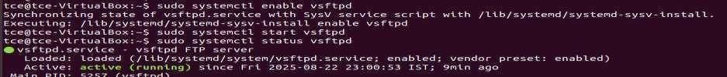
Step 2: Configure vsftpd Edit the config file:

sudo nano /etc/vsftpd.conf

Make sure these lines are set (uncomment or add if missing):

local_enable=YES write_enable=YES chroot_local_user=YES allow_writeable_chroot=yes Save (CTRL+S, CTRL+X)
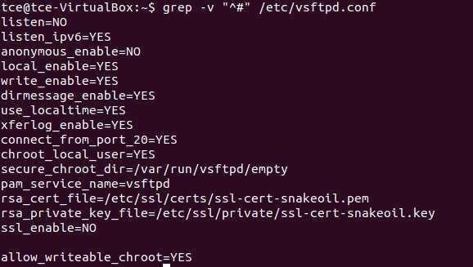

Restart the ftp server:

sudo systemctl restart vsftpd

Step 3: Check VM1 IP Address On VM1, run:
ip a

Allow firewall settings for FTP to avoid Connection timed out error.
sudo ufw allow 21/tcp
sudo ufw allow 20/tcp # (for data transfer)
sudo ufw status

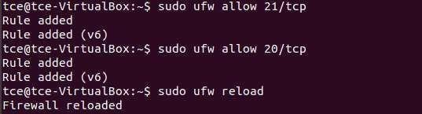

Step 4: Connect from VM2 (FTP client) On VM2, install ftp client:
sudo apt install ftp -y

Now connect:

ftp 192.168.56.103
Enter VM1’s username (tce) and password when prompted.
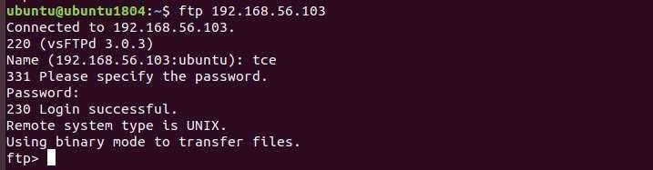

Step 5: FTP Commands Once connected, you can use:
- ls → list files on VM1
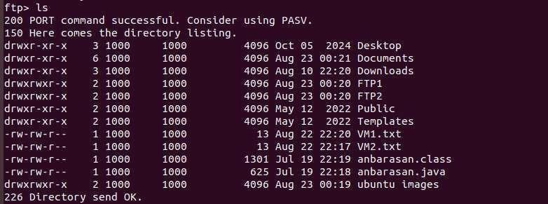

- cd folder → change directory on VM1

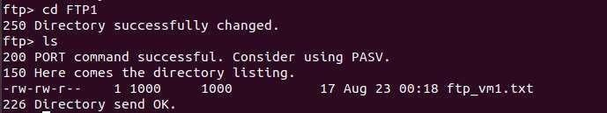

- get filename → download file from VM1 → VM2
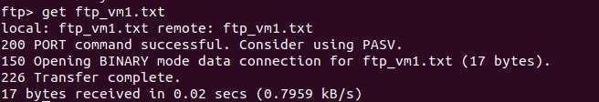

- put filename → upload file from VM2 → VM1
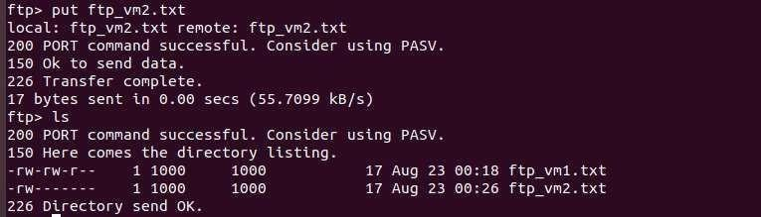

- bye → exit
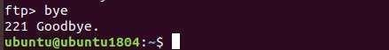

Step 6: Verify
- ftp_vm1.txt should now be in VM2’s current directory.

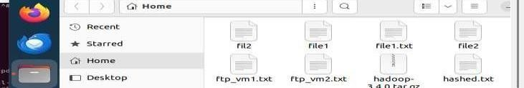

- ftp_vm2.txt should now be uploaded to VM1’s /home/FTP1/ directory.
