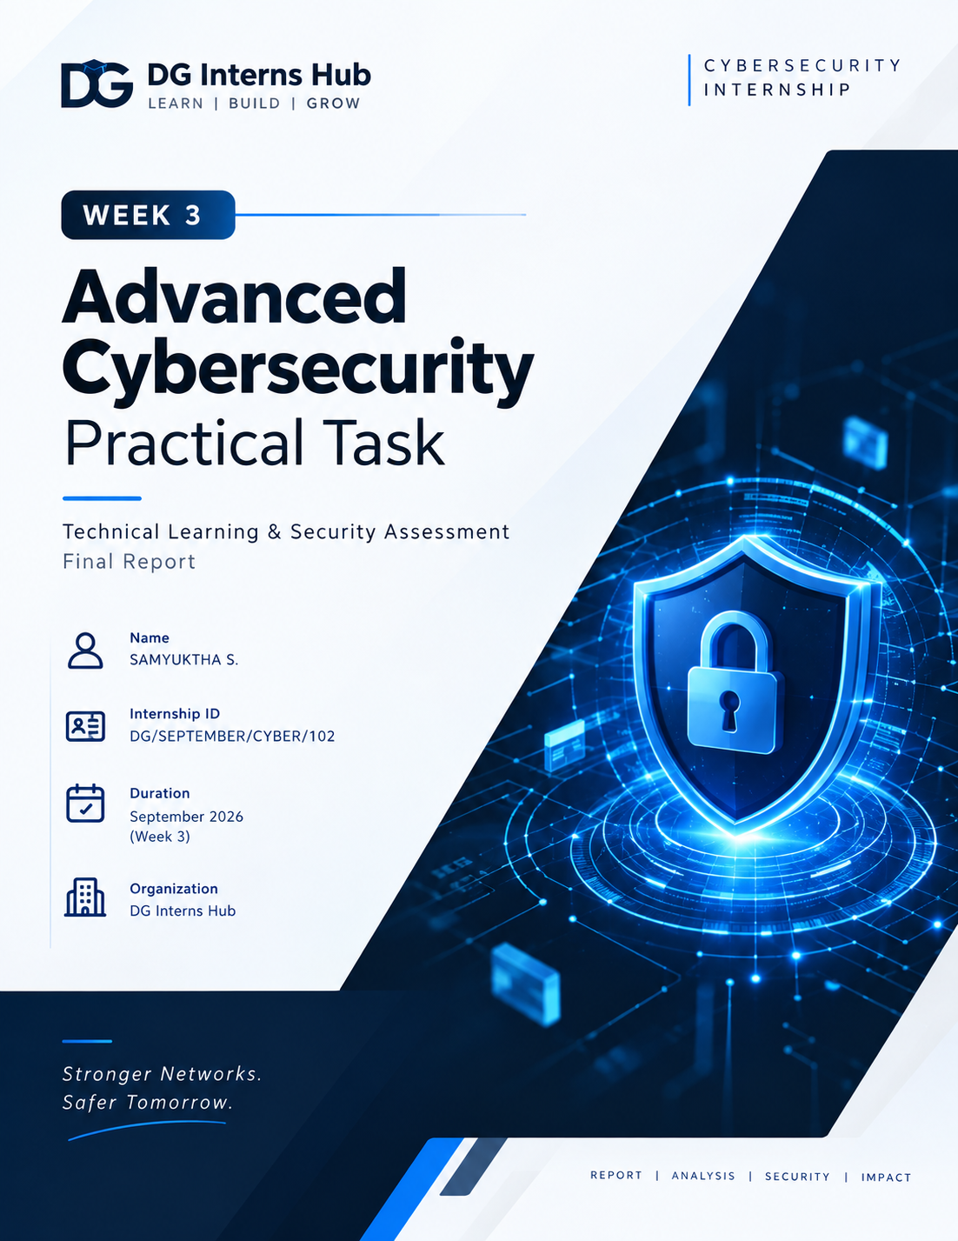
DOCUMENT MAP

Table of Contents
# | Section | Page
1 | Cover Page | 1
2 | Table of Contents | 2
3 | Introduction | 3
4 | Objectives | 3
5 | Lab Environment | 4
6 | Network Diagram | 5
7 | Tools Used | 6
8 | Nmap Methodology | 6
9 | Nmap Results | 7
10 | Advanced Nmap Analysis | 8
11 | Wireshark Methodology | 9
12 | Packet Analysis | 10
13 | Nmap + Wireshark Investigation | 11
14 | Vulnerability Assessment | 12
15 | Risk Classification | 12
16 | Security Hardening | 13
17 | Before/After Comparison | 13
18 | Security Recommendations | 14
19 | Challenges Faced | 14
20 | Conclusion | 15
21 | References | 15
22 | Screenshots / Evidence | 15

01

Introduction
From networking fundamentals to an evidence-based security assessment.
Week 3 extended the networking concepts learned earlier into a controlled cybersecurity assessment workflow. A two-VM VMware lab was created so that discovery, service enumeration, packet capture, traffic investigation and hardening could be performed against an authorized target without relying on public systems.
The assessment deliberately separated observation from interpretation. Nmap was used to establish the target surface, Wireshark was used to observe the underlying traffic, and the final findings were based only on evidence produced in the lab.
02

Objectives
- Build and validate an isolated VMnet1 cybersecurity lab.
- Discover live hosts and exposed services using Nmap.
- Perform service/version, OS, SYN, UDP and NSE assessments.
- Capture and interpret ICMP, DNS, TCP, UDP and ARP traffic with Wireshark.
- Correlate Nmap port states with packet-level TCP behavior.
- Assess security posture and distinguish confirmed findings from hardening opportunities.
- Apply controlled firewall hardening and validate the change with before/after testing.
Assessment principle
Only the user-owned VMs on the authorized lab network were scanned and analyzed. No public or third-party systems were included.

03

Lab Environment
Virtualization, addressing and target preparation.
Component | Configuration
Hypervisor | VMware Workstation
Kali Linux | 4 GB RAM, 2 vCPU, eth0 = 192.168.162.128/24
Ubuntu Server Target | 2 GB RAM, 2 vCPU, 20 GB disk, hostname ubuntu-target
Primary network | VMnet1 Host-only, 192.168.162.0/24
SSH service | OpenSSH Server installed on Ubuntu
Packet analysis | Wireshark on Kali eth0
04

Installation & Target Preparation
Ubuntu Server was installed as the dedicated target and OpenSSH Server was enabled during installation. Kali was used as the assessment VM. Host-only networking provided the isolated assessment path.
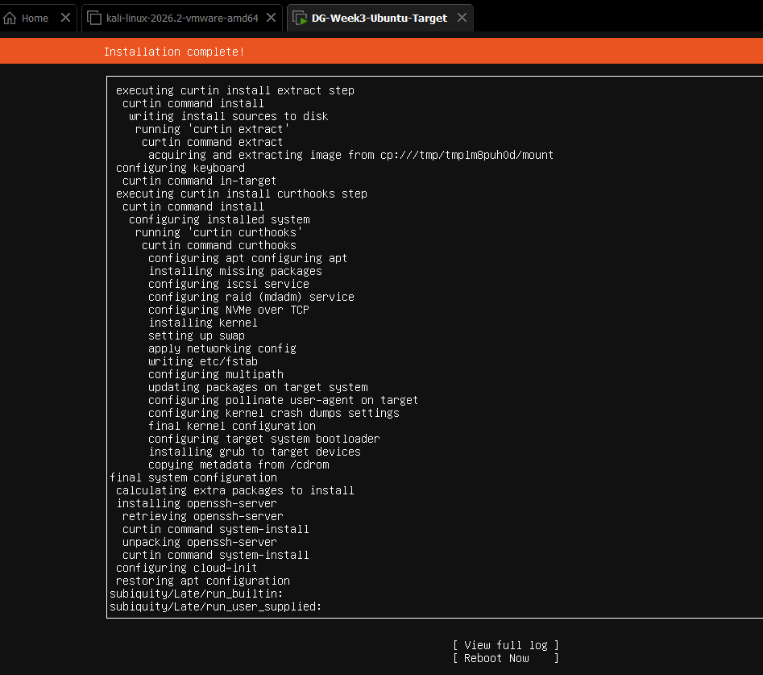  Installation completed with OpenSSH Server. | 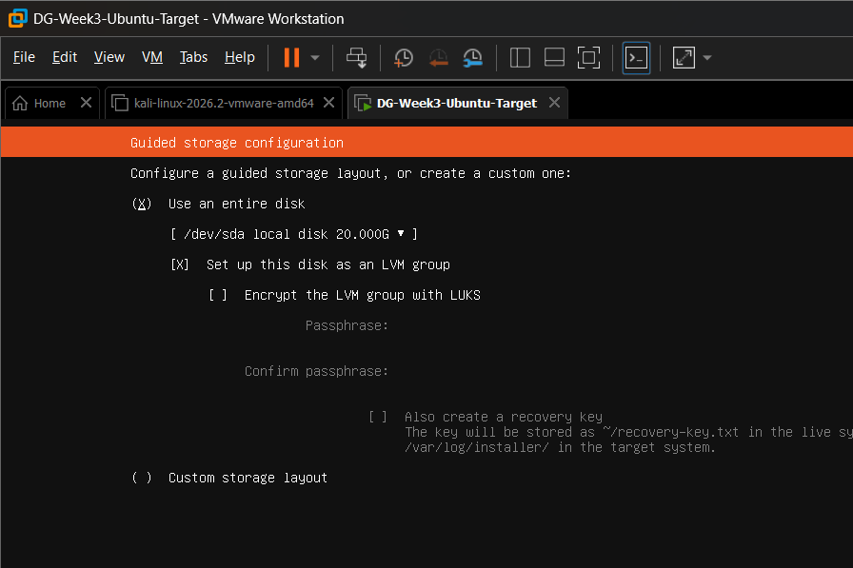  Target storage configuration.

05

Network Diagram
Authorized assessment architecture - primary path is isolated VMnet1.
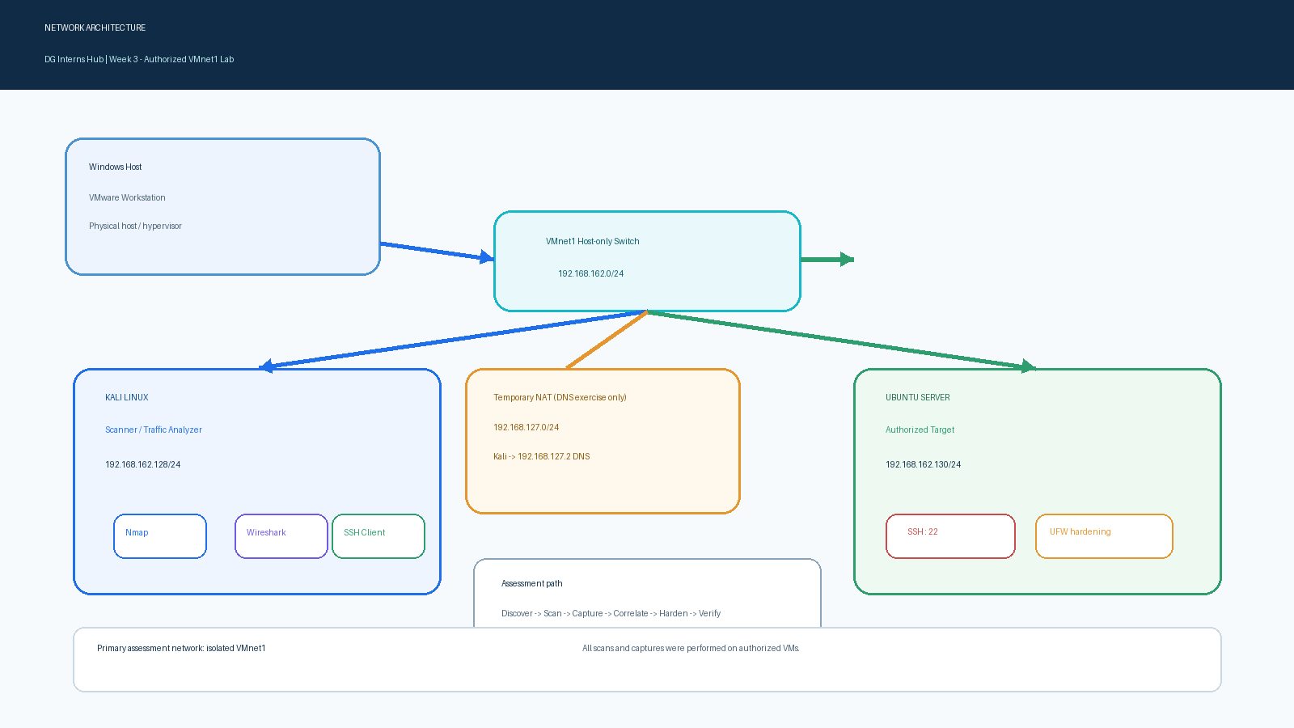
Figure 1. Advanced Week 3 lab topology. The temporary NAT path was used only for the DNS exercise and was not part of the assessment network.
Network roles
Kali = scanner + packet analyzer | Ubuntu = authorized target | VMnet1 = isolated assessment segment | SSH/22 = intentionally exposed service for validation.

06

Tools Used
Tools were selected to cover discovery, analysis and validation.
Tool | Purpose
VMware Workstation | Virtualize the lab systems and create the Host-only assessment network.
Kali Linux | Assessment workstation for Nmap, SSH and packet analysis.
Ubuntu Server | Authorized target and hardening platform.
Nmap | Host discovery, TCP/UDP enumeration, service/version and NSE assessment.
Wireshark | Packet capture, protocol filtering and traffic investigation.
UFW | Host-based firewall used for the hardening phase.
07

Nmap Methodology
A repeatable assessment sequence.
Stage | Command / focus | Purpose
Discovery | nmap -sn 192.168.162.0/24 | Identify responding hosts.
Baseline scan | nmap 192.168.162.130 | Identify exposed default TCP ports.
Service detection | nmap -sV 192.168.162.130 | Identify service/version details.
OS detection | nmap -O 192.168.162.130 | Attempt network fingerprinting.
SYN scan | nmap -sS 192.168.162.130 | Observe TCP SYN-based port states.
UDP scan | nmap -sU --top-ports 20 192.168.162.130 | Review common UDP exposure.
NSE review | nmap --script vuln 192.168.162.130 | Run vulnerability-oriented scripts.

08

Nmap Results
Baseline discovery and exposed-service evidence.
Host discovery
The 192.168.162.0/24 lab scan identified four responsive addresses. The relevant assessment machines were Kali 192.168.162.128 and Ubuntu 192.168.162.130; the remaining responsive addresses were VMware virtual-network infrastructure.
Assessment | Observed result
Host discovery | 4 hosts up on the /24; Kali and Ubuntu were the relevant VMs.
Basic TCP scan | 22/tcp open SSH; 999 default TCP ports closed before UFW hardening.
Service/version | OpenSSH 10.2p1 Ubuntu 2ubuntu3.5 identified on 22/tcp.
OS detection | No exact OS match returned; one-hop network distance.
UDP top 20 | No port conclusively identified as open; several reported open|filtered.
NSE vuln scripts | No vulnerability findings reported in the scan output.
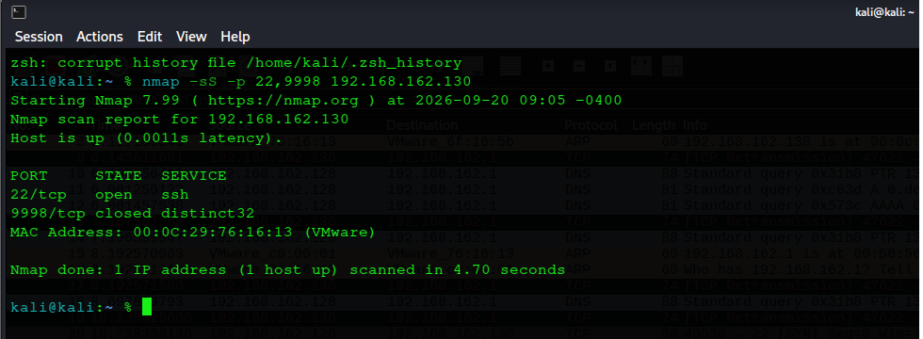
Evidence - Controlled Nmap correlation scan: 22/tcp open and 9998/tcp closed.

09

Advanced Nmap Analysis
Interpreting the results without over-claiming.
Check | Result | Analyst interpretation
-sV | OpenSSH 10.2p1 Ubuntu 2ubuntu3.5 | Provides a concrete service/version baseline for later assessment.
-O | No exact OS match | Fingerprinting was inconclusive; the target is known to be Ubuntu from lab configuration.
-sS | 22/tcp open | SYN behavior confirmed the open SSH service.
UDP top 20 | open|filtered on several ports | Not treated as confirmed open services without additional evidence.
--script vuln | No findings reported | Automated result is not proof that the host has zero vulnerabilities.
Key interpretation
Open ports describe attack surface. A service/version match or scanner result is evidence for follow-up, not proof of exploitability by itself.

10

Wireshark Methodology
Capture first, filter second, interpret with context.
Wireshark was used on Kali eth0 to inspect packet-level behavior on the authorized lab network. Each traffic pattern was generated deliberately, captured, filtered and then interpreted against the known lab topology.
Capture focus | Filter used | Purpose
ICMP | icmp | Show Echo request/reply behavior.
DNS | dns | Observe query and response pairs.
TCP/SSH | tcp.port == 22 | Observe TCP handshake and SSH negotiation.
UDP | udp | Observe a controlled UDP datagram.
ARP | arp | Observe IP-to-MAC address resolution.
TCP SYN | tcp.port == 22 && tcp.flags.syn == 1 | Isolate SYN/SYN-ACK behavior.
TCP RST | tcp.port == 9998 && tcp.flags.reset == 1 | Observe reset behavior for a closed port.
Temporary NAT note
Kali temporarily used NAT for the DNS capture because 192.168.162.1 did not provide a working DNS service. The VM was returned to Host-only / VMnet1 for the security assessment.

11

Packet Analysis
Selected packet-level evidence from the controlled captures.
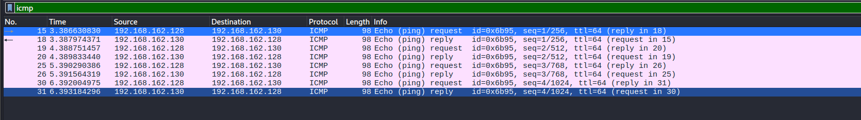  ICMP: 4 Echo requests + 4 replies | 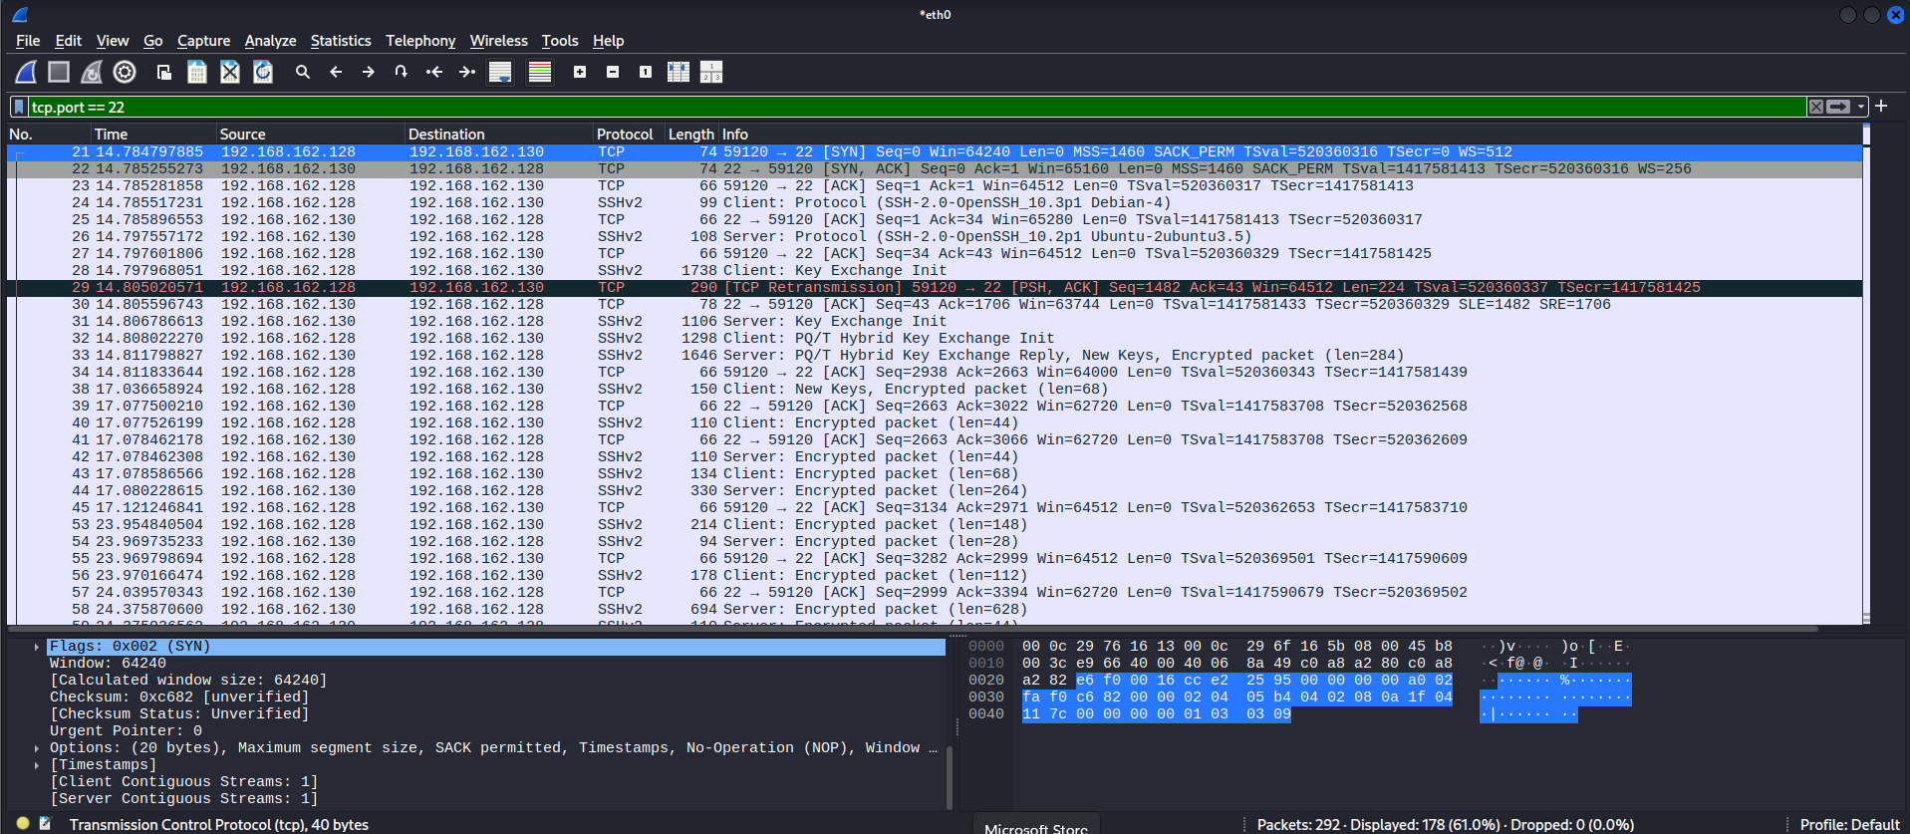  TCP/SSH: SYN -> SYN-ACK -> ACK + SSHv2
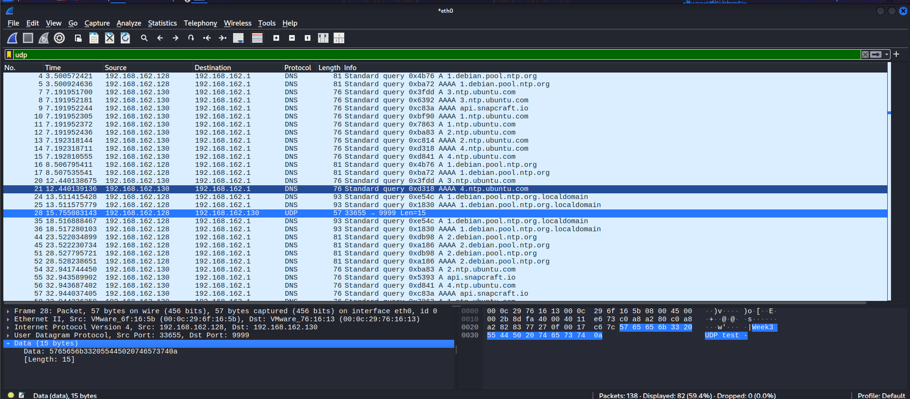  UDP: controlled 33655 -> 9999 datagram | 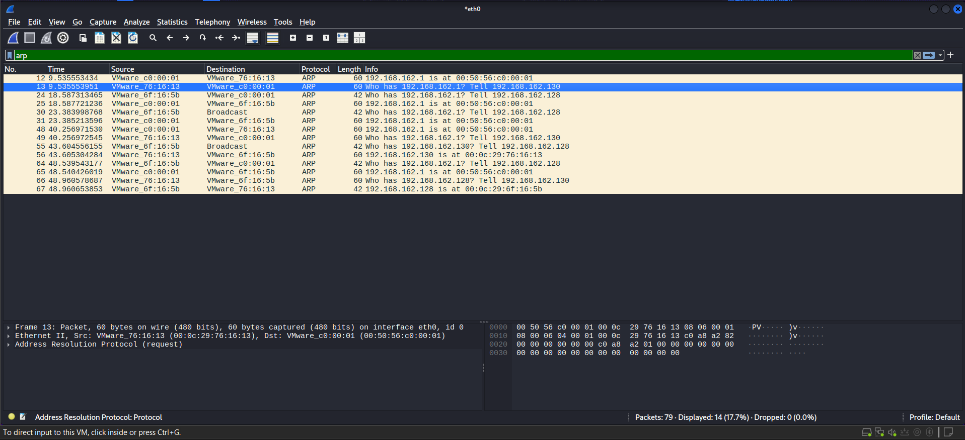  ARP: target IP -> MAC resolution
Observed protocols
ICMP, DNS, TCP/SSH, UDP and ARP were observed. The captures provided packet-level evidence for the connectivity, service and network-layer behaviors documented in the assessment.

12

Nmap + Wireshark Investigation
Correlating scanner output with TCP packet behavior.
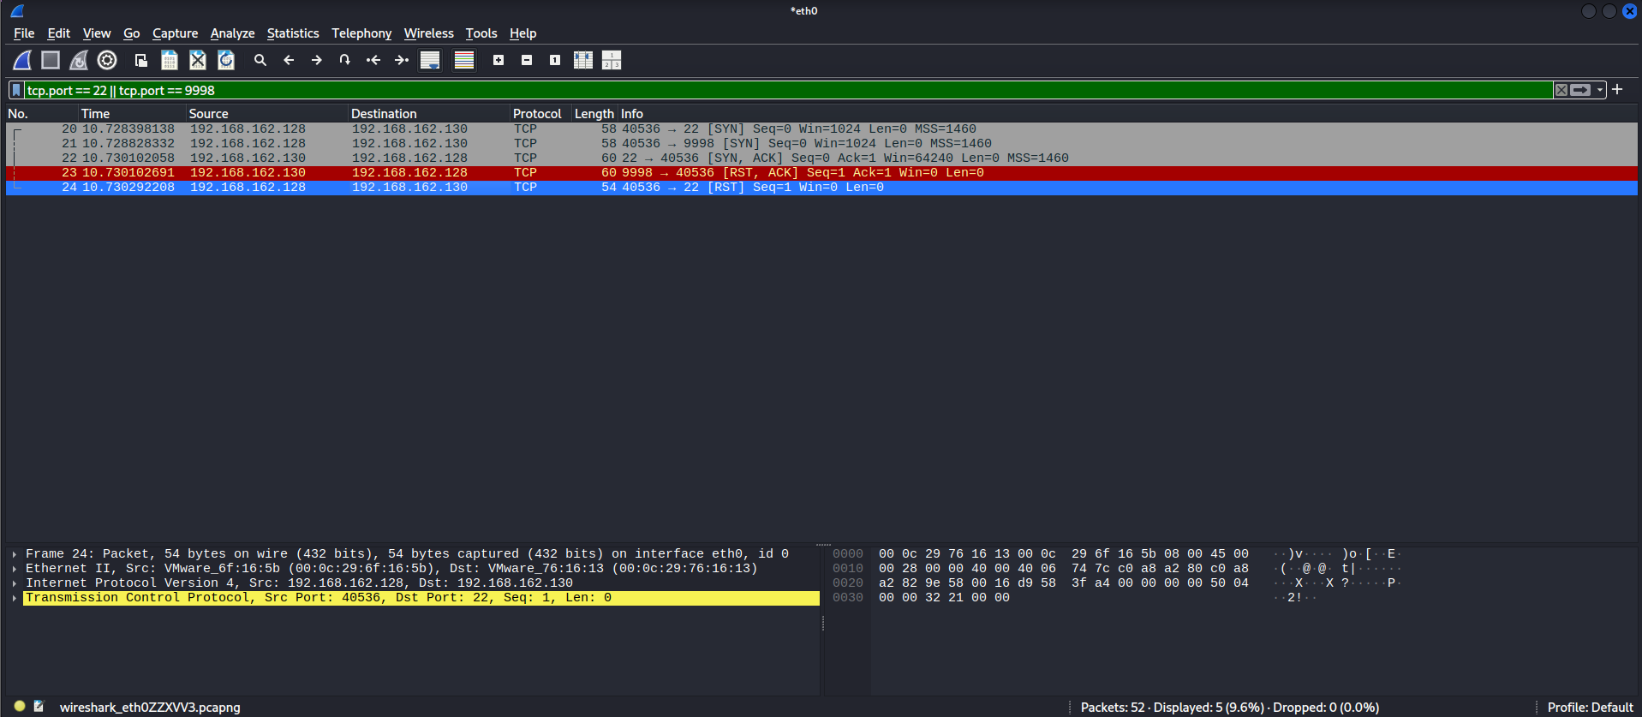
Evidence - Controlled port 22 / 9998 capture during Nmap SYN scan.
Nmap state | Observed packets | Interpretation
22/tcp open | SYN -> SYN-ACK -> ACK | Target accepted the TCP connection attempt; SSH service was reachable.
9998/tcp closed | SYN -> RST/ACK | Target reset the attempt; behavior was consistent with a closed port.
Correlation result
Nmap port-state classifications matched the packet-level TCP responses observed by Wireshark, strengthening the evidence behind the assessment.

13

Vulnerability Assessment
Evidence-based review of the target posture.
The vulnerability review combined the Nmap NSE result with direct target checks. No confirmed software vulnerability was established in the collected evidence. Instead, two security-hardening opportunities were identified and validated through configuration inspection.
Finding | Evidence | Assessment
UFW inactive | sudo ufw status verbose -> inactive | Security hardening gap in the pre-hardening baseline.
SSH password authentication enabled | sshd -T showed passwordauthentication yes | Hardening opportunity; not treated as a confirmed vulnerability by itself.
Root password login prohibited | permitrootlogin prohibit-password | Positive control; not a finding.
Public-key authentication enabled | pubkeyauthentication yes | Positive control; not a finding.
No pending updates observed | apt list --upgradable returned no packages | No update finding from this check.
Nmap NSE vuln scan | No findings reported | Automated scan did not report a vulnerability.
14

Risk Classification
Severity was assigned to the security posture evidence, not to a speculative exploit.
Item | Classification | Reason
UFW inactive | Medium | Unsolicited inbound traffic was not filtered at the host firewall layer before hardening.
Password authentication enabled | Low / hardening | Acceptable in some environments but weaker than key-only SSH for administrative access.
SSH exposed | Attack surface | Intentional lab service; exposure alone is not a vulnerability.
No NSE findings | Informational | No automated vulnerability finding was produced; validation limits remain.

15

Security Hardening
Controlled firewall hardening with validation.
- Recorded pre-hardening state: UFW inactive.
- Recorded the pre-hardening Nmap baseline: 22/tcp open; other default ports closed.
- Allowed SSH before enabling the firewall to preserve authorized administration.
- Enabled UFW with low logging.
- Repeated the same Nmap baseline using -T4.
- Verified SSH remained accessible after hardening.
16

Before / After Comparison
The same target and scan were used to make the comparison meaningful.
Metric | Before UFW | After UFW
Firewall status | Inactive | Active
SSH / TCP 22 | Open | Open
Other default TCP ports | Closed (RST response) | Filtered (no response)
SSH administrative access | Available | Verified available
Measured effect
The firewall change did not remove the required SSH service, but it changed unsolicited access to the other scanned TCP ports from closed responses to filtered/no-response behavior.
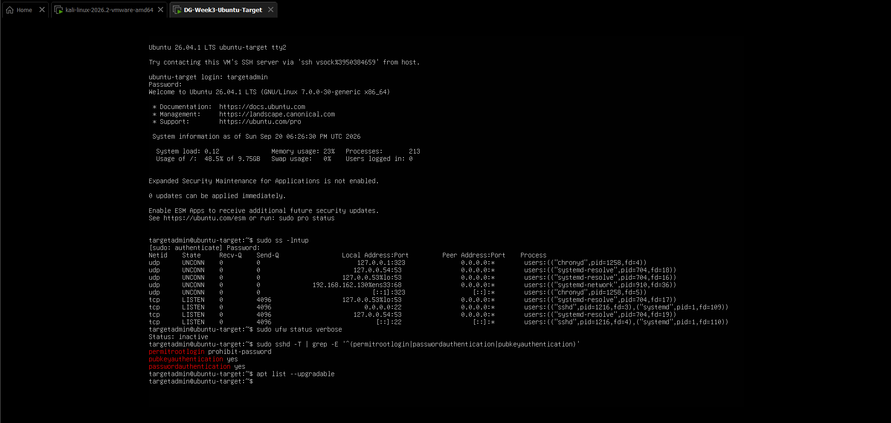
Evidence - Target baseline checks used to guide the hardening phase.

17

Security Recommendations
Practical next steps based on the observed posture.
- Keep UFW enabled and review inbound rules regularly.
- Prefer SSH public-key authentication and disable password authentication when operationally appropriate.
- Limit management access by source network wherever practical.
- Maintain normal Ubuntu and OpenSSH patch management.
- Monitor unusual SYN bursts, RST responses and retransmissions in context.
- Retest the exposed surface after service or configuration changes.
18

Challenges Faced
Troubleshooting was treated as part of the assessment workflow.
Challenge | How it was resolved | Learning
SSH initially appeared inactive | Started/verifed the service and then validated port 22 from Kali. | Installation and runtime state are separate checks.
IPv4 ICMP was initially missing in Wireshark | Forced IPv4 ping and captured the correct exchange. | Capture timing and protocol version matter.
DNS failed on Host-only network | Temporarily used NAT for DNS capture, then returned to VMnet1. | Lab services and network roles must be verified before capture.
Wireshark filters showed background traffic | Refined filters to target specific ports and flags. | Filtering is essential for evidence quality.
Analyst lesson
Good security reporting is as much about controlled troubleshooting and accurate interpretation as it is about running tools.

19

Conclusion
Assessment outcome and final learning.
The Week 3 assessment progressed from lab construction to host discovery, service enumeration, packet capture, traffic investigation, vulnerability review and controlled hardening. Nmap established the target surface, Wireshark provided packet-level evidence, and the final UFW change demonstrated a measurable reduction in unsolicited TCP exposure while preserving the required SSH service.
Key takeaway
The strongest improvement was the ability to connect a tool result to an observable network event, then make a controlled configuration change and prove its effect with a before/after test.
20

References
Source | Reference
Nmap Documentation | https://nmap.org/book/man.html
Wireshark Documentation | https://www.wireshark.org/docs/
Ubuntu Server Documentation | https://documentation.ubuntu.com/server/
Ubuntu UFW Documentation | https://documentation.ubuntu.com/server/how-to/security/firewalls/
OpenSSH | https://www.openssh.com/
21

Screenshots / Evidence
Selected evidence stored with the submission set.
Evidence set | Examples
Nmap | Network discovery, basic scan, service/version, OS, SYN, UDP and NSE outputs.
Wireshark | ICMP, DNS, TCP/SSH, UDP, ARP, SYN and RST captures.
Investigation | Nmap + Wireshark correlation and retransmission analysis.
Hardening | Target baseline, UFW before/after, and before/after Nmap comparison.

