MY ASSIGNMENT FOR VG SECOND TIME

CREATE DATABASE fiktiv_streamingplatform;

DROP TABLE IF EXISTS title , actor , rating , producer , title_producer;

DROP DATABASE IF EXISTS fiktiv_streamingplatform;

USE fiktiv_streamingplatform;

CREATE TABLE title (title_id INTEGER NOT NULL AUTO_INCREMENT, title VARCHAR (100) DEFAULT ' ' NOT NULL , released year YEAR , PRIMARY KEY (title_id));

CREATE TABLE actor ( actor_id INTEGER NOT NULL AUTO_INCREMENT, actor_name VARCHAR(100) DEFAULT ' ' NOT NULL , Gender CHAR NOT NULL , PRIMARY KEY (actor_id));

CREATE TABLE rating (rating_id INTEGER NOT NULL AUTO_INCREMENT , title_id INTEGER NOT NULL , rating INTEGER NOT NULL , PRIMARY KEY(rating_id) , FOREIGN KEY (title_id) REFERENCES title(title_id));

CREATE TABLE producer (producer_id INTEGER NOT NULL AUTO_INCREMENT , producer_name VARCHAR(100) DEFAULT ' ' NOT NULL , PRIMARY KEY (producer_id));

CREATE TABLE title_producer( title_id INTEGER NOT NULL , producer_id INTEGER NOT NULL , FOREIGN KEY (title_id) REFERENCES title(title_id) , FOREIGN KEY (producer_id) REFERENCES producer(producer_id));

INSERT INTO title (title,releasedyear) VALUES ( 'Bahubali' , '2015' ) , ( 'Arundathi' , '2009');

INSERT INTO title (title , releasedyear) VALUES ( 'SixthSense' , '2011') , ('LifeisBeautiful' , '2012 ');

INSERT INTO actor (actor_name,gender) VALUES ( 'Prabhas' , 'M') , ( 'Anushka' , 'F');

INSERT INTO rating(title_id,rating) VALUES ( 1 , 5 ) , ( 2 , 3);

INSERT INTO producer(producer_name) VALUES ( 'Rajamouli' ) , ( 'KodiRamakri');

INSERT INTO producer(producer_name) VALUES ( 'Dil' );

Fråga 1:

SELECT title , releasedyear FROM title;

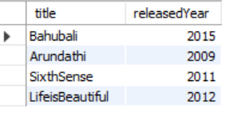

Fråga 2:

SELECT DISTINCT title FROM title WHERE releasedyear >2000;

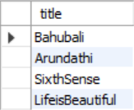

Fråga 3:

SELECT actor_name ,gender FROM actor;

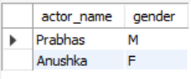

Fråga 4:

SELECT rating_id , title_id , rating FROM rating;

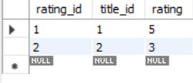

Fråga 5:

SELECT DISTINCT rating FROM rating INNER JOIN title ON rating.title_id= title.title_id WHERE title.title_id = 2 AND title.title ='Arundathi';

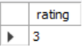

Fråga 6:

SELECT title FROM title INNER JOIN rating ON title.title_id =rating.title_id WHERE rating.rating >=4 ORDER BY title.title_id DESC;



Fråga 7:

SELECT DISTINCT producer_name FROM producer;

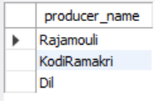

Fråga 8:

SELECT title.title FROM title LEFT JOIN title_producer ON title.title_id =title_producer.title_id WHERE title.title_id

= 2 ;



Fråga 9:

SELECT title.title FROM title LEFT JOIN title_producer ON title.title_id =title_producer.title_id GROUP BY title.title_id;

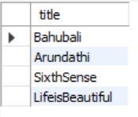

Fråga 10:

INSERT INTO title ( title ) VALUES ( 'Bommarillu ');

Fråga 11:

INSERT INTO actor ( actor_name , gender ) VALUES ( 'Surya' ,'F');

INSERT INTO actor (actor_name , gender ) VALUES ('Siddartha' ,'M');

Fråga 12:

INSERT INTO producer(producer_name) VALUES ( 'Shekarkamla');

INSERT INTO producer(producer_name) VALUES ( 'Savitri');

Fråga 13:

INSERT INTO rating(title_id,rating) VALUES((SELECT title_id FROM title WHERE title_id=2),4);

INSERT INTO rating(title_id ,rating) VALUES((SELECT title_id FROM title WHERE title.title='LifeisBeautiful') ,5);

Fråga 14:

INSERT INTO title_producer(title_id,producer_id) VALUES (

(SELECT title_id FROM title WHERE (title.title)= Lower('Bahubali')),(SELECT producer_id FROM producer WHERE producer.producer_name = 'Dil'));

Fråga 15:

UPDATE title SET releasedyear = '2020' WHERE title.title_id=2 AND title.title='Arundhati';

Fråga 16:

UPDATE actor SET gender = 'M' WHERE actor.actor_id =6;

Fråga 17:

UPDATE rating SET rating = 4 WHERE rating.rating_id =2;

Fråga 18:

DELETE FROM title WHERE title.title_id= '2'AND title.title='Arundhati';

Fråga 19:

DELETE FROM actor WHERE actor.actor_id = '7' AND actor.actor_name= 'Sunil';

Fråga 20:

DELETE FROM producer WHERE producer.producer_id = '20';

Fråga 21:

DELETE FROM rating WHERE rating.rating_id = '10';

title table:

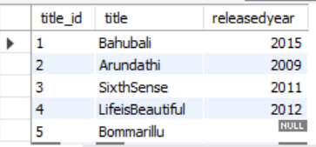

actor table:

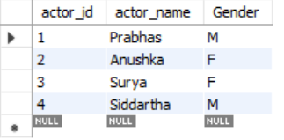

rating table:

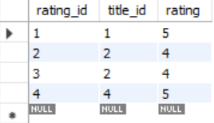

producer table:

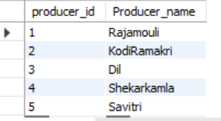

title_producer table:

