CO 2 – AT 3
COURSE: C PROGRAMMING
CODE : CSA0209
NAME : SAMYUKTHA.R
REG NO : 1913260047
GITHUB RESPIRATORY:

Q7 – DIAGNOSE, REDESIGN AND VALIDATE
C Programming Assignment | K5 – Evaluate | 13 Marks
Important note: This is a worked example using a basic prime-number checking program. The numerical counts below are calculated for the sample program and sample inputs; they are not claimed to be measurements from your Q1–Q6 submission. Before submitting, confirm that prime checking is one of your Q1–Q6 programs. If your original code is different, replace the program, inputs and counts with your own evidence.

Selected Program: Checking Whether a Number Is Prime
The program reads an integer and determines whether it is prime. A prime number has exactly two factors: 1 and itself. The original approach checks every possible divisor from 2 up to n − 1.

A. Diagnose the Bottleneck – 2 Marks
In the original program, the for-loop tests each integer i from 2 to n − 1 using the remainder operation n % i. Therefore, for a prime input n, the number of remainder tests is n − 2. This count grows directly with the input value. For example, when n = 10,007, the original program performs 10,005 remainder tests before concluding that the number is prime. Most of these tests are unnecessary because a factor larger than the square root of n must be paired with a factor smaller than the square root of n.

B. Define the Design Objective – 2 Marks
The objective is to reduce the number of remainder tests for prime inputs by at least 50%, while producing the same correct prime/not-prime result. The redesign will test 2 once and then test only odd possible divisors up to the square root of n. The number of remainder tests will be counted in both versions.

C. Design the Revised Solution – 4 Marks
The redesigned program uses two mathematical properties. First, every even number greater than 2 is not prime, so even divisors do not need to be tested repeatedly. Second, if n has a factor greater than √n, its paired factor must be smaller than √n. Therefore, if no divisor is found up to √n, no larger divisor needs to be checked.
The redesign checks divisibility by 2 once. If n is even, it is not prime. Otherwise, the loop starts at 3 and increases i by 2, checking only odd divisors. The condition i <= n / i is used instead of calculating i * i, avoiding possible multiplication overflow for large integer values. No lookup table or additional array is required; the extra memory is constant, O(1). The trade-off is a slightly more involved condition and an integer division in each loop-condition evaluation.

Pseudocode
- Read n
- If n < 2, report NOT PRIME
- Else if n == 2, report PRIME
- Else if n is divisible by 2, report NOT PRIME
- Else:
- Set i = 3
- While i <= n / i:
- If n is divisible by i, report NOT PRIME and stop
- Increase i by 2
- If no divisor was found, report PRIME

Original C Program (baseline)
#include <stdio.h>
int main(void)
{
int n, i, isPrime = 1;
int remainderTests = 0;
scanf("%d", &n);
if (n < 2)
isPrime = 0;
else
{
for (i = 2; i < n; i++)
{
remainderTests++;
if (n % i == 0)
{
isPrime = 0;
break;
}
}
}
printf("%s\n", isPrime ? "PRIME" : "NOT PRIME");
printf("Remainder tests: %d\n", remainderTests);
return 0;
}
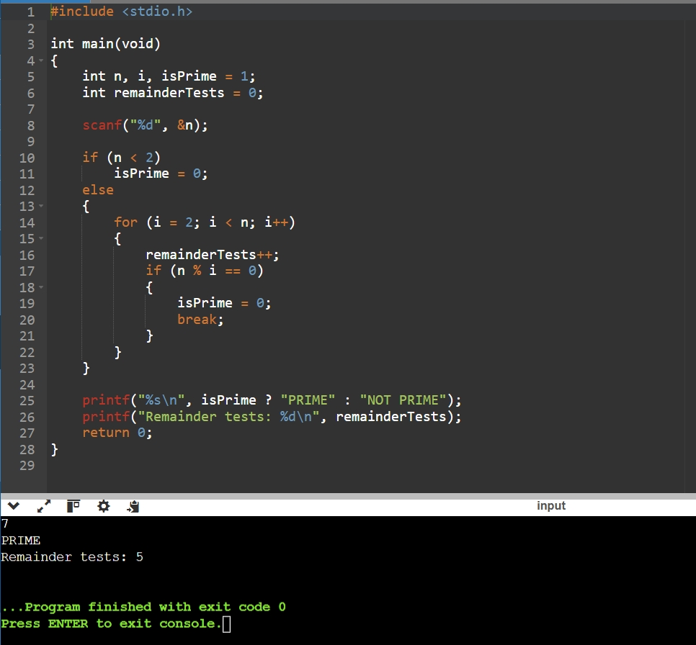

Redesigned C Program
#include <stdio.h>
int main(void)
{
int n, i, isPrime = 1;
int remainderTests = 0;
scanf("%d", &n);
if (n < 2)
isPrime = 0;
else if (n == 2)
isPrime = 1;
else
{
remainderTests++; /* Test divisibility by 2 */
if (n % 2 == 0)
isPrime = 0;
else
{
for (i = 3; i <= n / i; i += 2)
{
remainderTests++;
if (n % i == 0)
{
isPrime = 0;
break;
}
}
}
}
printf("%s\n", isPrime ? "PRIME" : "NOT PRIME");
printf("Remainder tests: %d\n", remainderTests);
return 0;
}
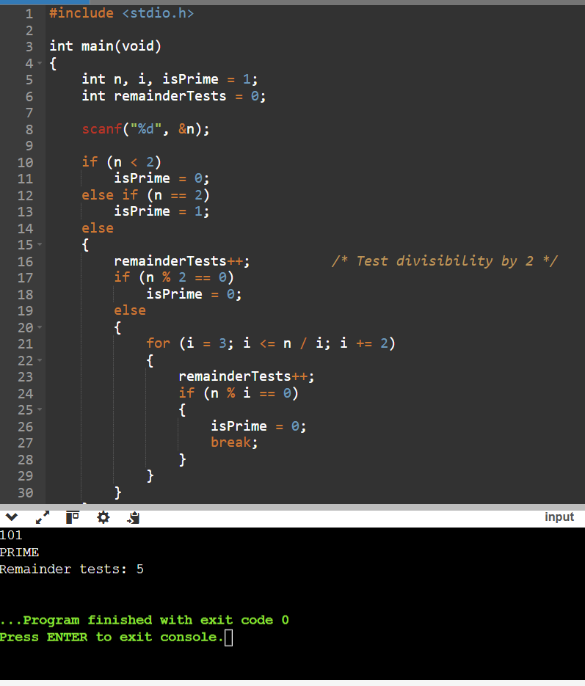
Original vs Redesigned Comparison
Input | Original tests | Redesigned tests
7 | 5 | 2
10 | 1 | 1
101 | 99 | 4
25 | 3 | 2
2 | 0 | 0
1 | 0 | 0

D. Predict Before Implementing – 1 Mark
For large prime inputs, I predict that the redesigned program will perform far fewer remainder tests because it checks only odd divisors up to √n. For n = 10,007, I predict a reduction from 10,005 remainder tests to 50 remainder tests. This is a testable prediction; both programs must be run with the same input.

E. Implement and Validate the Redesign – 2 Marks
The following table gives the operation counts obtained from the two algorithms for the stated sample prime inputs. “Remainder tests” counts executions of the % operation. The redesigned version also performs integer divisions in the loop condition; these are a separate cost and are not included in the remainder-test column.
Input n | Expected output | Original remainder tests | Redesigned remainder tests | Reduction
101 | PRIME | 99 | 5 | 94.95%
997 | PRIME | 995 | 16 | 98.39%
10,007 | PRIME | 10,005 | 50 | 99.50%
Calculation for n = 10,007: Original tests = 10,007 − 2 = 10,005. Redesigned tests = 1 test for divisor 2 + 49 odd-divisor tests (3, 5, 7, …, 99) = 50. Percentage reduction = ((10,005 − 50) / 10,005) × 100 = approximately 99.50%.
Validation procedure: compile both programs, run each with exactly the same input values, and record the displayed output and counter. Also test boundary and composite values such as −5, 0, 1, 2, 9 and 100. Both versions should give the same classification. The sample table above is an algorithm-based count; replace it with your own terminal output/raw count evidence after executing the programs.

F. Defend the Final Design – 2 Marks
The redesign achieves the stated objective for the tested prime inputs. For n = 10,007, the number of remainder tests falls from 10,005 to 50, a reduction of approximately 99.50%. The improvement becomes more significant as n increases because the original method grows approximately in proportion to n, while the redesigned divisor search only reaches √n and skips even candidates.
The redesigned method uses constant extra memory and preserves the correct result. Its additional costs are the even-number check and integer division in the loop condition. For very small inputs, the simpler original program may be easier to read and its speed difference may be insignificant. However, for larger prime inputs, the redesigned method is preferable because it avoids a large number of unnecessary remainder operations. Therefore, the redesign meets the objective without changing the problem being solved.

Evidence to Include in the Final Submission
- Screenshot or copied terminal output for both program versions using identical inputs.
- The original source code and redesigned source code saved in the GitHub repository.
- A raw-count text file showing input, output and remainder-test count for each version.
- A README.md section explaining how to compile and run both programs.
- If your Q1–Q6 selected program is not a prime checker, replace this worked example with the actual program and measured evidence.

Conclusion: A good redesign is justified by the limitation it removes and by measured evidence, not simply by using a different loop. The prime-checking example reduces repeated divisibility tests by exploiting mathematical properties of factors.

