1.username, password

 EXPECTED -login successful



ACTUAL    -login successful , STATUS-pass

2) wrong_username,wrong_password

 EXPECTED- couldn't find an  account associated with user

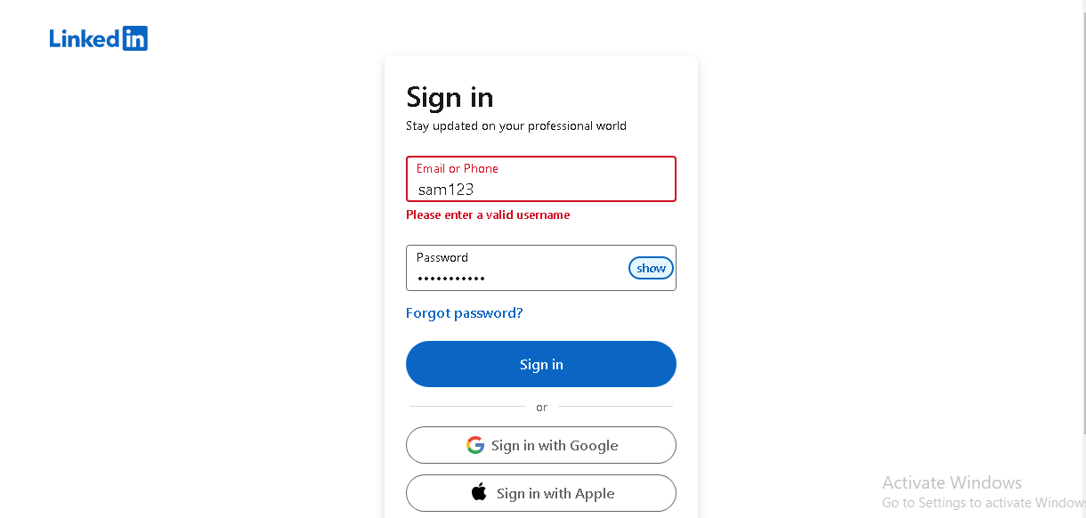

ACTUAL    -couldn't find an  account associated with user , STATUS-pass

3) wrong_username,password

  EXPECTED- couldn't find an  account associated with user



ACTUAL    -couldn't find an  account associated with user, STATUS-pass

1. username,wrong_password

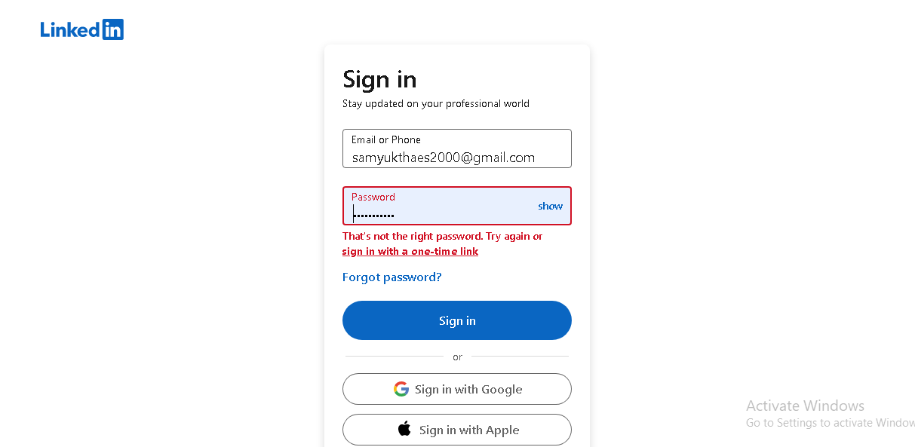

EXPECTED - invalid password ,ACTUAL   - invalid password, STATUS-pass