A PROJECT REPORT
On
REAL TIME MAINTENANCE DASHBOARD
Submitted in partial fulfillment of the
requirements for the degree of
BACHELOR OF TECHNOLOGY
In
Information and Communication Technology

Submitted by
117014082 – Samyuktha.M



Under the Guidance of
Sivakumar Mayamuthu Nadar
iNautix Technolgies Ltd.
April 2017


Examiner I Examiner II



Acknowledgement
I would forever remain grateful to honorable Prof. R. Sethuraman, Vice Chancellor for his encouragement in my academic life at SASTRA University.
I wish to express my profound gratitude toDr. S. Vaidhyasubramaniam, Dean - Planning & Development, Dr. S. Swaminathan, Director CeNTAB and Prof. G. Bhalachandran, Registrar for their overwhelming support provided during my course span in SASTRA University.
I am extremely thankful to Dr. K.S. Ravichandran, Associate Dean, Department of Information and Communication Technology for providing me the opportunity to do this project and for all the academic help extended in my project.
I sincerely express my gratitude to my manager Mr. Padmaraj Ramachandran and my team mentor Mr. Ramasubramanian Balasubramanian, iNAUTIX TECHNOLOGIES INDIA PVT LTD for their assistance and guidance for the successful implementation of project in a systematic and professional manner. I also express my gratitude to my mentor Mr. Manikandan Kathireson, iNAUTIX TECHNOLOGIES INDIA PVT LTD for always guiding me in the right direction to complete my project.
I also thank all the Teaching and Non-teaching staff, and those who have directly or indirectly helped me by extending their moral support and encouragement for completion of this project.
I thank God Almighty and my parents for helping me procure such a challenging and interesting project, and in completing the same in due course without much difficulty.

SYNOPSIS

Every organization needs a Monitoring Architecture to promptly alert the users about the servers, databases, hard disks, CPU usage etc and report the related problems to the immediate point of contact. In a multi-national organization, where a lot of hardware is being run round the clock, there is an urgent need for monitoring the servers and other resources for issues.

The eMONA monitoring system is used to detect and alert on events real-time that may create outages that have customer impact. eMONA provides a browser based GUI to view monitoring screens, reports and to configure alerts. It is a self-service tool that supports real-time alerting capabilities.

This project mainly aims at adding more values to the existing monitoring system. All the ongoing and upcoming maintenance activities such as scheduled system/server upgrades, application upgrade/deployment, host reboot, disk cleanup and several other maintenance activities are captured and presented in a consolidated dashboard. This would support the stakeholders aware about the activities and its progress.

TABLE OF FIGURES USED IN THIS PROJECT:

S.NO | FIG.NO | NAME OF THE FIGURE | PAGE NUMBER
1 | Fig 3.1 | Spring Framework Runtime Diagram | 4
2 | Fig 3.2 | Spring IoC Container Layout Diagram | 6
3 | Fig 3.3 | Aspect Oriented Programming Layout | 7
4 | Fig 3.4 | Spring MVC Flow Diagram | 8
5 | Fig 3.5 | Scatter chart using HighCharts | 9
6 | Fig 3.6 | jUnit Architecture | 10
8 | Fig 4.1 | Class Diagram for eMona Dashboard | 13
9 | Fig 4.2 | Use Case Diagram for eMona Dashboard | 14
10 | Fig 4.3 | Activity Diagram for eMona Dashboard | 15

TABLE OF CONTENTS

Chapter No. | TITLE | Page Number
1. | Introduction | 1
2. | Software Project Plan | 3
3. | Software Requirements Specification | 4
4. | System Analysis and Design | 12
5. | Coding | 16
6. | Implementation | 19
7. | Output Snapshots | 20
7. | Conclusion | 27
8. | References | 28

1.INTRODUCTION
1.1 INTRODUCTION TO THE COMPANY – iNAUTIX
1.1.1 INTRODUCTION
iNautix Technologies India Private Limited is a captive organisation of Bank of New York Mellon - a leading financial services provider. iNautix provide technology development, business & technology operations and remote infrastructure management services for BNY Mellon and its subsidiaries. iNautix also develops and delivers comprehensive technology solutions and software development products for customers of BNY Mellon.

1.1.2 FOUNDERS
The Bank of New York Mellon was founded by Alexander Hamilton in 1784. Gerald Hassell is an American bank executive and is the Chairman and CEO of the Bank of New York Mellon from 2011. Suresh Kumar is the CEO of iNautix Technologies.

1.1.3 ABOUT COMPANY
iNautix Technologies, established in the year 2000,provides technology solutions to BNY Mellon. As an innovation-focused company, iNautix specializes in providing insightful and new age technology solutions to help meet clients' business needs end-to-end. Since its inception in 2000, iNautix has maintained a relentless commitment to develop products and solutions that are designed to improve operational efficiencies, make planning more dynamic and realistic, monitoring and evaluation simple, risk-free and methodical, increase productivity, enhance delivery performance and ensure success for our clients.

1.2 BACKGROUND OF THE PROJECT
Each organization has its datacenters in different geographical locations far from each other, in order to withstand any natural calamities. Each datacenter in turn has numerous severs associated with it. .These servers are run round the clock and databases are accessed several times a day. When a server goes down for a few hours, it can affect the service of thousands of customers. Scheduled shut downs are also carried out for the maintenance of servers. Other maintenance activities like
- Disk Usage,
- Application deployment;
- Host Reboot
are also carried out. A monitoring Architecture has to be in place for ensuring proper delivery of services. A monitoring architecture also reports the performance of the IT infrastructure.

2. SOFTWARE PROJECT PLAN
2.2.1 OBJECTIVE
The ultimate aim is to develop a Real Time Maintenance dashboard that will help the administrator identify the various issues that are encountered and also gives an insight about the status of the issue, reporter and the attendee of the issue.
2.2.2 EXISTING SYSTEM AND LIMITATIONS
The eMONA Monitoring system used to detect and alert on events real-time that may create outages that may have customer impact. eMONA provides a browser based GUI to view monitoring screens, reports and to configure alerts. It is a self-service tool where the users are notified on real time. eMONA provides a dashboard that helps the personnel not only identify the issue but also specifies the severity of the issue.
2.2.3 PROPOSED SYSTEM
The proposed system adds more values to the existing monitoring architecture. Maintenance activities such as
- scheduled system/server updates,
- application upgrade/deployment,
- Host reboot,
- Disk cleanup and several other maintenance activities of the servers, databases, CPUs in an organization are reported on the dashboard based on its history.
The results can be exported to multiple formats which include excel, txt, JSON. The dashboard also provides functionalities which provides details about the application usage through various visual aids such as graph, pie chart, bar graph.

3.SOFTWARE REQUIREMENTS SPECIFICATION
3.1. FUNCTIONAL REQUIREMENTS
3.1.1. SPRING MVC ARCHITECTURE:
The spring web MVC framework provides model-view-controller architecture and in-built components that could be used to develop flexible and loosely coupled web applications. The MVC pattern helps in separating the different parts of the application (input logic, business logic, and User Interactive logic), by providing a loose coupling between these elements.
Model - encapsulates the application data and in general they will consist of POJO.
View - responsible for rendering the model data and in general it generates HTML output that the client's browser can interpret.
Controller - responsible for processing user requests and building appropriate model and passes it to the view for rendering.

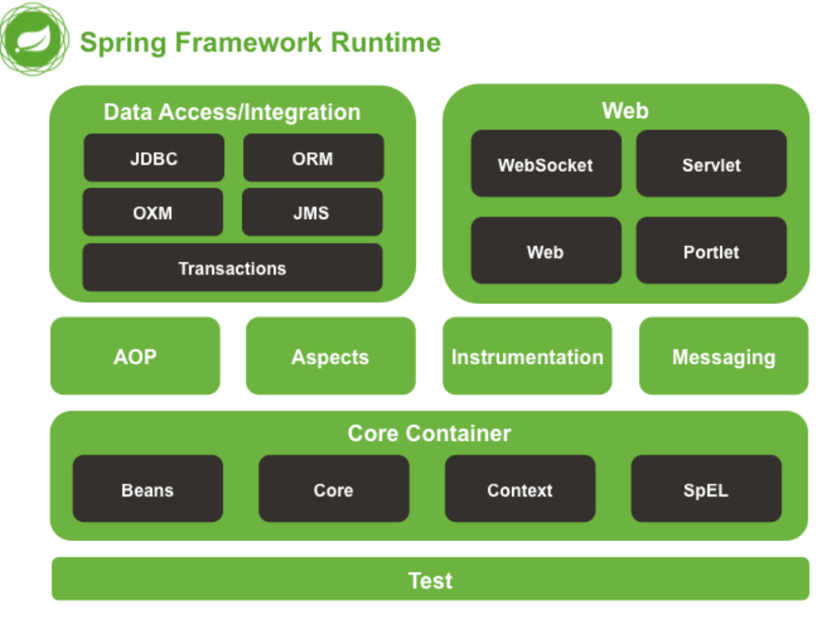
Fig 3.1 Spring Framework Runtime Diagram

BENEFITS OF SPRING FRAMEWORK:
- Spring helps developers to develop enterprise-class applications using POJOs. The advantage of using only POJOs is that you need have an EJB container product such as an application server instead use only a robust servlet container such as Tomcat Server.
- Spring is organized in a modular structure.
- Spring truly makes use of some of the existing technologies like ORM frameworks, logging frameworks, JEE, Quartz and JDK timers.
- Spring applications are easy to test and simple because environment dependent code is moved into framework. In addition, by using Java Bean-style POJOs, it becomes easier to use dependency injection for injecting test data.
- Spring provides a suitable and compatible API to translate technology-specific exceptions (thrown by JDBC, Hibernate, or JDO) into consistent, unchecked exceptions.
- Lightweight IoC containers are useful for developing and deploying applications on systems with limited memory and CPU resources.
- Spring provides consistent transaction management interface which scales down to a local transaction (using a single database, for example) and scales up to global transactions (using JTA, for example).

3.1.2. SPRING IOC CONTAINERS:
The spring container is the core element of Spring Framework. The container creates objects, wire them together, configure them, and manage their complete lifecycle from creation till destruction.
The spring container uses dependency injection (DI) to manage the components which constitute an application. These objects are called Spring Beans .The container gets information on what objects to create, configure, and assemble from configuration metadata provided which can be represented either by XML, Java annotations, or Java code. The following diagram is a high-level view of how spring works. The Spring IoC container makes use of POJO classes and configuration metadata to produce a completely configured and executable application.
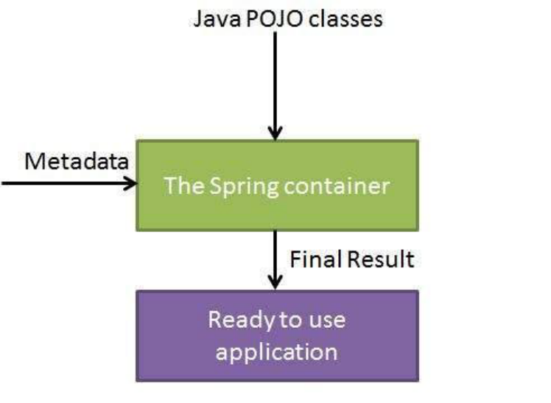
Fig 3.2 Spring IoC Container Layout Diagram

3.1.3. DEPENDENCY INJECTION(DI):
The spring framework is recognized and used widely for having Dependency Injection (DI) as flavour of Inversion of Control. Dependency Injection is a concrete example of Inversion of Control.
When we build complex Java application, DAO classes should be independent as possible of other Java classes to increase the reusability and to test independently Dependency Injection helps in connecting these classes together and same time keeping them independent.
Dependency is something which translates into an association between two classes. For example, class A is dependent on class B. Now, Injection is that class B will get injected into class A by the IoC. Dependency injection can be as of passing parameters to the constructor or by post-construction using setter methods.

3.1.4. ASPECT -ORIENTED PROGRAMMING:
Aspect oriented programming (AOP) is one of the key components of spring framework. The functions which span multiple points of an application are called cross-cutting concerns and they are theoretically separate from the application's business logic. There are numerous examples of aspects including logging, declarative transactions, security, and caching.

The key aspect of modularity in OOP is the class, whereas in AOP the unit of modularity is the aspect. The AOP module provides aspect-oriented programming implementation which enables you to define method-interceptors and point cuts to clearly decouple code which implements functionality that should be separated.

- Aspect: modularization of a concern that cuts across multiple classes. Eg :Transaction management
- Join point: a point which occurs during the execution of a program or the handling of an exception. In Spring AOP, it always represents a method execution.
- Advice : Action taken at a particular joinpoint occurred. Different types of advice are “after”, ”before” and “around”. Spring model an advice as an interceptor.
- Pointcut: a predicate which is matched with join points. Advice is associated with a pointcut expression and runs at any join point matched by the pointcut.

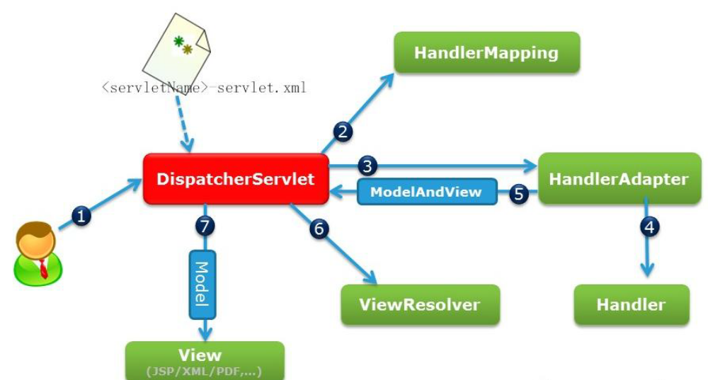
Fig 3.3 Aspect Oriented Programming Layout

3.1.5. DISPATCHER SERVLET:
The Spring Web(MVC) framework is designed with a DispatcherServlet that handles all the HTTP requests and responses. Therequest processing workflow of DispatcherServlet is described in the following diagram

Sequence of events for an incoming HTTP request to DispatcherServlet:
- After receiving an HTTP request, DispatcherServlet goes to handler mapping to call the appropriate Controller.
- The Controller processes request and calls the appropriate service methods based on GET or POST methods. The service method will set model data based on business logic defined and view name is returned to the DispatcherServlet.
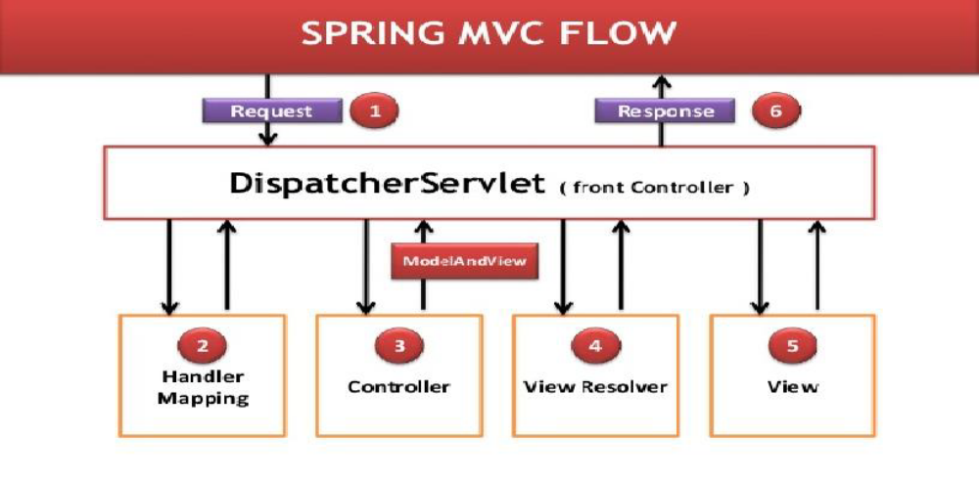
Fig 3.4 Spring MVC Flow Diagram

- With the help of ViewResolver, DispatcherServlet picks defined view for the request.
- DispatcherServlet passes model data to view when finalized which is rendered on the browser.
3.1.6 JAVASCRIPT
JavaScript is a lightweight programming language which is used to create network-centric applications. It is complimentary to Java programming language. It is open and cross-platform.

3.1.7 HIGHCHARTS
Charts are displayed on the GUI which uses real time data. They are developed using high charts as they provide efficient charting capability and enhance the application. High charts are charting libraries by JavaScript. Issues that are recorded in the servers are put on the dashboard with the help of highcharts.These charts are highly compatible with all the browsers and provide multi touch support. Highcharts require jQuery dependencies. These charts take json documents as input.
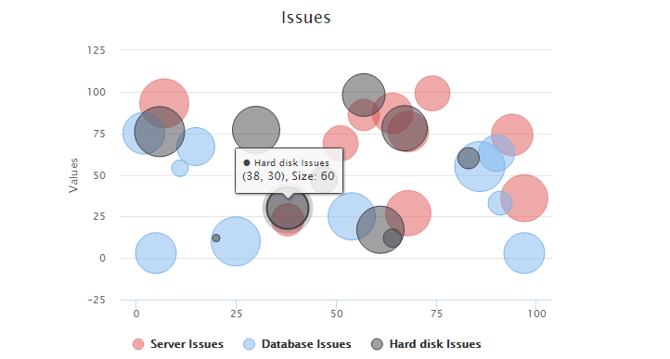

Fig 3.5 Scatter Chart using highcharts

3.1.8 . REST
Representational State Transfer (REST) is an architecture style that defines a particular way of integrating web based applications. RESTful services are mostly used in the project over Simple Object Access Protocol (SOAP) since SOAP protocol permits xml formats only to be written.
Moreover, RESTful services are lightweight as they use jsons. RESTful services require less bandwidth. RESTful services are developed using spring framework. Spring framework uses a model-view-controller pattern and also helps a developer in the lifecycle management of objects. It enables the creation of dynamic Web-based applications that are also platform-independent.
3.1.9 . JSP
The Java Server Pages Standard Tag Library (JSTL) is a collection of useful JSP tags which hold together the core functionality common to many JSP applications.
JSTL has support for common applications such as formatting, database access, iterating, manipulating XML documents, structural tasks such as iteration and conditionals, tags for manipulating XML documents, internationalization tags, and SQL tags. It also provides a framework for integrating existing custom tags with JSTL tags.

3.1.10. JUNIT
Unit Testing is a software testing method where each components are tested individually before integration. Several tools are available in market for testing the components. Test cases are put into a test suite and they are tested sequentially. jUnit, a unit testing framework has been helpful in test-driven development. jUnits has annotations that facilitate invocation of test methods.
A formal written unit test case is characterized by a known input and an expected output, which is worked out before the test is executed. The known input should test a precondition and the expected output should test a post-condition.
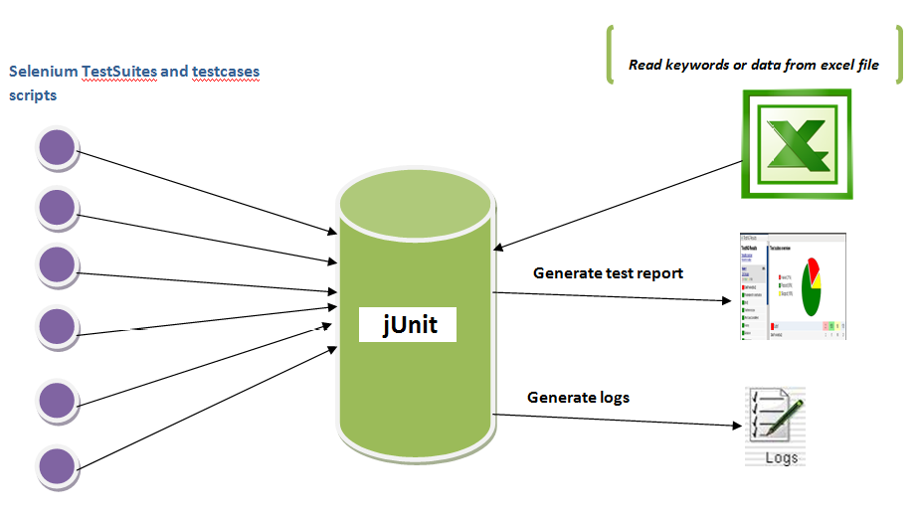
Fig 3.6 jUnit Architecture

3.2. NON FUNCTIONAL REQUIREMENTS
3.2.1 HARDWARE CONFIGURATION
Operating System: Windows 7 Enterprise
Installed Ram : 8 GB
Processor : Intel(R) Core(TM) CPU @ 3.20GHz

3.2.2 SOFTWARE CONFIGURATION
Software Version
Microsoft Visual Studio 2013 12.0.21005.1
Microsoft SQL Server Management Studio 2008 10.50.1600.1
DIA 0.97.2
Bootstrap 3.3.7
AngularJS 1.9.1
jQuery 2.1.1
JavaScript 4.1

4.SYSTEM ANALYSIS AND DESIGN
4.1 SYSTEM DESIGN
System design is the process of defining the elements of a system such as the architecture, modules and components, the different interfaces of those components and the data that goes through that system. It is meant to satisfy specific needs and requirements of a business or organization through the engineering of a coherent and well-running system. Systems design could see it as application of systems theory to product development. There is some overlap with the discipline of the system analysis, architecture and engineering. Conceptual design is not the end of design process. It serves as the basis for a brief design.
System design implies a systematic and rigorous approach to the design as demanded by complexity of many system problems

4.1.1 HIGH LEVEL DESIGN
UML stands for Unified Modeling Language. UML is a standard language for specifying, visualizing, constructing, and documenting the artifacts of software systems. In other words, it is often described as the successor of object oriented design and analysis.
The goal is for UML to become a common language for creating models of object oriented computer software. UML is just not limited to software systems but also can be used to model non software systems. The UML uses mostly graphical notations to express the design of software objects.

4.2 UML DIAGRAMS
4.2.1 CLASS DI AGRAM
Class Diagrams portrays the static structure of any project. Thus, it is easy for the developers to create plain old java objects using class diagram. Class Diagrams also has a facility to include association, composition and aggregation. Multiplicity or cardinality can also be represented in the class diagram.

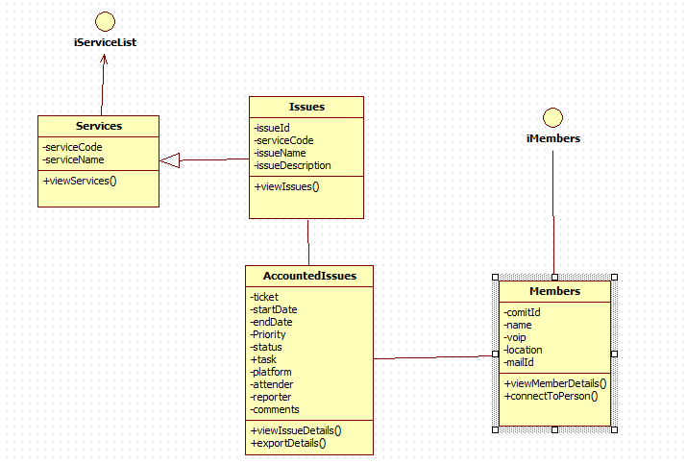
Fig 4.1 Class Diagram for eMona Dashboard

4.2.2 USE CASE DIAGRAM
The purpose of use case diagram is to capture the dynamic aspect of a system. Use Case Diagrams are used to gather those requirements that influence the system internally and externally. They are most often requirements related to design. Therefore, when a system is studied to understand and gather its functionalities uses cases are constructed.

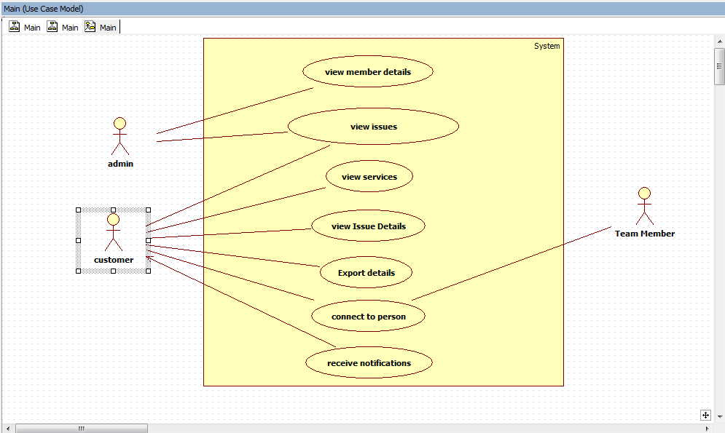

Fig 4.2 Use Case Diagram for eMona Dashboard

4.2.3. ACTIVITY DIAGRAM
Activity diagram deals with the dynamic aspects of any system. Activity diagram describes change from one state to another. Constraints, Association and other relationships has to be identified before starting with the activity diagram. The specific usage is to model the control flow from one activity to another. This control flow does not include messages.

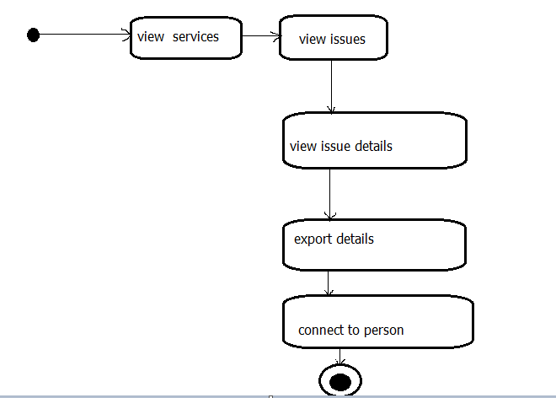

Fig 4.3 Activity Diagram for eMona Dashboard

5. CODING
5.1. SAMPLE CODING
Any dependency that has to be included has to be injected in the pom.xml file. Maven helps in maintaining the project structure especially when the project grows exponentially. The following code has to be injected in the pom.xml file:

<project xmlns="http://maven.apache.org/POM/4.0.0" xmlns:xsi="http://www.w3.org/2001/XMLSchema-instance"
xsi:schemaLocation="http://maven.apache.org/POM/4.0.0 http://maven.apache.org/maven-v4_0_0.xsd">
<modelVersion>4.0.0</modelVersion>
<groupId>ira.training.xeccq49</groupId>
<artifactId>SpringEmonaWebService</artifactId>
<packaging>war</packaging>
<version>0.0.1-SNAPSHOT</version>
<name>SpringStudentRestWebService Maven Webapp</name>
<url>http://maven.apache.org</url>
<properties>
<jdk.version>1.7</jdk.version>
<spring.version>4.1.1.RELEASE</spring.version>
<jstl.version>1.2</jstl.version>
<junit.version>4.11</junit.version>
<logback.version>1.0.13</logback.version>
<jcl-over-slf4j.version>1.7.5</jcl-over-slf4j.version>
</properties>

<dependencies>

<!-- Unit Test -->
<dependency>
<groupId>junit</groupId>
<artifactId>junit</artifactId>
<version>${junit.version}</version>
</dependency>

<!-- Spring Core -->
<dependency>
<groupId>org.springframework</groupId>
<artifactId>spring-core</artifactId>
<version>${spring.version}</version>
<exclusions>
<exclusion>
<groupId>commons-logging</groupId>
<artifactId>commons-logging</artifactId>
</exclusion>
</exclusions>
</dependency>

<dependency>
<groupId>org.slf4j</groupId>
<artifactId>jcl-over-slf4j</artifactId>
<version>${jcl-over-slf4j.version}</version>
</dependency>

<dependency>
<groupId>ch.qos.logback</groupId>
<artifactId>logback-classic</artifactId>
<version>${logback.version}</version>
</dependency>

<dependency>
<groupId>org.springframework</groupId>
<artifactId>spring-web</artifactId>
<version>${spring.version}</version>
</dependency>

<dependency>
<groupId>org.springframework</groupId>
<artifactId>spring-webmvc</artifactId>
<version>${spring.version}</version>
</dependency>

<!-- jstl -->
<dependency>
<groupId>jstl</groupId>
<artifactId>jstl</artifactId>
<version>${jstl.version}</version>
</dependency>

<dependency>
<groupId>org.springframework</groupId>
<artifactId>spring-jdbc</artifactId>
<version>${spring.version}</version>
</dependency>

<!-- Jackson JSON Processor -->
<dependency>
<groupId>com.fasterxml.jackson.core</groupId>
<artifactId>jackson-databind</artifactId>
<version>2.4.1</version>
</dependency>

</dependencies>
<build>
<finalName>SpringStudentRestWebService</finalName>
</build>
</project>
All the spring configurations are placed in an xml file named Spring servlet.xml. The following code has to be paced in the spring configuration file.
<beans xmlns="http://www.springframework.org/schema/beans"
xmlns:xsi="http://www.w3.org/2001/XMLSchema-instance" xmlns:context="http://www.springframework.org/schema/context"
xmlns:mvc="http://www.springframework.org/schema/mvc"
xsi:schemaLocation="http://www.springframework.org/schema/beans http://www.springframework.org/schema/beans/spring-beans.xsd
http://www.springframework.org/schema/context http://www.springframework.org/schema/context/spring-context.xsd
http://www.springframework.org/schema/mvc http://www.springframework.org/schema/mvc/spring-mvc.xsd">

<context:component-scan base-package="main.services" />

<mvc:annotation-driven />
<mvc:default-servlet-handler/>

<bean id="dataSource" class="org.springframework.jdbc.datasource.DriverManagerDataSource">
<property name="driverClassName" value="org.apache.derby.jdbc.ClientDriver" />
<property name="url" value="jdbc:derby://**.***.***.**:****/****" />
<property name="username" value="*****" />
<property name="password" value="*****" />
</bean>

<bean id="issuesDAO" class="main.services.IssuesDAO" />

</beans>

5.IMPLEMENTATION

5.1 PROBLEMS FACED
The process of development of any application involves certain issues which might be encountered in any of the various stages of the software development life cycle. During models development there were problems faced during training (development) and evaluation phases.

Some of the issues that were encountered:
- Integrating the real time data to charts using highcharts.
- Mapping jsons to objects.
- Populating jsons from web services to datatables .
- Creating widgets from the web services.
- Designing UI involved when bootstrap components misaligned with the angular js components.

During evaluation phase the problem that arose was:
- Independent execution of test cases using a junit file was easier but when the test cases were used to test the web services, JSON objects were not displayed.
- resolving the errors from the test error log was difficult as it involved step by step execution of the test cases.
- Validation of score cards created additional problems.
- The Exception history is saved as a log traversing through these logs to validate created additional challenges.

6. OUTPUT SNAPSHOTS-REALTIME MAINTENANCE DASHBOARD

6.1 WELCOME PAGE

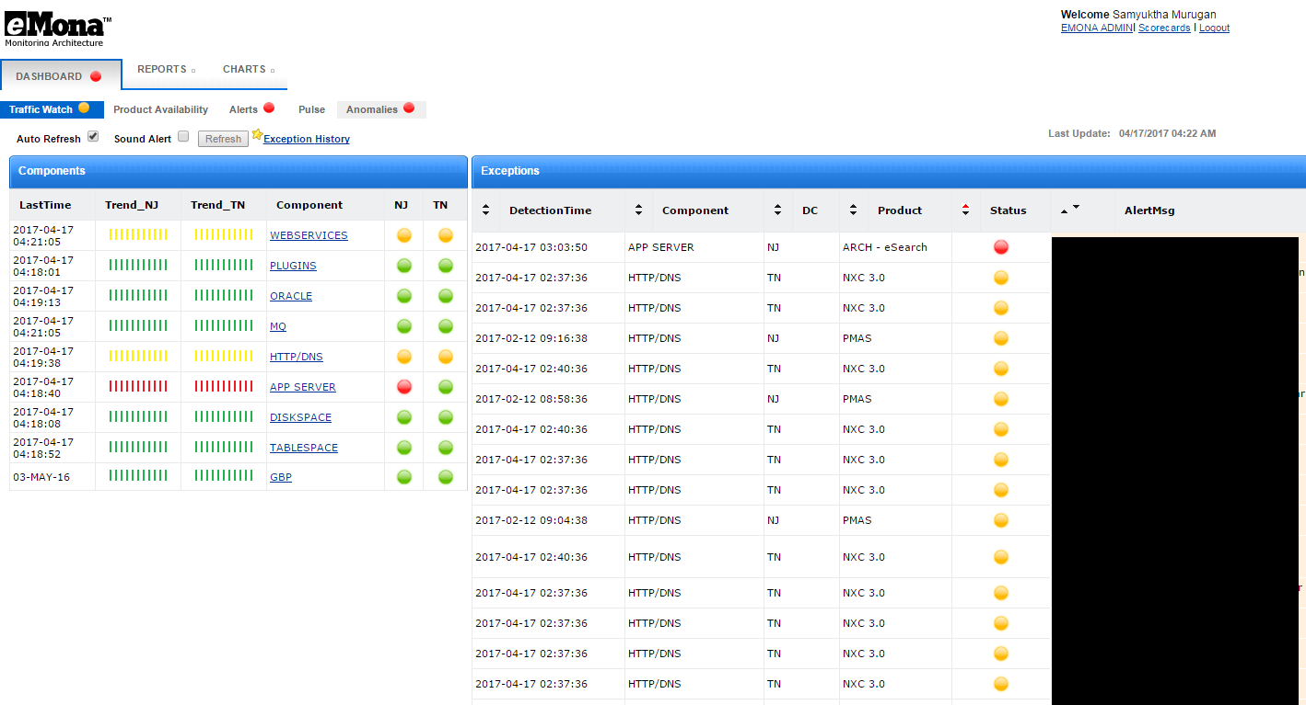

6.2 REPORTS PAGE

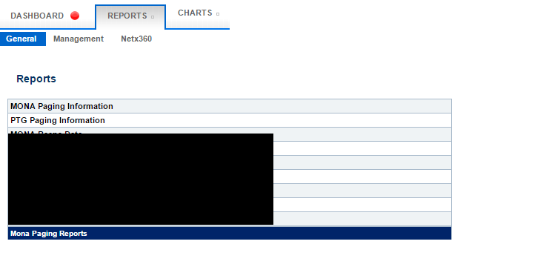

6.3 PREDICTIVE ANALYSIS
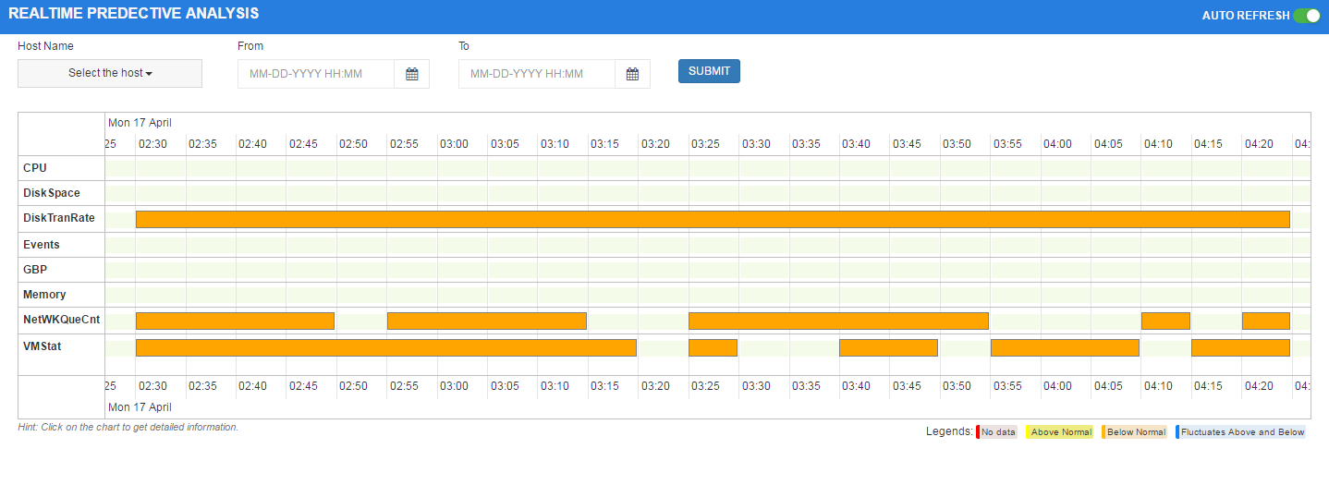
6.4 EXCEPTION HISTORY

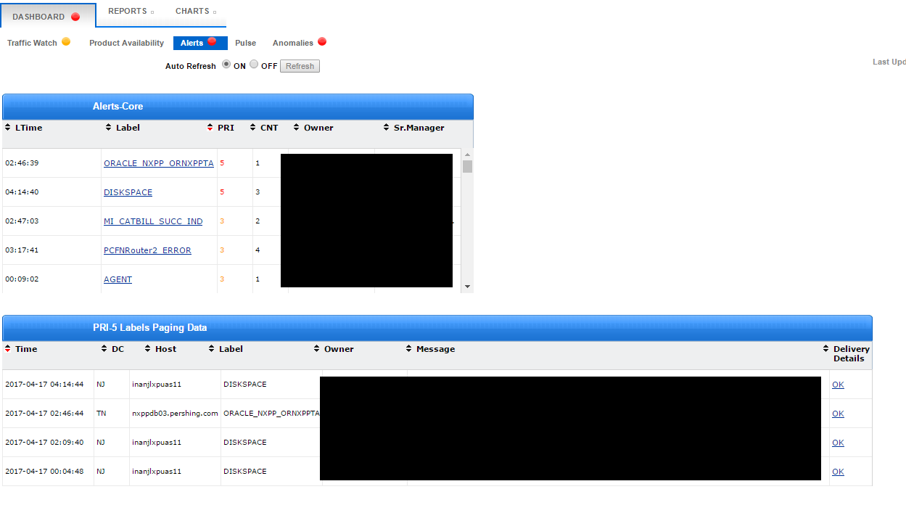

6.5 ANOMALIES IN DATA

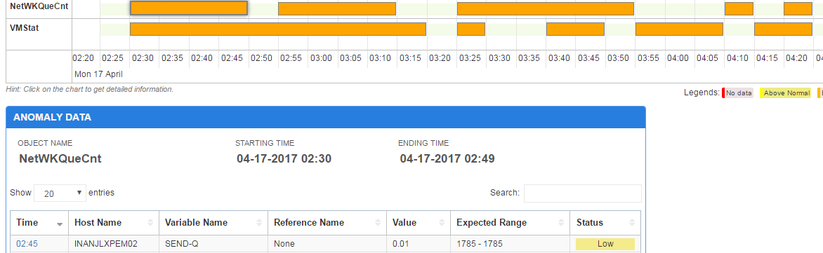

6.6 PRODUCT AVAILABILITY

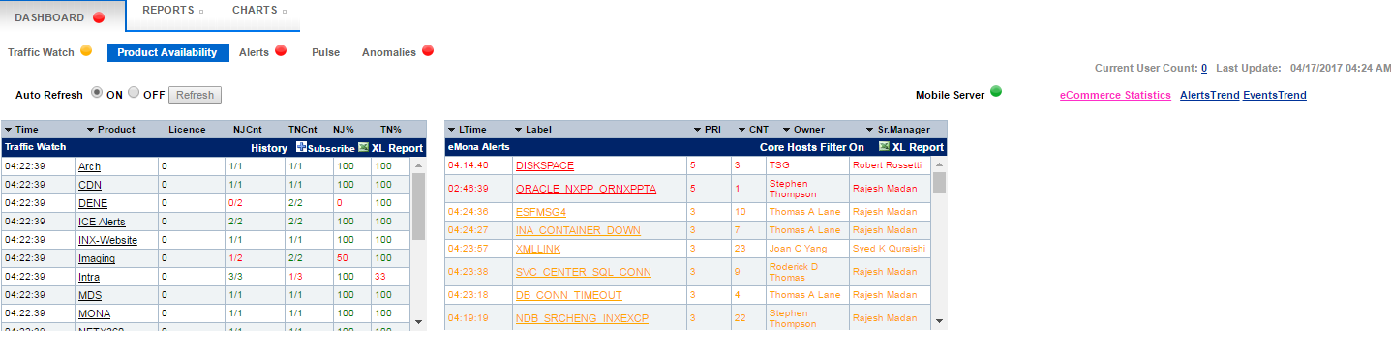

6.7 DATA TABLES
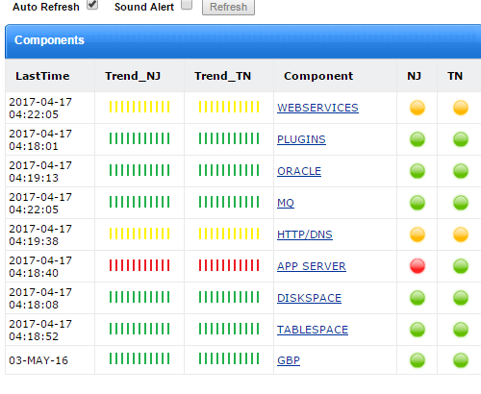
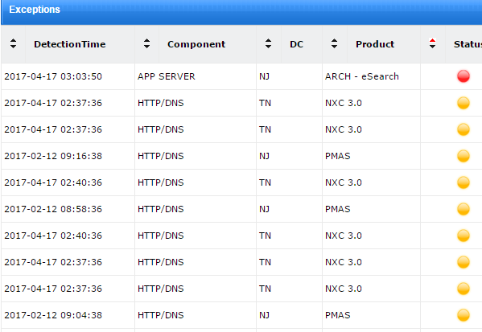

6.8. DYNAMIC COLUMN ADDING
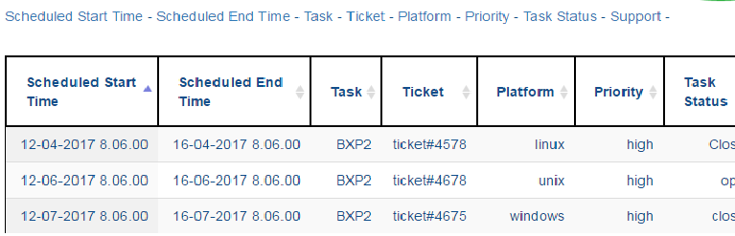

6.9. ISSUES ALONG WITH THEIR PRIORITIES

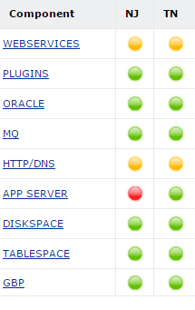

7. CONCLUSION

7.1 CONCLUSION
Thus a monitoring architecture that would promptly report the status of any issue that has been raised has been developed. This project adds additional functionalities to the existing application. Every issue is displayed along with their priority on the dashboard. Issues are categorized according to their domains. It is easy for the administrator to visualize the issues through a scatter / bubble chart.

7.2 FUTURE PLANS
Security Implementations can be included and the facility to view the table details in the form of charts can be accommodated. This effort can also be extended for issues other than servers, databases and hard disks. Functionalities to include hardware issues can also be incorporated.

8.REFERENCE

http://spring.io/guides/gs/rest-service/
https://docs.angularjs.org/tutorial/step_11
https://github.com/junit-team/junit4/blob/master/doc/ReleaseNotes4.11.md
https://www.highcharts.com/demo

