Editor feature matrix
Editor feature matrix
Headings
Heading 3
Heading 4
Heading 5
Heading 6
Text marks & styles
Alignment
Lists
Quote & divider
Callout variants
Code block
Table
Columns
Block equation
YouTube embed
Mermaid diagram
Quiz block
Question 1
Question 2
Question 3
Question 4
Quiz answer key
Flashcards block
Card 1
Card 2
This note intentionally exercises every Plate feature except uploaded media nodes (img / audio / file).

Headings

Heading 3

Heading 4

Heading 5

Heading 6

Text marks & styles
plain · bold · italic · underline · strike · inline code · Ctrl+B · highlight · H₂O · E=mc²
colored · tinted · larger · serif sample
Inline link: OpenStax Biology · mention @Kate Malone · inline math 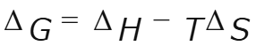.

Alignment
Left-aligned paragraph (default).
Center-aligned paragraph.
Right-aligned paragraph.
Justify-aligned paragraph: membranes separate compartments so gradients can do work across the bilayer.

Lists
• Bulleted item — organelles
• Bulleted item — membranes
1. Numbered step — isolate the variable
2. Numbered step — apply the model
☑ Todo checked — skim the matrix
☐ Todo open — try each toolbar control

Quote & divider
“Nothing in biology makes sense except in the light of evolution.” — Theodosius Dobzhansky

Callout variants
Info
Info callout — background reading is linked above.

Success
Success callout — you covered every non-media block.

Warning
Warning callout — osmolarity units trip people up.

Danger
Danger callout — do not confuse lysis with crenation.

Code block
def atp_yield(glucose_mol: float) -> float:
"""Rough aerobic yield (~30-32 ATP / glucose)."""
return glucose_mol * 30

Table
Process | Location | ATP net
Glycolysis | Cytosol | 2
Krebs cycle | Mitochondrial matrix | 2
ETC / oxidative phosphorylation | Inner membrane | ~28

Columns
Two-column left — structure. | Two-column right — function.

Prokaryote | Eukaryote animal | Eukaryote plant

Wide column: endosymbiotic origin of mitochondria. | Narrow: DNA circular.

Block equation
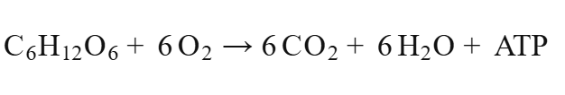

YouTube embed
YouTube video
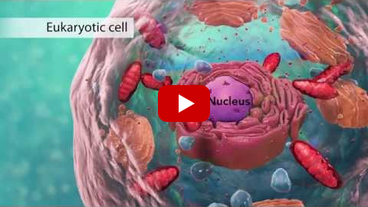

Mermaid diagram
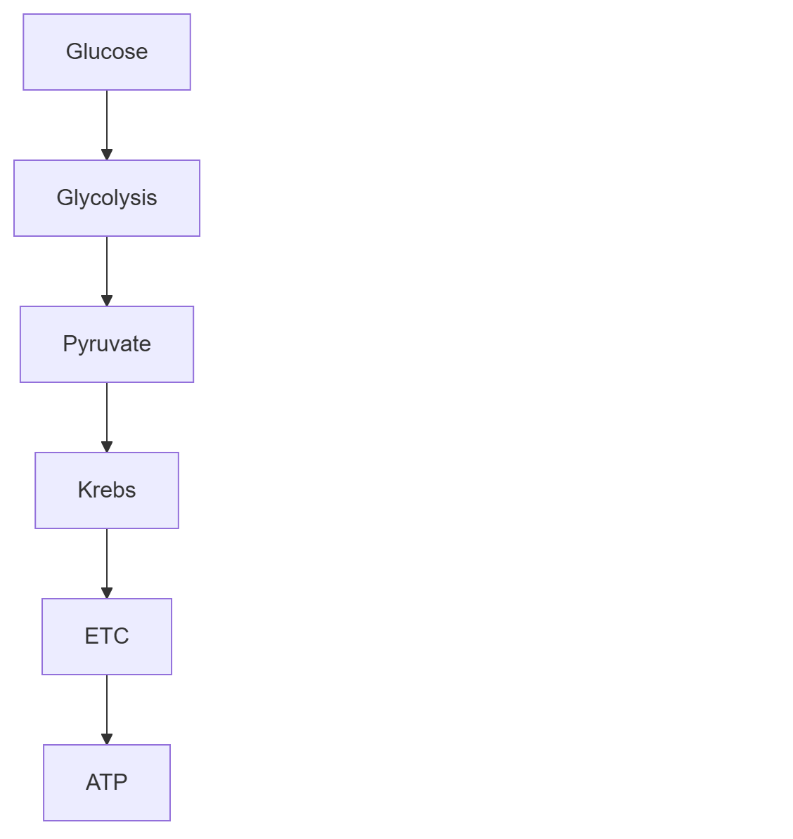
Respiration overview

Quiz block

Question 1
(a) Marks: 1
Where does glycolysis occur?
A. Cytosol
B. Nucleus
C. Golgi lumen

Question 2
(a) Marks: 1
Which organelles contain their own DNA? (multi)
☐ Mitochondria
☐ Lysosomes
☐ Chloroplasts

Question 3
(a) Marks: 1
Ribosomes are present in both prokaryotes and eukaryotes.
☐ True ☐ False

Question 4
(a) Marks: 1
The main short-term energy carrier is ____.
Answer: ______________________________

Quiz answer key
1. Answer
A. Cytosol
Marking scheme · Marks: 1
• Glycolysis occurs in the cytosol of the cell.
Worked solution
Glycolysis occurs in the cytosol of the cell.
2. Answer
A. Mitochondria
C. Chloroplasts
Marking scheme · Marks: 1
• Both mitochondria and chloroplasts have their own DNA.
Worked solution
Both mitochondria and chloroplasts have their own DNA.
3. Answer
True
Marking scheme · Marks: 1
• True — ribosomes are not membrane-bound.
Worked solution
True — ribosomes are not membrane-bound.
4. Answer
ATP
adenosine triphosphate
Marking scheme · Marks: 1
• ATP is the cell’s short-term energy currency.
Worked solution
ATP is the cell’s short-term energy currency.

Flashcards block

Card 1
Front: What does ATP stand for?
Back: Adenosine triphosphate — cellular energy currency

Card 2
Front: Define osmosis
Back: Diffusion of water across a semi-permeable membrane
End of matrix. Media uploads (img / audio / file) are omitted on purpose.
Comparison
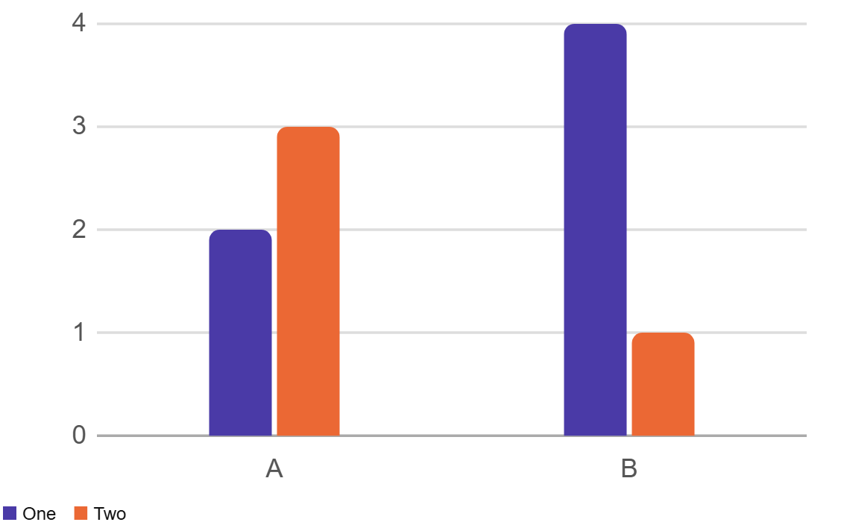

 | One | Two
A | 2 | 3
B | 4 | 1

