Samuel Guizar
9/25/26
Module 9.2 Assignment

Step 4 Screenshot:
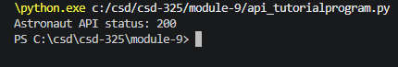

Step 5 Screenshot:
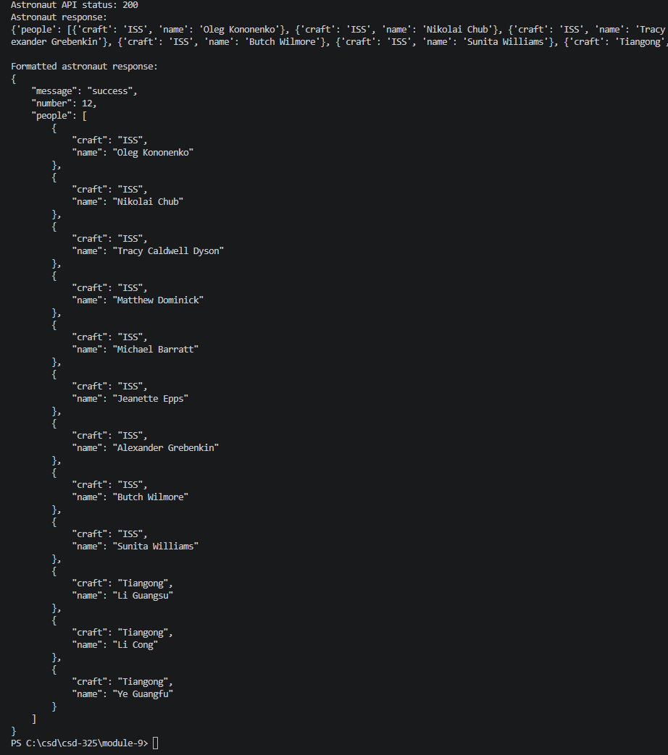

Step 6 Screenshot: Found an API on Digimon. Lots of data so the result goes for quite a while.
