Samuel Guizar
9/17/26
Module 7.2 Assignment

Step 4a:
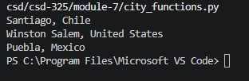
Step 4b:
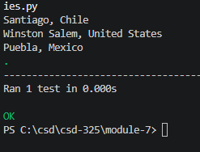
Step 4d:
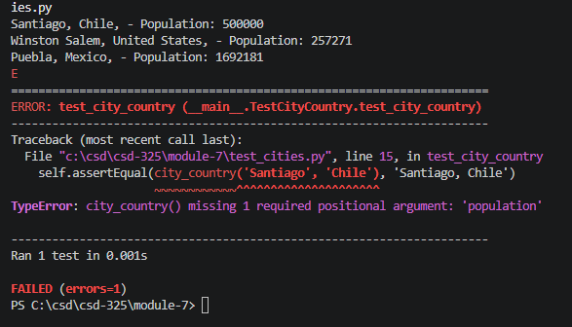
Step 4f:
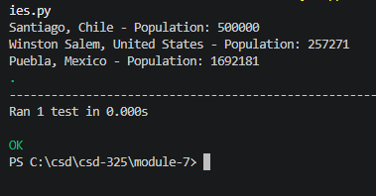
Step 4h:
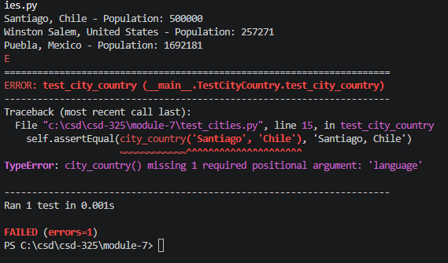
Step 4j:
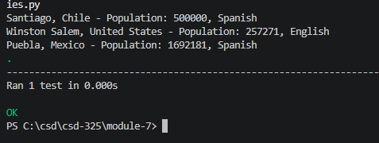
Step 4k:
