Samuel Guizar
9/18/26
Module 8.2 Assignment

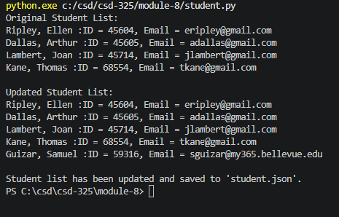

I didn’t get a notification for this step:
Run the program and take a screenshot of the results. Paste that screenshot into your Word document.

But I checked the json file and it was updated correctly.
The file kept automatically updating without asking me or giving me the popup.
I tried multiple things to get it to show up but nothing worked.

[
{
"F_Name": "Ellen",
"L_Name": "Ripley",
"Student_ID": 45604,
"Email": "eripley@gmail.com"
},
{
"F_Name": "Arthur",
"L_Name": "Dallas",
"Student_ID": 45605,
"Email": "adallas@gmail.com"
},
{
"F_Name": "Joan",
"L_Name": "Lambert",
"Student_ID": 45714,
"Email": "jlambert@gmail.com"
},
{
"F_Name": "Thomas",
"L_Name": "Kane",
"Student_ID": 68554,
"Email": "tkane@gmail.com"
},
{
"F_Name": "Samuel",
"L_Name": "Guizar",
"Student_ID": "59316",
"Email": "sguizar@my365.bellevue.edu"
}
]

