Samuel Guizar
8/31/26
Module 4.2 Assignment

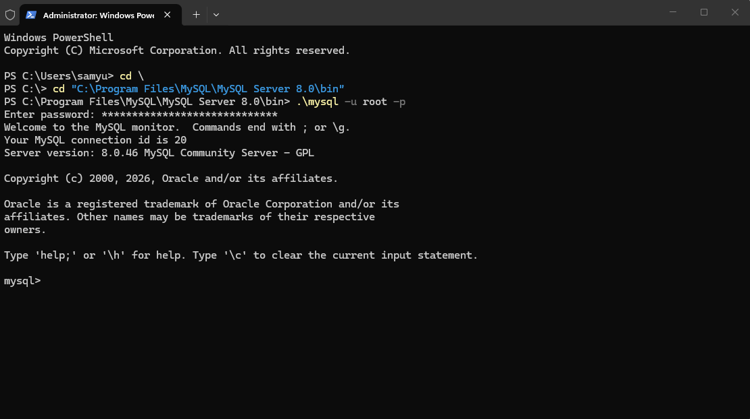
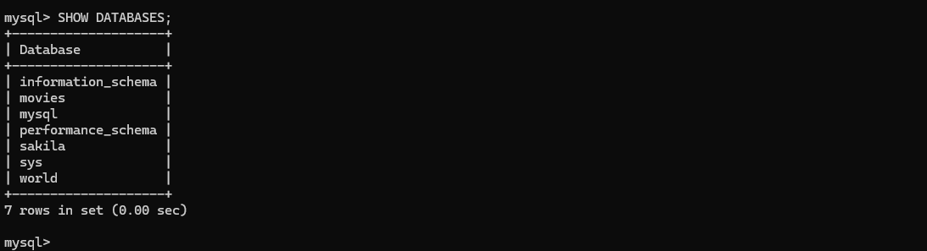

Function: LOWER
When it might be used: To provide consistent formatting
Appropriate Alias: lowercase_supplier_name
SQL Statement: SELECT LOWER(SupplierName) AS lowercase_supplier_name FROM Suppliers;

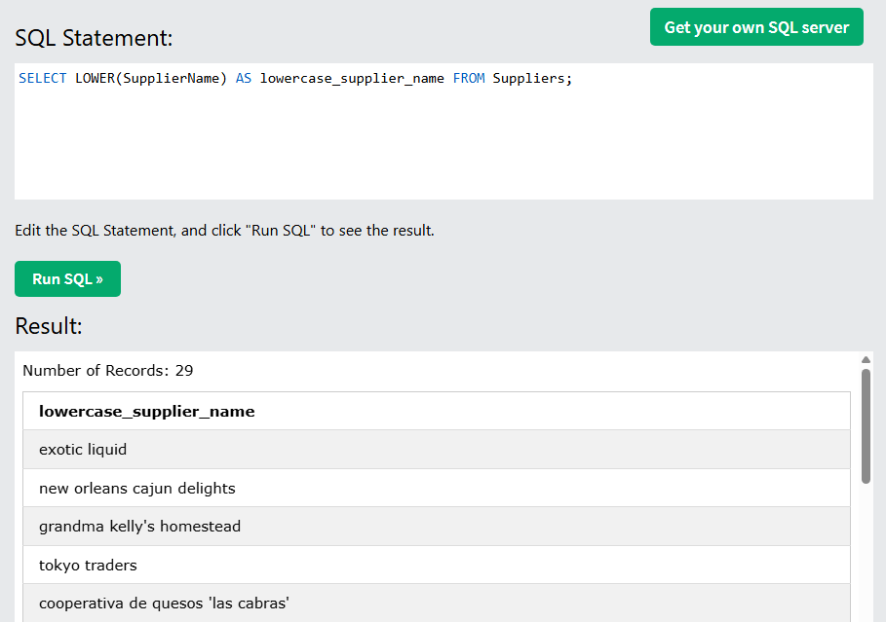

Function: REPEAT
When it might be used: To execute certain code more than once
Appropriate Alias: repeat_units
SQL Statement: SELECT REPEAT(Unit, 3) AS repeat_units FROM Products;

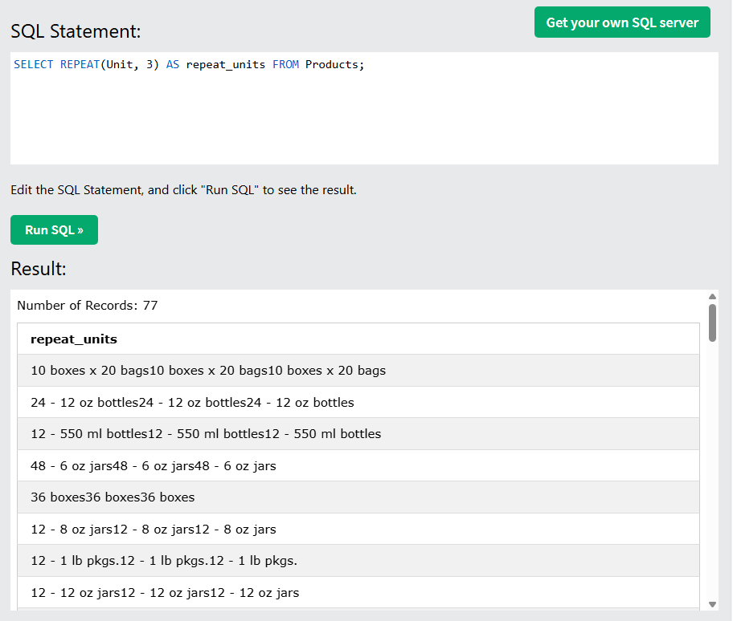

Function: UPPER
When it might be used: To provide consistent formatting
Appropriate Alias: uppercase_category_name
SQL Statement: SELECT UPPER(CategoryName) AS uppercase_category_name FROM Categories;

