Samuel Guizar
8/29/2026
Module 3.2 Assignment

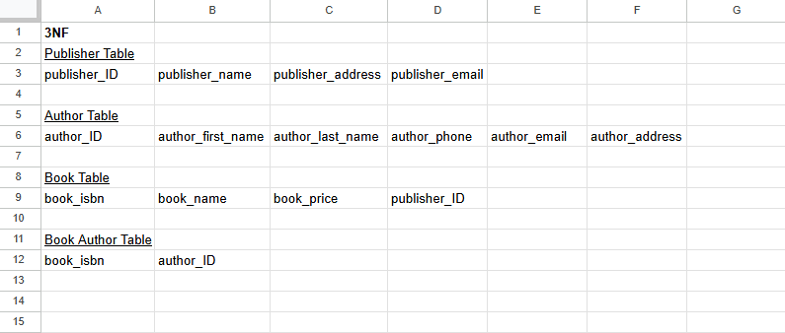

Assumptions Made:
- Publisher Table should store all publisher information
- Author Table should store all author information
- Each book has one publisher, so publisher_ID should be a foreign key in Book Table
- A book can have multiple authors, and authors can have multiple books, so there is a Book Author table to display the relationship between book_isbn and author_ID

