GROUP D
Bacchus Winery Case Study
Milestone 3

Team Members | Verdis Moorer and Samuel Guizar
Case Study | Bacchus Winery

Reports

Report 1: Supplier Delivery Report
Purpose: This report displays supplier names, purchase order numbers, order dates, expected delivery dates, shipping dates, expected arrival dates, actual arrival dates, and tracking numbers.
Bacchus Winery receives bottles, corks, labels, boxes, vats, and tubing from three different suppliers. This report allows Stan and Davis to check whether suppliers are delivering supplies on time and identify delays between expected and actual arrival dates. It can also help them identify suppliers that regularly deliver late and determine whether changes to their ordering process are needed.
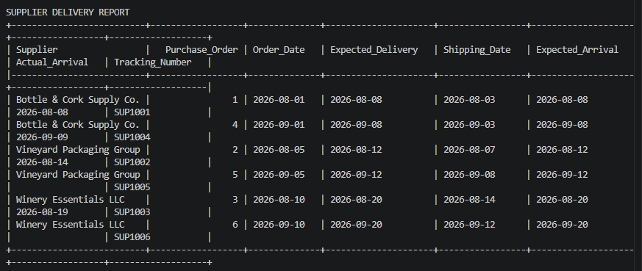

Report 2: Wine Sales Report
Purpose: This report displays the date of each sales report, the distributor, the wine name, the wine type, and the quantity sold.
Bacchus Winery produces four types of wine: Merlot, Cabernet, Chablis, and Chardonnay. This report helps Stan and Davis review how much of each wine is being sold through their distributors. They can use this information to identify wines with lower sales, compare sales between wine types, and make decisions about production and marketing. It also helps them see which distributors are reporting sales for each wine.
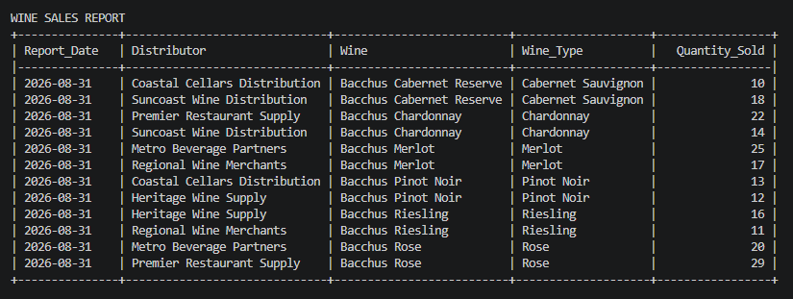

Report 3: Distributors' Orders Report
Purpose: This report displays each distributor, the wines they order, the wine types, the number of order items, the total quantity ordered, and the total value of those items.
Maria Costanza is responsible for distribution, and the winery wants to make it easier for distributors to place orders and track shipments online in the future. This report helps Maria and the owners review which wine distributors are ordering, how much they are ordering, and the value of those orders. This information can help with planning wine production, managing distribution, and understanding distributor demand. It can also provide a starting point for the winery’s planned online ordering system.
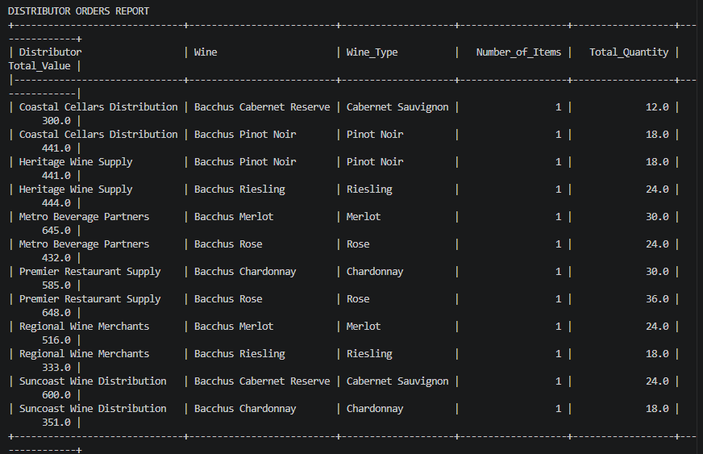

Report 4: Employee Quarterly Hours Report
Purpose: This report displays each employee’s ID, first and last name, job title, department, year, quarter, and total hours worked. It covers the four most recent completed quarters.
The winery has employees working in different departments, including marketing, production, finance, and distribution. This report allows the owners to review how many hours each employee worked during the last four completed quarters. Janet Collins, who is responsible for finances and payroll, can use the information to help review employee hours and payroll records. Stan and Davis can also use it to understand staffing levels and review how employee time is distributed across departments.
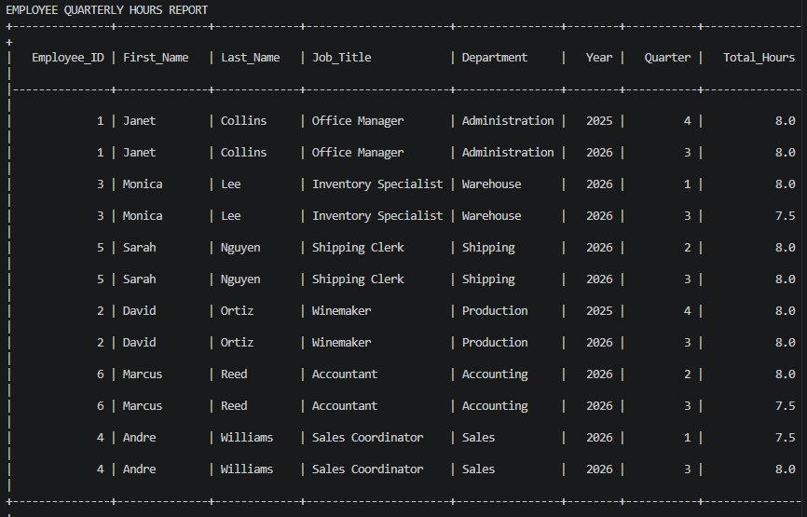

Report 5: Supply and Wine Inventory Report
Purpose: This report displays inventory records, including the inventory type, supply item or wine, item or wine type, quantity on hand, and the date the inventory was last updated.
Stan and Davis are responsible for keeping track of the winery’s supply inventory. This report provides them with a view of the supplies and wine currently in inventory. They can use it to identify low supply quantities, monitor available wine, and determine when additional supplies may need to be ordered. This supports their goal of improving inventory tracking and developing a more efficient ordering process.
