Samuel Guizar
9/4/26
Module 5.2 Assignment

Screenshot from step 5: Run the SQL script
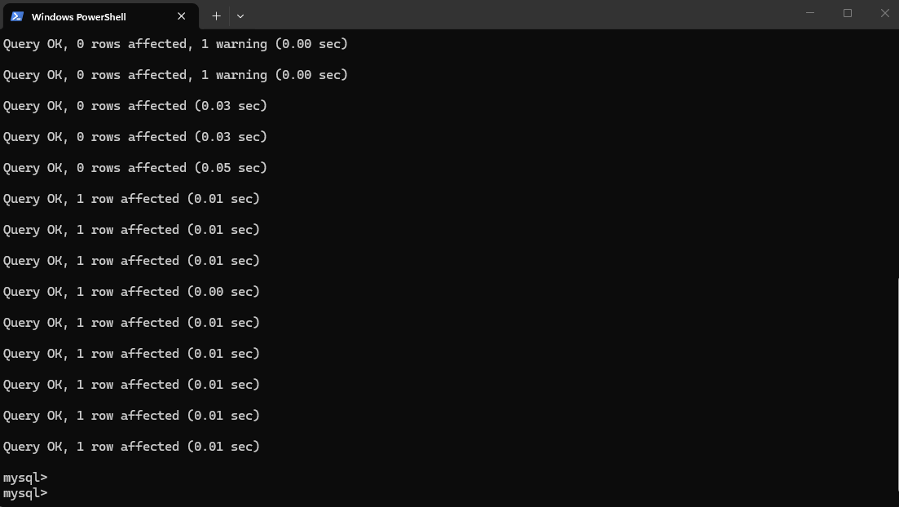
Screenshot from step 6: Show a list of database tables (this assumes you have activated the database)
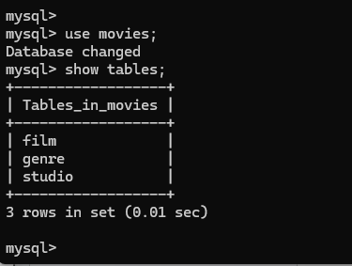
Screenshot from step 9: MySQL: mysql_test.py.
