Samuel Guizar
10/30/26
Module 3.2 Assignment

HTML Validation:
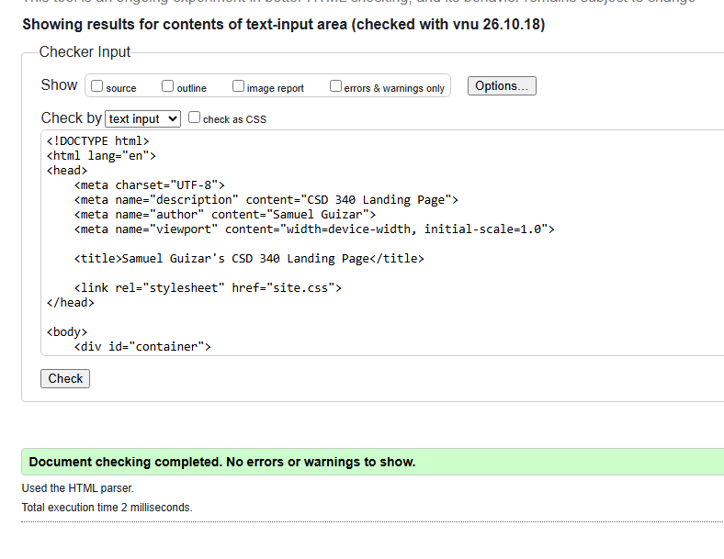

CSS Validation:
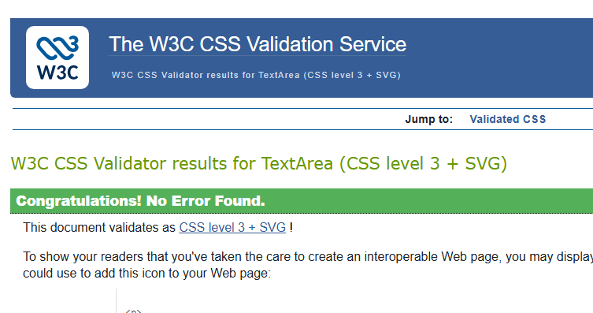

Index Page:
