Samuel Guizar
10/19/26
Module 1.3 Assignment

Github Repository Link: https://github.com/samyusei3-design/csd-340

Validator Errors:
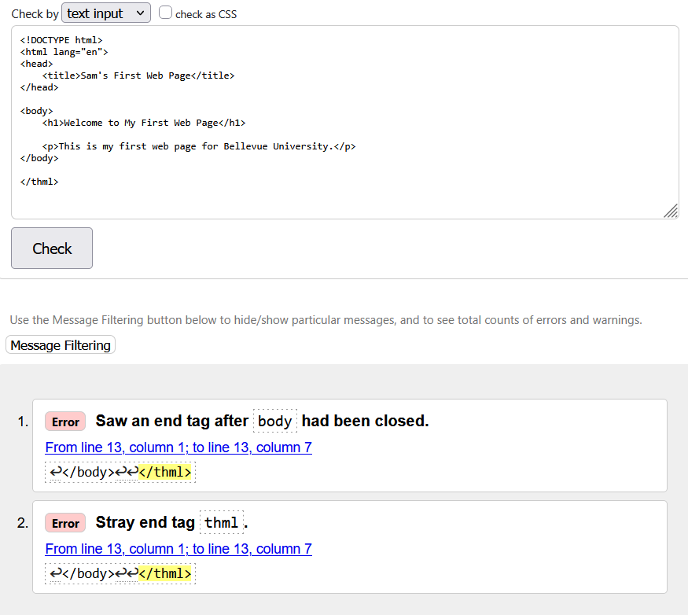

Fixed Errors:
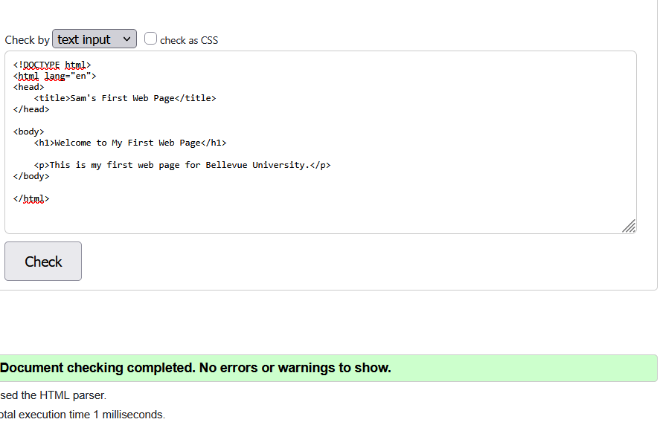

Revalidate new code:
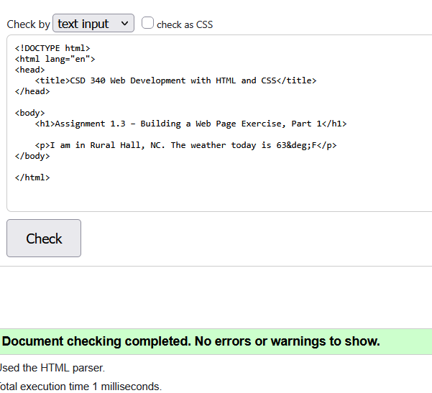

Website when opening file:
