Samuel Guizar
10/24/26
Module 1.3 Assignment Screenshots

Proof of Java
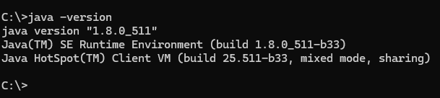

Path to JavaFX
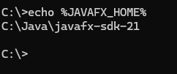

JavaFX legal folder
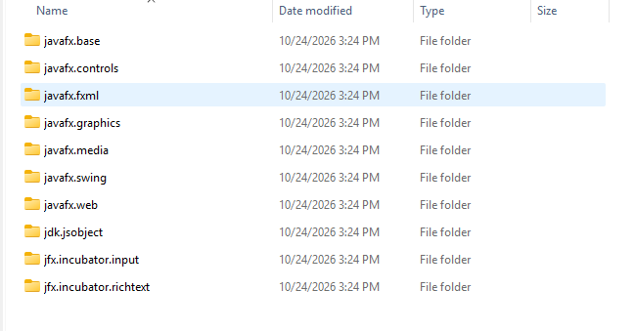

JavaFX lib folder
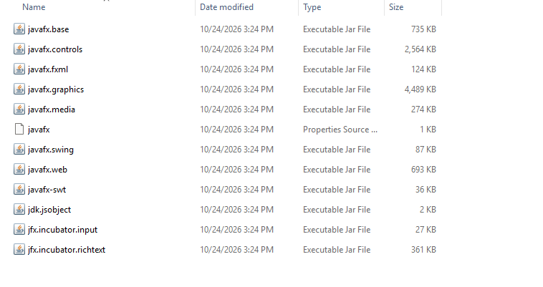

JavaFX src folder
