4.1(a)

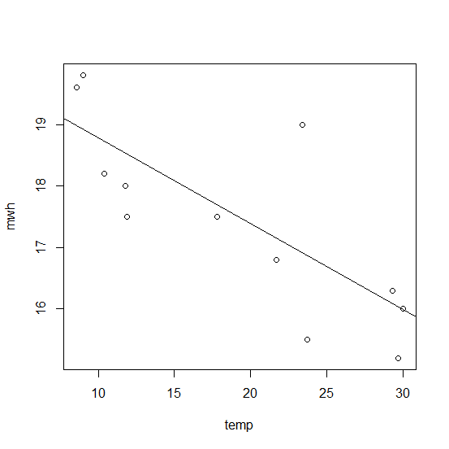

Because the the graph shows negative relation.

(b) are there any outlier?

Residual plot. According to the summary, the standard error (sigma) of the error is 0.98. One of the points in the residual plot is with error more then 2.0, which is outside the 2 sigma confidence band. So there is one outlier. But because there is no data point is extreme on x axis. It doesn’t look like there is influential point.

(c)

Call:

lm(formula = mwh ~ temp)

Residuals:

Min 1Q Median 3Q Max

-1.2593 -0.5395 -0.1827 0.4274 2.1972

Coefficients:

Estimate Std. Error t value Pr(>|t|)

(Intercept) 20.19952 0.73040 27.66 8.86e-11 \*\*\*

temp -0.14516 0.03549 -4.09 0.00218 \*\*

---

Signif. codes: 0 ‘\*\*\*’ 0.001 ‘\*\*’ 0.01 ‘\*’ 0.05 ‘.’ 0.1 ‘ ’ 1

Residual standard error: 0.9888 on 10 degrees of freedom

Multiple R-squared: 0.6258, Adjusted R-squared: 0.5884

F-statistic: 16.73 on 1 and 10 DF, p-value: 0.00218

Because the parameter of temp pass t-test, and

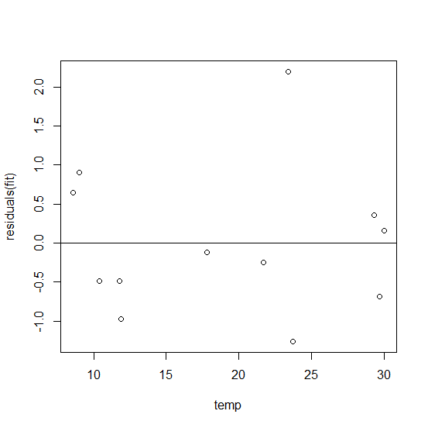

(c)

2(a)

(b) the wining times decrease with year

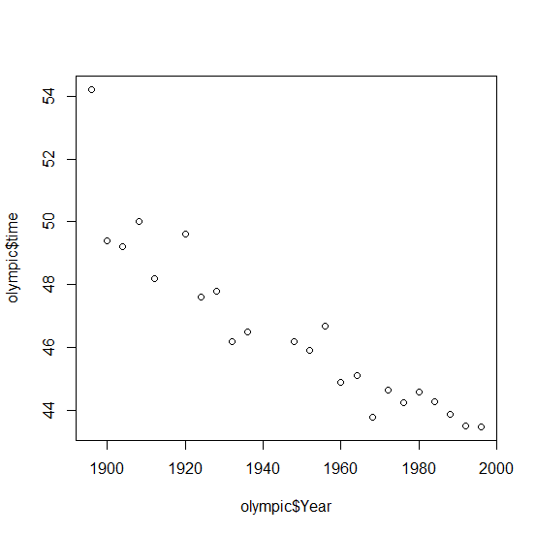

(c) average rate = -0.076790

Residuals:

Min 1Q Median 3Q Max

-1.5215 -0.7037 -0.1642 0.4952 3.7141

Coefficients:

Estimate Std. Error t value Pr(>|t|)

(Intercept) 196.079876 14.177031 13.83 5.09e-12 \*\*\*

Year -0.076790 0.007278 -10.55 7.51e-10 \*\*\*

---

Signif. codes: 0 ‘\*\*\*’ 0.001 ‘\*\*’ 0.01 ‘\*’ 0.05 ‘.’ 0.1 ‘ ’ 1

Residual standard error: 1.089 on 21 degrees of freedom

Multiple R-squared: 0.8413, Adjusted R-squared: 0.8337

F-statistic: 111.3 on 1 and 21 DF, p-value: 7.515e-10

(d)

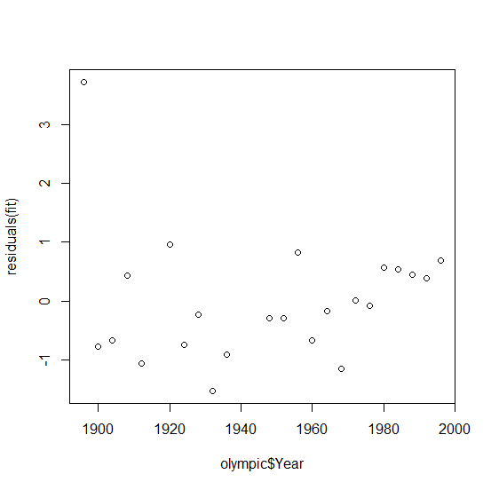

(e) > forecast(fit,newdata=data.frame(Year=c(2000,2004,2008,2012)))

Point Forecast Lo 80 Hi 80 Lo 95 Hi 95

1 42.49977 40.94361 44.05593 40.05401 44.94554

2 42.19261 40.62355 43.76167 39.72657 44.65866

3 41.88545 40.30266 43.46825 39.39782 44.37308

4 41.57829 39.98095 43.17563 39.06780 44.08879

Assumption:

(f) 2000: 43.84

2004: 44.00

2008: 43.75