(a)

(b)

(c)

(d)

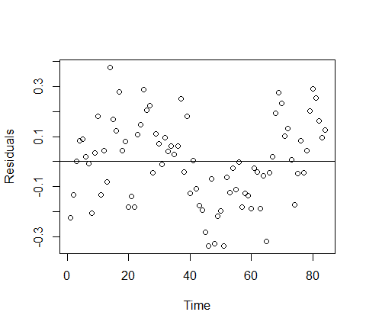

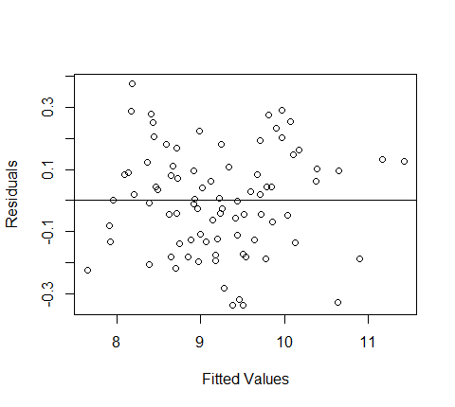

(e)

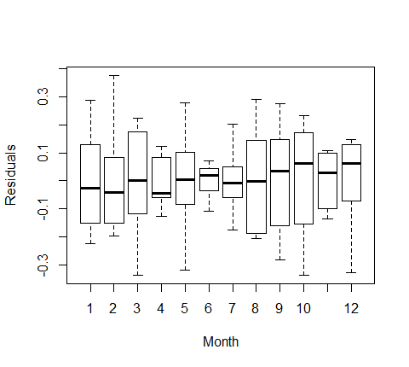

(f)

(g)

Durbin-Watson test

data: fitlm

DW = 0.8889, p-value = 1.956e-07

alternative hypothesis: true autocorrelation is not 0

5.2

(a)

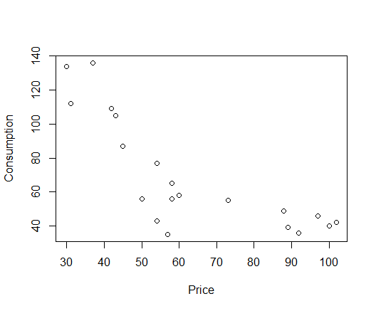

(b) People consume less oil when the oil price is going up.

(c) Model 1

Ci=exp(5.10-0.015Pi)

> fit1=lm(log(consumption)~price,data=texasgas)

> summary(fit1)

Call:

lm(formula = log(consumption) ~ price, data = texasgas)

Residuals:

Min 1Q Median 3Q Max

-0.67079 -0.11047 0.06403 0.20322 0.38066

Coefficients:

Estimate Std. Error t value Pr(>|t|)

(Intercept) 5.097833 0.176163 28.938 < 2e-16 \*\*\*

price -0.015293 0.002625 -5.825 1.62e-05 \*\*\*

---

Signif. codes: 0 ‘\*\*\*’ 0.001 ‘\*\*’ 0.01 ‘\*’ 0.05 ‘.’ 0.1 ‘ ’ 1

Residual standard error: 0.2712 on 18 degrees of freedom

Multiple R-squared: 0.6534, Adjusted R-squared: 0.6341

F-statistic: 33.93 on 1 and 18 DF, p-value: 1.616e-05

Model 2

> pricep=pmax(texasgas$price-60,0)

> fit2a=lm(consumption~price+pricep,data=texasgas)

> summary(fit2a)

Call:

lm(formula = consumption ~ price + pricep, data = texasgas)

Residuals:

Min 1Q Median 3Q Max

-21.744 -5.084 1.722 9.442 22.749

Coefficients:

Estimate Std. Error t value Pr(>|t|)

(Intercept) 218.8263 17.4986 12.505 5.34e-10 \*\*\*

price -2.8534 0.3560 -8.015 3.56e-07 \*\*\*

pricep 2.7092 0.5144 5.266 6.30e-05 \*\*\*

---

Signif. codes: 0 ‘\*\*\*’ 0.001 ‘\*\*’ 0.01 ‘\*’ 0.05 ‘.’ 0.1 ‘ ’ 1

Residual standard error: 13.23 on 17 degrees of freedom

Multiple R-squared: 0.8572, Adjusted R-squared: 0.8404

F-statistic: 51.01 on 2 and 17 DF, p-value: 6.55e-08