Aim: Classification using orange tool

Step 1: Select file and drag & drop on screen.

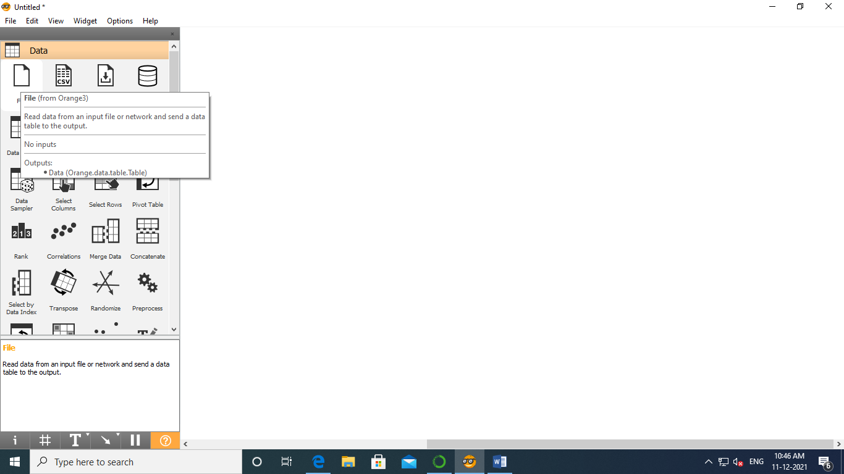

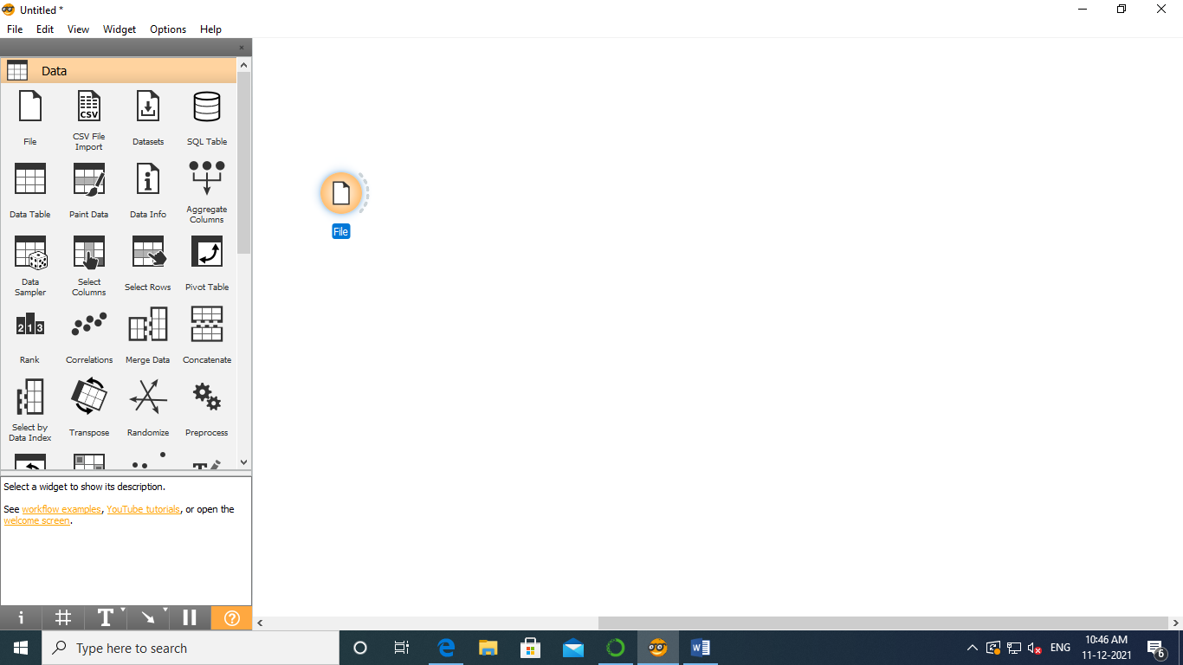

Step 2: Double click on file and select zoo.tab

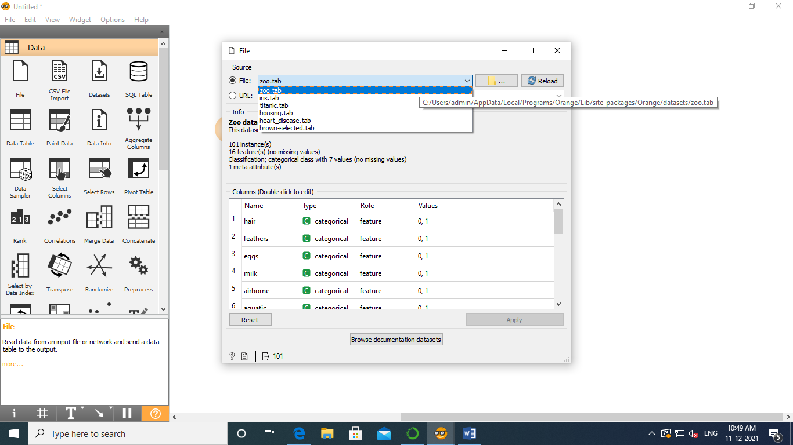

Step 3: Double click on screen and select Data Sampler and connect them both

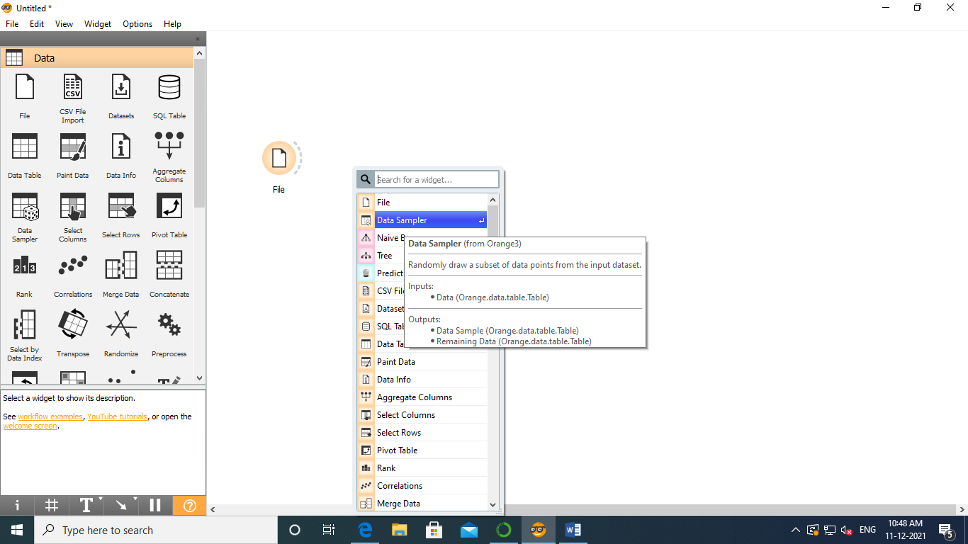

Step 4: Select Navie Bayes and connect it with Data Sampler

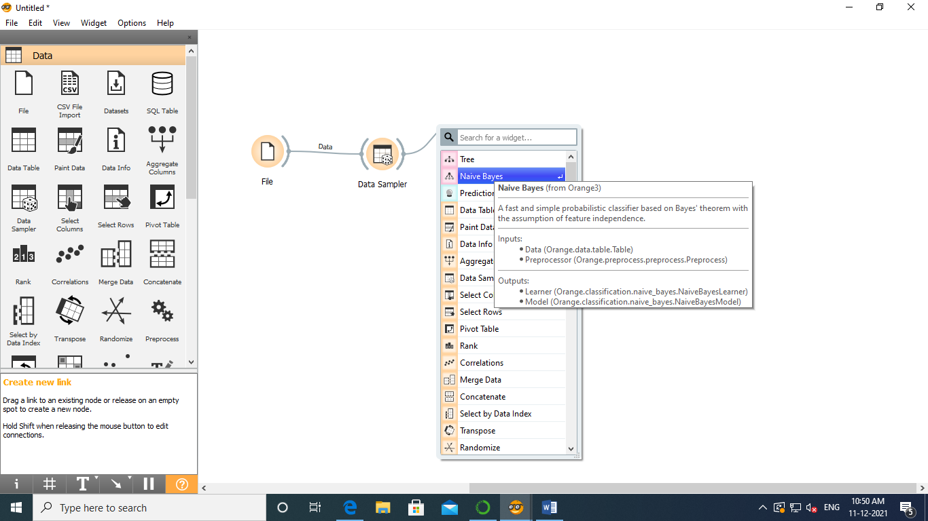

Step 5: Select Tree and connect it with Data Sampler

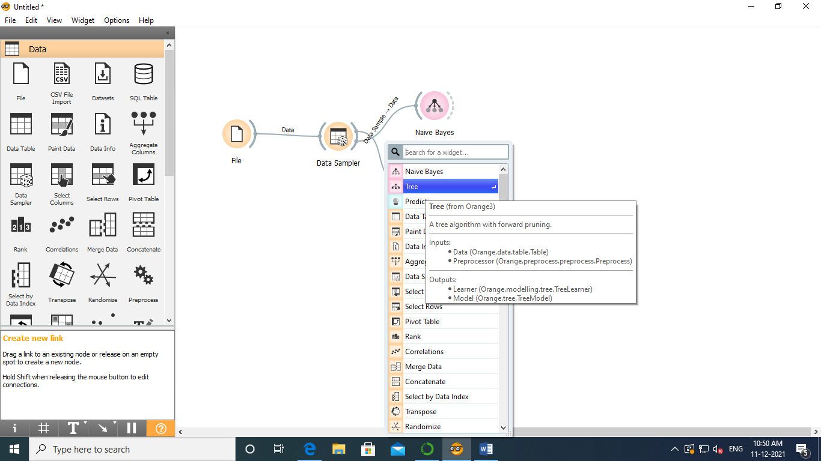

Step 6: Select Predication and connect it with Data Sampler

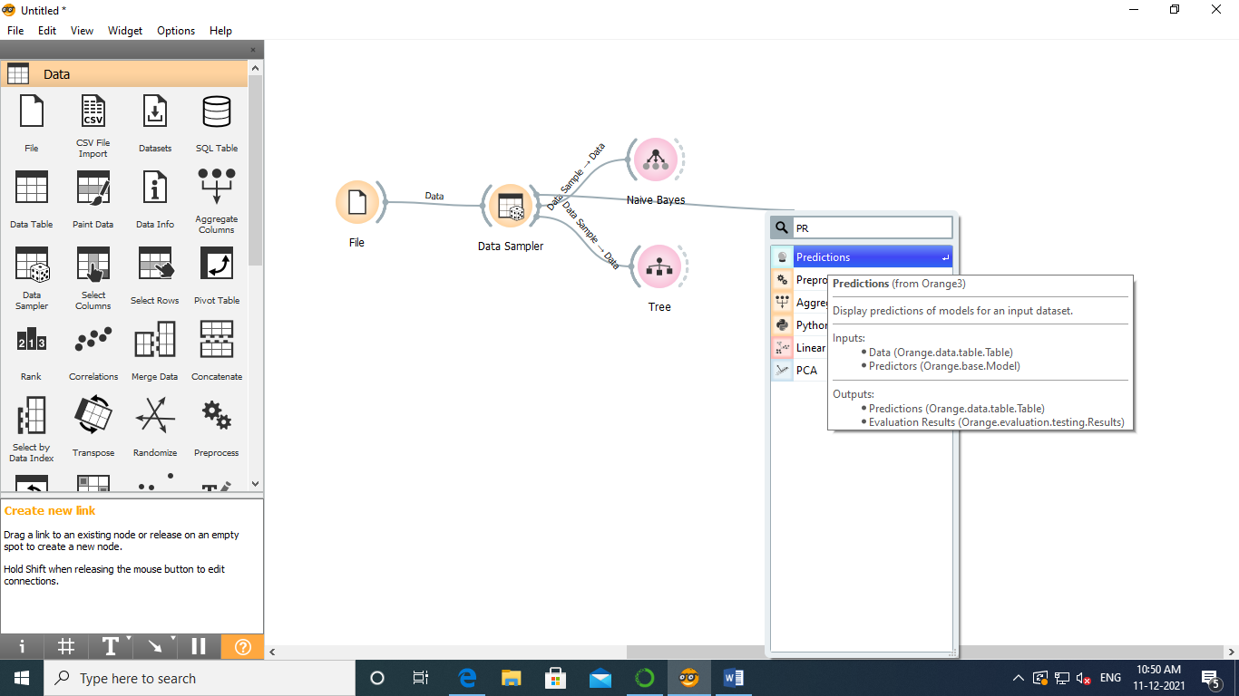

Step 7: Select Homogram and connect it with Navie Bayes and double click on homogram

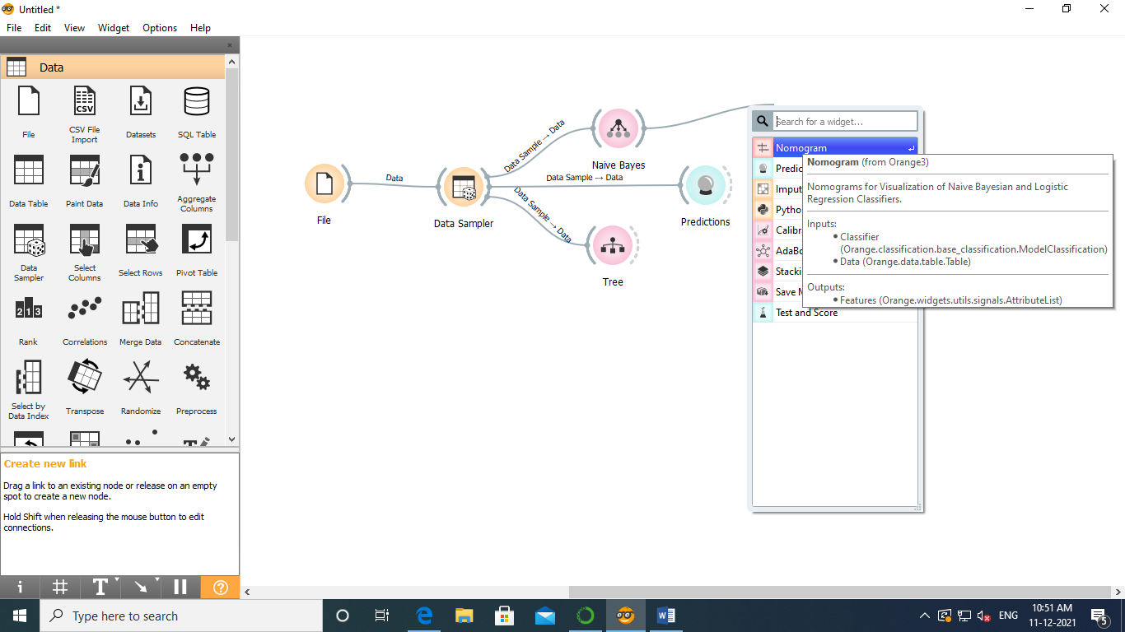

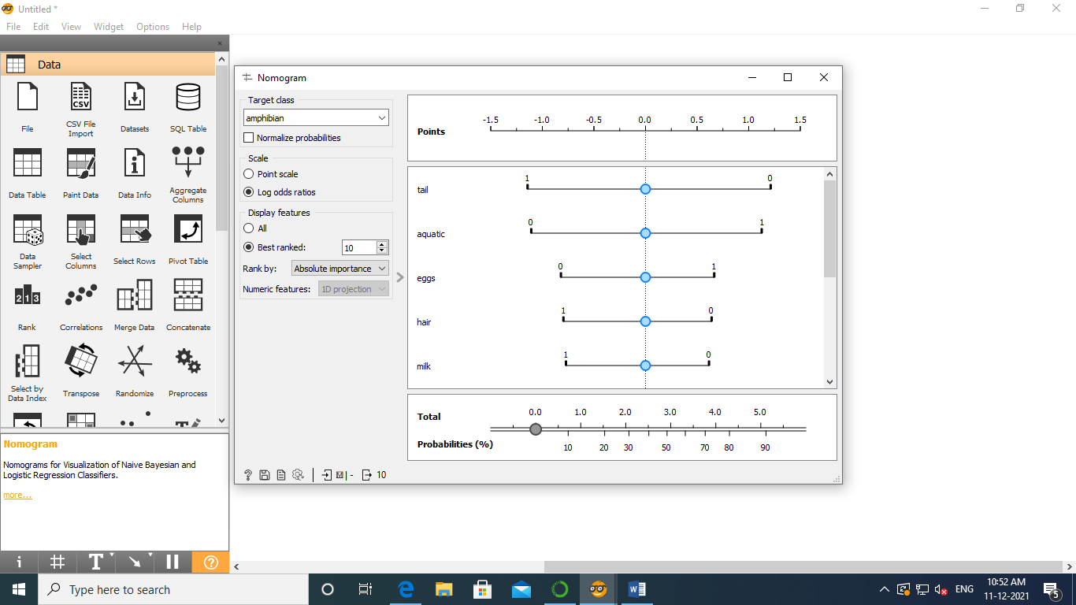

Step 8: Select Navie Bayes and Tree with Predication and double click on Predication

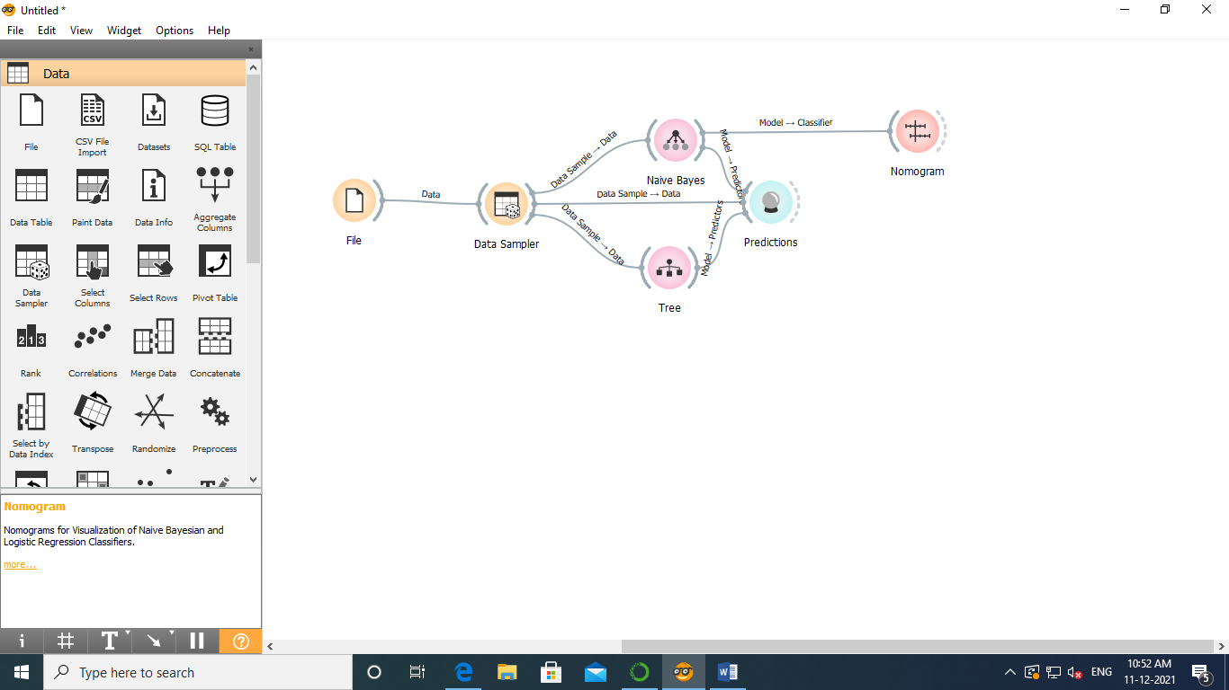

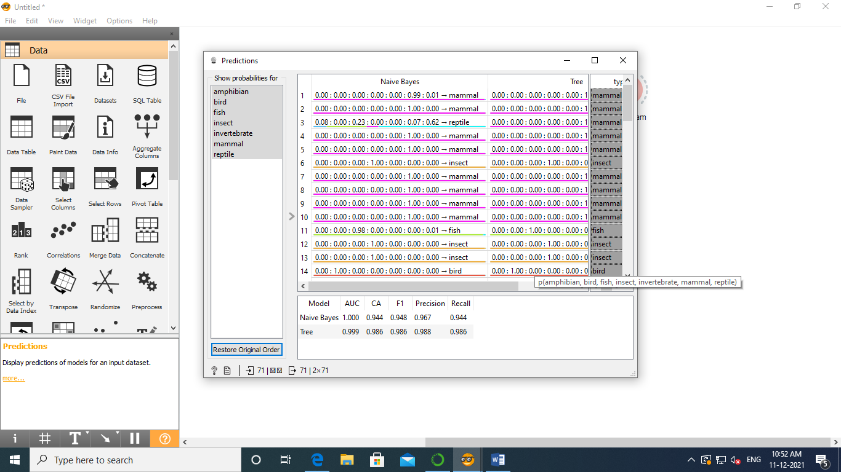

Step 9: Select Linear Projection and connect it with Predication

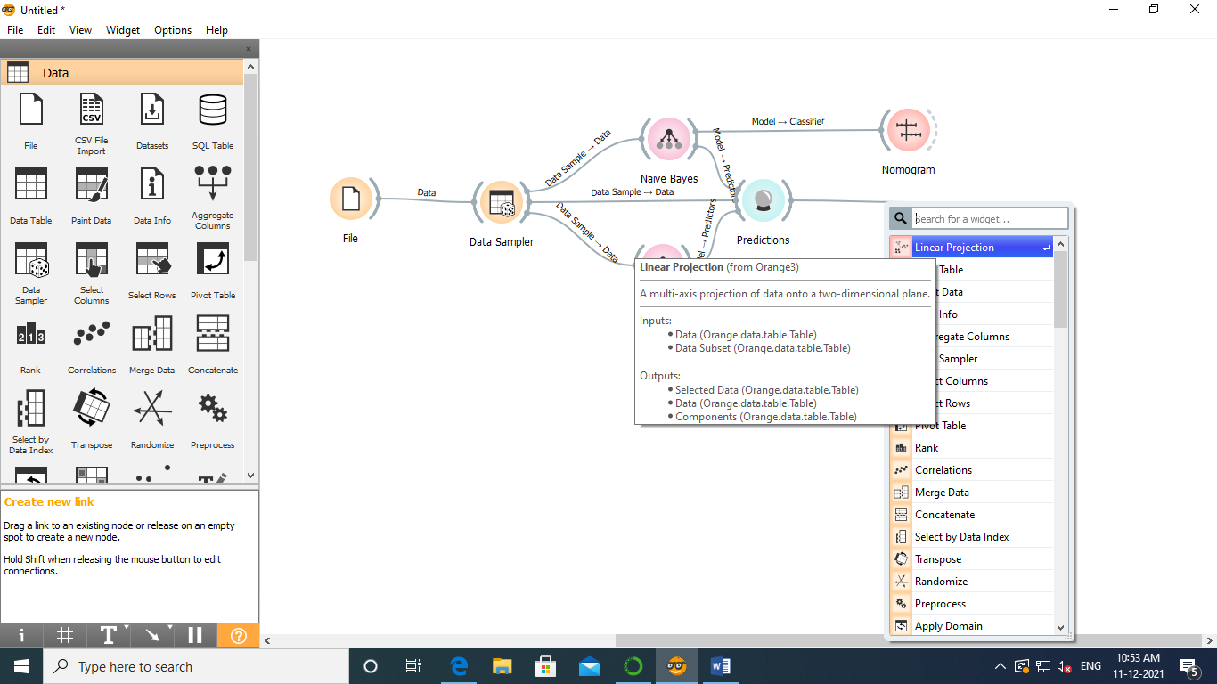



Step 10: Double click on Linear projection

