Home-work Date: 12thJuly2025
Home work: calculate other evaluation metric apart from Accuracy and display them (Confusion Matrix)
Python source code from visual studio code:
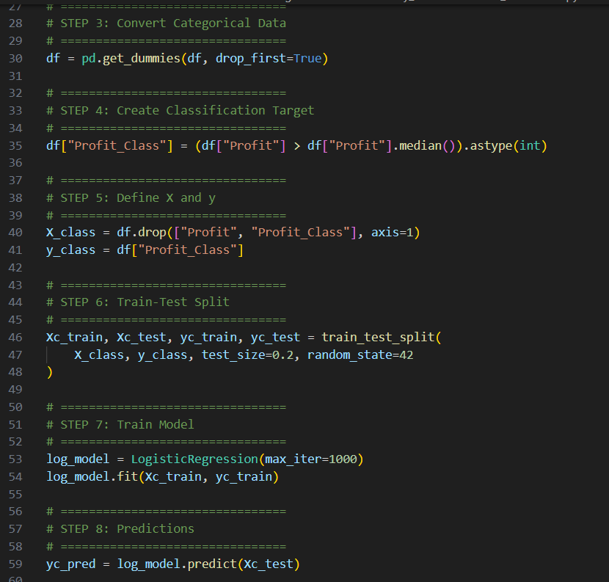
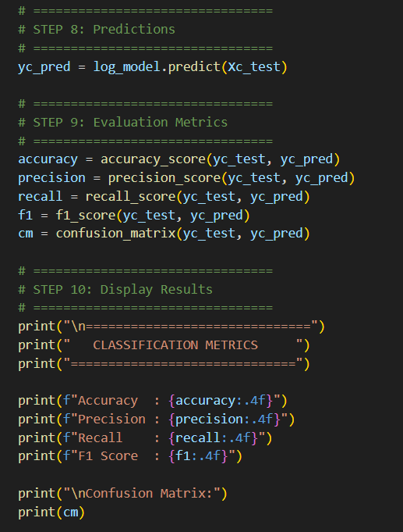
Output:
