Homework Date: 12thJuly2025
Home work: Calculate correlation between each X and y and rerun the model by
dropping X which have correlation less than 0.55
Compare the Rsquare and RMSE values.
Source Code Screenshots (Taken from Visual Studio Code):
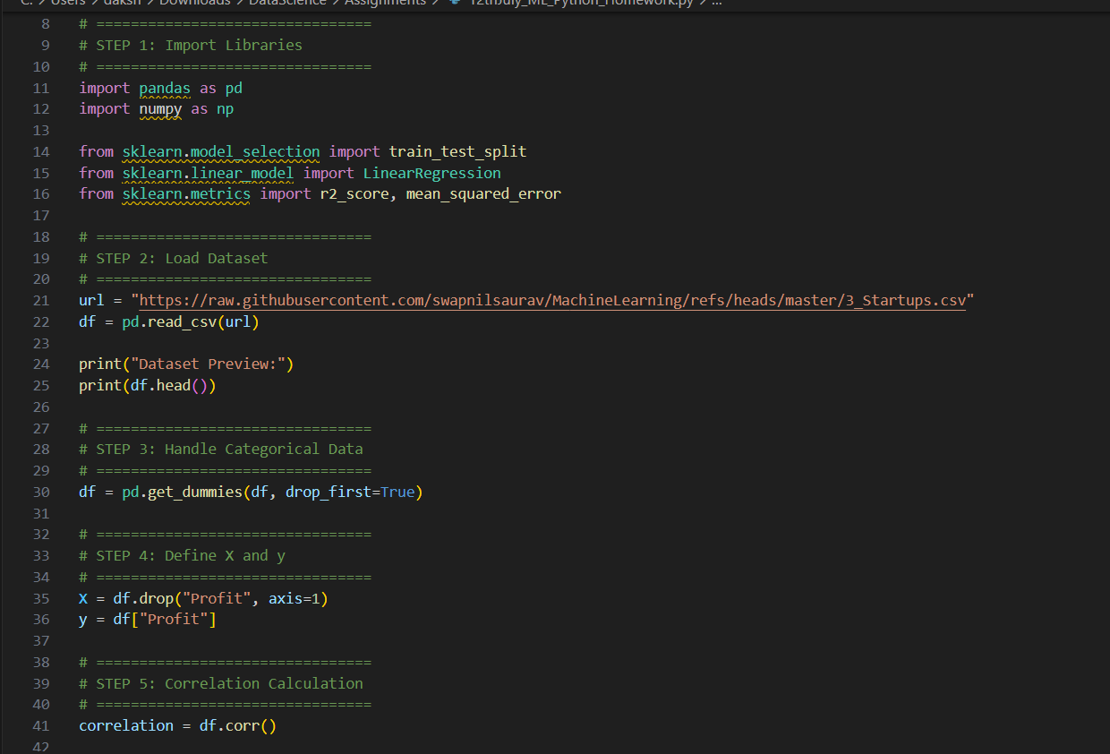
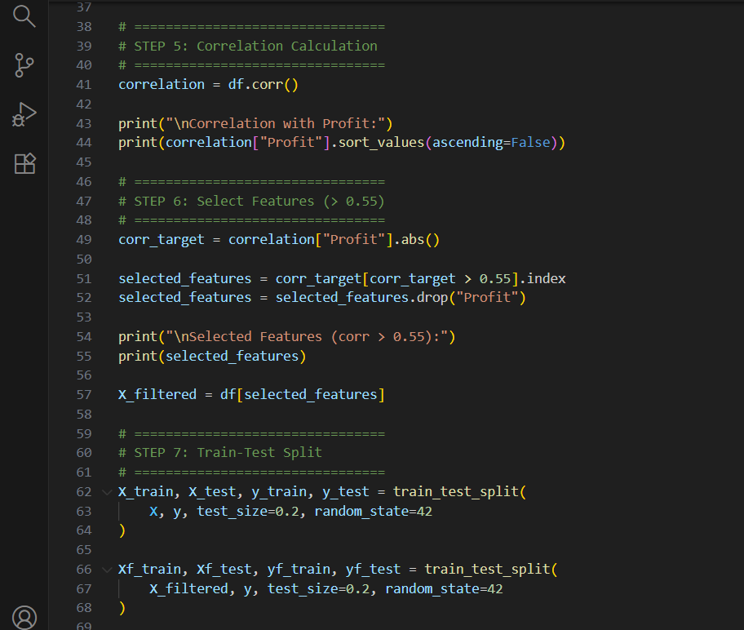
Output:
