MUKESH PATEL SCHOOL OF TECHNOLOGY MANAGEMENT AND ENGINEERING
(Affiliated to NMIMS Deemed to be University, Mumbai)



A REPORT
ON
PROPHET MODEL IMPLEMENTATION FOR DIGITAL PAYMENT VOLUME FORECASTING WITH HOLIDAY AND EVENT EFFECTS

Submitted by:

Rohan Dedhia E004
Duncan D'lima E026
Sanaz Katpitia E020

B. Tech Integrated – Semester IX

AY 2026-2027

1.0 Abstract 3
2.0 Introduction 3
3.0 Literature Review 4
3.1 ARIMA and SARIMAX Models 4
3.2 The Prophet Model 4
3.3 Holiday and Event Effects 4
3.4 Forecast Evaluation 4
3.5 Research Gap 4
4.0 Data 5
4.1 NPCI Monthly Data 5
4.2 Synthetic Daily Series 5
4.3 Anchoring to NPCI Totals and a Correction 5
4.4 Holidays and Events 6
5.0 Methodology 7
5.1 Exploratory Analysis 7
5.2 Prophet 7
5.3 SARIMAX 7
5.4 Baseline 7
5.5 Evaluation Design and Metrics 7
5.6 Effect Recovery and Diagnostics 8
6.0 Results and Analysis 9
6.1 Exploratory Findings 9
6.2 SARIMAX Order Selection 10
6.3 Forecast Accuracy 11
6.4 Holiday and Event Effects 12
6.5 Residual Diagnostics 13
6.6 Final Forecast 14
7.0 Discussion 15
7.1 Why Holidays and Events Help 15
7.2 Prophet Versus SARIMAX 15
7.3 Why Diwali Is Underestimated 15
7.4 Limitations 15
8.0 Conclusion and Future Scope 16
References 17

1.0 Abstract
Daily forecasts of digital payment volume help banks and payment networks plan server capacity, fraud monitoring and settlement liquidity. Daily volume depends strongly on the calendar: weekends, salary days, festivals and online sales all move it. This report implements the Prophet model to forecast daily Unified Payments Interface (UPI) transaction volume and examines the contribution of holiday and event information. Since the National Payments Corporation of India (NPCI) publishes UPI figures monthly, the study uses a synthetic daily series anchored to real NPCI monthly totals from January 2022 to August 2026, with holiday and event effects of known size. Five models were compared with rolling-origin cross-validation (10 folds, 90-day horizon): a seasonal-naive baseline, SARIMAX and three Prophet variants. Accuracy was measured with MAPE, WAPE, sMAPE, MAE, RMSE and mean forecast error, at 7-, 30- and 90-day lead horizons. Prophet with holidays and events achieved the lowest error, with a MAPE of 2.44% against 5.54% for seasonal naive and 4.73% for SARIMAX, and it remained the most accurate model at every horizon (2.15% at 7 days). Prophet also recovered most injected effects closely, including the payday lift (6.2% estimated against 6.0% true). All conclusions are limited to the synthetic data-generating assumptions and are not claims about real-world daily UPI accuracy.

2.0 Introduction
The Unified Payments Interface (UPI), launched by NPCI in 2016, has become India's main channel for digital payments. Monthly UPI volume grew from about 4.6 billion transactions in January 2022 to about 24.5 billion in August 2026, more than five times in under five years. At this scale, even a small forecasting error means millions of transactions that servers, fraud systems and settlement teams were not prepared for.
Daily payment volume is not smooth. It is higher on Saturdays and lower on Sundays, rises when salaries are credited at the start of the month, ramps up for about two weeks before Diwali, dips on national holidays and jumps during e-commerce sales. A forecast that ignores these calendar effects is wrong on exactly the days that matter most.
Prophet, developed at Facebook (now Meta), is a forecasting model built for this kind of business data. It splits a series into a trend, seasonal patterns, holiday effects and extra regressors, and it lets the analyst list holidays and events directly. This project tests how well Prophet uses that calendar information. It addresses four questions:
- Does adding holidays and events to Prophet improve forecast accuracy, and on which days?
- Does Prophet recover the true size of each holiday and event effect?
- How does Prophet compare with SARIMAX, the classical model covered in the course?
- What does the model forecast for September 2026 to February 2027?
Section 3 reviews the relevant literature. Section 4 describes the data, Section 5 the methods and evaluation metrics, Section 6 the results and additional horizon/fold analyses, Section 7 discusses the findings and limitations, and Section 8 concludes.

3.0 Literature Review

3.1 ARIMA and SARIMAX Models
The Box-Jenkins approach models a series through its own past values (autoregressive terms), past errors (moving average terms) and differencing to remove trends [2]. Seasonal ARIMA (SARIMA) adds the same terms at a seasonal lag, such as 7 days for weekly patterns. SARIMAX further adds exogenous variables, for example holiday indicators. Model orders are usually chosen by the Akaike Information Criterion (AIC) [10], and the residuals are checked with the Ljung-Box test for leftover autocorrelation [7]. These models describe short-term dependence well, but their forecast uncertainty grows quickly with the forecast horizon.

3.2 The Prophet Model
Taylor and Letham [1] proposed Prophet as a decomposable model: a piecewise-linear trend whose slope can change at points called changepoints, seasonal patterns written as Fourier series, holiday effects with a window of days around each date, and optional regressors. The model is fitted in the probabilistic language Stan, with prior distributions that keep each component from overfitting. Prophet was designed so that analysts with domain knowledge, such as which festivals matter, can feed that knowledge into the model directly instead of tuning ARIMA orders.

3.3 Holiday and Event Effects
Calendar effects are central in retail sales, electricity demand and payment volumes [3]. Festivals that follow the lunar calendar, such as Diwali, Holi and Eid, move by several weeks from year to year, so a fixed yearly seasonal pattern cannot capture them. The standard approach is to add indicator variables for each holiday, often for several days before and after it, so that build-up and recovery effects are captured [3].

3.4 Forecast Evaluation
A model that fits its training data well does not necessarily forecast well. Tashman [9] recommends rolling-origin evaluation: the model is trained up to a cutoff date, forecasts the period after it, and the cutoff is then moved forward. Every error is measured on data the model has not seen. We use this design throughout.

3.5 Research Gap
There is no public daily UPI series, so the effect of festivals on daily UPI volume has not been measured directly. More generally, with real data the true size of a holiday effect is never known, so it is hard to tell whether a model estimates it correctly. A synthetic series with known effects, anchored to real monthly totals, allows both forecast accuracy and effect recovery to be tested.

4.0 Data

4.1 NPCI Monthly Data
NPCI publishes UPI ecosystem statistics on its website [11], one month at a time. We collected total, person-to-person (P2P) and person-to-merchant (P2M) volume and value for January 2022 to August 2026 (56 months), using an automated browser (Playwright) because the page is rendered with JavaScript. Every month passed the check P2P + P2M = total. Data before 2022 sits in an archived view that could not be collected reliably, so the study starts in January 2022, after the COVID-19 lockdowns.

4.2 Synthetic Daily Series
Prophet's holiday modelling needs daily data, because a two-week festival effect disappears inside a monthly total. We therefore generated a daily series in which each day's volume is the product of six components:
y(t) = trend(t) × weekday(t) × monthday(t) × holiday(t) × sale(t) × noise(t)
Table 1: Components of the synthetic daily series
Component | How it is built | Size
Trend | Smooth curve through NPCI monthly averages (log scale) | About 150 to 790 million a day
Weekday | Fixed multiplier per day of week | Saturday +3%, Sunday -7%
Payday | Days 1 to 5 of each month | +6%
Month-end | Last two days of each month | +3%
Holidays | Festival and national holiday windows (Table 2) | -10% to +20%
Sale | One 4 to 6 day e-commerce sale per year | +8% to +12%
Noise | Autocorrelated noise, AR(1) | phi = 0.3, sigma = 2.5%

Because every effect is injected with a known size, the true effect on each day is stored with the data. This is the ground truth that Prophet's estimates are compared against in Section 6.4.

4.3 Anchoring to NPCI Totals and a Correction
Each month of the synthetic series is scaled so that it sums exactly to the real NPCI total. In the first version of the generator, this was applied to every month, including festive months. NPCI's real data shows a festive bump of the injected size only in October 2024, so forcing the other festive months to match NPCI pushed their ordinary days about 5% below trend. Prophet then saw Diwali as only about 4% instead of the true 9.1%.
We corrected the generator. Five festive months (October 2022, October 2023, November 2023, October 2024 and October 2025) are no longer forced to match NPCI. Their ordinary days follow the trend and the festival sits on top. All other months still match NPCI exactly, and the festive months differ from it by between -1.4% and +6.5%.

4.4 Holidays and Events
Table 2 lists the calendar effects given to the models. Holidays are recurring public or cultural dates, each with a window of days around it. Events are other calendar effects: the yearly e-commerce sale, payday and month-end. Other gazetted holidays such as Dussehra and Christmas were also given to the models as single days. Their true effect is zero, which tests whether a model invents effects that are not there.
Table 2: Holidays and events modelled
Name | Type | Window (days) | True effect
Diwali | Holiday | -10 to +3 | Ramp to +20%, then a dip
Holi | Holiday | -2 to +1 | +8% before, -10% on the day
Eid al-Fitr | Holiday | -3 to 0 | Ramp to +6%
Raksha Bandhan | Holiday | -3 to 0 | Ramp to +5%
Republic Day, Independence Day, Gandhi Jayanti | Holiday | 0 | -5%
E-commerce sale | Event | 4 to 6 days | +8% to +12%
Payday | Event | Days 1 to 5 | +6%
Month-end | Event | Last 2 days | +3%

5.0 Methodology

5.1 Exploratory Analysis
The series was examined with an STL decomposition on the log scale with a weekly period [4], the Augmented Dickey-Fuller (ADF) test [5] and the KPSS test [6] for stationarity, ACF and PACF plots, and average weekday and day-of-month profiles.

5.2 Prophet
In multiplicative mode, Prophet models the series as:
y(t) = g(t) × [ 1 + s(t) + h(t) + βx(t) ] + ε(t)
Here g(t) is the trend, s(t) the weekly and yearly seasonality, h(t) the holiday and event effects, x(t) the payday and month-end regressors with coefficients β, and ε(t) the error. Each day of a holiday window gets its own coefficient, so Prophet can learn the shape of a festival, such as Diwali's ten-day build-up.
Multiplicative mode was used because volume grew more than five times, and a festival adds a percentage of current volume rather than a fixed number of transactions. Payday and month-end were added as regressors because they are known in advance. A smooth trend (changepoint prior scale 0.005) and a low-order yearly pattern (Fourier order 3) performed best in a preliminary search. Three versions were built: Prophet base (trend and seasonality only), Prophet + holidays, and Prophet + holidays + events.

5.3 SARIMAX
SARIMAX was fitted to log volume as a regression with seasonal ARIMA errors. Its exogenous variables carry the same calendar information as the full Prophet model: one indicator for each day of each holiday and sale window, payday and month-end indicators, and yearly Fourier terms. Following the course procedure, the order was chosen by fitting combinations of p and q from 0 to 2 and P and Q from 0 to 1, with d = 1, D = 0 and a seasonal period of 7. The lowest-AIC candidate was selected using only the first two years (2022–2023), so the evaluation period did not influence the order choice. For forecasting, SARIMAX predicts log volume. Forecasts are converted back to the transaction scale with an approximate lognormal mean correction, exp(μ + 0.5σ²), where σ² is the training residual variance.

5.4 Baseline
The seasonal naive baseline forecasts each day with the value from the same weekday in the last week of training data. Any useful model must beat it.

5.5 Evaluation Design and Metrics
All models were evaluated with rolling-origin cross-validation [9]. Each model was trained up to a cutoff and forecast the following 90 days; the cutoff then advanced by 90 days. The initial training period was two years, and all models used the same forecast origins. In addition to the primary 90-day evaluation, pooled errors are also summarized for the first 7, 30 and 90 lead days, allowing short-, medium- and longer-horizon performance to be compared. Fold-level MAPE, WAPE, MAE and RMSE are also summarized using the mean, standard deviation, minimum and maximum across folds. Because forecast windows overlap, these fold summaries are descriptive measures of variability and are not treated as independent-sample confidence intervals.
The evaluation uses MAPE as a familiar percentage-based measure, together with weighted absolute percentage error (WAPE), symmetric MAPE (sMAPE), and mean forecast error (forecast minus actual). MAE and RMSE remain reported in millions of transactions per day. MAPE summarizes average absolute percentage error, WAPE weights errors by the total transaction volume, sMAPE scales the absolute error by the average magnitude of actual and predicted values, and mean error indicates whether forecasts tend to overpredict or underpredict. Reporting multiple metrics reduces reliance on any single score.
MAE = (1 / n) × Σ | y(t) − ŷ(t) | RMSE = √[ (1 / n) × Σ ( y(t) − ŷ(t) )² ]
Errors were also split by day type: holiday-window days, sale days and ordinary days. This shows where each model gains or loses accuracy, which an overall average would hide.

5.6 Effect Recovery and Diagnostics
The full Prophet model was fitted on all the data, and its estimated effect for each holiday and event was compared with the true injected effect. Residuals were checked with the Ljung-Box test for autocorrelation [7] and the ARCH-LM test for changing variance [8]. All work was done in Python using prophet, statsmodels, pandas and matplotlib.

6.0 Results and Analysis

6.1 Exploratory Findings
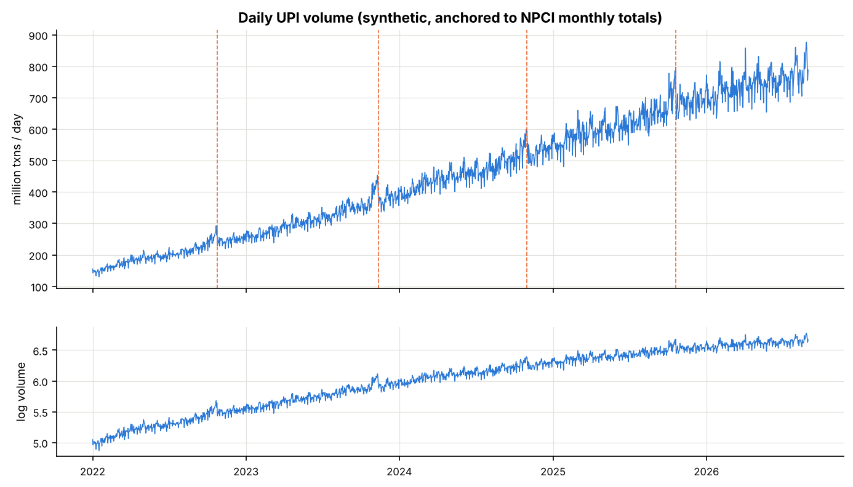
Figure 1: Daily UPI volume (top) and log volume (bottom); dashed lines mark Diwali
Volume grows about fivefold over the period, and the growth is close to linear on the log scale. The weekly up-and-down pattern grows with the level of the series, which supports multiplicative seasonality. Festival seasons appear as bumps each October and November.
Table 3: Stationarity tests
Series | ADF p-value | KPSS p-value | Result
log y | 0.0739 | 0.01 | Non-stationary
First difference of log y | 0.0000 | 0.10 | Stationary

Log volume is non-stationary, and one difference makes it stationary, so SARIMAX uses d = 1. The ACF of the differenced series (Figure 2) has strong spikes at lags 7, 14, 21 and 28, showing a weekly cycle, so the seasonal period is 7.
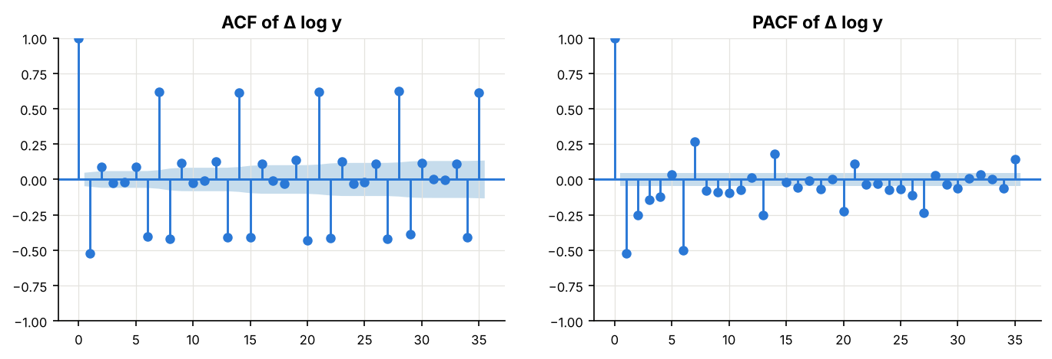
Figure 2: ACF and PACF of the differenced log series
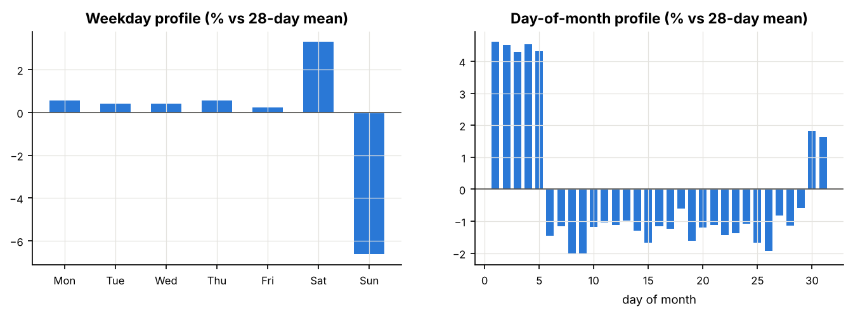
Figure 3: Average weekday and day-of-month profiles (ordinary days only)
Saturday volume is about 3% above the weekly average and Sunday about 6.5% below. Days 1 to 5 of each month are about 4.5% above the 28-day average, and the last two days about 1.7% above it. Both patterns are recurring calendar effects that the models must capture.

6.2 SARIMAX Order Selection
Table 4: Five best SARIMAX models by AIC (2022 to 2023)
(p, q, P, Q) | AIC | BIC
(1, 1, 1, 1) | -3080.1 | -2795.4
(2, 1, 1, 1) | -3073.5 | -2784.3
(0, 2, 1, 1) | -3070.9 | -2786.2
(1, 2, 1, 1) | -3066.5 | -2777.2
(2, 2, 1, 1) | -3048.4 | -2754.6

The AIC search selected SARIMAX(1,1,1)(1,0,1) with a weekly period. All five best models include seasonal AR and MA terms, so the weekly pattern matters most. The residual diagnostics (Figure 4) look fairly close to white noise: the Ljung-Box test finds only a small amount of autocorrelation (p = 0.010 at lag 7 and 0.001 at lag 14), far less than in the Prophet residuals.
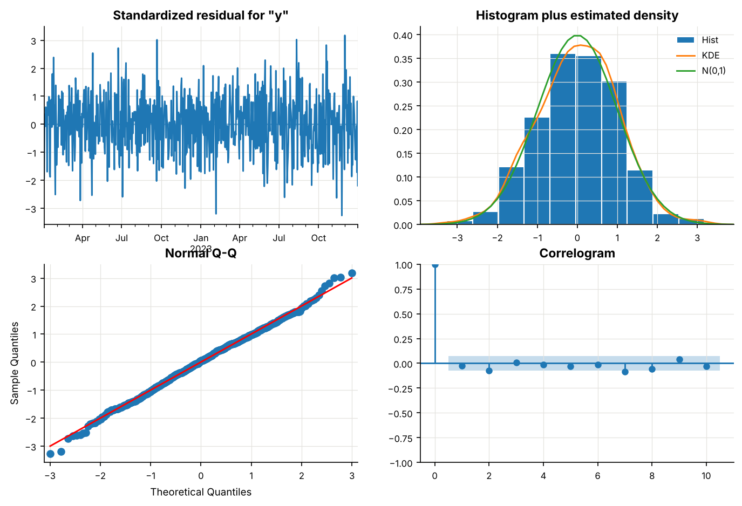
Figure 4: Residual diagnostics of the selected SARIMAX model

6.3 Forecast Accuracy
Table 5: Cross-validated forecast accuracy (10 folds, 90-day horizon)
Model | MAPE % | MAE | RMSE | Ordinary % | Holiday % | Sale %
Seasonal naive | 5.54 | 32.48 | 41.08 | 5.29 | 7.88 | 11.01
SARIMAX | 4.73 | 28.64 | 38.03 | 4.61 | 6.32 | 4.56
Prophet base | 3.32 | 19.48 | 25.43 | 3.11 | 5.21 | 7.26
Prophet + holidays | 3.17 | 18.55 | 23.87 | 3.07 | 3.64 | 8.56
Prophet + holidays + events | 2.44 | 14.20 | 18.14 | 2.36 | 3.10 | 4.12

Prophet with holidays and events had the lowest MAPE (2.44%), compared with 5.54% for the seasonal-naive baseline and 4.73% for SARIMAX. WAPE gives the same ranking (2.43%, 5.56% and 4.90%). Adding holidays reduced holiday-window MAPE from 5.21% to 3.64%, while adding events reduced overall MAPE from 3.17% to 2.44% and sale-day MAPE from 8.56% to 4.12%. The mean forecast error of the full Prophet model was close to zero (−0.71 million transactions per day), so it shows no systematic bias, while seasonal naive under-forecast (−26.9) and SARIMAX over-forecast (+12.3).
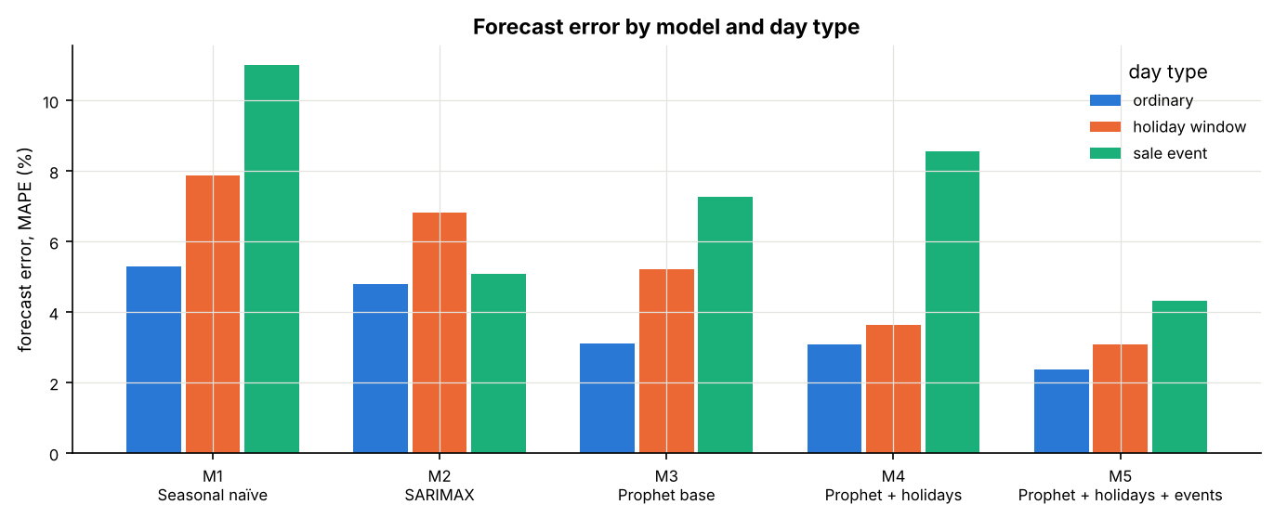
Figure 5: Forecast error by model and day type
SARIMAX was given the same calendar information as the full Prophet model. It is competitive at short lead times, with a 7-day MAPE of 2.92%, but its error rises to 3.25% at 30 days and 4.73% at 90 days. The full Prophet model stays between 2.15% and 2.44% across the same horizons, so the gap widens as the horizon grows. SARIMAX is also the least stable model across folds, with fold MAPE ranging from 2.6% to 8.7%, against 1.9% to 3.3% for the full Prophet model. Prophet's deterministic trend and calendar terms hold up better over long horizons than SARIMAX's autoregressive structure.

6.4 Holiday and Event Effects
Table 6: Estimated and true effects (mean over each window, %)
Effect | True | Estimated | Error (pp)
Diwali | 9.14 | 8.05 | -1.10
Holi | 1.50 | 0.89 | -0.61
Eid al-Fitr | 4.50 | 3.79 | -0.71
Raksha Bandhan | 3.87 | 5.20 | +1.33
Republic Day | -5.00 | -6.70 | -1.70
Independence Day | -5.00 | -7.40 | -2.40
Gandhi Jayanti | -5.00 | -6.23 | -1.23
E-commerce sale | 10.67 | 10.21 | -0.46
Payday (days 1 to 5) | 6.00 | 6.18 | +0.18
Month-end (last 2 days) | 3.00 | 3.25 | +0.25

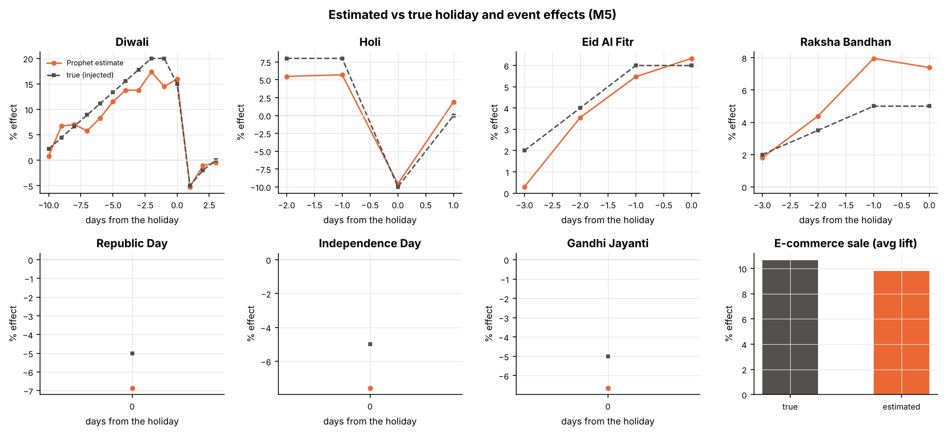
Figure 6: Estimated (orange) and true (dashed) effect for each day of each holiday window
Events were recovered almost exactly: payday within 0.2 percentage points and month-end within 0.3. The sale was estimated at 10.2% against a true 10.7%; its real lift varies between 8% and 12% from year to year, while the model fits one average. Diwali's shape was recovered, including the ten-day ramp, the peak on Dhanteras and Diwali eve and the dip after, but its size was underestimated: an 8.1% window average against a true 9.1%. Holi, Eid and Raksha Bandhan were within about 1.3 points, and Holi's -10% on the day itself was caught almost exactly. Single-day national holidays came out 1.2 to 2.4 points too negative, as each occurs only four or five times.

6.5 Residual Diagnostics
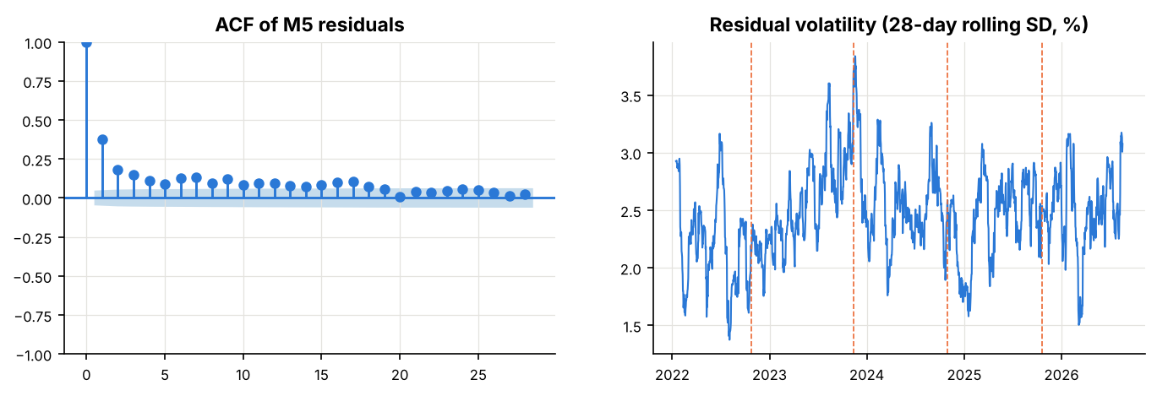
Figure 7: ACF of Prophet residuals (left) and residual volatility over time (right)
The residuals of the full Prophet model are autocorrelated: the lag-1 autocorrelation is 0.38, above the 0.3 built into the noise, and the Ljung-Box test rejects strongly (p < 0.001). Prophet assumes independent errors and does not model this. The ARCH-LM test (LM = 29.4, p = 0.0001) shows that the residual variance also changes over time. Prophet's prediction intervals assume constant variance, so they are too narrow in volatile periods.

6.6 Final Forecast
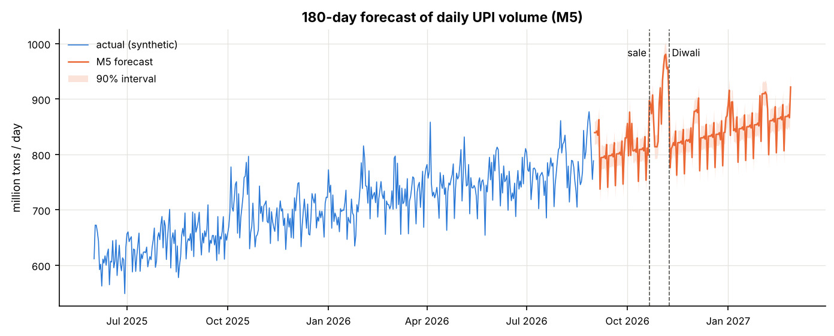
Figure 8: 180-day forecast with 90% interval (September 2026 to February 2027)
Table 7: Forecast monthly totals
Month | Forecast (billion transactions) | Days covered
September 2026 | 24.08 | 30
October 2026 | 25.75 | 31
November 2026 | 25.51 | 30
December 2026 | 26.01 | 31
January 2027 | 26.44 | 31
February 2027 | 23.53 | 27

The forecast continues the trend at about 24 to 26 billion transactions a month, against 24.5 billion in August 2026. February 2027 is lower only because the forecast ends on 27 February. The October 2026 sale and the Diwali ramp in early November give the highest forecast days, close to one billion transactions a day. These figures forecast the synthetic series and illustrate the method; they are not predictions of real UPI volume.

7.0 Discussion
The evaluation includes several safeguards. WAPE and sMAPE complement MAPE, while mean forecast error identifies systematic over- or underprediction. Results are reported for 7-, 30- and 90-day lead horizons, which separates near-term from longer-horizon performance. Since rolling-origin windows overlap, fold-level results are interpreted descriptively rather than as independent statistical replicates. SARIMAX forecasts are converted from log volume with an approximate lognormal mean correction; this is an approximation that assumes the log-scale errors are roughly normal.

7.1 Why Holidays and Events Help
Each improvement appeared on exactly the days the added information describes. Holidays improved holiday days, the sale improved sale days, and payday and month-end improved ordinary days. This shows that the gains come from the calendar knowledge itself, not from extra model flexibility.

7.2 Prophet Versus SARIMAX
SARIMAX had the cleaner in-sample residuals, yet it forecast worse than every Prophet version. AIC rewards a good fit to the training window, not accuracy 90 days ahead. ARIMA forecasts depend on recent values, so their errors build up with the horizon, while Prophet's forecast comes from a smooth trend and fixed calendar terms. For long-horizon planning of daily volume, Prophet is the better choice; for next-day forecasts, the gap would likely be smaller.

7.3 Why Diwali Is Underestimated
Diwali is the largest and longest effect. Each of its 14 daily coefficients is estimated from only four Diwalis in the data. Diwali also always falls in October or November, so the yearly seasonal pattern can absorb part of its effect, and the trend inherits some month-to-month variation from the real NPCI data around festive months. The earlier anchoring issue (Section 4.3) made this much worse; after the correction, about 1.1 points of the gap remain.

7.4 Limitations
- The daily data is synthetic, so the results show how the models behave under the specified data-generating assumptions, not the real size of festival effects or validated real-world UPI forecast accuracy. Five festive months differ from NPCI totals by design, and only four Diwalis are available for estimating the festival profile. Forecast folds overlap, so fold-level variation is descriptive rather than a formal independent-sample uncertainty estimate. The lognormal correction for SARIMAX is an approximation. Prophet residuals were found to be autocorrelated and their variance changes over time; so its prediction intervals are likely too narrow, and their coverage has not been tested on held-out data.
- Five festive months differ from the NPCI totals by up to 6.5% by design.
- Only four Diwalis are in the sample.
- Prophet's residuals are autocorrelated and their variance changes, so its prediction intervals are too narrow.

8.0 Conclusion and Future Scope
This project implemented Prophet to forecast daily UPI transaction volume with holiday and event effects, using a synthetic daily series anchored to real NPCI monthly totals. Prophet with holidays and events was the most accurate of five models, with a 90-day MAPE of 2.44% against 4.73% for SARIMAX and 5.54% for seasonal naive, and it stayed the most accurate at 7-, 30- and 90-day horizons. Holidays reduced error on holiday days by about 30%, and events more than halved error on sale days. Because the true effects are known, the study also showed that Prophet recovers payday, month-end and sale effects closely while under-estimating Diwali. This is a simulation check rather than a causal estimate of actual UPI behaviour, and Prophet's autocorrelated, heteroskedastic residuals mean its prediction intervals need further testing before operational use.
The code, data and an interactive dashboard of the results are available at https://github.com/san2736/upi-project and https://san2736.github.io/upi-project/.
Future work could:
- Use real daily payment data if NPCI or RBI publish it;
- Measure the empirical coverage of the 90% prediction intervals on held-out data;
- Combine Prophet with an ARIMA model of its residuals, or a GARCH model of their changing variance;
- Detect unannounced events automatically from forecast errors;
- Compare with machine learning models such as LSTM networks;
- Model P2P and P2M volume together with VAR models to study how festivals shift the payment mix.

References
- S. J. Taylor and B. Letham, “Forecasting at scale,” The American Statistician, vol. 72, no. 1, pp. 37-45, 2018.
- G. E. P. Box, G. M. Jenkins, G. C. Reinsel and G. M. Ljung, Time Series Analysis: Forecasting and Control, 5th ed. Hoboken, NJ, USA: Wiley, 2015.
- R. J. Hyndman and G. Athanasopoulos, Forecasting: Principles and Practice, 3rd ed. Melbourne, Australia: OTexts, 2021. https://otexts.com/fpp3/
- R. B. Cleveland, W. S. Cleveland, J. E. McRae and I. Terpenning, “STL: A seasonal-trend decomposition procedure based on loess,” Journal of Official Statistics, vol. 6, no. 1, pp. 3-73, 1990.
- D. A. Dickey and W. A. Fuller, “Distribution of the estimators for autoregressive time series with a unit root,” Journal of the American Statistical Association, vol. 74, no. 366, pp. 427-431, 1979.
- D. Kwiatkowski, P. C. B. Phillips, P. Schmidt and Y. Shin, “Testing the null hypothesis of stationarity against the alternative of a unit root,” Journal of Econometrics, vol. 54, pp. 159-178, 1992.
- G. M. Ljung and G. E. P. Box, “On a measure of lack of fit in time series models,” Biometrika, vol. 65, no. 2, pp. 297-303, 1978.
- R. F. Engle, “Autoregressive conditional heteroscedasticity with estimates of the variance of United Kingdom inflation,” Econometrica, vol. 50, no. 4, pp. 987-1007, 1982.
- L. J. Tashman, “Out-of-sample tests of forecasting accuracy: an analysis and review,” International Journal of Forecasting, vol. 16, no. 4, pp. 437-450, 2000.
- H. Akaike, “A new look at the statistical model identification,” IEEE Transactions on Automatic Control, vol. 19, no. 6, pp. 716-723, 1974.
- National Payments Corporation of India, “UPI Ecosystem Statistics.” https://www.npci.org.in/product/ecosystem-statistics/upi (accessed Oct. 2026).

