**TITLE :**

AIR QUALITY DATASET ANALYSIS AND VISUALIZATION

**PROBLEM DEFINITION :**

Analyzing the Air quality effects in India. Stagewise analysis and visualizing the analysed result for better understanding

**INTRODUCTION :**

Air is what keeps humans alive. Monitoring it and understanding its quality is of immense importance to our well-being. For analyzing Air quality in India, a dataset was collected from the Database, this dataset provides information about different particles such as PM2.5, PM10, NO2, SO2 etc. which will affect human beings, animals and birds. examined the effects of particles in each city by using statistical operations on the given dataset. The findings explain which cities are less affected and which are more affected, as well as which cities are good from pollutant particles.

Also calculated the percentage of AQI for different levels, which is very important to take control from it. Using the Pandas, Matplotlib libraries, visualized the statistical results to make them easier to understand.

**DATASETS USED :**

1. Air_quality.csv

**PRE-PROCESSING :**

Preprocess the Datasets by implementing shape(), size(), info() methods. Identify the statistical values of the dataset by using describe() method.

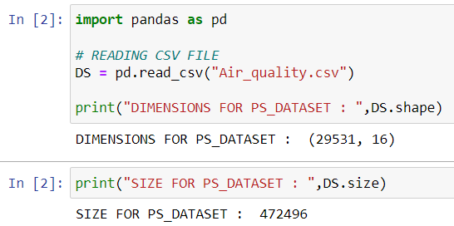

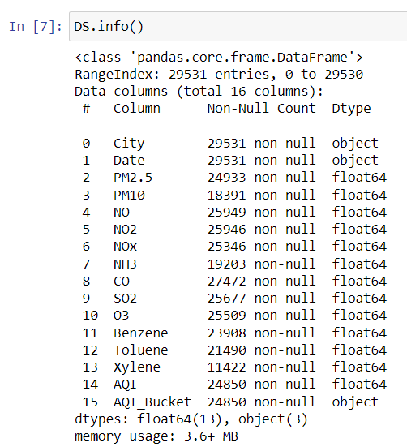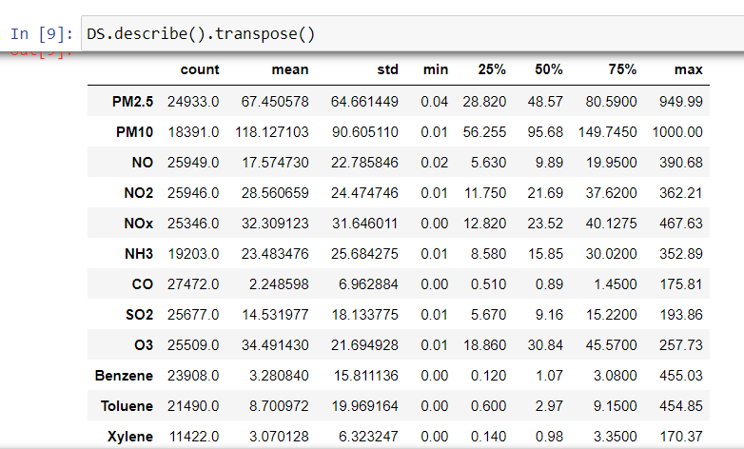

**DATA CLEANING :**

* Check whether the given data-set contains null values. By using isnull() method with sum() method.

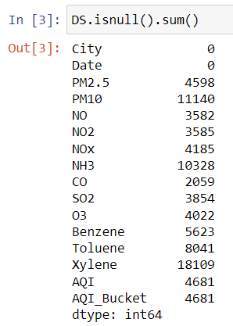

* Cleaning the data-set by deleting the null values using the dropna() method from the Pandas library.

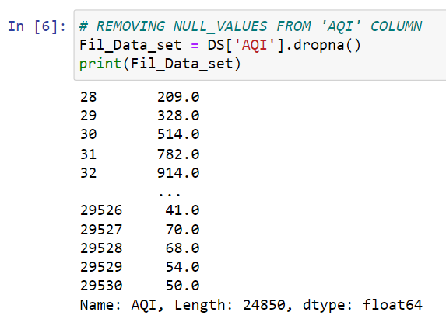

**DATA ANALYSIS :**

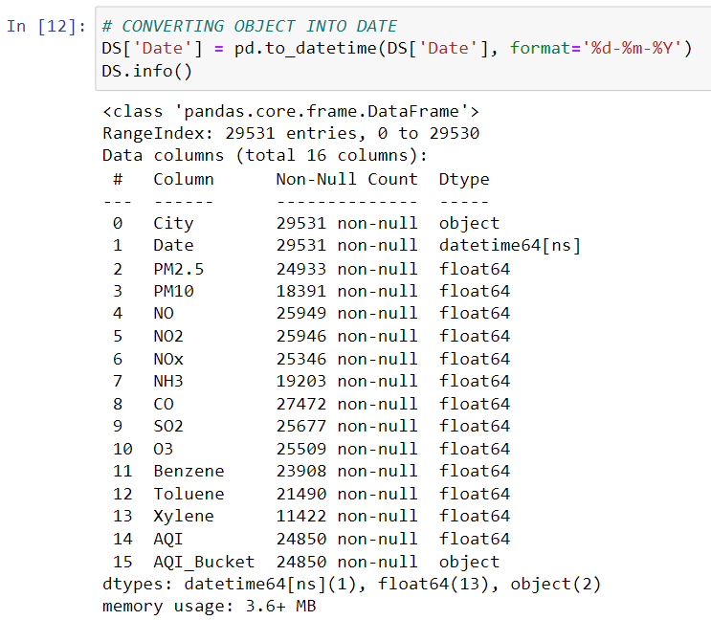For analyzing the date converted the date column from string into date format by using the to_datetime() method with format.

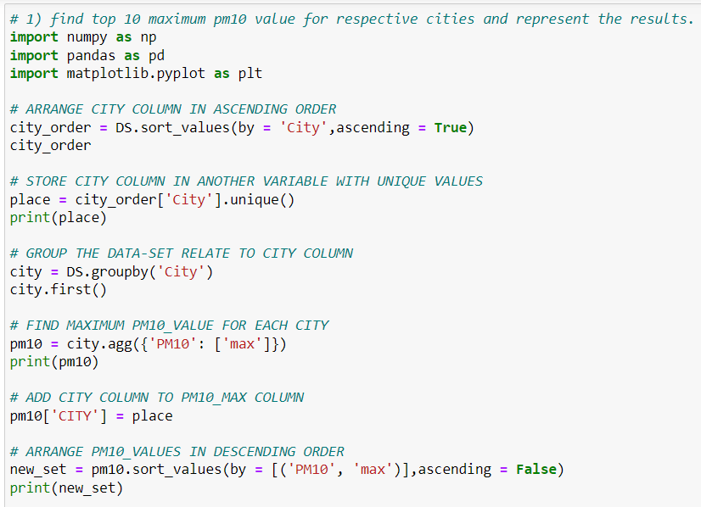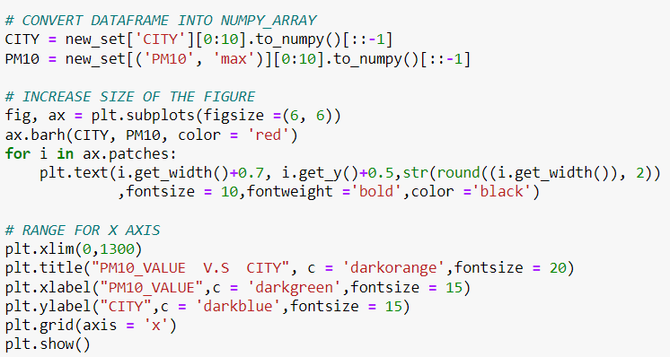

**OUTPUT :**

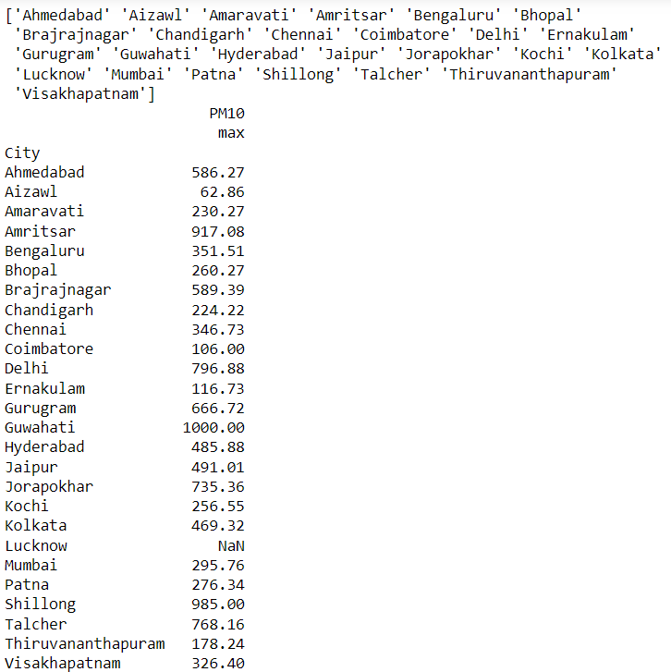

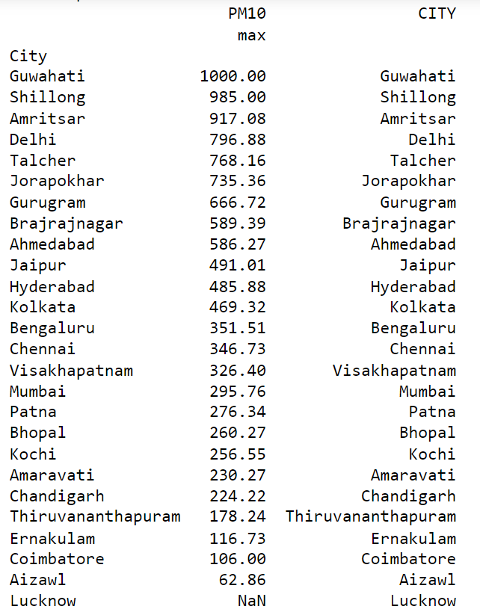

**DATA VISUALIZATION :**

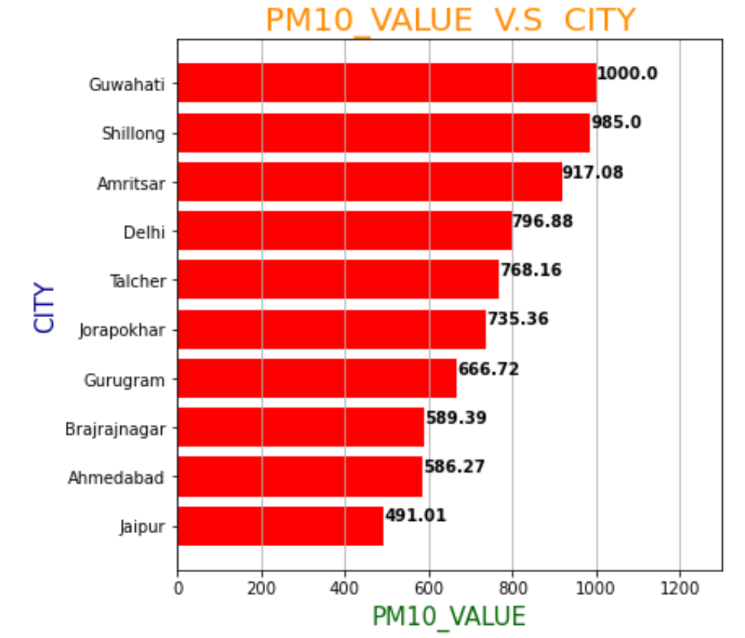

**CONCLUSION :**

The findings explain which top 10 cities in india are highly affected by PM10 fine particles.

Guwahati, Shillong, Amritsar, Delhi, Taicher, Jorapokhar, Gurugram, Brajrajnagar, Ahmedabad, Jaipur are the cities have PM10 value ranges from 491 to 1000.

This data is helpful for further years, to compare values and also take measures to control it.

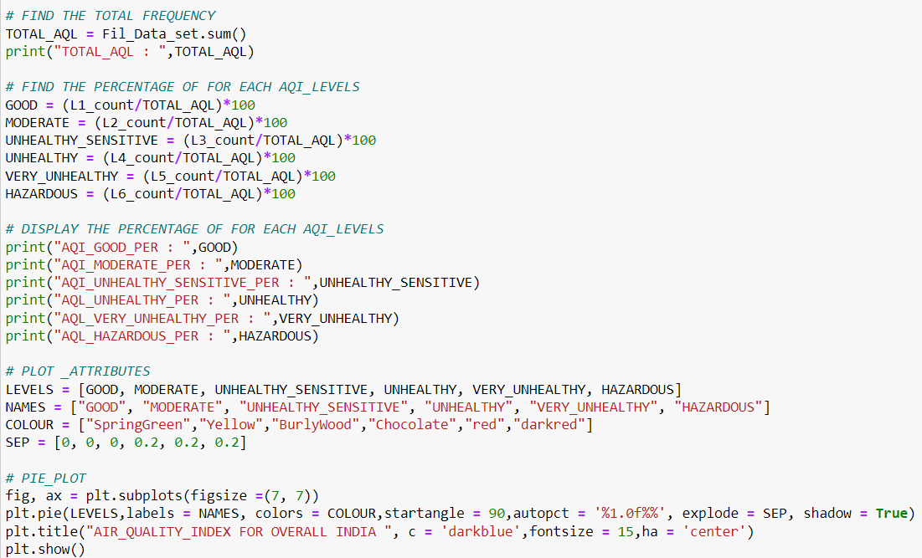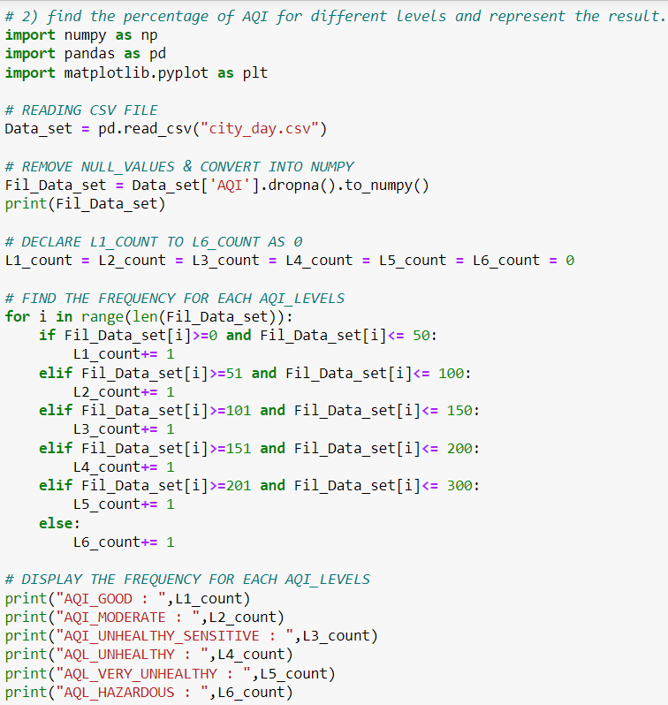

**OUTPUT :**

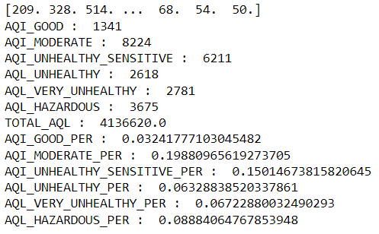

**DATA VISUALIZATION :**

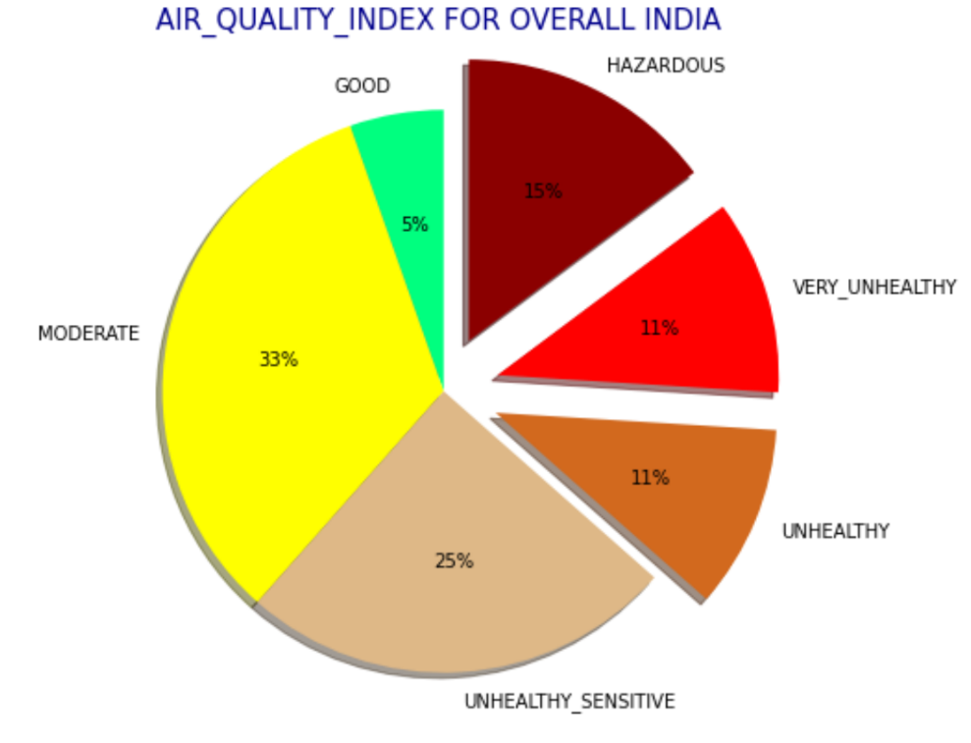

**CONCLUSION :**

The findings explain different AQI levels percentage for overall India. The most dangerous levels are hazardous, very unhealthy and unhealthy which has 15%, 11% and 11% respectively. The total percentage is 37% which is not fine.

This percentage data is helpful for further years, to compare values and also take measures to control it.