Experiment 1 Low Code and Traditional Application Development
CB23F35 Low Code Application Development using Zoho Creator
Loan Application Lab uses fictional coursework data. Observations below describe the actions and results verified during this lab.

Aim
Compare low code and traditional development using a fictional loan application workflow.

Theory
Loan Application Lab collects fictional applications, validates values and presents status reports. The study compares how these requirements are implemented with visual components and how a conventional application team would implement the equivalent layers. A separate traditional application was not built or benchmarked.
In Creator, forms define fields and storage, reports retrieve records, pages display summaries and Deluge handles exceptional logic. In a conventional stack, the developer chooses the database, builds API endpoints and screens, and manages deployment. Both approaches still need requirements, tests and access control.

Procedure
- Define the common requirements: unique reference, applicant, amount, term, status and reporting.
- Build the Creator form, list report, Kanban board and status chart.
- Add submission validation and execute a reusable aggregation function.
- Compare component ownership, customization, testing and deployment responsibilities.

Observations
- Data model: Creator field configuration produced persisted records and reports. A conventional implementation would need a schema, constraints and data-access code.
- Interface: the form and Kanban were configured visually. Conventional development would require form state, rendering and interaction code.
- Logic: a short Deluge workflow rejected invalid values. Visual design did not eliminate the need to understand field link names and server-side validation.
- Delivery: Creator offers managed environments. A conventional team would select infrastructure and a deployment pipeline.
- Tradeoff: the lab suited structured record processing. Specialized algorithms and unrestricted UI behavior would require extensions or a different architecture. No speed or cost percentage is claimed.
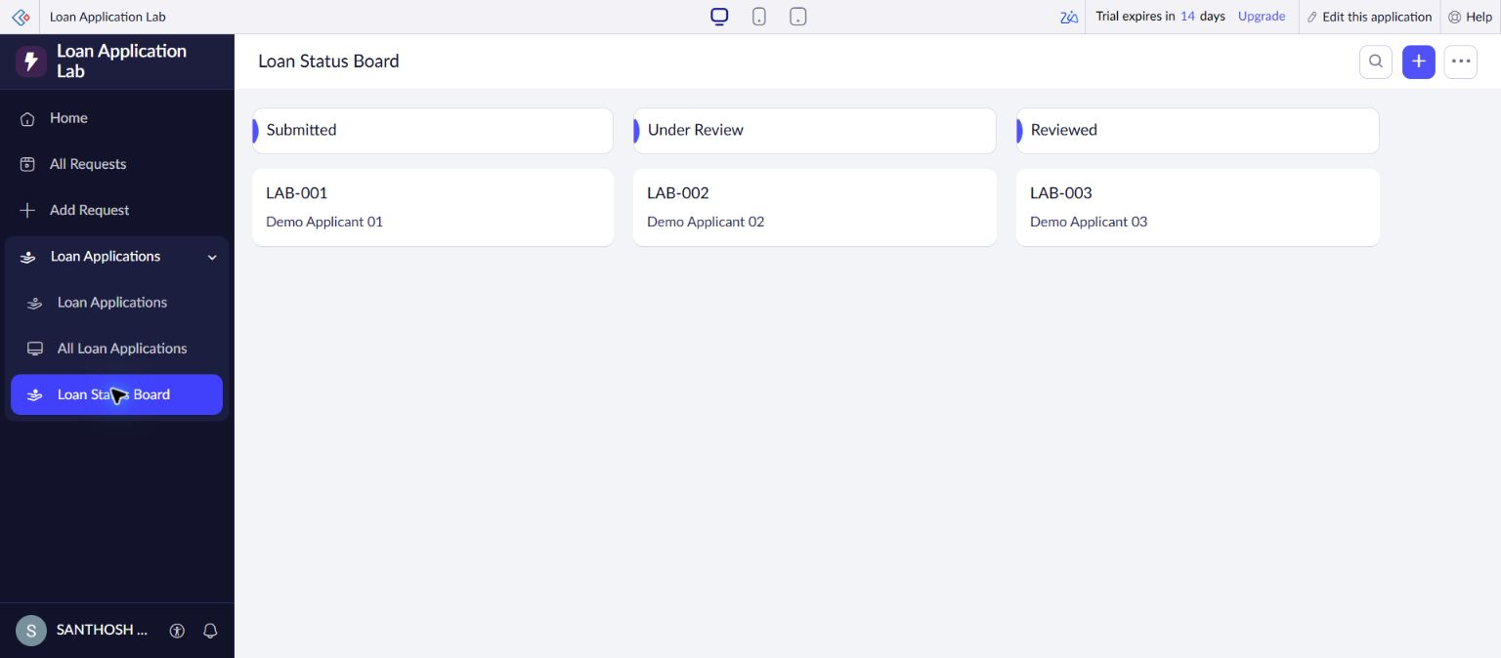
Figure 1 Actual Kanban view created during the lab with three fictional applications.

Result
The comparison identifies where visual configuration reduced implementation work and where programming, testing and governance remained necessary.

Sources
https://www.zoho.com/creator/glossary.html

