Experiment 7 Zoho Sheet Integration Through an OAuth Connection
CB23F35 Low Code Application Development using Zoho Creator
Loan Application Lab uses fictional coursework data. Observations below describe the actions and results verified during this lab.

Aim
Call a read-only Zoho Sheet API from a Creator custom function.

Theory
A named connection manages OAuth authorization without embedding tokens in source code. Loan Lab Sheet Read uses link name loan_lab_sheet_read, administrator authorization and only the Get all Spreadsheets action. The user explicitly approved this read-only connection.
The Sheet API workbook.list method lists accessible workbooks. The India data-centre endpoint is https://sheet.zoho.in/api/v2/workbooks. Although the documented transport is POST, this selected method only reads a listing. The function requests at most one workbook and logs only status, method and resource count.

Procedure
- Open Microservices and create the Zoho Sheet connection.
- Select Only Specific Actions and Get all Spreadsheets, then complete the approved OAuth consent.
- Enable connection access for Loan Application Lab.
- Create testSheetConnection and call invokeurl with method workbook.list, start_index 1 and count 1.
- Save and execute the function, then inspect only the sanitized result fields.

Observations
- The initial save identified that the connection was authorized but app access was still disabled. Enabling the application switch resolved that error.
- The custom function executed successfully and logged status success, method workbook.list and resource_count 0.
- Zero resources is a successful empty listing, not an authentication failure. No workbook data was invented to make the result look fuller.
- No access token, refresh token, workbook name or resource identifier is included in this record or its source files.
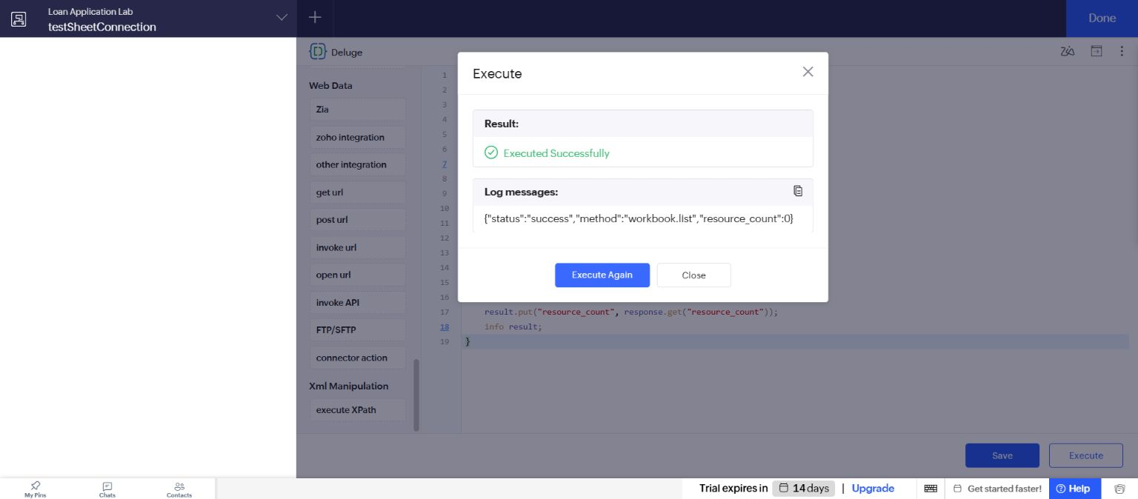
Figure 1 Actual successful integration execution with sanitized log fields.

Result
A real authenticated read-only integration call succeeded using the approved named connection.

Sources
https://www.zoho.com/sheet/help/api/v2/
https://help.zoho.com/portal/en/kb/creator/developer-guide/microservices/connector-references/articles/zoho-sheet-connector-references

