Experiment 2 Zoho Creator Setup and Platform Architecture
CB23F35 Low Code Application Development using Zoho Creator
Loan Application Lab uses fictional coursework data. Observations below describe the actions and results verified during this lab.

Aim
Explore the account, application builder and live application interface.

Theory
The account uses Zoho Creator in the India data centre. The application display title is Loan Application Lab. The account was already available for the student; the lab uses the available trial features. Edition and feature availability must be checked when demonstrating later.
Develop contains applications and microservices. The builder separates Design, Workflow and Settings. Forms represent data entry, reports present stored records, pages combine information, and workflows execute logic. Deploy contains environments, while Manage contains administrative tools.

Procedure
- Sign in to the existing Creator account and open Applications.
- Create the lab app and set the display name to Loan Application Lab.
- Inspect Design, Workflow, Settings and the live application.
- Create a Loan Applications form and check its saved-record report.
- Record the distinction between the builder, live app and administrative console.

Observations
- The app title was saved and verified after refreshing the application list.
- The live application and builder are separate views; a live form submission becomes a stored report row.
- The initial onboarding supplied Home, All Requests and Add Request leave-approval samples. Those are sample components, not the loan dashboard built in this lab.
- Student identity belongs in this record header. The application title does not include the student name.
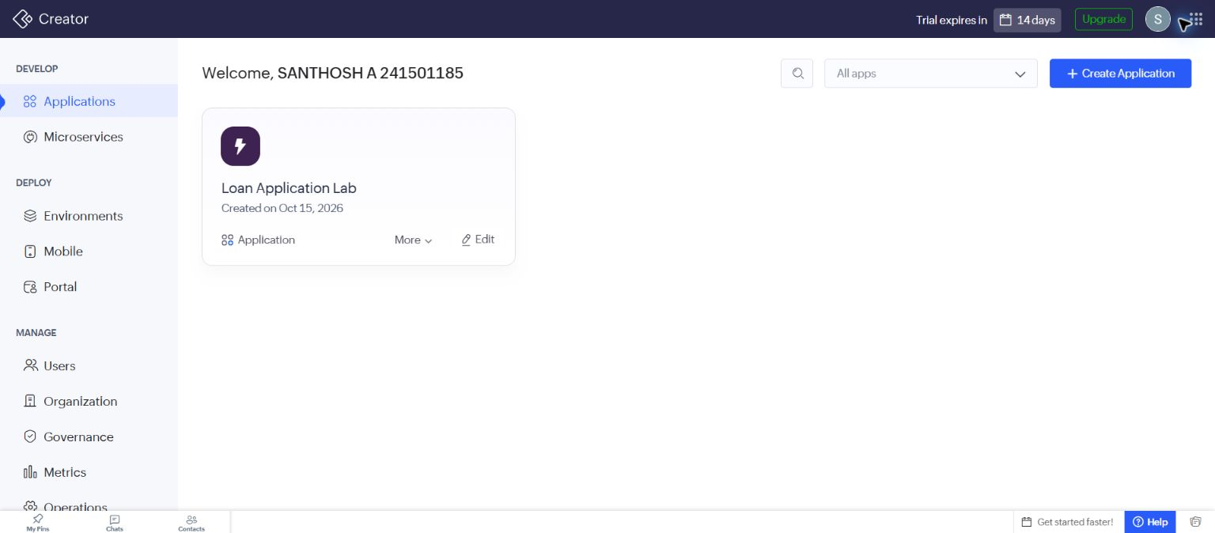
Figure 1 Application list after the title was changed and reloaded.

Result
The builder, live app and administrative areas were explored, and the lab application was created and used successfully.

Sources
https://www.zoho.com/creator/glossary.html

